PRICING & ENGAGEMENT MODELS

Transparent Pricing. Flexible Options. No Surprises.
OptiHR offers flexible pricing tailored to your business needs in South Africa—whether you need once-off project support, ad hoc assistance, prepaid hours, or comprehensive annual retainers . Choose how you engage: pay only for what you use, or lock in predictable monthly support with our fixed packages .
How We Price Our Services
Every business is different. Pricing depends on:
✔ Complexity – A simple policy review costs less than a full retrenchment process with union negotiations
✔ Time required – Quick compliance checks differ from multi-month Employment Equity plan development
✔ Resources allocated – Some projects need one consultant; others require legal partners, investigation teams, or multi-disciplinary support
✔ Urgency – Standard timelines vs. emergency interventions (e.g., CCMA case starting tomorrow)
✔ Organization size – 10 employees vs. 500 employees changes scope significantly
We don’t believe in one-size-fits-all pricing. We believe in fair pricing based on the value we deliver and the work required .
Engagement Options

1. Ad Hoc / Project-Based Services
Pay for specific projects or services as you need them—no ongoing commitment .
Best for:
• One-off needs (labour audit, policy development, retrenchment support)
• Businesses wanting to “try before committing” to retainers
• Organizations with unpredictable HR needs
How it works:
• You contact us with a specific need
• We scope the project and provide a fixed quote
• Work is completed and invoiced upon completion
• No ongoing obligations
Examples of ad hoc services:
• Labour audits
• Job evaluation projects
• Retrenchment Section 189 process management
• CCMA representation (single case)
• Employment Equity Plan development
• Board constitution drafting
• Disciplinary hearing chairing (per hearing)
• Policy development (single policy or full suite)
• Training workshops (per session)
• Compliance audits

2. Prepaid Hours Packages
Purchase blocks of consulting hours upfront at discounted rates—use them when you need them within 12 months .
How it works:
• Buy a prepaid hours package (10, 20, 50, or 100 hours)
• Use hours for any OptiHR service: advisory calls, document review, meeting attendance, research, drafting
• Hours roll over monthly within your 12-month period
• Unused hours expire after 12 months

Hourly rates decrease as you buy more hours:

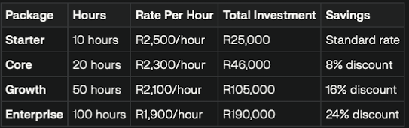
Best for:
• Businesses with sporadic but recurring HR needs
• Companies wanting expert support available on-demand without monthly retainers
• Organizations building internal HR capability but needing backup expertise
What hours cover:
• Telephonic consultations and email advice
• Document drafting and review (contracts, policies, letters, charge sheets)
• Meeting attendance (disciplinary hearings, grievance meetings, union negotiations)
• CCMA preparation and strategy sessions
• Compliance research and advisory
• Training facilitation
Subject to 12-month Service Level Agreement (SLA) – Hours purchased are valid for 12 months from purchase date.

3. Fixed Monthly Packages (Annual Retainers)
Predictable monthly fees for ongoing HR support—comprehensive services, unlimited access, proactive management .
All packages include telephonic and email support plus regular onsite visits (frequency depends on package level). Perfect for businesses wanting HR expertise without hiring full-time staff .
All packages subject to 12-month SLA – Annual commitment ensures continuity, relationship building, and proactive support (not reactive crisis management).

OPTI-ESSENTIALS – Foundational HR Support for Growing Businesses
R8,500/month (billed annually: R102,000)
Best for: Small businesses (10-30 employees) needing essential HR compliance and support .
What’s included:
✔ Unlimited telephonic and email support – Quick answers to HR questions, compliance queries, and employment law guidance
✔ Monthly onsite visit (4 hours) – Face-to-face consultation, document review, compliance checks
✔ Employment contract drafting and review – Up to 5 contracts/amendments per month
✔ 1 policy development or review per year – Choose one policy area (disciplinary, leave, grievance, etc.)
✔ Basic compliance support – Reminder of key deadlines (EE, WSP, annual returns)
✔ Disciplinary advisory – Guidance on handling discipline (you chair hearings; we advise)
✔ CCMA preparation support – We prepare you; external representation coordinated if needed (additional fees apply)
✔ Priority response – Calls/emails answered within 4 business hours
Not included: CCMA/Labour Court representation, retrenchments, full compliance management, investigations, hearing chairing, training delivery.
OPTI-ADVANTAGE – Comprehensive HR Partnership for Established Businesses
R16,500/month (billed annually: R198,000)
Best for: Medium businesses (30-100 employees) needing hands-on HR support and compliance management .
What’s included (everything in Essentials, PLUS):
✔ Unlimited telephonic and email support
✔ Bi-weekly onsite visits (8 hours/month) – Regular presence for consultations, meetings, and proactive support
✔ Disciplinary hearing chairing – Up to 2 hearings per month chaired by OptiHR
✔ Annual compliance management – EE reports (EEA2/EEA4), WSP/ATR submissions, CIPC annual returns
✔ 3 policies developed or reviewed per year – Build or refresh your HR policy suite
✔ Quarterly training workshops – 4 workshops per year (manager training, compliance updates, HR topics)
✔ Grievance facilitation – We manage grievance processes, investigations, and resolutions
✔ Employment Equity Plan development and updates – 5-year plan aligned with sectoral targets
✔ 1 CCMA conciliation per year (included) – We represent you at one CCMA conciliation; additional cases at reduced rates
✔ Priority response – Calls/emails answered within 2 business hours
Not included: Retrenchments, Labour Court matters, extensive investigations (fraud/theft), multiple CCMA arbitrations.
OPTI-PREMIER – Full-Service HR & IR Solution for Complex Organizations
R28,500/month (billed annually: R342,000)
Best for: Large businesses (100-300 employees), unionized workforces, or organizations with complex HR/IR needs
What’s included (everything in Advantage, PLUS):
✔ Unlimited telephonic and email support
✔ Weekly onsite visits (16 hours/month) – Embedded HR expertise with regular presence
✔ Unlimited disciplinary hearing chairing – We chair all hearings as needed
✔ Full compliance management – EE, WSP/ATR, SACE (schools), CIPC, Department of Labour, POPIA, OHS—everything managed proactively
✔ Unlimited policy development/review – Complete HR policy suite development and annual reviews
✔ Monthly training/workshops – 12 training sessions per year on any HR/compliance topic
✔ Industrial relations support – Union negotiations, recognition agreements, collective bargaining support, workplace forum management
✔ Employers organization membership included – Join our registered employers organization for collective bargaining power
✔ Retrenchment support (1 per year included) – Full Section 189 process management
✔ Unlimited CCMA conciliations – We represent you at all conciliation hearings
✔ 2 CCMA arbitrations per year (included) – Full representation; additional at reduced rates
✔ Company secretary services (for private companies) – CIPC compliance, statutory registers, board resolutions, governance support
✔ Workplace wellness program coordination – Annual wellness strategy, EAP coordination, wellness days
✔ 24/7 emergency support – After-hours access for urgent crises (strikes, serious misconduct, workplace incidents)
✔ Immediate response – Calls/emails answered within 1 business hour
Not included: Labour Court litigation (coordinated through legal partners at reduced rates), extensive forensic investigations.
OPTI-PLATINUM – Strategic HR Executive Partnership
Custom Pricing (typically R45,000-R75,000/month depending on organization size and complexity)
Best for: Large enterprises (300+ employees), multi-site operations, listed companies, or organizations needing executive-level HR strategy .
What’s included (everything in Premier, PLUS):
✔ Unlimited telephonic and email support
✔ Dedicated account manager – Senior HR consultant assigned exclusively to your business
✔ Unlimited onsite visits – As needed, including multi-site support across South Africa
✔ Strategic HR planning – Workforce planning, succession planning, organizational design, transformation strategies
✔ Executive coaching for HR leadership – Develop internal HR team capabilities
✔ Unlimited CCMA arbitrations – Full representation at all arbitrations
✔ Labour Court support coordination – We coordinate with specialist labour law attorneys for court matters (attorney fees additional)
✔ Full industrial relations management – Strike preparedness, lockout strategy, multi-union negotiations, bargaining council representation
✔ Job evaluation and salary benchmarking – Annual reviews ensuring market competitiveness
✔ Performance management system design and support – KPI development, appraisal systems, performance improvement plans
✔ Recruitment support – Job profiling, interview support, selection criteria development
✔ Change management support – Restructures, mergers, acquisitions, organizational transformation
✔ Board reporting – Quarterly HR reports for boards covering compliance, risks, and people metrics
✔ 24/7 emergency support with guaranteed response – After-hours support within 30 minutes for critical incidents
✔ Quarterly business reviews – Strategic planning sessions with executive leadership
Custom scope: Platinum packages are tailored to your specific organizational needs. Contact us for a comprehensive proposal.

Service-Specific Pricing (Ad Hoc)
Can’t commit to a retainer? Need a specific service now? Here’s project-based pricing for common services:
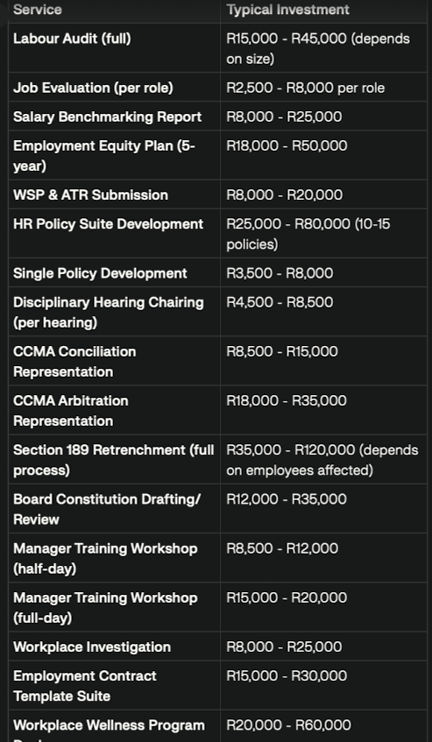
Pricing depends on complexity, urgency, organization size, and resources required. All quotes customized to your specific needs.
What’s NOT Included in Any Package
To maintain transparency, here’s what typically requires additional fees even in retainer packages:
❌ External legal representation – Labour Court litigation coordinated through our attorney network (attorney fees separate)
❌ Extensive forensic investigations – Fraud, theft, or complex misconduct requiring forensic accountants or investigators
❌ Out-of-province travel – Travel and accommodation for services outside Gauteng (costs recovered at cost)
❌ Psychometric testing – Third-party assessments for recruitment or development
❌ EAP services – Employee Assistance Programs require separate EAP provider contracts
❌ Background checks – Criminal, credit, and qualification verification services

Why Choose OptiHR Retainers?
🔹 Predictable budgeting – Fixed monthly fees, no surprise invoices
🔹 Proactive support – We prevent problems before they become CCMA cases
🔹 Relationship building – We learn your business, culture, and people over time
🔹 Priority access – Retainer clients get first access during busy periods
🔹 Cost savings – Retainer rates significantly lower than ad hoc hourly fees
🔹 12-month SLA protection – Service levels guaranteed in writing
🔹 Scalability – Upgrade or downgrade packages at renewal based on changing needs
12-Month Service Level Agreements (SLAs)
All retainer packages and prepaid hours are subject to 12-month SLAs ensuring:
✔ Guaranteed response times – Defined by package level (1-4 business hours)
✔ Service scope clarity – What’s included, what’s additional, and how we engage
✔ Termination provisions – Fair exit clauses with 60-day notice after initial 12 months
✔ Annual review meetings – Quarterly (Premier/Platinum) or annual (Essentials/Advantage) reviews assessing service delivery and needs evolution
✔ Fee protection – Rates locked for 12 months; increases capped at CPI + 2% at renewal
✔ Escalation procedures – Clear pathways if service levels aren’t met
Frequently Asked Questions
Q: Can we start with a smaller package and upgrade later?
Yes. We recommend starting where you’re comfortable. As your business grows or needs change, you can upgrade at your next renewal—or even mid-term if urgent needs arise .
Q: What happens if we use more services than our package includes?
Additional services are billed at reduced ad hoc rates for retainer clients—typically 20-30% lower than standard project pricing. We’ll always get approval before exceeding package scope .
Q: Can we pause our retainer if business slows down?
Retainers require 12-month commitments, but we can discuss reduced-scope arrangements during genuinely tough times. Prepaid hours might suit businesses with fluctuating needs better .
Q: Do prepaid hours expire?
Yes—prepaid hours are valid for 12 months from purchase date. This encourages regular engagement and ensures we stay current with your business .
Q: Can we mix ad hoc services with retainers?
Absolutely. Many clients retain us for ongoing compliance/advisory support but engage ad hoc for specialized projects like retrenchments or Labour Court matters.
Q: Are training workshops included in all packages?
Essentials: No. Advantage: 4 per year. Premier: 12 per year. Platinum: Unlimited. Additional workshops can be purchased separately .
Q: What if we’re not sure which package suits us?
Contact us for a free consultation. We’ll assess your business size, industry, HR maturity, compliance status, and needs—then recommend the best fit. Many clients start with prepaid hours to “test drive” our services before committing to retainers .
How to Get Started
Step 1: Choose Your Engagement Model
Decide whether ad hoc, prepaid hours, or monthly retainers suit your business best.
Step 2: Book Your Free Consultation
We’ll discuss your specific needs, compliance status, risks, and goals—then recommend the right solution.
Step 3: Receive Your Custom Proposal
We’ll provide a detailed proposal outlining scope, pricing, timelines, and SLA terms.
Step 4: Sign Your Agreement
Once you’re happy, we execute the SLA and get to work immediately.
Step 5: Onboarding
We conduct a comprehensive intake understanding your business, workforce, policies, and current challenges—setting the foundation for successful partnership.
Call-to-Action
Stop guessing what HR support costs. Get transparent pricing tailored to your South African business.
Whether you need once-off project support, prepaid hours for flexibility, or comprehensive monthly retainers—OptiHR offers pricing that works for businesses of all sizes in Gauteng and across South Africa .
👉 Request Your Free Pricing Consultation and get a customized proposal showing exactly what you’ll pay and what you’ll get—no surprises, no hidden fees, just transparent pricing for professional HR support.
📞 Contact us today to discuss which engagement model suits your business best.

