Decision Time Information and the Validity of Response Models for Constrained Marketing
Rong Zhao
Temple University, Fox School of Business
Abstract
Response models can rank prospective contacts accurately while answering the wrong managerial question if their predictors were not available when the contact decision was made. We examine this problem using 41,176 deduplicated records from a historical Portuguese bank telemarketing campaign and a fixed, previously analyzed development holdout. We distinguish strict planning, planning with macroeconomic context, operational pre-contact scoring, operational scoring with macro context, and an intentionally invalid post-contact specification. The calibrated strict planning model achieves precision–recall area under the curve (PR-AUC) of 0.339 (95% bootstrap interval 0.307–0.372), receiver operating characteristic area (ROC-AUC) of 0.706 (0.687–0.724), and Brier score of 0.087 (0.082–0.092). Prioritizing 20% of holdout contact records captures 45.5% (42.6%–48.3%) of observed subscribers. Relative to strict planning, legitimate information sets increase PR-AUC by 0.084–0.145 and top-20% capture by 14.7–19.8 percentage points in paired bootstrap comparisons. Adding post-contact duration to the richest valid specification produces a further apparent increase of 0.167 in PR-AUC and 22.4 points in capture, but cannot inform whom to call. These information-set differences are materially larger than the small, uncertain differences among the competent algorithms examined. The evidence supports a decision-specific interpretation of predictive validity and a budget-based account of observed targeting efficiency. It does not identify the incremental effect or monetary return of contacting customers.
Keywords: direct marketing; response modeling; decision-time information; targeting; data leakage; calibration

1. Introduction
A direct marketer choosing whom to contact faces a concrete allocation problem: rank potential contacts before the available calling capacity is committed. A response model may report an impressive discrimination statistic and still offer little evidence for that choice if it uses the channel, timing, economic conditions, or even call duration recorded after the list was assembled. Performance belongs to a decision and its available information, rather than to an algorithm in isolation. This paper asks: How does information available at different decision times change the measured predictive and targeting value of response models under a contact constraint?
The question is consequential because customer selection occurs at several times. Before a campaign, the marketer can use known customer attributes and prior interactions. Once a contact is scheduled, the planned channel and date and the number of earlier campaign contacts may also be known. Economic indicators might be observable at the relevant date, although retrospectively merged values can stand in for later releases or revisions. Call duration is only known during or after the focal call. A model using each of these sets answers a distinct question. Treating all features as interchangeable turns a claim about retrospective fit into an unsupported claim about advance targeting.
Prior marketing research established response modeling as a tool for customer selection, including work on the selection decision and its economic objective (Bult and Wansbeek 1995) and machine learning for direct marketing (Cui, Wong, and Lui 2006). Marketing analytics more broadly connects data and modeling to decisions across the customer journey (Wedel and Kannan 2016), while predictive fit and managerial policy value remain distinct criteria (Smith, Seiler, and Aggarwal 2023). The Portuguese Bank Marketing data and prediction of deposit subscription were studied by Moro, Cortez, and Rita (2014); the data are old and extensively reused. Our contribution therefore rests neither on predicting this outcome for the first time nor on introducing a new algorithm. We operationalize an information-availability distinction on this familiar benchmark, quantify its effect on ranking with paired uncertainty, and connect the valid planning estimate to observed outcomes at fixed contact budgets. A deliberately impossible duration-based model makes the validity boundary visible rather than presenting its higher score as a useful advance.
Three claims organize the analysis. First, a valid predictive comparison must define the decision at which every predictor is available. Second, adding genuinely available information can improve performance, but the resulting estimate applies to a later or otherwise different decision. Third, ranking, calibrated probabilities, and the number of observed subscribers found at a fixed budget capture different dimensions of usefulness. We compare these dimensions without inferring that a contact caused a subscription.

2. Conceptual Background and Research Motivation
The targeting problem has a time index. Let X(t) contain the information legitimately observable at time t, Y indicate observed subscription, and f(X(t)) be a score used to select the highest-ranked records subject to a contact budget. Predictive analysis has a different objective from explanation (Shmueli 2010), and prediction used in policy must be evaluated against the action it is meant to inform (Kleinberg et al. 2015). The same outcome can be predicted using a later information set X(t+1), but its apparent improvement says nothing about the earlier policy unless those variables can actually be obtained before that policy is executed. This is the operational face of data leakage: information outside the intended prediction process enters estimation or evaluation (Kaufman et al. 2012). A predictor need not literally reveal the outcome to be misaligned; a current contact's weekday can be legitimate for a scheduled-call decision and unavailable for the prior campaign-list decision.
Marketing scholarship also distinguishes selecting likely responders from selecting customers whose behavior an intervention changes. Bult and Wansbeek (1995) derive contact selection in relation to marginal returns and costs. Ascarza (2018) demonstrates in retention that customers at high risk need not be the most responsive to intervention; Devriendt, Berrevoets, and Verbeke (2021) formalize the practical case for uplift models; Lemmens and Gupta (2020) and Hitsch, Misra, and Zhang (2024) evaluate incremental targeting policies using experimental evidence. Our outcome is observed subscription following historical calls. We estimate the propensity of that recorded outcome among observed contacts. Without randomized noncontact outcomes, this is neither an uplift model nor evidence that calling any selected individual creates a subscriber. Accordingly, our budget analysis counts observed subscribers and does not price incremental value.
Because the positive class is relatively uncommon, accuracy can be dominated by correct negatives. We report PR-AUC, implemented as average precision, together with ROC-AUC; precision–recall analysis is informative for unequal class prevalence (Saito and Rehmsmeier 2015). We also examine calibration: a score that ranks correctly may still overstate the probability of response. Niculescu-Mizil and Caruana (2005) show why probability estimates and discrimination require separate attention. A contact budget depends immediately on ranking, whereas probability-based thresholding or expected-value planning also requires credible probabilities. Neither metric solves the information-timing problem.
This framing suggests a measurable implication rather than a claim of theoretical novelty: within the same data and split, changing the available information set may alter the estimated targeting value more than switching among common competent algorithms. Out-of-sample predictive fit itself can be a poor guide to the value of a targeting policy when the decision objective differs from the prediction task (Smith, Seiler, and Aggarwal 2023). Here, paired resampling measures the uncertainty around performance differences produced by complete specifications. The comparisons remain descriptive: they neither isolate causal effects of individual variables nor establish performance in a new campaign regime.

3. Data and Decision Setting
We use UCI's bank-additional-full extract, which records 41,188 telemarketing contacts from a Portuguese institution between May 2008 and November 2010 (Moro, Cortez, and Rita 2014; Moro, Rita, and Cortez 2014). The binary outcome identifies whether the client subscribed to a term deposit. Removing 12 exact duplicate rows leaves 41,176 contact records with 4,639 subscriptions, a prevalence of 11.3%. These are contact records, not independently identified customers: the public file lacks a stable customer identifier, so different records might belong to the same person. The outcome and the available predictors describe historical operations; they do not describe current banking demand.
The primary decision is selecting a campaign list before the current campaign's contact is scheduled. The strict information set consists of ten bank-held attributes and previous-campaign history: age, job, marital status, education, credit default, housing loan, personal loan, days since prior-campaign contact (pdays), number of earlier-campaign contacts (previous), and the prior campaign's outcome (poutcome). The pdays sentinel for no prior contact is retained as coded. These fields define a conservative planning scenario, not proof that every real bank would have all ten fields accurate and legally usable at the same instant.
Table 1 separates three additional conditions. Five macroeconomic fields can be observed in principle but are sensitive to release dates, revisions, and campaign-period proxying. A later operational choice may include current contact channel, month, weekday, and the number of contacts before the focal contact; the last is computed as nonnegative campaign_prior = campaign - 1. UCI defines raw campaign as including the focal contact, so that raw field is excluded. Finally, focal-call duration is known only after the call; we add it solely to show an invalid benchmark. The four pre-contact sets are conditional scenarios, not a monotone ladder of universal deployability: planning plus macro and operational pre-contact represent different information additions. A prospective implementation must audit publication vintages and the particular workflow before using either.
Table 1. Decision-time information sets and paired performance differences
Information set | Decision status | PR-AUC | Top-20% capture | Paired ΔPR-AUC; Δcapture [95% CI]
Strict planning | List selection | 0.339 | 45.5% | Reference
Planning + macro | Planning if release vintages available | 0.454 | 65.3% | +0.115 [0.094, 0.138]  +19.8 pp [17.1, 22.6]
Operational pre-contact | Scheduled, before call | 0.423 | 60.1% | +0.084 [0.066, 0.099]  +14.7 pp [12.1, 17.4]
Operational + macro | Later pre-call decision | 0.485 | 65.1% | +0.145 [0.124, 0.167]  +19.6 pp [17.2, 22.7]
Invalid + duration | After focal call | 0.651 | 87.5% | +0.167 [0.149, 0.185]  +22.4 pp [19.5, 25.1]

Note. Valid specifications are compared with strict planning; the invalid duration specification is compared with operational plus macro. Differences are comparison minus reference from 1,000 paired bootstrap resamples. pp = percentage points.
The source is ordered by date but lacks full row-level dates. Month and weekday do not uniquely recover the 2008–2010 sequence. We therefore use a fixed stratified random 80/20 split: 32,940 training records and 8,236 records in a development holdout, of which 928 are subscriptions. This split cannot exclude repeated customers across partitions and cannot substitute for prospective temporal validation. Earlier repository analyses examined the same holdout. We call it a development holdout throughout, and treat its numerical uncertainty as conditional on this fixed historical exercise.

4. Empirical Method
We compare a prevalence-only dummy, class-weighted logistic regression, random forest, and histogram gradient boosting. Numeric inputs are median-imputed and standardized; categorical inputs are mode-imputed and one-hot encoded with unknown categories handled explicitly. Preprocessing is fit within the training folds. Five stratified training folds select the base estimator by mean PR-AUC, breaking an exact tie by ROC-AUC. For the selected estimator, three-fold nested training-only out-of-fold predictions compare uncalibrated, sigmoid, and isotonic probabilities by Brier score. The selected calibrated model is then fit on training data and scored on the fixed development holdout. This does not make the holdout pristine; it does avoid using it to choose the current model and calibrator.
PR-AUC summarizes ranking with emphasis on positive predictions, ROC-AUC measures discrimination across thresholds, and Brier score measures squared probability error. At contact share q we select the ceiling of q times the 8,236 holdout records by descending score. Responder capture is observed subscribers in that selected group divided by all 928 holdout subscribers. Observed conversion is subscribers divided by selected contacts; lift is this conversion divided by the holdout's 11.3% prevalence. Contacts per observed subscriber is selected contacts divided by selected subscribers. A random allocation of the same number of contacts has expected capture approximately q and expected conversion equal to prevalence. These quantities evaluate historical ranking against random allocation within the observed-contact sample; they cannot estimate avoided calls or additional subscriptions under an untested deployment policy.
For uncertainty in the primary fixed-holdout metrics, 1,000 bootstrap samples resample holdout records. Paired resampling of identical holdout indices compares algorithms and four prespecified information-set contrasts for PR-AUC and top-20% capture. The information-set bootstrap uses seed 143 and reports comparison minus reference: each valid specification is compared with strict planning, while the invalid duration specification is compared with operational plus macro. These are pointwise intervals for named contrasts, not simultaneous familywise guarantees. They quantify sampling variation conditional on the split, fitted models, historical selection process, and previously inspected holdout. They do not turn specification contrasts into causal effects of individual variables. The same selected estimator and calibration method are refit on the training portion for each valid information-set sensitivity, so the results contrast inputs under a common model family, while the final strict model remains the prespecified primary specification.

5. Results
On the training folds, random forest and histogram gradient boosting both achieve mean PR-AUC of 0.353 (fold standard deviations 0.015 and 0.018). Logistic regression reaches 0.337 and the prevalence dummy 0.113. The forest's unrounded training mean exceeds boosting's by only 0.000028. The selection rule chooses forest, and training-only Brier score chooses isotonic calibration (0.086, versus 0.086 for sigmoid when rounded to three decimals and 0.186 uncalibrated; the underlying values are 0.086236, 0.086450, and 0.186349). Table 2 reports both training selection and fixed-holdout results without treating this near-tie as substantive superiority.
Table 2. Training selection and development-holdout results
Model | CV PR-AUC | Holdout PR-AUC | ROC-AUC | Brier score
Dummy Baseline | 0.113 | 0.113 | 0.500 | 0.100
Logistic Regression | 0.337 | 0.327 | 0.703 | 0.202
Random Forest | 0.353 | 0.341 | 0.707 | 0.188
Histogram Gradient Boosting | 0.353 | 0.342 | 0.707 | 0.195
Random Forest (isotonic calibration) | — | 0.339 | 0.706 | 0.087

Note. CV denotes five-fold training-only mean. Uncalibrated class-weighted models have poorly calibrated raw probabilities. Isotonic calibration is chosen on training data and defines the primary model.
The final strict planning model yields holdout PR-AUC 0.339 (95% bootstrap interval 0.307–0.372), ROC-AUC 0.706 (0.687–0.724), Brier score 0.087 (0.082–0.092), and log loss 0.310. Its 20% budget captures 45.5% of observed subscribers (42.6%–48.3%) with lift 2.27 (2.13–2.41). The calibrated forest minus gradient boosting has paired PR-AUC difference −0.003 (95% interval −0.011 to 0.006) and top-20% capture difference 0.006 (−0.012 to 0.020). Against logistic regression, corresponding differences are 0.012 (−0.0002 to 0.026) and 0.012 (−0.011 to 0.030). These intervals do not support a strong claim that forest materially improves ranking over boosting or logistic regression in this split. Isotonic calibration greatly improves the forest's Brier score relative to its raw class-weighted scores (0.087 versus 0.188), while its PR-AUC changes slightly from 0.341 to 0.339; probability correction and ranking improvement are separate results.
Information timing generates larger and more precisely estimated differences than the algorithm comparisons in this study (Table 1 and Figure 1). Relative to strict planning, planning plus macro context increases PR-AUC by 0.115 (95% paired bootstrap interval 0.094–0.138) and top-20% capture by 19.8 percentage points (17.1–22.6). Operational pre-contact increases PR-AUC by 0.084 (0.066–0.099) and capture by 14.7 points (12.1–17.4). Operational plus macro increases PR-AUC by 0.145 (0.124–0.167) and capture by 19.6 points (17.2–22.7). In levels, the respective PR-AUC/ROC-AUC/top-20% capture values are 0.454/0.805/65.3%, 0.423/0.781/60.1%, and 0.485/0.813/65.1%, compared with 0.339/0.706/45.5% for strict planning. Legitimately available later information can therefore improve ranking for the corresponding later decision. The sets do not order neatly by label: planning plus macro has slightly greater top-20% capture than operational plus macro despite lower PR-AUC. PR-AUC averages ranking over many cutoffs, whereas capture evaluates one cutoff. Macro variables can additionally encode historical campaign regimes, so their observed benefit should not be read as proof of prospective access to exactly these released values or portability across time.
Against the operational-plus-macro specification, adding post-call duration changes PR-AUC from 0.485 to 0.651, ROC-AUC from 0.813 to 0.946, and top-20% capture from 65.1% to 87.5%. The paired differences are 0.167 for PR-AUC (95% interval 0.149–0.185) and 22.4 percentage points for capture (19.5–25.1). Duration is an outcome of the focal interaction and cannot inform a pre-call targeting decision. Its high score is a diagnostic of an invalid evaluation, not a candidate intervention policy. The full 0.339-to-0.651 difference is not a leakage estimate because the endpoint also adds legitimate operational and macro information. The paired operational-plus-macro contrast measures the specification change associated with adding duration within the available outputs, not a causal effect of duration.
Figure 1. Apparent PR-AUC under different information sets; the duration model is invalid for pre-contact selection.
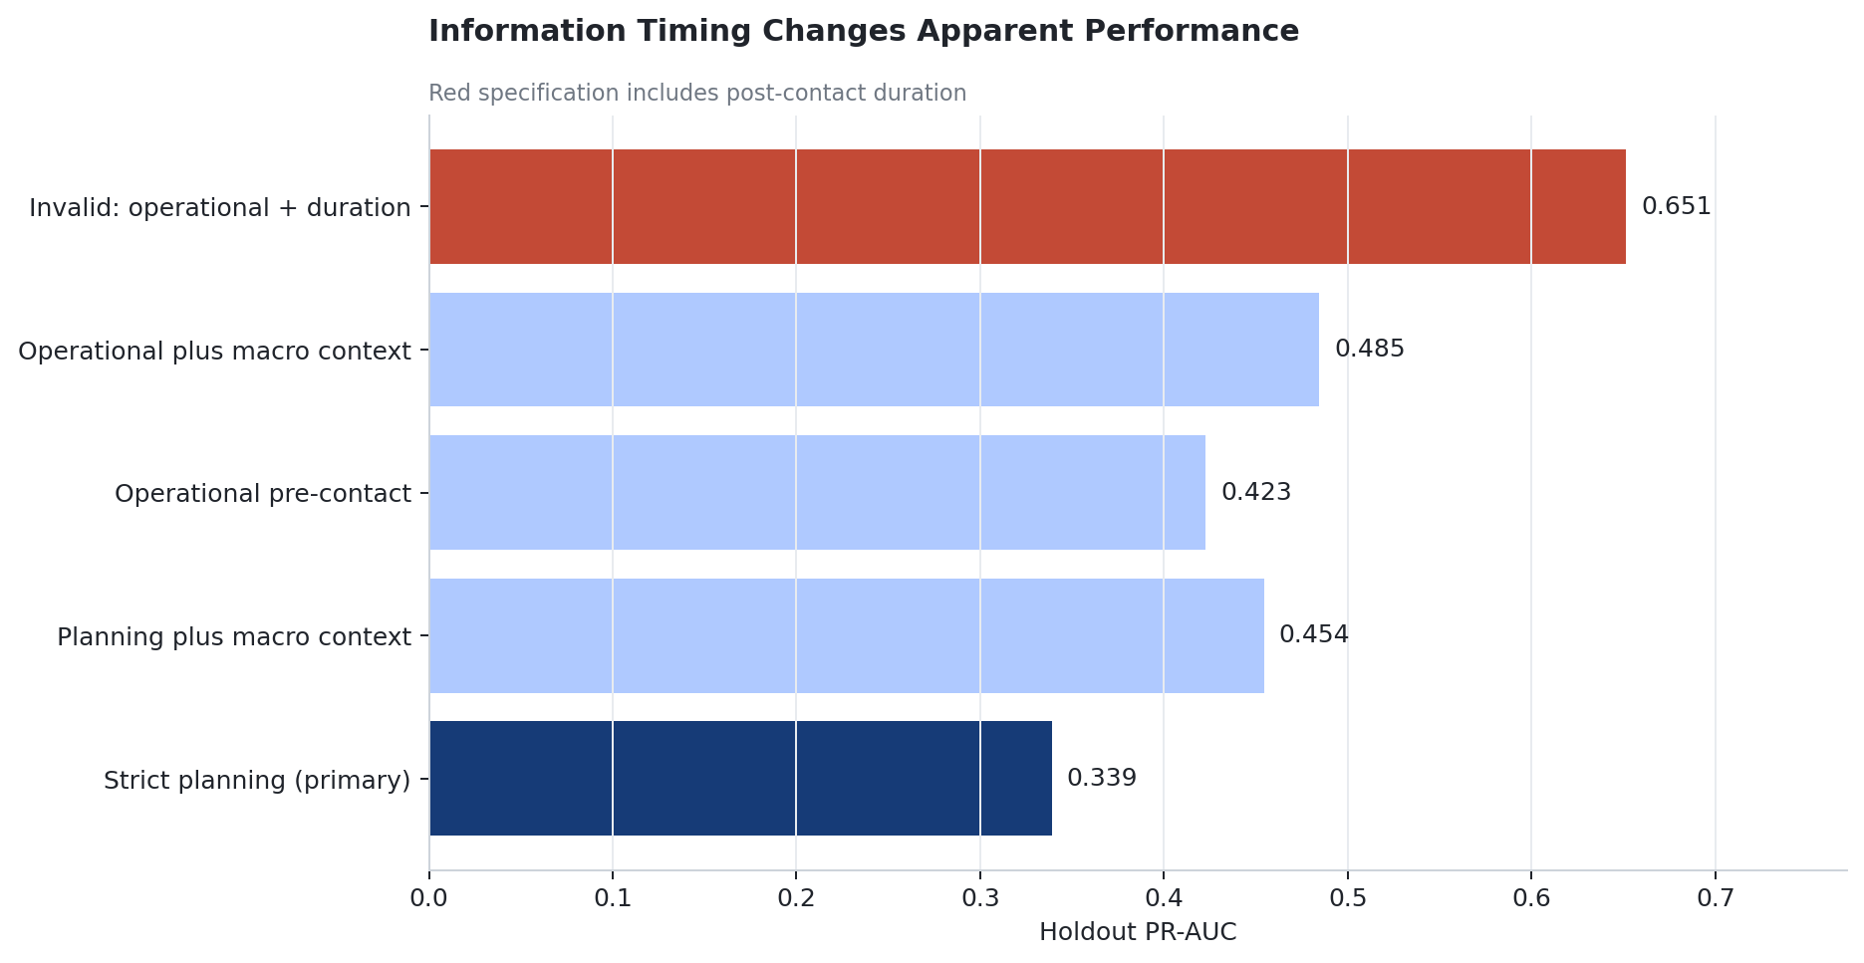

6. Targeting and Managerial Implications
The strict planning model offers a directly interpretable budget calculation. Table 3 and Figure 2 show the cumulative ranking outcomes. At a 10% contact share, 824 records include 318 observed subscribers, giving 38.6% observed conversion, 34.3% capture, 3.43-fold lift, and 2.59 contacts per observed subscriber. At 20%, 1,648 contacts include 422 observed subscribers: 25.6% conversion, 45.5% capture, 2.27-fold lift, and 3.91 contacts per observed subscriber. At 30%, 2,471 contacts include 518 subscribers, and at 40%, 3,295 include 595. With the 20% budget, random selection within the holdout would be expected to contain 185.7 observed subscribers, assuming the observed-contact sample is the relevant universe. The comparison says the model concentrates historically observed subscriptions; it does not say the model creates the difference in subscriptions.
Table 3. Observed targeting outcomes for strict planning model
Budget | Contacts | Observed  subscribers | Capture | Lift | Contacts per  observed subscriber
10% | 824 | 318 | 34.3% | 3.43 | 2.59
20% | 1,648 | 422 | 45.5% | 2.27 | 3.91
30% | 2,471 | 518 | 55.8% | 1.86 | 4.77
40% | 3,295 | 595 | 64.1% | 1.60 | 5.54

Note. All figures describe observed holdout contact records. At the 20% budget, random selection expects 185.7 observed subscribers.
Figure 2. Cumulative observed subscriber capture under strict planning, compared with random selection.
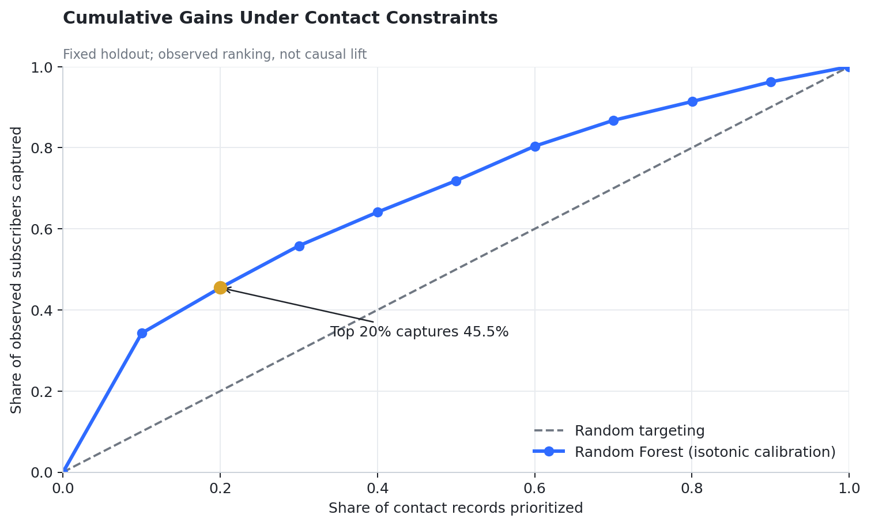
As capacity expands, additional selected records have lower average observed conversion. A manager can use this curve to describe the tradeoff between contact volume and the fraction of historical subscribers reached, but cannot set an economically optimal threshold from these data. A defensible policy would need contact-specific cost, expected customer value, and the incremental probability of subscription because of a contact. Bult and Wansbeek (1995) provide the economic framing, whereas causal marketing studies such as Ascarza (2018) and Lemmens and Gupta (2020) show why a high propensity need not identify the highest incremental return. Our 3.91 contacts per observed subscriber is a descriptive efficiency ratio, not cost per acquired customer. If the decision moves from planning to a scheduled contact, an operational score may legitimately be more informative, but its evaluation should explicitly state the later decision and revalidate its input availability.

7. Robustness and Validity Analysis
Exact deduplication affects the estimate only modestly in this fixed procedure: retaining all 41,188 rows changes strict-model PR-AUC from 0.339 to 0.349, while top-20% capture changes from 45.5% to 45.3%. An exact duplicate might represent repeated identical contact records rather than a data error; without customer IDs we cannot adjudicate that distinction. This sensitivity does not cure possible customer overlap between training and holdout.
Permutation analysis on the development holdout reports the greatest mean PR-AUC decrease when pdays is shuffled (0.0409), followed by age (0.0297), previous-campaign outcome (0.0280), default (0.0173), and previous contacts (0.0144). These scores identify variables useful to this fitted model in this sample; correlated predictors, historical selection, and repeated measurement restrict their interpretation. They are not estimates of the effect of changing age, credit default, or past contact behavior. We omit a feature-importance exhibit because the paper's contribution concerns information timing, and the same holdout was used for this descriptive inspection.
The calibration diagnostic and holdout Brier score indicate that the selected isotonic transform corrects severely inflated raw class-weighted probabilities in this historical sample. The curve does not certify probabilities at every risk level, prospective stability, or fairness across subgroups. Macro-context robustness is likewise conditional on the recorded values; genuine deployment would reconstruct what had actually been released at the decision date. More flexible results cannot compensate for the absent full timestamps, unseen customers, or contemporaneous policy data.

Additional Research Interpretation
The empirical contrast can also be understood as a choice of estimand. Planning scores represent conditional variation in observed subscription among contact records using X available before list construction. An operational score instead conditions on parts of the bank’s own scheduling and contact process. Its gain need not represent more enduring knowledge of customer preferences: channel and timing may reflect the bank’s policy, while macro indicators may reflect calendar regimes shared by many records. Evaluation across random partitions of the same historical campaigns cannot distinguish stable individual sorting from favorable interpolation across periods. A prospective campaign-level split with release-vintage data would test whether those signals continue to rank customers when the operating context changes. This is why the reported information-set differences are informative as a diagnosis of the retrospective evidence but not a validated gain from procuring each new field.
This distinction bears on what counts as a managerial benchmark. With a fixed budget, the cumulative gain curve is the relevant descriptive object: it states how many subscribers appear in the highest-ranked fraction of historically contacted records. With heterogeneous customer value or contact costs, the preferred ranking might change even if PR-AUC were constant. With an untreated comparison group, the preferred ranking might change again because a likely subscriber might have subscribed without this contact. These are separate changes to the policy objective, not minor adjustments to the threshold of the same response model. The present work deliberately holds its objective to observed response concentration so that it can state precisely what is and is not measured.
The paper thus offers a portable design principle with a deliberately narrow empirical claim. Before choosing an estimator, an analyst should record the action, decision time, eligible population, feature release time, and observed outcome. The analyst can then report metrics for the resulting information set and budget, alongside clearly labeled scenarios for later decisions. Such an audit does not require a novel classifier. Its value lies in preventing a strong retrospective score from being misreported as evidence for a policy that could never have used those inputs. The historical bank data make this failure mode transparent, but they cannot tell us how often it occurs in present-day campaigns.

8. Discussion and Limitations
The main contrast is about the referent of model performance. A strict list-selection estimate answers how well the recorded prior information ranks subscription outcomes among historical contacted records. An operational estimate answers a later choice after channel, date, and earlier current-campaign contacts are known. A retrospective score using duration answers neither pre-contact question. More information can be genuinely valuable when its availability matches the decision; invalid information can make an apparently strong model unusable. The paired information-set differences are materially larger than the small, uncertain algorithm differences in this study, directing attention first to the decision, eligible features, and policy objective. This ordering does not establish a universal hierarchy of modeling choices.
Several constraints narrow inference. The dataset is historical, from one Portuguese bank, and widely studied. Contact records have no stable customer ID and no full row-level timestamps; the random split may mix contacts from the same customer and campaign periods. The development holdout was previously inspected in earlier repository work, which creates a risk of adaptive overinterpretation even though the current training procedures were isolated from it. The valid information sets are workflow assumptions and the macro fields may proxy time or include retrospectively known revisions. We have no never-contacted comparison group, randomized outreach, monetary customer value, or contact cost. Neither modern digital targeting nor international transfer is established. The study is consequently an empirical demonstration of an evaluation discipline, not proof of a new profitable targeting policy.
Future work should link true customer IDs to unambiguous decision timestamps and reconstruct feature values available at each date. It should prospectively validate across campaign periods, audit probability calibration and drift, and randomize contact policies to estimate incremental response and policy value. Hitsch, Misra, and Zhang (2024) illustrate why treatment-effect estimation, off-policy evaluation, and transportability across periods deserve separate scrutiny. With observed costs and customer value, the next study could select a budget on expected incremental net value rather than observed response alone. Before operational use, it should also review eligibility, fairness, privacy, and applicable banking compliance constraints. Those extensions would address questions this dataset cannot answer, rather than retroactively changing what its holdout measures.

9. Conclusion
In this historical telemarketing application, the primary pre-campaign model achieves PR-AUC 0.339 and captures 45.5% of observed subscribers in the highest-ranked 20% of contact records. Paired comparisons show that legitimate information sets improve PR-AUC by 0.084–0.145 and capture by 14.7–19.8 percentage points for their corresponding decisions, while adding post-call duration produces a further large but unusable apparent gain. A performance claim is therefore meaningful for targeting only when its predictors, evaluation sample, probability quality, and budget metric correspond to the decision being made. The strongest result is the measured, uncertainty-qualified change in decision-relevant evidence across information sets, not a victory for one classifier.

References
Ascarza, Eva (2018), “Retention Futility: Targeting High-Risk Customers Might Be Ineffective,” Journal of Marketing Research, 55 (1), 80–98. https://doi.org/10.1509/jmr.16.0163.
Bult, Jan Roelf and Tom Wansbeek (1995), “Optimal Selection for Direct Mail,” Marketing Science, 14 (4), 378–394. https://doi.org/10.1287/mksc.14.4.378.
Cui, Geng, Man Leung Wong, and Hon-Kwong Lui (2006), “Machine Learning for Direct Marketing Response Models: Bayesian Networks with Evolutionary Programming,” Management Science, 52 (4), 597–612. https://doi.org/10.1287/mnsc.1060.0514.
Devriendt, Floris, Jeroen Berrevoets, and Wouter Verbeke (2021), “Why You Should Stop Predicting Customer Churn and Start Using Uplift Models,” Information Sciences, 548, 497–515. https://doi.org/10.1016/j.ins.2019.12.075.
Hitsch, Günter J., Sanjog Misra, and Walter W. Zhang (2024), “Heterogeneous Treatment Effects and Optimal Targeting Policy Evaluation,” Quantitative Marketing and Economics, 22, 115–168. https://doi.org/10.1007/s11129-023-09278-5.
Kaufman, Shachar, Saharon Rosset, Claudia Perlich, and Ori Stitelman (2012), “Leakage in Data Mining: Formulation, Detection, and Avoidance,” ACM Transactions on Knowledge Discovery from Data, 6 (4), Article 15, 1–21. https://doi.org/10.1145/2382577.2382579.
Kleinberg, Jon, Jens Ludwig, Sendhil Mullainathan, and Ziad Obermeyer (2015), “Prediction Policy Problems,” American Economic Review, 105 (5), 491–495. https://doi.org/10.1257/aer.p20151023.
Lemmens, Aurélie and Sunil Gupta (2020), “Managing Churn to Maximize Profits,” Marketing Science, 39 (5), 956–973. https://doi.org/10.1287/mksc.2020.1229.
Moro, Sérgio, Paulo Cortez, and Paulo Rita (2014), “A Data-Driven Approach to Predict the Success of Bank Telemarketing,” Decision Support Systems, 62, 22–31. https://doi.org/10.1016/j.dss.2014.03.001.
Moro, Sérgio, Paulo Rita, and Paulo Cortez (2014), “Bank Marketing,” UCI Machine Learning Repository, dataset. https://doi.org/10.24432/C5K306.
Niculescu-Mizil, Alexandru and Rich Caruana (2005), “Predicting Good Probabilities with Supervised Learning,” Proceedings of the 22nd International Conference on Machine Learning, 625–632. https://doi.org/10.1145/1102351.1102430.
Saito, Takaya and Marc Rehmsmeier (2015), “The Precision–Recall Plot Is More Informative than the ROC Plot When Evaluating Binary Classifiers on Imbalanced Datasets,” PLOS ONE, 10 (3), e0118432. https://doi.org/10.1371/journal.pone.0118432.
Shmueli, Galit (2010), “To Explain or to Predict?” Statistical Science, 25 (3), 289–310. https://doi.org/10.1214/10-STS330.
Smith, Adam N., Stephan Seiler, and Ishant Aggarwal (2023), “Optimal Price Targeting,” Marketing Science, 42 (3), 476–499. https://doi.org/10.1287/mksc.2022.1387.
Wedel, Michel and P. K. Kannan (2016), “Marketing Analytics for Data-Rich Environments,” Journal of Marketing, 80 (6), 97–121. https://doi.org/10.1509/jm.15.0413.

