1. In the introduction section

Can provide more insights to show understanding: e.g., multiple reviewers can provide comments from different angles as they may have different expertise. Review comments can help authors double check the validity, and/or trigger new thoughts leading to good future research.

2) In Literature Reviewsection

Consider outlining the key contributions using bullet points, as this is the most important thing that needs to be provided to reviewers.

It would be even better to also discuss the progressiveness, e.g., how the relevant work evolved and how this work places its role in this research area, which other papers haven't focused on.

3) In the part of the image  
Figure quality/resolution needs to be improved. They look fuzzy when zoomed in**.**

In addition, the fonts used in the figure are too small.

Also, for some images，reformat these into captions for better readability

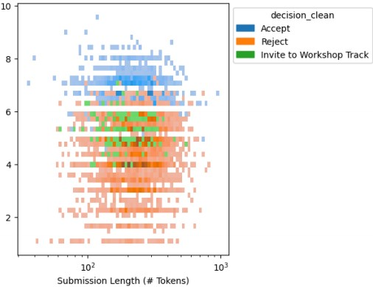

Provide a caption and do cross reference in the text

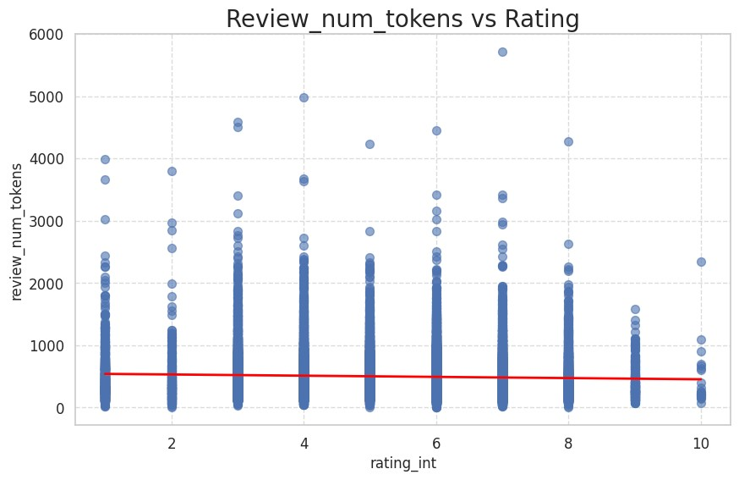

Provide the legends for blue dots, red line.

For T-SNE, need to provide some reference or details/equations to show understandings

4) Methods and Experiments section

Logistic regression, it would be good to provide the platform, e.g., R, Python

5) Conclusion and Future Direction

For a research project report, it should be sufficient, but for a conference/journal paper, I would recommend further improving on the innovation to increase the chance of acceptance.

Authors need to perform a more detailed proofreading

# Rebuttal:

Thank you, reviewer, for your insightful comments. We would like to offer the explanation of our work.

1. We agree that reviewers may provide multiple points of view however we believe that reviewers should provide the same assessment of the paper in order to maintain quality of the research process.
2. Thank you for the feedback we will consider the formatting during camera ready
3. Thank you for pointing out issues with our images we will work better on displaying such figures
4. We used python and provided a replication notebook here: <https://github.com/raymondEDS/seven_research_paper>
5. Thank you for the inspiration, we are grateful for your time and will continue working on such work.