CPT 244 – Program 5

A few years ago, a style of puzzle became pretty popular. The name most people know it by is Sudoku. If you’ve played it, you know the rules. I’ll give them here in a nutshell. The user starts with a 9x9 grid. That grid is split into nine 3x3 blocks. There are a handful of cells filled in. The goal of the game is to fill in all the cells such that the following three rules are true:

* each column uses each digit (1-9) **exactly** once
* each row uses each digit **exactly** once
* each of the 3x3 blocks uses each digit **exactly** once

Here are examples of a starting grid and a solution (lifted from Wikipedia).

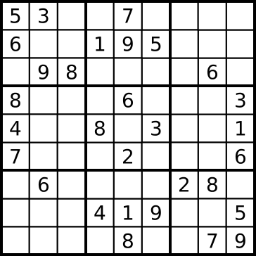

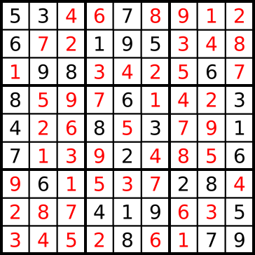

"Sudoku-by-L2G-20050714 solution" by en:User:Cburnett

Your mission, should you choose to accept it, is to determine whether a given Sudoku answer is correct. This means that you will need to validate the three rules above for the given puzzle answer.

The puzzle will be in a .csv file. It will have nine rows of nine digits. The digits will be separated by commas. You will need to place the digits into a 9x9 two dimensional array. Then you will need to check each of the rules on the array.

At the end, you need to output VALID or INVALID. If the answer is invalid, you should write where you found it to be invalid. For a starting grade of ‘90’, you need to return only the first problem you find (e.g. ROW 0); for a starting grade of ‘100’, you must continue on to find and report **all** invalid locations, e.g.

* ROW 0
* COL 4
* BLK 1

The rows are numbered left to right, the columns top to bottom, the blocks left-to-right, top to bottom, all starting with zero,

To be clear the blocks are numbered:

|  |  |  |
| --- | --- | --- |
| 0 | 1 | 2 |
| 3 | 4 | 5 |
| 6 | 7 | 8 |

The errors will be related to each other. E.g. there might be transposed cells, transposed rows or columns, etc. There will not be unrelated errors, e.g. two different sets of transposed cells. Note, though that some of the transpositions can cause lots of errors; this is important if you are striving for an ‘A’.

There are a number of txt files attached to the assignment, one good solution and a number of bad ones. There are notes in the file that give the expected errors. You may find these useful for testing your program. You are encouraged to create other good (and bad) solutions for further testing. Also, feel free to use any data structures in addition to a two-dimensional array that will help you in your validation.

Use good programming practices as you solve this problem. As always, you will be graded on efficiency, maintainability, etc. as well as correctness. Do not do this all in one big loop. Write methods to test each portion, e.g. one to test rows, one to test columns, etc. If you do not, you will find it difficult to think through your program logically; it will also be harder to maintain when your employer wants to add a ‘killer Sudoku’ checker.