TECHNICAL REPORT
Emergency Healthcare Accessibility in Zimbabwe
A Baseline and Flood-Scenario Accessibility Analysis
Driving and Walking Travel-Time Modelling, National Flood Impact Assessment, and Six Community Case Studies
Prepared by: R Choga
Date: 18 August 2026
Scope: National (Zimbabwe) 91 districts, 15,178,957 people
How to read this report
This report has two registers. The introduction, data, methodology, and national results sections are written for a technical audience and document exactly what was measured and how. The six community case studies section is written in plain, non-technical language on purpose it is meant to be readable by anyone, not only by someone comfortable with GIS or statistics.

Executive Summary
This analysis models emergency healthcare accessibility for Zimbabwe's entire population 15,178,957 people across 91 districts under normal conditions and during a modelled 1-in-50-year river flood (RP50). Accessibility is measured as travel time to the nearest of 1,486 public, non-private health facilities, along a 131,349km merged road network, for two realistic travel modes: driving and walking.
Under normal conditions, 64.9% of the population (9.84 million people) is well served by vehicle (under 30 minutes to the nearest facility), but only 16.0% (2.43 million people) is well served on foot. The gap between these two figures is one of the most important findings in this report, for a large share of the country, whether someone counts as “well-served” depends entirely on whether they have access to a vehicle, not on how close the nearest clinic actually is.
Flooding worsens both pictures. In the driving scenario, 323,420 people who are reachable at baseline become completely cut off once the flood hits no route to any facility exists, by any path. In the walking scenario, 260,267 people are newly cut off. Six representative communities were examined in detail as case studies (Section 7) in every one of them, the flood leaves no alternate route by either mode.
The two maps in Section 6 combine the baseline and flood results into a single four category picture per travel mode well served, persistently underserved, degraded by flood, and newly cut off by flood so the before/after story can be read directly off the map rather than compared across separate figures.

1. Introduction and Purpose
Zimbabwe's healthcare system, like many others, has always faced a basic geographic problem, distance and travel time to care are not evenly distributed, and the communities furthest from a hospital or clinic tend to be the same communities most exposed to natural hazards such as flooding. This project sets out to answer three linked questions for the whole country that is how far are communities from emergency healthcare under normal conditions, which communities are underserved even on a normal day and how does that picture change during flooding, when roads, bridges, and river crossings can become impassable exactly when they are needed most.
The analysis was built entirely from open and publicly sourced data, combined with a custom routing model built specifically for this project (Section 4.3), and is intended to support two practical uses, identifying which communities most need new or upgraded facilities and road access under normal conditions and identifying which specific communities and routes are at greatest risk of being cut off from care during a flood so that emergency planning and pre-positioning of resources can be targeted rather than generic.
This report classifies every community by travel time to the nearest of the 1,486 public health facilities that is, well-served (under 30 minutes), underserved (30–60 minutes), and critical (over 60 minutes, including communities with no reachable facility at all). These bands are a finer grained, sub-national adaptation of the internationally recognized benchmark for geographic access to emergency care by the Lancet Commission on Global Surgery's "two-hour access" and also by WHO's Global Reference List of 100 Core Health Indicators.

2. Data Sources and Limitations

2.1 Administrative boundaries
Zimbabwe's country, province (10), and district (91) boundaries were sourced from geoBoundaries, an open alternative to the UN OCHA COD-AB dataset named in the original project methodology, functionally equivalent for this project's purposes.

2.2 Health facilities
The facility list is the Zimbabwe Ministry of Health and Child Care (MoHCC) master facility list. Of the facilities in the source list, 1,486 non-private, publicly accessible facilities were retained for this analysis; 202 were excluded, made up of 145 private facilities (hospitals/clinics run privately, plus mine and industrial clinics), 35 facilities that are non-operational, not yet open, or administrative offices rather than real service points, and 22 prison and police clinics that serve only inmates or staff rather than the public.

2.3 Population
Population is based on WorldPop's 2020 gridded population density (1km resolution), rescaled so that every district's total matches Zimbabwe's 2022 census exactly (extracted programmatically from ZimStat's official district-level report, all 91 districts matched and validated against the published national total of 15,178,979, with the analysis total of 15,178,957 reflecting a 22 person rounding discrepancy in the source tables, not a processing error). One district (Mvurwi) required a 7.85x calibration factor far outside the normal 0.66–1.43x range seen elsewhere because its small (2.8km²) boundary polygon is covered by only two native WorldPop grid cells, too coarse a base to trust for the pattern of population *within* the district, even though the district level total is still exactly correct against the census.

2.4 Roads
The road network was rebuilt from OpenStreetMap (trunk, primary, secondary, tertiary, and unclassified road classes) merged with a WFP/humanitarian roads dataset that adds tracks and trails not well covered by OSM alone in rural areas. The merged network totals 30,619 segments and 131,349km. Facility-to-road connectivity is good overall (median distance from a facility to the nearest mapped road is 166m), but 1.9% of population points, representing about 46,000 people (0.3% of the national population, concentrated in Hurungwe's remoter resettlement areas) are more than 10km from any mapped road a genuine gap in road-data coverage rather than a computation issue. Travel times for these points are dominated by an assumed walking-speed “last mile” and should be read as “very poorly served” rather than as precise figures.

2.5 Flood hazard
Flood hazard is modelled using the JRC/Copernicus Global River Flood Hazard Maps for a 1-in-50-year return period (RP50), giving flood depth in metres at roughly 93m resolution.
2.6 Limitations
1. This analysis assigns travel speed by road classification (Table 1) trunk, primary, secondary, tertiary, unclassified using OpenStreetMap and WFP road-type tags. It has no way to account for the physical condition of a given road that is potholes, erosion, unmaintained gravel, or seasonal degradation common on Zimbabwe's rural and unclassified road network. A tertiary or unclassified road tagged in OSM is treated as uniformly drivable at its assumed class speed (40 km/h and 20 km/h respectively) regardless of whether it is, in practice, a badly rutted track passable only at walking pace or by 4x4. Because road condition data is not available at national scale, this is a structural limitation of the model rather than a fixable data gap. Modeled driving times, particularly outside the trunk/primary network should be trated as a ‘best-case’ estimates. Where a community's actual experience is worse than this report suggests, degraded road condition separate from and in addition to flooding is a likely explanation, and this should be considered when using "well-served" or "underserved" classifications to make resourcing decisions.
2. Reaching a public facility is not the same as receiving care there, this report measures distance and travel time to the nearest public health facility, not the capacity of that facility to treat the emergency in question. The facility dataset (Section 2.2) does not currently distinguish primary-level clinics, most of which in Zimbabwe have no surgical capacity and limited capacity for other emergency interventions, from district and referral hospitals, which do. Zimbabwe's public health system is also operating under significant strain understaffing, shortages of medicines, equipment, and basic supplies are widely reported at both clinic and hospital level. For an unknown share of the "well-served" and "underserved" populations in this report, the nearest facility by travel time may not be able to treat their emergency at all meaning the true delay to actual emergency care is understated here and may require an additional trip to a better-equipped facility. This report should therefore be read as a measure of geographic reach to the public health system in general, not as a guarantee of adequate emergency treatment on arrival.

3. Methodology
All spatial processing used EPSG:32736 (WGS 84 / UTM Zone 36S), a metres-based projection appropriate for Zimbabwe whilst population and flood rasters were kept in their native EPSG:4326 grid to avoid the accuracy loss that comes from resampling a raster into a different projection.

3.1 Representing communities
Rather than using coarse district or ward centroids, the calibrated population raster was converted into a population-weighted 5km grid of 15,894 points (total population 15,178,954, matching the raster to within rounding). This resolution balances fine-grained results against a dataset that is practical to compute and to review each point represents its local population, and results are reported relative to the named facility that point is nearest to, rather than by an invented place name for the grid point itself.

3.2 Travel-time modelling
The intended tool for this kind of analysis, the QNEAT3 network-analysis plugin, is not yet available for the QGIS 4.0.3 release used on this project. In its place, a custom multi-source shortest path model was built directly from the road network. Every vertex of every road segment becomes a node in a routing graph, with coordinates snapped at a 5m tolerance to merge near-duplicate nodes across the different source datasets. This produced a graph of 1,764,043 nodes and 1,773,753 edges, of which 99.2% form a single connected network (the remaining nodes sit in 392 small, disconnected islands, a road data artefact. Any facility or population point that happened to snap onto one of these was explicitly re-snapped to the nearest node in the main network rather than being wrongly marked unreachable).
Travel time on each edge is assigned by assumed speed, either from the road's classification (driving scenario) or a single uniform walking speed (walking scenario):
Road class | Driving speed | Walking speed
Trunk / primary | 80 km/h | 4.5 km/h
Secondary | 60 km/h | 4.5 km/h
Tertiary | 40 km/h | 4.5 km/h
Unclassified | 20 km/h | 4.5 km/h
WFP “Road” class | 50 km/h | 4.5 km/h
WFP “Trail” class | 15 km/h | 4.5 km/h
Table 1. Assumed travel speed by road classification and mode. The walking speed is uniform across all road/track types, including the off-road “last mile” between a population point and the nearest mapped road in both scenarios, so the two modes are directly comparable.
For every one of the 15,894 population points, nearest facility travel time was computed with a single multi-source shortest-path search (a Dijkstra search seeded simultaneously from all 1,486 facilities) a method that finds the true nearest facility and its distance for every point in the network in one pass, rather than testing facilities one at a time. Communities are classified as well-served (under 30 minutes), underserved (30–60 minutes), or critical (over 60 minutes, including points with no reachable facility at all).

3.3 Driving and walking as brackets, not a single answer
Rural Zimbabwe's real travel modes span a spectrum private vehicles, shared “pirate taxis” (mushika-shika), ox-drawn scotch carts, and walking, so a single driving-only model would misrepresent. Rather than pick one, this analysis runs the identical model twice, once at driving speeds and once at a uniform 4.5km/h walking speed, using the same graph, same facilities, and same snap distance handling in both. Driving and walking/scotch cart are the fastest and slowest plausible brackets so shared pirate taxi (mushika-shika) falls somewhere between the two considering the time it takes loading. The difference between a point's driving class and walking class (referred to below as the “access gap”) directly flags communities whose apparent accessibility depends on vehicle ownership.

3.4 Flood scenario
The RP50 flood depth raster was sampled at the midpoint of every one of the 1,773,753 routing graph edges. 17,656 edges (1.0% of the network) intersect the mapped flood extent, with a mean depth of 2.5m among affected edges. A three-tier, depth based passability rule was then applied, explicitly as a modelling assumption rather than a measured fact.
Flood depth | Driving | Walking
Under 0.3m | Passable, heavy penalty (capped at 10 km/h) | Passable, heavy penalty (capped at 1.5 km/h)
0.3m – 1.0m | Impassable (edge removed for driving) | Passable, heavy penalty (capped at 1.0 km/h)
1.0m or more | Impassable (edge removed) | Impassable (edge removed)
Table 2. Flood depth passability rule. At 1.0m or deeper, an edge is removed from both the driving and walking graphs entirely not merely slowed down. Under this rule, 16,377 of the 17,656 flood-affected edges become undriveable and 12,966 become unwalkable, most affected edges (12,966 of 17,656) fall in the deepest, both-modes-impassable tier, consistent with RP50 being a fairly severe, valley-bottom flood event.
The identical multi-source shortest path search from Section 3.2 was then re-run against these flood penalized graphs, for both driving and walking, producing a directly comparable “before” and “after” travel time and nearest facility result for every one of the 15,894 population points.

3.5 Combined baseline + flood status
For the two maps in Section 6, each population point's baseline class and flood class (for a given travel mode) are combined into one of four categories, so a single map communicates the full before/after picture:
Category | Meaning
Well-served (unaffected by flood) | Well-served at baseline and still well-served during the flood
Persistently underserved / critical | Underserved or critical at baseline, and no worse (or already at the floor) during the flood
Degraded by flood (not cut off) | Still reachable during the flood, but travel time class gets worse
Newly cut off by flood | Reachable at baseline, completely unreachable (no path at all) during the flood
Table 3. Combined baseline + flood status categories used to symbolise the two maps in Section 6. A fifth category, “always cut off” (unreachable in both baseline and flood), exists in the underlying data but has effectively zero population in this dataset and does not appear on the maps.

4. Results National Accessibility Findings

4.1 Baseline: driving vs. walking
Class | Driving population | Driving % of national pop. | Walking population | Walking % of national pop.
Well-served (<30 min) | 9,840,000 | 64.9% | 2,430,000 | 16.0%
Underserved (30–60 min) | 3,180,000 | 21.0% | 2,160,000 | 14.2%
Critical (>60 min / unreachable) | 2,160,000 | 14.2% | 10,600,000 | 69.8%
Table 4. National baseline accessibility, driving vs. walking. Median walking time to the nearest facility nationally is approximately 3.7 hours.
The scale of the gap between the two modes is the single most important baseline finding, roughly a third of the national population looks well-served if they have access to a vehicle, but falls into the critical band on foot. Read together with Section 4.2, this driving-vs-walking divergence is arguably a more useful signal of true vulnerability than either scenario in isolation, since it identifies communities where accessibility is conditional on vehicle ownership rather than on physical distance to care.
As a cross check against known geography, the worst-served districts under the driving scenario are Kariba (73% critical), Binga (65% critical), Tsholotsho (59% critical), and Mbire (50% critical) all Zambezi valley or remote districts, consistent with expectations while Harare, Bulawayo, and Chitungwiza average 3–9 minutes to the nearest facility by vehicle.

4.2 Flood impact: driving vs. walking
 | Driving | Walking
Well-served population, baseline → flood | 9,840,000 → 9,530,000 | 2,430,000 → 2,400,000 (approx.)
Newly cut off entirely (unreachable by any path) | 323,420 people | 260,267 people
Table 5. National flood impact, relative to the driving/walking baselines in Table 4.
The walking scenario's newly-cut-off figure is smaller in absolute terms mainly because so much of the walking baseline was already critical or unreachable before any flooding occurred there is simply less “room to fall.” Newly cut-off population under the driving scenario concentrates in Chiredzi, Hurungwe, Chipinge, Lupane, Gokwe North, Beitbridge, Hwange, Tsholotsho, Mbire, and Victoria Falls districts, consistent with known flood prone and remote geography along the Save/Runde and Zambezi valley systems.

4.3 Chronic flood-hotspot check: Mount Darwin, Muzarabani, Kariba
Three of the districts most commonly cited as chronic flood hotspots were checked individually against the model's results:
District | Result
Muzarabani | 1,385 people (1.0% of the district's population) cut off entirely, for both driving and walking — the isolating road segment floods past 1.0m, which blocks both modes equally.
Kariba (rural) | The hardest-hit of the three proportionally: 2,568 people (5.1%) cut off driving, 2,196 people (4.3%) cut off walking, on top of an already-severe baseline (roughly 80 minutes average travel time even without flooding).
Mount Darwin | Zero people cut off in this model, despite the district's flood-hotspot reputation.
The Mount Darwin result is flagged, not asserted, as correct. It may reflect genuine route redundancy in that district's road network, or it may reflect a mismatch between the JRC river-flood model (RP50, river/valley flooding) and Mount Darwin's actual flood pattern, which may be driven more by localised or stream-level flooding than the RP50 model captures. This is worth checking against local knowledge before being relied on operationally.

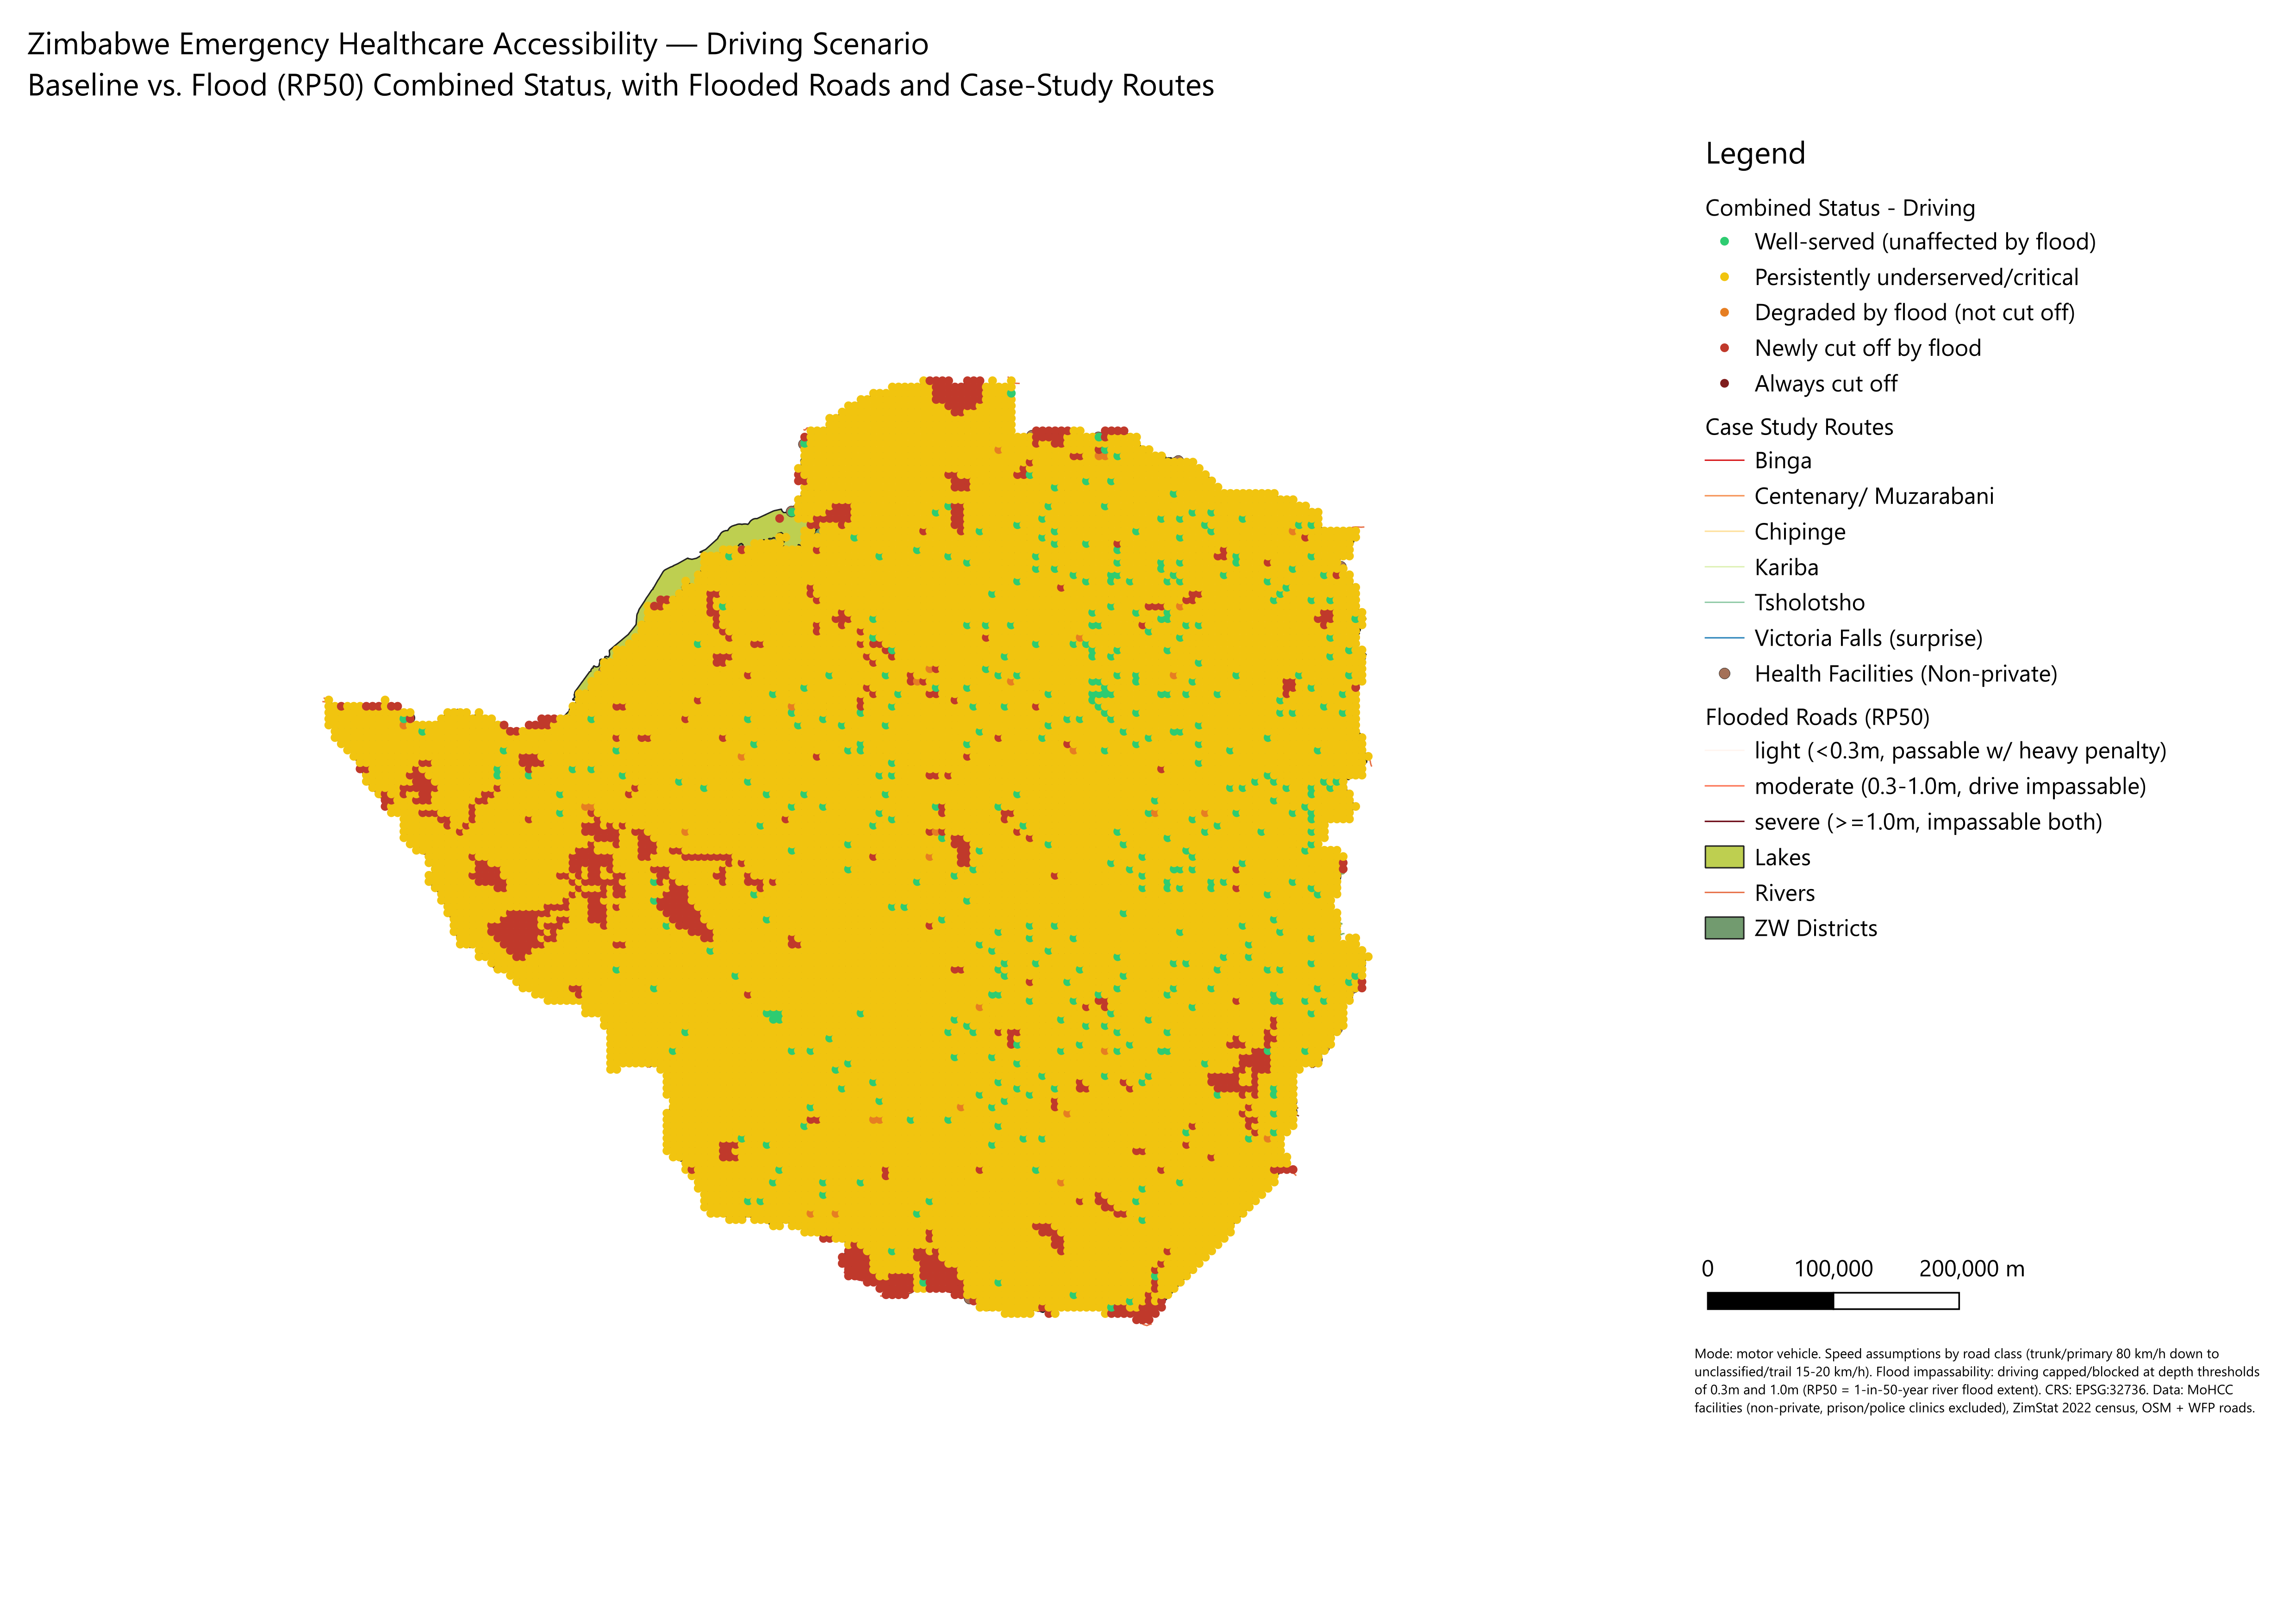

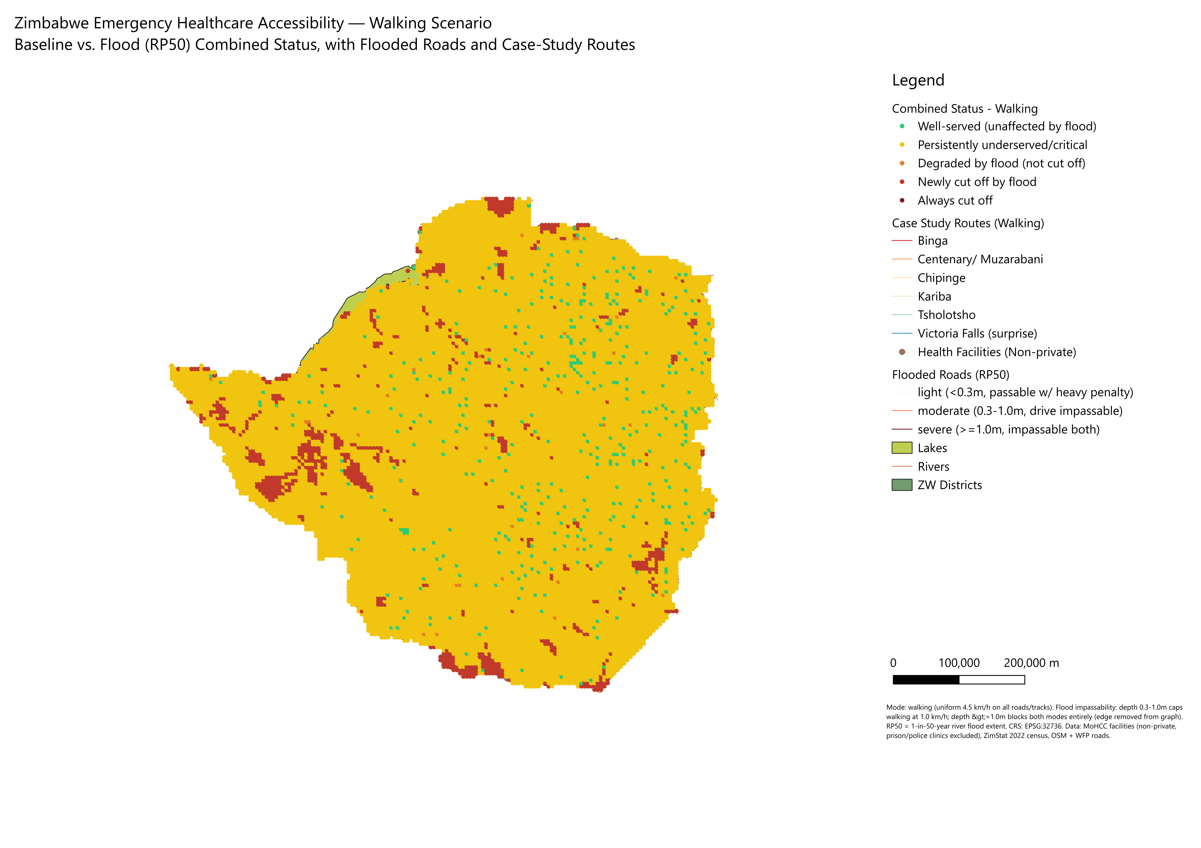

6. Discussion
Maps 1 and 2 (previous two pages) each combine baseline and flood results for one travel mode into the four categories defined in Table 3: green for communities that are well-served and unaffected by the flood, yellow for communities that are persistently underserved or critical (with or without the flood), orange for communities whose service degrades under the flood but are not completely cut off, and dark red for communities newly cut off entirely by the flood. Both maps also show the RP50 flooded road network, the 1,486 public health facilities, and the six case-study routes from Section 7 (driving routes on Map 1, walking routes on Map 2).
A visual pattern worth noting on both maps, yellow (persistently underserved) covers more of the country's area than green (well-served), because rural areas cover more land per person. But green points, concentrated around cities and towns, represent far more people per point than the sparser rural yellow points which is why the population totals in Table 4 (majority well-served under driving) can look different from a simple visual read of the map's area coverage. This is expected and is exactly why the population-weighted point analysis, not just the map, is the source of truth for the figures in this report.
The dark red “newly cut off” clusters are concentrated in the same valley-bottom, flood-prone geography discussed in Section 4.2 while most visibly along the Zambezi valley in the north and northwest, and along the Save/Runde river systems in the southeast, matching the JRC flood extent itself.

7. Six Case Studies, in Plain Terms
This section walks through six real communities, picked to show both the chronic flood-prone areas (Muzarabani, Kariba, Chipinge, Binga, Tsholotsho) and one community that looks completely fine on an ordinary day but turns out to be at serious risk during a flood (Victoria Falls). In every case below, the community's normal route to care was traced turn by turn, and then checked, segment by segment, against where the flood actually reaches.

Muzarabani (Centenary/Muzarabani district)
About 780 people in one community normally reach the David Nelson clinic in around 17 minutes a roughly 14km drive. When the river floods, three crossings on that road go underwater, and none of them are shallow all three are more than a metre deep, easily enough to sweep away a vehicle or a person on foot. With those three crossings gone, there is no other way to reach the clinic. This community is completely cut off during a flood, by car or on foot.

Kariba
A small, remote community of about 220 people normally takes just under 27 minutes about 9km to reach the Chinego clinic. This is one of the worst-hit routes in the whole study flooding submerges 16 separate points along that short road, with the deepest water reaching nearly 4 metres. The road effectively disappears under the flood. As with Muzarabani, there is no detour this community loses all access to emergency care.

Chipinge
This is one of the most striking findings in the whole study. About 2,769 people live just 2.5km roughly seven and a half minutes from Tongogara clinic under normal conditions, among the closest and best-served distances anywhere in this analysis. But when the area floods, 47 of the 48 small road segments that make up that short route go underwater. This is not one bridge being out almost the entire road to the clinic is submerged. A community that would normally be held up as a model of good access to care becomes completely isolated during a flood a reminder that being close to a clinic on a map does not guarantee safe access to it once the rains come.

Binga
About 545 people take roughly 12 minutes to drive the 14.8km to Zhomba clinic under normal conditions. When it floods, 30 points along that road go underwater, in one place as much as 16.8 metres deep almost certainly a major river crossing rather than a puddle on the road. Interestingly, someone walking to Zhomba does not take the same road a vehicle would, the walking route because it follows a more direct but more flood-exposed line, actually crosses far more flooded ground, versus 30 on the driving route. Either way, during a flood, Binga residents have no way to reach care.

Tsholotsho
In one community in Tsholotsho 717 people normally take about 23 minutes to cover the 12.6km to Sodaka clinic. Here, flooding at just 3 points along the route with water between knee and waist deep, 0.3 to 1.3 metres is enough to sever the connection completely. This is a good example of a “chokepoint” the community is not sitting in the middle of a large flood zone, but a small number of low crossings act as a bottleneck that, once flooded, cuts off the entire road.

Victoria Falls (the “surprise” case)
This case best shows why flood accessibility needs its own analysis, rather than assuming that a facility that looks fine on an ordinary day will still be fine during a flood. In dry conditions, this is one of the best-served communities in the whole study about 7,288 people are only 3.7 minutes and 4.9km from Victoria Falls Hospital. But when the area floods, 14 points on that short route go underwater, including one crossing more than 31 metres deep almost certainly close to the Zambezi gorge itself. Despite being minutes from a major hospital in normal conditions, over seven thousand people are left with no way to reach it during a flood. Because this community has by far the largest population of the six case studies, it represents the single biggest “hidden risk” found in this whole project a place any ordinary, non-flood accessibility map would rate as excellent, but which is entirely unprepared for a flood emergency.

Case studies at a glance
Community | District | Community Population | Nearest facility | Normal travel | Flooded route segments | Flood result
Muzarabani | Centenary/Muzarabani | 780 | David Nelson | 17.4 min / 14.0km | 3 (all ≥1.0m deep) | Cut off, both modes
Kariba | Kariba | 220 | Chinego | 26.8 min / 8.9km | 16 (up to 3.8m deep) | Cut off, both modes
Chipinge | Chipinge | 2,769 | Tongogara | 7.5 min / 2.5km | 47 of 48 segments | Cut off, both modes
Binga | Binga | 545 | Zhomba | 12.4 min / 14.8km | 30 (up to 16.8m deep) | Cut off, both modes
Tsholotsho | Tsholotsho | 717 | Sodaka | 22.7 min / 12.6km | 3 (0.3–1.3m deep) | Cut off, both modes
Victoria Falls* | Victoria Falls | 7,288 | Victoria Falls Hospital | 3.7 min / 4.9km | 14 (one at 31.0m) | Cut off, both modes
* The “surprise” case: well-served at baseline, then completely cut off during the flood — unlike the other five, which were already known chronic flood-risk areas.

8. Recommendations
The following recommendations follow directly from the results above and are intended as a starting point for prioritisation, not a complete emergency-planning document.

8.1 Facility and outreach priorities
Kariba, Binga, Tsholotsho, and Mbire stand out as the worst-served districts even under normal, non-flood conditions (driving critical shares of 50–73%), and should be the first priority for new or upgraded facilities, mobile outreach clinics, or subsidised transport programmes, independent of any flood risk. Because the driving/walking access gap identified in Section 4.1 shows that roughly a third of the population is only “well-served” if they have a vehicle, transport-focused interventions (ambulance coverage, community transport schemes) may do as much for real-world accessibility as new fixed facilities in some areas.

8.2 Flood-resilience priorities
The six case-study routes in Section 7, and the broader newly cut-off clusters identified in Section 4.2 (Chiredzi, Hurungwe, Chipinge, Lupane, Gokwe North, Beitbridge, Hwange, Tsholotsho, Mbire, and Victoria Falls districts), are the most concrete candidates for flood-proofing investment, raised causeways or bridges at the specific crossing points identified in Section 7, rather than blanket road upgrades. The Chipinge case in particular (47 of 48 route segments flooded on an otherwise very short, well-served route) suggests a single strategic crossing or short stretch of road may be disproportionately valuable to harden.

8.3 Emergency pre-positioning
Ahead of the flood season, emergency response resources (ambulances, boats, satellite phones, pre-positioned medical supplies) should be prioritised for the newly-cut-off communities identified in this report, since these are precisely the places where the normal emergency response plan (drive to the nearest facility) will not work once flooding begins. The Victoria Falls case is a useful reminder that this list should not be limited to areas already known as flood-prone a full-network flood analysis, as done here, catches communities that a reputation-based priority list alone would miss.

8.4 Data and modelling follow-ups
Three follow-ups would improve confidence in this analysis, closing the road-data gap affecting roughly 46,000 people in Hurungwe's remoter areas (Section 2.4), checking the Mount Darwin zero-cutoff result (Section 4.3) against local knowledge, since it runs counter to that district's flood-hotspot reputation and re-auditing the facility ownership field for other restricted-access facilities.

9. Appendix: Technical Notes
This report and its underlying data are maintained as part of a live QGIS project (zw_health_access.qgz, CRS EPSG:32736) containing all source and processed layers referenced in this report, including the combined baseline+flood status layers used to build the two maps in Section 6. Full phase-by-phase methodology notes, including the routing-graph construction approach and data-correction history summarised in Section 2.2, are maintained in the project's methodology guide alongside the QGIS project itself.

References
- Meara, J.G., Leather, A.J.M., Hagander, L., et al. (2015). Global Surgery 2030: evidence and solutions for achieving health, welfare, and economic development. The Lancet, 386(9993), 569–624. (Establishes the two-hour access to surgical/obstetric care indicator.)
- World Health Organization (2018). Global Reference List of 100 Core Health Indicators (plus health-related SDGs). Geneva: WHO. (Adopts two-hour surgical access as a core global indicator.)
- Thaddeus, S. and Maine, D. (1994). Too far to walk: maternal mortality in context. Social Science & Medicine, 38(8), 1091–1110. (Originates the "three delays" framework, including delay in reaching a facility.)
- Harris, B., Goudge, J., Ataguba, J.E., et al. (2011). Inequities in access to health care in South Africa. Journal of Public Health Policy, 32(S1), S102–S123. (Example of a national distance/time-based access norm for primary care.)

