# **Instruction**

# 1. Introduction

This program is designed to calculate the Value of Risk(VaR) and Expected Shortfall(ES) of bonds (with or without coupon) with data sets of bond price or bond yield.

Note that, based on whether the data set is bond price, or bond yield, the calculations of VaR and ES are different. But we can actually calculate daily price based on daily yield, or vice versa. Results will be slightly different due to different calculation methods.

# 2. Notation

Denote:

P: bond price, P0 for current bond price

y: bond yield, y0 for current bond yield

Q: quantity of holding position

MV: current market value of bond, i.e. current bond price*quantity;

MD: current modified duration

dy: change of bond yield

alpha: confidence level

Z: normal distribution Z-value based on accordingly confidence level

sigma_P: volatility of bond price (sample standard deviation of bond price return)

sigma_y: volatility of bond yield (sample standard deviation of bond yield return)

sigma_Port: volatility of bond portfolio value

rho(i,j): correlation between bond yield return of bond i and bond j

# 3. Calculation

As we know, the price and modified duration calculation for zero-coupon bond and coupon bond are different; the VaR and ES calculation for individual bond and bond portfolio are also different. So we have to discuss separately.

## 3.1 Zero-Coupon Bond

For individual zero-coupon bond, we use following three traditional methods (see Example 1&2 in main.cpp):

#### a. Historical Method:

1) Based on bond price data: Use historical bond price change to simulate future bond price, then calculate future P&L distribution (P*Q), then we have VaR and ES based on their definition.

2) Based on bond yield data: Use historical yield change to simulate future bond yield, then calculate future P&L distribution (-MV*MD*dy), then we have VaR and ES.

#### b. Analytical Method:

Assume return of bond price and bond yield follow normal distribution, VaR = - Z * sigma, ES = sigma*(-exp(-Z^2 / 2) / (alpha*sqrt(2 * pi)))

1) Based on bond price data: VaR = - MV * Z * sigma_P

2) Based on bond yield data: Using delta-normal approach, i.e. VaR = -MV * MD * VaR(yield) = - MV * MD * (y0 * sigma_y * Z)

c. Monte Carlo Methods: Use interest rate model (Hull-white one factor model) to simulate future short rate, and result in simulated zero-coupon bond price, then perform calculation similar with a. 1).

## 3.2 Coupon Bonds

### 3.2.1 Treasury Bonds

For treasury bond with coupons, we have two calculation methods.

First, we can decompose the T-bond into a portfolio with individual zero-coupon bonds (no-arbitrage pricing). Then consider the VaR and ES of the "zero-coupon bond portfolio". The calculation for bond portfolio will be discussed in 3.3.

Second, if we have access to the data of T-bond price or T-bond yield, we can follow the same calculation for corporate bond, which we will discuss next.

### 3.2.2 Corporate Bond/Treasury Bond

For corporate bond, which we usually cannot decompose into individual zero-coupon bond due to data availability, we use following calculation method. Note this method is also applicable to treasury bond with coupon.

We use similar calculation for VaR and ES with zero-coupon bond. That is:

#### a. Historical Method:

1) Based on bond price data: Use historical bond price change to simulate future bond price, then calculate future P&L distribution (P*Q), then we have VaR and ES based on definition.

2) Based on bond yield data: Use historical yield change to simulate future bond yield, then calculate future P&L distribution (-MV*MD*dy), then we have VaR and ES.

#### b. Analytical Method:

Assume return of bond price and bond yield follow normal distribution, VaR = -Z*sigma, ES = sigma*(-exp(-Z^2 / 2) / (alpha*sqrt(2 * pi)));)

1) Based on bond price data: VaR = - MV * Z*sigma_P

2) Based on bond yield data: Using delta-normal approach, i.e. VaR = - MV * MD * VaR(yield) = -MV * MD * (y0 * sigma_y * Z)

#### c. Monte Carlo Methods:

This program is unable to price corporate bond based on Monte Carlo Simulation due to the complexity of default.

## 3.3 Bond Portfolio

Consider a portfolio consists of several individual bonds (with or without coupon), then we can use following methods to calculation VaR and ES of bond portfolio:

#### a. Historical Method:

Use historical daily portfolio value to simulate future portfolio P&L

1) Based on bond price data: daily portfolio value is the sum of daily market values of each bond, i.e. portfolio value = sum(P*Q)

2) Based on bond yield data: daily portfolio value = sum(P*Q*MD*y)

#### b. Analytical Method:

1) Based on bond price data: VaR = - MV * Z* sigma_Port. Note sigma_Port is calculated using covariance matrix of returns of individual bonds' price and market values of individual bonds, similar to MPT.

2) Based on bond yield data: similar with Markowitz MPT, VaR(portfolio) = sum(VaR(bond i)*VaR(bond j)*rho(i,j))

# 4. Data Sets

See "Daily Treasury Yield Curve Rates(2010-2011).csv" or "BAC yield.csv"for data of yield or "Discount Factor(2010-2011).csv" or "BAC price.csv" for data of price.

Note: the header must be "x Yr", for example: "1/12 Yr" for 1 month, "6/12 Yr" for 6 months, "3 Yr" for 3 years.

# 5. Input

See example and comments in Main.cpp.

filename: Data sets (.csv)

alpha: confidence level

frequency: coupon frequency

quantity: par value of bond

maturity: bond maturity

Note that if one will use Monte Carlo method to calculate, current swaption volatility data must be input in MonteCarlo.h in order to calibrate the interest rate model.

# 6. Output

In order to demonstrate the function and output of the program, we use 6 examples to demonstrate the VaR & ES calculation for zero-coupon bonds, treasury coupon bonds and company bonds. For treasury coupon bonds, as we discussed before, they can be decomposed into zero-coupon bonds. So, in section 4.1, we first demonstrate zero-coupon bonds & treasury coupon bonds using two bond portfolios with different maturity. In section 6.2, we will demonstrate the results for corporate bonds as we cannot use Monte Carlo method to calculate them as we discussed.

## 6.1 Treasury Bonds with / without Coupon

We consider following treasury coupon bonds:

One 3-year-maturity $100 par value bonds with 5% annually coupon rates, which will be used in Example 1 & 3 as follow, it can be decomposed into three zero-coupon bonds:

Bond1: $5 par value 1-year zero coupon bond

Bond2: $5 par value 2-year zero coupon bond

Bond3: $105 par value 3-year zero coupon bond

For these bond, we use yield data, and the results are:

*Example 1: zero-coupon bond calculation based on bond yield instead of bond price.*

*(one 3-year-maturity $100 par value bonds with 5% annually coupon rates)*

*Analytical ES of 1 year bond based on yield is: -0.0010569*

*analytical VaR of 1 year bond based on yield is: -0.000842796*

*Historical ES of 1 year bond based on yield is: -0.00167145*

*historical VaR of 1 year bond based on yield is: -0.000997006*

*Simulated ES of 1 year bond by Monte Carlo is: -0.0111995*

*Simulated VaR of 1 year bond by Monte Carlo is: -0.0100705*

*Analytical ES of 2 year bond based on yield is: -0.00590867*

*analytical VaR of 2 year bond based on yield is: -0.0047117*

*Historical ES of 2 year bond based on yield is: -0.00766837*

*historical VaR of 2 year bond based on yield is: -0.00592556*

*Simulated ES of 2 year bond by Monte Carlo is: -0.0211175*

*Simulated VaR of 2 year bond by Monte Carlo is: -0.0188248*

*Analytical ES of 3 year bond based on yield is: -0.262737*

*analytical VaR of 3 year bond based on yield is: -0.209513*

*Historical ES of 3 year bond based on yield is: -0.320176*

*historical VaR of 3 year bond based on yield is: -0.244629*

*Simulated ES of 3 year bond by Monte Carlo is: -0.621935*

*Simulated VaR of 3 year bond by Monte Carlo is: -0.549092*

We can see from the results that, the results by Analytical method and Historical method are very close to each other, while the one by Monte Carlo (Simulated) is bigger, especially for short-term bond like 1-year zero-coupon bond. The reason will be illustrated later.

We now consider a special $100 par value bonds with 5% annually coupon rates, which will be used in Example 2 & 3. It can be decomposed into three zero-coupon bonds:

Bond4: $5 par value 5-year zero coupon bond

Bond5: $5 par value 7-year zero coupon bond

Bond6: $105 par value 10-year zero coupon bond

For this time, we use bond price data instead of yield data, the results are:

*example 2: zero-coupon bond calculation based on bond price instead of yield.*

*Analytical ES of 5 year bond based on price is: -0.0291153*

*analytical VaR of 5 year bond based on price is: -0.0232172*

*Historical ES of 5 year bond based on price is: -0.0328843*

*historical VaR of 5 year bond based on price is: -0.0224744*

*Simulated ES of 5 year bond by Monte Carlo is: -0.0388067*

*Simulated VaR of 5 year bond by Monte Carlo is: -0.0338735*

*Analytical ES of 7 year bond based on price is: -0.0386272*

*analytical VaR of 7 year bond based on price is: -0.0308022*

*Historical ES of 7 year bond based on price is: -0.0442241*

*historical VaR of 7 year bond based on price is: -0.0325804*

*Simulated ES of 7 year bond by Monte Carlo is: -0.0422668*

*Simulated VaR of 7 year bond by Monte Carlo is: -0.0362121*

*Analytical ES of 10 year bond based on price is: -0.969941*

*analytical VaR of 10 year bond based on price is: -0.773453*

*Historical ES of 10 year bond based on price is: -1.09778*

*historical VaR of 10 year bond based on price is: -0.838287*

*Simulated ES of 10 year bond by Monte Carlo is: -0.985369*

*Simulated VaR of 10 year bond by Monte Carlo is: -0.821421*

We can see that for long-term zero-coupon bond, all the result by Analytical, Historical and Monte Carlo (Simulated) are very close to each other.

Compared with Example 1, we can see Monte Carlo method with Hull-White One Factor model doesn’t perform well for short-term zero-coupon bonds. This is because the Hull-White cannot capture the market volatility in the short term, when the market volatility is a curve with hump (See following graph Fig. 3.16 from *Brigo, Damiano, and Fabio Mercurio. Interest rate models-theory and practice: with smile, inflation and credit. Springer Science & Business Media, 2007.*).

However, the hump curve is very common in the market. The problem can be fixed using more advanced interest rate model like CIR++ etc.

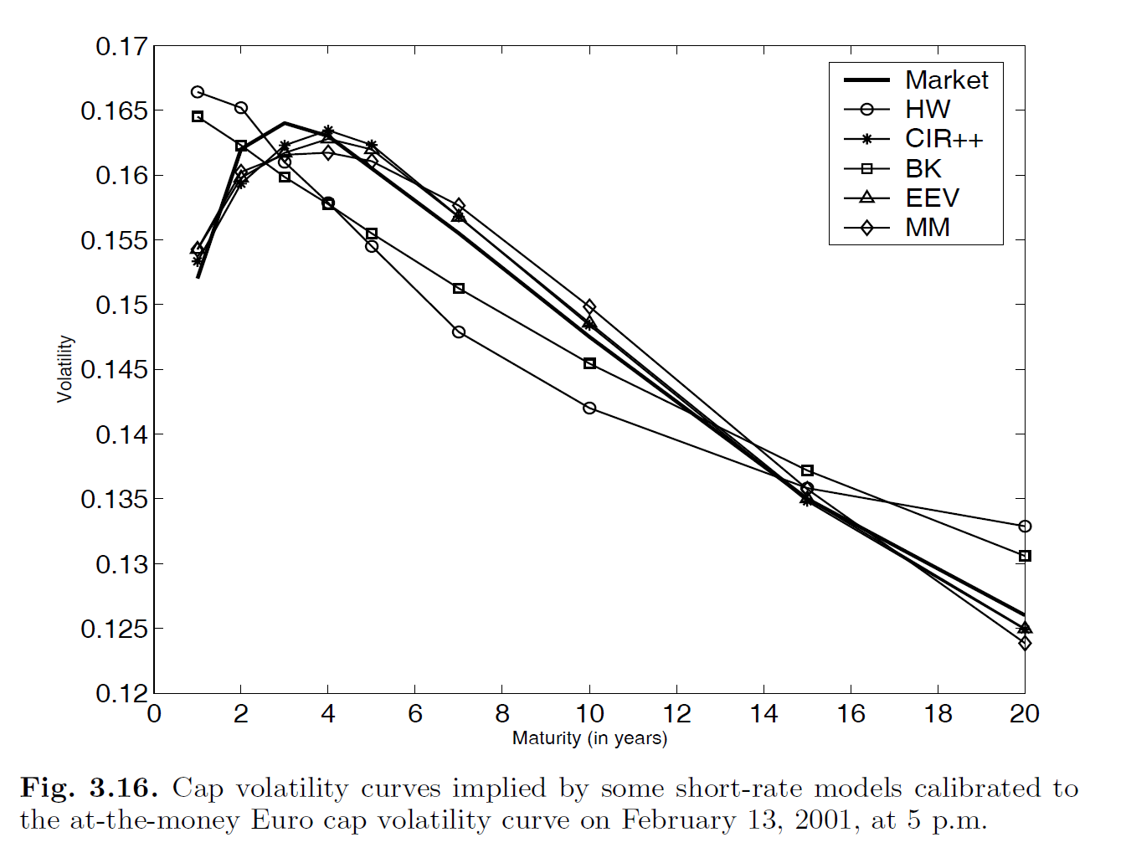

Now we move on to treasury coupon bonds, which can be considered as a portfolio of zero-coupon bonds. Example 3 demonstrates the results for the two treasury coupon bonds we discussed before, remember that the first treasury coupon bond is based on yield data, and consists of 1-year, 2-year, 3-year zero-coupon bonds. The second coupon bond is based on price data, and consists of 5-year, 7-year, 10-year zero-coupon bonds. The result is as follow:

*example 3: bond portolio consists of zero-coupon bonds (based on yield data)*

*Diversified porfolio ES based on yield and Analytical method is: -0.268507*

*Diversified porfolio VaR based on yield and Analytical method is: -0.214114*

*Porfolio ES based on yield and Historical method is:-0.325138*

*Porfolio VaR based on yield and Historical method is:-0.220973*

*Porfolio ES based on MonteCarlo Simulation method is:-0.654252*

*Porfolio VaR based on MonteCarlo Simulation method is:-0.577987*

*bond portolio consists of zero-coupon bonds (based on price data)*

*Diversified porfolio ES based on price and Analytical method is: -1.03507*

*Diversified porfolio VaR based on price and Analytical method is: -0.825389*

*Porfolio ES based on price and Historical method is:-1.17489*

*Porfolio VaR based on price and Historical method is:-0.893342*

*Porfolio ES based on MonteCarlo Simulation method is:-1.06644*

*Porfolio VaR based on MonteCarlo Simulation method is:-0.891506*

Note because we have considered the covariance between zero-coupon bonds when we use Analytical method, so we call it Diversified portfolio.

We can see that, again, Monte Carlo performs not so well for the first bond portfolio due to the model failure of Hull-White one factor model. Still, we are now able to calculate the VaR & ES of treasury bond (with or without coupon).

Now we consider coupon bonds (no matter it’s treasury bond or corporate bond as long as yield/price data is available). We use a corporate bullet bond (BAC) which has 4.2% fixed coupon rate, issued at 8/26/2014 and matures at 8/26/2024, that is 10-year time to maturity.

Example 4 shows the result based on yield data, while Example 5 shows the result based on price data.

*Example 4: Coupon Bond Calculation Based on Yield Data*

*Analytical ES of 10 year bond based on yield is: -1.89617*

*Analytical VaR of 10 year bond based on yield is: -1.51205*

*Historical ES of 10 year bond based on yield is: -3.07662*

*Historical VaR of 10 year bond based on yield is: -1.12117*

*Example 5: Coupon Bond Calculation Based on Price Data (Notice different function name)*

*Analytical ES of 10 year bond based on price is: -2.02995*

*Analytical VaR of 10 year bond based on price is: -1.61873*

*Historical ES of 10 year bond based on price is: -3.0009*

*Historical VaR of 10 year bond based on price is: -1.121*

We can see there are tiny difference between the results based on different data sets. This is because the calculation method is different. To be more specific, we only consider the first order derivate, that is duration, when we use yield data.

Finally, we consider a bond portfolio which consists of coupon bond in Example 4 &5. The results are:

*Example 6: Bond Portolio Consists of Bonds (based on yield data)*

*Diversified porfolio ES based on yield and Analytical method is: -3.92611*

*Diversified porfolio VaR based on yield and Analytical method is: -3.13077*

*Porfolio ES based on yield and Historical method is:-3.84525*

*Porfolio VaR based on yield and Historical method is:-3.37799*

*Bond Portolio Consists of Bonds (based on price data)*

*Diversified porfolio ES based on price and Analytical method is: -4.0599*

*Diversified porfolio VaR based on price and Analytical method is: -3.23746*

*Porfolio ES based on price and Historical method is:-3.6483*

*Porfolio VaR based on price and Historical method is:-2.989*