A.W.A.R.E. - Agent for Water Autonomy, Resilience, and Efficiency
CMPE-272: Enterprise Software Platforms — San José State University (Fall 2025)
Team: A.W.A.R.E — Raymond Li, Sophia Atendido, Jack Liang, Dhruv Verma
Date: November 1, 2025
GitHub: https://github.com/raymondli01/aware-water-agent

Executive Summary
A.W.A.R.E. is a proactive, self-healing AI agent for municipal water utilities that couples a digital twin with a multi-agent decision system. It anticipates failures (e.g., leaks), orchestrates autonomous responses (valve isolation, pump scheduling), and optimizes energy use while preserving safety and compliance. This document applies a Design Thinking approach -Empathize, Define, Ideate - to de-risk the product and align it with operator workflows, trust requirements, and measurable outcomes.

Objectives
- Reduce non-revenue water (NRW) and outage minutes by detecting and isolating leaks earlier.
- Lower energy cost per million gallons (MGal) via demand/price co-optimization.
- Increase operator trust with transparent, explainable recommendations and full auditability.

Empathize

Goal
Understand the users and context deeply.

User Research Plan

Who
- Primary: Municipal water utility operators (control room staff, field technicians), asset managers, SCADA engineers.
- Secondary: City sustainability officers, CFO/finance analysts for utilities, public works leadership, call center reps.
- Tertiary: Residents in pressure zones affected by outages; regulatory auditors.

How
- Semi-structured interviews (45-60 min) with operators and asset managers (remote and on-site).
- Contextual inquiry & shadowing during a morning peak and a maintenance window.
- Artifact analysis: past incident reports, SCADA alarm logs, energy bills, leak ticket histories, valve maintenance logs.
- Survey to gather baseline metrics: perceived alarm fatigue, response times, confidence in data, and tooling satisfaction.
- Data ethnography: sample telemetry streams (pressure, flow, acoustic) with strict de-identification and security review.

What We’ll Study
- Decision workflows during leak/contamination events and planned maintenance.
- Pain points: alarm fatigue, data gaps, inter-team handoffs, night-shift coverage, GIS/SCADA mismatches.
- KPIs in use today: NRW (non-revenue water), MTTD/MTTR, energy spend per MGal, service interruption minutes.
- Trust and oversight expectations for autonomous actions (valve isolation, setpoint changes).
- Regulatory/reporting constraints (AWWA, EPA, state water board).

Interview Transcript Excerpts
- “During storms, the alarms light up like a Christmas tree. We mute half because we know they’re noisy.” - Control Room Operator
- “If a 6-inch main pops at 2 AM, finding the right valve sequence fast is roulette unless the GIS is perfectly up to date.” - Field Tech
- “Our energy spend spikes when we’re forced to refill tanks during on-peak. Demand forecasting is guesswork.” - Asset Manager
- “Contamination false positives are rare but terrifying—nobody wants to be the one who missed it.” - SCADA Engineer
Observation Notes
- The control room operator was observed sorting through a large number of alarms, switching between SCADA and GIS screens, and calling the field crew to confirm actions, due to a lack of full trust in the system's information.
- The field technician was seen using old paper maps and making phone calls to locate valves, since the digital information was not always accurate and it was faster to ask someone directly.
- The asset manager was observed reviewing old incident logs and energy bills to plan maintenance, assembling information from multiple sources because there was no single place with all the necessary data.
- The SCADA engineer was observed monitoring system alarms and configuring alert thresholds, spending time investigating false positives and verifying sensor data accuracy, because there was concern about missing critical events due to noisy or unreliable signals.

Empathy Maps / Journey Maps
- Operator (Control Room)
Feel: Anxious and overwhelmed during multi-alarm bursts. Pressured to respond fast with incomplete data.
Think: The data is noisy and can’t trust the system fully with too many false alarms. Why can’t the tools show cause and effect clearly
Do: Constantly triage alarms and calls out field crews. Also manually checks SCADA/GIS maps.
Say: “Which alarm is real?”, “I’d rather have fewer, smarter alerts than a lot of noisy data.”
- Field Technician
Feel: Pressured by ETAs to act fast under uncertain conditions. Frustrated by outdated or inaccurate maps.
Think: “These maps are so outdated.” “I wish I had live updates from the control room.”
Do: Drives to verify the leaks and locates valves manually and confirm with physical inspection.
Say: “Where’s the shutoff?” “This map doesn’t match what’s in the ground.”
- Asset Manager
Feel: Accountable for savings and cost efficiency. Pressured to justify budgets and frustrated by lack of clear ROI from maintenance.
Think: “I need to see data patterns clearly to make better investment calls”
Do: Analyze SCADA logs and plans rehab schedules.
Say: “Prove ROI.” “If we had earlier leak detection, we could cut NRW fast.”
- Resident / Community Member
Feel: Frustrated by sudden water shutoffs or low pressure with little warning and delayed communication.
Think: “Why does this happen so often and how long will my water be out?”
Do: Reads city notifications and posts on local forums during outages.
Say: “We never get a warning.” “I just want consistent, safe water service.”
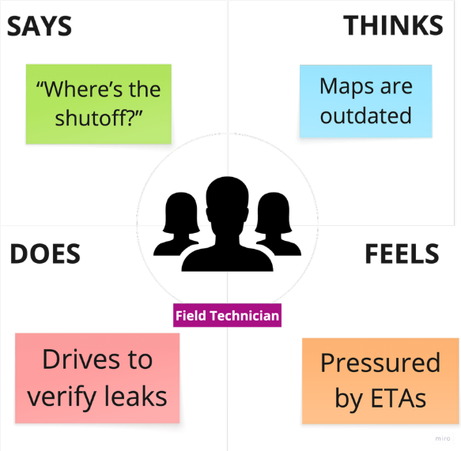
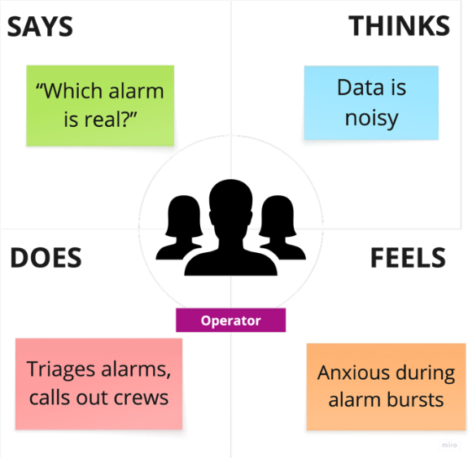

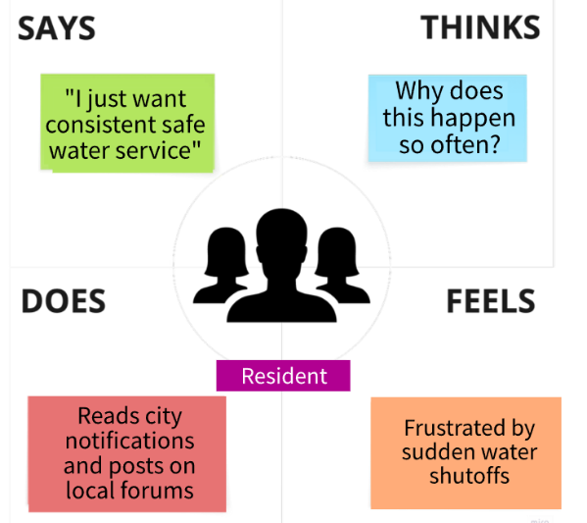
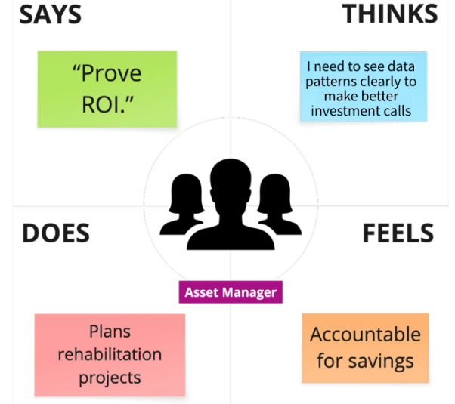

Journey (Leak Event)
1)Alarm burst 2) Visual check on SCADA/GIS 3) Dispatch crew 4) On-site verification 5) Valve isolation 6) Pressure rebalancing 7) Customer communications 8) Postmortem.
Pain points: alarm noise, locating valves, coordination.
Opportunities: pre-emptive isolation suggestions, auto-updated network state, playbooks.

Key Insights
- Alarm fatigue and noisy sensors create delayed responses Need confidence-scored, fused detections.
- Valve location and isolation planning are slow Need automated valve-sequence recommendations with risk scoring.
- Energy spend is controllable but under-optimized Need demand/price co-forecasting with automated pump/tank scheduling.
- Trust requires transparency Need human-in-the-loop controls, audit trails, and rollbacks.

Define

Point of View (POV) Statement
A night-shift control room operator (user) needs high-confidence, explainable leak pre-emption and isolation guidance (need) because alarm floods and outdated maps delay decisive action, driving excess water loss and service minutes (insight).

How Might We (HMW) Questions
- How might we fuse acoustic, pressure, and flow to raise a single, confidence-scored “actionable” signal?
- How might we recommend (and optionally execute) a valve isolation sequence that minimizes customer impact and hydrant outages?
- How might we co-optimize pump/tank schedules against day-ahead energy prices while protecting pressure zones?
- How might we surface explanations and “why now” rationales to build trust in autonomous actions?
- How might we auto-update the digital twin’s topology from field confirmations and SCADA/GIS drift?

Problem Framing / Storyboard (Leak Scenario)
Scenario: Nightshift in the control room. A.W.A.R.E. is used during a potential main break.
- Sensors detect micro-anomalies
Pain Point: Dozens of small fluctuations occur every night, operators struggle to tell which ones matter.
Opportunity: Continuous anomaly detection with fused data confidence levels.
- Multi-agent fusion proposes a likely fissure at Pipe #P-234 (84% confidence):
System correlates flow, pressure and sound data to pinpoint a probable leak zone.
Pain Point: Manual triage is slow and error prone.
Opportunity: Automated, explainable detection builds operator trust and saves time.
- A.W.A.R.E simulates isolation options in the digital twin: Multiple scenarios are tested virtually, showing pressure redistribution and energy impact.
Pain Point: Without simulation, isolation choices often depend on memory and guesswork.
Opportunity: Digital twin modeling enables data-driven, low-risk decision-making.
- System presents top 3 isolation sequences with predicted service impact and recovery time: Each option shows affected customers, hydrant coverage, and estimated downtime.
Pain Point: Operators lack clear trade-off visibility under time pressure.
Opportunity: Transparent scenario ranking helps select the best overall outcome quickly.
- Operator approves Plan B: Decision made with confidence after reviewing rationale and simulation results.
Pain Point: past approvals might feel like blind trust in automation.
Opportunity: Explainable AI justifies recommendations in plain language.
- System actuates smart valves, updates dashboard, and notifies affected zone. Audit records are saved, and response time would have been reduced.
Pain Point: Manual coordination between departments previously caused delays and might have missed documentation.
Opportunity: Closed-loop automation shortens recovery and improves accountability.
Key Insight: Empowering operators with explainable, simulation-driven guidance turns reactive crisis management into proactive control.

User Personas
- Alex - Control Room Operator, 8 years experience. Goals: keep pressure stable, respond fast. Frictions: alarm floods, unclear valve maps. Needs: clear, explainable actions; low false alarms.
- Maya - Field Technician, 5 years experience. Goals: quick isolation, safety. Frictions: hidden/locked valves, outdated GIS. Needs: mobile valve list, step-by-step sequence.
- Jordan - Asset Manager, 12 years experience. Goals: reduce NRW and energy spend. Frictions: siloed data, hard ROI. Needs: dashboards, savings attribution, audit-ready reports.

Ideate

Brainstorming Outputs (Divergent)
- Leak Pre-emption: Self-calibrating acoustic fingerprints per pipe segment; seasonal drift models; pressure-wave triangulation; citizen-sourced audio via hydrant mics.
- Isolation & Safety: Auto-generated valve choreography; hydrant availability safeguard; truck roll minimization; backflow prevention checks.
- Energy Optimization: Day-ahead LMP ingestion; thermal storage analogs via elevated tanks; pump efficiency curves learning; demand response participation.
- Trust & UX: “Why” timeline; model lineage; simulation-before-execution; red-team “what-if” drills; one-click rollback.
- Data/GIS Integrity: Auto-diff between SCADA and GIS; field-confirmed edits; topology anomaly detector; QR-tagged valves.
- Resilience: Contamination sentinel with confirmatory sampling routes; micro-island operation during power constraints; fail-open/fail-closed policies.

Concept Clusters Prioritization (Feasibility × Impact)

High Impact / High Feasibility (v1 focus)
- Multi-sensor leak fusion with confidence scores.
- Valve isolation sequencing + digital twin simulation.
- Pump/tank co-optimization using day-ahead prices.

High Impact / Low Feasibility
4) Auto GIS-SCADA drift reconciliation with field confirmations.
5) “Why/Explainability” panel and audit trails.

Low Impact / High Feasibility
6) Operator playbooks & postmortem automation.
7) Customer communications templating and outage maps.
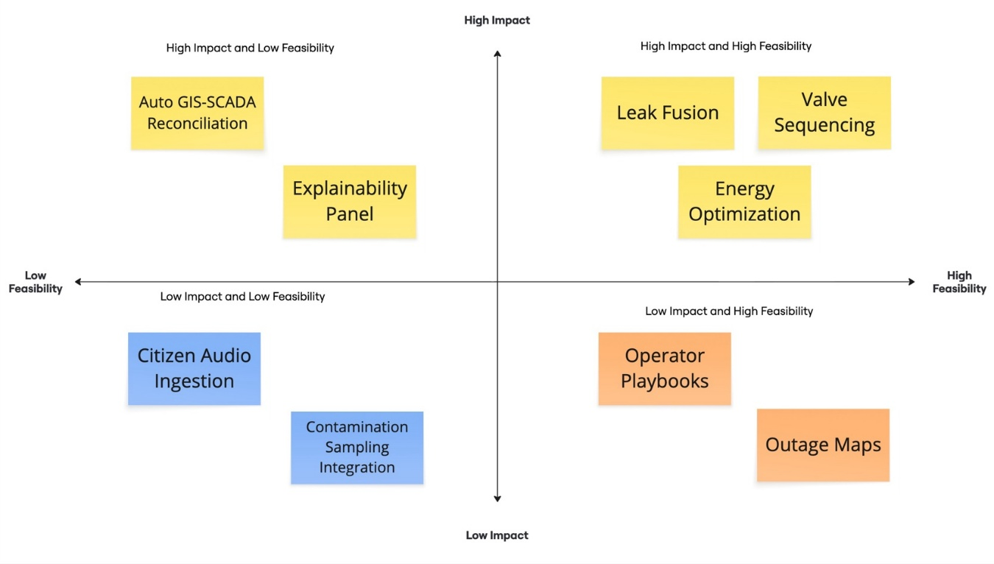

Top Concepts - Concept Cards / Mini Storyboards
- Proactive Leak Pre-emption - Inputs: acoustic, pressure, flow; Output: leak-likelihood heatmap per pipe; Action: recommend isolation; KPI: MTTD↓, NRW↓.
- Autonomous Visual Isolation - Inputs: confirmed leak, topology; Output: ordered valve sequence; UI: live network turns red on affected segment; KPI: service minutes↓.
- Dynamic Energy Optimization - Inputs: forecast demand + day-ahead price; Output: schedule for pumps/tanks; Guardrails: pressure floors; KPI: $/MGal↓.
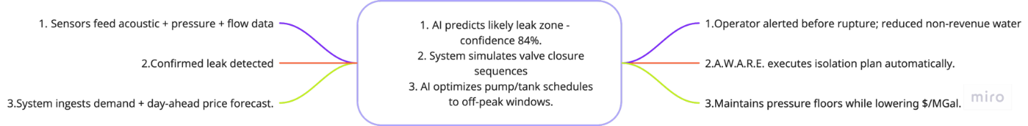

Success Metrics
- Leading: false-alarm rate ≤ 5%; time-to-first-action ≤ 3 min; confidence calibration error ≤ 10%.
- Lagging: NRW ↓ 10-20%; outage minutes ↓ 25-40%; energy cost/MGal ↓ 12-25% over baseline.
- Trust & Safety: ≥ 70% operator opt-in to auto-execute by week 8; zero safety incidents.

Scope & MVP (8–10 weeks)

MVP (v1) Capabilities
- Leak fusion (pressure + acoustic demo dataset).
- Isolation simulation on a simplified digital twin.
- Pump/tank scheduler with synthetic day-ahead price feed.
- Explainability panel and full audit log.

Out of Scope for v1
- Contamination lab integrations.
- Citywide GIS reconciliation.
- Citizen-sourced audio ingestion.

Risks & Mitigations
- Sensor noise smoothing/bandpass + calibration.
- Topology errors operator confirmation before actuation.
- Trust simulation-first execution with one-click rollback.

