POLYGRAPH REPORT

TO: Det. Lisa Brannan
San Diego County Sheriff’s Dept.
Child Abuse Unit
9621 Ridgehaven Court
San Diego, CA 92123

FROM: Paul Redden
3111 Camino del Rio North
Suite 400
San Diego, CA 92108
(619) 977-8877
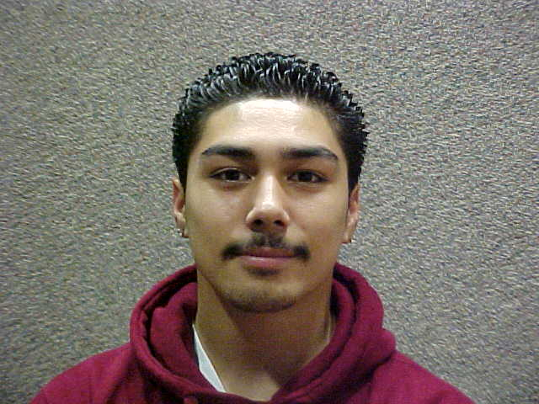
DATE: March 17, 2009

INCIDENT: 288 / Case # 09022667

SUBJECT AND DATE OF EXAM

Smith, Mikey Dean -------------------- 3/17/2009

ARRANGEMENTS

The above named subject voluntarily submitted to a polygraph examination administered by Paul Redden at 3111 Camino del Rio, North, San Diego, California 92108.

The examination utilized a Lafayette computerized polygraph instrument which indicated and recorded relative changes in blood pressure, rate and strength of pulse beat, galvanic skin response and breathing pattern.

It was the understanding of the examiner that the primary purpose of this examination was to determine the truthfulness of the subject’s statement when he denied kissing, feeling the breasts, and trying to put his hand inside Marissa Ramirez, a 13 year old student that frequented the Spring Valley Community Recreation Center where he was employed.

The subject stated that he has been employed with the San Diego County Parks and Rec Department since April 2008. He said that he is responsible for providing security at the Spring Valley Community Recreation Center, located at 8735 Jamacha Boulevard. Mikey said that he has known Marissa Ramirez for approximately 2 months and he met her at the rec center where she frequents regularly. On the day in question he admitted that he did invite Marissa to go with him to the shed. He said the shed is a secluded area where they store mats and equipment. When they arrived in the shed area he said that Marissa told him her grandmother was coming to pick her up and then hugged him and left. Mikey said that he did not try anything sexual with her and did not kiss her. Smith denied that he felt Marissa’s breasts, either outside or inside her clothing and denied that he tried to put his hand inside Marissa’s pants.

Polygraph Report
Smith, Mikey Dean

During the course of the three administered polygraph examinations the following relevant questions were asked:

RELEVANT QUESTIONS

1. On that day in question did you feel Marissa's (Ramirez) breasts?

SUBJECT answered: “No.”

2. Did you ever put your hand inside Marissa's (Ramirez) clothing and feel her breasts?

SUBJECT answered: “No.”

RESULTS

At the conclusion of the polygraph examination a careful evaluation of all the subject’s
polygraph charts revealed physiological responses generally associated with deception. It is my opinion, as the examiner, based on a careful analysis of all the subject’s polygraph charts that the subject was attempting deception when he answered “no” to the above relevant questions.

An extensive interview was conducted with the subject at the conclusion of the polygraph examination and the subject admitted that he had touched Marissa’s breast. He said that when she hugged him he put his hand on her left breast. She looked down at his hand and he said that he realized that was wrong and pulled his hand away. He continued to deny putting his hand inside her clothing, denied kissing her and denied trying to put his hand inside her pants. This information was provided to Detective Brannan for further investigation.

The subject’s charts were also scored using the APL algorithm which concurred with my conclusion.

Respectfully,

Paul Redden

Polygraph Examiner

