**Objective:**

To host Plumber APIs on AWS Fargate.

**Pre-requisite:**

1. AWS Account
2. Docker image with Plumber APIs in DockerHub. “raymondowf/deploymodel:latest” will be used as an example.

**Steps:**

1. Login the AWS Console.
2. Choose “Elastic Container Service”.
3. Create a cluster.
   1. Choose “Networking Only” as we will be using AWS Fargate to run the container.
   2. Give a cluster name. Create VPC is optional. You can leave it unchecked.
4. Create a new task definition and select ”Fargate”.
   1. Give a task definition name. For example, “Task1”.
   2. Set “Task Role” to None.
   3. Set “Task Execution Role” to “ecsTaskExecutionRole”.
   4. Set “Task Memory Size” to 0.5GB. Running the APIs does not require much memory.
   5. Set “Task CPU” to “0.25 vCPU”.
   6. Click “Add Container”.
      1. Give a container name.
      2. Set “Image” with the value “raymondowf/deploymodel:latest”
      3. Set “Container Port” to 8000 under “Port mappings”.
5. To run the task you’ve just created in (4),
   1. Select the cluster created in (3).
   2. Select the “Tasks” tab.
   3. Click “Run new Task”.
      1. Choose “FARGATE” as the launch type.
      2. Choose “Task1” as the Task Definition.
      3. Under “VPC and security groups”,
         1. Choose the “default VPC” for the Cluster VPC. To know which one is the default VPC, go to the link VPC from the “Services” at the top left corner.
         2. Choose any subnets.
         3. “Edit” the Security groups.
            1. Click “Add rule” and specify “Custom TCP” and “8000” as “Port Range”.
            2. Then click “Save”.
         4. Choose “ENABLED” for Auto-assign public IP so that we can use the IP + port 8000 to access the APIs.
         5. Click “Run Task”.
   4. When the container is online, you should see a screen similar to Figure 1.
   5. To identify the public IP address (the address that you can access using any web browser), click the “Task” ID. You can find the “Public IP” under the “Network” section. Copy the address and paste it as follow: http://<Public IP>:8000/
   6. You should see the screen like Figure 2. You access to the Swagger APIs, concatenate the URL above with __docs__. For example, <http://13.212.79.22:8000/__docs__/>
6. After testing, please make sure that you terminate the task so that AWS stops charging you for the usage of AWS Fargate.

Figure 1: The container is running on AWS Fargate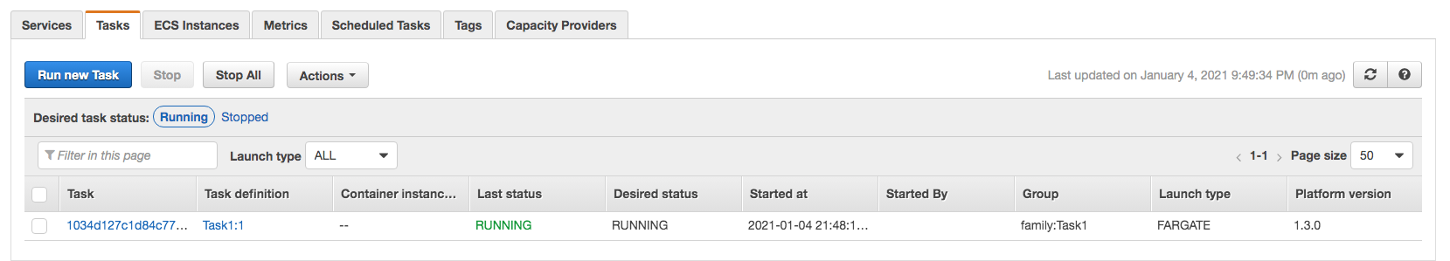

Figure 2: The index page.

