Software Requirements Specification
for
Trivia Maze
Version 1.0 approved
Prepared by Daylyn Hoxie
Triple Threat
November 5, 2019
Table of Contents
1. Introduction 1
1.1 Purpose 1
1.2 Document Conventions 1
1.3 Intended Audience and Reading Suggestions 1
1.4 References 1
2. Overall Description 1
2.1 Product Perspective 1
2.2 User Classes and Characteristics 2
2.3 Operating Environment 2
2.4 Design and Implementation Constraints 2
2.5 User Documentation 3
2.6 Assumptions and Dependencies 3
3. System Features 3
3.1 Play Game 3
3.2 Save Game 3
4. External Interface Requirements 3
4.1 User Interfaces 3
4.2 Hardware Interfaces 4
4.3 Software Interfaces 4

Revision History
Name | Date | Reason For Changes | Version
Daylyn Hoxie | 11/6/19 | Initial draft | 1.0 draft 1

Introduction

Purpose
This SRS describes the software functional and nonfunctional requirements for release 1.0 of the Trivia Maze. This document is intended to be used by the members of the project team that will implement and verify the correct functioning of the system. Unless otherwise noted, all requirements specified here are high priority and committed for release 1.0.

Document Conventions
The Trivia Maze will permit a player to navigate a maze by correctly answering trivia questions. A detailed project description is available in the Class Project assignment in the CSCD 350 course [1].

Intended Audience and Reading Suggestions
This document is intended for use by developers, users, client, testers, and documentation writers.

References
[1] Capaul, Tom. Software Development Principles, http://penguin.ewu.edu/cscd350/Spring_15/index.html

Overall Description

Product Perspective
The purpose of the Trivia Maze is to give students experience working on a development team and project management experience and to give Tom extra work to do over the weekend. The simplified UML diagram in Figure 1 illustrates the system interfaces for release 1.0. The system is expected to evolve over several releases, ultimately connecting to the Trivia Maze to a database containing questions.

User Classes and Characteristics
Player A Player is a user of the Trivia Maze.

Question A Question is a trivia question that the Player must answer in order to navigate the maze.

Database A Database contains the questions and answers for use by the Maze.

Figure 1

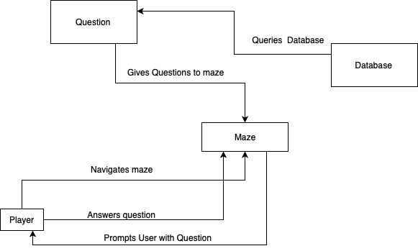
Operating Environment
OE-1: Undecided

Design and Implementation Constraints
CO-1: The software will be currently be written using IntelliJ IDEA ULTIMATE 2018.1.5 and will conform to new updates of IntelliJ as released.
CO-2: The software will be written using JUnit 5 for testing.

User Documentation
Undecided

Assumptions and Dependencies
AS-1: The user will have Java installed on their machine.

System Features

Play Game
3.1.1 Description and Priority
A user will be able to play the game by answering trivia questions to get through the maze. A user will be able to quit the game.
3.1.2 Stimulus/Response Sequences
Stimulus: User requests to start game.
Response: Software creates maze and starts Player in the entrance.

Stimulus: Player requests to open door.
Response: Software provides Player a Question to answer (if door has not already been opened).

Stimulus: Player answers Question.
Response: Software determines if the answer was correct and changes door status accordingly.

Stimulus: Player requests to quit game.
Response: Software ends game.

Save Game
[details will be provided in the next revision]

External Interface Requirements

User Interfaces
UI-1: The Trivia Maze will provide standard keyboard functions that will be displayed on every screen.
UI-2: Error message displays will be standardized to return the Player to the last place they were before the error occurred.

Hardware Interfaces
No hardware interfaces have been identified.

Software Interfaces
SI-1: Question Database System
SI-1.1: The Maze shall retrieve the questions and answers through a programmatic interface.
SI-2: Player System
SI-2.1: The Player System will allow a Player to start the game.
SI-2.2: The Player System will allow a Player to move through the Maze.
SI-2.3: The Player System will allow a Player to answer questions.
SI-2.4: The Player System will allow a Player to quit the game.

