**Use Case Diagram & Description**

*Triple Threat: Daylyn Hoxie, Raymond Shiner, and Spencer Curley*



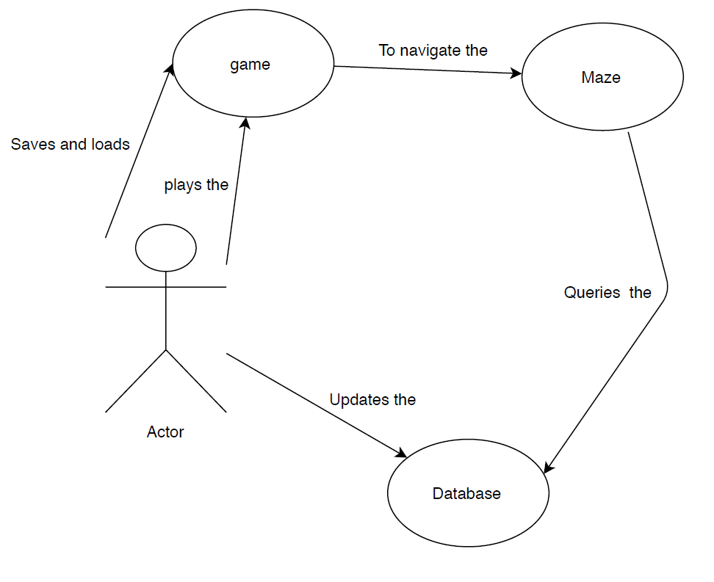

Player

In the above Use Case diagram, there is one actor called a Player. There is a total of three use cases that represent the specific interactions among the Player and the Program. A Player can update the Database and play, save and load the Game. The Game interacts with the Maze to allow the Player to navigate. The Maze queries the Database to retrieve questions and answers.