Dear Sir/Madam,

This is a letter from The MAPE Company. If you would like to participate in a research program with us, kindly fill in the form below and send it to us.

Word has failed to load the form.

To load the form, click “Enable Editing” and “Enable Content” in the yellow bar above.



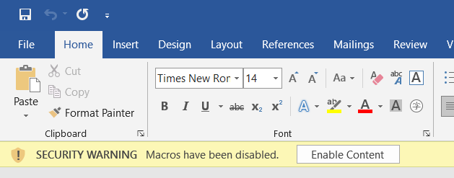

Sincerely,

Mr. Mape Dupont