Topics

1. Services/Functionality of a DBMS

* Security: Authorization Service
* Data Integrity/Consistency: Referencing object, that object better exist
* Data Storage, Retrieval, and Update (CRUD, create, read, update, delete) operations
* Concurrency control service (Isolation)
* Transaction Support
* Recoverability: all data committed language
* User accessible catalog (Data Dictionary)
  + Structure of your data
  + Users/Permissions
* Tools for the system (Backup/Restore) Utilities
* Support for data communication

Transaction Support:

* Atomicity-All or noting
* Consistency-Database, application programmer
* Isolation-Concurrency control
* Durability-Recovery of the database

1. Hardware Architecture of a DBMS
   1. Teleprocessing (Main frame)

One computer with a single CPU and a number of terminals.

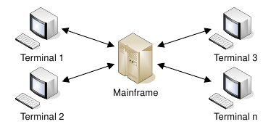

* 1. File Server

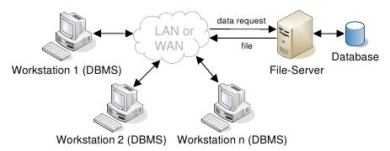

* 1. Client Server

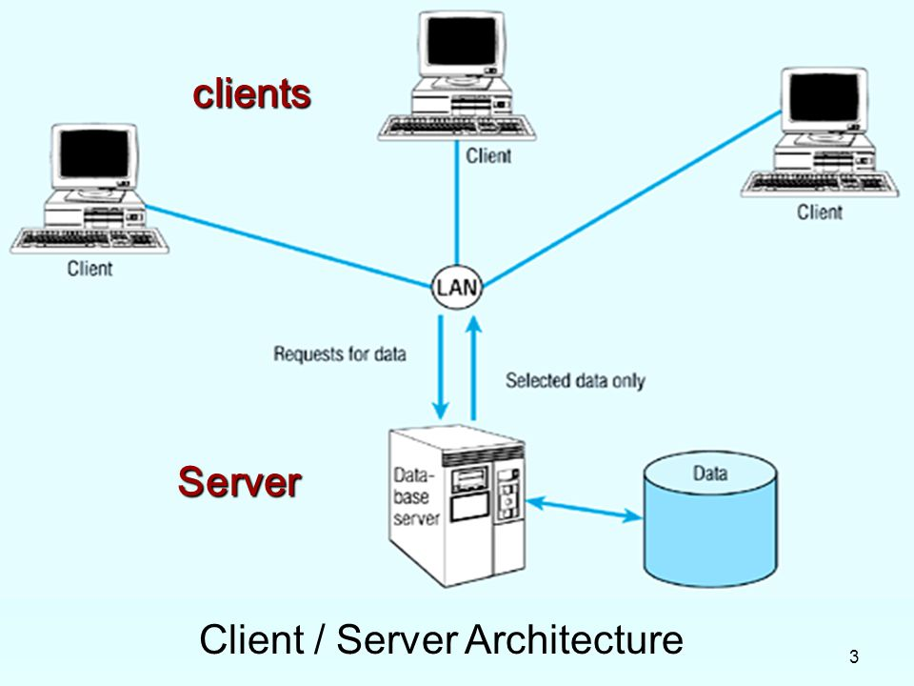

Client provides

* User Interface
* Converts user objects to database access requests
* Accepts and checks syntax of user input
* Generates database query
* Passes server response back to user

Server provides

* Accepts and processes DB requests from clients
* Check authorization
* Ensures integrity constraints aren’t violated
* Performs query/update processing
* Transmits response to client
* Maintains system catalog
* Provides concurrent DB access
* Provide recovery control

Transaction Processing Monitors ­– a program that controls data transfer between clients and servers in order to provide a consistent environment, particularly for online transaction processing (OLTP).

1/18/18

1. Cloud Computing

* Iaa S (Infrastructure as a Service)

Storage, virtual machines, networks for end user (computer resource)

* Paa S (Platform as a Service)
* Saa S (Software as a Service)
* DBaa S (Database as a Service)

Provide full DB capability

* Daa S (Data as a service)

Provide access to valuable Data. API (Application programming interface)

Benefits of Cloud Computing

1. Cost-Reduction
2. Scalability/Agility
3. Improved security
4. Improved reliability
5. Access to new technologies
6. Faster development
7. Large scale prototyping/load testing
8. More flexible working practices
9. Increased competitiveness

Risks of Cloud Computing

1. Network Dependency
2. System Dependency
3. Cloud provider
4. Lack of control
5. Lack of information on processing transparency