**Raymond You**

**EECE 2160 - Kimani**

**HW #3**

**1.**

a)

-23 + 2^8 = 233

233 = 2^7 + 2^6 + 2^5+ 2^3 + 2^0

=(1110 1001)2

**=E916**



b)

(1110 1101)2

=2^7 + 2^6 + 2^5 + 2^3 + 2^2 + 2^0

**=23710**

**2.**



|  |  |  |  |  |  |  |
| --- | --- | --- | --- | --- | --- | --- |
| A | B | C | Minterm | Minterm Designation | Maxterm | Maxterm Designation |
| 0 | 0 | 0 | A’B’C’ | m0 | A + B + C | M0 |
| 0 | 0 | 1 | A’B’C | m1 | A + B + C’ | M1 |
| 0 | 1 | 0 | A’BC’ | m2 | A + B’ + C | M2 |
| 0 | 1 | 1 | A’BC | m3 | A + B’ + C’ | M3 |
| 1 | 0 | 0 | AB’C’ | m4 | A’ + B + C | M4 |
| 1 | 0 | 1 | AB’C | m5 | A’ + B + C’ | M5 |
| 1 | 1 | 0 | ABC’ | m6 | A’ + B’ + C | M6 |
| 1 | 1 | 1 | ABC | m7 | A’ + B’ + C’ | M7 |



= m0 + m2 + m4 + m5

= A’B’C’ + A’BC’ + AB’C’ + AB’C

**F(A,B,C) = π (1,3,6,7) = M1 • M3 • M6 • M7**

**= (A + B + C’)(A + B’ + C’)(A’ + B’ + C)(A’ + B’ + C’)**

**3.**



|  |  |  |  |  |  |  |
| --- | --- | --- | --- | --- | --- | --- |
| A | B | C | Minterm | Minterm Designation | Maxterm | Maxterm Designation |
| 0 | 0 | 0 | A’B’C’ | m0 | A + B + C | M0 |
| 0 | 0 | 1 | A’B’C | m1 | A + B + C’ | M1 |
| 0 | 1 | 0 | A’BC’ | m2 | A + B’ + C | M2 |
| 0 | 1 | 1 | A’BC | m3 | A + B’ + C’ | M3 |
| 1 | 0 | 0 | AB’C’ | m4 | A’ + B + C | M4 |
| 1 | 0 | 1 | AB’C | m5 | A’ + B + C’ | M5 |
| 1 | 1 | 0 | ABC’ | m6 | A’ + B’ + C | M6 |
| 1 | 1 | 1 | ABC | m7 | A’ + B’ + C’ | M7 |



= M0 • M2 • M5

= (A + B + C)(A + B’ + C)(A’ + B + C’)

**F(A,B,C) = Σm(1,3, 4, 6, 7) = m1 + m3 + m4 + m6 + m7**

**= A’B’C + A’BC + AB’C’ + ABC’ + ABC**

**4.**

**a) A′C′ + ABC + AC′**

(~A /\ ~C) V (A /\ B /\ C) V (A /\ ~C)

(~A /\ A /\ A /\ B) V (~C /\ C /\ ~C)

(A /\ B) V (~C)

= (A • B) + C’

|  |  |  |  |
| --- | --- | --- | --- |
| A | B | C | (A • B) + C’ |
| T | T | T | T |
| T | T | F | T |
| T | F | T | F |
| T | F | F | T |
| F | T | T | F |
| F | T | F | T |
| F | F | T | F |
| F | F | F | T |

Simplifies to (A • B) + C’

**b) (A + B)’ • (A’ + B’)’**

(A’ • B’) • (A • B)

A’ • A • B’ • B

|  |  |  |
| --- | --- | --- |
| A | B | (A’ • B’) • (A • B) |
| T | T | F |
| T | F | F |
| F | T | F |
| F | F | F |

Simplifies to FALSE

**5.**

**a)**

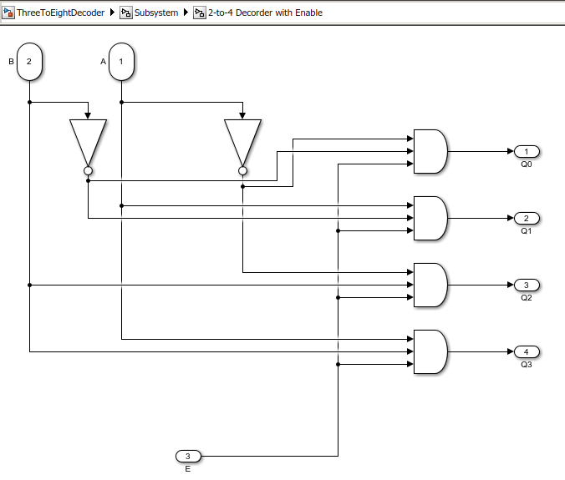

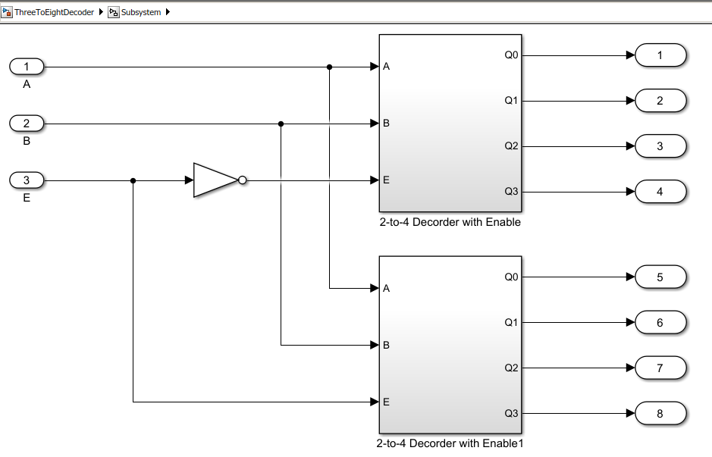

**b)**

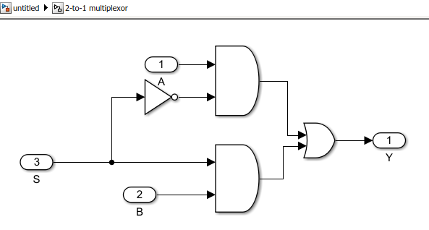

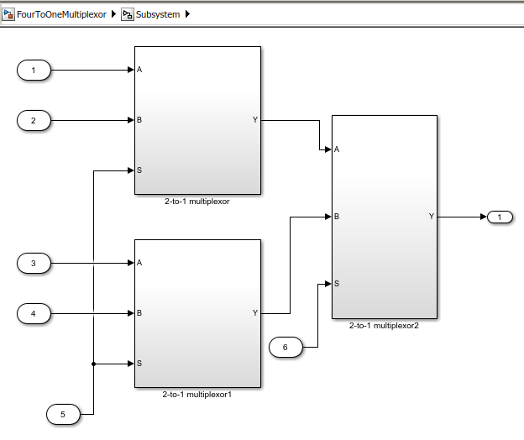

**6.**

**Truth Table:**

|  |  |  |  |  |  |  |  |  |
| --- | --- | --- | --- | --- | --- | --- | --- | --- |
| A0 | A1 | A2 | S0 | S1 | S2 | S3 | S4 | S5 |
| 0 | 0 | 0 | 0 | 0 | 0 | 0 | 0 | 0 |
| 0 | 0 | 1 | 0 | 0 | 0 | 0 | 1 | 0 |
| 0 | 1 | 0 | 0 | 0 | 1 | 0 | 0 | 0 |
| 0 | 1 | 1 | 0 | 0 | 1 | 0 | 0 | 1 |
| 1 | 0 | 0 | 1 | 0 | 0 | 0 | 0 | 0 |
| 1 | 0 | 1 | 1 | 0 | 0 | 1 | 1 | 0 |
| 1 | 1 | 0 | 1 | 0 | 0 | 1 | 0 | 0 |
| 1 | 1 | 1 | 1 | 0 | 0 | 0 | 1 | 1 |

**Boolean expression:**

S0 = A0

S1 =0

S2 = A0` • A1

S3 = A0 • (A1 ⊕ A2)

S4 = (A0 + A1’) • A2

S5 =A1 • A2

**Logic Circuit:**

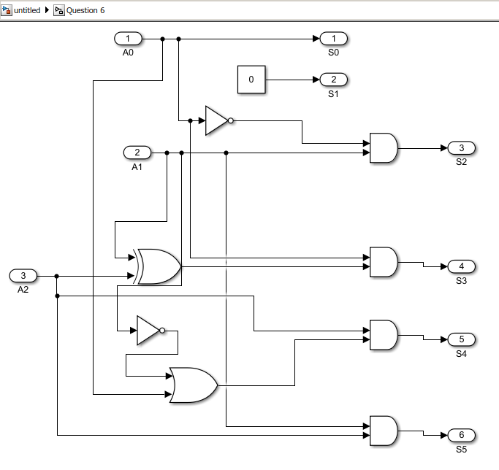

**7.**

**Sample Outputs**

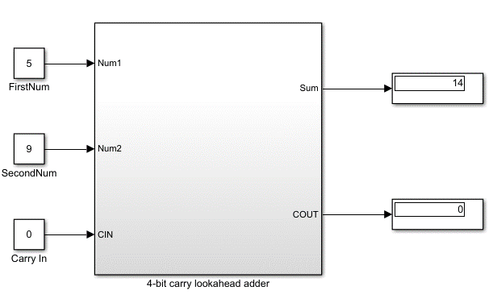

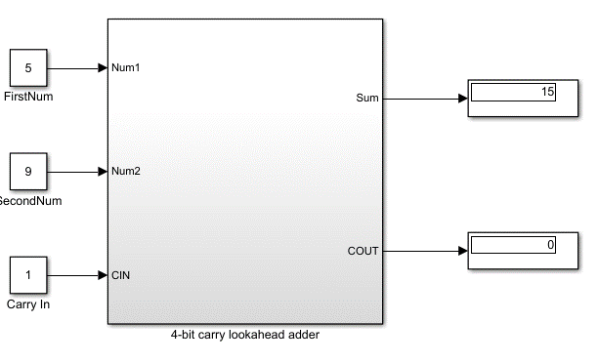

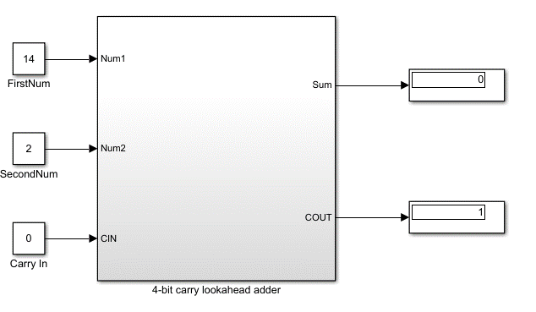

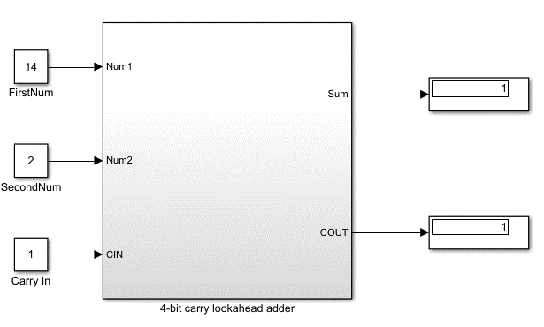

**Detailed Design**

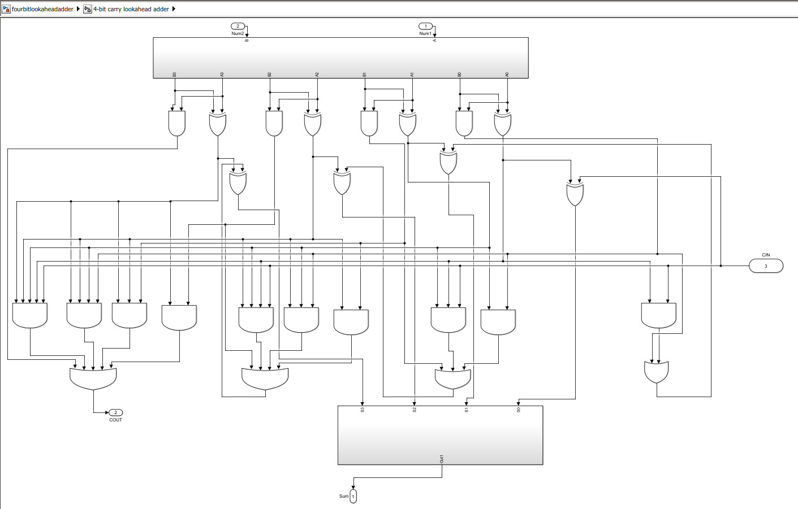

**8**.

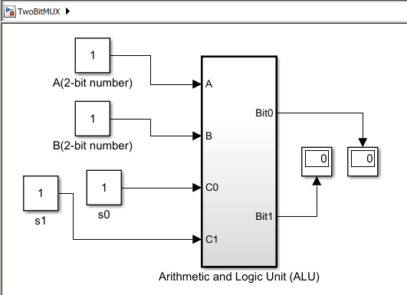

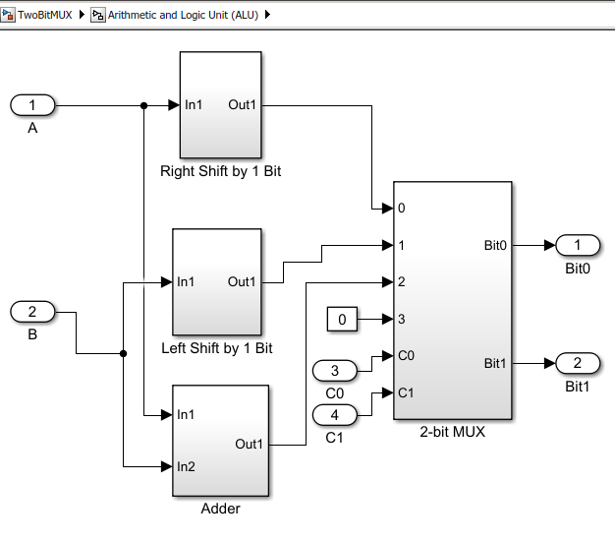

Example Outputs

**00 – shift the first operand right by 1 position**

A is originally 012. After the bits are shifted right by 1 position, it becomes 002.

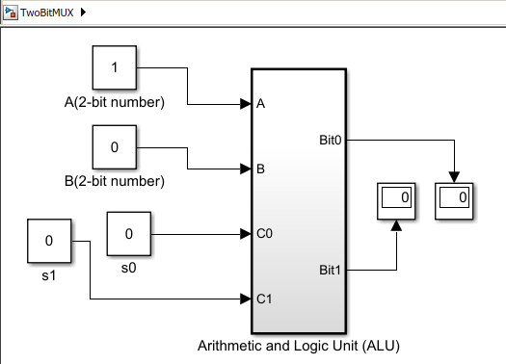

A originally is 112. After the bits are shifted right by 1 position, it becomes 012.

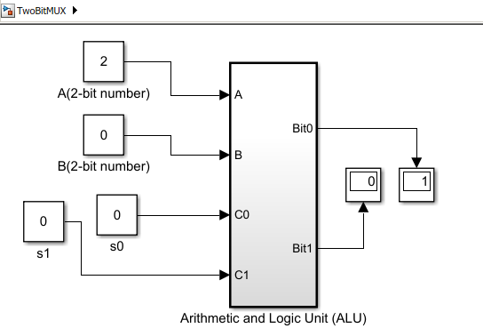

**01 - shift the second operand left by 1 position**

B is originally 012, after the bits are shifted left by 1 position, it becomes 102

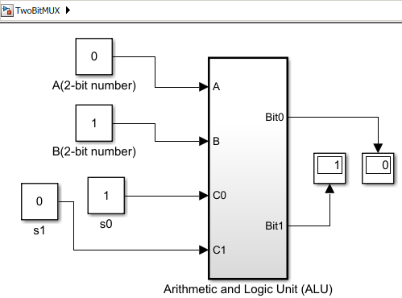

B is originally 102. After the bits are shifted left by 1 position it becomes, 002.

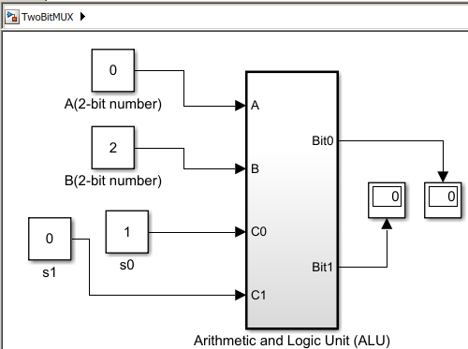

**10 – add the two 2-bit quantities**

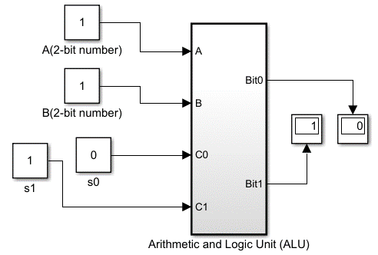

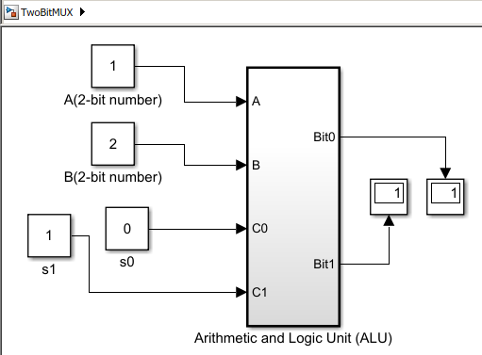

**11 – set the output to zero**

