Raymond You

EECE 2160 Kimani

HW 5

1.

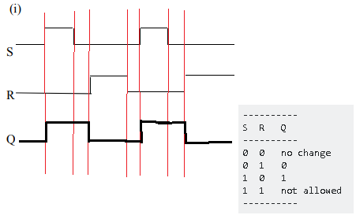

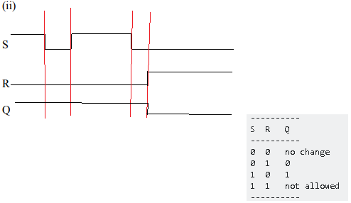

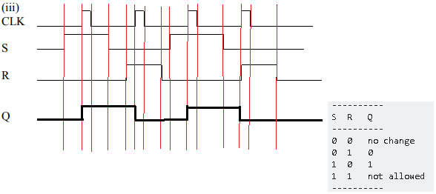

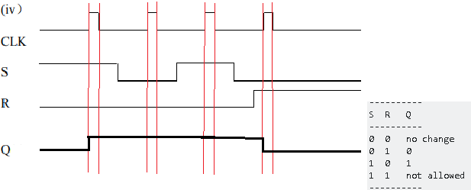

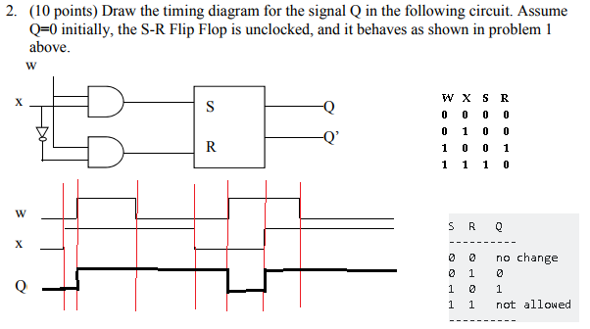

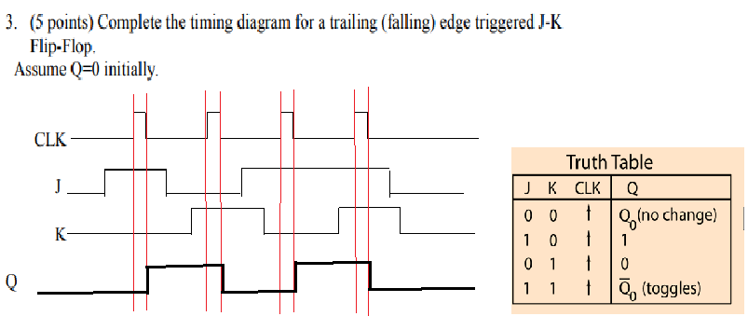

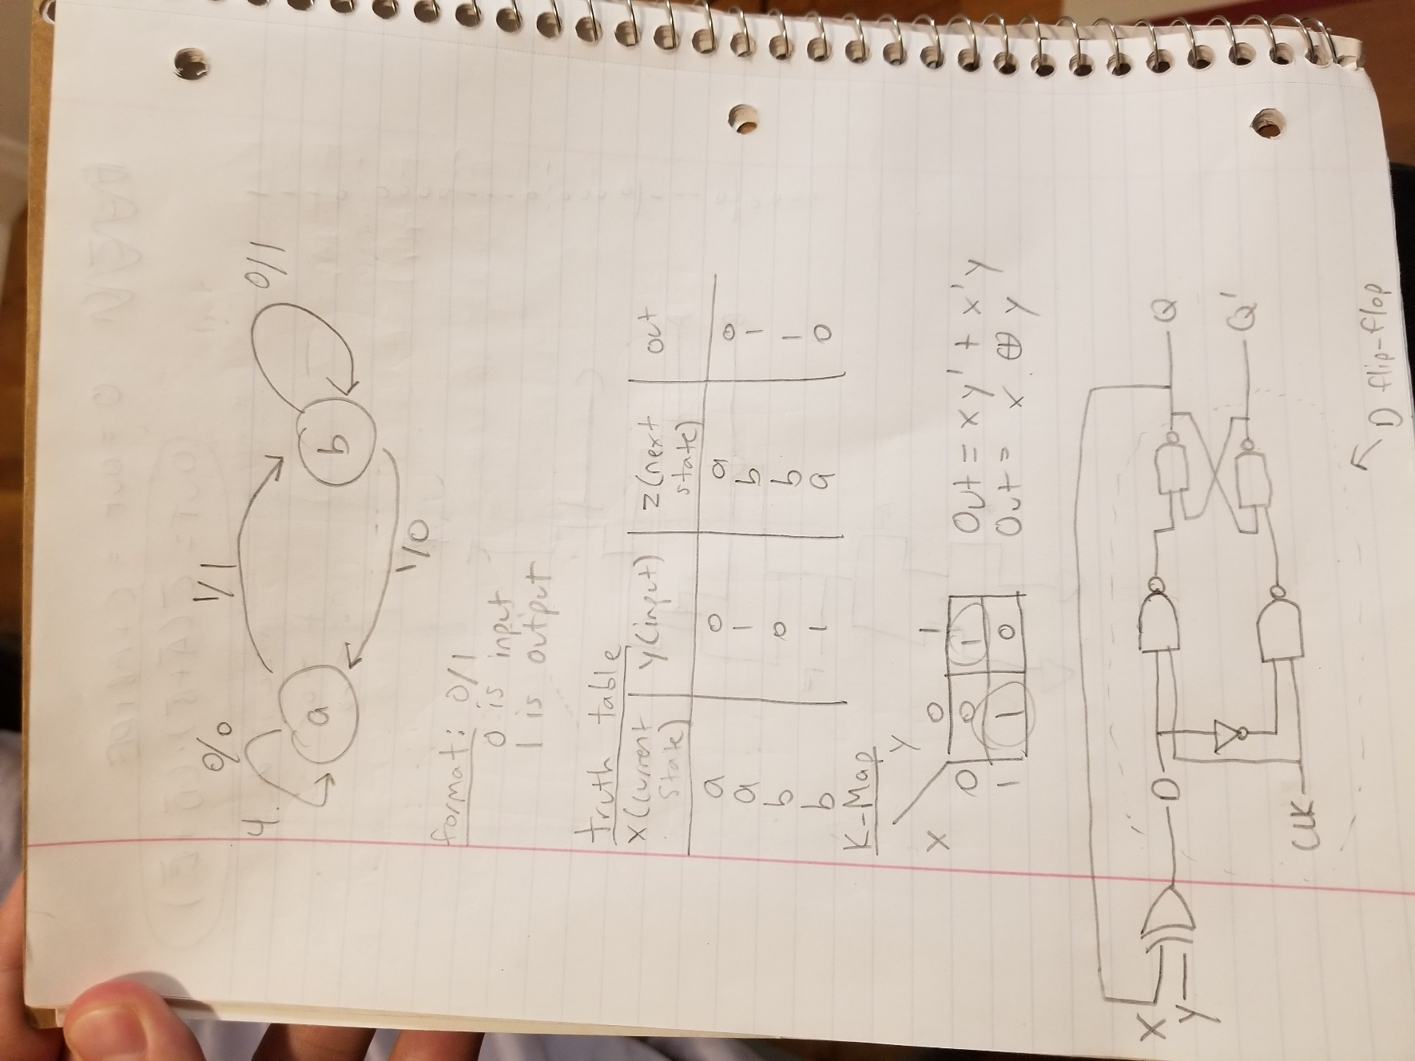4.

5.

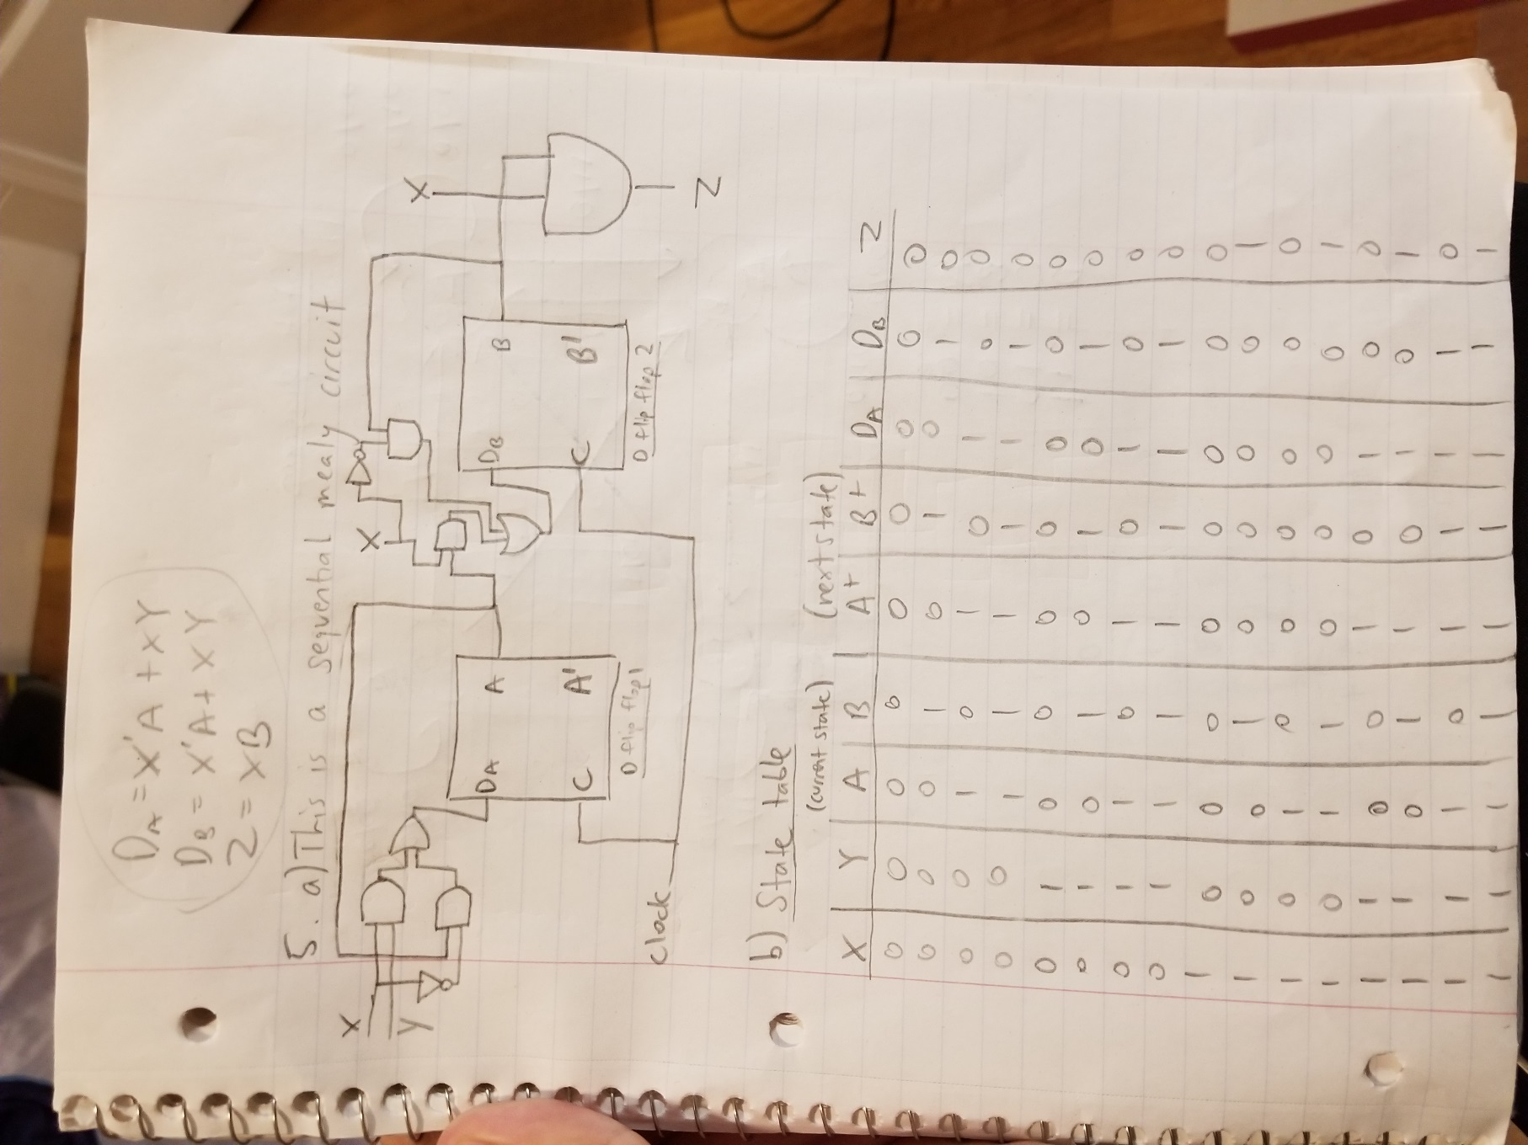

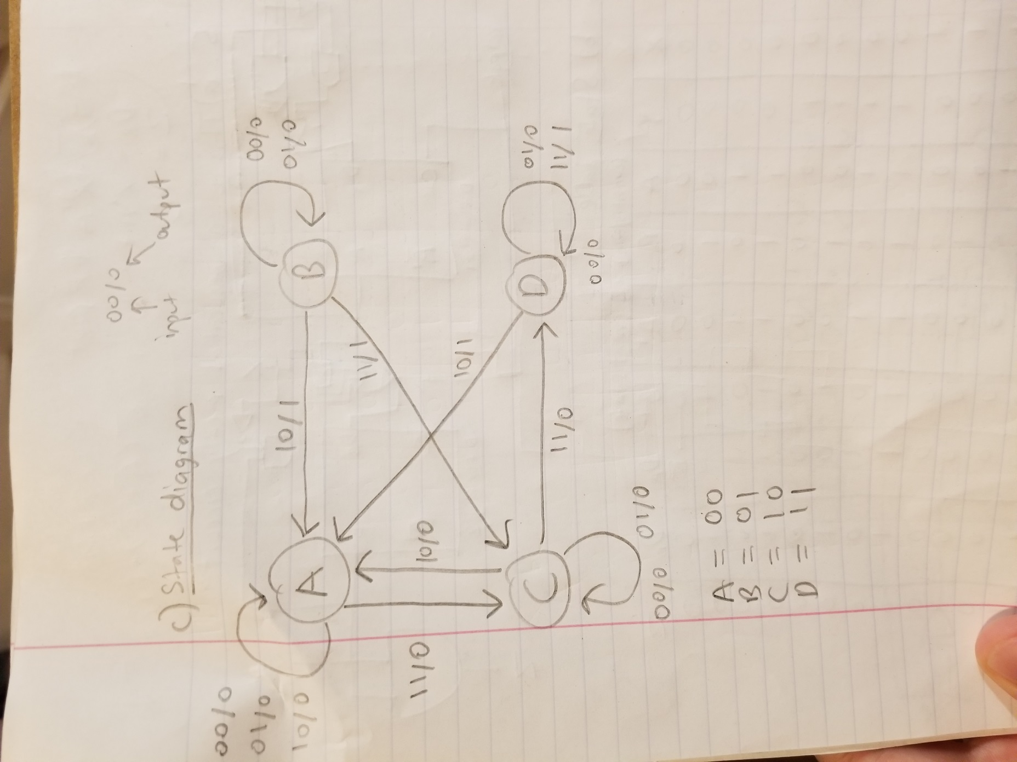

6. 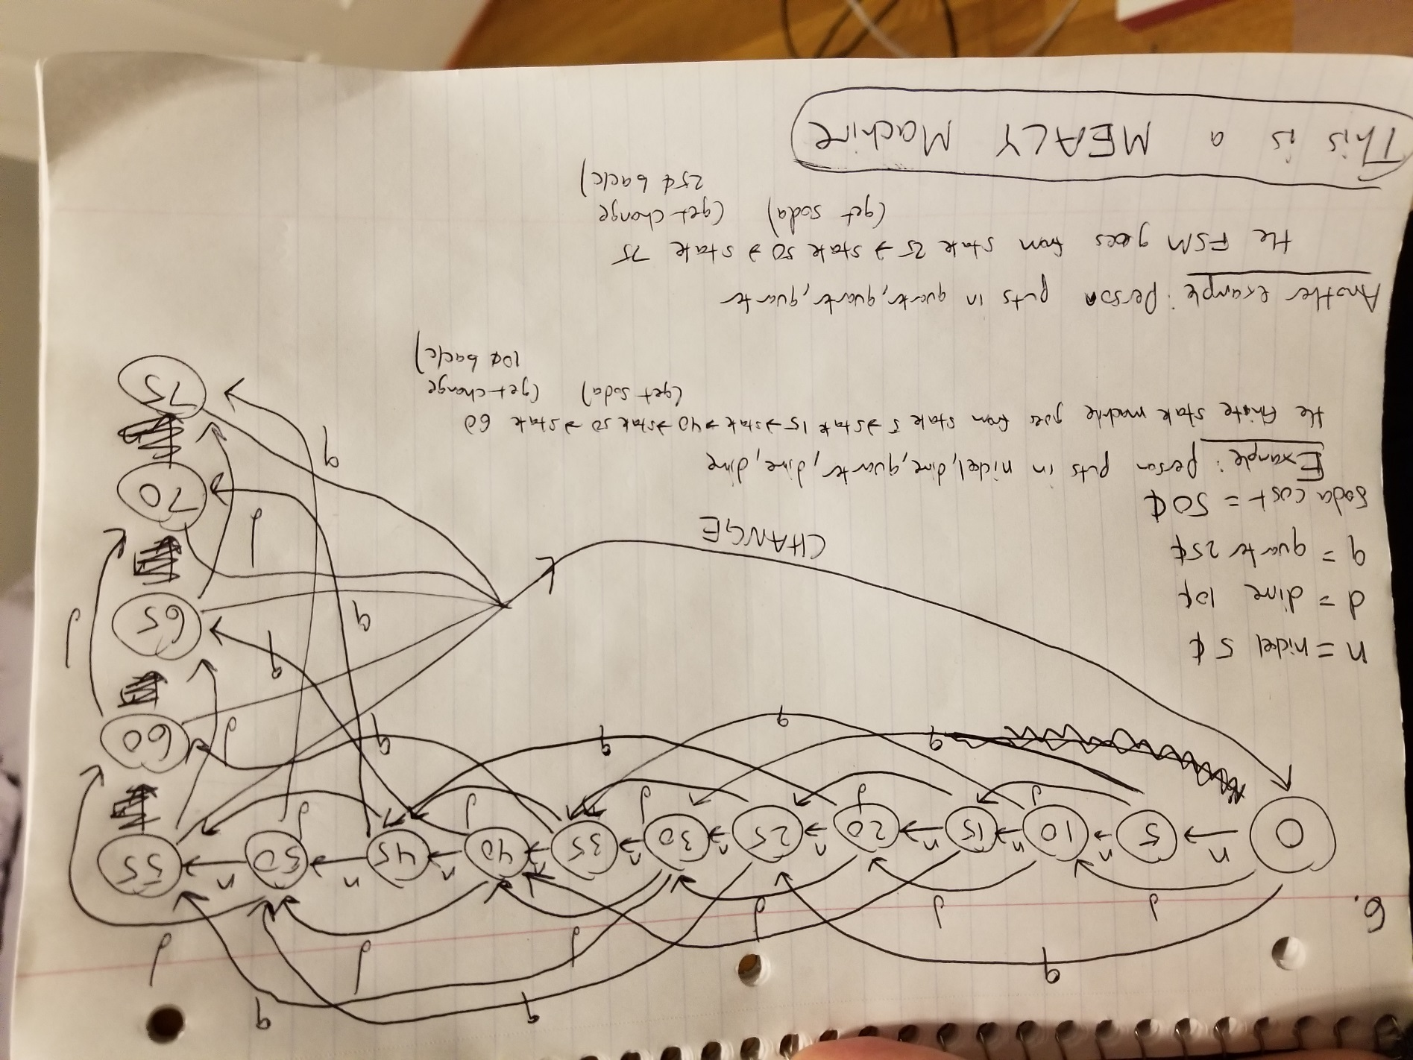

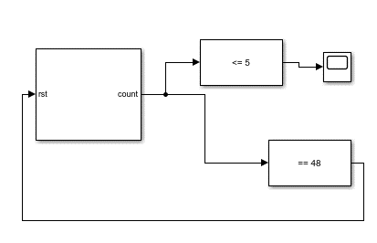7.

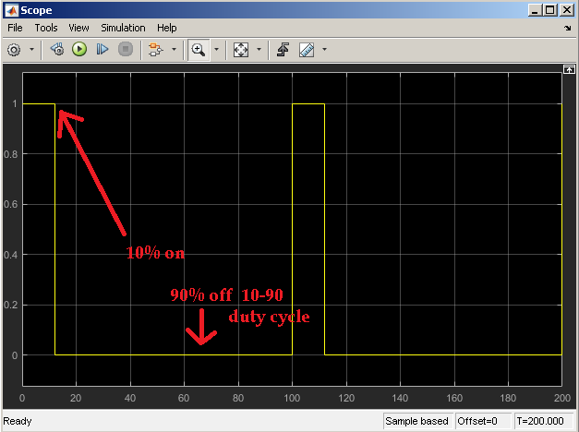

In the scope, it is generated for 2 cycles. Each cycle having 100 periods. Everything got scaled down to smaller number for simpler scoping purposes. The original values for the 2 gigahertz clock were: 1 ms was 2,000,000,000 cycles. This was based off of the zedboard which is 50 MHZ and each ms in the zedboard is 50,000,000 cycles. The initial value of the counter is 0 and it goes up by step values of 2. Because the step values are 2, both the compare to constants are also halved. So the original compare to constants were 10 and 96. Now they are 5 and 48.