Raymond You

Pre-Lab 10

EECE 2160 – Kimani 8 am

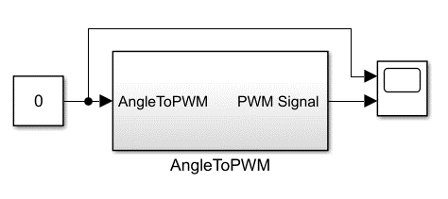

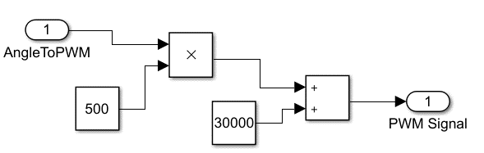

0 degrees = 30000 count value (0.6ms)

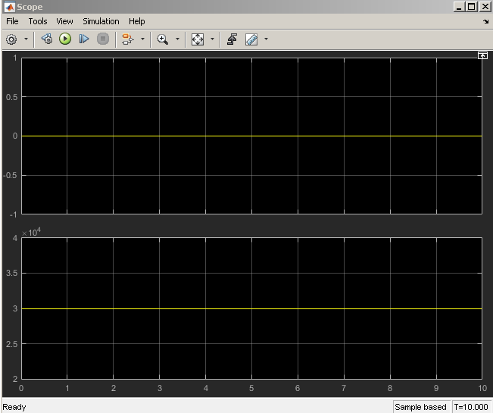

90 degrees = 75000 count value (1.5ms)

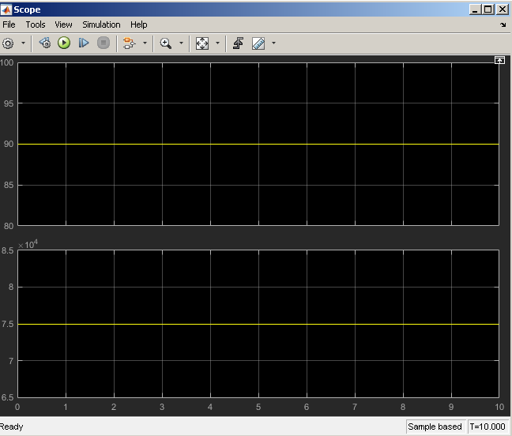

180 degrees = 120000 count value (2.4ms)

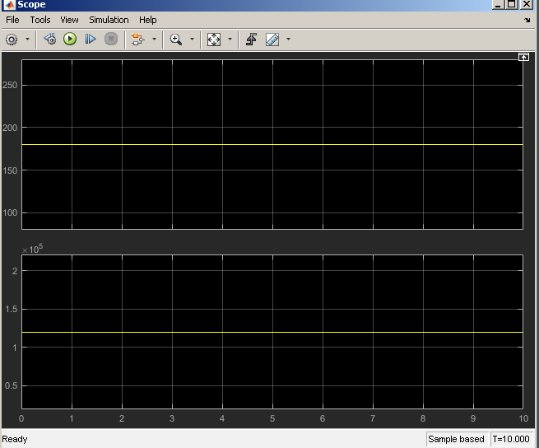

All of the outputs are correct and match my expectations.