Raymond You

EECE 2160 Pre Lab 4

a)

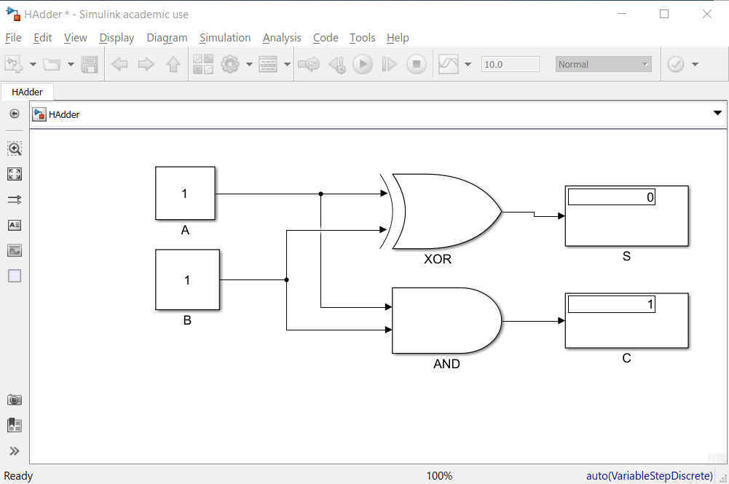

b)

Truth table half adder

**Inputs** **Outputs**

|  |  |  |  |
| --- | --- | --- | --- |
| A | B | SUM | CARRY |
| 1 | 1 | 0 | 1 |
| 1 | 0 | 1 | 0 |
| 0 | 1 | 1 | 0 |
| 0 | 0 | 0 | 0 |

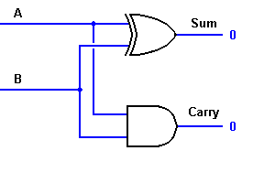

Truth table full adder

**Inputs Outputs**

|  |  |  |  |  |
| --- | --- | --- | --- | --- |
| A | B | CIN | COUT | S |
| 1 | 1 | 1 | 1 | 1 |
| 1 | 1 | 0 | 1 | 0 |
| 1 | 0 | 1 | 1 | 0 |
| 1 | 0 | 0 | 0 | 1 |
| 0 | 1 | 1 | 1 | 0 |
| 0 | 1 | 0 | 0 | 1 |
| 0 | 0 | 1 | 0 | 1 |
| 0 | 0 | 0 | 0 | 0 |

