Raymond You

EECE 2160 – Kimani

Pre-Lab 5

**8-bit Adder/Subtractor system**

**First picture shows addition. 12 + 5 = 7**

**Second picture shows subtraction. 12 – 5 = 7**

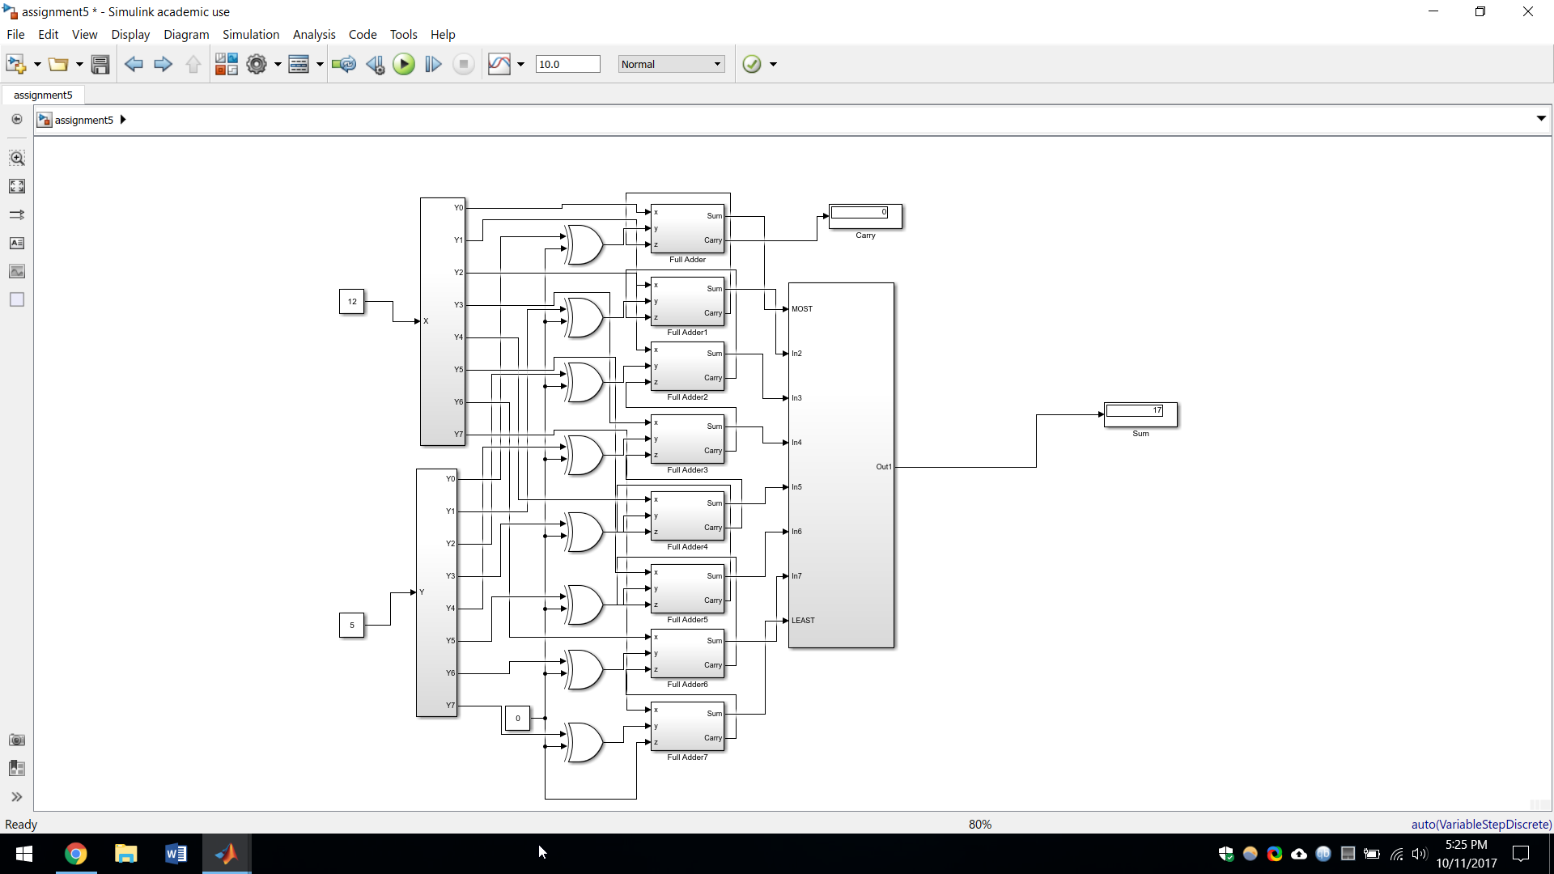

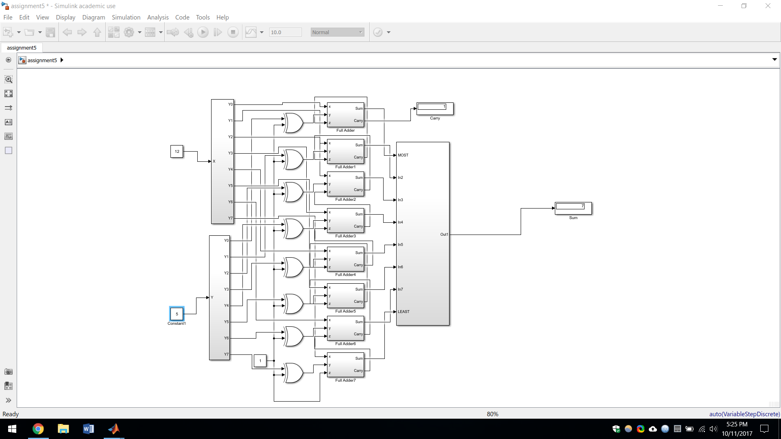

8-bit multiplier design

Because it is 8-bit multiplied by 8-bit, there will be a total of 64 inputs in the total system (X1Y1, X1Y2, X1Y3…., X1Y8….., X8Y1….., X8Y8 etc)

Top of the design will be where all the inputs go, X1Y1, X1Y2, etc.

Bottom of the design will be where all the product bits come out

There will be 7 rows.

Row 1 at the top will have a half adder, 6 full adders, and then a half adder from left to right.

Row 2-7 will have 7 full adders and then a half adder from left to right.

Each of the half adders on the right of each row will output a product. So row 1 has P1, row 2 has P2, row 3 has P3, ……., row 7 has P7, and all of the full adders of roll 7 will have the rest of the product bits so, P8-P15. P0 comes from the AND gate at the beginning that takes in input X1 and Y1.

The leftmost half adder on row 1 takes in X8Y2. The following leftmost full adders going row to row down will be X8Y3, X8Y4, X8Y5, X8Y6, X8Y7, X8Y8

The full adders in the middle that aren’t any of the adders in the bottom row, the leftmost adders of each row, and the adder that outputs P0 all output to the adder to the left and to the bottom of that adder. Furthermore, as the adder goes down it takes in an AND which contains X(# - 1)Y(# + 1).

For example, a full adder in the middle takes in an AND that contains X3Y2 and an AND that contains X4Y1. That full trickles down to another full adder which takes in another AND of X3Y3 and so on.