Raymond You

Pre-Lab 9

**Pre 9.1**

1,000 ms / 50,000,000 cycles = 20 ms / x

x= 1000000 number of cycles

**20 ms = 1000000** **number of cycles**

1,000 ms / 50,000,000 cycles = 1.5 ms / x

x= 75000 number of cycles

**1.5 ms = 75000 number of cycles**

For Two periods and each period is 20ms

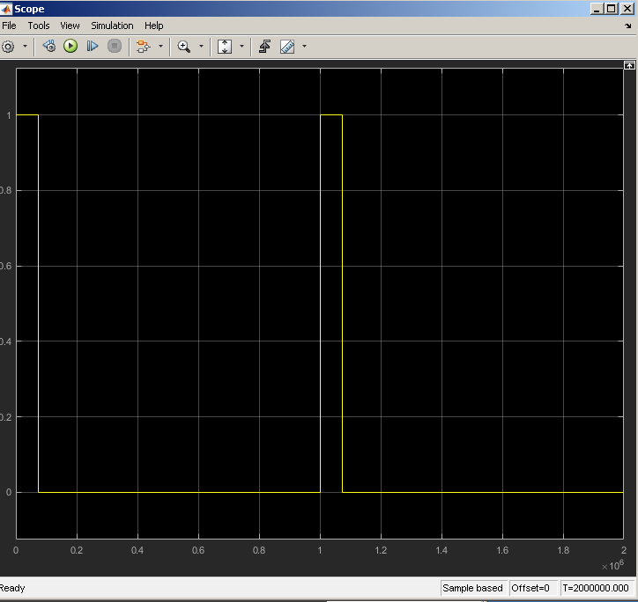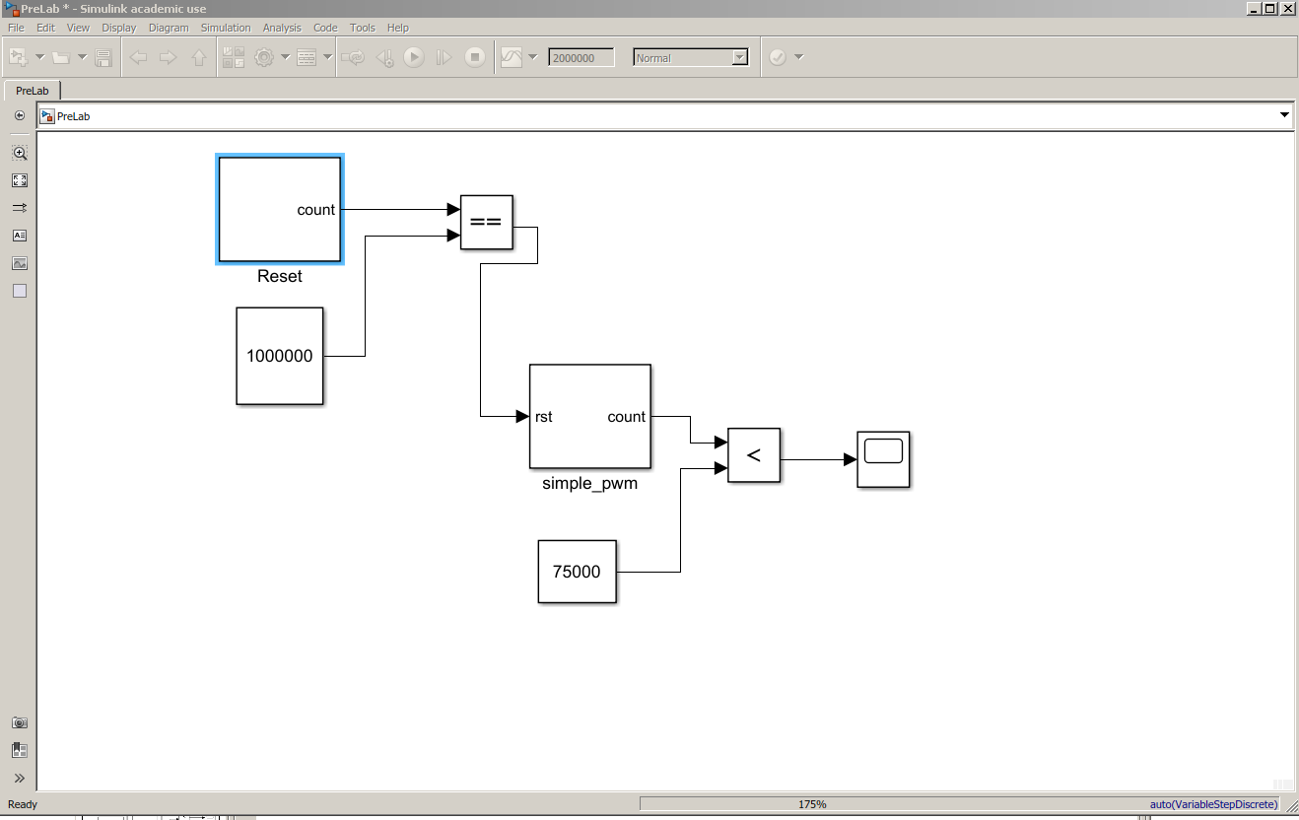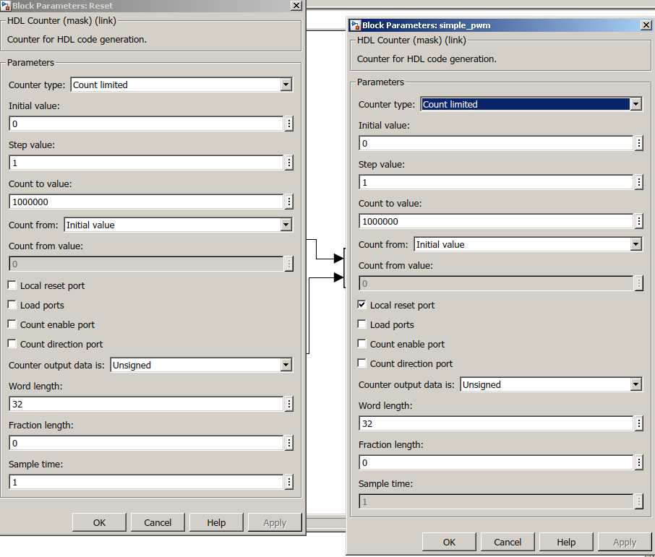

**Pre9.2**

a) 1000000 count value / 20 ms = x count value / 0.6 ms

30000 count value (minValue)

b) 1000000 count value / 20 ms = x count value / 1.5 ms

75000 count value (midValue)

c) 1000000 count value / 20 ms = x count value / 2.4 ms

120000 count value (maxValue)