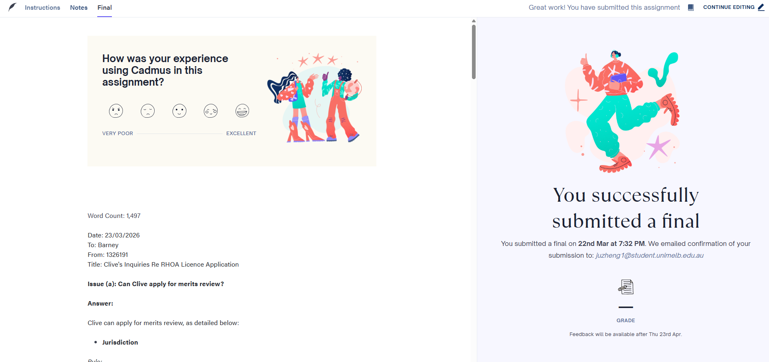

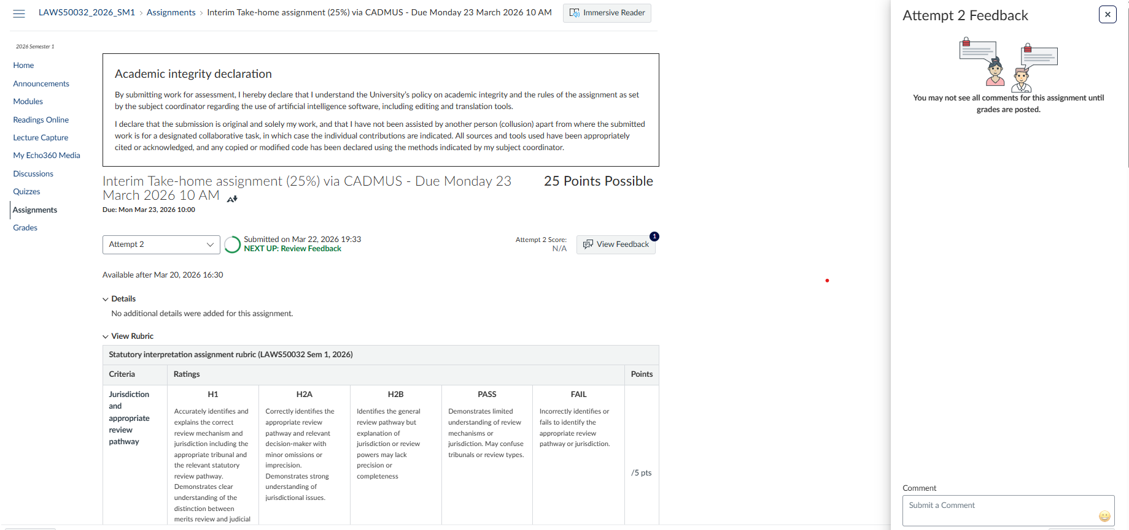

Word Count: 1,497
Date: 23/03/2026
To: Barney
From: 1326191
Title: Clive's Inquiries Re RHOA Licence Application

Issue (a): Can Clive apply for merits review?

Answer:

Clive can apply for merits review, as detailed below:

Jurisdiction

Rule:
Victorian Civil and Administrative Tribunal Act 1998 (Vic) ('VCAT Act') s42(1) holds that VCAT has review jurisdiction where an enabling Act expressly confers it, and the relevant enabling Act is the RHOA.
RHOA s42(1) provides the statutory basis for review when a person’s application for a licence is refused.
RHOA s42(3)(a) also provides that an application must be lodged within 28 days after the decision. The time limit set under RHOA s42(3)(a) is reinforced by VCAT Act s48, which governs when the review jurisdiction is invoked.
Application:
VCAT has review jurisdiction for Clive’s case. Under RHOA s3, licence means a licence to operate a rooming house. Clive received the outcome on 21 February 2026 for his application of licence to operate a rooming house and the advice date for this memo is 23 February 2026. Therefore he also meets the temporal requirement.

Standing

Rule:
Clive would need to have standing to bring the application.
VCAT Act s48(a) allows a person to bring an application to VCAT if the person is entitled to do so by an enabling enactment.
Standing is governed by RHOA s42(1), providing specifically that “A person whose application for a licence or for renewal of a licence is refused may apply to VCAT…”
Application:
Clive has his licence application refused. Accordingly, Clive satisfies the standing requirement in RHOA s42(1).
Furthermore, the RHOA ss 9–11 set out other requirements, including age and formality. On the facts, Clive appears to satisfy these threshold criteria.
Conclusion
Clive may bring the merits review application to VCAT provided he complies with the 28-day time limit in RHOA s42(3)(a). In the event when Clive does not meet this temporal requirement, he can still consider requesting VCAT to extend a time limit fixed by RHOA s42(3)(a), in pursuant to VCAT Act s 126(1).

Issue (b) What are Clive’s prospects of success?

Answer:

Clive’s prospects of success are high for the following reasons:

Nature and function

Merits review is carried out by tribunals within the executive branch, not involving judicial power. In Victoria, VCAT performs this function.
When VCAT conducts a merits review, it “stands in the shoes” of the original decision-maker and determines the “correct or preferable decision” on the material before it. This approach is also codified in VCAT Act s 51(1)(a). High Court also held in Frugtniet and Shi that VCAT should base its decision on the best and most current evidence available.

Power and Function

In conducting the merits review, VCAT exercises the powers and functions conferred by both VCAT Act and RHOA. These powers determine the scope of VCAT’s authority and the nature of the decision it must make. VCAT remakes the decision afresh, applying the same statutory criteria that bind the Authority. Therefore, VCAT must apply RHOA s16 directly when determining whether a licence should be granted.
Rule:
RHOA s16(1)(a) mandates that if the Authority is satisfied that the applicant is a fit and proper person, the authority must grant a licence. RHOA s16(2) also mandates that (a) “the Authority must refuse to grant a licence if the Authority is satisfied that the applicant is not a fit and proper person” or (c) “any information required under section 14 has not been provided within the time specified by the Authority”. RHOA s16(2)(c) does not operate here as Clive is still within the period to provide information. So the only question here is around fit and proper person.
Relevantly, RHOA s3 defines that fit and proper person means that “none of the relevant persons meets any of the licence disqualification criteria”. RHOA s3 further holds that relevant person means that natural person.
Application:
VCAT needs to engage in statutory construction on the criteria set out in RHOA s17. It requires VCAT to determine the meaning of the statute by taking text, context and purpose approach.
VCAT must adopt the interpretation that best achieves the purpose of the statute, consistent with purposive interpretation mandated in Interpretation of Legislation Act 1984 (Vic) s35(a). Decision-makers may consult extrinsic materials.
VCAT also needs to apply the same statutory criteria that bind the authority. This is upheld in Frugtniet in which Keifel CJ, Keane and Nettle JJ stated that “AAT is not at large. It is subject to the same general constraints as the original decision-maker...”
Therefore, what VCAT needs to determine here is whether Clive is a fit and proper person. This needs to be reviewed against licence disqualification criteria, defined under RHOA s17, relevantly, the following (s17(1)(a), s17(1)(b) and s17(1)(f)(viii)):

s17(1)(a) within the preceding 10 years, a relevant person has been convicted or found guilty of an offence involving … drug cultivation … that was punishable by a term of imprisonment of 3 months or more…

The facts are not clear with regards to drug cultivation. The key is to understand if there is any conviction that was punishable by a term of imprisonment of 3 months or more. Barney’s notes state that “he has never been convicted or found guilty of an offence against any section of any of the laws listed in the request for information”. Therefore, it is unlikely that Clive fell into this category for his hydroponic tomatoes episode.

The counter argument is that given Clive’s credibility of his statement (especially on that he wanted to do rooming house service to help the vulnerable and on the other hand, he planned to use his tactics to collect debt which is likely to be illegal - see my analysis under S17(f)(viii) below, further enquiry should be made on relevant conviction in the past 10 years that might impact Clive’s chance for his application.

The better view is that further enquiry is required. For the rest of the assignment, I will assume that Clive has not been convicted under legislations relevant under RHOA s17(1)(a).

s17(1)(b) a relevant person is an insolvent under administration

This section is stated in a present tense (i.e. is) which suggests that it is the person’s current status that matters. Barney’s notes indicated that Clive was “an insolvent…All clear now.”. As Clive is no longer an insolvent now, this is unlikely to be an issue for Clive.

The counter argument is that this clause should be construed widely to include historical insolvency. This is because the purpose of RHOA s1(a)(ii) is to “reduce exploitative and undesirable practices”. Any person who has been insolvent tends to have bad judgement, thus more likely to engage in exploitative and undesirable conduct.

The better view is that this is unlikely to be an issue for Clive as the text of the statute is clear and insolvency is normally considered a financial failing, not a moral failing.

s17(1)(f)(viii) within the preceding 5 years, a relevant person has been convicted or found guilty of an offence against section 45 of the Australian Consumer Law and Fair Trading Act 2012;

Clive is a debt collector and his employees ‘park a car outside their home with its hazard lights on and a big sign saying “debt collection in process’. this action is highly likely to be prohibited under s45(2)(e) and (f) of the Australian Consumer Law and Fair Trading Act 2012 (Vic) because this action (car with hazard light on and having a big sign saying debt collection in progress) intimidates the debtor by creating public pressure and exposes the debtor to ridicule by signalling to neighbours that they are in debt. Even though Clive did not do it himself, under common law principles, Clive might be held liable through vicarious liability for his employee's prohibited conduct. Under equitable principles, Clive may also be liable if he authorised, encouraged, knowingly permitted, or failed to prevent the conduct.

The counter argument is that Clive has not been found convicted or found guilty of an offence under this. Clive is not personally involved in this type of prohibited activities. So this should not be taken into consideration as RHOA s17(1)(f)(viii) is clearly referring to Clive as a natural person.

The better view is that because of no facts showing Clive’s past conviction relevant under s17(1)(f)(viii) and VCAT needing to make decision based on statutory requirements, Clive should be fine under this requirement.

Conclusion:
VCAT Act s 51(2) sets out the orders VCAT may make on review, including affirming, varying and setting aside the decision aside the decision. RHOA s4(a) and s16(1) further define the substantive powers and functions that the original decision-maker has to determine (i.e. grant or refuse) applications for licences.
Therefore, these broad remedial powers allow VCAT to fully reconsider the merits of licence application and, if appropriate, substitute with its own decision granting the licence.
Based on the analysis above, VCAT is highly likely to find Clive a fit and proper person for RHOA purposes.
Therefore, VCAT is highly likely to grant Clive the licence.
Frugtniet v Australian Securities and Investments Commission [2019] HCA 16, [51] (Bell, Gageler, Gordon and Edelman JJ).
Drake v Minister for Immigration and Ethnic Affairs (No 1) (1979) 46 FLR 409, 419 (Bowen CJ and Deane J).
Frugtniet v Australian Securities and Investments Commission [2019] HCA 16, [14] (Fiefel CJ, Keane and Nettle JJ).
Shi v Migration Agents Registration Authority (2008) 248 ALR 390; [2008] HCA 31, [41] (Kirby J), [143] (Kiefel J).
Frugtniet v Australian Securities and Investments Commission [2019] HCA 16, [14] (Fiefel CJ, Keane and Nettle JJ).

Footnotes
Close
Footnote 1
Frugtniet v Australian Securities and Investments Commission [2019] HCA 16, [51] (Bell, Gageler, Gordon and Edelman JJ).
Footnote 2
Drake v Minister for Immigration and Ethnic Affairs (No 1) (1979) 46 FLR 409, 419 (Bowen CJ and Deane J).
Footnote 3
Frugtniet v Australian Securities and Investments Commission [2019] HCA 16, [14] (Fiefel CJ, Keane and Nettle JJ).
Footnote 4
Shi v Migration Agents Registration Authority (2008) 248 ALR 390; [2008] HCA 31, [41] (Kirby J), [143] (Kiefel J).
Footnote 5
Frugtniet v Australian Securities and Investments Commission [2019] HCA 16, [14] (Fiefel CJ, Keane and Nettle JJ).

