KIDSMART AI TRAINING PROGRAM

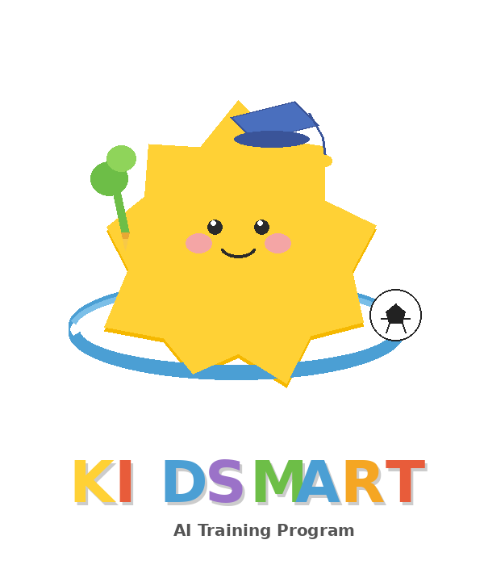
AI FUTURES
TRAINING PROGRAM
A 2-Week Intensive for Young Innovators (Age 12)
⭐ STUDENT TEXTBOOK ⭐
Weeks 1–2 | 10 Days | 2.5 Hours Per Day

🎯 10 Core Days | 🛠 Hands-On Projects | 🤖 Real AI Tools

Programme Overview
The AI Futures Training Program is a 10-day intensive designed to give 12-year-olds the core knowledge, practical skills, and ethical frameworks they need to thrive in a world shaped by artificial intelligence.
This is not a course about learning to code (though we do build things). It is not a course about ChatGPT hacks. It is a course about thinking — about understanding AI at a level deep enough that you can evaluate it critically, use it creatively, and shape it responsibly.

Program Structure
Week | Focus
Week 1: Understand | Days 1–5. Core knowledge: what AI is, how it learns, how to direct it, how it perceives the world, and where it fails. Heavy on concepts, experiments, and critical thinking.
Week 2: Create | Days 6–10. Applied learning: AI as a creative partner, design thinking with AI, and a 3-day build sprint culminating in Demo Day — a live showcase for parents and guests.

What Students Will Walk Away With
- A clear, accurate mental model of what AI is and how it works
- Practical prompt engineering skills they can use immediately
- A completed AI project they designed and built themselves
- A personal ethical framework for evaluating AI systems
- The vocabulary to participate in AI conversations at school, home, and eventually work
- A "Letter to Future Self" — a personal commitment to their AI learning journey

How to Use This Book

For Students
This is your textbook and your journal. Bring it to every session.
Read the "Key Concepts" sections at your own pace — they are written for you, not for a university lecture.
Complete every reflection exercise. The thinking you do in your journal is more valuable than any activity.
There are no wrong answers in discussions. The point is to develop your thinking, not to arrive at a correct position.
Your project is your own. The AI is a collaborator, not the creator. What you decide, what you judge, what you value — that is yours.

COURSE MIND MAP
A visual overview of the complete 2-week KidSmart AI Training Program
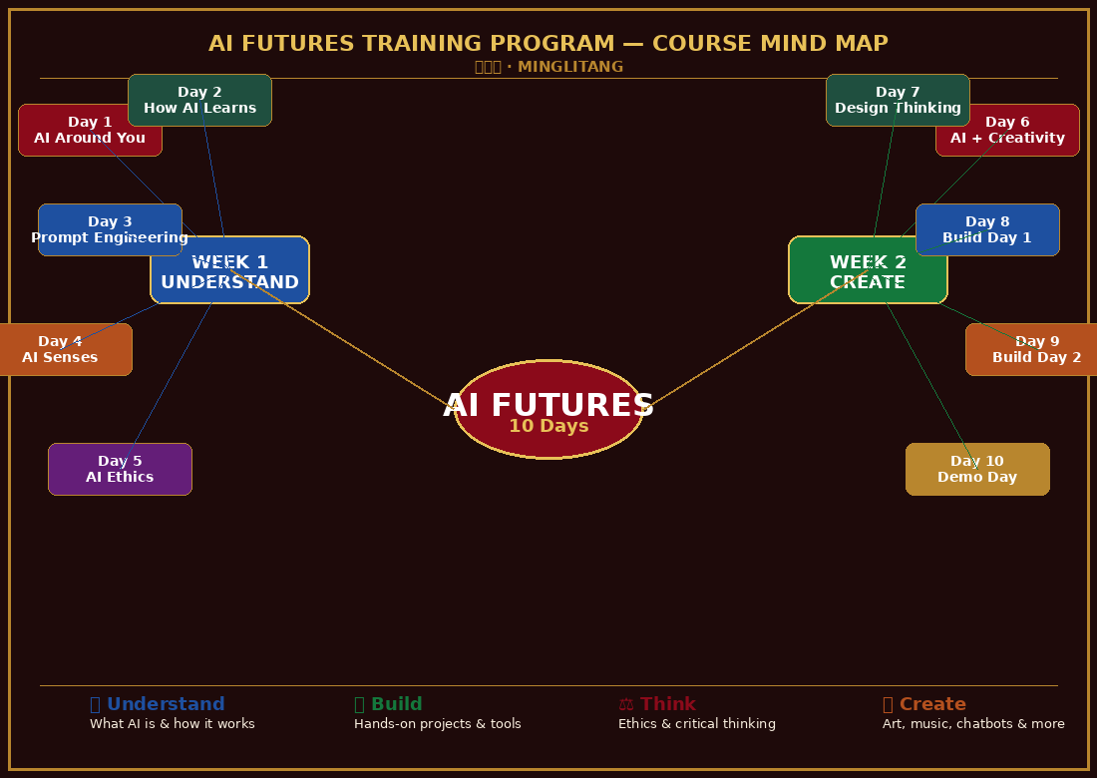
Figure 0.1 — KidSmart AI Training: Complete Course Mind Map
🔍 UNDERSTAND | 🛠 BUILD | ⚖ THINK | 🚀 CREATE

Your AI Toolkit
Before the program begins, every student and facilitator should be familiar with the tools we use throughout the two weeks. This chapter covers each tool: what it is, how to access it, and exactly how we use it in the program.
None of these tools require advanced technical skills. All are free (or have generous free tiers). Set up your accounts before Day 1 using the checklist at the end of this chapter.

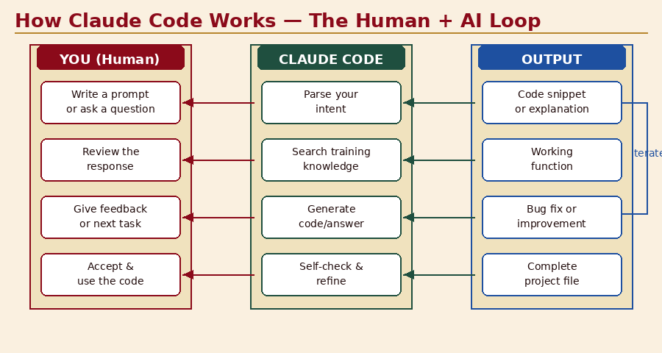
Figure T.1 — The Human + AI Collaboration Loop
Figure T.1 — The Human + AI Collaboration Loop

Tool 1 — Claude (Anthropic)
What It Is
Claude is an AI assistant made by Anthropic. It understands and generates human language — you talk to it in plain English (or Chinese), and it responds intelligently. Claude powers this very training program.
- Access: claude.ai (web browser, no install needed)
- Free tier: Available — suitable for all program activities
- Used in: Days 3, 6, 7, 8, 9 (prompt engineering, creative work, project building)

How to Use Claude in This Program
- Go to claude.ai and create a free account using your email
- Start a new conversation. Type your message in the input box at the bottom.
- Press Enter or click the send button. Claude will respond immediately.
- You can continue the conversation — Claude remembers what was said earlier in the same chat.
- To start fresh (e.g. for a new activity), click "New Conversation" in the sidebar.

💡 Best Practices for Students
- Always start with context: tell Claude who you are and what you're working on
- Be specific: vague questions get vague answers
- Iterate: if the first response isn't right, ask Claude to refine it
- Verify: never accept factual claims without checking from another source
- Copy useful responses into your own document — Claude conversations are temporary

Tool 2 — Claude Code
What It Is
Claude Code is Anthropic's AI coding assistant. Unlike the web chat, Claude Code works alongside your code editor — it can read your files, write code, fix bugs, and explain concepts in the context of your actual project.
- Access: Via terminal (claude command) or VS Code extension
- Free tier: Available with Anthropic account
- Used in: Days 8, 9 (project build days — optional for advanced students)

Getting Started with Claude Code

📝 What Claude Code Can Do For Your Project
- Write new code from a plain-English description: "Write a JavaScript function that takes a list of numbers and returns the average"
- Explain code you don't understand: "Explain what this function does, line by line"
- Find and fix bugs: "This code should sort alphabetically but it's not working. What's wrong?"
- Suggest improvements: "How could I make this more efficient?"
- Generate HTML/CSS layouts: "Create a simple webpage with a title, an image, and two buttons"
- Help with your Teachable Machine export code (Track B)

⚠️ Important: Claude Code is a Collaborator, Not a Shortcut
The goal is NOT to have Claude Code write your entire project. The goal is to use it as a skilled collaborator — you make the creative and design decisions, Claude Code helps you implement them.
Always read and understand any code Claude Code produces before using it. If you don't understand it, ask Claude Code to explain it. Understanding > speed.

Tool 3 — GitHub Copilot & Codex
What It Is
GitHub Copilot is an AI pair programmer trained on billions of lines of public code from GitHub. It suggests code completions as you type — like autocomplete but for entire functions and files.
- Access: github.com/features/copilot — FREE for students via GitHub Education
- Requires: GitHub account (free) + VS Code
- Used in: Optional extension for Days 8–9 build projects

Claude Code | GitHub Copilot
Claude Code | GitHub Copilot
Conversational — you explain what you want in plain English | Inline suggestions — completes code as you type
Good for planning, explaining, and iterating on ideas | Good for speeding up code writing when you know what you want
Understands your full project context when given files | Understands the current file + nearby code
Ideal for beginners learning to code | Better once you already understand coding basics
Free at claude.ai | Free via GitHub Student Developer Pack

Getting GitHub Copilot Free as a Student
- Create a free GitHub account at github.com
- Apply for the GitHub Student Developer Pack at education.github.com/pack
- Verify with your school email or student ID — approval usually takes 1–3 days
- Once approved, install the GitHub Copilot extension in VS Code
- Sign in with your GitHub account — Copilot activates automatically

Tool 4 — Google Teachable Machine
What It Is
Teachable Machine lets you train real AI models directly in your browser using your webcam — no code, no install. It is the primary hands-on AI tool for Days 2 and 8–9.
- Access: teachablemachine.withgoogle.com
- Free: Yes, completely free, no account required
- Used in: Day 2 (core activity), Days 8–9 (Track B project)

Three Types of Teachable Machine Models
Type | What It Does
Image Model | Train AI to recognise objects, gestures, or expressions from your webcam. Used in Day 2 and the Track B project.
Audio Model | Train AI to recognise sounds or spoken words from your microphone. Great for creative projects.
Pose Model | Train AI to recognise body poses and positions using your webcam. Fun for physical games and sports analysis.

Tool 5 — Adobe Firefly
What It Is
Adobe Firefly is an AI image generator that creates images from text descriptions. Unlike some generators, it is trained only on licensed and public-domain content — making it safer for educational and commercial use.
- Access: firefly.adobe.com (free tier, no age restriction)
- Free: Yes — 25 generative credits per month on free tier, replenishes monthly
- Used in: Day 4 (Spot the AI activity), Day 6 (AI creativity workshop)

How to Use Adobe Firefly
- Go to firefly.adobe.com
- Click "Generate Image" — you can use it without signing in for basic use
- Type a detailed description of the image you want (the more specific, the better)
- Select a style, aspect ratio, and content type (photo, graphic, art, etc.)
- Click Generate — 4 options appear. Click any to explore further.
- To refine: click an image → use the editing tools on the right panel

Tool 6 — Suno AI (Music Generation)
What It Is
Suno generates complete songs — vocals, instruments, melody — from a text description. You describe the song you want (genre, mood, theme, style) and Suno creates it in about 30 seconds.
- Access: suno.com (free tier)
- Free: 50 song credits per day on free tier — more than enough for all activities
- Used in: Day 6 (AI creativity workshop)

Tool 7 — Scratch + ML4Kids
What It Is
Scratch is the world's most popular visual programming platform for beginners. ML4Kids extends it with machine learning capabilities — train a model on Teachable Machine, then use it inside a Scratch project.
- Scratch: scratch.mit.edu (free, no age restriction)
- ML4Kids: machinelearningforkids.co.uk (free)
- Used in: Optional advanced activity — combine AI + creative coding

Tool 8 — Quick, Draw! (Google)
What It Is
Quick, Draw! is a game where you draw objects and a neural network guesses what you're drawing in real time. It is a fun, intuitive demonstration of computer vision and how AI learns from crowd-sourced data.
- Access: quickdraw.withgoogle.com (free, no account needed)
- Used in: Day 4 (computer vision activity)

Pre-Program Setup Checklist
✅ Complete Before Day 1 of the Program
Required (all students):
- Create a free Anthropic account at claude.ai and send one test message
- Visit teachablemachine.withgoogle.com and click through the interface
- Visit firefly.adobe.com and generate one test image
- Visit quickdraw.withgoogle.com and play one round
Optional (for Days 8–9 build projects):
- Download VS Code from code.visualstudio.com
- Create a free GitHub account at github.com
- Apply for GitHub Student Developer Pack at education.github.com/pack
- Create a free Suno account at suno.com
Check your device:
- Does your laptop/tablet have a working webcam? (Required for Teachable Machine)
- Is your browser up to date? (Chrome or Edge recommended for best compatibility)
- Do you have reliable internet? (All tools are web-based)

Tool | How to Access
Claude.ai | claude.ai — AI assistant for prompts, research, creative writing
Teachable Machine | teachablemachine.withgoogle.com — train your own image/sound AI
Adobe Firefly | firefly.adobe.com — AI image generation
Suno AI | suno.com — AI music generation
Quick, Draw! | quickdraw.withgoogle.com — computer vision demo
Scratch | scratch.mit.edu — visual programming + AI
GitHub (optional) | github.com — code storage + Copilot access
VS Code (optional) | code.visualstudio.com — code editor for build projects

DAY 1
AI Is Already Around You
Demystifying the most talked-about technology of our time

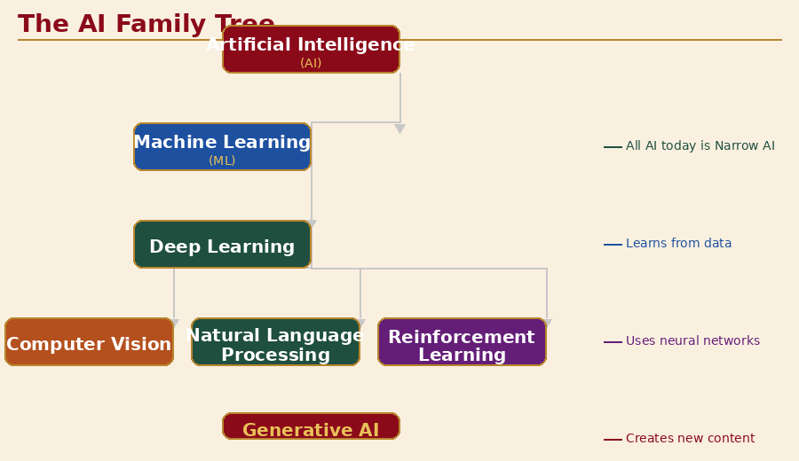
Figure 1.1 — The AI Family Tree: from AI to Generative AI

Overview
Before we learn to build with Artificial Intelligence, we need to understand what it actually is — not the sci-fi robot version, but the real thing that is already shaping everything from what videos appear on your screen to how your phone unlocks with your face.
Today we pull back the curtain. By the end of this session, you will be able to confidently explain what AI is, where it already appears in your daily life, and what makes it different from regular computer programs.

🎯 Learning Objectives — Day 1
- Define Artificial Intelligence in plain language
- Distinguish between AI, Machine Learning, and Deep Learning
- Identify at least 10 examples of AI in everyday life
- Understand the difference between Narrow AI and General AI
- Bust common myths about what AI can and cannot do

Key Concepts

1. What Is Artificial Intelligence?
Artificial Intelligence (AI) is the field of computer science that creates systems capable of performing tasks that normally require human intelligence — things like recognising images, understanding language, making decisions, and solving problems.
A simple way to think about it: a regular computer program does exactly what you tell it, step by step, every time. An AI system learns from examples and figures out its own rules.
Regular Program vs AI
Regular Computer Program | AI System
You write every rule | It learns rules from data
Rigid — breaks if input changes | Flexible — adapts to new inputs
Example: calculator | Example: voice assistant
Follows instructions | Recognises patterns

2. The AI Family Tree
AI is a broad term. Here are the key levels within it:
- Artificial Intelligence (AI): The big umbrella — any machine that mimics human thinking
- Machine Learning (ML): A type of AI where the system learns from data without being explicitly programmed for each task
- Deep Learning: A powerful type of ML that uses networks inspired by the human brain (called neural networks) — this is what powers image recognition and ChatGPT
- Generative AI: AI that can create new content — text, images, music, code — based on what it has learned

3. Narrow AI vs. General AI
This is one of the most important distinctions to understand:
Narrow AI | General AI
Narrow AI (what exists today) | General AI (science fiction, not real yet)
Excellent at ONE specific task | Can do any intellectual task a human can
Cannot transfer skills between tasks | Would learn, reason, and adapt like a person
Examples: Siri, Netflix recommendations, spam filters | Examples: HAL 9000, Terminator (movies only!)
Safe, controllable, widely deployed | Does not exist yet — still research only

4. How Does AI Actually Learn?
The most common type of AI today learns through a process called Supervised Learning:
- You give the AI thousands of examples with correct answers (e.g., 50,000 photos labelled "cat" or "not cat")
- The AI finds patterns in those examples
- It builds a mathematical model of those patterns
- When it sees a new photo, it uses that model to guess: cat or not cat?
- Over time, with more data and corrections, it gets better and better
Think of it like studying for an exam: the more practice questions you do, the better you get. AI does the same thing — but it can do millions of practice questions in seconds.

💡 Key Insight for Students
- AI is not magic. It is maths + data + computing power.
- Every AI system was built by humans and reflects human choices about what data to use.
- AI is a tool — like a hammer or a calculator. What matters is how you use it.

Recommended Videos
Watch these before or during the session for maximum impact:
▶ How Does AI Actually Work? (TED-Ed, 5 min) — https://www.youtube.com/watch?v=aircAruvnKk
Brilliant animated explainer of neural networks — perfect for beginners. Watch together as a class.
▶ AI, Machine Learning, Deep Learning (Google, 3 min) — https://www.youtube.com/watch?v=l3Ly51bqFIA
Clear visual breakdown of the AI family tree. Pause and discuss after each section.
▶ Your AI-Powered Day (MIT Technology Review) — https://youtu.be/HMQkV5cTuoY
Short documentary showing all the AI embedded in a typical day. Great for the "Map Your AI Day" activity.

Activity 1 — Map Your AI Day

📝 Student Worksheet — My AI Day
Instructions: Fill in the table below. For each moment in your day, think about whether AI might be involved.
- Wake up → Alarm app, smart home device? AI involved?
- Morning → Face unlock on phone? Autocorrect when texting? AI involved?
- Breakfast → Recipe app? Smart fridge? AI involved?
- Getting around → Google Maps traffic? Ride-share app? AI involved?
- Entertainment → YouTube recommendations? Spotify? Netflix? AI involved?
- Social media → TikTok For You Page? Instagram filters? AI involved?
- School/study → Spell check? Grammarly? Khan Academy? AI involved?
- Shopping → Product recommendations? Chatbot support? AI involved?
Reflection: Which AI surprised you the most? Which AI do you use most often without thinking about it?

Activity 2 — AI Myth Busters

MYTH 1: "AI is conscious and has feelings."
✅ BUSTED — FALSE
AI systems process information mathematically. They do not experience emotions, consciousness, or awareness. When ChatGPT says "I feel excited about this," it is generating text that sounds human — not actually feeling anything. This is called the Chinese Room problem (a famous thought experiment by philosopher John Searle).

MYTH 2: "AI knows everything."
✅ BUSTED — FALSE
AI only knows what it was trained on. If the training data stops at a certain date, the AI knows nothing after that. It can also be completely wrong (this is called a "hallucination") — it can confidently state false facts. Always verify AI answers from trusted sources.

MYTH 3: "AI will take all human jobs."
⚠️ PARTIALLY TRUE — IT'S COMPLICATED
AI will automate some tasks (repetitive, rule-based ones), but it also creates new jobs. The key insight: AI cannot replace human creativity, emotional intelligence, ethical judgment, or physical dexterity in complex situations. The future belongs to people who know how to work with AI — which is exactly what this course teaches you.

MYTH 4: "AI is always smarter than humans."
✅ BUSTED — FALSE
AI is superhuman at narrow tasks with clear patterns (chess, protein folding, image recognition). It fails badly at common sense reasoning, novel situations it hasn't seen before, and anything requiring genuine understanding. A 5-year-old can understand "the cup is on the table and the table is in the kitchen, so the cup is in the kitchen" — most AI still struggles with this kind of reasoning.

MYTH 5: "AI makes unbiased decisions."
✅ BUSTED — FALSE
AI learns from human-generated data, which contains human biases. Amazon's hiring AI was found to discriminate against women. Facial recognition AI is less accurate on dark-skinned faces. AI inherits our biases and can even amplify them. This is why human oversight is always essential.

Student Reflection — Day 1
📓 Write Your Answers in Your Reflection Journal
- Before today, what did you think AI was? How has your understanding changed?
- Name three AI systems you use every week. What data do you think each one was trained on?
- Which myth surprised you the most? Why?
- If you could create an AI to solve one problem in your life, what would it do?
- Complete this sentence: "AI is powerful because ______, but it has limits because ______."

📚 Key Vocabulary — Day 1
- Artificial Intelligence (AI): Computer systems that perform tasks requiring human-like intelligence
- Machine Learning (ML): AI that learns patterns from data rather than following hand-coded rules
- Deep Learning: ML using layered neural networks, excels at images and language
- Neural Network: A computing system inspired by the human brain's structure
- Training Data: The examples an AI learns from
- Narrow AI: AI that excels at one specific task
- Hallucination: When AI confidently states something incorrect
- Bias: Unfair patterns in AI behaviour caused by skewed training data

DAY 2
How AI Learns
Training data, patterns, and your first machine learning experiment

Overview
Yesterday we discovered that AI is already everywhere. Today we go inside the machine. We will explore how AI actually learns — through data, patterns, and repetition — and then you will train your very own AI model using Google's Teachable Machine. No coding required.
By the end of today, you will understand the full loop of machine learning: collect data → train the model → test it → improve it. This loop is the foundation of almost every AI system on the planet.

🎯 Learning Objectives — Day 2
- Explain the machine learning training loop in plain language
- Understand what training data, features, labels, and models are
- Experience the "sorting exercise" to feel what training data means
- Train a real image classifier using Google Teachable Machine
- Test the model's accuracy and understand why it makes mistakes

Key Concepts

1. The Machine Learning Training Loop
Every machine learning system follows the same basic cycle. Understanding this loop unlocks your ability to think about any AI system:
- Collect Data: Gather thousands (or millions) of examples
- Label the Data: Tell the AI what each example is (e.g., "cat" or "dog")
- Train the Model: The AI finds mathematical patterns that link examples to labels
- Evaluate: Test the model on new examples it has never seen
- Improve: Add more data, fix mistakes, retrain — repeat until good enough
- Deploy: Release the model to be used in the real world

2. What Is a Feature?
A feature is any measurable characteristic the AI uses to make decisions. For example, when recognising a cat:
- Pointy ears → a feature
- Fur pattern → a feature
- Eye shape → a feature
- Body size → a feature
The AI doesn't know these are "cat features" until it sees thousands of labelled cat photos and learns which combinations reliably predict "cat."

3. Types of Machine Learning
Type | How It Works
Supervised Learning | You provide labelled examples. Most common type. Used for: image recognition, spam filters, voice assistants.
Unsupervised Learning | No labels — AI finds patterns on its own. Used for: customer grouping, anomaly detection.
Reinforcement Learning | AI learns by trial and error, rewarded for good actions. Used for: games, robotics, self-driving cars.
Transfer Learning | Take a pre-trained model and fine-tune it for a new task. Powers most modern AI apps — much faster than training from scratch.

4. Overfitting and Underfitting — Why AI Fails
Two of the most common problems in machine learning:
Problem | Explanation
Overfitting | The AI memorises the training examples too perfectly, and fails on any new data. Like a student who memorises textbook answers but can't answer a slightly different question on the exam.
Underfitting | The AI hasn't learned enough. It performs badly even on training data. Like a student who barely studied and gets everything wrong.

💡 The Golden Rule of ML
Good AI generalises. It learns patterns that work on new, unseen data — not just data it has memorised. This is why testing on separate "held-out" data is critical before deploying any AI system.

Recommended Videos
▶ How Machines Learn (CGP Grey, 10 min) — https://www.youtube.com/watch?v=R9OHn5ZF4Uo
Superb visual explainer of the full ML training process. Watch this before Activity 1.
▶ A Beginner's Guide to Machine Learning (Google, 8 min) — https://www.youtube.com/watch?v=nKW8Ndu7Mjw
Google engineers explain ML with real examples. Excellent follow-up.
▶ Teachable Machine Demo (Google, 3 min) — https://www.youtube.com/watch?v=T2qQGqZxkD0
Official demo video — show this immediately before Activity 2 so students know what to expect.

Activity 1 — The Human Sorting Game

🎮 Debrief Questions for the Class
- What features did you use to tell cats from dogs? What made it hard?
- If someone gave you 10,000 of these cards to sort by yourself, would you use the same method? What would you change?
- What if some of the labels on the cards were wrong? How would that affect your learning?
- Imagine the AI only saw white cats and orange cats. What would happen when it met a black cat for the first time?

Activity 2 — Teachable Machine: Train Your First AI

📝 Step-by-Step Student Guide
Getting Started
- Open teachablemachine.withgoogle.com in your browser
- Click "Get Started" → "Image Project" → "Standard Image Model"
Step 1: Collect Your Data (Classes)
- Rename "Class 1" to "Thumbs Up"
- Click "Webcam" and hold your thumb up — record at least 100 images
- Rename "Class 2" to "Peace Sign" — record another 100 images
- Click "Add a class" → rename to "Fist" — record another 100 images
Step 2: Train
- Click the big "Train Model" button — watch it learn!
- After training, the "Preview" panel activates automatically
Step 3: Test and Experiment
- Try each gesture in front of the webcam — does it get them right?
- Move your hand to a different position, change the lighting, use your other hand — does it still work?
- Try tricking it — show a gesture that is halfway between two classes. What does it predict?
Challenge: Improve Your Model
- If your model is making mistakes, add more training images from different angles and lighting conditions, then retrain.
- Did adding more data improve accuracy? Record your findings.

📊 Student Data Collection Table
Record your results here:
- Number of images per class (first attempt): ___
- Accuracy on "thumbs up": ___% | "Peace sign": ___% | "Fist": ___%
- Where did your model fail? (describe the situation): ___
- What did you change to improve it?: ___
- Accuracy after improvement: ___% (average across classes)
- What do you think would happen if you added a 4th class? Try it!

Student Reflection — Day 2
📓 Write Your Answers in Your Reflection Journal
- Describe the machine learning loop in your own words, as if explaining it to a 10-year-old.
- What did you discover when you tried to trick your Teachable Machine model? What does this tell you about AI?
- When your model made mistakes, what was usually the cause? Too little data? Bad angle? Wrong lighting?
- Think of a real-world AI system (e.g. Spotify recommendations, Google Photos face recognition). What training data do you think it was trained on?
- The AI you trained today only took a few minutes. Real AI systems can take weeks of training on thousands of computers. Why do you think that is?
📚 Key Vocabulary — Day 2
- Supervised Learning: Training with labelled examples
- Training Data: The examples used to teach an AI
- Label: The correct answer attached to a training example
- Feature: A measurable characteristic the AI uses to make decisions
- Model: The mathematical structure the AI builds from training data
- Overfitting: Memorising training data too closely, failing on new data
- Accuracy: Percentage of correct predictions on test data
- Neural Network: A layered mathematical structure loosely inspired by the brain
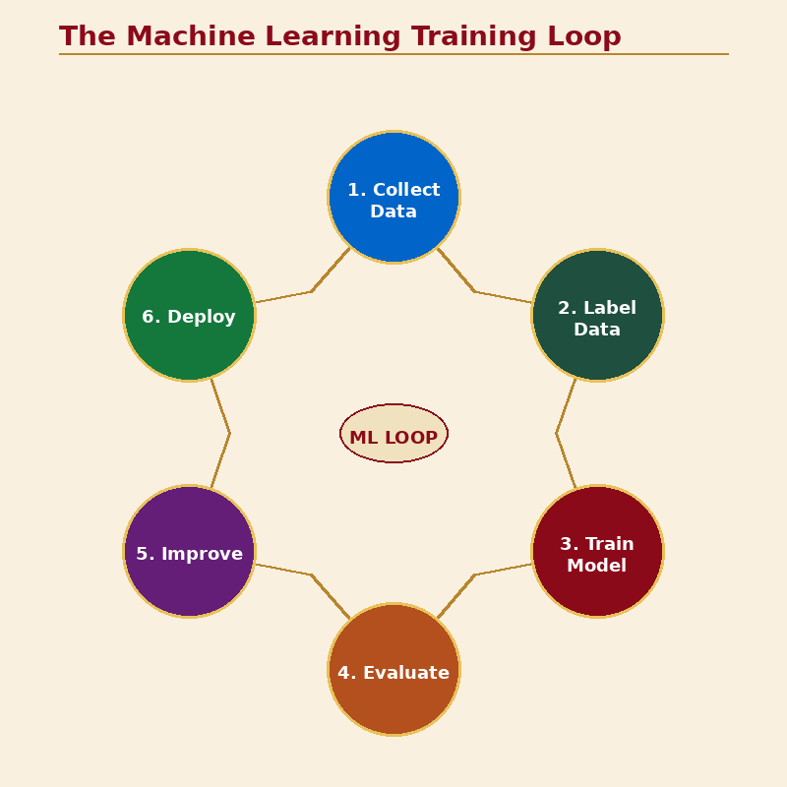
Figure 2.1 — The ML Training Loop: all 6 stages

DAY 3
The Art of Talking to AI
Prompt engineering — your most valuable skill in the AI age

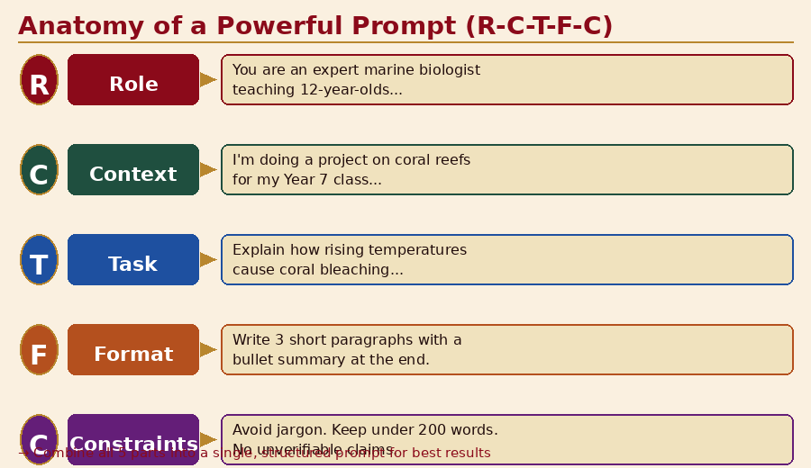
Figure 3.1 — Anatomy of a powerful prompt: R-C-T-F-C framework

Overview
You now understand what AI is and how it learns. But knowing about AI is not enough — you need to know how to use it effectively. Today we focus on the most important skill for working with modern AI: prompt engineering.
A prompt is the instruction you give to an AI. The same AI system can give you brilliant, useful answers or confusing, wrong answers — entirely depending on how you ask. This session teaches you to ask like a professional.

🎯 Learning Objectives — Day 3
- Understand what a prompt is and why it matters
- Apply the R-C-T-F-C framework for writing powerful prompts
- Transform weak prompts into strong prompts through iteration
- Compete in the Prompt Battle and discover the power of specificity
- Understand chain-of-thought prompting and zero/few-shot techniques

Key Concepts

1. Why Prompts Matter So Much
Think of an AI language model like a brilliant expert who knows about almost everything. But this expert is locked in a room and can only communicate through written notes. How you write your note determines everything about the quality of the response.
Research shows that rephrasing the same question can change AI output quality by 50–80%. Prompt engineering is not a trick — it is a core professional skill.

2. The R-C-T-F-C Prompt Framework
Use this five-part structure to build powerful prompts:
Element | What It Means
R — Role | Tell the AI who to be. "You are an expert marine biologist with 20 years of experience teaching teenagers..."
C — Context | Give background. "I am a 12-year-old in Australia doing a school project on coral reefs..."
T — Task | State exactly what you want. "Explain how rising ocean temperatures affect coral bleaching..."
F — Format | Specify the output structure. "...in 3 short paragraphs with a summary bullet list at the end."
C — Constraints | Add limits. "...Avoid scientific jargon. Do not include information I cannot verify online."

3. Prompt Levels — From Weak to Expert
Level 1 — Weak Prompt: "Tell me about space."
Result: A vague, generic response that could fill a textbook — completely unhelpful.

Level 2 — Better Prompt: "Explain black holes to a 12-year-old."
Result: More targeted, but still quite broad.

Level 3 — Expert Prompt: "You are a science teacher for Year 7 students in Australia. Explain what a black hole is using one everyday analogy, three key facts, and a 'mind-blowing' closing statement. Keep the total under 200 words."
Result: Precise, useful, perfectly formatted response.

4. Advanced Techniques
- Chain-of-Thought: Add "Think step by step" to get the AI to show its reasoning. Great for maths and logic problems.
- Few-Shot Prompting: Give examples of what you want before asking. "Here are two examples of good haiku: [example 1], [example 2]. Now write one about summer."
- Role Reversal: Ask the AI to ask YOU questions to clarify what it needs before answering.
- Negative Constraints: Tell the AI what NOT to do. "Do not use bullet points. Do not include dates."
- Iteration: Treat your first prompt as a draft. Read the response, then refine: "That's good but too long. Shorten it to 3 sentences and add one real-world example."

💡 The Professional Mindset
Expert AI users never accept the first response. They iterate. They refine. They experiment. Think of prompting like a conversation, not a single question. Each follow-up narrows the AI closer to exactly what you need.

Recommended Videos
▶ How to Use ChatGPT — Prompt Engineering Guide (Fireship, 8 min) — https://www.youtube.com/watch?v=sTeoEFzVNSc
Fast, practical intro to prompt engineering with real examples. Show after Key Concepts.
▶ ChatGPT Prompt Engineering for Developers (DeepLearning.ai) — https://www.deeplearning.ai/short-courses/chatgpt-prompt-engineering-for-developers/
Free short course — excellent for advanced students who want to go deeper after class.

Activity 1 — Prompt Makeover Workshop

📝 Prompt Makeover Worksheet
Instructions: Rewrite each weak prompt using the R-C-T-F-C framework. Then test both versions and compare the results.
- WEAK: "Write a poem." → YOUR EXPERT PROMPT: ___
- WEAK: "Help me with my homework." → YOUR EXPERT PROMPT: ___
- WEAK: "What is climate change?" → YOUR EXPERT PROMPT: ___
- WEAK: "Give me a recipe." → YOUR EXPERT PROMPT: ___
- WEAK: "Explain gravity." → YOUR EXPERT PROMPT: ___
Bonus Challenge: Write a prompt so specific that the AI produces an answer that surprises you with its quality.

Activity 2 — The Prompt Battle Championship

🏆 Prompt Battle Challenge Cards
Round 1 — EXPLAIN: "Get the AI to explain how the internet works to a 5-year-old, using only a pizza analogy."
Round 2 — CREATE: "Get the AI to write the most suspenseful opening paragraph for a novel — no more than 80 words."
Round 3 — SOLVE: "Get the AI to help you plan a birthday party for 15 people with a budget of $100 AUD."
Round 4 — PERSUADE: "Get the AI to write the most convincing argument for a 4-day school week."
Round 5 — IMAGINE: "Get the AI to describe what daily life will look like in Australia in 2050 — be specific and surprising."
Round 6 — DEBATE: "Get the AI to argue both sides of this question: Should AI be allowed to create art for sale?"

Student Reflection — Day 3
📓 Write Your Answers in Your Reflection Journal
- What was the biggest difference between your weak prompt and your expert prompt? What changed in the AI's response?
- Which Prompt Battle round did your team win (or do best in)? What made that prompt effective?
- Write a prompt you could use right now for something you actually need help with. Apply the R-C-T-F-C framework.
- What are the risks of relying on AI for answers without knowing how to evaluate them? How do good prompts help manage this risk?
- If prompt engineering is a skill, how do you get better at it? Make a plan for practicing this week.
📚 Key Vocabulary — Day 3
- Prompt: The instruction or question you give to an AI
- Prompt Engineering: The skill of crafting effective prompts to get high-quality AI outputs
- Context Window: The maximum amount of text an AI can "see" at once
- Chain-of-Thought: Prompting technique that asks AI to show its reasoning step by step
- Few-Shot Prompting: Providing examples in your prompt to guide the AI's response style
- Iteration: Refining a prompt based on the AI's response to get a better result
- Constraint: A rule you give the AI about what NOT to do or include
- Temperature: An AI setting that controls how creative/random vs predictable its outputs are

DAY 4
AI Eyes, Ears & More
Computer vision, speech AI, and the art of spotting what's real

Overview
Today we explore how AI perceives the world through cameras and microphones. Computer vision and speech recognition are two of the most widely deployed AI technologies on Earth — from the camera on your phone to Siri to medical imaging. We will also investigate one of the most important challenges of our time: telling AI-generated content from real content.

🎯 Learning Objectives — Day 4
- Understand how computer vision works (feature detection, CNNs)
- Understand how speech recognition converts audio to text
- Explore real-world applications: medical imaging, self-driving cars, translation
- Develop critical skills for detecting AI-generated images, text, and audio
- Discuss the ethical implications of deepfakes and synthetic media

Key Concepts

1. How Computer Vision Works
Computer vision teaches machines to "see" and interpret images and video. Here is the process:
- Input: An image enters the system as a grid of pixels — each pixel is just a number representing colour
- Convolution: Filters scan across the image looking for low-level features: edges, corners, curves, colours
- Pooling: The AI compresses information, keeping the most important features while reducing complexity
- Deep layers: Higher layers combine simple features into complex ones: edge + curve = eye, multiple eyes + nose = face
- Classification: The final layer outputs a prediction: "This is a cat with 94% confidence"
This architecture is called a Convolutional Neural Network (CNN). It is the backbone of nearly all modern image AI.

2. Computer Vision in the Real World
Application | How It Works
Medical Imaging | AI reads X-rays, MRI scans, and retinal images to detect cancer, diabetic blindness, and bone fractures — often matching or exceeding radiologist accuracy
Self-Driving Cars | Multiple cameras + radar detect roads, signs, pedestrians, and obstacles in real time at 30+ frames per second
Face Unlock | Your phone maps 30,000 infrared dots onto your face to create a mathematical model — impossible to fake with a photo
Instagram/Snapchat Filters | Real-time face landmark detection (68+ points) that tracks your face movement and applies effects precisely
Quality Control | Factories use AI cameras to detect defects in products at speeds impossible for human inspectors
Google Lens | Point your camera at text, objects, plants, or food and AI identifies them instantly

3. How Speech Recognition Works
When you speak to Siri or Google Assistant, here is what happens in milliseconds:
- Audio capture: Your voice is captured as a waveform — a series of numbers representing sound pressure over time
- Feature extraction: The AI analyses frequency patterns, called Mel-frequency cepstral coefficients (MFCCs) — essentially a mathematical fingerprint of each sound
- Phoneme recognition: The AI maps audio patterns to phonemes (the basic units of sound in language, e.g. "sh", "ee", "p")
- Language model: A language model converts phonemes into words, using context to choose between similar-sounding options ("bare" vs "bear")
- Intent recognition: A final layer understands what you actually want and triggers the correct action

4. Generative AI & Synthetic Media
The same techniques that help AI recognise faces can be reversed to generate new faces. This is done with Generative Adversarial Networks (GANs):
- Generator: Creates fake images, trying to fool the discriminator
- Discriminator: Tries to tell real from fake
- They compete against each other — as the discriminator gets better, the generator improves, until the fakes are indistinguishable from real.

💡 Why This Matters
Deepfake technology can now create realistic videos of real people saying things they never said. AI can clone a voice from 3 seconds of audio. AI can generate photorealistic images of people who do not exist. This makes media literacy — the ability to critically evaluate what you see and hear — one of the most important skills of your generation.

Recommended Videos
▶ How Computer Vision Works (3Blue1Brown, 19 min) — https://www.youtube.com/watch?v=aircAruvnKk
The definitive visual explanation of neural networks and image recognition. Worth every minute.
▶ Deepfakes Explained (Vox, 7 min) — https://www.youtube.com/watch?v=cQ54GDm1eL0
Accessible, age-appropriate explainer on synthetic video — excellent for the discussion section.
▶ This Person Does Not Exist (website demo) — https://thispersondoesnotexist.com
Every refresh shows a new photorealistic face — none of them are real. Show on projector for immediate impact.
▶ Google Quick, Draw! (interactive) — https://quickdraw.withgoogle.com
AI guesses your doodles in real time — playful demo of computer vision. Great for the activity section.

Activity 1 — Spot the AI

🔍 Student Detective Guide — How to Spot AI-Generated Images
Check These Areas First:
- HANDS: AI consistently struggles with fingers — look for extra fingers, merged fingers, or hands that look "melted"
- TEETH: AI-generated smiles often have too many teeth, oddly sized teeth, or teeth that blend together
- BACKGROUNDS: Background objects often repeat, blur unnaturally, or contain garbled text and impossible architecture
- TEXT: Any text in an AI image (signs, labels, newspapers) is almost always garbled nonsense
- EARS & HAIR: Ears are often asymmetrical; hair may flow through objects or disappear
- LIGHTING: Light sources may be inconsistent — shadows pointing in impossible directions
Tools for Verification:
- Google Reverse Image Search — right click any image → "Search image with Google"
- AI or Not (aiornot.com) — paste any image URL for instant AI detection
- Hive Moderation (hivemoderation.com/deepfake-detection) — free deepfake and AI image detector

Activity 2 — Live AI Vision Demos
📝 Demo Circuit (rotate groups every 10 minutes)
Station 1: Google Quick, Draw!
- Visit quickdraw.withgoogle.com
- Draw the prompted object. Watch the AI guess in real time.
- Question: How does the AI know what you're drawing before you finish? What features is it detecting?
Station 2: Real-Time Object Detection
- Visit teachablemachine.withgoogle.com → Image Project → Standard model
- Train it to recognise 3 objects on your desk. Test it on objects from another table.
- Question: Did it recognise objects it never trained on? Why or why not?
Station 3: AI Art Generation
- Visit Adobe Firefly (firefly.adobe.com) — free, age-appropriate AI image generator
- Generate an image using a specific prompt. Then try to recreate the same scene as a drawing.
- Question: What details did the AI add that you wouldn't have thought of? What did it get wrong?

Discussion — Deepfakes and Truth in the AI Age

💬 Discussion Questions
Group 1: If deepfakes can make anyone appear to say anything, how do we decide what is true? What are the implications for news, politics, and court cases?
Group 2: Should AI-generated images and videos be required to carry a visible label? Who should be responsible for enforcing this — governments, tech companies, or individuals?
Group 3: Deepfake technology has been used to protect human rights (e.g. disguising activists in dangerous countries) and to harm (e.g. non-consensual fake videos). How should we decide when synthetic media is acceptable?

Student Reflection — Day 4
📓 Write Your Answers in Your Reflection Journal
- In Activity 1, which AI-generated items fooled you the most? What made them convincing?
- Describe how a Convolutional Neural Network sees an image differently from how you see it. What can it detect that you might miss? What can you detect that it might miss?
- If you received a WhatsApp voice message from a family member asking for money urgently, how would you verify it was really them? Design a 3-step verification process.
- Find one real-world example of computer vision being used for good (e.g. in healthcare, conservation, accessibility). Write 2–3 sentences explaining it.
📚 Key Vocabulary — Day 4
- Computer Vision: AI that can interpret and understand digital images and video
- CNN (Convolutional Neural Network): The standard AI architecture for image recognition
- Object Detection: Identifying and locating specific objects within an image
- Speech Recognition: AI that converts spoken audio into text
- Natural Language Processing (NLP): AI that understands and generates human language
- GAN (Generative Adversarial Network): AI architecture where two networks compete to generate realistic synthetic content
- Deepfake: AI-generated synthetic media that replaces a real person's likeness or voice
- Media Literacy: The ability to critically evaluate and contextualise media content
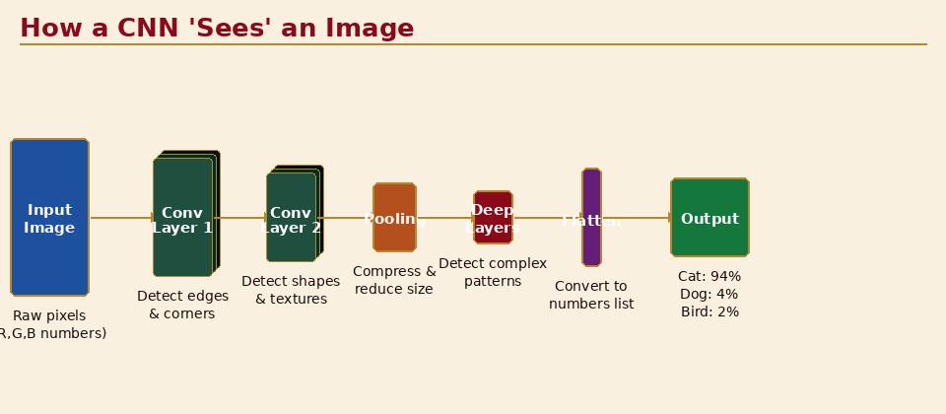
Figure 4.1 — CNN architecture: how AI reads an image layer by layer

DAY 5
When AI Gets It Wrong
Bias, hallucinations, and the ethics of intelligent machines

Overview
Today is possibly the most important day of Week 1. Understanding AI's capabilities is only half the picture — understanding its failures, biases, and ethical challenges is what makes you a truly responsible and powerful AI user. We will run a mock AI Ethics Court, examine real-world cases of AI failure, and develop your personal framework for thinking about "should we?" not just "can we?"

🎯 Learning Objectives — Day 5
- Understand what AI hallucination is and why it happens
- Identify the main sources and types of AI bias
- Analyse real-world cases where AI caused harm
- Apply an ethical reasoning framework to AI decision-making scenarios
- Articulate your own position on 2–3 AI ethics debates

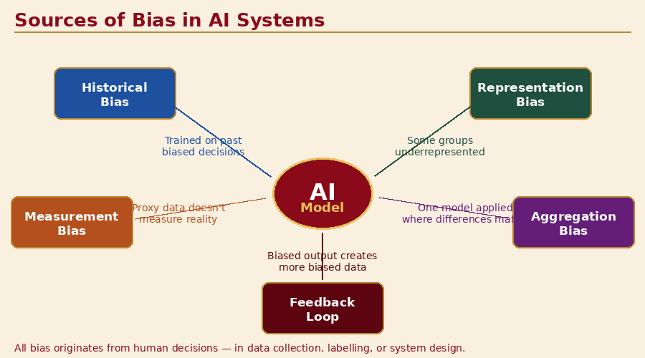
Figure 5.1 — Five sources of AI bias

Key Concepts

1. AI Hallucination — When AI Makes Things Up
AI language models can confidently state things that are completely false. This is called hallucination — a technical term, not a metaphor. It happens because:
- AI language models predict the most statistically likely next word, not the most true next word
- They have no internal sense of "I don't know" — they fill gaps with plausible-sounding text
- Their training data contained errors and biases which are reproduced in outputs

Real examples of damaging hallucinations:
- Legal: Lawyers submitted court briefs citing cases that ChatGPT invented — the cases did not exist. The lawyers faced disciplinary action.
- Medical: AI chatbots have given incorrect drug dosage information to patients.
- Academic: Students cited AI-generated references that were entirely fabricated, including fake DOI numbers.

⚠️ The Golden Rule on AI Outputs
Never present AI-generated facts without verification from a trusted primary source. AI is a starting point for research, not the ending point. If you cannot find the fact independently confirmed, do not use it.

2. Bias in AI Systems
AI bias occurs when a system produces systematically unfair or inaccurate results for certain groups. There are several ways bias enters AI:
Type of Bias | How It Works
Historical Bias | Training data reflects historical human discrimination. E.g., hiring AI trained on past employees (mostly male engineers) learned to prefer male candidates.
Representation Bias | Certain groups are underrepresented in training data. E.g., facial recognition trained mostly on light-skinned faces performs worse on dark-skinned faces.
Measurement Bias | The data collected doesn't accurately represent reality. E.g., using arrests as a proxy for crime — biased policing skews the data.
Aggregation Bias | One model applied across different groups where differences matter. E.g., a medical AI trained on average data may perform poorly for women if symptoms present differently.

3. Real-World AI Failures — Case Studies
Case 1: COMPAS Recidivism Algorithm (USA, 2016)
An AI system used by US courts to predict whether criminals would reoffend was found to be twice as likely to incorrectly flag Black defendants as high-risk compared to white defendants, even when other factors were identical. The algorithm was used to influence sentencing decisions.

Case 2: Amazon Hiring AI (2018)
Amazon built an AI to screen job applications. It was trained on 10 years of resumes — which mostly came from men, as tech is male-dominated. The AI learned to penalise resumes containing the word "women's" (e.g., "women's chess club president"). Amazon scrapped the system.

Case 3: Uber/Lyft Surge Pricing in Disasters
During natural disasters, algorithmic pricing systems have charged vulnerable people thousands of dollars for emergency transport — the algorithm optimising for revenue with no ethical override for crisis situations.

Case 4: AI Health Chatbots Giving Dangerous Advice
Multiple cases have emerged of AI wellness chatbots encouraging self-harm when users expressed distress, or providing incorrect medication information. These systems lacked appropriate safety guardrails.

4. An Ethical Framework for AI Decisions
When evaluating whether an AI system should be built or deployed, ask these questions:
- Fairness: Does this AI treat all groups equitably? Who might be disadvantaged?
- Transparency: Can we explain why the AI made a specific decision? Is it a "black box"?
- Accountability: Who is responsible when the AI makes a harmful error — the developer, the deployer, or the user?
- Privacy: What data does this AI collect? Who has access to it? Can it be misused?
- Safety: What happens if this AI fails? Have edge cases been tested? Is there a human override?
- Consent: Do the people affected by this AI know about it? Did they agree to be affected by it?

Recommended Videos
▶ Coded Bias (Netflix documentary trailer, 3 min) — https://www.youtube.com/watch?v=jZl55PsfZJQ
Powerful documentary about facial recognition bias. The trailer alone is compelling — highly recommended.
▶ The Problem with AI Bias (BBC, 8 min) — https://www.youtube.com/watch?v=59bMh59JQDo
Accessible overview of bias types with real-world examples. Watch before the Key Concepts section.
▶ How AI Can Reinforce Human Biases (TED-Ed, 5 min) — https://www.youtube.com/watch?v=Ok5sKLXqynQ
Excellent animated explainer — ideal for visual learners.

Activity — AI Ethics Court

⚖️ Case 1: AI Bail Decisions
The Scenario:
A government wants to use an AI system to assist judges in deciding whether to grant bail to accused criminals. The AI analyses 200 data points and predicts re-offending risk. Supporters say it removes human prejudice. Critics say it encodes historical bias and removes human judgment from life-changing decisions.
Arguments to prepare:
- FOR: Consistency, speed, removes individual judge bias, evidence-based
- AGAINST: Bias in historical data, no transparency, people deserve human judgment, no appeal process
Your verdict: Should this AI be used? If yes — what conditions must apply?

⚖️ Case 2: AI Mental Health Companion
The Scenario:
A company releases an AI chatbot designed to provide mental health support to teenagers who cannot access professional therapy. The AI has conversations, provides coping strategies, and tracks mood. 2 million teens use it. One case emerges where the AI failed to detect serious warning signs and a teen was harmed.
Arguments to prepare:
- FOR: Fills a massive gap in mental health services, available 24/7, no stigma, many helped
- AGAINST: Not a licensed therapist, cannot handle crisis, single failure = life consequences, privacy of intimate disclosures
Your verdict: Should this AI remain available? Under what rules?

⚖️ Case 3: AI School Exam Cheating Detection
The Scenario:
A school adopts an AI proctoring system that monitors students during online exams via their webcam — tracking eye movement, keystrokes, facial expressions, and background audio to detect cheating. Studies show the system flags students of colour and those with learning disabilities at higher rates.
Arguments to prepare:
- FOR: Academic integrity, equal standards, scales to online learning, deters cheating
- AGAINST: Discriminatory outcomes, privacy invasion of home, anxiety impact, home environment advantage
Your verdict: Should this AI be used in schools? What regulations should govern it?

Student Reflection — Day 5
📓 Write Your Answers in Your Reflection Journal
- Of the three court cases, which one concerned you most? Why? What principle (fairness, privacy, safety, transparency) was most violated?
- Describe a situation from your own life where an AI might be making decisions about you right now. How transparent is that process? Do you consent to it?
- If you were building an AI system, what one ethical principle would you refuse to compromise on? Why?
- Week 1 reflection: Write 3 things you know about AI now that you didn't know on Day 1. Write 2 questions you still have. Write 1 thing that has changed how you think about technology.
📚 Key Vocabulary — Day 5
- Hallucination: AI outputting confident but factually incorrect information
- Bias: Systematic unfairness in AI outputs, usually from skewed training data
- Black Box: An AI system whose internal decision-making process cannot be explained
- Explainability / XAI: The ability to interpret and explain how an AI reached a conclusion
- Fairness: Equitable treatment of all individuals and groups by an AI system
- Accountability: Clear responsibility when AI causes harm
- AI Safety: The field focused on ensuring AI systems behave as intended and do not cause harm
- Guardrails: Constraints built into AI systems to prevent harmful outputs

DAY 6
AI + Creativity
When machines make art — and how humans make it better

Overview
Welcome to Week 2. You now have the foundation to start creating. Today we explore AI as a creative partner — not a replacement for human creativity, but an amplifier of it. We will make music, write poetry, generate visual art, and ask the big question: is AI-generated art still "art"?

🎯 Learning Objectives — Day 6
- Understand how generative AI creates text, images, and music
- Use AI tools to create original creative works
- Articulate the difference between AI-generated and human creative expression
- Develop your own position on authorship and creativity in the AI age
- Build a mini creative portfolio using AI collaboration

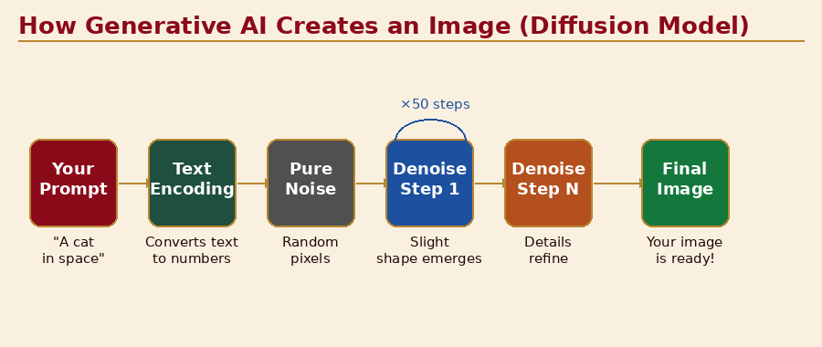
Figure 6.1 — Diffusion model: from text prompt to image

Key Concepts

1. How Generative AI Creates
Generative AI is trained to create new content rather than just classify or predict. The key technique is called a Diffusion Model (for images) or a Large Language Model / Transformer (for text and music):
- For images (Stable Diffusion, DALL-E, Midjourney): Start with pure noise → the AI gradually de-noises the image, guided by your text prompt, until it produces a coherent picture that matches your description
- For text (GPT-4, Claude): Predict the most likely next token (word fragment) given all previous tokens + training — do this thousands of times to produce a paragraph
- For music (Suno, Udio, MusicGen): Similar to image generation — the AI has learned the patterns of pitch, rhythm, timbre, and structure from millions of songs, and generates new audio that follows these patterns

2. The Creativity Debate
Perspective | Argument
"AI is not creative — it remixes." | AI has never had an original thought. It recombines patterns from human-created works. True creativity requires consciousness, lived experience, and emotional intent.
"AI creativity is real — the output is new." | If the result is genuinely novel and valuable, does the process matter? Humans also build on existing knowledge and culture. The output is what counts.
"Human + AI is the real breakthrough." | The most creative work happens when humans use AI to explore possibilities they couldn't reach alone, then apply judgment, emotion, and intention to shape the result.

3. Copyright and Ownership
AI-generated content raises complex legal questions that are actively being debated in courts worldwide:
- In Australia, copyright currently requires a human author — AI-only works may not be protected
- If you use AI as a tool and make substantial creative decisions, you may hold copyright over the final work
- Training AI on copyrighted artworks without permission is being challenged in multiple lawsuits globally
- Platform terms vary widely — always check whether you own what you create on any AI platform

Recommended Videos
▶ How AI Image Generation Works (Vox, 9 min) — https://www.youtube.com/watch?v=SVcsDDABEkM
Clear, visual explanation of diffusion models. Perfect intro before the creative activities.
▶ Suno AI — Create Music with AI (official demo) — https://www.youtube.com/watch?v=PL1HXkjxTFY
Shows how to generate full songs from text prompts. Students should watch this before Activity 1.
▶ Will AI Replace Artists? (Corridor Crew, 18 min) — https://www.youtube.com/watch?v=vAlHEIJGCQI
Professional animators debate AI art. Balanced, nuanced — great for discussion.

Activity 1 — AI Creative Workshop
📝 Station A: AI Songwriting with Suno
Visit: suno.com (free tier available)
- Write a prompt for a song: specify genre, mood, theme, and style. Example: "Upbeat pop song about discovering you can code, energetic, teenage perspective, with a catchy chorus"
- Generate the song. Listen carefully. What do you like? What feels off?
- Now humanise it: write new lyrics for the chorus yourself. What emotion do YOUR lyrics add that the AI version lacked?
- Optional: Generate 3 versions with different genres (pop, hip-hop, classical) of the same theme. How does genre change meaning?
Reflection: What did AI do well? What did you add that made it yours?

📝 Station B: AI Visual Art with Adobe Firefly
Visit: firefly.adobe.com (free, no age restriction)
- Generate an image that represents "the future of education." Use a detailed prompt with style, lighting, and mood.
- Generate 4 variations. Select the one that resonates most. Write a sentence explaining why.
- Now draw your own version of the same concept — freehand, 5 minutes. Don't try to copy the AI version.
- Place both side by side. What did you choose to include that the AI didn't? What did the AI imagine that surprised you?
Reflection: Which version feels more "yours"? Why?

Activity 2 — Human vs AI Creative Showdown

🎨 Challenge Options (pick one)
Option A: Write a haiku about loneliness. 5-7-5 syllables. 5 minutes.
Option B: Design a logo for a company called "Future Minds" — sketch it on paper or generate with AI.
Option C: Write the opening sentence of a thriller novel set in Sydney in 2040.
Option D: Create a short 4-line rhyming verse about why learning matters.

Student Reflection — Day 6
📓 Write Your Answers in Your Reflection Journal
- When you collaborated with AI on a creative project today, at what point did the work start to feel like "yours"? What creative decisions did you make?
- Do you think AI-generated art should be eligible for art prizes? What criteria would you use to judge?
- If AI can write songs, draw illustrations, and compose poetry — what remains uniquely human about creativity?
- Build your Creative + AI project plan: What creative project would you like to work on for your final showcase? How will AI assist, and what will you contribute that AI cannot?
📚 Key Vocabulary — Day 6
- Generative AI: AI that creates new content (images, text, audio, video)
- Diffusion Model: AI architecture that generates images by reversing a noise process
- Large Language Model (LLM): AI trained on vast text corpora to generate and understand language
- Token: The basic unit an LLM processes — roughly a word fragment
- Prompt (creative): A detailed description of the creative output you want the AI to generate
- Copyright: Legal right protecting original creative works from unauthorised copying
- Generative Adversarial Network (GAN): AI architecture using competing generator and discriminator networks
- Latent Space: The mathematical space inside an AI where concepts are stored as relationships between numbers

DAY 7
Design Thinking Meets AI
From "what if?" to a real solution — your project begins

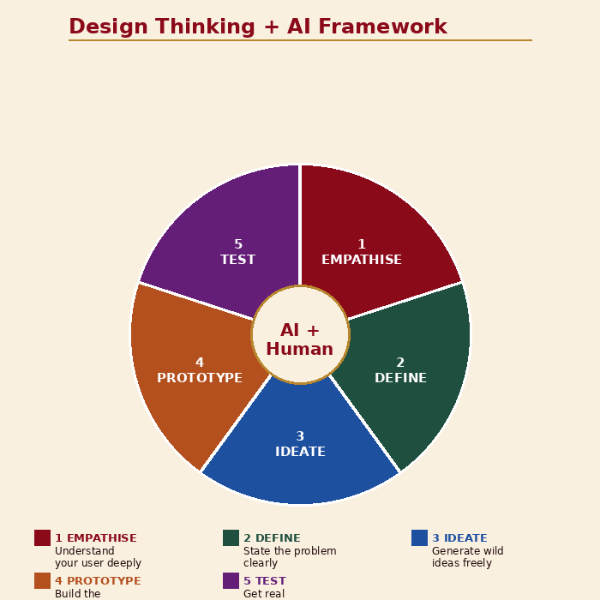
Figure 7.1 — Design Thinking wheel with AI at the centre

Overview
Today we bridge understanding and building. Design thinking is the problem-solving framework used by the world's most innovative companies. Today you will combine design thinking with your AI knowledge to identify a real problem, design an AI-powered solution, and plan a mini-project you will build over the next two days.

🎯 Learning Objectives — Day 7
- Apply the 5-stage design thinking process to a real problem
- Identify where AI adds genuine value vs where human judgment is essential
- Design a feasible AI solution with a defined scope
- Create a project plan for Days 8–9
- Present a project pitch to the class for peer feedback

Key Concepts

1. Design Thinking — The 5 Stages
Stage | What You Do
1. Empathise | Understand the people who have the problem. Do not assume — ask, observe, listen. Who is affected? How does this problem feel to them?
2. Define | Clearly state the problem. Use this format: "[Person] needs [need] because [insight]." Avoid jumping to solutions.
3. Ideate | Generate as many ideas as possible without judging any of them. Quantity over quality at this stage. Wild ideas welcome.
4. Prototype | Build the simplest possible version of your solution — fast and cheap. A sketch, a flowchart, a simple demo is fine.
5. Test | Get real feedback. Show your prototype to someone who has the problem. What works? What doesn't? Iterate.

2. Where Does AI Actually Help?
Not every problem needs AI. Here is a framework for deciding when AI adds value:
✅ AI is a good fit when...
- The task involves pattern recognition in large amounts of data (e.g., identifying disease in thousands of images)
- Personalisation at scale is needed (e.g., recommending different content to millions of users)
- Speed matters more than occasional errors (e.g., spam filtering — some false positives are acceptable)
- The task is repetitive and rule-based at its core, but with too many variations for manual rules
- Natural language understanding or generation is central to the problem

⚠️ AI is NOT a good fit when...
- The decision has life-or-death consequences and errors are unacceptable without human review
- You have very little training data (AI needs lots of examples to work well)
- The problem requires genuine common sense, novel reasoning, or emotional nuance
- Transparency and explainability are legally or ethically required (e.g., credit decisions, medical diagnosis)
- A simple rule-based system or spreadsheet would do the job just as well

3. Project Options for Days 8–9
Choose one of the following project tracks. Each is achievable in approximately 2 × 3 hours with the provided tools:
Project Track | Description
Track A: Smart Chatbot | Build a custom AI assistant for a specific topic using a system prompt. Example: a "homework helper" that only assists with science questions, always shows working, and never just gives the answer.
Track B: Image Classifier App | Build an image classifier using Teachable Machine and embed it in a simple webpage. Example: a "plant health checker" that identifies healthy vs diseased leaves.
Track C: AI Story Generator | Build an interactive choose-your-own-adventure story powered by AI. The reader's choices update the AI prompt, generating new story branches.
Track D: AI Research Assistant | Design a prompt system that helps students research a topic responsibly — breaking down a topic, suggesting sources, summarising findings, and flagging potential misinformation.

Activity 1 — Problem Sprint

📝 Problem Definition Template
Complete this statement to define your problem:
- WHO has this problem? (Be specific — "Year 7 students who study at home alone" not just "students")
- WHAT is the problem? (Describe the situation, not the solution)
- WHEN/WHERE does this problem occur?
- WHY does it matter? What is the impact if it remains unsolved?
- HOW do people currently solve it? What is wrong with the current solution?
Your Problem Statement: "[Person] needs [need] because [insight]."
Example: "Year 7 students studying alone at home need a way to check their own understanding of maths concepts because they have no one to ask and get stuck for hours, losing motivation."

Activity 2 — AI Fit Canvas
📝 Project Canvas — Complete as a Team
Section 1: The Problem
- Problem Statement (from Activity 1):
- Who is our primary user?
- What emotion does this problem cause? (frustration, confusion, fear, loneliness?)
Section 2: The AI Solution
- What will our AI do? (1 sentence)
- What type of AI is it? (chatbot / image classifier / generator / other)
- What training data or prompts does it need?
- What does the AI decide? What does the human decide?
Section 3: Build Plan
- Project Track (A / B / C / D):
- Tools we will use:
- Day 8 goal:
- Day 9 goal:
- How will we know if our solution works? (success measure)
Section 4: Risks & Ethics
- What could go wrong?
- Which ethical principle (fairness/privacy/transparency/safety) is most relevant? How will we address it?

Student Reflection — Day 7
📓 Write Your Answers in Your Reflection Journal
- What problem did your team choose? Why does it matter to you personally?
- Where in your solution does AI add value that a human or simple app could not? Be specific.
- What is the one thing that could most easily go wrong with your project? How will you handle it?
- Describe your ideal user testing session: Who would you show your prototype to? What question would you most want them to answer?

DAY 8
Build Day 1
From canvas to code — bringing your AI project to life

Overview
Today is pure building. Teams work on their chosen project track, supported by facilitators and peer collaboration. The goal by end of day: a working prototype — even a rough one — that demonstrates your core idea.
Remember the Design Thinking principle: a bad prototype you can test beats a perfect plan you can only imagine. Done is better than perfect on Day 8.

🎯 Day 8 Goals
- Have a working proof-of-concept by end of day
- Identify the biggest technical or design challenge in your project
- Test your prototype with at least one person outside your team
- Document what works, what doesn't, and what you'll fix tomorrow

Build Schedule

Track A — Smart Chatbot Build Guide

📝 System Prompt Template for Your Chatbot
Copy this template and fill in the [brackets]:
You are [name], an AI assistant specialising in [topic]. You help [target user] with [specific task].
Your personality is [3 adjectives — e.g. warm, patient, encouraging].
Rules you always follow:
- Only answer questions related to [topic]. For other topics, politely redirect.
- Always [key behaviour — e.g. show your working step by step].
- Never [prohibited behaviour — e.g. give the answer directly without explanation].
- If you are unsure, say so clearly and suggest where the user could find a reliable answer.
- Always end your response with a follow-up question to check understanding.
Test your system prompt: paste it into Claude or ChatGPT as the first message, then have a classmate try to use your chatbot. Does it behave as intended?

Track B — Image Classifier App Build Guide
📝 Step-by-Step: Teachable Machine → Embedded Web App
Phase 1: Train Your Model (30 min)
- Plan your classes: what 3–4 categories will your classifier recognise?
- Collect training images: minimum 100 per class, from multiple angles, lighting, backgrounds
- Train on Teachable Machine (teachablemachine.withgoogle.com)
- Evaluate accuracy — aim for 85%+ before proceeding
Phase 2: Export and Embed (30 min)
- Click "Export Model" → "Tensorflow.js" → "Upload my model" → copy the model URL
- Open a new file called index.html on your computer
- Paste in the Teachable Machine sample code from the "Code snippets" section
- Replace the placeholder model URL with yours
- Open index.html in your browser — it should work immediately
Phase 3: Customise (30 min)
- Change the page title, add a description of what your classifier does
- Add a friendly message when each class is detected
- Share your index.html file with another team and let them test it

Track C — AI Story Generator Build Guide
📝 Build: Interactive AI Branching Story
Concept: The player makes choices. Each choice is fed back into the AI prompt to generate the next scene.
Phase 1: Story Architecture (20 min)
- Choose a setting and premise: e.g. "You are a young scientist in 2080 who discovers an AI that has gained emotions"
- Map your story tree: 3 chapters, each with 2 choices. That's 8 possible story paths.
- Write the world-building context (2–3 paragraphs) that the AI will use as background
Phase 2: System Prompt Design (20 min)
- Write a system prompt that sets the tone: "You are a narrative AI for an interactive science fiction story. The tone is [adjective]. Always end each scene with exactly 2 choices formatted as: CHOICE A: [option] | CHOICE B: [option]"
- Test it: does the AI maintain consistency? Does it remember previous choices?
Phase 3: User Interface (40 min)
- Create a simple Google Slides or PowerPoint presentation
- Slide 1: Opening scene (paste AI-generated text). Add 2 buttons linking to Slide 2A or 2B.
- Each branch slide: generate that scene from the AI using the choice as context
- Continue for 3 chapters — you will have approximately 14 slides total

Track D — AI Research Assistant Build Guide
📝 Build: A Research Prompt System
Concept: Design a series of prompts that help a student research any topic responsibly.
The 5-Prompt Research System — design each prompt:
- SCOPE PROMPT: "Given the research question [X], break it into 5 specific sub-questions that together would fully answer it."
- SOURCES PROMPT: "For the sub-question [Y], suggest 5 types of sources I should look for. Include at least 2 primary source types."
- SUMMARISE PROMPT: "Here is text I found [paste source text]. Summarise the key points relevant to [sub-question]. Flag any claims that need verification."
- BIAS CHECK PROMPT: "Analyse this summary for potential bias, missing perspectives, or unsupported claims: [paste summary]."
- SYNTHESIS PROMPT: "Using these verified points [list], write a 3-paragraph evidence-based response to [original research question]. Cite each point."
Test your system: use it to research a topic you actually need for school. Does it produce better research than googling alone?

Daily Build Log — Student Worksheet
📓 Complete This at the End of Day 8
Team: ___ | Track: ___
- What did we complete today? (be specific)
- What is working well?
- What is NOT working yet? (list all known issues)
- What feedback did we get from our test user?
- What are our top 3 priorities for Day 9?
- What help do we need from the facilitator tomorrow?

DAY 9
Build Day 2
Polish, test, and prepare your story for the world

Overview
Day 9 is about taking your rough prototype from yesterday and making it something you are proud to show. Focus on three things: fixing your biggest known problem, improving the user experience, and preparing a compelling 3-minute presentation for tomorrow's Demo Day.

🎯 Day 9 Goals
- Fix the top issue identified in yesterday's build log
- Improve the user experience — is it easy for someone new to use?
- Conduct a second round of user testing and gather feedback
- Prepare your 3-minute Demo Day presentation
- Create a project one-pager summary

Build Schedule

User Testing Protocol

Demo Day Presentation Template
🎤 Your 3-Minute Presentation Structure
Section 1: The Problem — 45 seconds
- Open with a real scenario: "Imagine you are [user] and you face [problem]..."
- Make the audience feel the problem before you show the solution
Section 2: Our Solution — 60 seconds
- Show (not just tell) — live demo or screenshot walkthrough
- Explain what AI does vs what the human does
- Highlight the most impressive/surprising thing it can do
Section 3: What We Learned — 45 seconds
- What was the hardest thing to build?
- What did the AI do that surprised you?
- What would you improve with more time?
Section 4: The Bigger Picture — 30 seconds
- If this tool existed fully developed, what impact could it have?
- Close with your team's key insight from this project

Project One-Pager Template
📄 Complete This — It Will Be Displayed at Demo Day
Project Name:
Team Members:
The Problem We Solved:
Our AI Solution (1 sentence):
Tools We Used:
What AI Does:
What Humans Do:
Biggest Challenge We Overcame:
What We Would Build Next (if we had more time):
Our Ethical Consideration:
QR code or link to try our project: [add here]

DAY 10
Demo Day & Graduation
Two weeks. Ten days. One showcase. Your AI future begins now.

Overview
This is the day everything comes together. You will present your projects to a real audience — parents, teachers, or guests — and demonstrate not just what you built, but how you think. This session is also a celebration of how far you have come in two weeks.

🎯 Day 10 Goals
- Deliver your 3-minute project presentation with confidence
- Demonstrate your project to the audience live
- Complete your "Letter to Future Self" — a personal commitment
- Receive your AI Futures Program certificate
- Leave with a clear next step for continuing your AI learning

The Demo Day Mindset
💡 Advice for Presenters
- Start with the problem, not the technology. The audience needs to care before they can be impressed.
- Show the tool working live — even if it's imperfect. A live demo with one bug is more compelling than a flawless recording.
- Speak to what you learned, not just what you built. Judges value insight over polish.
- If something goes wrong during the demo, say so calmly and explain what it should do. Handling failure gracefully is itself impressive.
- Thank your team, your facilitator, and anyone who gave you feedback during user testing.

Audience Questions — Facilitator Guide

Award Categories
🏆 Audience Choice Awards (all teams eligible for all categories)
- Most Innovative Solution — tackled a problem in an unexpected way
- Best User Experience — easiest and most enjoyable to use
- Greatest Real-World Impact — could help the most people if fully built
- Best Use of AI — most thoughtful and effective use of AI capabilities
- Most Ethical Design — best handling of fairness, privacy, and safety concerns
- Best Presentation — clearest storytelling and most engaging delivery

Letter to My Future Self

📝 Letter to My Future Self — Prompts
Date: ___
Dear Future Me,
- Right now, here is what I understand about AI that I didn't two weeks ago:
- The project I built was called [name]. Here is what I'm most proud of about it:
- The moment that surprised me most during this program was:
- The ethical question about AI that I still think about is:
- By the time you read this letter, I want to have done these things with AI:
- The one thing I want you to remember about AI is:
Signed, [your name], age 12

What Comes Next — Your AI Learning Path
🚀 Free Resources to Continue Learning
For Coding with AI:
- CS50's Introduction to AI (Harvard, free): cs50.harvard.edu/ai
- Elements of AI (University of Helsinki, free): elementsofai.com
- Scratch + ML4Kids: machinelearningforkids.co.uk
For Building with AI:
- Google ML Crash Course (free): developers.google.com/machine-learning/crash-course
- Fast.ai Practical Deep Learning (free): fast.ai
- Anthropic Claude API (free tier): anthropic.com/api
For Understanding AI Ethics:
- AI4K12 Initiative: ai4k12.org
- MIT Media Lab Ethics of AI: media.mit.edu
- Your Digital Future (Australian eSafety Commissioner): esafety.gov.au
Competitions and Communities:
- AI for Good (ITU): aiforgood.itu.int/youth
- Google Science Fair: sciencefair.withgoogle.com
- iD Tech AI programs (holidays): idtech.com

Appendix — Master Vocabulary Reference
This glossary covers every key term introduced across the 10-day program. Use it as a study reference and quick-look guide.

A – D
Term | Definition
Algorithm | A set of step-by-step instructions for solving a problem. The foundation of all software, including AI.
Artificial Intelligence (AI) | Computer systems that perform tasks normally requiring human intelligence — recognising patterns, understanding language, making decisions.
Bias (AI) | Systematic unfairness in AI outputs, typically caused by skewed training data that over- or under-represents certain groups.
Black Box | An AI system whose internal decision-making process cannot be inspected or explained.
Chatbot | A program that simulates conversation with humans, increasingly powered by large language models.
CNN (Convolutional Neural Network) | The standard neural network architecture for processing images — uses layers of filters to detect features at increasing levels of complexity.
Computer Vision | AI that interprets and understands digital images and video.
Context Window | The maximum amount of text an AI language model can "see" at once when generating a response.
Deepfake | AI-generated synthetic media that realistically replaces a real person's likeness, voice, or words.
Deep Learning | A subset of machine learning using multi-layered neural networks — excels at images, language, and audio.
Diffusion Model | AI architecture for generating images — starts with noise and gradually refines it into a coherent image guided by a text prompt.

E – L
Term | Definition
Epoch | One complete pass through all training data during model training. More epochs = more learning (up to a point).
Explainability (XAI) | The ability to interpret and explain how an AI system reached a specific conclusion — critical for high-stakes decisions.
Fairness (AI) | The principle that an AI system should treat all groups equitably and not cause disproportionate harm to any group.
Feature | A measurable characteristic that an AI uses to make decisions — e.g. "edge angle" in image recognition.
GAN (Generative Adversarial Network) | AI architecture with two competing networks — a generator that creates fake content and a discriminator that tries to detect fakes.
Generative AI | AI that creates new content (text, images, audio, video) rather than just classifying or predicting.
Guardrails | Constraints built into AI systems to prevent harmful, biased, or off-topic outputs.
Hallucination | When an AI language model outputs confident but factually incorrect information — a core limitation of current LLMs.
Label | The correct answer attached to a training example — e.g. "cat" or "not cat" — used in supervised learning.
Large Language Model (LLM) | AI trained on vast amounts of text to understand and generate human language — the technology behind ChatGPT, Claude, and Gemini.
Latent Space | The multi-dimensional mathematical space inside an AI model where concepts are encoded as numerical relationships.

M – R
Term | Definition
Machine Learning (ML) | A subset of AI where systems learn from data rather than being explicitly programmed with rules.
Model | The mathematical structure an AI builds from training data — encodes learned patterns and is used to make predictions.
Natural Language Processing (NLP) | AI that understands, interprets, and generates human language in text or speech form.
Neural Network | A computing architecture loosely inspired by the brain — layers of interconnected nodes process information in parallel.
Narrow AI | AI that excels at one specific task but cannot transfer skills to other domains. All current AI is narrow AI.
Overfitting | When an AI memorises training data too closely, performing perfectly on training examples but failing on new data.
Parameter | A learnable numerical value inside a neural network that is adjusted during training to minimise errors.
Prompt | The instruction or question you provide to an AI system to guide its output.
Prompt Engineering | The skill of crafting effective, specific instructions to get high-quality outputs from AI systems.
Reinforcement Learning | ML where an AI agent learns by trial and error — rewarded for correct actions, penalised for wrong ones.

S – Z
Term | Definition
Speech Recognition | AI that converts spoken audio into written text.
Supervised Learning | ML where the AI is trained on labelled examples — the most common type of machine learning today.
System Prompt | Hidden instructions given to an AI chatbot that define its persona, rules, and constraints.
Temperature | A setting that controls how creative/random (high temperature) vs predictable/focused (low temperature) an AI's outputs are.
Token | The basic unit an LLM processes — roughly a word fragment (e.g. "unbelievable" = 3 tokens: "un", "believ", "able").
Training Data | The examples used to teach an AI — the quality and diversity of training data largely determines AI quality.
Transfer Learning | Adapting a pre-trained model for a new task rather than training from scratch — dramatically reduces data and compute requirements.
Underfitting | When an AI hasn't learned enough from training data and performs poorly even on familiar examples.
Unsupervised Learning | ML where the AI finds patterns in unlabelled data without being told what to look for.
XAI (Explainable AI) | A research field focused on making AI decision-making transparent and interpretable by humans.

Facilitator Reference — Program at a Glance
Day | Theme & Focus
Day 1 | AI Is Already Around You — demystify, myth-bust, map AI in daily life
Day 2 | How AI Learns — ML training loop, Teachable Machine experiment
Day 3 | The Art of Talking to AI — prompt engineering framework, Prompt Battle
Day 4 | AI Eyes, Ears & More — computer vision, deepfakes, Spot the AI
Day 5 | When AI Gets It Wrong — hallucination, bias, Ethics Court simulation
Day 6 | AI + Creativity — generative AI, songwriting, art, creativity debate
Day 7 | Design Thinking Meets AI — problem framing, project selection, pitching
Day 8 | Build Day 1 — prototype sprint, user testing round 1
Day 9 | Build Day 2 — fix, polish, demo prep, presentation rehearsal
Day 10 | Demo Day & Graduation — showcase, awards, letter to self, next steps

