Data Centers in Local Communities: The Real Costs Behind the AI Boom

Track B Case Study — Google Data Analytics Capstone
Analyst: Raymos Gonzales Date: September 2026 Tools: Python (pandas, matplotlib)

1. Ask — The Question
Research question: What impacts do data centers have on the local communities that host them — and do the benefits outweigh the costs for the people who live there?
Why this question: The AI boom has triggered the biggest data center construction wave in history. These facilities are landing in ordinary neighborhoods, and communities across America are fighting back. I wanted to look at both sides — the money they bring in, and what they take out.
Stakeholders: Local residents, county governments, utility customers (everyone who pays an electric bill), data center operators (Amazon, Google, Microsoft, Meta), and the environment.

2. Prepare — Data Sources
- Global Data Center Map (ATLAS) — community-compiled open dataset on GitHub: 18,110 data centers across 116 countries, with operator, city, state, and country fields. (Community source — not official; treated as directional, not exact.)
- LBNL / U.S. Department of Energy — 2024 United States Data Center Energy Usage Report (updated June 2026) — official federal figures on data center electricity and water consumption. (Official government source.)
- Virginia JLARC Report 598, “Data Centers in Virginia” (Dec 2024) — official state study on jobs, tax revenue, and siting. (Official government source.)
- Loudoun County, VA budget figures — data center tax revenue by year. (Official government source.)
- Community and advocacy perspectives — Sierra Club, Southern Environmental Law Center, Data Center Watch, and local reporting (Business Insider, Fox 10 Phoenix, Data Center Dynamics) on resident opposition. (Advocacy/journalism — claims cross-checked against official sources where possible.)
Credibility check (ROCCC): Government and national-lab data is reliable, original, and cited. The community-compiled map dataset is comprehensive but crowdsourced, so I cleaned and validated it before use and treated counts as estimates. Advocacy claims were included deliberately — residents’ lived experience is data too — but each is labeled by source type.

3. Process — Cleaning Documentation
- Loaded the global dataset (18,110 rows) into pandas.
- Filtered to United States records (8,818 rows).
- Problem found: the state column was messy — mixed formats (“VA” vs “Virginia” vs “TX” vs “Texas”) and thousands of rows where a city name appeared in the state field (e.g., “Ashburn”, “Phoenix”).
- Fix: built a state-name normalization map and a city→state lookup, and applied it row by row.
- Result: 5,631 US records with a verified state (64% of US rows). The remaining rows were excluded from state-level analysis and documented here — honesty about data quality is part of the process.
- Source figures from LBNL and Loudoun County were transcribed into small analysis tables.

4. Analyze — What the Data Shows

Geography: data centers cluster in a few states
Of the cleaned US dataset, Virginia leads the nation with 977 data centers — nearly double Texas (768) and far ahead of California (494), Illinois (370), and Georgia (348). Northern Virginia (“Data Center Alley”) is the densest concentration of data centers on Earth. Top operators in the US dataset: Amazon AWS (457), Lumen (361), DataBank (216), Equinix (188), Microsoft (174), Google (160).

Energy: the hunger is exploding
US data centers consumed 58 TWh of electricity in 2014 — and 192 TWh (4.7% of the entire country’s electricity) in 2024. Federal projections reach 464 TWh by 2028 and 649 TWh by 2030 — nearly 12% of all US electricity. In Virginia, data centers already consume about a quarter of the state’s power. One large AI facility can use as much electricity as 100,000 households.

Money: the tax windfall is real
Loudoun County’s data center tax revenue grew from roughly $150M (2014) to $700M (2024), $894M (2025), and a projected $1.14B in 2026 — funding about 40% of the county budget. Virginia’s official study credits the industry with ~74,000 jobs and $9.1B in annual GDP (though most jobs are temporary construction roles, not permanent positions).

5. Share — Key Findings
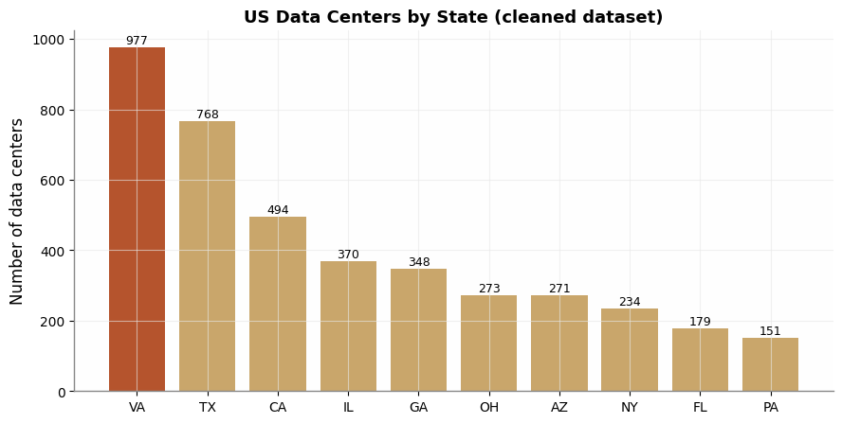
US Data Centers by State
Chart 1 — US Data Centers by State: Virginia’s dominance is visible at a glance — one small state hosts more facilities than entire regions.
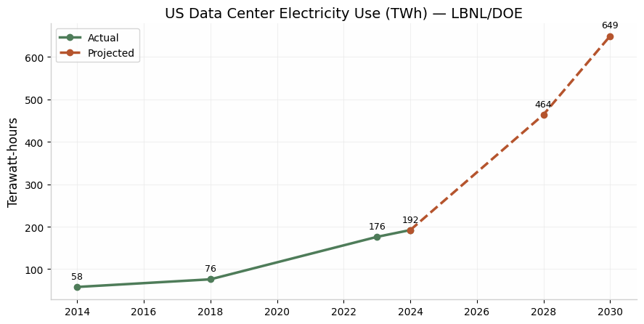
US Data Center Electricity Use
Chart 2 — US Data Center Electricity Use: the curve bends sharply upward after 2023 — the AI boom — and the projected line to 2030 is nearly vertical.
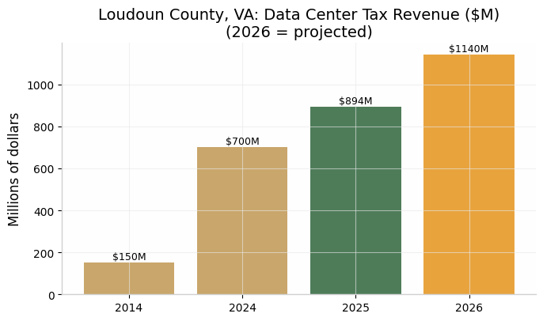
Loudoun County Tax Revenue
Chart 3 — Loudoun County Tax Revenue: the benefit side of the story — revenue up more than 7× in a decade.

The story the data tells — pros vs. cons
The pros are real: - Massive local tax revenue that funded schools and lowered residents’ property tax rates in Loudoun County for a decade straight - Construction jobs and tech investment - Digital infrastructure the whole economy runs on
But the costs land on the neighbors: - Electric bills: Grid capacity costs driven by data-center demand added an estimated $9.3 billion passed onto regular ratepayers in the PJM region — bills rising up to 29% in some areas. People who will never use an AI chatbot are paying for the servers behind it. - Water: One large facility can consume up to 5 million gallons per day — in drought-stressed states like Arizona and Texas, that competes directly with residents and farms. - Noise: About a third of Virginia data centers sit within 200 feet of residentially zoned land; residents describe a constant industrial “hum” above 60 decibels, audible miles away. - Air: Northern Virginia alone has an estimated 10,500 diesel backup generators; when they run, their emissions rival mid-sized coal plants. - Communities are revolting: Opposition groups grew from 396 to 833 groups across 49 states in about a year. Over $156 billion in projects were blocked or delayed in 2025. Chandler, Arizona unanimously rejected a data center in December 2025 over water and bill concerns; in Memphis, residents and the NAACP sued over turbines installed near a majority-Black neighborhood without full air permits. In Warrenton, VA, every council member who backed a data center lost their next election.

6. Act — Conclusions and Recommendations
Conclusion: Data centers are neither villains nor saviors — they are a trade. The tax money is real, but so are the bills, the water draw, the noise, and the diesel. Right now, the profits are privatized while too many of the costs are pushed onto local residents. The data says the imbalance is fueling a nationwide, bipartisan backlash.
My three recommendations:
- Make operators pay their own grid costs. Utilities and regulators should require data centers to fund the power plants and transmission lines their demand creates — through minimum-take contracts and dedicated rate classes — instead of spreading those costs onto household bills.
- Require transparency before approval. No project should be approved without public disclosure of projected electricity, water use, and noise modeling, plus mandatory air permits for backup generators — with real community hearings, not after-the-fact permits.
- Set buffer zones and noise limits with teeth. No data centers within a meaningful distance of homes, enforceable decibel limits day and night, and water-use caps in drought regions — so growth doesn’t come at the cost of the people already living there.
Next steps for deeper analysis: pair facility locations with Census income and demographic data to test whether data centers (and their costs) are disproportionately sited near lower-income and minority communities; and track residential electricity price changes in high-density data center counties versus the national average.

Data sources: LBNL/DOE 2024 US Data Center Energy Usage Report; Virginia JLARC Report 598 (2024); Loudoun County budget reports; Global Data Center Map (ATLAS, community-compiled); IEA “Energy and AI” (2025); Data Center Watch; Sierra Club; SELC; Business Insider; Fox 10 Phoenix; Data Center Dynamics. Community/advocacy claims are labeled as such and were cross-checked against official sources where possible.

