ShowUp: A Relational Database–Driven Campus Event Discovery, Registration and Check-in System
Rayna Agarwal
Registration No. 25BCE0703
Department of Computer Science and Engineering
Vellore Institute of Technology, Vellore, Tamil Nadu, India
Database Management Systems — Course Project Report · Source code: github.com/raynaagarwal01-rgb/ShowUp

Abstract—College events such as hackathons, workshops, competitions and cultural programmes are still announced and registered through a patchwork of Google Forms, spreadsheets and messaging groups. This produces duplicated and inconsistent data, over-subscribed events, lost team codes and paper-based attendance. This report presents ShowUp, a web application for discovering events across colleges, registering solo or as a team, receiving a QR ticket and being checked in at the venue. The work follows the complete database development life cycle: requirements were identified and analysed; a conceptual Entity–Relationship (ER) model with an Enhanced ER (EER) specialization was constructed; the model was mapped to a relational schema and verified to be in Third Normal Form (3NF) and Boyce–Codd Normal Form (BCNF); the schema was implemented in MySQL 8.0 as eight InnoDB tables with twelve foreign keys and declarative CHECK, UNIQUE and NOT NULL constraints; and the database was populated with representative data. A React and TypeScript front end communicates with a Node.js/Express application tier that issues only parameterised SQL through a connection pool, and enforces business rules—deadlines, capacity, duplicate prevention and team-size limits—inside ACID transactions that use row-level locks. Thirty-five test cases covering authentication, registration, teams, check-in, database constraints, concurrency and SQL-injection resistance were executed against a live MySQL 8.0.46 server and all passed, including a race of five simultaneous registrations for a single remaining seat.
Index Terms—Database design, entity–relationship model, EER specialization, relational mapping, normalization, MySQL, SQL DDL/DML, transactions, concurrency control, web application, event management.

I. Introduction
University campuses host a large number of co-curricular events every semester. At institutions such as VIT Vellore a student may, in a single week, be invited to a 24-hour hackathon, a design workshop, an e-sports tournament and a guest lecture, each organised by a different club and each using its own registration form. Organisers, in turn, export responses to spreadsheets, try to reconcile duplicate submissions, chase incomplete teams and mark attendance on paper at the venue.
These are fundamentally data management problems: the same student is stored many times in unrelated files, there is no single authoritative count of seats taken, team membership is captured as free text, and nothing prevents two people from taking the last seat at the same moment. A relational database management system (RDBMS) is designed precisely to remove such redundancy and to enforce integrity and consistency under concurrent access [1], [2].
ShowUp addresses the problem with a single web platform backed by a normalized MySQL database. Students browse events from several colleges, register individually or form a team that friends join with a six-character code, and receive a QR ticket. Organisers create and edit events, view participants grouped by team, post announcements, answer questions, publish results and check participants in by scanning their tickets.

A. Objectives
- Identify and document the functional, non-functional and data requirements of campus event registration.
- Design a conceptual ER/EER model and map it systematically to a relational schema.
- Normalize every relation to at least 3NF and verify BCNF using functional dependencies.
- Implement the schema with SQL DDL, populate it with SQL DML and enforce integrity declaratively wherever possible.
- Build a usable front end and an application tier that implements business rules transactionally.
- Validate the system with documented test cases, including constraint and concurrency tests.

B. Scope
The project covers user accounts (students and organisers), events, solo and team registration, QR tickets and check-in, announcements, questions and answers, and results. Online payment, e-mail/SMS notification and waitlists are deliberately out of scope; the event fee is stored for information only. The database and back end were kept intentionally small—eight tables and plain SQL with no Object–Relational Mapper (ORM)—so that every design decision can be traced from requirement to table to query.

C. Organization of the Report
The report follows the eleven stages of the project. Section II analyses the problem and requirements; Section III constructs the ER/EER diagrams; Section IV maps them to the relational model; Section V normalizes the relations; Sections VI and VII present the DDL and DML; Section VIII describes the front end; Section IX the business logic; Section X database connectivity; Section XI testing and validation; and Section XII the demonstration and documentation. Section XIII concludes.

II. Problem Identification and Requirement Analysis

A. Problem Statement
Design and implement a database-driven system that allows students of multiple colleges to discover events and register for them individually or as teams, and that allows organisers to manage events and attendance, while guaranteeing that (i) no student is registered twice for the same event, (ii) no event exceeds its capacity even under simultaneous registrations, (iii) registrations close at the deadline, (iv) teams respect minimum and maximum sizes, and (v) all data about a person, event or team is stored exactly once.

B. Analysis of the Existing Process
Interviews with club coordinators and inspection of typical registration sheets revealed the following deficiencies, each of which maps to a database concept:
- Redundancy and update anomalies—a student's name, e-mail and registration number are retyped on every form; correcting one copy leaves the others stale.
- No integrity constraints—forms accept duplicate submissions, invalid team sizes and registrations after the deadline.
- No concurrency control—capacity is checked manually after the fact, so popular events are routinely over-subscribed.
- Repeating groups—team members are typed into one cell ("Ananya, Rohan, …"), which cannot be queried or validated.
- No single source of truth for attendance—check-in is done on paper and never linked back to the registration.

C. Stakeholders
Three actors were identified. A student (participant) browses, registers, forms or joins teams, asks questions and presents a ticket. An organizer (club or society account) creates and manages its own events and checks participants in. A visitor (not signed in) sees the landing page and may sign up. Following IEEE Std 830 practice [6], requirements are numbered so that they can be traced to design elements and test cases.
TABLE I
Functional Requirements
ID | Requirement | Actor
FR-1 | Sign up and log in with e-mail and password; choose role student or organizer | All
FR-2 | List all events with organizer, college and live seats left; search, filter and sort | Student
FR-3 | View event detail: description, venue, date, deadline, team size, fee | Student
FR-4 | Register for a solo event before the deadline if seats remain | Student
FR-5 | Create a team for a team event and receive a unique join code | Student
FR-6 | Join a team with its code, subject to the team's maximum size | Student
FR-7 | Cancel a registration; leave the team; free the seat | Student
FR-8 | View own registrations with QR ticket and team details | Student
FR-9 | Create, edit and delete own events | Organizer
FR-10 | View participants grouped by team; export CSV | Organizer
FR-11 | Check participants in by scanning or typing the ticket number | Organizer
FR-12 | Post announcements, answer questions, publish winners | Organizer
FR-13 | Ask a question about an event | Student

TABLE II
Non-Functional Requirements
ID | Category | Requirement
NFR-1 | Integrity | Keys, foreign keys, CHECK and UNIQUE constraints enforced by the DBMS, not only by code
NFR-2 | Consistency | Multi-statement operations are atomic (ACID transactions)
NFR-3 | Concurrency | Capacity can never be exceeded by simultaneous requests
NFR-4 | Security | Passwords stored as bcrypt hashes; all SQL parameterised; role-based authorization
NFR-5 | Usability | Responsive UI; actions complete in at most three clicks from the event page
NFR-6 | Maintainability | Plain SQL, small route files, schema scripts that are safe to re-run
NFR-7 | Portability | Runs on any OS with Node.js 20+ and MySQL 8.0.16+

D. Data Requirements
From the functional requirements the following data must be stored: for every user—name, unique e-mail, password hash, role, optional college and registration number; for every event—organizer, title, description, category, venue, start date-time, registration deadline, capacity, fee, and minimum/maximum team size; for every team—event, name (unique within the event), globally unique join code and leader; membership of users in teams; for every registration—participant, event, optional team, status and check-in time; and per event, announcements, questions with optional answers and winners with position and prize. Seats left is a derived value and is not stored.
TABLE III
Hardware and Software Requirements
Layer | Specification
DBMS | MySQL Community Server 8.0 (tested on 8.0.46), InnoDB engine
Server | Node.js 20+ with Express 5, mysql2, bcryptjs, jsonwebtoken
Client | React 19, TypeScript 6, Vite 8, Tailwind CSS 4, qrcode, html5-qrcode
Tools | MySQL Workbench / mysql CLI, VS Code, Git and GitHub
Hardware | Any PC with 4 GB RAM; phone camera for QR check-in (optional)

III. Construction of ER/EER Diagram
The conceptual model was built with Chen's ER notation [4] and the EER extensions described by Elmasri and Navathe [1]. Nouns in the requirements became candidate entities, verbs became relationships, and descriptive nouns became attributes.

A. Entities and Attributes
TABLE IV
Entity Sets and Attributes
Entity | Key | Other attributes
USER | id | name, email (unique), password_hash, role, college, reg_no, created_at
EVENT | id | title, description, category, venue, event_date, reg_deadline, capacity, fee, team_min, team_max, created_at; seats_left (derived)
TEAM | id | name, join_code (unique), created_at
REGISTRATION | id | status, checked_in_at, registered_at (associative entity)
ANNOUNCEMENT | id | title, content, created_at
EVENT_QUESTION | id | question, answer (optional), created_at
EVENT_WINNER | id | position, winner_name, prize (optional)

B. Relationships, Cardinality and Participation
TABLE V
Relationship Sets
Relationship | Entities | Card. | Participation
ORGANIZES | USER – EVENT | 1:N | EVENT total
REGISTRATION | USER – EVENT | M:N | partial both
PART_OF | REGISTRATION – TEAM | N:1 | REGISTRATION partial
MEMBER_OF | USER – TEAM | M:N | TEAM total
LEADS | USER – TEAM | 1:N | TEAM total
FORMS | EVENT – TEAM | 1:N | TEAM total
POSTS | EVENT – ANNOUNCEMENT | 1:N | ANNOUNCEMENT total
ASKS | USER – EVENT_QUESTION | 1:N | QUESTION total
ABOUT | EVENT – EVENT_QUESTION | 1:N | QUESTION total
HAS_RESULT | EVENT – EVENT_WINNER | 1:N | WINNER total

REGISTRATION is modelled as an associative entity (a relationship promoted to an entity) because it carries its own attributes—status, check-in time and timestamp—and itself participates in the PART_OF relationship with TEAM. Its identifier is printed in the QR ticket (SHOWUP-REG-<id>). MEMBER_OF carries the attribute joined_at, which is used to choose a new leader when the current leader leaves.

C. ER Diagram
The complete ER diagram is shown in Fig. 2. Double lines denote total participation; for example, every event must be organized by exactly one user and every team must belong to one event.

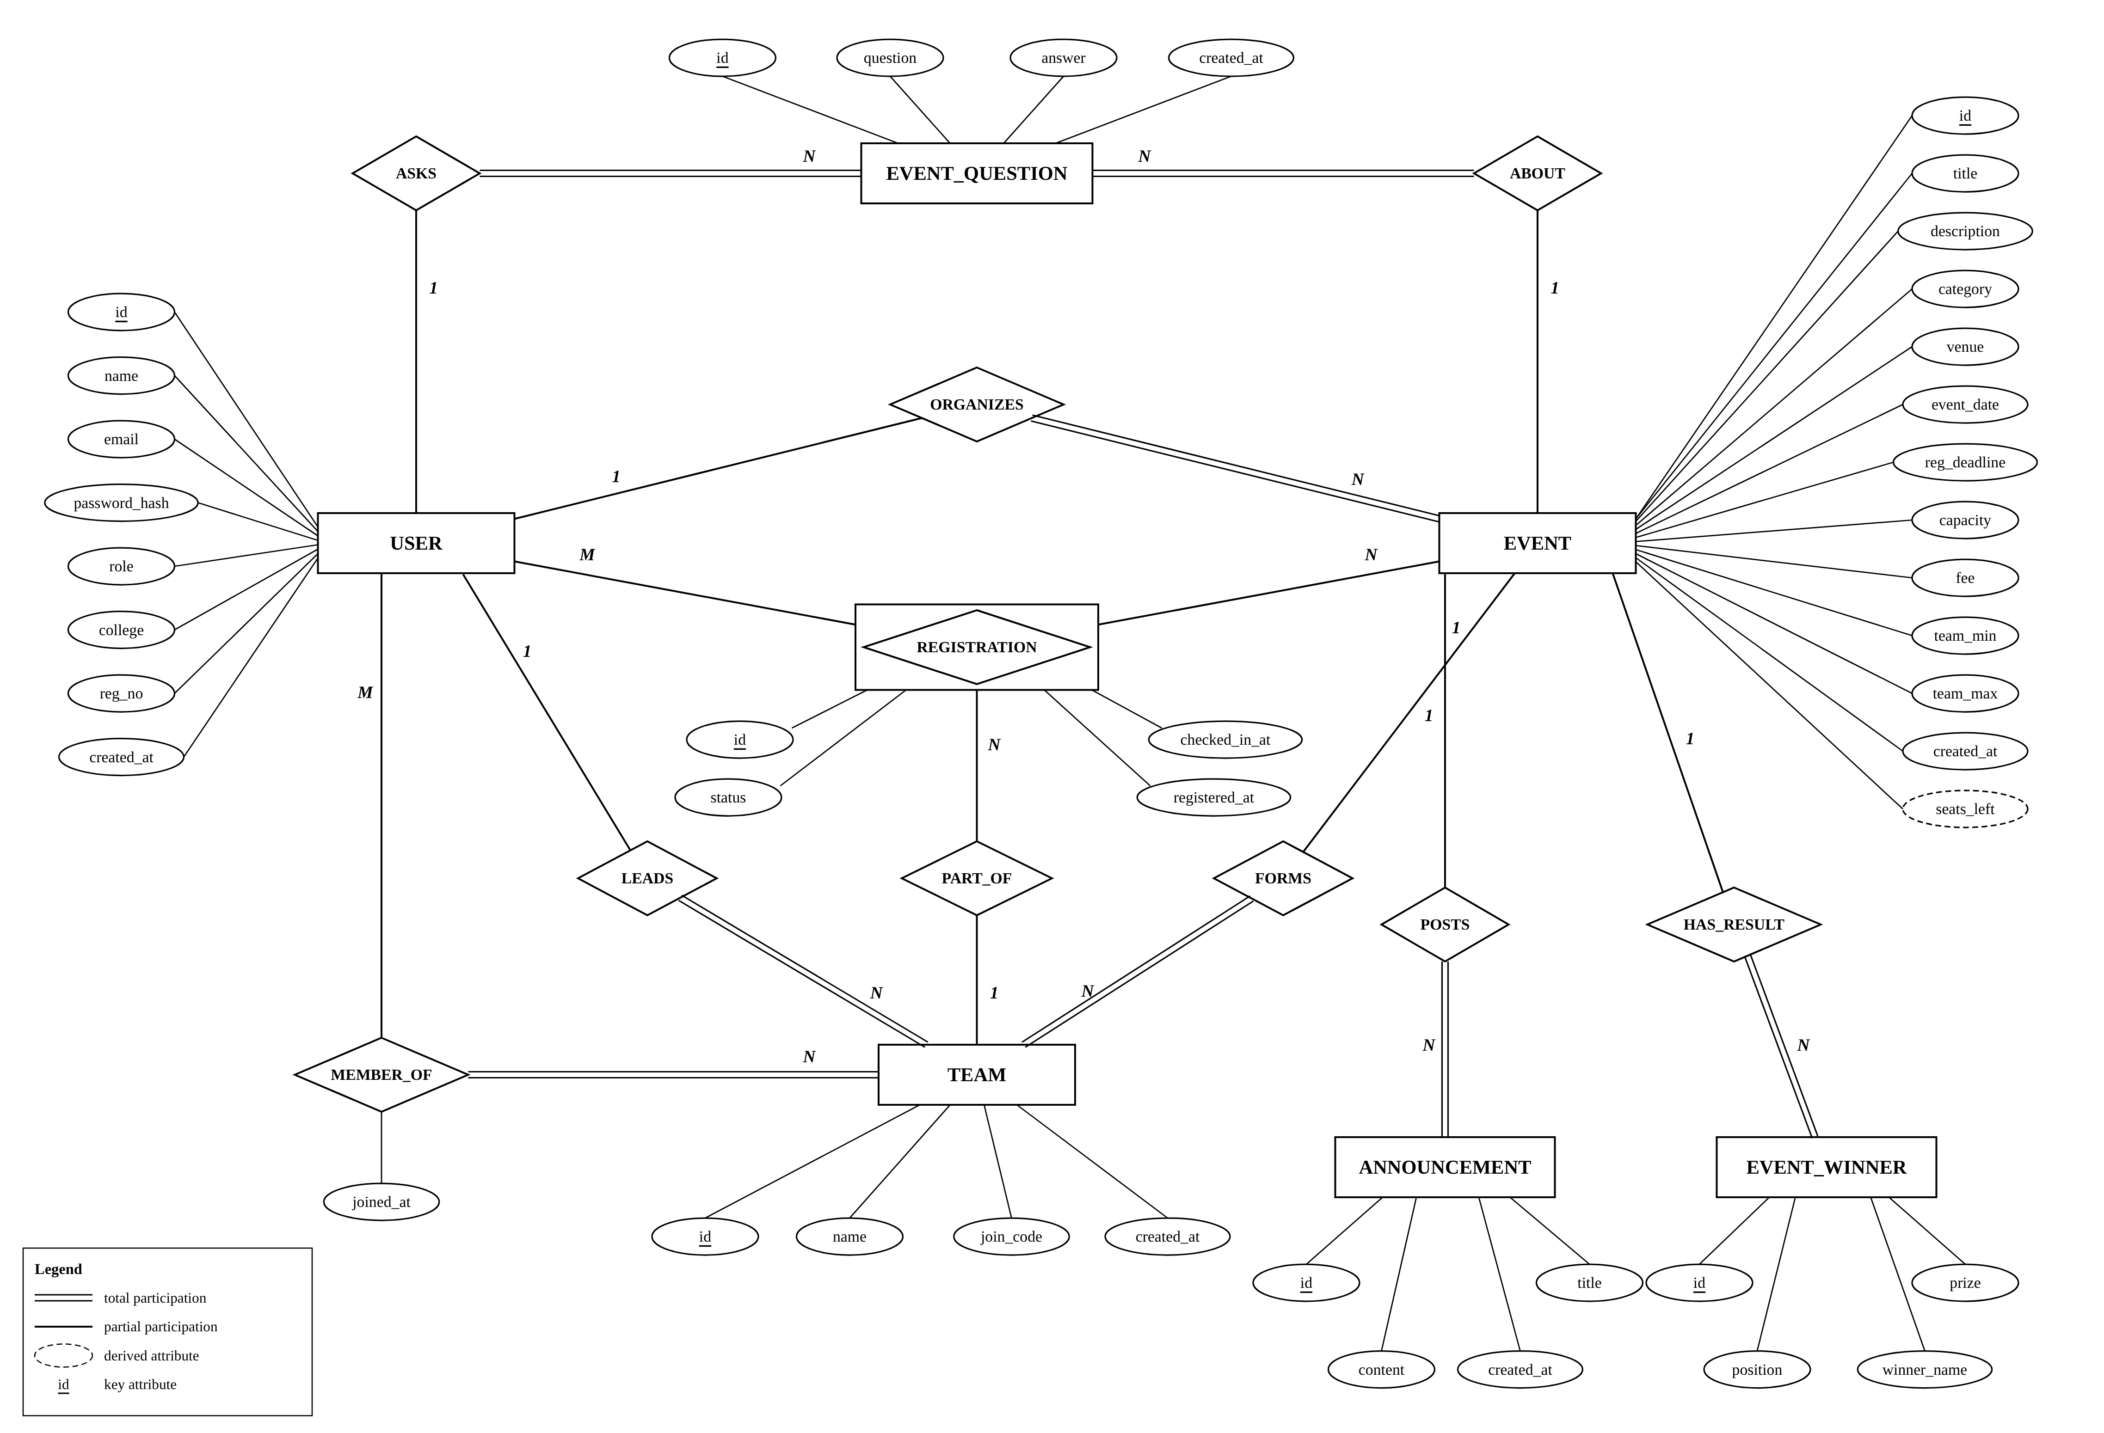
Fig. 2. Entity–Relationship diagram of ShowUp in Chen notation: seven entity sets (REGISTRATION is associative), ten relationship sets, cardinality ratios and participation constraints. The dashed ellipse marks the derived attribute seats_left = capacity − COUNT(confirmed registrations).

D. EER Specialization
Students and organizers share most attributes (name, e-mail, password, college) but take part in different relationships: only students register, join teams and ask questions, and only organizers create events. This is modelled in Fig. 3 as a specialization of the superclass USER into subclasses STUDENT and ORGANIZER on the defining attribute role. The specialization is disjoint (a user cannot be both) and total (every user is one of the two). STUDENT has the specific attribute reg_no.
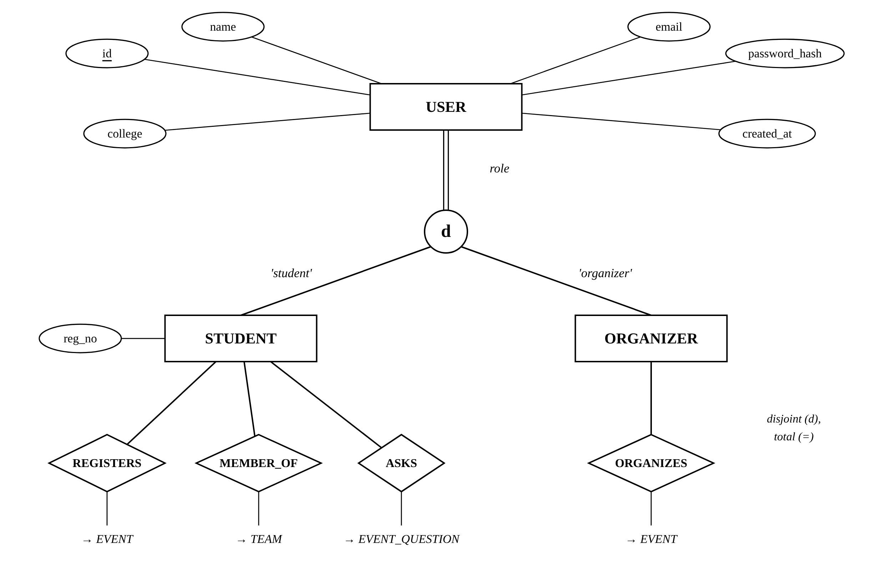
Fig. 3. EER specialization of USER into STUDENT and ORGANIZER (disjoint, total, attribute-defined on role) and the relationships in which each subclass participates.

E. Design Assumptions
- Capacity counts people, not teams, so every team member holds an individual registration and ticket.
- A join code identifies a team across the whole site, so it is unique globally; a team name need only be unique within its event.
- A cancelled registration is retained (status = cancelled) as history; re-registering reactivates the same row.
- Winners are stored by name (a team or a person) because results may include external teams.

IV. ER Diagram to Relational Model
The standard seven-step ER-to-relational mapping algorithm [1] plus Step 8 for specialization was applied. Surrogate integer keys (INT AUTO_INCREMENT) were chosen for every strong entity because natural keys such as e-mail may change and would make foreign keys wide.
TABLE VI
Application of the Mapping Algorithm
Step | Rule | Result in ShowUp
1 | Strong entity → relation | users, events, teams, announcements, event_questions, event_winners
2 | Weak entity → relation with owner key | none (all entities have surrogate keys)
3 | 1:1 relationship | none present
4 | 1:N → FK on N side | events.organizer_id, teams.event_id, teams.leader_id, announcements.event_id, event_questions.event_id / user_id, event_winners.event_id, registrations.team_id
5 | M:N → new relation | team_members(team_id, user_id) with composite PK; registrations (associative entity) with UNIQUE(user_id, event_id)
6 | Multivalued attribute | none; repeating groups removed (Section V)
7 | n-ary relationship | none
8 | Specialization | Option 8C: single relation users with type attribute role ENUM('student','organizer'); reg_no nullable

Option 8C (single relation with a type attribute) was chosen over separate subclass tables because the subclasses have only one specific attribute, the specialization is disjoint, and authentication must look a user up by e-mail regardless of role. The cost is that reg_no is NULL for organizers and that role-specific participation (e.g. only students register) is enforced in the application tier.

A. Resulting Relational Schema
Primary keys are underlined and foreign keys are shown in italics and marked with †:
users(id, name, email, password_hash, role, college, reg_no, created_at)
events(id, organizer_id†, title, description, category, venue, event_date, registration_deadline, capacity, fee, team_min, team_max, created_at)
teams(id, event_id†, name, join_code, leader_id†, created_at)
team_members(team_id†, user_id†, joined_at)
registrations(id, user_id†, event_id†, team_id†, status, checked_in_at, registered_at)
announcements(id, event_id†, title, content, created_at)
event_questions(id, event_id†, user_id†, question, answer, created_at)
event_winners(id, event_id†, position, winner_name, prize)

Fig. 4 shows the schema diagram with every referential integrity constraint, and Table VII lists the twelve foreign keys with their delete rules.

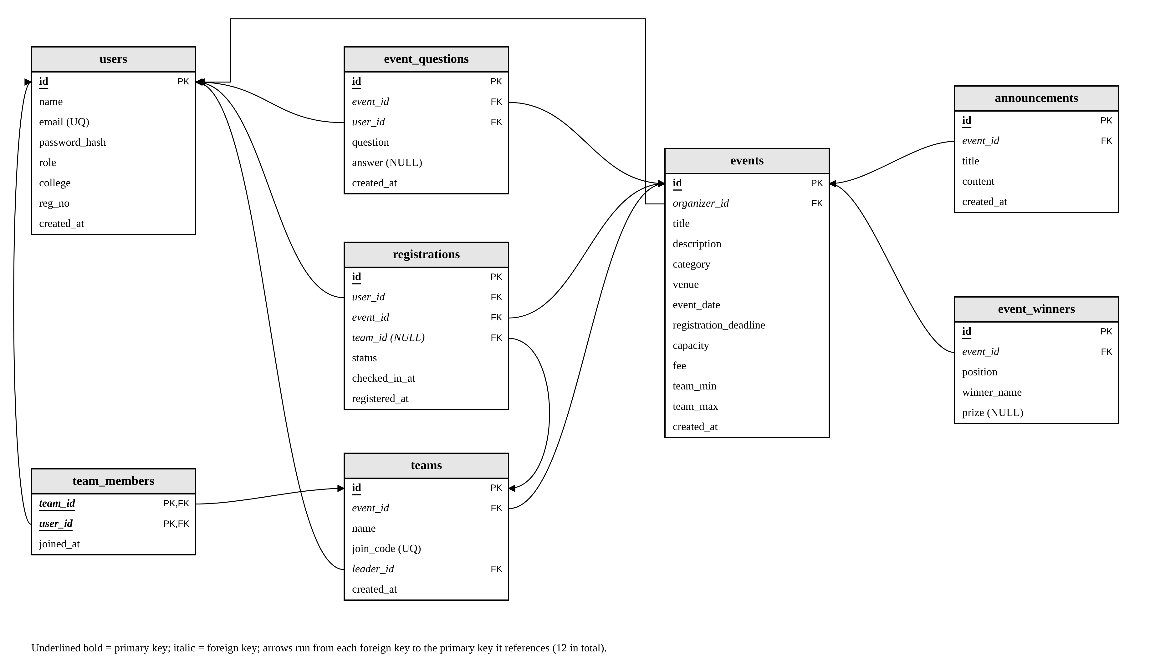
Fig. 4. Relational schema diagram. Each arrow is a FOREIGN KEY from the referencing column to the referenced primary key.

TABLE VII
Referential Integrity Constraints
Foreign key | References | On delete
events.organizer_id | users.id | CASCADE
teams.event_id | events.id | CASCADE
teams.leader_id | users.id | CASCADE
team_members.team_id | teams.id | CASCADE
team_members.user_id | users.id | CASCADE
registrations.user_id | users.id | CASCADE
registrations.event_id | events.id | CASCADE
registrations.team_id | teams.id | SET NULL
announcements.event_id | events.id | CASCADE
event_questions.event_id | events.id | CASCADE
event_questions.user_id | users.id | CASCADE
event_winners.event_id | events.id | CASCADE

CASCADE expresses existence dependency: deleting an event deletes its teams, memberships, registrations, announcements, questions and winners in a single statement. registrations.team_id uses SET NULL because a registration may legitimately outlive its team (it then becomes a solo registration rather than disappearing).

V. Normalization (1NF, 2NF, 3NF)
Normalization was carried out in two directions. First, the bottom-up view: the flat sign-up sheet used by clubs before ShowUp was normalized step by step, which independently produces the same relations as the ER mapping. Second, the verification view: the functional dependencies (FDs) of every final relation were listed and checked against the definitions of 2NF, 3NF and BCNF [1], [5].

A. Unnormalized Form (UNF)
A typical club spreadsheet has one row per team with the members typed into one cell:
EventSignupSheet(event_title, event_date, venue,
organizer_name, organizer_college, team_name,
join_code, {member_name, email, reg_no,
member_college, status, checked_in})

CodeSprint 24 | … | NeuralCraft | NC8821 |
{Ananya, ananya@…, 25BCE0101, VIT Vellore, …;
Rohan, rohan@…, 25BCE0102, VIT Vellore, …}
The braces mark a repeating group, so the relation is not even in 1NF; announcements, questions and winners would form further repeating groups per event.

B. First Normal Form
1NF requires atomic attribute values and no repeating groups. The member group is flattened into one row per (event, member), a surrogate event_id is introduced, and the primary key becomes (event_id, member_email). Per-event repeating groups (announcements, questions, winners) are moved to their own relations keyed by their own id with event_id as a foreign key.
Signup_1NF(event_id, member_email, event_title,
event_date, venue, organizer_email,
organizer_name, organizer_college, team_name,
join_code, member_name, reg_no,
member_college, status, checked_in)

C. Second Normal Form
2NF forbids partial dependencies of non-prime attributes on part of a composite key. In Signup_1NF:
FD1: event_id -> event_title, event_date, venue,
organizer_email, organizer_name,
organizer_college (partial)
FD2: member_email -> member_name, reg_no,
member_college (partial)
FD3: event_id, member_email -> team_name,
join_code, status, checked_in (full)
FD1 and FD2 are removed by decomposition into EVENT(event_id, …), MEMBER(member_email, …) and SIGNUP(event_id, member_email, team_name, join_code, status, checked_in). The decomposition is lossless because each common attribute is a key of one of the projections.

D. Third Normal Form
3NF forbids transitive dependencies of non-prime attributes on the key. Two remain:
FD4: event_id -> organizer_email
organizer_email -> organizer_name,
organizer_college
FD5: event_id, member_email -> team_name
event_id, team_name -> join_code, leader
FD4 is removed by observing that organizers are themselves users: EVENT keeps only organizer_id (a foreign key to USER), and the organizer's name and college are obtained with a JOIN. This is exactly the change made during the project's simplification phase, when event-level copies of the host college, state and city were dropped. FD5 is removed by creating TEAM(id, event_id, name, join_code, leader_id) and TEAM_MEMBERS(team_id, user_id); SIGNUP becomes REGISTRATIONS(id, user_id, event_id, team_id, status, checked_in_at, registered_at). MEMBER and organizer data merge into USERS with the attribute role, matching the EER specialization.

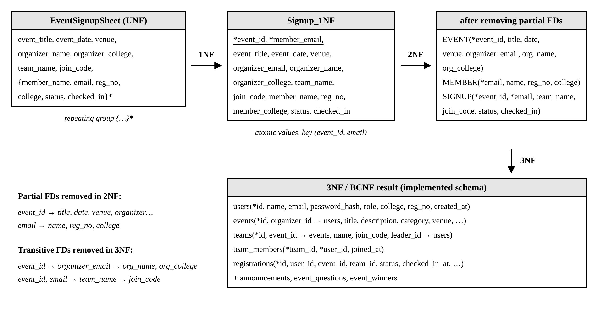
Fig. 5. Normalization of the club sign-up sheet from UNF through 1NF and 2NF to the 3NF/BCNF schema that is implemented.

E. Verification of the Final Schema (BCNF)
Table VIII lists the non-trivial FDs that hold in each implemented relation. In every case the determinant of each FD is a candidate key; hence every relation is in BCNF and therefore also in 3NF and 2NF. All attributes are atomic (1NF).
TABLE VIII
Functional Dependencies and Normal Form
Relation | Candidate keys and FDs | NF
users | id → all; email → all (email UNIQUE) | BCNF
events | id → all | BCNF
teams | id → all; join_code → all; (event_id, name) → all | BCNF
team_members | (team_id, user_id) → joined_at | BCNF
registrations | id → all; (user_id, event_id) → all | BCNF
announcements | id → all | BCNF
event_questions | id → all | BCNF
event_winners | id → all | BCNF

F. Derived Data and Controlled Redundancy
Seats left is not stored: it is computed as capacity − COUNT(*) of confirmed registrations. Storing it would create an update anomaly whenever a registration is inserted, cancelled or reactivated. One controlled redundancy remains across relations: for a team registration, the pair (user, team) appears both in team_members and as registrations.team_id. It is not a normal-form violation (each relation is BCNF) but an inter-relational dependency; it is kept so that capacity and tickets are per person while team size is counted from team_members. Both rows are always written or removed inside the same transaction (Section IX), so they cannot diverge.

VI. Database Design and Table Creation (DDL)
The schema is created by the script sql/schema.sql. Tables are created parent-first (users → events → teams → team_members → registrations → announcements → event_questions → event_winners) so that every foreign key references an existing table. Every statement uses CREATE TABLE IF NOT EXISTS, so the script is idempotent and never destroys data; a separate reset.sql drops the tables for local development only. Table IX is the data dictionary and Listing 1 the DDL.

TABLE IX
Data Dictionary
Table | Column(s) | Data type | Constraints | Description
users | id | INT | PK, AUTO_INCREMENT | Surrogate key
 | name | VARCHAR(100) | NOT NULL | Full name / club name
 | email | VARCHAR(255) | NOT NULL, UNIQUE | Login identifier
 | password_hash | VARCHAR(255) | NOT NULL | bcrypt hash, never the password
 | role | ENUM | NOT NULL, DEFAULT 'student' | 'student' | 'organizer' (specialization)
 | college / reg_no | VARCHAR(150) / (30) | NULL | Optional profile data
 | created_at | TIMESTAMP | DEFAULT CURRENT_TIMESTAMP | Account creation
events | id | INT | PK, AUTO_INCREMENT | Surrogate key
 | organizer_id | INT | NOT NULL, FK → users | Owning organizer
 | title / description | VARCHAR(200) / TEXT | NOT NULL | Content shown to students
 | category / venue | VARCHAR(50) / (200) | NOT NULL | Hackathon, Workshop, …
 | event_date | DATETIME | NOT NULL | Start (UTC)
 | registration_deadline | DATETIME | NOT NULL | Registrations close
 | capacity | INT | NOT NULL, CHECK > 0 | Max confirmed people
 | fee | INT | DEFAULT 0, CHECK ≥ 0 | Informational (₹)
 | team_min / team_max | INT | DEFAULT 1, CHECK 1 ≤ min ≤ max | team_max = 1 ⇒ solo event
teams | id | INT | PK, AUTO_INCREMENT | Surrogate key
 | event_id | INT | NOT NULL, FK → events | Event entered
 | name | VARCHAR(100) | NOT NULL, UNIQUE(event_id, name) | Team name
 | join_code | VARCHAR(10) | NOT NULL, UNIQUE | 6-char code shared with friends
 | leader_id | INT | NOT NULL, FK → users | Current leader
team_members | team_id, user_id | INT, INT | composite PK; FKs | M:N users ↔ teams
 | joined_at | TIMESTAMP | DEFAULT CURRENT_TIMESTAMP | Used for leader succession
registrations | id | INT | PK, AUTO_INCREMENT | Ticket number in QR code
 | user_id / event_id | INT | NOT NULL, FKs; UNIQUE(user_id, event_id) | One row per person per event
 | team_id | INT | NULL, FK → teams (SET NULL) | NULL for solo
 | status | ENUM | DEFAULT 'confirmed' | 'confirmed' | 'cancelled'
 | checked_in_at | DATETIME | NULL | Attendance timestamp
announcements | id, event_id, title, content, created_at | INT, INT, VARCHAR(150), TEXT, TIMESTAMP | PK; FK → events; NOT NULL | Organizer notices
event_questions | id, event_id, user_id, question, answer | INT, INT, INT, TEXT, TEXT | PK; FKs; answer NULL | Student Q&A
event_winners | id, event_id, position, winner_name, prize | INT, INT, INT, VARCHAR(150), VARCHAR(100) | PK; FK; CHECK position ≥ 1 | Results podium

Listing 1. DDL for the ShowUp database (sql/schema.sql, comments omitted).
CREATE DATABASE IF NOT EXISTS showup
CHARACTER SET utf8mb4
COLLATE utf8mb4_0900_ai_ci;
USE showup;

CREATE TABLE IF NOT EXISTS users (
id INT AUTO_INCREMENT PRIMARY KEY,
name VARCHAR(100) NOT NULL,
email VARCHAR(255) NOT NULL UNIQUE,
password_hash VARCHAR(255) NOT NULL,
role ENUM('student','organizer')
NOT NULL DEFAULT 'student',
college VARCHAR(150) NULL,
reg_no VARCHAR(30) NULL,
created_at TIMESTAMP NOT NULL
DEFAULT CURRENT_TIMESTAMP
) ENGINE = InnoDB;

CREATE TABLE IF NOT EXISTS events (
id INT AUTO_INCREMENT PRIMARY KEY,
organizer_id INT NOT NULL,
title VARCHAR(200) NOT NULL,
description TEXT NOT NULL,
category VARCHAR(50) NOT NULL,
venue VARCHAR(200) NOT NULL,
event_date DATETIME NOT NULL,
registration_deadline DATETIME NOT NULL,
capacity INT NOT NULL,
fee INT NOT NULL DEFAULT 0,
team_min INT NOT NULL DEFAULT 1,
team_max INT NOT NULL DEFAULT 1,
created_at TIMESTAMP NOT NULL
DEFAULT CURRENT_TIMESTAMP,
FOREIGN KEY (organizer_id)
REFERENCES users (id) ON DELETE CASCADE,
CHECK (capacity > 0),
CHECK (fee >= 0),
CHECK (team_min >= 1 AND team_max >= team_min)
) ENGINE = InnoDB;

CREATE TABLE IF NOT EXISTS teams (
id INT AUTO_INCREMENT PRIMARY KEY,
event_id INT NOT NULL,
name VARCHAR(100) NOT NULL,
join_code VARCHAR(10) NOT NULL UNIQUE,
leader_id INT NOT NULL,
created_at TIMESTAMP NOT NULL
DEFAULT CURRENT_TIMESTAMP,
UNIQUE (event_id, name),
FOREIGN KEY (event_id)
REFERENCES events (id) ON DELETE CASCADE,
FOREIGN KEY (leader_id)
REFERENCES users (id) ON DELETE CASCADE
) ENGINE = InnoDB;

CREATE TABLE IF NOT EXISTS team_members (
team_id INT NOT NULL,
user_id INT NOT NULL,
joined_at TIMESTAMP NOT NULL
DEFAULT CURRENT_TIMESTAMP,
PRIMARY KEY (team_id, user_id),
FOREIGN KEY (team_id)
REFERENCES teams (id) ON DELETE CASCADE,
FOREIGN KEY (user_id)
REFERENCES users (id) ON DELETE CASCADE
) ENGINE = InnoDB;

CREATE TABLE IF NOT EXISTS registrations (
id INT AUTO_INCREMENT PRIMARY KEY,
user_id INT NOT NULL,
event_id INT NOT NULL,
team_id INT NULL,
status ENUM('confirmed','cancelled')
NOT NULL DEFAULT 'confirmed',
checked_in_at DATETIME NULL,
registered_at TIMESTAMP NOT NULL
DEFAULT CURRENT_TIMESTAMP,
UNIQUE (user_id, event_id),
FOREIGN KEY (user_id)
REFERENCES users (id) ON DELETE CASCADE,
FOREIGN KEY (event_id)
REFERENCES events (id) ON DELETE CASCADE,
FOREIGN KEY (team_id)
REFERENCES teams (id) ON DELETE SET NULL
) ENGINE = InnoDB;

CREATE TABLE IF NOT EXISTS announcements (
id INT AUTO_INCREMENT PRIMARY KEY,
event_id INT NOT NULL,
title VARCHAR(150) NOT NULL,
content TEXT NOT NULL,
created_at TIMESTAMP NOT NULL
DEFAULT CURRENT_TIMESTAMP,
FOREIGN KEY (event_id)
REFERENCES events (id) ON DELETE CASCADE
) ENGINE = InnoDB;

CREATE TABLE IF NOT EXISTS event_questions (
id INT AUTO_INCREMENT PRIMARY KEY,
event_id INT NOT NULL,
user_id INT NOT NULL,
question TEXT NOT NULL,
answer TEXT NULL,
created_at TIMESTAMP NOT NULL
DEFAULT CURRENT_TIMESTAMP,
FOREIGN KEY (event_id)
REFERENCES events (id) ON DELETE CASCADE,
FOREIGN KEY (user_id)
REFERENCES users (id) ON DELETE CASCADE
) ENGINE = InnoDB;

CREATE TABLE IF NOT EXISTS event_winners (
id INT AUTO_INCREMENT PRIMARY KEY,
event_id INT NOT NULL,
position INT NOT NULL,
winner_name VARCHAR(150) NOT NULL,
prize VARCHAR(100) NULL,
FOREIGN KEY (event_id)
REFERENCES events (id) ON DELETE CASCADE,
CHECK (position >= 1)
) ENGINE = InnoDB;

TABLE X
Summary of Declarative Constraints
Constraint | Count | Examples
PRIMARY KEY | 8 | 7 surrogate INT keys; composite (team_id, user_id)
FOREIGN KEY | 12 | 11 CASCADE, 1 SET NULL (Table VII)
UNIQUE | 4 | users.email, teams.join_code, (event_id, name), (user_id, event_id)
CHECK | 4 | capacity > 0, fee ≥ 0, 1 ≤ team_min ≤ team_max, position ≥ 1
ENUM domain | 2 | users.role, registrations.status
DEFAULT | 11 | role, status, fee, team sizes, all timestamps

InnoDB was selected because it supports foreign keys, transactions and row-level locking. MySQL 8.0.16 or later is required because earlier versions parse but silently ignore CHECK constraints [7]. InnoDB automatically creates an index for every primary key, UNIQUE constraint and foreign key, so all join columns used by the application are indexed without additional DDL. The created structure was verified with SHOW TABLES, DESCRIBE and a query on information_schema.REFERENTIAL_CONSTRAINTS, which returned the twelve foreign keys with the expected delete rules.

VII. Data Population (DML)
Sample data is loaded by sql/seed.sql. Ids are written explicitly so that foreign keys in later INSERT statements are easy to follow, and event dates are expressed relative to CURDATE() so the demonstration always contains upcoming, open events as well as one completed event with results. Every demo account uses the password password123; only its bcrypt hash is stored. Table XI summarizes the data set.
TABLE XI
Sample Data Loaded by seed.sql
Table | Rows | Content
users | 8 | 3 organizers (VIT Vellore, VIT Chennai, IIT Madras), 5 students
events | 7 | 2 hackathons, workshop, 2 competitions, cultural, talk; 1 in the past
teams | 3 | NeuralCraft (NC8821), BotBusters, ByteForge
team_members | 6 | Members of the three teams
registrations | 9 | 8 confirmed (3 checked in), 1 cancelled
announcements | 3 | Mentor schedule, desk timing, results
event_questions | 3 | 2 answered, 1 unanswered (answer IS NULL)
event_winners | 4 | 1st–3rd place and a special mention

Listing 2. Representative INSERT statements from seed.sql (abridged).
SET time_zone = '+00:00';
INSERT INTO users
(id, name, email, password_hash, role,
college, reg_no) VALUES
(1, 'Code Cell', 'codecell@showup.local',
'$2b$10$A8P…', 'organizer', 'VIT Vellore', NULL),
(4, 'Ananya Sharma', 'ananya@showup.local',
'$2b$10$A8P…', 'student', 'VIT Vellore',
'25BCE0101');

INSERT INTO events (id, organizer_id, title,
description, category, venue, event_date,
registration_deadline, capacity, fee,
team_min, team_max) VALUES
(1, 1, 'CodeSprint 24', 'Form a team of 2-4…',
'Hackathon', 'Technology Tower',
TIMESTAMP(CURDATE() + INTERVAL 6 DAY,'09:00'),
TIMESTAMP(CURDATE() + INTERVAL 5 DAY,'23:59'),
40, 0, 2, 4);

INSERT INTO teams (id, event_id, name,
join_code, leader_id)
VALUES (1, 1, 'NeuralCraft', 'NC8821', 4);
INSERT INTO team_members (team_id, user_id)
VALUES (1, 4), (1, 5);
INSERT INTO registrations (id, user_id,
event_id, team_id, status) VALUES
(1, 4, 1, 1, 'confirmed'),
(2, 5, 1, 1, 'confirmed');

A. DML Issued by the Application
At run time the application performs all four kinds of data manipulation. Representative statements (with ? placeholders bound by the driver) are:
Listing 3. Run-time UPDATE and DELETE statements.
-- cancel: keep the row as history
UPDATE registrations
SET status = 'cancelled', team_id = NULL
WHERE id = ?;

-- check-in: idempotent, guarded by WHERE
UPDATE registrations
SET checked_in_at = CURRENT_TIMESTAMP
WHERE id = ? AND status = 'confirmed'
AND checked_in_at IS NULL;

-- leader leaves: earliest member succeeds
UPDATE teams SET leader_id =
(SELECT user_id FROM team_members
WHERE team_id = ?
ORDER BY joined_at, user_id LIMIT 1)
WHERE id = ? AND leader_id = ?;

-- delete event: cascades to 6 child tables
DELETE FROM events WHERE id = ?;

B. Retrieval Queries and Results
The queries below exercise inner and outer joins, aggregation, grouping, HAVING and NULL handling. Their output was captured from the seeded MySQL 8.0.46 database and is reproduced in Listings 4–6.

Listing 4. Seats taken per event — INNER JOIN, LEFT JOIN, COUNT, GROUP BY (the query behind GET /api/events).
SELECT e.id, e.title, u.name AS organizer, e.capacity, COUNT(r.id) AS registered
FROM events e
JOIN users u ON u.id = e.organizer_id
LEFT JOIN registrations r ON r.event_id = e.id AND r.status = 'confirmed'
GROUP BY e.id ORDER BY e.event_date;

+----+----------------------------+-------------------------+----------+------------+
| id | title | organizer | capacity | registered |
+----+----------------------------+-------------------------+----------+------------+
| 7 | Hack Night 2026 | Code Cell | 30 | 3 |
| 2 | Figma to Front-End | Code Cell | 60 | 2 |
| 1 | CodeSprint 24 | Code Cell | 40 | 2 |
| 5 | Founders' Fireside | Code Cell | 120 | 0 |
| 3 | Valorant 5v5 Showdown | Cultural & Esports Club | 70 | 0 |
| 4 | Battle of the Bands | Cultural & Esports Club | 48 | 0 |
| 6 | Line Follower Championship | Robotics Club | 30 | 1 |
+----+----------------------------+-------------------------+----------+------------+

Listing 5. Members of a team — M:N resolution through team_members.
SELECT t.name AS team, t.join_code,
u.name AS member,
(u.id = t.leader_id) AS is_leader
FROM teams t
JOIN team_members tm ON tm.team_id = t.id
JOIN users u ON u.id = tm.user_id
WHERE t.join_code = 'NC8821';

+-------------+-----------+---------------+-----------+
| team | join_code | member | is_leader |
+-------------+-----------+---------------+-----------+
| NeuralCraft | NC8821 | Ananya Sharma | 1 |
| NeuralCraft | NC8821 | Rohan Mehta | 0 |
+-------------+-----------+---------------+-----------+

The LEFT JOIN in Listing 4 is essential: events with no registrations (e.g. Founders' Fireside) still appear with a count of 0, whereas an inner join would drop them. The condition r.status = 'confirmed' is placed in the ON clause rather than WHERE for the same reason.
Listing 6. Attendance per event — COUNT(*) versus COUNT(column) on a nullable column.
SELECT e.title, COUNT(*) AS confirmed,
COUNT(r.checked_in_at) AS checked_in
FROM registrations r
JOIN events e ON e.id = r.event_id
WHERE r.status = 'confirmed'
GROUP BY e.id, e.title;

+----------------------------+-----------+------------+
| title | confirmed | checked_in |
+----------------------------+-----------+------------+
| CodeSprint 24 | 2 | 0 |
| Figma to Front-End | 2 | 0 |
| Line Follower Championship | 1 | 0 |
| Hack Night 2026 | 3 | 3 |
+----------------------------+-----------+------------+

Listing 6 relies on the fact that COUNT(column) ignores NULLs, so the same pass yields both confirmed and checked-in totals. Two further queries are used by the organizer screens: teams below the minimum size (GROUP BY t.id … HAVING COUNT(tm.user_id) < e.team_min, which correctly returns an empty set on the seed data because every team meets its minimum) and unanswered questions (WHERE q.answer IS NULL, which returns Sameer Khan's question about overnight food for CodeSprint 24).

VIII. Front-End Design
The user interface is a single-page application written in React 19 with TypeScript and bundled by Vite; styling uses Tailwind CSS with a dark theme and a coral accent colour. Fig. 1 shows its position in the three-tier architecture. The browser never connects to MySQL: every screen obtains its data through the typed wrapper src/lib/api.ts, which attaches the user's token to each HTTP request.
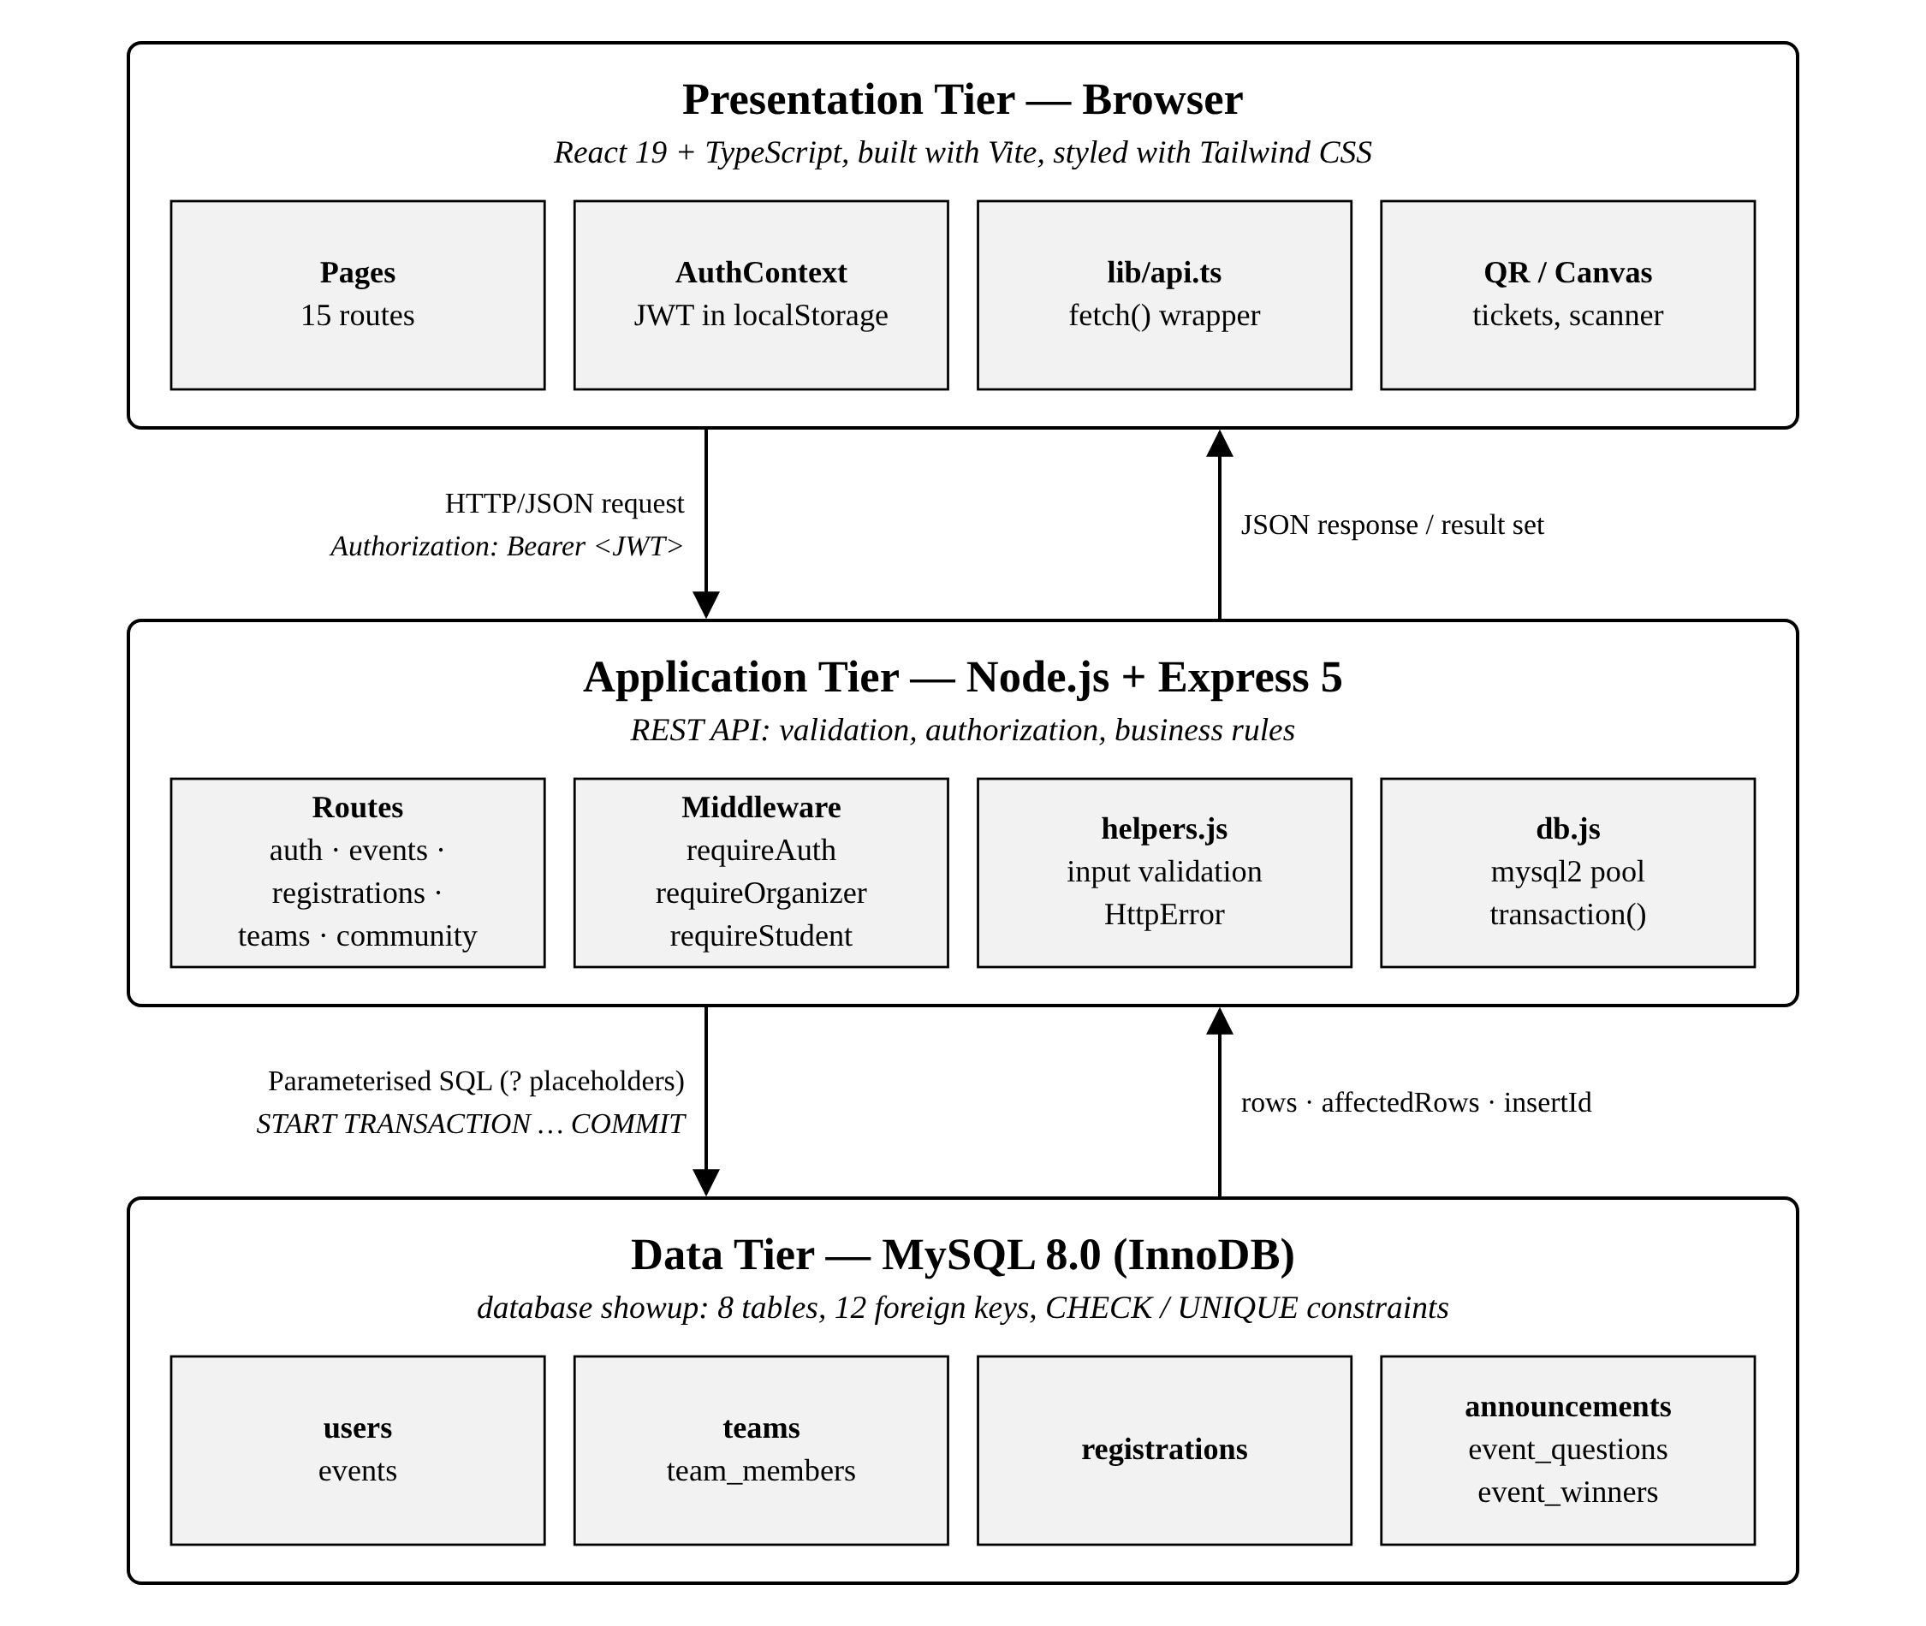
Fig. 1. Three-tier architecture: presentation tier (React), application tier (Express) and data tier (MySQL 8 InnoDB).

A. Design Principles
- Role-aware navigation—the navbar shows My Events to students and Organizer Studio to organizers; protected routes redirect signed-out visitors to log in and back.
- Database values are always live—seats left, team size and check-in counts are recomputed by SQL on each load rather than cached in the browser.
- Errors from the server are shown verbatim—e.g. "Sorry, this event is full."—so constraint violations are understandable to users.
- Purely client-side conveniences (bookmarks, calendar export, map distance, PNG pass) are kept out of the database to keep the schema small.
TABLE XII
Pages, Routes and Underlying Data
Page (route) | Purpose | Tables read / written
Landing (/) | Introduction, entry points | —
Sign up, Log in | Create account, obtain JWT | users
Events (/events) | Search, filter, sort, bookmark | events ⋈ users ⟕ registrations
Event detail | Overview, Announcements, Q&A, Winners tabs; register / create / join team | events, registrations, teams, team_members, announcements, event_questions, event_winners
My Events (/dashboard) | Tickets, team, cancel, calendar | registrations ⋈ events ⟕ teams
Profile | Account details and counts | users, registrations, team_members
Organizer Studio | Own events with fill rate; edit, delete | events, registrations
Create / Edit event | Validated event form | events
Participants | By team / all, KPIs, CSV export | registrations ⋈ users ⟕ teams
QR Check-in | Camera scan or manual ticket entry | registrations

Screenshots of the running system with the seed data are shown in Fig. 6–Fig. 10.

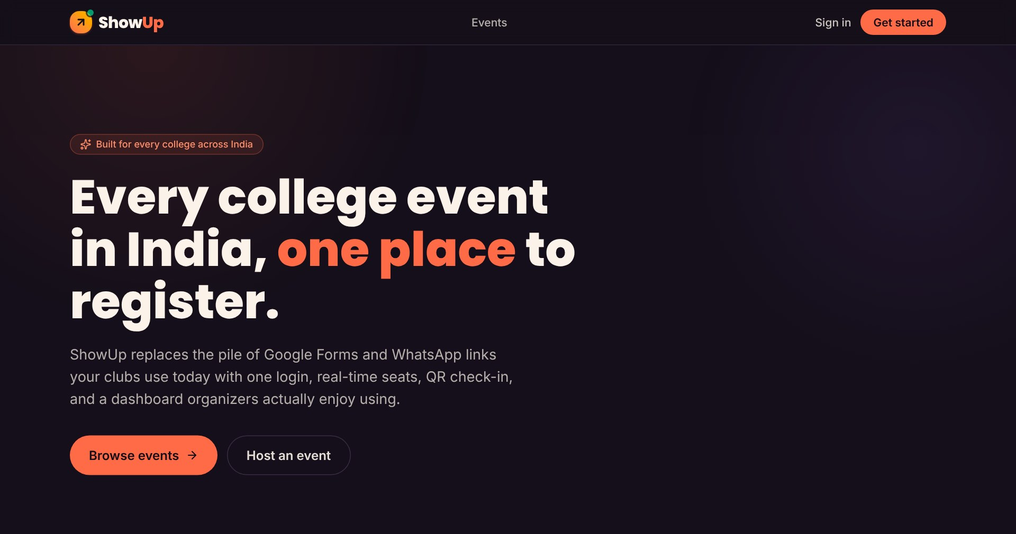  (a) Landing page | 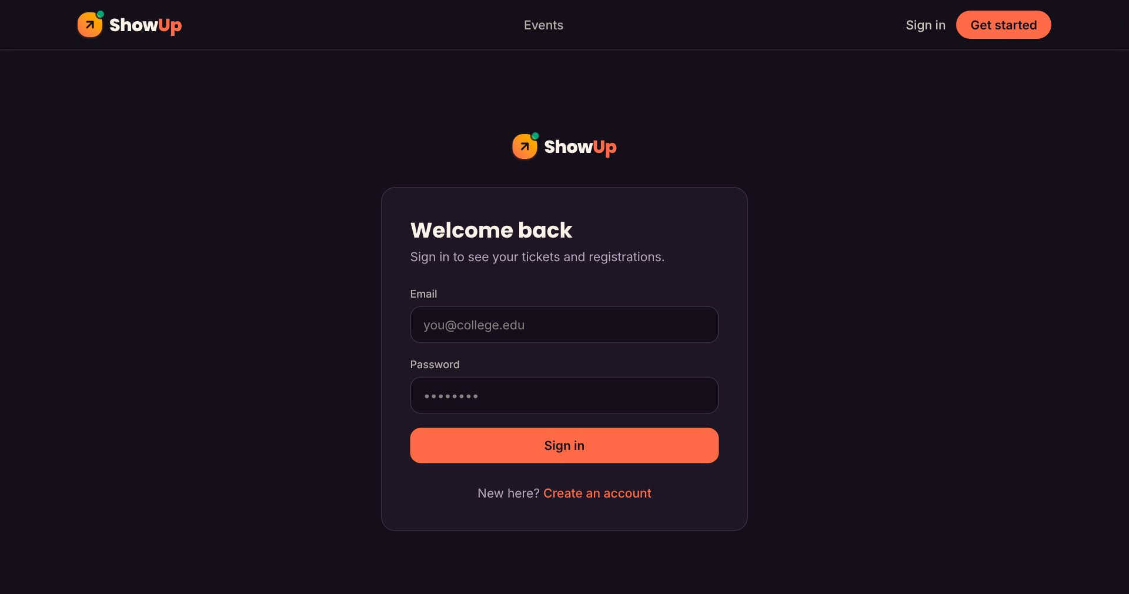  (b) Log-in form
Fig. 6. Public pages. Signing in returns a JWT that the browser stores and sends with every API request.
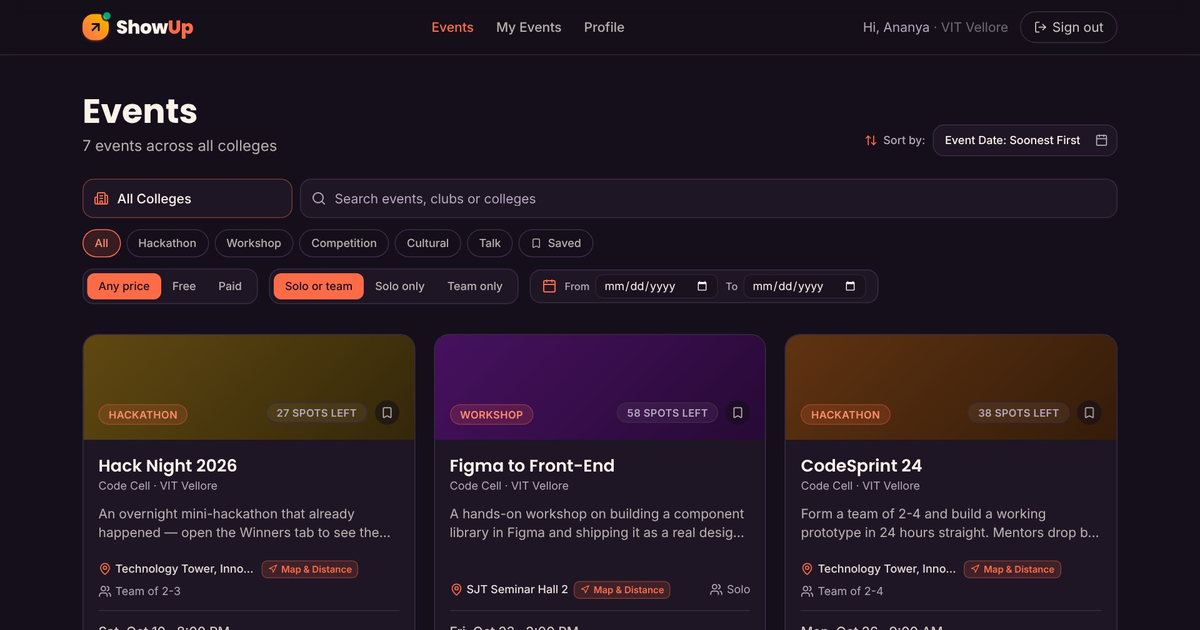  (a) Event directory with filters and live seats left | 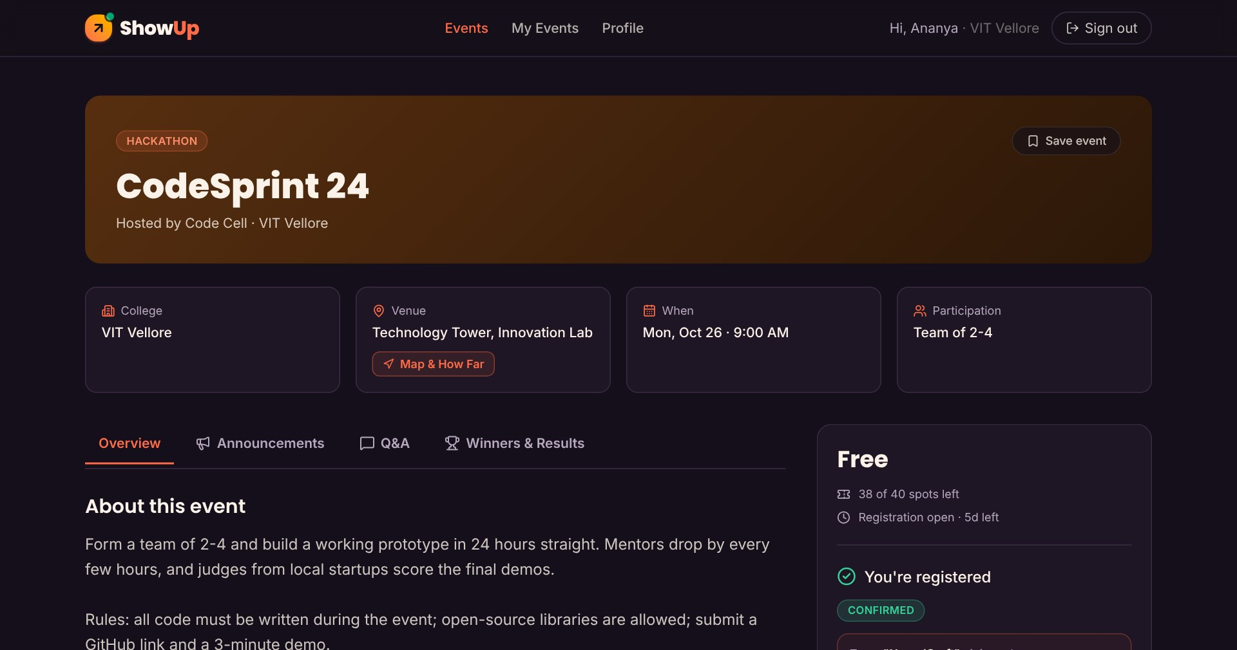  (b) Event detail with team join code
Fig. 7. Student discovery and registration. "27 spots left" on each card is capacity minus the COUNT of confirmed registrations computed by SQL.

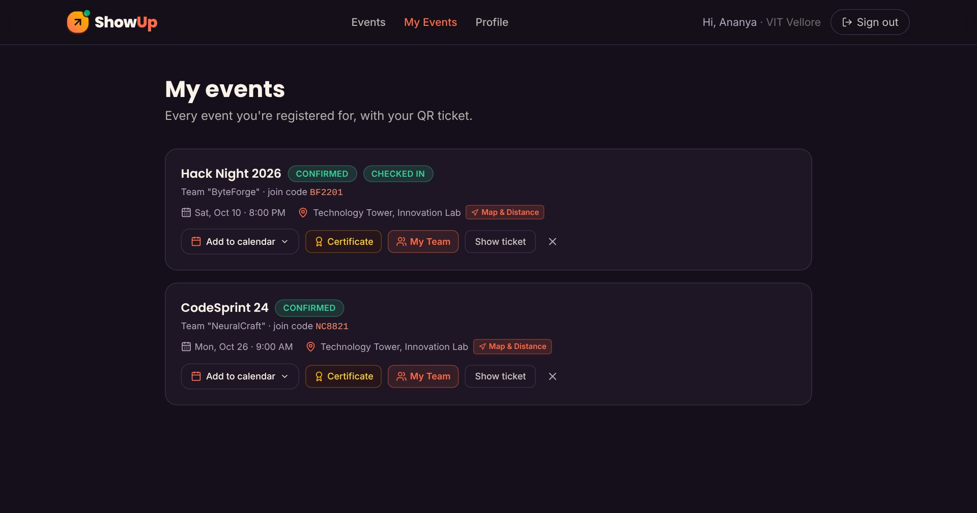  (a) My Events — tickets, team, certificate | 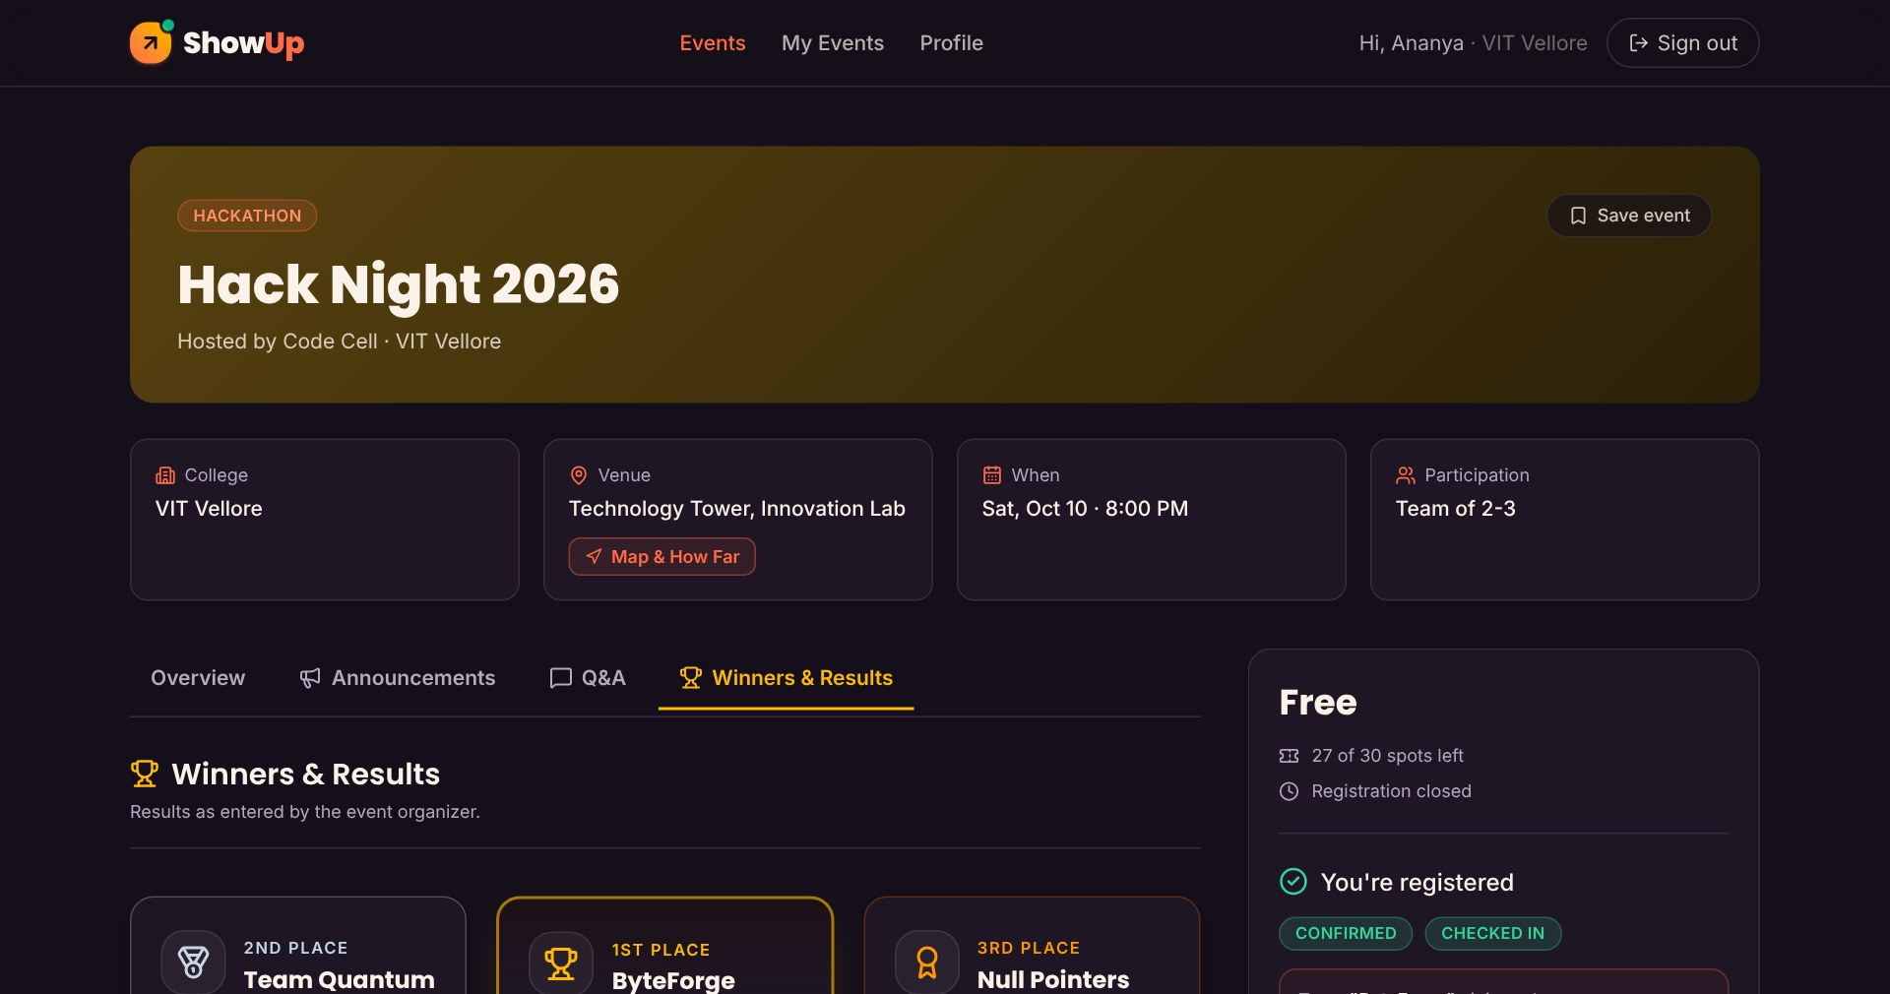  (b) Winners & Results tab
Fig. 8. Student dashboard and results podium read from registrations and event_winners.
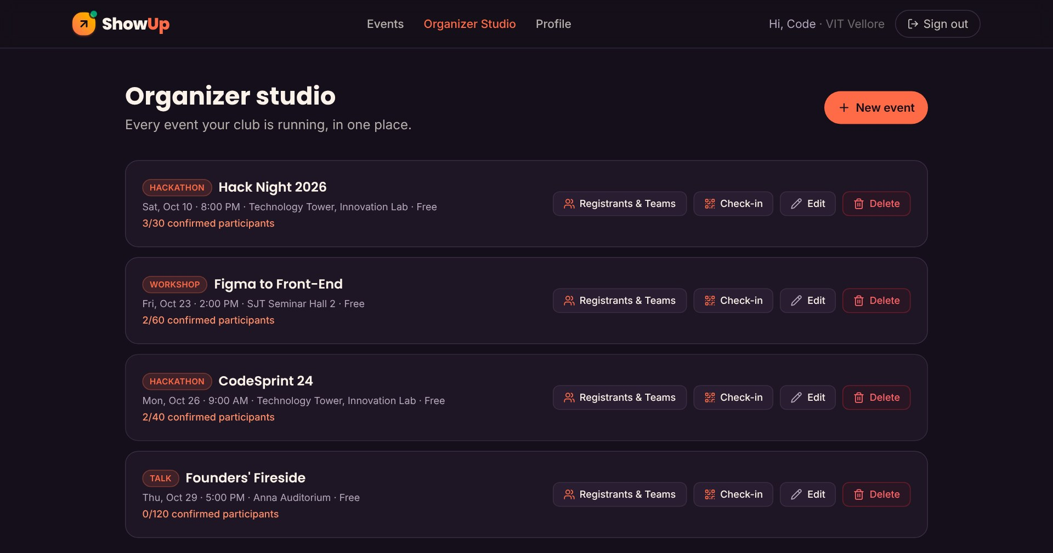  (a) Organizer Studio | 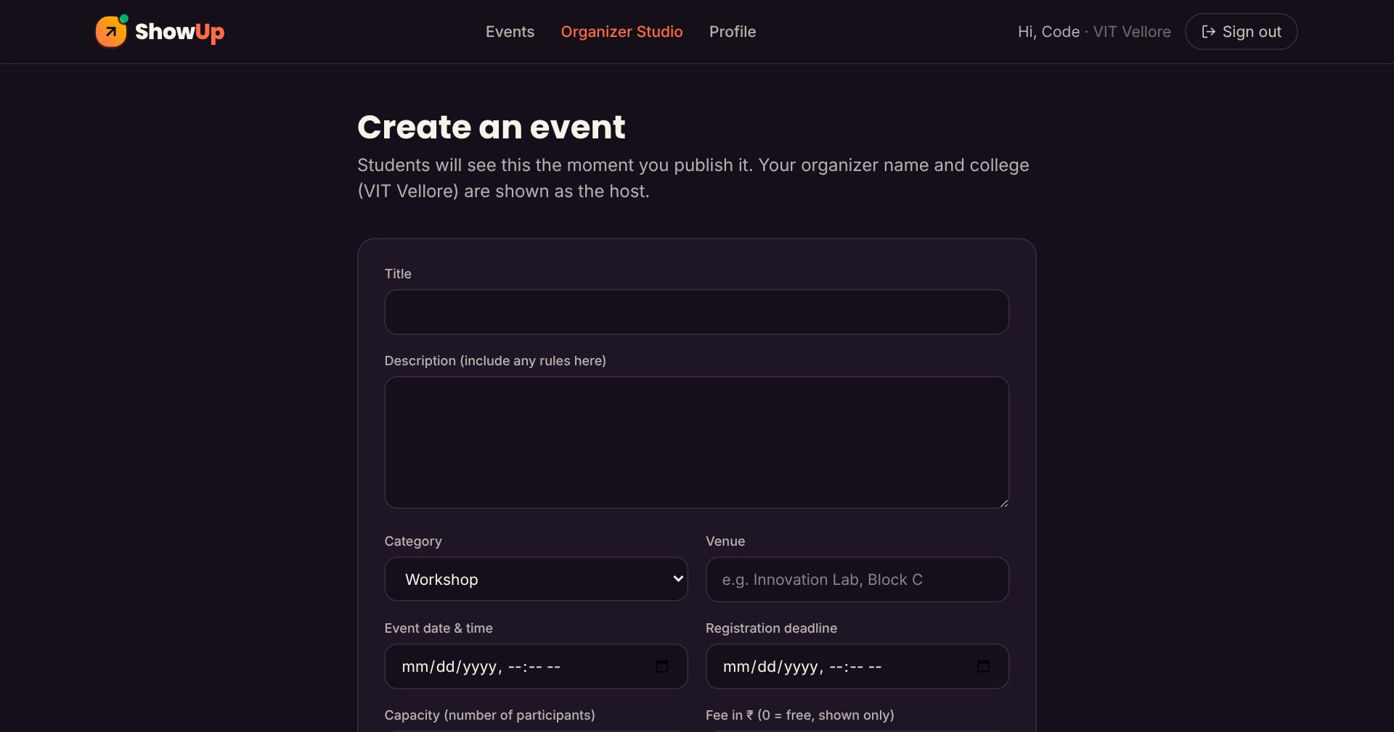  (b) Create-event form
Fig. 9. Organizer pages for event CRUD; the form enforces the same rules as the CHECK constraints.
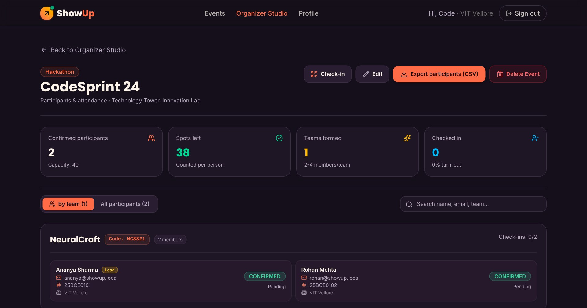  (a) Participants grouped by team | 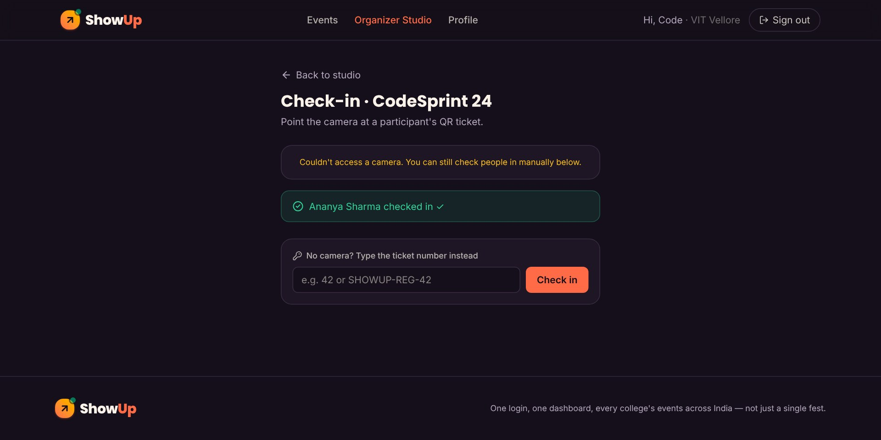  (b) QR check-in (manual entry shown)
Fig. 10. Attendance management. A successful check-in sets registrations.checked_in_at.

IX. Business Logic Implementation
Business rules are enforced in two layers. Rules that can be expressed declaratively are placed in the schema, so they hold no matter which client modifies the data; rules that depend on time, on aggregates or on the identity of the requester are implemented in the Express route handlers inside transactions. Where possible a rule is enforced in both layers—the application gives a friendly message and the constraint is the backstop.
TABLE XIII
Business Rules and Where They Are Enforced
ID | Rule | Enforced by
BR-1 | E-mail is unique per account | UNIQUE + API (409)
BR-2 | Capacity > 0; fee ≥ 0; 1 ≤ team_min ≤ team_max | CHECK + API (400)
BR-3 | Deadline must precede event date | API
BR-4 | No registration after the deadline | API (in transaction)
BR-5 | One registration per student per event | UNIQUE + API (409)
BR-6 | Confirmed registrations ≤ capacity | API: lock + COUNT
BR-7 | Solo events: register; team events: create/join | API
BR-8 | Team size ≤ team_max when joining | API: COUNT team_members
BR-9 | Team names unique within an event | UNIQUE(event_id, name)
BR-10 | Only students register; only organizers create events | Middleware
BR-11 | Only the owner organizer edits, deletes, checks in | API ownership check
BR-12 | Capacity cannot be lowered below current count | API
BR-13 | A ticket is checked in at most once | Guarded UPDATE
BR-14 | Leader leaves → earliest member leads; empty team deleted | API (in transaction)

A. Registration Transaction
Fig. 11 shows the algorithm for a solo registration. The decisive step is SELECT … FOR UPDATE on the event row: InnoDB grants an exclusive row lock that is held until COMMIT or ROLLBACK, so concurrent registrations for the same event are serialized and the capacity check followed by INSERT behaves atomically [14]. Registrations for different events lock different rows and proceed in parallel. If any check fails the handler throws, and the transaction helper issues ROLLBACK.
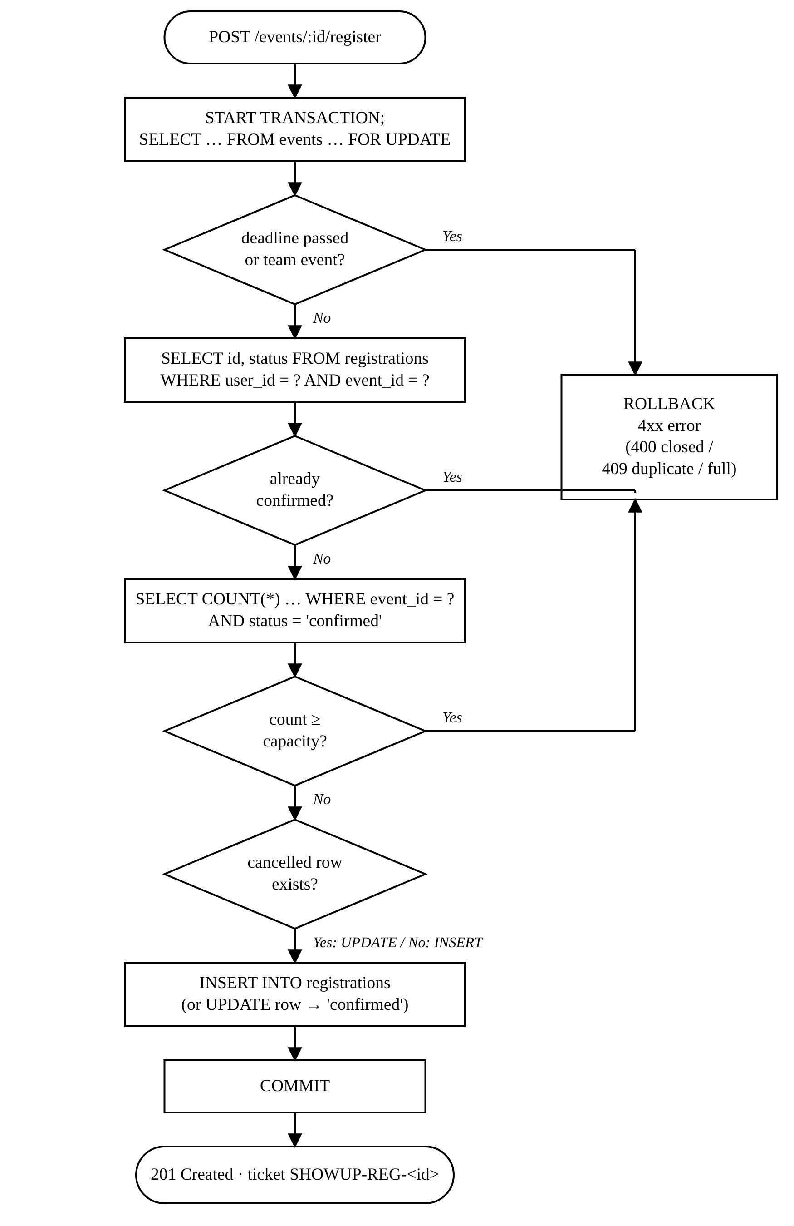
Fig. 11. Flowchart of the solo-registration transaction (POST /api/events/:id/register).
Listing 7. Shared registration steps (server/routes/registrations.js, abridged).
async function lockOpenEvent(conn, eventId) {
const [[event]] = await conn.query(
"SELECT * FROM events WHERE id = ? FOR UPDATE",
[eventId]);
if (!event) throw new HttpError(404, "Event not found.");
if (new Date(event.registration_deadline) < new Date())
throw new HttpError(400, "Registration … closed.");
return event;
}
async function ensureSeatAvailable(conn, event) {
const [[{ taken }]] = await conn.query(
`SELECT COUNT(*) AS taken FROM registrations
WHERE event_id = ? AND status = 'confirmed'`,
[event.id]);
if (taken >= event.capacity)
throw new HttpError(409, "Sorry, this event is full.");
}

B. Team Creation and Joining
Creating a team locks the event, checks the deadline, duplicate registration and capacity, then inserts into teams, team_members and registrations in one transaction. The join code is six characters drawn with crypto.randomInt from a 32-symbol alphabet that omits look-alike characters (0/O, 1/I), giving 32⁶ ≈ 1.07 × 10⁹ codes; uniqueness is checked before insertion and guaranteed by the UNIQUE constraint. Joining looks the team up by code, locks its event, verifies that COUNT(*) of team_members is below team_max and that a seat is free, and inserts the membership and registration.

C. Cancellation and Leader Succession
Cancelling sets status = 'cancelled' instead of deleting, so the seat is released (seats count only confirmed rows) while history is retained; re-registering reactivates the same row and the ticket number is preserved. If the person belonged to a team, their team_members row is deleted; the team is deleted when it becomes empty, and if the leader left, the member with the earliest joined_at becomes leader via the correlated sub-query in Listing 3.

D. Authorization and Validation
TABLE XIV
Authorization Matrix
Action | Visitor | Student | Organizer
Browse events / Q&A / winners | ✓ | ✓ | ✓
Register, create / join team |  | ✓
Cancel registration |  | own | own event
Ask a question |  | ✓ | ✓
Create event |  |  | ✓
Edit / delete event, check-in |  |  | own event
Answer, announce, publish winners |  |  | own event
View participant list / team |  | own team | own event

Middleware requireAuth verifies the token and attaches the user's id and role; requireStudent and requireOrganizer enforce role rules. Ownership is checked against events.organizer_id. Request bodies are validated by small helpers (requireText, requireInt, requireDate) that trim input, bound lengths and ranges, and reject invalid categories or dates with HTTP 400.

X. Database Connectivity
The application tier connects to MySQL with the mysql2 driver [13] using its promise API. A single connection pool of ten connections is created at start-up from environment variables (DB_HOST, DB_PORT, DB_USER, DB_PASSWORD, DB_NAME) read from a git-ignored .env file. Every pooled connection sets time_zone = '+00:00' so that all DATETIME values are stored and returned in UTC and converted to local time only in the browser.
Listing 8. Connection pool and transaction helper (server/db.js).
export const pool = mysql.createPool({
host, port, user, password, database,
connectionLimit: 10,
timezone: "Z",
});

export async function transaction(work) {
const conn = await pool.getConnection();
try {
await conn.beginTransaction();
const result = await work(conn);
await conn.commit();
return result;
} catch (err) {
await conn.rollback();
throw err;
} finally {
conn.release();
}
}

All statements in a transaction must run on the same connection, which is why transaction() checks out one connection and passes it to the callback; single-statement reads use the pool directly. The finally clause guarantees that the connection is returned to the pool even when an error occurs.

A. Parameterised Queries and SQL-Injection Prevention
No SQL string in the code base is built by concatenating user input. Values are always passed separately and bound to ? placeholders by the driver, which is the primary defence recommended by OWASP [12]. Test TC-35 (Section XI) confirms that the classic payload ' OR '1'='1 is treated as a literal e-mail address.

B. Request Life Cycle
Fig. 12 traces a complete request—joining a team—from the browser through the API to the database and back, showing the transaction boundaries and the row lock.
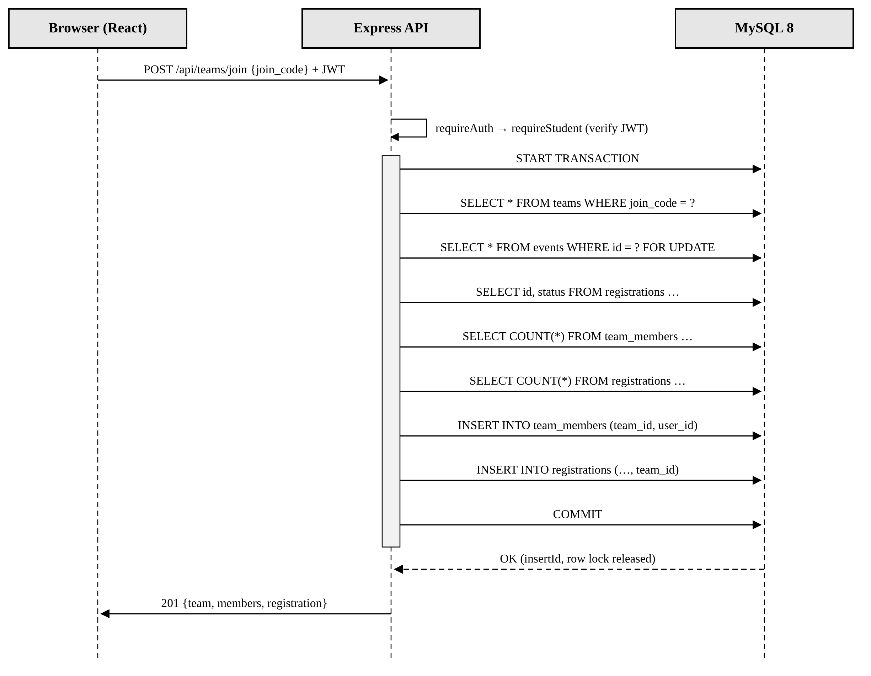
Fig. 12. Sequence diagram for POST /api/teams/join, showing authentication, the transaction and the row-level lock on the event.

C. Authentication
At sign-up the password is hashed with bcrypt (cost factor 10) [11]; at log-in the stored hash is compared and a JSON Web Token [10] containing the user id, name and role is returned, signed with a server secret and valid for seven days. Because the token is self-contained, no sessions table is needed. Logging out simply discards the token in the browser.

D. Error Mapping
A central Express error handler converts errors into JSON responses: application errors keep their HTTP status; MySQL ER_DUP_ENTRY (1062) becomes 409 Conflict; connection and missing-table errors become 503 with a hint to run npm run db:init; anything else is logged and returned as 500 without exposing internal details.

TABLE XV
REST API Endpoints and the SQL They Execute
Method and path | Access | SQL operation
POST /api/auth/signup · POST /api/auth/login · GET /api/auth/me | public / public / signed in | INSERT INTO users (bcrypt hash) · SELECT … WHERE email = ? · SELECT … WHERE id = ?
GET /api/events · GET /api/events/:id | public | events ⋈ users ⟕ registrations, COUNT … GROUP BY e.id
POST /api/events · PUT /api/events/:id · DELETE /api/events/:id | organizer (owner for PUT/DELETE) | INSERT INTO events · UPDATE events … WHERE id = ? · DELETE FROM events (cascades)
POST /api/events/:id/register | student | transaction: SELECT … FOR UPDATE, COUNT, INSERT/UPDATE registrations
GET /api/my-registrations | signed in | registrations ⋈ events ⋈ users ⟕ teams
DELETE /api/registrations/:id | participant or owner organizer | transaction: UPDATE status, DELETE team_members, DELETE/UPDATE teams
GET /api/events/:id/registrations | owner organizer | registrations ⋈ users ⟕ teams
POST /api/registrations/:id/check-in | owner organizer | guarded UPDATE registrations SET checked_in_at
POST /api/events/:id/teams · POST /api/teams/join | student | transaction: INSERT teams, team_members, registrations
GET /api/teams/:id | team member or owner organizer | team_members ⋈ users
GET | POST /api/events/:id/announcements | public | owner organizer | SELECT … ORDER BY created_at DESC | INSERT
GET | POST /api/events/:id/questions · PUT /api/questions/:id/answer | public | signed in | owner organizer | event_questions ⋈ users | INSERT | UPDATE … SET answer = ?
GET | POST /api/events/:id/winners | public | owner organizer | SELECT … ORDER BY position | INSERT

XI. Testing and Validation

A. Strategy
Testing followed the structure of IEEE Std 829 [15]: each test case has an identifier, input, expected result, actual result and verdict. Four levels were used:
- Static checks—TypeScript compilation (tsc -b) and the production build succeed with no errors; the oxlint linter reports 0 errors (8 style warnings about React effects).
- API black-box tests—a Node.js script sends real HTTP requests to the running server and compares status codes and messages with expectations (TC-01 to TC-27, TC-34, TC-35).
- Database constraint tests—invalid statements are executed directly against MySQL to prove that the DBMS itself rejects them, independently of the application (TC-28 to TC-33).
- Manual UI walkthrough—every page in Table XII was exercised in Chromium with the seed accounts; the screenshots in Section VIII were captured during this pass.
All tests were run on MySQL Community Server 8.0.46 with Node.js 22 after npm run db:reset, so the starting state is exactly the seed data of Table XI.

TABLE XVI
Test Cases and Results
ID | Module | Test description | Input | Expected | Actual | Result
TC-01 | Auth | Login with valid credentials | ananya@showup.local / password123 | 200, JWT returned | 200 | Pass
TC-02 | Auth | Login with wrong password | ananya@… / wrong | 401 rejected | 401 – "Invalid email or password." | Pass
TC-03 | Auth | Sign up new student | new e-mail, 8-char password | 201, user created | 201 | Pass
TC-04 | Auth | Sign up with existing e-mail | ananya@showup.local | 409 (UNIQUE email) | 409 – "An account with this email already exists." | Pass
TC-05 | Auth | Sign up with short password | password = 123 | 400 validation error | 400 – "Password must be at least 6 characters." | Pass
TC-06 | Auth | Protected route with invalid token | Bearer not-a-token | 401 rejected | 401 – "Your session has expired. Please sign in again." | Pass
TC-07 | Registration | Solo registration for open event | Sameer → Founders' Fireside | 201, status confirmed | 201 | Pass
TC-08 | Registration | Duplicate registration | Sameer → same event again | 409 already registered | 409 – "You're already registered for this event." | Pass
TC-09 | Registration | Register after deadline | Priya → Hack Night (past) | 400 registration closed | 400 – "Registration for this event has closed." | Pass
TC-10 | Registration | Solo register on team event | Priya → CodeSprint 24 | 400 use team flow | 400 – "This is a team event — create a team or join one with a code." | Pass
TC-11 | Registration | Organizer tries to register | Code Cell → event 5 | 403 students only | 403 – "Only student accounts can register for events." | Pass
TC-12 | Registration | Re-register after cancellation | Priya (cancelled row id 9) → event 5 | 201, same row id 9 reused | 201 | Pass
TC-13 | Teams | Create team with duplicate name | "NeuralCraft" on CodeSprint | 409 UNIQUE(event_id,name) | 409 – "A team with that name already exists for this event." | Pass
TC-14 | Teams | Create team | Priya → "Pixel Pirates" | 201, 6-char join code | 201 | Pass
TC-15 | Teams | Join with invalid code | ZZZZZZ | 404 no such team | 404 – "No team has that join code." | Pass
TC-16 | Teams | Join team with code (lower-case) | Sameer → nc8821 | 201, member added | 201 | Pass
TC-17 | Teams | Join team, 4th member (max 4) | Test Student → NC8821 | 201, team now full | 201 | Pass
TC-18 | Teams | Join a full team | Vikram → NC8821 (4/4) | 409 team full | 409 – "This team is full (maximum 4 members)." | Pass
TC-19 | Check-in | Check in a confirmed ticket | SHOWUP-REG-10 by Code Cell | 200, attendance recorded | 200 | Pass
TC-20 | Check-in | Check in same ticket twice | same ticket | 409 already checked in | 409 – "Sameer Khan is already checked in." | Pass
TC-21 | Check-in | Check in by another organizer | Robotics Club | 404 not your event | 404 – "That ticket isn't for one of your events." | Pass
TC-22 | Events | Deadline after event date | deadline = event + 1 day | 400 validation error | 400 – "The registration deadline must be before the event starts." | Pass
TC-23 | Events | Invalid category | category = Party | 400 validation error | 400 – "Category must be one of: Hackathon, Workshop, Competition, Cultural, Talk." | Pass
TC-24 | Events | Create valid event | capacity = 1 | 201, event created | 201 | Pass
TC-25 | Events | Edit another organizer's event | Robotics Club → event 1 | 403 forbidden | 403 – "Only the organizer who created this event can change it." | Pass
TC-26 | Concurrency | 5 simultaneous registrations for 1 seat | Promise.all × 5 | exactly 1 × 201, 4 × 409 | 1 × 201, 4 × 409 – "Sorry, this event is full." | Pass
TC-27 | Teams | Team leader cancels registration | Ananya cancels reg 1 | status cancelled; leadership passes to Rohan (id 5) | 200; leader_id = 5 | Pass
TC-28 | DB constraint | CHECK capacity > 0 | INSERT event with capacity = 0 | rejected by CHECK | ER_CHECK_CONSTRAINT_VIOLATED (3819) | Pass
TC-29 | DB constraint | CHECK team_max >= team_min | UPDATE events SET team_min = 5, team_max = 2 | rejected by CHECK | ER_CHECK_CONSTRAINT_VIOLATED (3819) | Pass
TC-30 | DB constraint | FOREIGN KEY on registrations.event_id | INSERT registration with event_id = 999 | rejected by FK | ER_NO_REFERENCED_ROW_2 (1452) | Pass
TC-31 | DB constraint | UNIQUE (user_id, event_id) | INSERT duplicate (user 5, event 1) | rejected as duplicate | ER_DUP_ENTRY (1062) | Pass
TC-32 | DB constraint | ENUM on users.role | INSERT user with role = 'admin' | rejected (strict mode) | WARN_DATA_TRUNCATED (1265) | Pass
TC-33 | DB constraint | NOT NULL on events.title | INSERT event with title = NULL | rejected | ER_BAD_NULL_ERROR (1048) | Pass
TC-34 | DB constraint | ON DELETE CASCADE from events | DELETE /api/events/7 | child rows removed | teams 1→0, regs 3→0, ann. 1→0, winners 4→0 | Pass
TC-35 | Security | SQL injection in login | email = ' OR '1'='1 | 401, treated as plain text | 401 – "Invalid email or password." | Pass

TABLE XVII
Test Summary
Module | Cases | Passed
Auth | 6 | 6
Registration | 6 | 6
Teams | 7 | 7
Check-in | 3 | 3
Events | 4 | 4
Concurrency | 1 | 1
DB constraint | 7 | 7
Security | 1 | 1
Total | 35 | 35

B. Concurrency Validation
TC-26 is the most important test for a registration system. An event with capacity 1 was created and five newly registered students sent their registration requests simultaneously with Promise.all. Exactly one request returned 201 Created and the other four returned 409 "Sorry, this event is full." Without the FOR UPDATE lock, all five transactions could read a count of 0 before any of them inserted, and the event would be over-subscribed five times—the classic lost-update anomaly.

C. Integrity Validation
TC-28 to TC-33 show that the DBMS rejects invalid data even if the application were bypassed: CHECK violations raise error 3819, a dangling foreign key raises 1452, a duplicate registration raises 1062, a value outside the ENUM domain raises 1265 in strict mode, and a NULL title raises 1048. TC-34 deletes an event through the API and confirms that its 1 team, 3 registrations, 1 announcement and 4 winners were removed by ON DELETE CASCADE. TC-27 confirms leader succession: when Ananya (leader of NeuralCraft) cancelled, teams.leader_id changed to Rohan (id 5).

XII. Project Demonstration and Documentation

A. Installation
Listing 9. Commands to install and run ShowUp locally.
npm install
cp .env.example .env # DB_USER, DB_PASSWORD,
# JWT_SECRET
npm run db:reset # schema.sql + seed.sql
npm run dev # API :3001, web :5173

The same SQL files can be run from MySQL Workbench or the command line (mysql -u root -p < sql/schema.sql). The script runner refuses to execute reset.sql unless the host is local and NODE_ENV is not production, preventing accidental data loss.
TABLE XVIII
Demonstration Accounts (password: password123)
Account | Role and purpose
codecell@showup.local | Organizer, VIT Vellore; owns CodeSprint 24, workshop, Hack Night
culturals@showup.local | Organizer, VIT Chennai
robotics@showup.local | Organizer, IIT Madras
ananya@ / rohan@showup.local | Students in team NeuralCraft (NC8821)
priya@ / vikram@ / sameer@ | Students (…@showup.local)

B. Demonstration Script
The live demonstration walks through the full life cycle while showing the effect of each action in MySQL Workbench:
- Run SHOW TABLES and DESCRIBE registrations to present the schema.
- Sign in as sameer@showup.local, open CodeSprint 24 and Join with code NC8821; show the new rows in team_members and registrations.
- Attempt to join again to show the 409 duplicate message and the UNIQUE(user_id, event_id) backstop.
- Open My Events and display the QR ticket (SHOWUP-REG-<id>).
- Sign in as codecell@showup.local, open Participants to see the team grouping, then Check-in and enter Sameer's ticket; show checked_in_at updated.
- Run the queries of Listings 4–6 to show live aggregates.
- Delete a test event and show that child rows disappear (ON DELETE CASCADE).

C. Documentation Deliverables
- README.md—features, setup, database design, every foreign key, example queries, API table and project structure.
- sql/schema.sql, seed.sql, reset.sql—commented DDL and DML scripts.
- Inline code comments—each route explains the SQL it runs and why (e.g. why the event row is locked).
- This report—requirements, ER/EER, mapping, normalization, implementation and test evidence.
- Git history—commits on GitHub record the evolution from an earlier 12-table Supabase design to the present 8-table MySQL design.

D. Repository Structure
sql/ schema.sql, seed.sql, reset.sql
server/ index.js, db.js, auth.js, helpers.js,
run-sql.js
routes/ auth, events, registrations,
teams, community
src/ lib/api.ts, types/, context/,
components/, pages/, pages/organizer/

XIII. Conclusion and Future Work
ShowUp demonstrates the complete database development life cycle on a real, everyday problem. Starting from the deficiencies of form-and-spreadsheet registration, the requirements were analysed and modelled as an ER diagram with an EER specialization, mapped to eight relations, and shown to be in BCNF. The resulting MySQL schema enforces integrity declaratively through twelve foreign keys and CHECK, UNIQUE and ENUM constraints, while the application tier enforces time- and aggregate-dependent rules inside ACID transactions with row-level locking. All 35 test cases passed, including a concurrency test that confirms an event cannot be over-subscribed.
Possible extensions, each of which maps to a further DBMS topic, include: a waitlist table with automatic promotion implemented by a trigger or stored procedure; views for organizer reports; a secondary index on events.event_date and a FULLTEXT index for search as data grows; an audit table populated by triggers; e-mail notifications through an outbox table; and replication with read replicas for large inter-college festivals.

Acknowledgment
The author thanks the faculty of the Database Management Systems course at Vellore Institute of Technology for their guidance, and the student club coordinators who described how event registration is handled today.

References
[1] R. Elmasri and S. B. Navathe, Fundamentals of Database Systems, 7th ed. Boston, MA, USA: Pearson, 2016.
[2] A. Silberschatz, H. F. Korth, and S. Sudarshan, Database System Concepts, 7th ed. New York, NY, USA: McGraw-Hill, 2020.
[3] E. F. Codd, "A relational model of data for large shared data banks," Commun. ACM, vol. 13, no. 6, pp. 377–387, Jun. 1970.
[4] P. P.-S. Chen, "The entity-relationship model—Toward a unified view of data," ACM Trans. Database Syst., vol. 1, no. 1, pp. 9–36, Mar. 1976.
[5] E. F. Codd, "Further normalization of the data base relational model," in Data Base Systems, R. Rustin, Ed. Englewood Cliffs, NJ, USA: Prentice-Hall, 1972, pp. 33–64.
[6] IEEE Recommended Practice for Software Requirements Specifications, IEEE Std 830-1998, 1998.
[7] Oracle Corporation, "MySQL 8.0 Reference Manual." [Online]. Available: https://dev.mysql.com/doc/refman/8.0/en/
[8] OpenJS Foundation, "Express 5.x API reference." [Online]. Available: https://expressjs.com/en/5x/api.html
[9] Meta Platforms, Inc., "React documentation." [Online]. Available: https://react.dev/
[10] M. Jones, J. Bradley, and N. Sakimura, "JSON Web Token (JWT)," IETF RFC 7519, May 2015.
[11] N. Provos and D. Mazières, "A future-adaptable password scheme," in Proc. USENIX Annu. Tech. Conf., FREENIX Track, Monterey, CA, USA, 1999, pp. 81–91.
[12] OWASP Foundation, "SQL Injection Prevention Cheat Sheet." [Online]. Available: https://cheatsheetseries.owasp.org/cheatsheets/SQL_Injection_Prevention_Cheat_Sheet.html
[13] A. Sidorov et al., "node-mysql2: Fast MySQL driver for Node.js." [Online]. Available: https://github.com/sidorares/node-mysql2
[14] J. Gray and A. Reuter, Transaction Processing: Concepts and Techniques. San Mateo, CA, USA: Morgan Kaufmann, 1993.
[15] IEEE Standard for Software and System Test Documentation, IEEE Std 829-2008, 2008.

