Aplikasi Kasir Sederhana   
untuk Coffeeshop

LAPORAN STUDI KASUS TUGAS AOL  
MATA KULIAH COMP6360004 – ALGORITHM & PROGRAMMING  
KELAS LC20

DISUSUN OLEH :  
2602172233 – RAYNALDY DWI KHARISMA

COMPUTER SCIENCE

SEMESTER GANJIL 2022/2023  
MALANG

Daftar Isi

BAB I PENDAHULUAN 3

1. LATAR BELAKANG 3

2. KEBUTUHAN APLIKASI 3

BAB II DESAIN PROGRAM 4

BAB III SOURCE CODE 5

BAB IV TAMPILAN HASIL 24

1. Tampilan Awal 24

2. Tampilan Input Order 24

3. Tampilan Rekap Order 24

4. Tampilan Checkout 25

5. Tampilan Menu Admin 25

6. Tampilan View Sales 25

7. Tampilan Sort Sales 25

8. Tampilan Sort Sales Berdasarkan Nama Produk 26

9. Tampilan Sort Sales Berdasarkan Qty Produk Terjual 26

10. Tampilan Sort Sales Berdasarkan Total Pembayaran 27

11. Tampilan Search Sales 27

12. Tampilan Search Berdasarkan Nama Produk 27

13. Tampilan Search Berdasarkan Qty Penjualan 28

14. Tampilan Search Berdasarkan Total Pembayaran 28

15. Tampilan Search Berdasarkan Metode Pembayaran 28

# BAB I PENDAHULUAN

## 1. LATAR BELAKANG

Di era yang semakin modern ini, saya sering kali melihat *coffeeshop* atau warung kopi yang masih manual dalam mencatat, merekap, dan memproses order pelanggan. Namun, sudah banyak juga *coffeeshop* yang sudah menggunakan mesin kasir otomatis yaitu aplikasi *Point of Sales* (POS). Hal ini membuat saya tertarik untuk mereplika aplikasi tersebut dalam skala kecil tetapi masih memiliki fungsi yang sama, yaitu otomatisasi order pelanggan.

## 2. KEBUTUHAN APLIKASI

Adapun beberapa hal yang saya butuhkan untuk membuat aplikasi tersebut:

1. Struktur kendali perulangan
   1. Do while loop
   2. For loop
2. Seleksi
   1. If else
   2. Switch case
3. Tipe data
   1. Empat buah struct untuk mencatat menu, order, sales, waktu, dan tanggal order
   2. Pointer bertipe const char untuk menyimpan format data read file
   3. Int, char, float, void untuk menyimpan sesuatu dalam variable
   4. Pointer FILE untuk membaca dan menulis file
4. Media penyimpanan
   1. File menu.txt untuk menyimpan menu *coffeeshop*
   2. File sales.txt untuk menyimpan sales *coffeeshop*
5. Algoritma sorting
   1. qsort *built-in* yang terdapat di library <stdlib.h>
   2. comparer nama – untuk sorting berdasarkan nama produk
   3. comparer qty – untuk sorting berdasarkan kuantitas produk terjual
   4. comparer total – untuk sorting berdasarkan total pembayaran
6. Algoritma searching
   1. Linear search menggunakan for loops dan if else statement untuk mencari data yang sesuai dengan kriteria

# BAB II DESAIN PROGRAM

# BAB III SOURCE CODE

#include <stdio.h>

#include <stdlib.h>

#include <ctype.h>

#include <time.h>

#include <string.h>

const char *FORMAT_DATA_READ = "%d/%d/%d, %[^,], %c, %d, %d, %s\n";

struct Sales{

int date[4];

char nama[50];

char size;

int qty;

int total_pembayaran;

char metode_pembayaran[20];

} array_sales[100], temp;

struct Menu{

char nama_menu[50];

float harga_regular;

float harga_large;

} array_menu[50];

struct Order{

char date[20];

int index_order;

char ukuran_order;

int qty_order;

} array_order[50];

void input_order();

void load_menu();

int index_counter(char FILE_DIR[]);

void print_menu_txt();

void scan_order(int index_temp);

void rekap_order(int index_temp);

void ubah_order();

void print_receipt(char sub_input3, int index_temp);

void write_to_file(char sub_input3, int index_temp);

void menu_admin();

void sort_sales();

void search_sales();

void print_sales();

int main(){

char input;

printf("Aplikasi Kasir\n");

printf("--------------\n");

printf("1. Input Order\n");

printf("2. Admin\n");

printf("0. Exit\n");

printf("--------------\n");

printf("Input: "); scanf("%d", &input); getchar();

switch(input){

case 1:

input_order();

break;

case 2:

menu_admin();

break;

case 0:

exit(0);

break;

default:

printf("Input salah!\n");

system("pause");

system("cls");

main();

}

return 0;

}

void load_menu(){

char buffer[256];

FILE *fp;

fp = fopen("menu.txt", "r");

if(fp == NULL){

printf("File menu.txt tidak ditemukan!\n");

}

fgets(buffer, sizeof(buffer), fp);

int index=0;

while(!feof(fp)){

fscanf(fp, "%[^,], %f, %f\n",

&array_menu[index].nama_menu,

&array_menu[index].harga_regular,

&array_menu[index].harga_large);

index++;

}

fclose(fp);

}

int index_counter(char FILE_DIR[]){

FILE *fp;

int count = 0;

char c;

fp = fopen(FILE_DIR, "r");

if (fp == NULL){

return 0;

}

for (c = getc(fp); c != EOF; c = getc(fp)){

if (c == '\n'){

count = count + 1;

}

}

fclose(fp);

return count;

}

void print_menu_txt(){

int index = index_counter("menu.txt");

printf("---------------------------------------------------\n");

printf("| No | Nama | Regular | Large |\n");

printf("---------------------------------------------------\n");

for(int i=0; i<index; i++){

printf("| %-2d | %-22s | %.0f | %.0f |\n",

i+1,

array_menu[i].nama_menu,

array_menu[i].harga_regular,

array_menu[i].harga_large);

}

printf("---------------------------------------------------\n");

}

void scan_order(int index_temp){

printf("Pesan (No Produk): "); scanf("%d", &array_order[index_temp].index_order); getchar();

printf("Ukuran (R/L): "); scanf("%c", &array_order[index_temp].ukuran_order); getchar();

printf("Qty: "); scanf("%d", &array_order[index_temp].qty_order); getchar();

}

void rekap_order(int index_temp){

float total=0;

printf("---------------------------------------------------------------\n");

printf("| No | Nama | Ukuran | Harga | Qty | Total |\n");

printf("---------------------------------------------------------------\n");

for(int i=0; i<index_temp; i++){

if(array_order[i].ukuran_order == 'R'){

printf("| %-2d | %-22s | %-3c | %.0f | %-2d | %-6.0f |\n",

i+1,

array_menu[array_order[i].index_order-1].nama_menu,

array_order[i].ukuran_order,

array_menu[array_order[i].index_order-1].harga_regular,

array_order[i].qty_order,

(array_menu[array_order[i].index_order-1].harga_regular * array_order[i].qty_order));

total+=(array_menu[array_order[i].index_order-1].harga_regular * array_order[i].qty_order);

}

else if(array_order[i].ukuran_order == 'L'){

printf("| %-2d | %-22s | %-3c | %.0f | %-2d | %-6.0f |\n",

i+1,

array_menu[array_order[i].index_order-1].nama_menu,

array_order[i].ukuran_order,

array_menu[array_order[i].index_order-1].harga_large,

array_order[i].qty_order,

(array_menu[array_order[i].index_order-1].harga_large * array_order[i].qty_order));

total+=(array_menu[array_order[i].index_order-1].harga_large * array_order[i].qty_order);

}

}

printf("---------------------------------------------------------------\n");

printf("\t\t\t\t Total Pembayaran = %.0f\n", total);

}

void ubah_order(){

int temp;

printf("Pilih nomor pesanan yang ingin diubah!\n");

printf("Input: "); scanf("%d", &temp); getchar();

print_menu_txt();

scan_order(temp-1);

}

void print_receipt(char sub_input3, int index_temp){

printf("---------------------------------------------------------------\n");

printf("|\t\t\tIP Cafe 2\t\t\t |\n");

printf("---------------------------------------------------------------\n");

time_t t = time(NULL);

struct tm tm = *localtime(&t);

printf("| %d/%02d/%02d\t\t", tm.tm_mday, tm.tm_mon + 1, tm.tm_year + 1900);

if(sub_input3 == '1'){

printf("\t\t\t\t Cash |\n");

}

else if(sub_input3 == '2'){

printf("\t\t\t\t QRIS |\n");

}

else if(sub_input3 == '3'){

printf("\t\t\t E-Wallet |\n");

}

printf("| %02d:%02d:%02d\t\t\t\t\t\t |\n", tm.tm_hour, tm.tm_min, tm.tm_sec);

rekap_order(index_temp);

}

void write_to_file(char sub_input3, int index_temp){

time_t t = time(NULL);

struct tm tm = *localtime(&t);

FILE *fp;

fp = fopen("sales.txt", "a");

for(int i=0; i<index_temp; i++){

if(toupper(array_order[i].ukuran_order) == 'R' && sub_input3 == '1'){

fprintf(fp, "%d/%d/%d, %s, %c, %d, %.0f, Cash\n",

tm.tm_mday, tm.tm_mon + 1, tm.tm_year + 1900,

array_menu[array_order[i].index_order-1].nama_menu,

array_order[i].ukuran_order,

array_order[i].qty_order,

(array_menu[array_order[i].index_order-1].harga_regular * array_order[i].qty_order));

}

else if(toupper(array_order[i].ukuran_order) == 'R' && sub_input3 =='2'){

fprintf(fp, "%d/%d/%d, %s, %c, %d, %.0f, QRIS\n",

tm.tm_mday, tm.tm_mon + 1, tm.tm_year + 1900,

array_menu[array_order[i].index_order-1].nama_menu,

array_order[i].ukuran_order,

array_order[i].qty_order,

(array_menu[array_order[i].index_order-1].harga_regular * array_order[i].qty_order));

}

else if(toupper(array_order[i].ukuran_order) == 'R' && sub_input3 =='3'){

fprintf(fp, "%d/%d/%d, %s, %c, %d, %.0f, E-Wallet\n",

tm.tm_mday, tm.tm_mon + 1, tm.tm_year + 1900,

array_menu[array_order[i].index_order-1].nama_menu,

array_order[i].ukuran_order,

array_order[i].qty_order,

(array_menu[array_order[i].index_order-1].harga_regular * array_order[i].qty_order));

}

else if(toupper(array_order[i].ukuran_order) == 'L' && sub_input3 == '1'){

fprintf(fp, "%d/%d/%d, %s, %c, %d, %.0f, Cash\n",

tm.tm_mday, tm.tm_mon + 1, tm.tm_year + 1900,

array_menu[array_order[i].index_order-1].nama_menu,

array_order[i].ukuran_order,

array_order[i].qty_order,

(array_menu[array_order[i].index_order-1].harga_large * array_order[i].qty_order));

}

else if(toupper(array_order[i].ukuran_order) == 'L' && sub_input3 =='2'){

fprintf(fp, "%d/%d/%d, %s, %c, %d, %.0f, QRIS\n",

tm.tm_mday, tm.tm_mon + 1, tm.tm_year + 1900,

array_menu[array_order[i].index_order-1].nama_menu,

array_order[i].ukuran_order,

array_order[i].qty_order,

(array_menu[array_order[i].index_order-1].harga_large * array_order[i].qty_order));

}

else if(toupper(array_order[i].ukuran_order) == 'L' && sub_input3 =='3'){

fprintf(fp, "%d/%d/%d, %s, %c, %d, %.0f, E-Wallet\n",

tm.tm_mday, tm.tm_mon + 1, tm.tm_year + 1900,

array_menu[array_order[i].index_order-1].nama_menu,

array_order[i].ukuran_order,

array_order[i].qty_order,

(array_menu[array_order[i].index_order-1].harga_large * array_order[i].qty_order));

}

}

fclose(fp);

}

void input_order(){

char sub_input;

char sub_input2;

char sub_input3;

int index_temp=0;

do{

system("cls");

load_menu();

print_menu_txt();

scan_order(index_temp);

index_temp++;

printf("Pesan lagi? (Y/N)\n");

printf("Input: "); scanf("%c", &sub_input); getchar();

}while(toupper(sub_input)!='N');

do{

system("cls");

rekap_order(index_temp);

printf("\n");

printf("1. Ubah pesanan\n");

printf("2. Checkout\n");

printf("Input: "); scanf("%c", &sub_input2); getchar();

if(sub_input2 == '1'){

ubah_order();

}

}while(sub_input2!='2');

printf("Pilih metode pembayaran\n");

printf("1. Cash\n");

printf("2. QRIS\n");

printf("3. E-Wallet\n");

printf("Input: "); scanf("%c", &sub_input3); getchar();

system("cls");

print_receipt(sub_input3, index_temp);

write_to_file(sub_input3, index_temp);

system("pause");

system("cls");

main();

}

void print_array_sales(int i){

printf("| %-2d | %d/%d/%d | %-22s | %-3c | %-3d | %-6d | %-8s |\n",

i+1,

array_sales[i].date[0],

array_sales[i].date[1],

array_sales[i].date[2],

array_sales[i].nama,

array_sales[i].size,

array_sales[i].qty,

array_sales[i].total_pembayaran,

array_sales[i].metode_pembayaran);

}

void initialize_data(){

FILE *fp;

int file_index = index_counter("sales.txt");

fp = fopen("sales.txt", "r");

for(int i=0; i<file_index; i++){

fscanf(fp, FORMAT_DATA_READ,

&array_sales[i].date[0],

&array_sales[i].date[1],

&array_sales[i].date[2],

&array_sales[i].nama,

&array_sales[i].size,

&array_sales[i].qty,

&array_sales[i].total_pembayaran,

&array_sales[i].metode_pembayaran);

}

fclose(fp);

}

void view_sales(){

int file_index = index_counter("sales.txt");

initialize_data();

system("cls");

print_sales();

}

void print_sales(){

int file_index = index_counter("sales.txt");

printf("----------------------------------------------------------------------------\n");

printf("| No | Tanggal | Nama | Size | Qty | Total | Metode |\n");

printf("----------------------------------------------------------------------------\n");

for(int i=0; i<file_index; i++){

print_array_sales(i);

}

printf("----------------------------------------------------------------------------\n");

}

typedef int (*compfn)(const void*, const void*);

int compare_nama(struct Sales *elem1, struct Sales *elem2){

if(strcasecmp(elem1->nama, elem2->nama) < 0){

return -1;

}

else if(strcasecmp(elem1->nama, elem2->nama) > 0){

return 1;

}

return 0;

}

int compare_qty(struct Sales *elem1, struct Sales *elem2){

if(elem1->qty < elem2->qty){

return -1;

}

else if(elem1->qty > elem2->qty){

return 1;

}

return 0;

}

int compare_total(struct Sales *elem1, struct Sales *elem2){

if(elem1->total_pembayaran < elem2->total_pembayaran){

return -1;

}

else if(elem1->total_pembayaran > elem2->total_pembayaran){

return 1;

}

return 0;

}

void sort_sales(){

int file_index = index_counter("sales.txt");

int sub_input;

initialize_data();

system("cls");

printf("Sort berdasarkan:\n");

printf("-----------------\n");

printf("1. Nama Produk\n");

printf("2. Qty\n");

printf("3. Total\n");

printf("0. Back\n");

printf("-----------------\n");

printf("Input: "); scanf("%d", &sub_input); getchar();

switch(sub_input){

case 1:

qsort((void *) &array_sales, file_index, sizeof(struct Sales), (compfn)compare_nama);

system("cls");

printf("Sort Berdasarkan Nama Produk\n");

print_sales();

system("pause");

sort_sales();

break;

case 2:

qsort((void *) &array_sales, file_index, sizeof(struct Sales), (compfn)compare_qty);

system("cls");

printf("Sort Berdasarkan Qty Produk Terjual\n");

print_sales();

system("pause");

sort_sales();

break;

case 3:

qsort((void *) &array_sales, file_index, sizeof(struct Sales), (compfn)compare_total);

system("cls");

printf("Sort Berdasarkan Nama Produk\n");

print_sales();

system("pause");

sort_sales();

break;

case 0:

menu_admin();

break;

default:

printf("Input salah!\n");

system("pause");

sort_sales();

break;

}

}

void search_by_name(){

char key[25];

int found;

int file_index=index_counter("sales.txt");

system("cls");

printf("Masukkan nama produk yang akan dicari : ");

scanf("%s", key);

getchar();

found=0;

for(int i=0; i<file_index; i++){

if(strstr(array_sales[i].nama, key) != NULL){

found = 1;

}

}

if(found==0){

printf("Data tidak ditemukan\n");

system("pause");

search_sales();

}

else{

printf("----------------------------------------------------------------------------\n");

printf("| No | Tanggal | Nama | Size | Qty | Total | Metode |\n");

printf("----------------------------------------------------------------------------\n");

for(int i=0; i<file_index; i++){

if(strstr(array_sales[i].nama, key) != NULL){

print_array_sales(i);

}

}

printf("----------------------------------------------------------------------------\n");

}

system("pause");

search_sales();

}

void search_by_qty(){

char key[25];

int found, high, low;

int file_index=index_counter("sales.txt");

system("cls");

printf("Masukkan qty terendah : ");

scanf("%d", &low);

printf("Masukkan qty tertinggi : ");

scanf("%d", &high);

for(int i = 0; i < file_index; i++){

if(array_sales[i].qty >= low && array_sales[i].qty <= high){

found=1;

};

}

if (found == 0){

printf("Data tidak ditemukan\n");

system("pause");

search_sales();

}

else{

printf("----------------------------------------------------------------------------\n");

printf("| No | Tanggal | Nama | Size | Qty | Total | Metode |\n");

printf("----------------------------------------------------------------------------\n");

for(int i = 0; i < file_index; i++){

if(array_sales[i].qty >= low && array_sales[i].qty <= high){

print_array_sales(i);

}

}

printf("----------------------------------------------------------------------------\n");

}

}

void search_by_sales(){

char key[25];

int found, high, low;

int file_index=index_counter("sales.txt");

system("cls");

printf("Masukkan pembayaran terendah : ");

scanf("%d", &low);

printf("Masukkan pembayaran tertinggi : ");

scanf("%d", &high);

for(int i = 0; i < file_index; i++){

if(array_sales[i].total_pembayaran >= low && array_sales[i].total_pembayaran <= high){

found=1;

};

}

if (found == 0){

printf("Data tidak ditemukan\n");

system("pause");

search_sales();

}

else{

printf("----------------------------------------------------------------------------\n");

printf("| No | Tanggal | Nama | Size | Qty | Total | Metode |\n");

printf("----------------------------------------------------------------------------\n");

for(int i = 0; i < file_index; i++){

if(array_sales[i].total_pembayaran >= low && array_sales[i].total_pembayaran <= high){

print_array_sales(i);

}

}

printf("----------------------------------------------------------------------------\n");

}

}

void search_by_method(){

char key[25];

int found;

int file_index=index_counter("sales.txt");

system("cls");

printf("Masukkan metode pembayaran yang akan dicari : ");

scanf("%s", key);

getchar();

found=0;

for(int i=0; i<file_index; i++){

if(strstr(array_sales[i].metode_pembayaran, key) != NULL){

found = 1;

}

}

if(found==0){

printf("Data tidak ditemukan\n");

system("pause");

search_sales();

}

else{

printf("----------------------------------------------------------------------------\n");

printf("| No | Tanggal | Nama | Size | Qty | Total | Metode |\n");

printf("----------------------------------------------------------------------------\n");

for(int i=0; i<file_index; i++){

if(strstr(array_sales[i].metode_pembayaran, key) != NULL){

print_array_sales(i);

}

}

printf("----------------------------------------------------------------------------\n");

}

system("pause");

search_sales();

}

void search_sales(){

int file_index = index_counter("sales.txt");

int sub_input;

char key[25];

int found;

int high, low;

initialize_data();

system("cls");

printf("Search berdasarkan:\n");

printf("-----------------\n");

printf("1. Nama Produk\n");

printf("2. Qty\n");

printf("3. Total Pembayaran\n");

printf("4. Metode Pembayaran\n");

printf("0. Back\n");

printf("-----------------\n");

printf("Input: "); scanf("%d", &sub_input); getchar();

switch(sub_input){

case 1:

search_by_name();

break;

case 2:

search_by_qty();

break;

case 3:

search_by_sales();

break;

case 4:

search_by_method();

break;

case 0:

menu_admin();

break;

default:

printf("Input salah!\n");

system("pause");

sort_sales();

break;

}

}

void menu_admin(){

char sub_input;

system("cls");

printf("Menu Admin\n");

printf("--------------\n");

printf("1. View Sales\n");

printf("2. Sort Sales\n");

printf("3. Search Sales\n");

printf("0. Back\n");

printf("--------------\n");

printf("Input: "); scanf("%d", &sub_input); getchar();

switch(sub_input){

case 1:

view_sales();

system("pause");

menu_admin();

break;

case 2:

sort_sales();

break;

case 3:

search_sales();

break;

case 0:

system("cls");

main();

break;

default:

printf("Input salah!\n");

system("pause");

menu_admin();

break;

}

}

# BAB IV TAMPILAN HASIL

1. Tampilan Awal  
   Text

   Description automatically generated
2. Tampilan Input Order  
   A screenshot of a computer

   Description automatically generated with low confidence
3. Tampilan Rekap Order  
   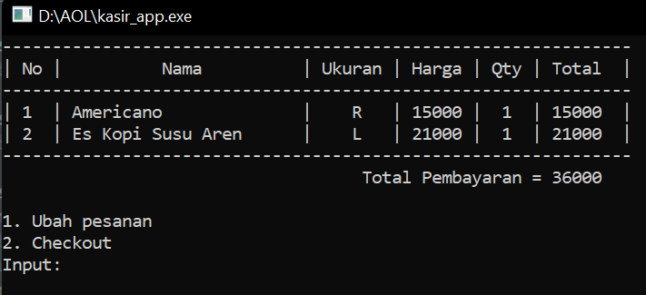
4. Tampilan Checkout  
   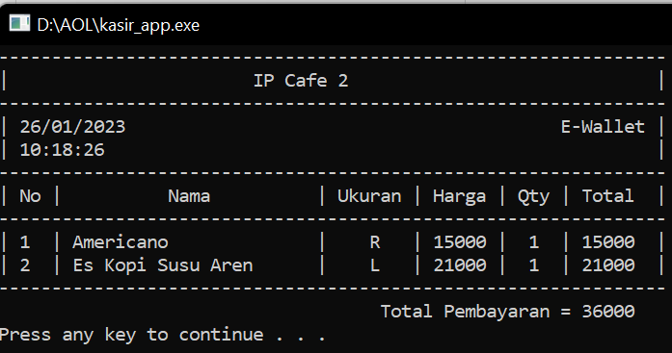
5. Tampilan Menu Admin  
   Text

   Description automatically generated
6. Tampilan View Sales  
   Text

   Description automatically generated
7. Tampilan Sort Sales  
   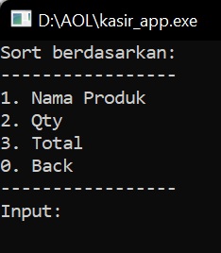
8. Tampilan Sort Sales Berdasarkan Nama Produk  
   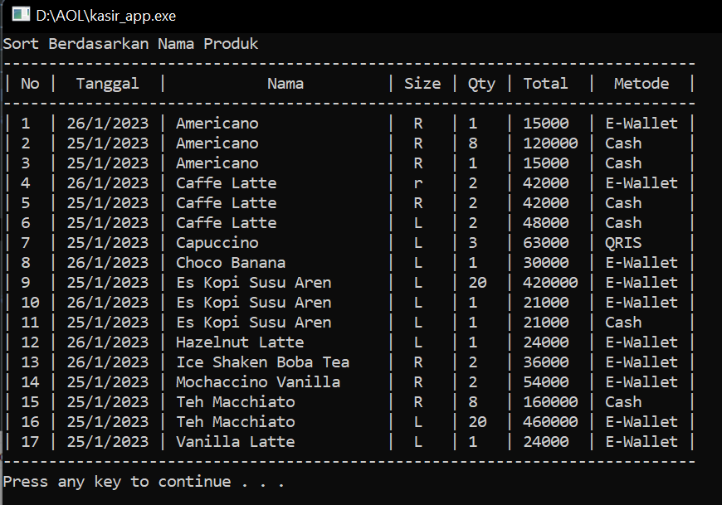
9. Tampilan Sort Sales Berdasarkan Qty Produk Terjual  
   Text

   Description automatically generated
10. Tampilan Sort Sales Berdasarkan Total Pembayaran  
    A screenshot of a computer

    Description automatically generated with medium confidence
11. Tampilan Search Sales  
    Text

    Description automatically generated
12. Tampilan Search Berdasarkan Nama Produk  
    Text

    Description automatically generated
13. Tampilan Search Berdasarkan Qty Penjualan  
    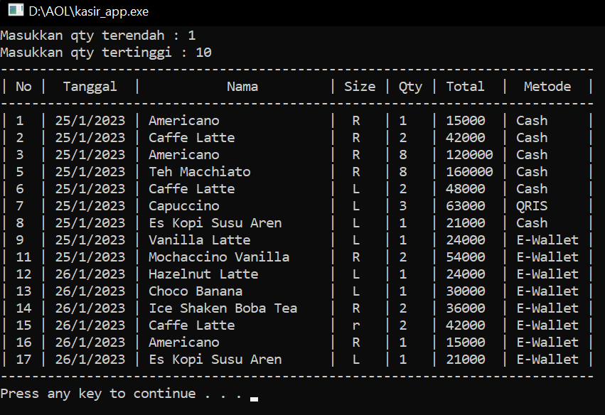
14. Tampilan Search Berdasarkan Total Pembayaran  
    Text

    Description automatically generated
15. Tampilan Search Berdasarkan Metode Pembayaran  
    Text

    Description automatically generated