**PAN INDIA RED BLOOD DONATION FOR COVID 19**

**A Project Report Submitted**

**In Partial Fulfilment of the Requirements**

**For the Degree of**

**MASTER OF COMPUTER APPLICATIONS**

**By**

**RAJAN KUMAR YADAV**

**University Roll No 1900290149076**

**Under the Supervision of**

**Mr.**

**Assistant Professor**

**KIET Group of Institutions**



**Submitted to**

**Department Of Computer Applications**

**A f f i l i a te d to**

**DR. A. P. J ABDUL KALAM TECHNICAL UNIVERSITY**

**Lucknow**

**JULY ,2021**

**DECLARATION**

I hereby declare that the work presented in this report entitled **“Pan India Red Blood Donation For COVID 19 "**, was carried out by US. I have not submitted the matter embodied in this report for the award of any other degree or diploma of any other University or Institute.

I have given due credit to the original authors/sources for all the words, ideas, diagrams, graphics, computer programs, experiments, results, that are not my original contribution.

I have used quotation marks to identify verbatim sentences and given credit to the original authors/sources.

I affirm that no portion of my work is plagiarized, and the experiments and results reported in the report are not manipulated. In the event of a complaint of plagiarism and the manipulation of the experiments and results, We shall be fully responsible and answerable.

**Rajan Kr. Yadav**

**(Univ. roll-1900290149076)**

**CERTIFICATE**

Certified that **Rajan Kumar Yadav (Univ. roll-1900290149076)** have carried out the project work having **“Pan India Red Blood Donation For Covid 19 ”** for Master of Computer Applications from Dr.A.P.J. Abdul Kalam Technical University (AKTU**)** (formerlyUPTU),Technical University, Lucknow under my supervision. The project report embodies original work, and studies are carried out by the student himself/herself and the contents of the project report do not form the basis for the award of any other degree to the candidate or to anybody else from this or any other University/Institution.

**Date:**

**Rajan Kr. Yadav (Univ. roll-1900290149076)**

This is to certify that the above statement made by the candidate is correct to the best of our knowledge.

**Date:**

**Ms.**

**Assistant Professor**

**Department of Computer Applications**

**KIET Group of Institutions, Ghaziabad**

**Signature of Internal Examiner Signature of External Examiner**

**Dr. Ajay KumarShrivastava**

**Head, Department of Computer Applications**

**KIET Group of Institutions, Ghaziabad**

**ABSTRACT**

The main of this system is to develop **Pan India Red Blood Donation For Covid 19** .Our life is so busy so we do not have time to spend going here and there, we can use technical way to search the blood by using the Blood Bank WebApp we can find thousands of people who are donating the blood and get the detail the of that person that in which city he belongs to and what is the Blood group of that person.

This system mainly reduces the work task and it is easy to maintain the records for a long time than normal hand written records as well give ease. The user can check his record details by just entering his demand no need to search all the record. So the maintenance and management of donation became very easy.

* This project is a Web application that enables efficient storage of student records to properly manage.
* The system is designed for blood donation. It makes searching records easier and faster.
* User is no longer required to check his register in search of records, as now it can be searched over the software by choosing some options.
* The user need not to type in most of the information.
* On the whole it liberates the user from keeping lengthy manual records.
* Every one wants his/her work to be done by computer automatically and displaying the result for further manipulations.
* So this project is about providing convenience.

**ACKNOWLEDGEMENTS**

Success in life is never attained single handedly. My deepest gratitude goes to my thesis supervisor **Mr.** , for his guidance, help and encouragement throughout our project work. Their enlightening ideas, comments, and suggestions.

Words are not enough to express my gratitude to **Dr. Ajay Kumar Shrivastava**, Professor and Head, Department of Computer Applications, for his insightful comments and administrative help at various occasions.

Fortunately, I have many understanding friends, who have helped me a lot on many critical conditions.

Finally, my sincere thanks go to my family members and all those who have directly and indirectly provided me moral support and other kind of help. Without their support, completion of this work would not have been possible in time. They keep my life filled with enjoyment and happiness.

**Rajan Kr. Yadav(Roll No. 190029014907)**

**TABLE OF CONTENTS**

Declaration ii

Certificate iii

Abstract iv

Acknowledge v

Table of content vi

List of tables viii

List of figures viii

Chapter 1: Introduction 9-18

1.1 Project description 9

1.2 Project Scope 10

1.3 Identification of need 11

1.4 Problem Statement 12

1.5 Hardware/software used in project 13

1.6 Project schedule 17

1.6.1 Pert Chart

1.6.2 Gantt Chart

Chapter 2: Feasibility Study 19-25

2.1 Introduction 19

2.2 Main Aspects 21

2.2.1 Technical feasibility

2.2.2 Economical Feasibility

2.2.3 Operational Feasibility

2.3 Benefits 23

2.4 SRS 24

Chapter 3:Design 26-36

3.1 Introduction 26

3.2 Analysis 27

3.3 SDLC 29

3.4 Soft. Engg. Paradigm 31

3.4.1 Prototype model

3.5 DFD 34

3.6 ER Diagram 36

Chapter 4: Report 37-41

4.1 Gist 37

4.2Some Screenshots 38

Chapter 5: Coding 42-46

Chapter 6: Testing 47-50

6.1 Introduction 47

6.2 Level of testing 48

6.3 Some Important observations 50

Chapter 7: Conclusion & Future scope 51-52

7.1 Conclusion 51

7.2 Future Scope 52

Bibliography 63

References 54-55

**LIST OF FIGURES**

Figure 1.1 Pert chart 17

Figure 1.2:Gannt chart for project 18

Figure 3.1:Above image depicting the planning step 29

Figure 3.2:Prototype model 32

Figure 3.3 Context level 34

Figure 3.4 dfd 1 level 34

Figure 3.5 DFD 2 level 35

Figure 3.2:ER diagram of system 36

Figure 4.1 System 37

Figure 5.1:Testing pyramid 48

**CHAPTER 1**

**INTRODUCTION**

* 1. **PROJECT DESCRIPION**

The number of persons who are in need of blood are increasing in large number day by day. In order to help people who are in need of blood, Pan India Red Blood Donation For Covid 19 can be used effectively for getting the details of blood donors having the same blood group and with in the same city. With the help of Pan India Red Blood Donation For Covid 19 people who are having the thought of donating blood gets registered in Pan India Red Blood Donation For Covid 19 giving his total details.

This site is available to everyone easily. A person who likes to donate blood gives his entire details i.e., fill in the registration form and can create a username with a password by which he can modify his details if at all there are any changes in his information given before.

This site also helps people who are in need of blood by giving the details of the donors by searching, if at all there are no donors having the same group and with in their own city they will be given the addresses with phone numbers of some contact persons in major cities who represent a club or an organization with free of cost. Such that the person gets help from us which saves his life.

The present project elucidates the following features.

* Registering the Donors
* Modification of Donor Information
* Searching a Donor
* Life Saving Contacts
  1. **PROJECT SCOPE**

The following documentation is a project the “Pan India Red Blood Donation For Covid 19”. It describe the drawbacks of the old system and how the new proposed system overcomes these shortcomings. The new system takes into account the various factors while designing a new system. It keeps into the account the Economical bandwidth available for the new system. The foremost thing that is taken care of is the need and requirements of the user.

It is basically for Hospital with the new trend of managing the stuffs. it help the accountant who is doing everything manually.

* It is time saving as it doesn’t involve manual process for facing difficulties due to heavy rush and safe from infectious place
* It is very user friendly.
* User across India come to the portal and register themselves for blood donation by giving some details regarding them
* It is eco-friendly as well, as it does not involve usage of papers.
* Errors are almost impossible as it requires less human interaction.
* Accuracy in work.
* Easy & fast retrieval of information.
* Decrease the load of the person involve in existing manual system.
* Access to any information individually.
* Work becomes very speedy.
* Easy to update information

**1.3 IDENTIFICATION OF NEED**

User need identification and analysis are concerned with what user needs rather than what he/she wants. Not until the problem has been identified, defined, and evaluated should the analyst think about solutions and whether the problem is worth working. This step intended to help the user and analyst understand the real problem rather than its symptoms. The user or the analyst may identify the need for a candidate system or for enhancement in the existing system.

An analyst is responsible for performing following tasks:

* Studied strength and weakness of the current system.
* Determined “what” must be done to solve the problem.
* Prepared a functional specifications document.

These modules are developed with the aim of reducing time, reducing manpower so that everything can be easily maintained and. The volume of work and complexity are increasing year by year. This system reduces complexity and time.

**1.4 PROBLEM STATEMENT**

In the existing system all the work is done manually. This is chance of committing errors and it will take more time to perform or checkout any information. There are so many limitations in the existing system. So the existing system should be automized. If the system is carried over manually, for everything it take more time. So it is difficult to take immediate decisions.

* In the traditional system, if you wish to Donate blood for needy people you all have to do is to go to the blood bank and donate your blood to bank.
* Existing systems are time consuming as it requires too much planning and so much human involvement.
* As it involves much human involvement, the cost of the system automatically gets increased.
* Existing systems require paper use, which isn’t good for the environment.
* Existing system does not ensure that, is your blood really going to help the needy people or the these blood bank are misusing your blood to sell at higher v
* With too much human involvement, there are high chances of risk as well.
* There is too much of paper work too, which makes the tasks in the existing system, very tedious.
  1. **HARDWARE / SOFTWARE USED IN PROJECT**

**Hardware specification:-**

* Processor : Intel(R) core (TM) i5-42100U CPU@ 1.70GHz (We are using)
* RAM : 4.00 GB or better.
* System Type : 64-bit Operating System , X64 based processor.

**Software Specification :-**

* **Front end**

HTML,CSS,JS Bootstrap –Css framework

Jinja2 - Django templating engine for HTML

* **Back end**

Python, Django - website framework, Sqlite

**1.5.1 SOME REQUIREMENTS**

Performance Requirements:

To achieve good performance the following requirements must be satisfied

* Scalability: The ease with which a system or component can be modified to fit the problem area.
* Portability: The ease with which a system or component can be transferred from one hardware or software environment to another.
* Security: It is the ideal state where all information can be communicated across the internet / company secure from unauthorized persons being able to read it and/or manipulate it..
* Maintainability: The ease with which a software system or component can be modified to correct faults, improve performance, or other attributes, or adapt to a changed environment.
* Reliability: The ability of a system or component to perform its required functions under stated conditions for a specified period of time.
* Reusability: The degree to which a software module or other work product can be used in more than one computing program or software system.

Safety Requirements:

In case scenarios where data integrity can be compromised, measures should be taken to ensure that all changes are made before system is shutdown. The user must have a registered account to use all facility of the web application.

* + 1. **OTHER REQUIREMENTS**

**Python**

Python is an interpreted high-level general-purpose programming language. Python's design philosophy emphasizes code readability with its notable use of significant indentation

**PyCharm**

PyCharm is an integrated development environment used in computer programming, specifically for the Python language. It is developed by the Czech company JetBrains.

**Django**

Django is a Python-based free and open-source web framework that follows the model–template–views architectural pattern. It is maintained by the Django Software Foundation

**SQLite**

SQLite is a relational database management system contained in a C library. In contrast to many other database management systems, SQLite is not a client–server database engine. Rather, it is embedded into the end program. SQLite generally follows PostgreSQL syntax.

* 1. **PROJECT SCHEDULE**

The objective of software project planning is to provide a framework that enables the manager to make reasonable estimates of resources, costs and schedule. These estimates are made within a limited time frame at the beginning of a software project and should be updated regularly as the project progresses. In addition, estimates should attempts to define “best case” and “worst case” scenarios so that project outcomes can be bounded.

The first activity in software project planning is the determination of software scope. Function and performance allocated to software during system engineering should be assessed to establish a project scope that is ambiguous and understandable at management and technical levels. Software scope describes function, performance, constraints, interfaces and reliability.

During early stages of project planning, a microscopic schedule is developed. This type of schedule identifies all major software engineering activities and the product functions to which they are applied. As the project gets under way, each entry on the macroscopic

schedule is refined into detailed schedule. Here specific software tasks are identified and scheduled.

Scheduling has following principles:

* 1. Compartmentalization: the project must be compartmentalized into a number of manageable activities and tasks.
  2. Interdependency: the interdependencies of each compartmentalized activity or tasks must be determined.
  3. Time allocation: each task to be scheduled must be allocated some number of work units.
  4. Effort validation: every project has a defined number of staff members.
  5. Defined responsibilities: every task that is scheduled should be assigned to a specific team member.
  6. Defined outcomes: every task that is scheduled should have a defined outcome.

**1.6.1 Pert chart**

Program evaluation and review technique (pert) is a project scheduling method that is applied to software development.

Pert provide quantitative tool that allow the software planner to-Determine the critical path-the chain of tasks that determines the duration of the project; Establish “most likely” time estimates for individual tasks by applying statistical models; and

Calculate “boundary times” that defines a time “window” for a particular task.

Pert chart(program evolution review technique) for project-

Figure 1.1 Pert chart

Preliminary investigation

Dummy

Testing

(73,91)

Coding

Design

Analysis

Data collection

**Project report**

* + 1. **Gantt Chart**

When creating a project schedule, the planner begins with a set of tasks (the work breakdown structure). If automated tools are used, the work breakdown is input as a task network. Effort, duration and start dates are input are each task network. As a consequence of this input, a timeline chart also called a Gantt chart is generated. A timeline chart is developed for entire project.

Gantt chart for project:

Task Apr May June July

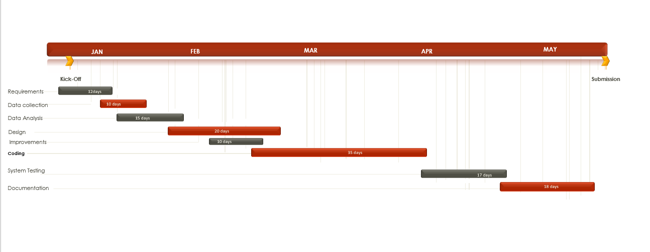

Figure 1.2:Gannt chart for project

Here horizontal bars indicate the duration of each task.

**CHAPTER 2**

**FEASBILITY STUDY**

**2.1 INTRODUCTION**

Feasibility of the system in an important aspect, which is to be considered. The system needs to satisfy the law of economic, which states that the maximum output should be yielded in minimum available resources.

A feasibility analysis evaluates the project’s potential for success; therefore, perceived objectivity is an essential factor in the credibility of the study for potential investors and lending institutions. There are five types of feasibility study—separate areas that a feasibility study examines, described below.

1. Technical Feasibility

This assessment focuses on the technical resources available to the organization. It helps organizations determine whether the technical resources meet capacity and whether the technical team is capable of converting the ideas into working systems. Technical feasibility also involves the evaluation of the hardware, software, and other technical requirements of the proposed system. As an exaggerated example, an organization wouldn’t want to try to put Star Trek’s transporters in their building—currently, this project is not technically feasible.

1. Economic Feasibility

This assessment typically involves a cost/ benefits analysis of the project, helping organizations determine the viability, cost, and benefits associated with a project before financial resources are allocated. It also serves as an independent project assessment and enhances project credibility—helping decision-makers determine the positive economic benefits to the organization that the proposed project will provide.

1. Legal Feasibility

This assessment investigates whether any aspect of the proposed project conflicts with legal requirements like zoning laws, data protection acts or social media laws. Let’s say an organization wants to construct a new office building in a specific location. A feasibility study might reveal the organization’s ideal location isn’t zoned for that type of business. That organization has just saved considerable time and effort by learning that their project was not feasible right from the beginning.

1. Operational Feasibility

This assessment involves undertaking a study to analyze and determine whether—and how well—the organization’s needs can be met by completing the project. Operational feasibility

studies also examine how a project plan satisfies the requirements identified in the requirements analysis phase of system development.

1. Scheduling Feasibility

This assessment is the most important for project success; after all, a project will fail if not completed on time. In scheduling feasibility, an organization estimates how much time the project will take to complete.

When these areas have all been examined, the feasibility analysis helps identify any constraints the proposed project may face, including:

* Internal Project Constraints: Technical, Technology, Budget, Resource, etc.
* Internal Corporate Constraints: Financial, Marketing, Export, etc.
* External Constraints: Logistics, Environment, Laws, and Regulations, et

**2.2 MAIN ASPECTS**

There are three aspects of feasibility to be considered namely.

1. Technical
2. Operational
3. Economical

TECHNICAL:

In the technical aspects one may consider the hardware equipment for the installation of the software. The system being centralized will required very little hardware appliances. Hence this helps the system to work smoothly with limited amount of working capitals.

OPERATIONAL:

In the operational aspects may think of the benefits of the workload that many a personal may have to share. This is eased out and the required output may be retrieved in a very short time. Thus there is accuracy in the work on time is also saved there will be very little work that needs to be performed.

ECONOMICAL:

Economical system is definitely feasible because the hardware requirement is less and the operational working for the system requires less number of recruits. This help introduction over-staffing and wastage funds.

We studied on the position to evaluate solution. Most important factors in this study were tending to overlook the confusion inherent in system Development the constraints and the assumed studies. It can be started that it the feasibility study is to serve as a decision document it must answer three key questions.

1. Is there a new and better way to do the job that will benefit the user?
2. What are the costs and savings of the alternatives?
3. What is recommended?

On these questions it can be explained that feasibility study of the system includes following different angles.

**2.2.1 Technical feasibility:**

This centers on the existing computer system (hardware, software etc.) and to what extent it can support the proposed additional equipment .in this stage of

study, we have collected information about technical tools available by which I could decide my system design as the technical requirements.

**2.2.2 Operational Feasibility:**

In this stage of study we have checked the staff availability. I concentrate on knowledge of end users that are going to use the system. This is also called as behavioral feasibility in which I have studied on following aspects; people are inherently resistant to change, and computers have been known to facilitate change .An estimate has been made to how strong a reaction the user staff is having toward the development of a computerized system. It is common knowledge that computer installations have something to do with turnover. I had explained that there is need to educate and train the staff on new ways of conducting business.

**2.2.3Economical feasibility**:

Economical analysis is the most frequently used method for evaluating the effectiveness of candidate system. More commonly known as cost\benefit analysis, the procedure is to determine the benefits and savings that benefits outweigh costs. The decision was to design and implement system because it is for having chanced to be approved. This is an on going effort that improves the accuracy at each phase of the system life cycle.

In developing cost estimates for a system I need to consider several cost elements. Among these is hardware personal facility. Operating and supply costs.

**2.3 BENEFITS**

Benefits of conducting a feasibility study:

* Improves project teams’ focus
* Identifies new opportunities
* Provides valuable information for a “go/no-go” decision
* Narrows the business alternatives
* Identifies a valid reason to undertake the project
* Enhances the success rate by evaluating multiple parameters
* Aids decision-making on the project
* Identifies reasons not to proceed

**2.4 SYSTEM REQUIREMENT SPECIFICATION**

Any system can be designed after specifies the requirement of the user about that system. For this first of all gathered information from user by the preliminary investigation which is starting investigation about user requirement..

The data that the analysts collect during preliminary investigation are gathered through the various preliminary methods.

1)Documents Reviewing Organization

The analysts conducting the investigation first learn the organization involved in, or affected by the project. Analysts can get some details by examining organization charts and studying written operating procedures.

Collected data is usually of the current operating procedure:

* The information relating to clients, projects and students and the relationship between them was held manually.
* Managing of follow-ups was through manual forms.
* Complaints require another tedious work to maintain and solve.
* Payments details had to be maintained differently.

2) Gathering Information By Asking Questions

Interviewing is the most commonly used techniques in analysis. It is always necessary first to approach someone and ask them what their problems are, and later to discuss with them the result of your analysis.

3) Questionnaires

Questionnaires provide an alternative to interviews for finding out information about a system. Questionnaires are made up of questions about information sought by analyst. The questionnaire is then sent to the user, and the analyst analyzes the replies.

4) Electronic Data Gathering

Electronic communication systems are increasingly being used to gather information. Thus it is possible to use electronic mail to broadcast a question to a number of users in an organization to obtain their viewpoint on a particular issue.

In my project, with the help of Marg software solutions, I have send questionnaire through electronic mail to twenty employees of the company and retrieved the information regarding the problem faced by existing system.

5) Interviews

Interview allows the analysts to learn more about the nature of the project request and reason of submitting it. Interviews should provide details that further explain the project and show whether assistance is merited economically, operationally or technically.

One of the most important points about interviewing is that what question you need to ask.

It is often convenient to make a distinction between three kinds of question that is

* Open questions
* Closed question
* Probes

Open questions are general question that establish a persons view point on a particular subject.

Closed questions are specific and usually require a specific answer.

Probes are question that follow up an earlier answer.

**CHAPTER 3**

**DESIGN**

**3.1 INTRODUCTION**

System is created to solve problems. One can think of the systems approach as an organized way of dealing with a problem. In this dynamic world, the subject system analysis and design, mainly deals with the software development activities.

Since a new system is to be developed, the one most important phases of software development life cycle is system requirement gathering and analysis. Analysis is a detailed study of various operations performed by a system and their relationship within and outside the system. Using the following steps it becomes easy to draw the exact boundary of the new system under consideration.

All procedures, requirements must be analysed and documented in the form of detailed DFDs, logical data structure and miniature specifications.

System analyses also include sub-dividing of complex process involving the entire system, identification of data store and manual processes.

**3.2 SYSTEM DESIGN**

System design is the process of planning a new system or to replace the existing system. Simply, system design is like the blueprint for building, it specifies all the features that are to be in the finished product.

System design phase follows system analysis phase. Design is concerned with identifying functions, data streams among those functions, maintaining a record of the design decisions and providing a blueprint the implementation phase.

Design is the bridge between system analysis and system implementation. Some of the essential fundamental concepts involved in the design of application software are:

* Abstraction
* Modularity
* Verification

**Abstraction** is used to construct solutions to problem without having to take account of the intricate details of the various component sub problems. Abstraction allows system designer to make step-wise refinement, which at each stage of the design may hide, unnecessary details associated with representation or implementation from the surrounding environment.

**Modularity** is concerned with decomposing of main module into well-defined manageable units with well-defined interfaces among the units. This enhances design clarity, which in turn eases implementation, Debugging, Testing, Documenting and Maintenance of the software product. Modularity viewed in this sense is a vital tool in the construction of large software projects.

**Verification** is fundamental concept in software design. A design is verifiable if it can be demonstrated that the design will result in implementation that satisfies the customer’s requirements. Verification is of two types namely.

* Verification that the software requirements analysis satisfies the customer’s needs.
* Verification that the design satisfies the requirement analysis.

Some of the important factors of quality that are to be considered in the design of application software are:

**Reliability:**

The software should behave strictly according to the original specification and should function smoothly under normal conditions.

**Extensibility:**

The software should be capable of adapting easily to changes in the specification.

**Reusability:**

The software should be developed using a modular approach, which permits modules to be reused by other application, if possible.

The System Design briefly describes the concept of system design and it contains four sections. The first section briefly describes the features that the system is going to provide to the user and the outputs that the proposed system is going to offer.

The second section namely Logical Design describes the Data Flow Diagrams, which show clearly the data movements, the processes and the data sources, and sinks, E-R diagrams which represent the overall logical design of the database, and high-level process structure of the system.

**Preliminary Design:**

Preliminary design is basically concerned with deriving an overall picture of the system. Deriving entire system into modules and sub-modules while keeping Cohesion and Coupling factors in mind. Tools, which assist in preliminary design process, are Data Flow Diagrams.

**Code design:**

The purpose of code is to facilitate the identification and retrieval for items of information. A code is an ordered collection of symbols designed to provide unique identification of an entity or attribute. To achieve unique identification there must be only one place where the identified entity or the attribute can be entered in the code; conversely there must be a place in the code for every thing that is to be identified. This mutually exclusive feature must be built into any coding system.

The codes for this system are designed with two features in mind. Optimum human oriented use and machine efficiencyThey are also operable i.e., they are adequate for present and anticipate data processing both for machine and human use.

**Input /Output design** :

is a part of overall system design, which requires very careful attention. The main objectives of input design are:

* To produce a cost-effective method of input.
* To achieve the highest possible level of accuracy.
* To ensure that the input is acceptable to and understood by the user staff.

Outputs from computer systems are required primarily to communicate the results of processing to users. They are also to provide a permanent hard copy of these results for later consultation.

The various types of outputs are required by this system are given below:

* External outputs, whose destination is outside the concern and which require special attention because they, project the image of the concern.
* Internal outputs, whose destination is within the concern and which require careful design because they are the user’s main interface within the computer.
* Operation outputs, whose use is purely within the computer department, E.g., program listings, usage statistics etc,

**3.3 SDLC**

Software Development Life Cycle (SDLC) is a framework that defines the steps involved in the development of software at each phase. It covers the detailed plan for building, deploying and maintaining the software.

SDLC defines the complete cycle of development i.e. all the tasks involved in planning, creating, testing, and deploying a Software Product.

Figure 3.1:Above image depicting the planning step

**SDLC Phases**

**Given below are the various phases:**

* Requirement gathering and analysis
* Design
* Implementation or coding
* Testing
* Deployment
* Maintenance

1) Requirement Gathering and Analysis

During this phase, all the relevant information is collected from the customer to develop a product as per their expectation. Any ambiguities must be resolved in this phase only.

Business analyst and Project Manager set up a meeting with the customer to gather all the information like what the customer wants to build, who will be the end-user, what is the purpose of the product. Before building a product a core understanding or knowledge of the product is very important.

Once the requirement gathering is done, an analysis is done to check the feasibility of the development of a product. In case of any ambiguity, a call is set up for further discussion.

Once the requirement is clearly understood, the SRS (Software Requirement Specification) document is created. This document should be thoroughly understood by the developers and also should be reviewed by the customer for future reference.

2) Design

In this phase, the requirement gathered in the SRS document is used as an input and software architecture that is used for implementing system development is derived.

3) Implementation or Coding

Implementation/Coding starts once the developer gets the Design document. The Software design is translated into source code. All the components of the software are implemented in this phase.

4) Testing

Testing starts once the coding is complete and the modules are released for testing. In this phase, the developed software is tested thoroughly and any defects found are assigned to developers to get them fixed.

Retesting, regression testing is done until the point at which the software is as per the customer’s expectation. Testers refer SRS document to make sure that the software is as per the customer’s standard.

5) Deployment

Once the product is tested, it is deployed in the production environment or first [UAT (User Acceptance testing)](https://www.softwaretestinghelp.com/what-is-user-acceptance-testing-uat/) is done depending on the customer expectation.

6) Maintenance

After the deployment of a product on the production environment, maintenance of the product i.e. if any issue comes up and needs to be fixed or any enhancement is to be done is taken care by the developers.

**3.4 SOFTWARE ENGG. PARADIGM APPLIED**

Software engineering is a layered technology. The foundation for software engineering is the process layer. Software engineering processes the glue that holds the technology layers together and enables ratios and timely development of computer software. Process defines a framework for a set of key process areas that must be established for effective delivery of software engineering technology.

Software engineering methods provide the technical how-to’s for building software. Methods encompass a broad array of tasks that include requirements analysis, design, program construction, testing and support. Software engineering tools provide automated or semi-automated support for the process and the methods. When tools are integrated so that information created by one tool can be used by another tool, a system for the support of software development, called computer-aided software engineering is established.

**The following paradigms are available:**

1. The Waterfall Model

2. The Prototyping Model

3. The Spiral model

Etc.

**3.4.1 The Prototype model**

The prototype model requires that before carrying out the development of actual software, a working prototype of the system should be built. A prototype is a toy implementation of the system. A prototype usually turns out to be a very crude version of the actual system, possible exhibiting limited functional capabilities, low reliability, and inefficient performance as compared to actual software. In many instances, the client only has a general view of what is expected from the software product. In such a scenario where there is an absence of detailed information regarding the input to the system, the processing needs, and the output requirement, the prototyping model may be employed.

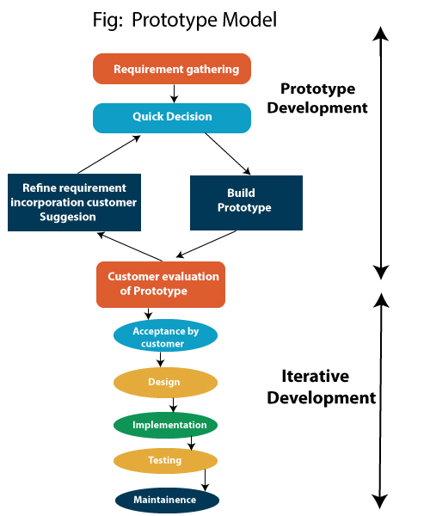

Figure 3.2:Prototype model

**3.4.1.1Advantage of Prototype Model**

1. Reduce the risk of incorrect user requirement
2. Good where requirement are changing/uncommitted
3. Regular visible process aids management
4. Support early product marketing
5. Reduce Maintenance cost.
6. Errors can be detected much earlier as the system is made side by side.

**3.4.1.2 Disadvantage of Prototype Model**

1. An unstable/badly implemented prototype often becomes the final product.
2. Require extensive customer collaboration
   * Costs customer money
   * Needs committed customer
   * Difficult to finish if customer withdraw
   * May be too customer specific, no broad market
3. Difficult to know how long the project will last.
4. Easy to fall back into the code and fix without proper requirement analysis, design, customer evaluation, and feedback.
5. Prototyping tools are expensive.
6. Special tools & techniques are required to build a prototype.
7. It is a time-consuming process.

**3.5 DFD**

**DFD** is the abbreviation for **Data Flow Diagram**. The flow of data of a system or a process is represented by DFD. It also gives insight into the inputs and outputs of each entity and the process itself. DFD does not have control flow and no loops or decision rules are present. Specific operations depending on the type of data can be explained by a flowchart. Data Flow Diagram can be represented in several ways.

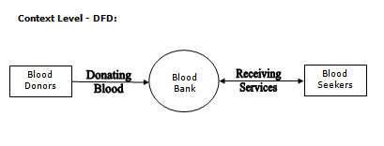

Figure 3.3 Context level

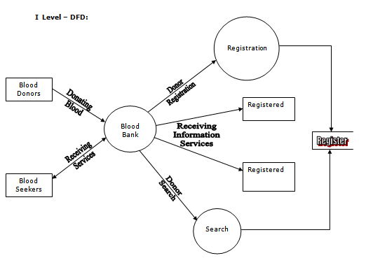

Figure 3.4 dfd 1 level

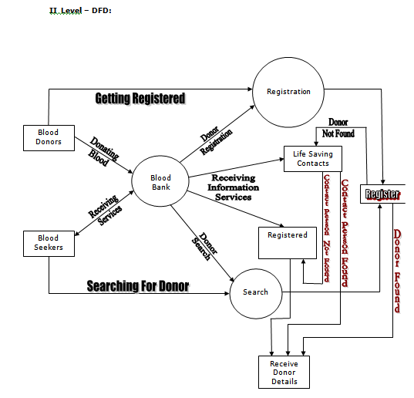

Figure 3.5 DFD 2 level

**3.6 ER DIAGRAM**

An Entity–relationship model (ER model) describes the structure of a database with the help of a diagram, which is known as Entity Relationship Diagram (ER Diagram). An ER model is a design or blueprint of a database that can later be implemented as a database. The main components of E-R model are: entity set and relationship set.

An ER diagram has three main components:

1. Entity

2. Attribute

3. Relationship

Figure 3.2:ER diagram of system

**3.7.1 ER- Diagram Notations**

ER- Diagram is a visual representation of data that describe how data is related to each other.

* **Rectangles:** This symbol represent entity types
* **Ellipses :** Symbolrepresent attributes
* **Diamonds:** This symbolrepresents relationship types
* **Lines:** It links attributes to entity types and entity types with other relationship types
* **Primary key:** attributes are underlined
* **Double Ellipses:** Represent multi-valued attributes

**CHAPTER 4**

**REPORT**

**4.1 GIST**

The diagram **figure 4.1,**depicting our system.

We have designed and developed an easy, Useful, reliable system.

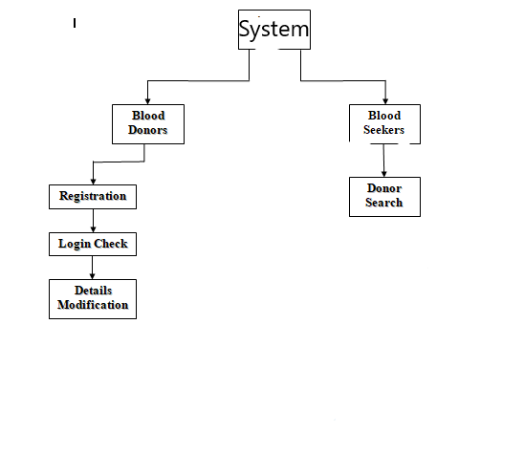

Figure 4.1 System

The proposed of PAN INDIA BLOOD DONATION FOR COVID-19 People web-App helps the people who need a blood by giving them all details of blood group availability or regarding the donors with the same blood group.

They do not need to go anywhere to search the blood when they need. They just need to use this WebApp then all the result will appear in just a second.

* 1. **SOME SCREENSHOTS**

HOME PAGE

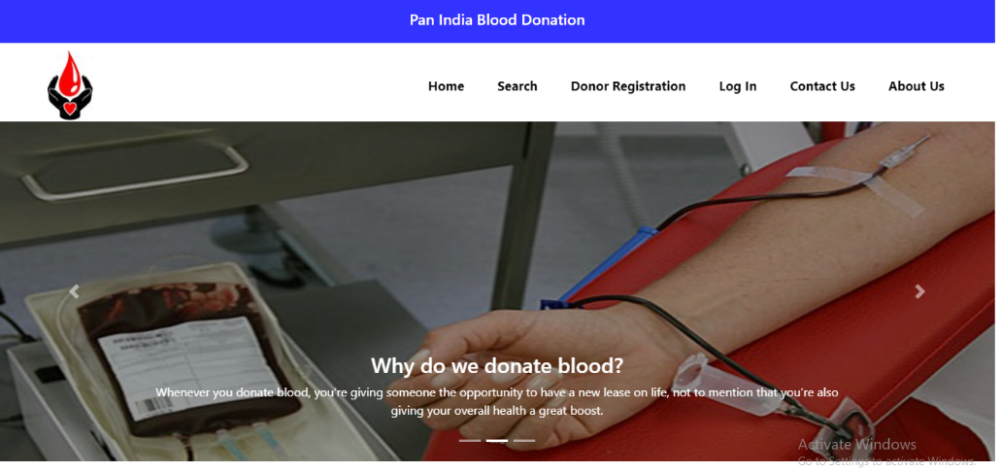

Click on login

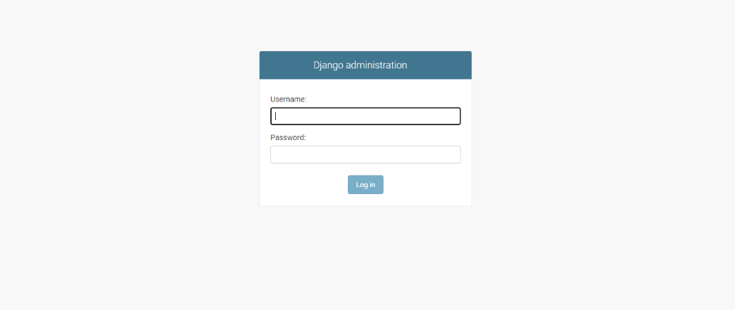

USERName is: admin

Password is: admin

click on login button, it will open Admin Section

Blood Donor List

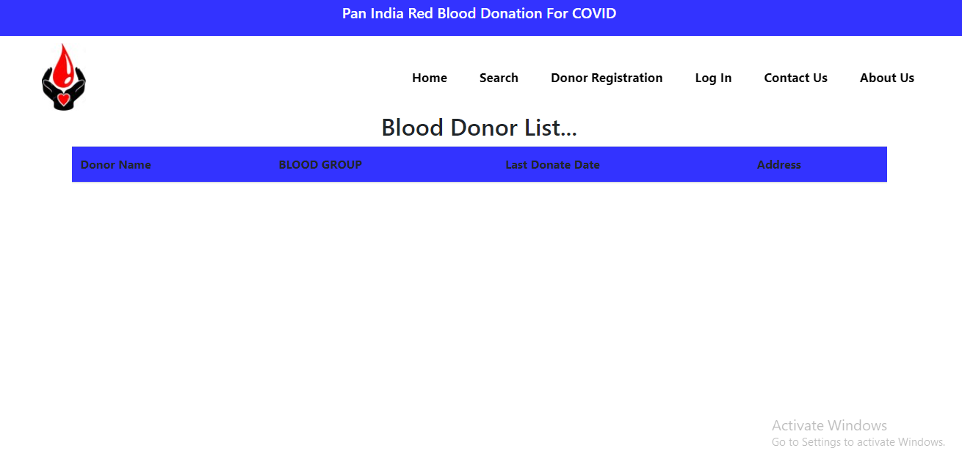

Click on Search

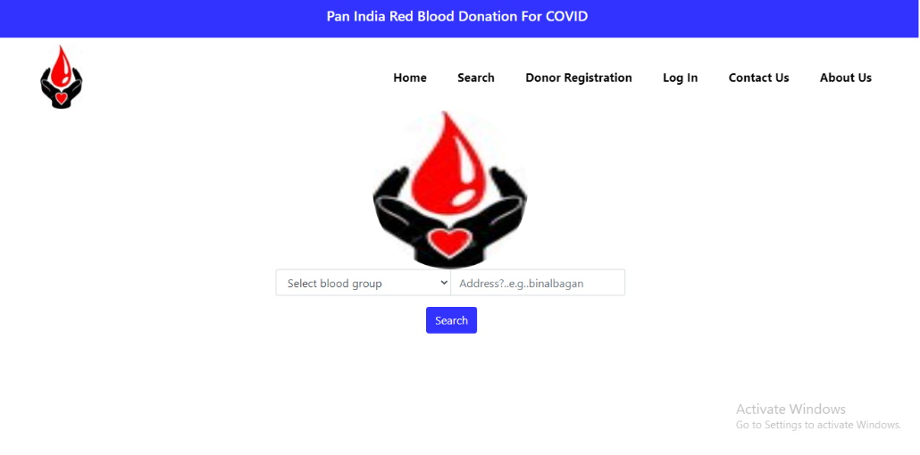

Donor Registration

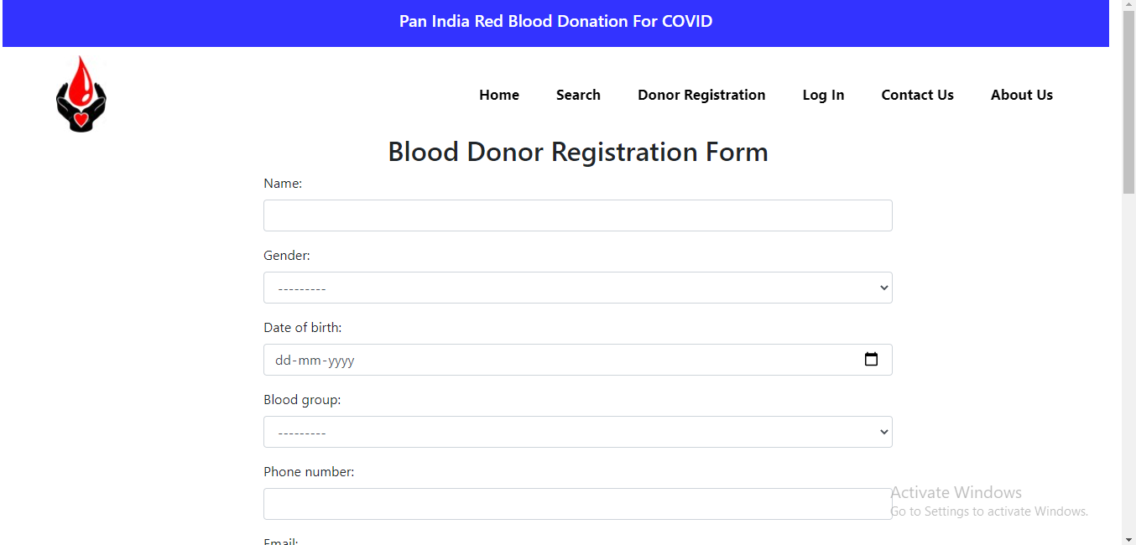

Contact us Section

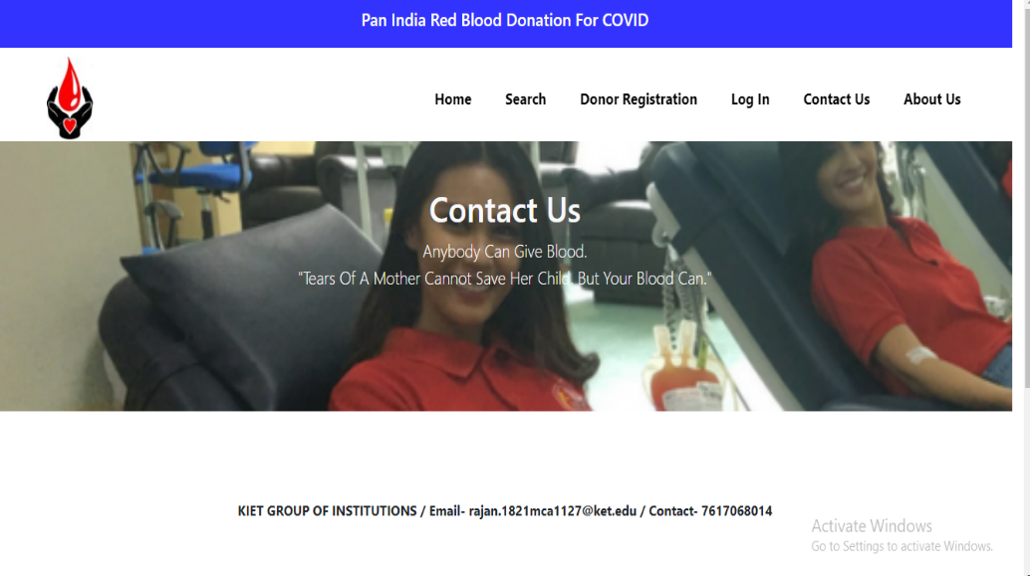

User Opinion

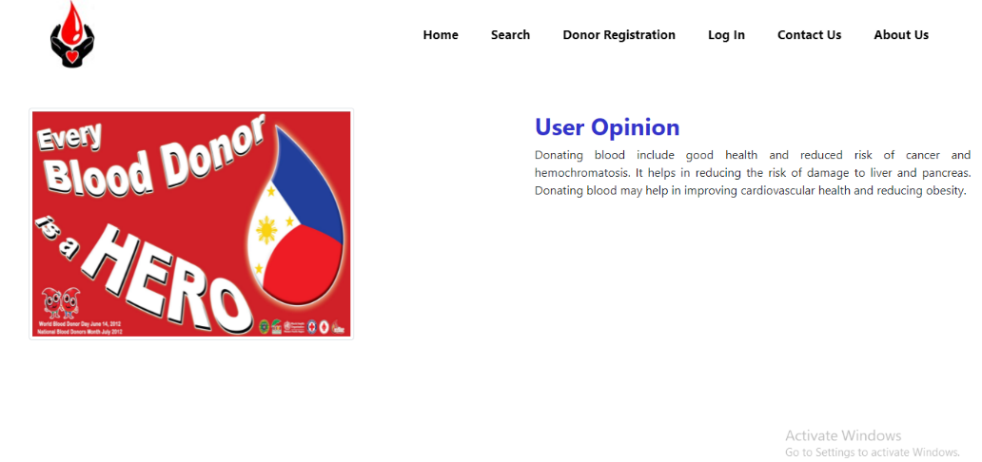

**CHAPTER 5**

**CODING**

This chapter contains some codes of the project.The goal of the coding is to **translate the design of the system into code in a given programming language**. For a given design, the aim of this phase is to implement the design in the best possible manner. The coding phase affects both testing and maintenance profoundly.

**Some Codes are as Written below:**

**manage.py**

#!/usr/bin/env python

"""Django's command-line utility for administrative tasks."""

import os

import sys

def main():

os.environ.setdefault('DJANGO_SETTINGS_MODULE', 'bloodsbanks.settings')

try:

from django.core.management import execute_from_command_line

except ImportError as exc:

raise ImportError(

"Couldn't import Django. Are you sure it's installed and "

"available on your PYTHONPATH environment variable? Did you "

"forget to activate a virtual environment?"

) from exc

execute_from_command_line(sys.argv)

if __name__ == '__main__':

main()

HOME

admin.py

from django.contrib import admin

from .models import HomePageSlider,HomePageBody

admin.site.register(HomePageSlider)

admin.site.register(HomePageBody)

apps.py

from django.apps import AppConfig

class HomeConfig(AppConfig):

name = 'home'

models.py

from django.db import models

class HomePageSlider(models.Model):

id_number = models.IntegerField(blank=True, null=True)

title = models.CharField(blank=True, null=True, max_length=20)

slider_1 = models.ImageField(upload_to='slider')

slider_2 = models.ImageField(upload_to='slider')

slider_3 = models.ImageField(upload_to='slider')

def __str__(self):

return self.title

views.py

from django.shortcuts import render

from .models import HomePageSlider, HomePageBody

def homedisplay(request):

home_slider = HomePageSlider.objects.get(id_number=1)

our_vision = HomePageBody.objects.get(id_vision=1)

donor_opinion = HomePageBody.objects.get(id_vision=2)

user_opinion = HomePageBody.objects.get(id_vision=3)

CONTACT

Admn.py

from django.contrib import admin

from .models import ContactPageBody

admin.site.register(ContactPageBody)

apps.py

from django.apps import AppConfig

class ContactConfig(AppConfig):

name = 'contact

models.py

from django.db import models

class ContactPageBody(models.Model):

id_contact = models.IntegerField(blank=True, null=True)

title = models.CharField(max_length=20, blank=True, null=True)

contact_text = models.TextField(blank=True, null=True)

def __str__(self):

return self.title

url.py

from django.urls import path

from .views import contactdisplay

urlpatterns = [

path('', contactdisplay, name='contactsite1'),

]

views.py

from django.shortcuts import render

from .models import ContactPageBody

def contactdisplay(request):

contact = ContactPageBody.objects.get(id_contact=1)

context = {

'contact' : contact

}

SEARCH

Admin.py

from django.contrib import admin

from .models import SearchLogo

admin.site.register(SearchLogo)

apps.py

from django.apps import AppConfig

class SearchConfig(AppConfig):

name = 'search'

models.py

from django.db import models

# data table for search logo

class SearchLogo(models.Model):

title = models.CharField(blank=True, null=True, max_length=10)

logo_number = models.IntegerField(blank=True, null=True)

logo_image = models.ImageField(upload_to='logo')

def __str__(self):

return self.title

url.py

from django.urls import path

from .views import searchdisplay, donorlistdetail

urlpatterns = [

path('', searchdisplay, name='searchsite1'),

path('donorlist/', searchdisplay, name='donorlistsite'),

path('donorlist/donorlistdetail/<email>/', donorlistdetail, name='donorlistdetailsite'),

]

views.py

from django.shortcuts import render

from .forms import DonorSearch

from dreg .models import DonorList

from .models import SearchLogo

def searchdisplay(request):

search_forms = DonorSearch()

logo_img = SearchLogo.objects.get(logo_number=1)

if request.method == 'POST':

search_forms = DonorSearch(request.POST)

if search_forms.is_valid():

blood_group = search_forms.cleaned_data['select_blood_group']

location = search_forms.cleaned_data['select_location']

donor_filter = DonorList.objects.filter(blood_group=blood_group, home_address__icontains=location)

context = {

'donor_filter' : donor_filter

}

return render(request, 'list.html', context)

context = {

'forms_search' : search_forms,

'logo_img' : logo_img

}

return render(request, 'search.html' ,context)

def donorlistdetail(request, email):

email = email

detail = DonorList()

detail = DonorList.objects.get(email=email)

context = {

'details' : detail

}

return render(request, 'information.html', context)

return render(request, 'contact_us.html', context)

This are some codes which are used in our project we have uploaded the packages also on github Repository. URL for packages.

URL- https://github.com/raynv1

**CHAPTER 6**

**TESTING**

**6.1 INTRODUCTION**

Software Testing is a critical element of software quality assurance and represents the ultimate review of specification, design and code generation. The increasing visibility of software as a system element and the attendant “costs” associated with a software failure are motivating forces for well planned, thorough testing.

**6.1.1 Testing Objectives**

The following are the testing objectives:

-Testing is a process of executing a program with the intent of finding an error.

-A good test case is one that has a high probability of finding an as-yet-undiscovered error

-successful test is one that uncovers an as yet undiscovered error.

**6.1.2 Testing Principles**

The basic principles that guide software testing are as follows:

-All tests should be traceable to customer requirements.

-Tests should be planned long before testing begins.

-The parate principle applies to software testing.

Pareto principle states that 80 percent of all errors uncovered during testing will likely be traceable to 20 percent of all program components.

Testing should begin “in the small “and progress toward testing “in the large.”

Exhaustive testing is not possible.

**6.2 LEVEL OF TESTING**

There are different levels of testing

->Unit Testing

->Integration Testing

->System Testing

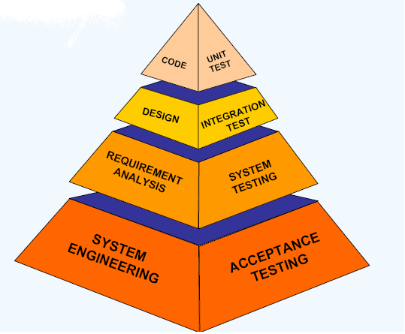

Figure 5.1:Testing pyramid

* + 1. **Unit testing**

Unit testing focuses verification effort on the smallest unit of software design, the module. The important control parts are tested to uncover with in the boundary of the module. The module interface is tested to ensure that the information properly flows into and out of the program unit and boundary conditions are tested to ensure that the modules operate properly at boundaries established to limit or restrict processing. Test date is provided through testing screens.

* + 1. **Integration testing**

Integrating testing is a systematic technique for constructing Program structure while conducting tests to uncover error associates with interfacing .The objective is to take unit modules and built a program structure that has been directed by design.

• Integration Testing will test whether the modules work well together.

• This will check whether the design is correct.

• Integration can be done in 4 different ways:

* + 1. **System testing**

System testing is the process of testing the completed software as a part of the environment it was created for. It is done to ensure that all the requirements specified by the customer are met. System testing involves functional testing and performance testing.

• System Testing will contain the following testing :

* Functional Testing.
* Performance Testing.

• Function Testing will test the implementation of the business needs.

• Performance Testing will test the non-functional requirements of the system like the speed, load etc

* 1. **SOME IMPORTANT OBSERVTIONS**

**6.3.1 System Testing and Validation Results.**

System testing was done after the system was duly coded. Individual modules of the system were checked to ensure they are fully functional units before the integrating them. This was done by examining each unit; each script was checked to ensure that it functions as required and that it performed exactly as intended. The success of each individual unit gave us the go ahead to carryout integration testing. Different system modules were put together to make a complete system and integration testing ensured modules were compatible to be integrated to form a complete working system.

The system was validated using a short questionnaire that was filled by representatives of the users who were let to interact with the system using test data and provided feedback about the system features. This was done to assess if the system met their needs and requirements as regards paying fees to the university. It was found out that the system performed in conformance to the then defined user needs and requirements. Results of the validation are shown as percentages of respondents against each requirement.

**6.3.2 Testing Test Scenarios**

1.Check if the page load time is within the acceptable range.  
2.Check the page load on slow connections.  
3.Check the response time for any action under a light, normal, moderate, and heavy load conditions.  
4.Check the performance of database stored procedures and triggers.  
5.Check the database query execution time.  
6.Check for load testing of the application.  
7.Check for the Stress testing of the application.  
8. Check CPU and memory usage under peak load conditions.

We have checked for scenarios and find that our system performing well in the circumstances.

` **CHAPTER 7**

**CONCLUSION AND FUTURE SCOPE**

**7.1 CONCLUSION**

* The Project entitled with **Pan India Red Blood Donation For Covid 19** was completed Successfully.
* It provides easy methods to manage the load of work easily for the users.
* It is much fast and more efficient as the data once entered can be used and accessed easily.
* This project has given me an ample opportunity to design, code, test and implements an application. This has helped in putting into practice of various Software Engineering principles and Database Management concepts like maintaining integrity and consistency of data.

**7.1.1Extensibility:**

The other features, which the Blood bank services provide, can also be incorporated into this Blood Bank. The Encryption standards can also be used to make the transactions more secure. The Socket Secure Layer protocol can also used in implementing the system, which gives highest security in the Internet.

**7.2 FUTURE SCOPE**

* The Future scope is to make the system more user friendly and enhanced .
* And we will make app for our system..
* As there was a little number of contact person’s information given, some people may face difficulty in getting blood fast. So i like to gather more information regarding the contact persons in other cities as well as villages and will provide much more services for the people and help everyone with humanity.

**BIBLIOGRAPHY**

The books , which are referred and which really helped me in building this system in time, are as follows:-

Books:

HTML Steven Holzner (Black Book)

FRONT PAGE Daniel A. Tauber, Brenda Kienan

SYSTEM ANALYSIS &DESIGN Ellias M. Award

SOFTWARE ENGINEERING Roger S. Pressman

Web Sites:

[www.google.com](http://www.google.com)

[www.msn.com](http://www.msn.com)

[www.bloodzone.com](http://www.bloodzone.com)

[www.bloodbankservices.com](http://www.bloodbankservices.com)

**REFERENCES**

1. Safe blood and blood products. Module 1: Safe blood donation. Geneva: World Health Organization; 2002. [17 August 2012]. [http://www​.who.int/bloodsafety​/transfusion_services​/bts_learningmaterials​/en/index.html](http://www.who.int/bloodsafety/transfusion_services/bts_learningmaterials/en/index.html).
2. Blood donor selection. Guidelines on assessing donor suitability for blood donation. Annex Geneva: World Health Organization; 2012. [17 August 2012]. [http://www​.who.int/bloodsafety​/voluntary_donation​/blood_donor​_selection_counselling/en/](http://www.who.int/bloodsafety/voluntary_donation/blood_donor_selection_counselling/en/)
3. Aide-mémoire. Blood safety. Geneva: World Health Organization; 2002. [17 August 2012]. [http://www​.who.int/bloodsafety​/publications​/who_bct_02_03/en/index.html](http://www.who.int/bloodsafety/publications/who_bct_02_03/en/index.html).
4. WHO/IFRC. Towards 100% voluntary blood donation: A global framework for action. Geneva: World Health Organization; 2010. [17 August 2012]. [http://www​.who.int/bloodsafety​/publications​/9789241599696/en/](http://www.who.int/bloodsafety/publications/9789241599696/en/)
5. The Melbourne Declaration on 100% voluntary non-remunerated donation of blood and blood components. Geneva: World Health Organization; 2009. [17 August 2012]. [http://www​.who.int/worldblooddonorday​/Melbourne​_Declaration_VNRBD_2009.pdf](http://www.who.int/worldblooddonorday/Melbourne_Declaration_VNRBD_2009.pdf).
6. WHO/CDC/IFRC. Blood donor counselling: Implementation guidelines. Geneva: World Health Organization; 2012. [17 August 2012]. [http://www​.who.int/bloodsafety​/voluntary_donation​/blood_donor​_selection_counselling/en/](http://www.who.int/bloodsafety/voluntary_donation/blood_donor_selection_counselling/en/)
7. Screening donated blood for transfusion-transmissible infections. Geneva: World Health Organization;2010<http://www.who.int/bloodsafety/publications/bts_screendondbloodtransf/en/index​.html>.
8. Reiss RF. Blood donor well-being: a primary responsibility of blood collection agencies. Annals of Clinical & Laboratory Science. 2011;41(1):3–7. [[PubMed](https://www.ncbi.nlm.nih.gov/pubmed/21325247)]
9. Global Database on Blood Safety. Summary report 2011. Geneva: World Health Organization; 2011. [22 August 2012]. [http://www​.who.int/entity​/bloodsafety/global_database​/GDBS_Summary_Report_2011​.pdf](http://www.who.int/entity/bloodsafety/global_database/GDBS_Summary_Report_2011.pdf).
10. Boulton F. Evidence-based criteria for the care and selection of blood donors, with some comments on the relationship to blood supply and emphasis on the management of donation-induced iron depletion. Transfusion Medicine. 2008;18:13–27. [[PubMed](https://www.ncbi.nlm.nih.gov/pubmed/18279189)]
11. Eder A, et al. Selection criteria to protect the blood donor in North America and Europe: past (dogma), present (evidence), and future (hemovigilance). Transfusion Medicine Reviews. 2009;23(3):205–220. [[PubMed](https://www.ncbi.nlm.nih.gov/pubmed/19539875)]
12. Moreno J. “Creeping precautionism” and the blood supply. Transfusion. 2003;43:840–842. [[PubMed](https://www.ncbi.nlm.nih.gov/pubmed/12823739)]
13. Farrugia A. The mantra of blood safety: time for a new tune? Vox Sanguinis. 2004;86:1–7. [[PubMed](https://www.ncbi.nlm.nih.gov/pubmed/14984553)]
14. Fifty-Eighth World Health Assembly. Resolution WHA58.13: *Blood safety: proposal to establish World Blood Donor Day*. Geneva: World Health Organization; 2005. [17 August 2012]. [http://www​.who.int/bloodsafety​/resolutions/en/index.html](http://www.who.int/bloodsafety/resolutions/en/index.html) & [http://www​.who.int/entity​/bloodsafety/BTS​_ResolutionsAdopted.pdf](http://www.who.int/entity/bloodsafety/BTS_ResolutionsAdopted.pdf).
15. Sixty-Third World Health Assembly. Resolution WHA63.12: *Availability, safety and quality of blood products*. Geneva: World Health Organization; 2010. [17 August 2012]. [http://www​.who.int/bloodsafety​/resolutions/en/index.html](http://www.who.int/bloodsafety/resolutions/en/index.html) & http://www​.who.int/entity​/bloodsafety/BTS​_ResolutionsAdopted.pdf