Testcase 1:

Test step : Login credentials(Invalid entry)

Test data : original username, no password

Expected : Error, Login failed

Actual : Error, Login failed

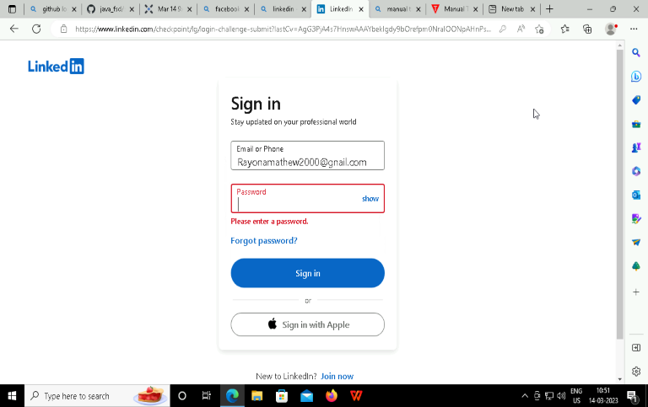

Testcase 2:

Test step : Login credentials(Invalid entry)

Test data : invalid username, original password, no @ is written in the email id

Expected : Error, Login failed

Actual : Error, Login failed

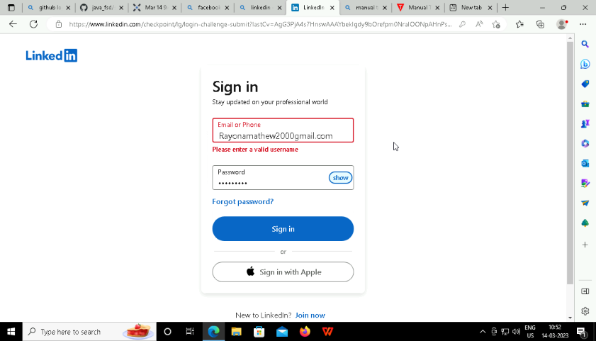

Testcase 3:

Test step : Login credentials(Invalid entry)

Test data : invalid username, original password, used ) instead of @ in email id

Expected : Error, Login failed

Actual : Error, Login failed

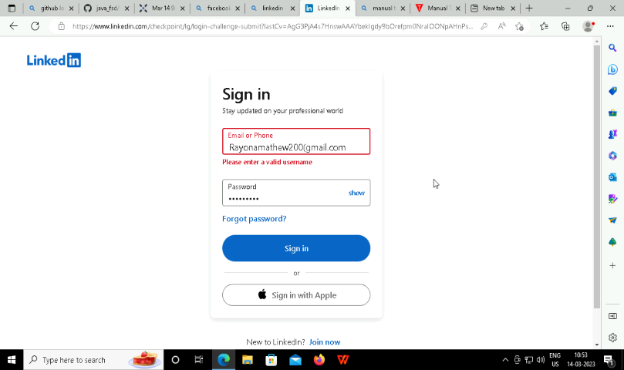

Testcase 4:

Test step : Login credentials(valid entry)

Test data : original username, original password

Expected : Passed, Login Successful

Actual : Passed, Login Successful

