Our transition from CLC Genomics Workbench version 20.0.2 to version 23.0.2 involved more in addition to an upgrade. We also consolidated artifact files, removed old artifact files, updated and added features to our workflows, and updated Qiagen reference data.

# Reorganizing

The CMOL-specific artifact files maintained within CLC Genomics Workbench folders had grown numerous and disorganized. In addition, many artifact files were no longer used, which led to confusion about what artifacts were used and where. We went through all the workflow elements within each workflow and recorded all the artifact files being used. We then backed up and deleted all artifact files that were not being used. For the remainder of the artifact files, we merged as many as we could into single files and stored all artifact files in a single “Components” folder.

Here is a snapshot of the file organization. For each workflow, common, comprehensive, and heme, we have a pair of primer and target region files that define each panel. We have dated artifact and hotspot files that are used in each workflow. Only the most recent dates are used in each workflow.

The 1000 genomes artifact is discussed below.

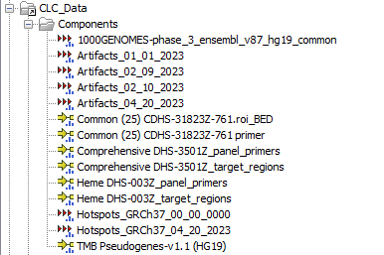

# Features

### 1000 Genomes Phase 3

### Alignment Quality (AQ) 30

# Reference Data

# Upgrade Procedure