This update procedure is a special case of jumping 3 major versions at once from version 20 to version 23. Upgrading 1 major version should be as easy as installing the latest version, opening it up, and opening each file for it to be converted to the version it is opened in. The conversion is usually accompanied by a message, and you are then given the opportunity to fix any errors.

# Shutdown

Before beginning the upgrade, make sure no other **CLC Genomics Workbench** instances are running on the computer. Even if you have shutdown your instance of **CLC Genomics Workbench**, another user may have a running instance in a different login session, in which case it will appear in the **Background processes** section of the **Task Manager**.

To make sure all instances of CLC Genomics Workbench are shutdown, right-click the task bar and then select **Task Manager** from the context menu. Within **Task Manager**, sort and look for a process named **CLC Genomics Workbench**, select the process and then click the **End Task** button.

The **Task Manager** with a **CLC Genomics Workbench** instance selected is shown below.

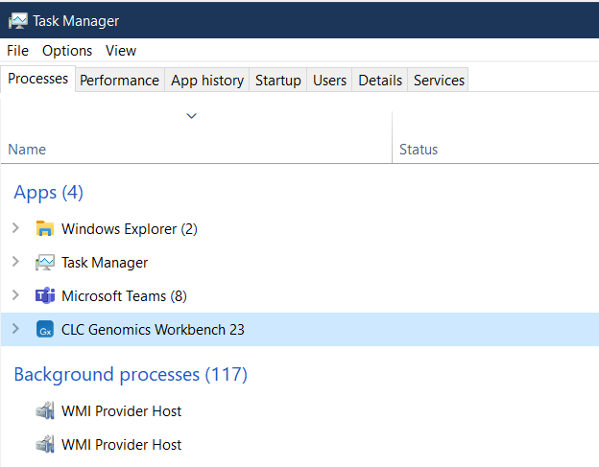

# Folder Prepration

First backup the *CLC_Data* and the *CLC_References* folders on a separate drive. To keep things simple, we use the same folder structure for version 23 as we had for version 20.

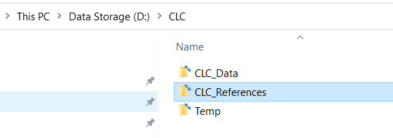

Next, delete the contents of both folders. Then, copy the contents of the *CLC_Data* directory into the *CLC_Data* folder for the latest version. Do not do this for the *CLC_References* folder. Instead, we must meticulously download the needed reference data through the **Reference Data Manager** within **CLC Genomics Workbench**. The reason we cannot copy over the contents of the *CLC_Reference*s folder is because reference data metadata is maintained in a separate location by **CLC Genomics Workbench**.

In addition, rename the *D:\CMOL data* directory to *D:\CMOL data backup* and then recreate the folder structure *D:\CMOL data\Clinical\Pending-Move to CMOL*. This will keep **CLC Genomics Workbench** from trying to reindex large amounts of data when it starts up.

# Install the Latest Version

Follow these steps to download and install the latest version of **CLC Genomics Workbench**.

1. Open the existing version of **CLC Genomics Workbench** as administrator
2. Select the *Help -> Check for Updates* menu option and the click the *Download* button, which will open a browser and take you to a web page
3. Download the Windows64bit.exe
4. Once downloaded, close the browser and close **CLC Genomics Workbench**
5. Open **Windows PowerShell** as administrator
6. Navigate to the **Downloads** directory with the command “cd $home/Downloads”
7. Install downloaded version with the command “.\CLCGenomicsWorkbench_23_0_3_64.exe”
8. Once the installation process starts, you can close **Windows PowerShell** with the command “exit”
9. Accept the license agreement and defaults, clicking the *Next* button each time.

# License Manager

The first time you start up the latest version of CLC Genomics Workbench you will have to configure the license. Warning, the second picture here is incorrect so first read the accompanying instructions before moving forward.

For this first screen choose *Configure license manager connection*

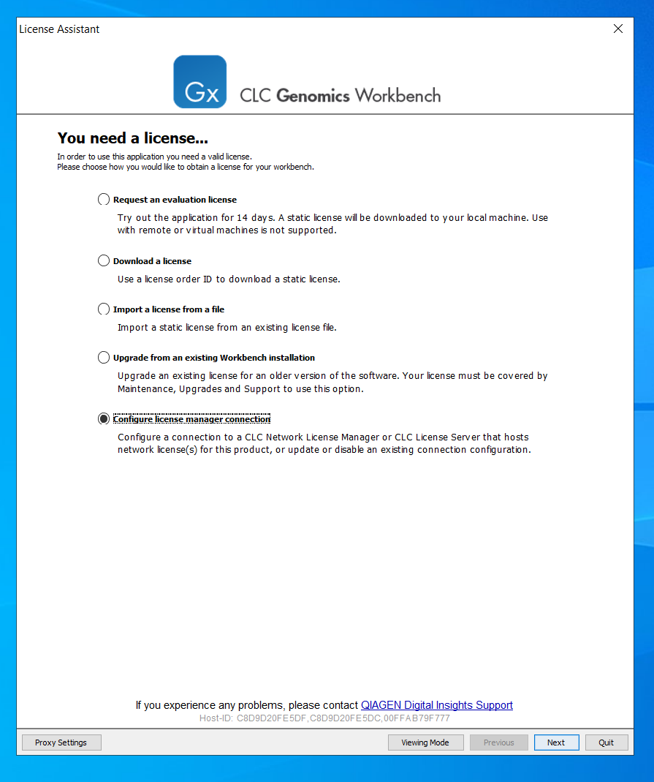

On this next screen, instead of choosing the option shown below, you should choose the *Manually specify license manager* and put “localhost” for the Hostname/IP-address field. Then click the *Finish* button.

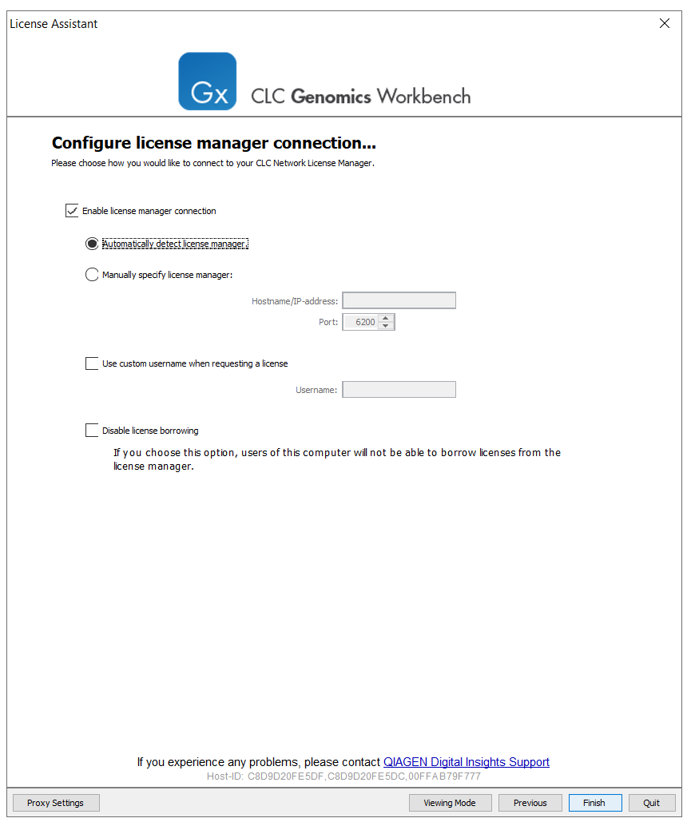

# Reference Data

Once you have successfully started **CLC Genomics Workbench**, right**-**click on the CLC_References folder and choose the menu option *Location -> Set As Default Location*.

Under **QIAGEN Sets**, manually download all the **Reference Data Elements** that are needed.

