Assignment report

Real-time Operating System - 48450

Student Name: Ryan Pereira

Student ID: 98112939

Note: This is a guide template to help you complete the assignment. There will be no penalty on your assignment score if you do not use this template. You are welcome to design your own template for the assignment.

**Table of Contents**

I. Introduction 3

II. Theory of operation 3

III. Operating condition 3

IV. Implementation 3

1. Method 3

2. Flow chart and/or Gantt Chart 3

V. Experiments 3

1. Hypothesis 3

2. Results 3

VI. Conclusion on result analysis 4

VII. References 4

1. Introduction

In this section, an introduction about the assignment is presented and some core technical knowledge that you will use are highlighted.

The Assignment is composed of two parts: CPU Scheduling and Paging in Virtual Memory.

1. Theory of operation

In this section, the brief but clear explanations about the technical knowledge are given for this assignment. For example, the theory, the functions and the usage etc.

1. Operating condition

In this section, a summary about your understanding of the assignment is given. In order to complete the assignment, you might give a summary about key points that the assignment contains. In addition, you might explain the relationships between these points.

1. Implementation
2. Method

In this section, you might list how you solve the problem and how you complete your program. You might write your software design strategy about your programing.

1. Flow chart and/or Gantt Chart

You might draft a flow chart and/or a Gantt chart about this assignment.

1. Experiments
2. Hypothesis

Give an explanation about the experiment questions. If there are no questions, just omit this part.

1. Results

For demonstration purpose, you might give some graphs about your program running. An example is shown below.

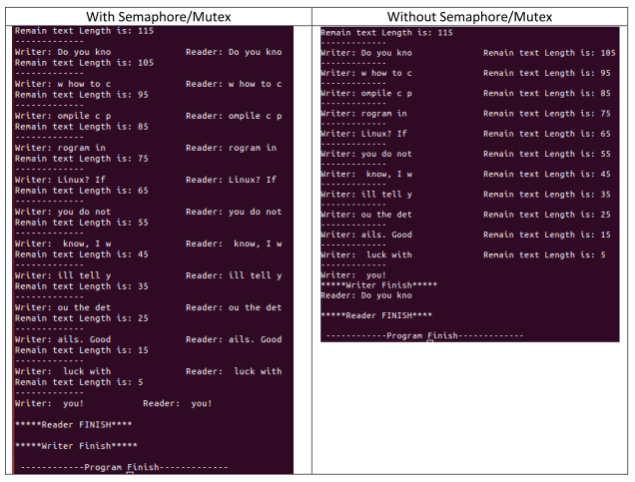

Figure 1. Sample of the figure -- Experimental results with and without semaphore/mutex.

1. Conclusion on result analysis

To give the report on this assignment, you might carefully observe the output of your program and give some explanations and analysis about the output/performance/outcomes based on our understanding.

1. References

If you have references, please referee them correctly.

A. Silberschatz, P. B. Galvin & G. Gagne, 2012, Operating System Concepts, 9 th edn, John Wiley & Sons, New York.