Dev Notes for ReconcilationTool

Build Notes
Compile
Pyinstaller --onefile --console --icon=Search-documents.ico --splash=Search-documents.png --version-file=version_info.txt --name=ReconcilationTool Search-documents.py
--noconsole does not create CLI interface, use –console for CLI
CLI Run
ReconcilationTool "SOURCE" "TARGET” --hash --find-all --timestamped-output
Use Test harness for collections

ReconcilationTool "D:\dev\Projects\Search-documents\test_data\folderA" "D:\dev\Projects\Search-documents\test_data\folderB" --hash --find-all --timestamped-output --output out

Command to check EXE archive>>pyi-archive_viewer.exe dist/ReconciliationToolCLI.exe, these search files for potential issues
Compile version_info.txt
python -c "from PyInstaller.utils.win32.versioninfo import *; exec(open('version_info.txt').read()); print('OK')"

Python Install
pip install pyinstaller openpyxl pytest pytest-cov hypothesis
Package Breakdown
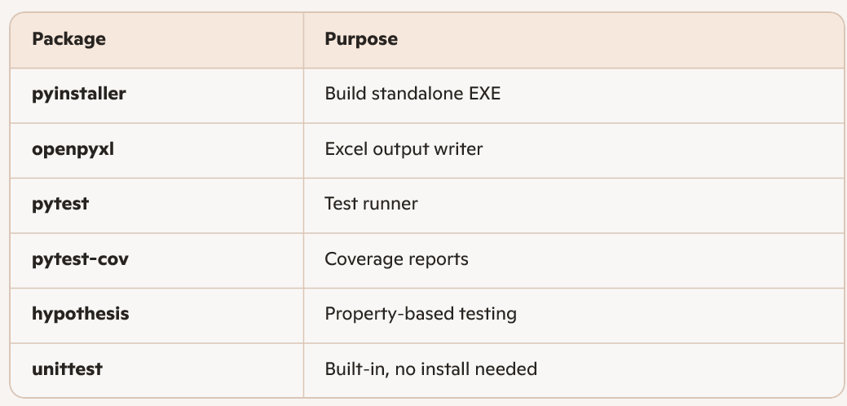
This command will freeze dependencies
pip freeze > requirements.txt

Build Standalone EXE
Your project uses PyInstaller with:
- Custom icon
- Splash screen
- Version metadata
- One-file bundle
- GUI mode (no console)
2.1 Build Command
From the project root:
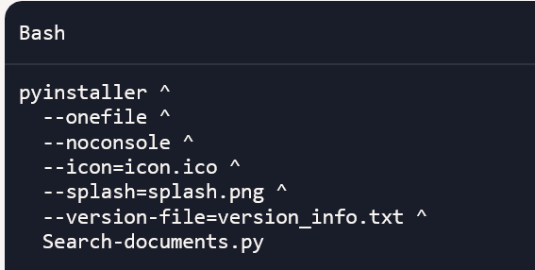
Pyinstaller –-onefile –-noconsole –-icon=Search-documents.ico --splash=Search-documents.png –-version-file=version_info.txt –-name=ReconcilationTool Search-documents.py
Splash is Search-documents.png
Icon is Search-documents.ico
Output>>dist/ReconcilationTool.exe

3. Building the MSI Installer
You have two supported methods:
3.1 Method A — Using Advanced Installer (recommended)
- Open Advanced Installer
- Create a Simple Project
- Add your EXE + icon + splash assets
- Set install path:
Program Files\ReconciliationTool
- Add Start Menu / Desktop shortcuts
- Set version metadata
- Build MSI
Output>>ReconcilationTool.msi
3.2 Method B — Using cx_Freeze (Python-native)
Install:
pip install cx_Freeze
Create file setup.py
from cx_Freeze import setup, Executable

setup(
name="ReconciliationTool",
version="1.0.0",
description="Document Reconciliation Utility",
executables=[Executable("Search-documents.py", base="Win32GUI", icon="Search-documents.ico")],
)
Build MSI>>python setup.py bdist_msi
OUTPUT>>dist/ReconciliationTool-1.0.0.msi

4. Running the Test Suite
Your project supports:
- unittest
- pytest
- pytest-cov
- Randomized filesystem tests
- Property-based tests
4.1 Run all tests with unittest
>>python -m unittest discover -s tests
4.2 Run all tests with pytest
>>pytest -v
4.3 Run tests with coverage
Terminal coverage:
>>pytest --cov=Search-documents --cov-report=term-missing
HTML coverage:
>>pytest --cov=Search-documents --cov-report=html
Output>>htmlcov/index.html

5. Recommended pytest.ini
Create pytest.ini in the project root:
[pytest]
testpaths = tests
python_files = test_*.py
addopts = --cov=Search-documents --cov-report=term-missing
Command>>pytest

6. Folder Structure (Recommended)
Search-documents/
│
├── Search-documents.py
├── Search-documents.ico
├── Search-documents.png
├── version_info.txt
├── requirements.txt
├── DEVELOPER_NOTES.md
│
├── tests/
│ ├── conftest.py
│ ├── test_normalization.py
│ ├── test_hashing.py
│ ├── test_comparison.py
│ ├── test_quarantine.py
│ ├── test_output.py
│ ├── test_comparison_real.py
│ └── test_deletion_randomized.py
│
└── dist/ (created by PyInstaller)

7. Optional: GitHub Actions CI
If you host this on GitHub, add:
.github/workflows/tests.yml
YAML File
name: Tests

on:
push:
pull_request:

jobs:
test:
runs-on: windows-latest

steps:
- uses: actions/checkout@v4

- uses: actions/setup-python@v5
with:
python-version: '3.11'

- name: Install dependencies
run: |
pip install -r requirements.txt
pip install pytest pytest-cov

- name: Run tests
run: pytest

