Task 2 — Core Security Concepts Explainer
CIA Triad plus authentication/authorization and encryption/hashing

Field | Details
Name | Yuvraj A Chaurasiya
Registration number | RA2611030020277
Year / branch | 1st Year, CSE W/S Cybersecurity
TryHackMe username | yuvi14
TryHackMe profile | https://tryhackme.com/p/yuvi14
Repository | https://github.com/rays-of-uv/yuvraj-cybersec-firstyear

Prepared for the CodeKrafters SRM 2026 Cybersecurity Recruitment Challenge

Purpose and approach
This explainer introduces five beginner-level security concepts through one connected scenario: a student portal that stores profiles, assignments, marks, and login credentials. Each section defines the concept, walks through a concrete situation, explains the security impact, and includes an original labeled diagram created for this document.
Concept | Question it answers | Scenario used
Confidentiality | Who is allowed to see the information? | A student’s marks are viewed by an unauthorized person.
Integrity | Has the information remained accurate and unaltered? | A mark is changed without authorization.
Availability | Can authorized users access the service when needed? | The portal becomes unavailable during submission time.
Authentication vs authorization | Who are you, and what may you do? | A student logs in but must not edit another student’s record.
Encryption vs hashing | Can data be recovered, or only verified? | HTTPS protects a message; password storage uses a one-way hash.

1. Confidentiality
Confidentiality means preventing unauthorized disclosure. In simple terms, information should be visible only to people, processes, or devices that have a legitimate reason and permission to see it.

Scenario: private marks exposed
A student portal stores marks in a database. An instructor and the student may view a record, but another student should not. If the portal accidentally returns every student’s marks when a user requests one record, confidentiality is violated even if the data has not been changed. The harm includes privacy loss, embarrassment, and possible misuse of academic information. Access checks, correct database queries, and encrypted connections reduce this risk.
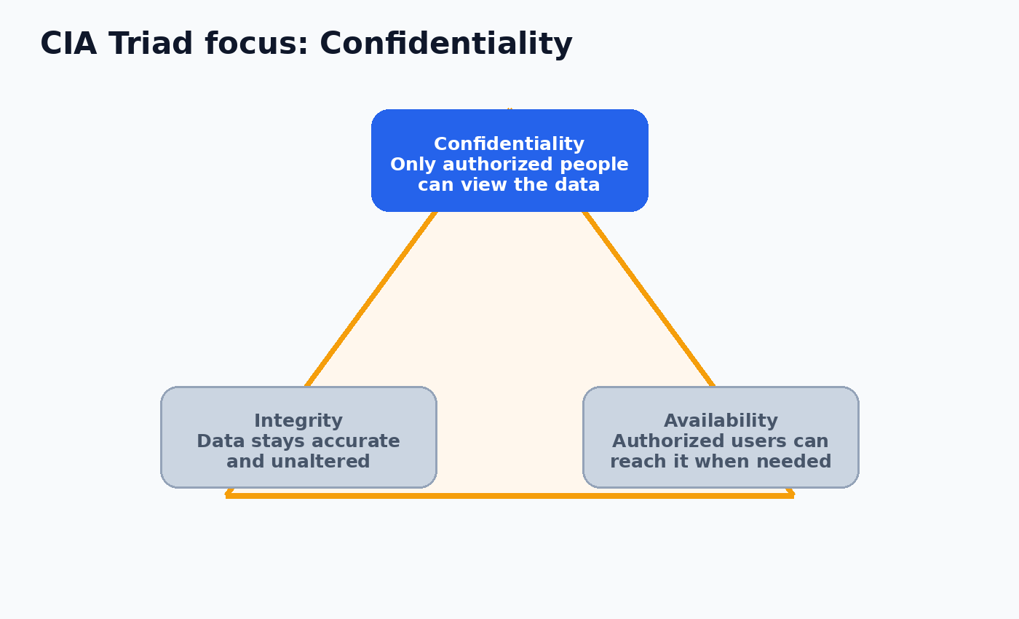
Figure 1. Original illustration of the CIA Triad with confidentiality highlighted.

2. Integrity
Integrity means that information remains accurate, complete, and protected from unauthorized modification. A system can preserve confidentiality while still failing integrity if someone changes data without permission.

Scenario: a mark is changed
Suppose a student submits an assignment and the portal records a mark of 78. A weak authorization check allows a normal student account to send a request that changes the mark to 98. The record may remain private, but it is no longer trustworthy. Audit logs, server-side validation, role-based permissions, and review of unusual changes help protect integrity.
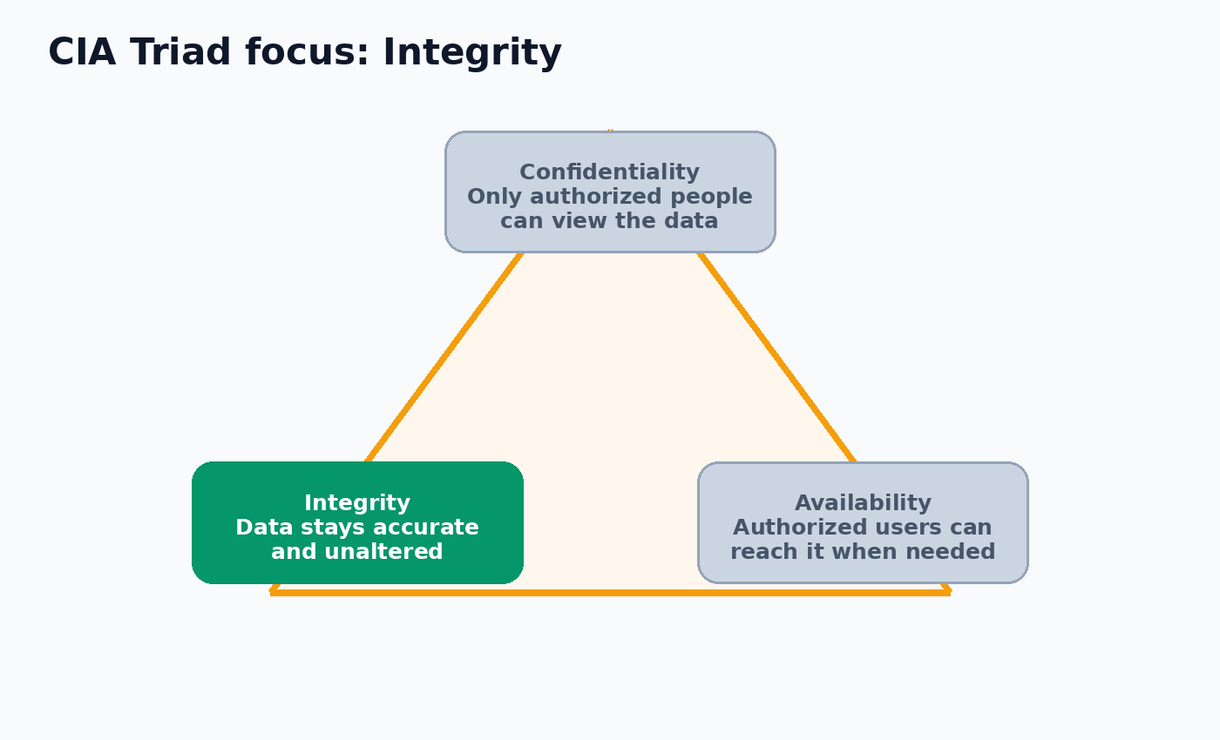
Figure 2. Original illustration of the CIA Triad with integrity highlighted.

3. Availability
Availability means that authorized users can access information and services when they need them. Availability is not the same as making a service public; it is about reliable access for the right users.

Scenario: submission deadline outage
On the final evening for assignment submission, the portal receives more requests than it can handle and stops responding. Students cannot upload work even though their accounts are valid. This is an availability failure. Capacity planning, monitoring, backups, redundancy, rate limiting, and a tested recovery plan can reduce the effect of outages.
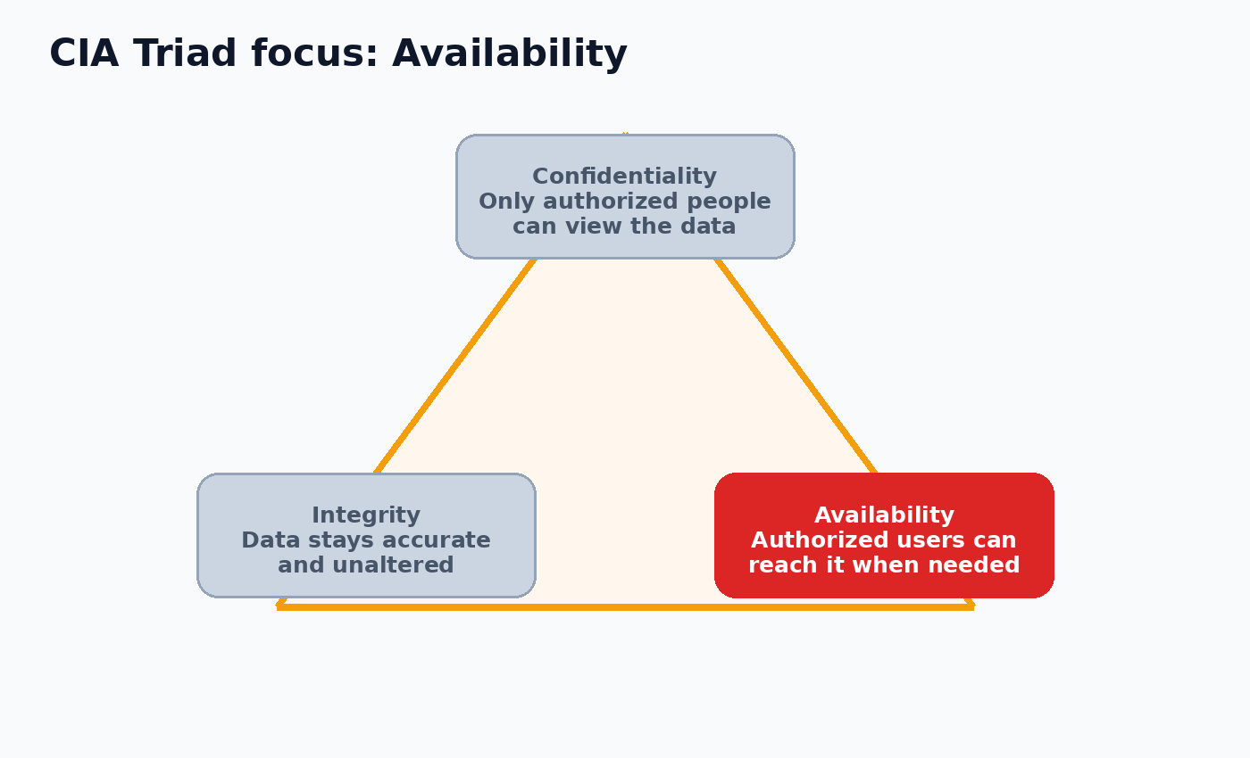
Figure 3. Original illustration of the CIA Triad with availability highlighted.

4. Authentication versus authorization
Authentication verifies identity: it answers “Who are you?” Authorization is the permission decision made after identity is known: it answers “What may you do?” A successful login does not automatically grant every action in the system.

Scenario: logged-in student tries to edit another record
A student enters a valid username, password, and one-time code. Authentication succeeds. The portal then checks the account’s role and the requested object. The student is authorized to view and submit their own work, but not to edit another student’s marks. If the portal checks only whether the user is logged in and skips the second decision, it has an authorization flaw.
Stage | Security question | Student-portal example
Authentication | Is this person really the account holder? | Password and one-time code are verified.
Authorization | Is this authenticated account allowed to perform this action? | The student may view their own marks but cannot edit another student’s marks.
Audit | Can the decision be reviewed later? | The portal records the account, action, time, and result.

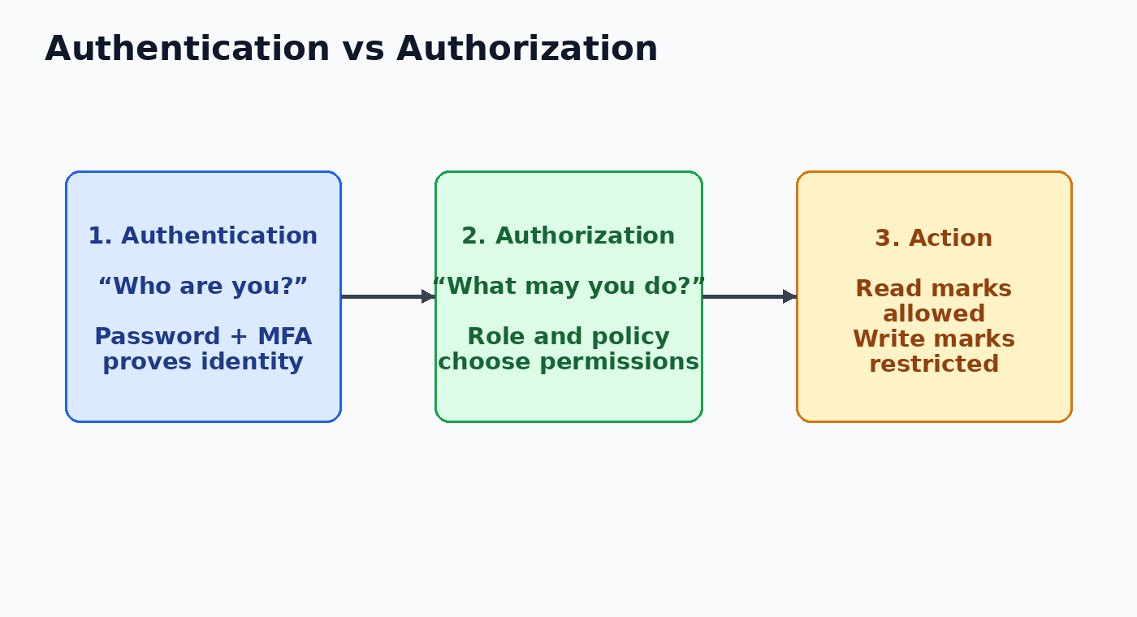
Figure 4. Original flow diagram showing identity verification before permission checking.

5. Encryption versus hashing
Encryption changes readable plaintext into ciphertext using a cryptographic method and key. It is designed to be reversible by an authorized recipient who has the required key. Hashing produces a fixed-size digest from input data and is intended to be one-way. A system can compare a newly computed password hash with the stored digest without needing to recover the original password.

Scenario: protecting a login and a private message
When a student logs in over HTTPS, encryption protects the request while it travels between the browser and the portal. The portal must still store the password safely. It should not store plaintext and should not treat ordinary fast hashing as sufficient; a modern password-hashing method with a unique salt is appropriate. If the portal stores an encrypted password, a stolen decryption key could reveal every password. If it stores a strong password hash, the server can verify guesses without keeping a reversible copy.
Property | Encryption | Hashing
Direction | Two-way transformation when the key is available. | One-way digest for verification.
Typical use | Protect messages, files, or data in transit/storage. | Store passwords safely or detect whether content changed.
Key point | The authorized recipient needs a key to decrypt. | The verifier compares digests; it should not decrypt a password.

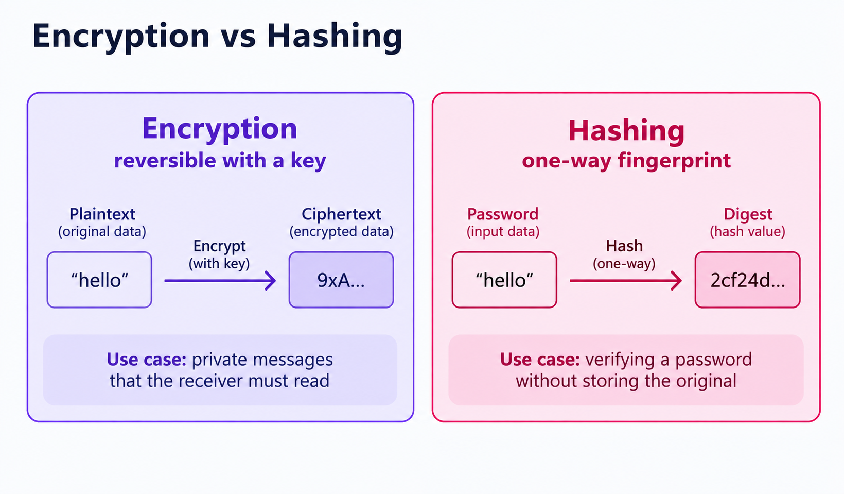
Figure 5. Original comparison of reversible encryption and one-way hashing.

Connection to threat, vulnerability, risk, and least privilege
The concepts above describe security goals and controls. A threat is a possible cause of harm, such as an attacker. A vulnerability is a weakness, such as a missing server-side authorization check. Risk is the possible impact when a threat can exploit that weakness. Least privilege limits each account to the minimum access needed, which reduces the damage if an account is misused.
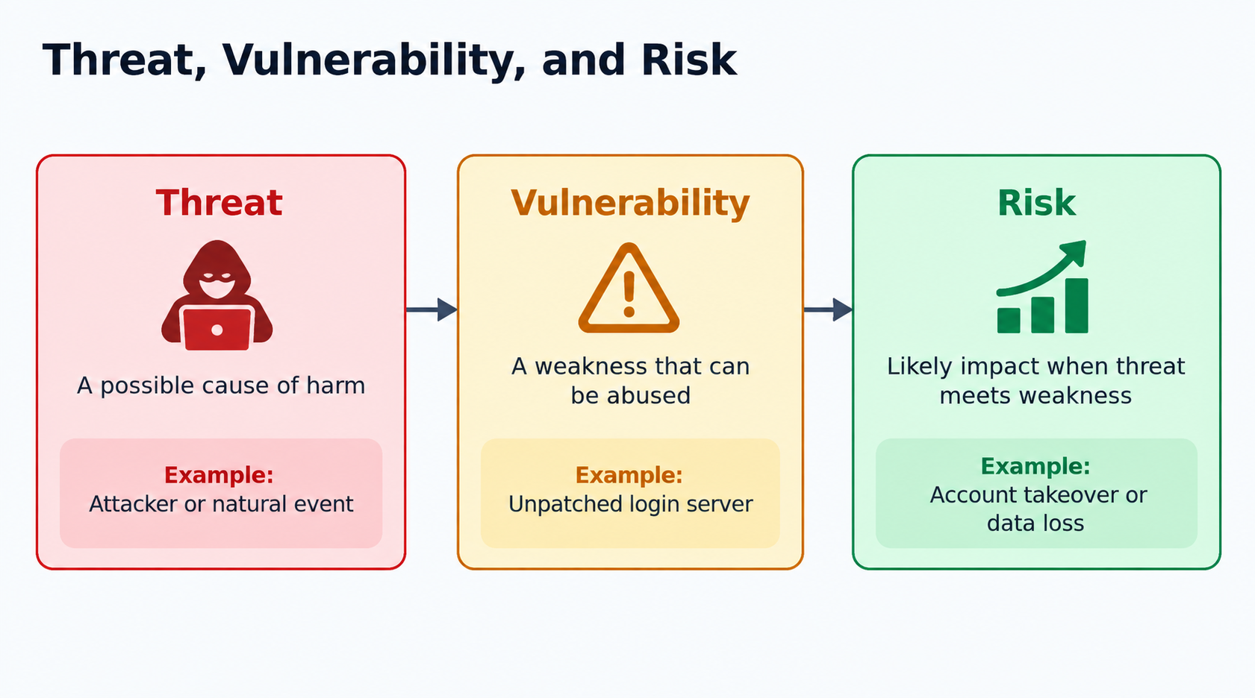
Figure 6. Original illustration connecting a threat, a vulnerability, and resulting risk.
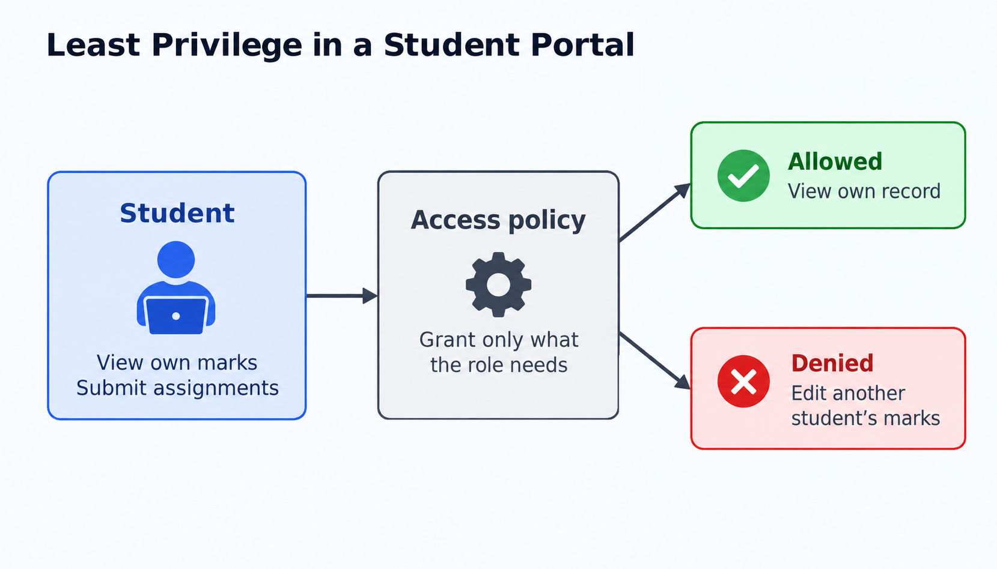
Figure 7. Original least-privilege example for a student portal.

Summary
The CIA Triad provides three questions for judging a system: can unauthorized people see the data, can unauthorized people change it, and can authorized users reach it? Authentication and authorization separate identity proof from permission. Encryption and hashing solve different problems: encryption protects recoverable data, while password hashing supports verification without storing the original secret. These distinctions form a practical foundation for reading security findings and designing safer applications.

