Task 1 — CTF Challenge Walkthroughs
What is Networking? and Introductory Networking

Field | Details
Name | Yuvraj A Chaurasiya
Year / branch | 1st Year, CSE W/S Cybersecurity
TryHackMe username | yuvi14
TryHackMe profile | https://tryhackme.com/p/yuvi14
Repository | https://github.com/rays-of-uv/yuvraj-cybersec-firstyear

Prepared for the CodeKrafters SRM 2026 Cybersecurity Recruitment Challenge

Submission overview
This document records the work completed in two beginner networking rooms on TryHackMe. Each room is presented in two separate parts: first, the actions and observations made while completing the room; second, the concepts learned and how they connect to cybersecurity. The screenshots were supplied as completion evidence and are captioned at the point where they support the narrative.
Room | Link | Reported status | Evidence included
What is Networking? | https://tryhackme.com/room/whatisnetworking | Completed | 6 screenshots: progress, lab, terminal output, and completion
Introductory Networking | https://tryhackme.com/room/introtonetworking | Completed | 8 screenshots: OSI/TCP-IP/tool tasks and completion

Important scope note
The walkthrough focuses on the two specified first-year rooms. Commands and demonstrations are described in the TryHackMe lab context only. They should not be used to impersonate devices or probe systems without authorization.

Part A — What is Networking?
Room link: https://tryhackme.com/room/whatisnetworking

A.1 What I did — step by step
Stage | Account of the work
1. Read the foundations | I opened the room from my TryHackMe account and worked through the introductory tasks on networks and the Internet. I treated a network as connected devices that exchange information, and the Internet as many smaller networks joined together.
2. Identified devices | I learned that a device can be identified by a logical IP address and a hardware-level MAC address. The room uses a name-versus-fingerprint comparison: an IP address can change with the network, while a MAC address is associated with the network interface.
3. Completed the MAC-filtering lab | I deployed the provided interactive site through the room’s View Site control. In the lab, I selected an allowed address from the supplied list and used the room’s spoofing exercise to request the page. The screenshot records the accepted flag response.
4. Tested reachability with ping | I used the AttackBox terminal to send ICMP echo requests to the room’s targets. The output showed transmitted and received packets, packet loss, response time, and TTL. I then entered the values requested by the room and confirmed the accepted answers.
5. Finished the learning path | I followed the room’s next-learning instruction and completed the final task. The room completion screen records the finished status and score.

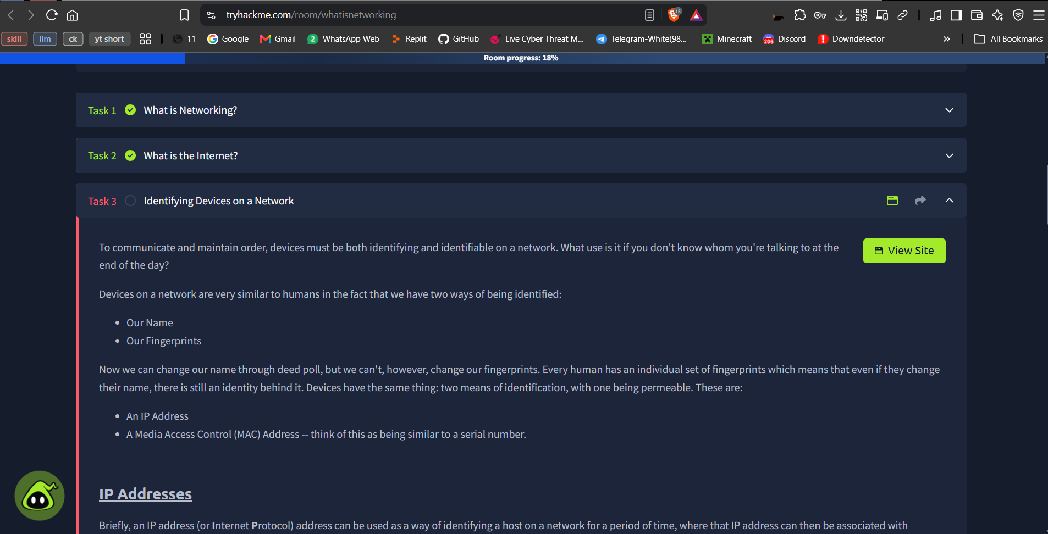
Figure 1. Early progress in the “What is Networking?” room, including the introductory material and task navigation.
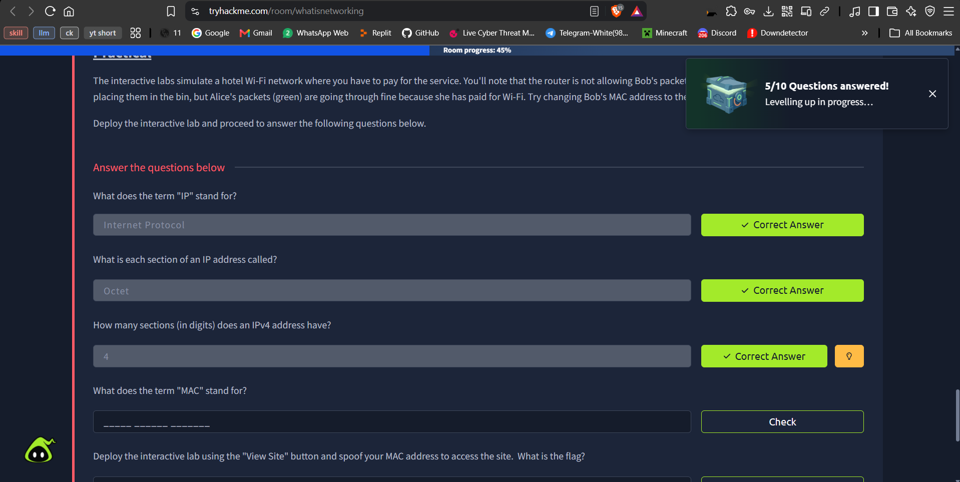
Figure 2. Answer fields and accepted progress while completing the device-identification section.
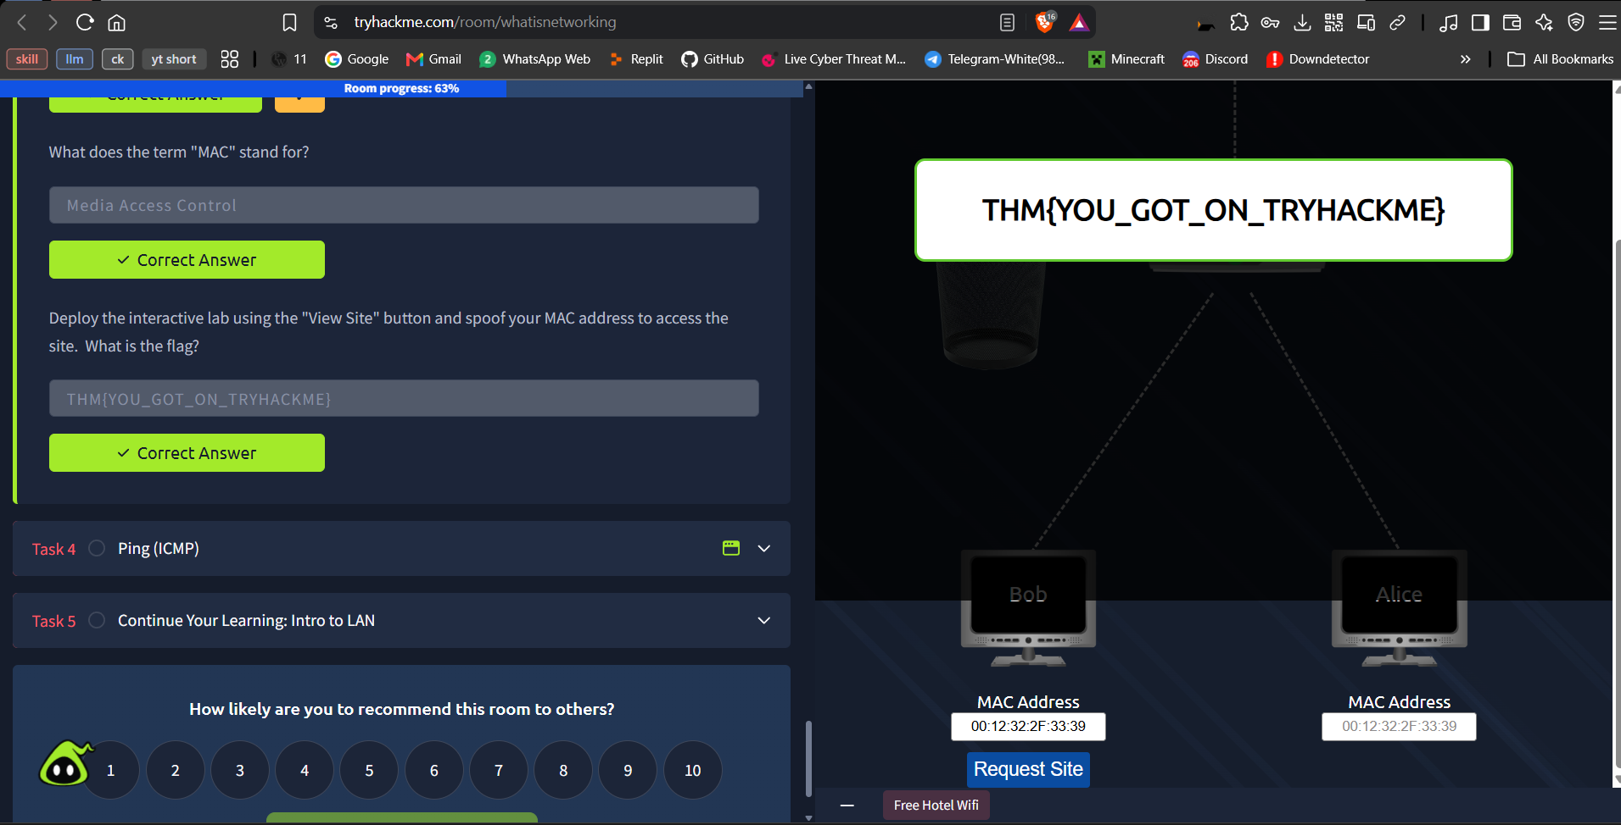
Figure 3. The interactive MAC-filtering lab showing the accepted response after the lab action.
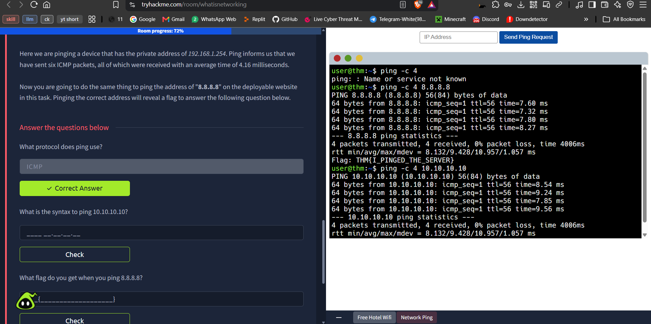
Figure 4. AttackBox terminal evidence for the ping task, shown alongside the TryHackMe question.
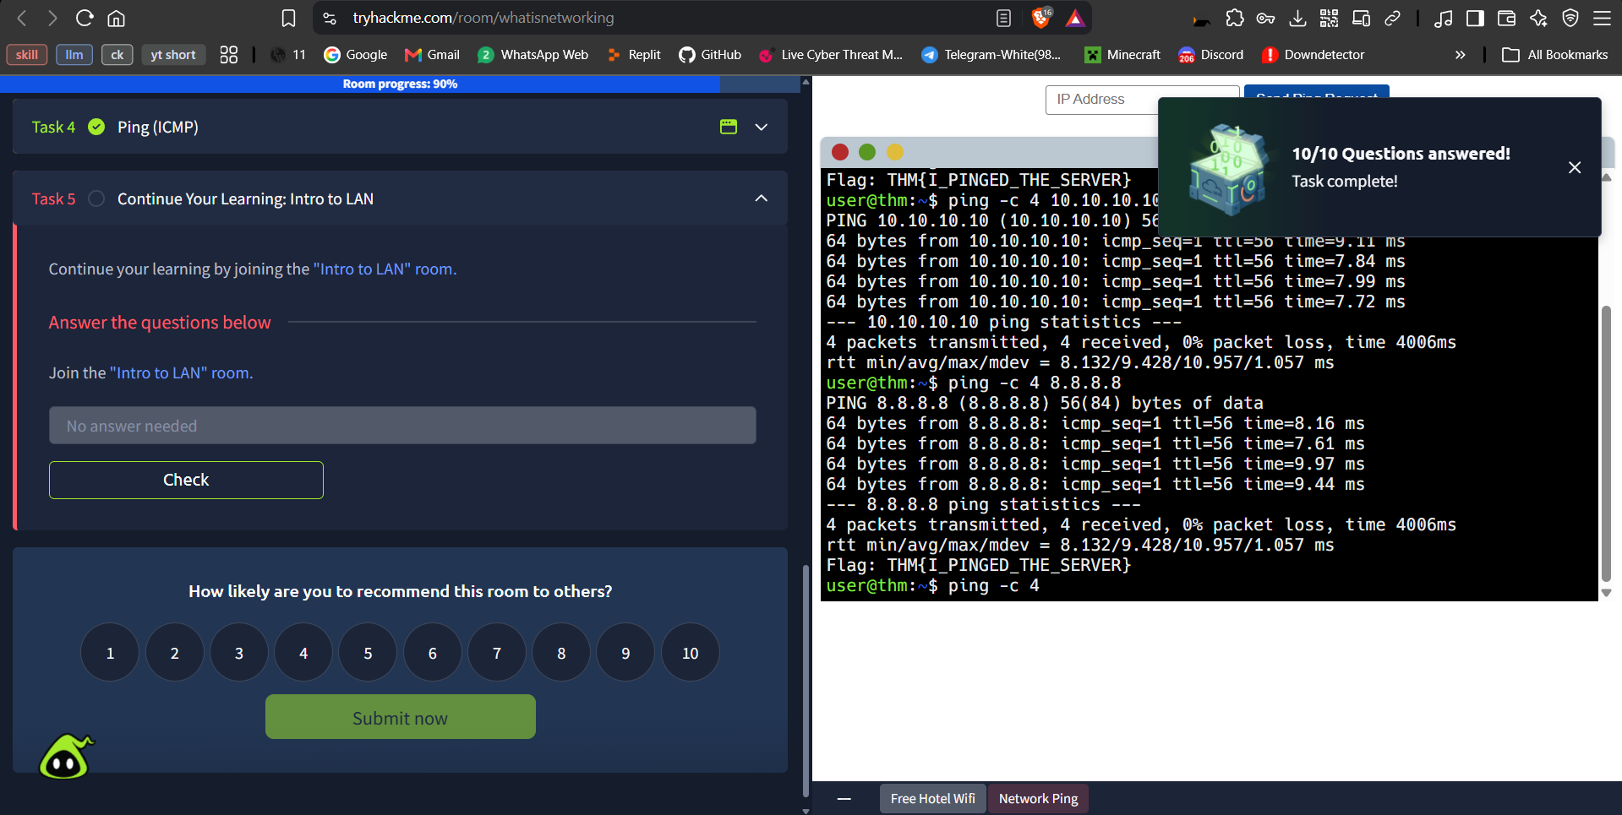
Figure 5. Additional terminal/task evidence from the reachability exercise.
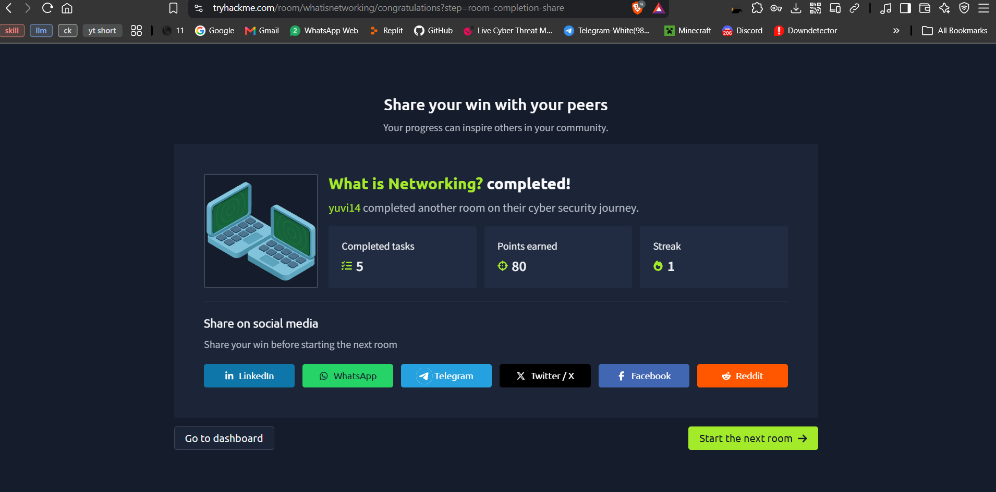
Figure 6. Final completion screen for “What is Networking?”.

A.2 What I learned
Concept | Beginner-friendly explanation | Why it matters in security
Network and Internet | A network is a group of connected devices. The Internet is a public network made from many interconnected networks. | Security controls must account for communication between devices, not only for one computer.
IP address | An IPv4 address identifies a host logically. It is written as four octets separated by dots, and it may change when the device changes networks. | Routing and access-control decisions often depend on logical addresses.
MAC address | A MAC address identifies a network interface at the local-link level. It is normally assigned to the interface, but the value can be changed in software. | MAC filtering can be useful for basic network management, but it should not be treated as strong identity proof by itself.
ICMP and ping | Ping sends ICMP echo requests and measures whether replies return. The result can show loss and round-trip delay. | Reachability checks are useful for troubleshooting, but a reply does not prove that a service is safe or that a user is authorized.

Part B — Introductory Networking
Room link: https://tryhackme.com/room/introtonetworking

B.1 What I did — step by step
Stage | Account of the work
1. Reviewed the room map | I read the room outline covering the OSI model, encapsulation, the TCP/IP model, and the practical tools ping, traceroute, and whois.
2. Worked through the OSI model | I mapped responsibilities to the seven layers: Application, Presentation, Session, Transport, Network, Data Link, and Physical. For example, choosing TCP or UDP belongs to the Transport layer; logical addressing belongs to the Network layer.
3. Studied encapsulation | I followed how data receives additional headers as it travels down the stack. The names change from data to segment or datagram, then packet, frame, and bits. At the receiver, de-encapsulation removes the added information in reverse order.
4. Compared TCP/IP with OSI | I mapped the practical four-layer TCP/IP model to the seven-layer OSI teaching model. The TCP/IP Application layer combines the OSI Application, Presentation, and Session layers; its Network Interface layer covers the OSI Data Link and Physical layers.
5. Used ping | In the AttackBox, I ran the room’s requested ping commands and read the resolved address and response information. I also used the interval option to understand how the timing between requests changes.
6. Used traceroute | I examined how traceroute reveals intermediate hops by using TTL values. Each responding hop represents a routing step between the source and destination, although some networks may not return every hop.
7. Used whois | I queried the requested domains and read registration-related fields from the output. When the free-machine limit or a transient network error appeared, I waited, redeployed, and retried until the room accepted the answers.
8. Confirmed completion | The final room screen recorded the completed status for the room.

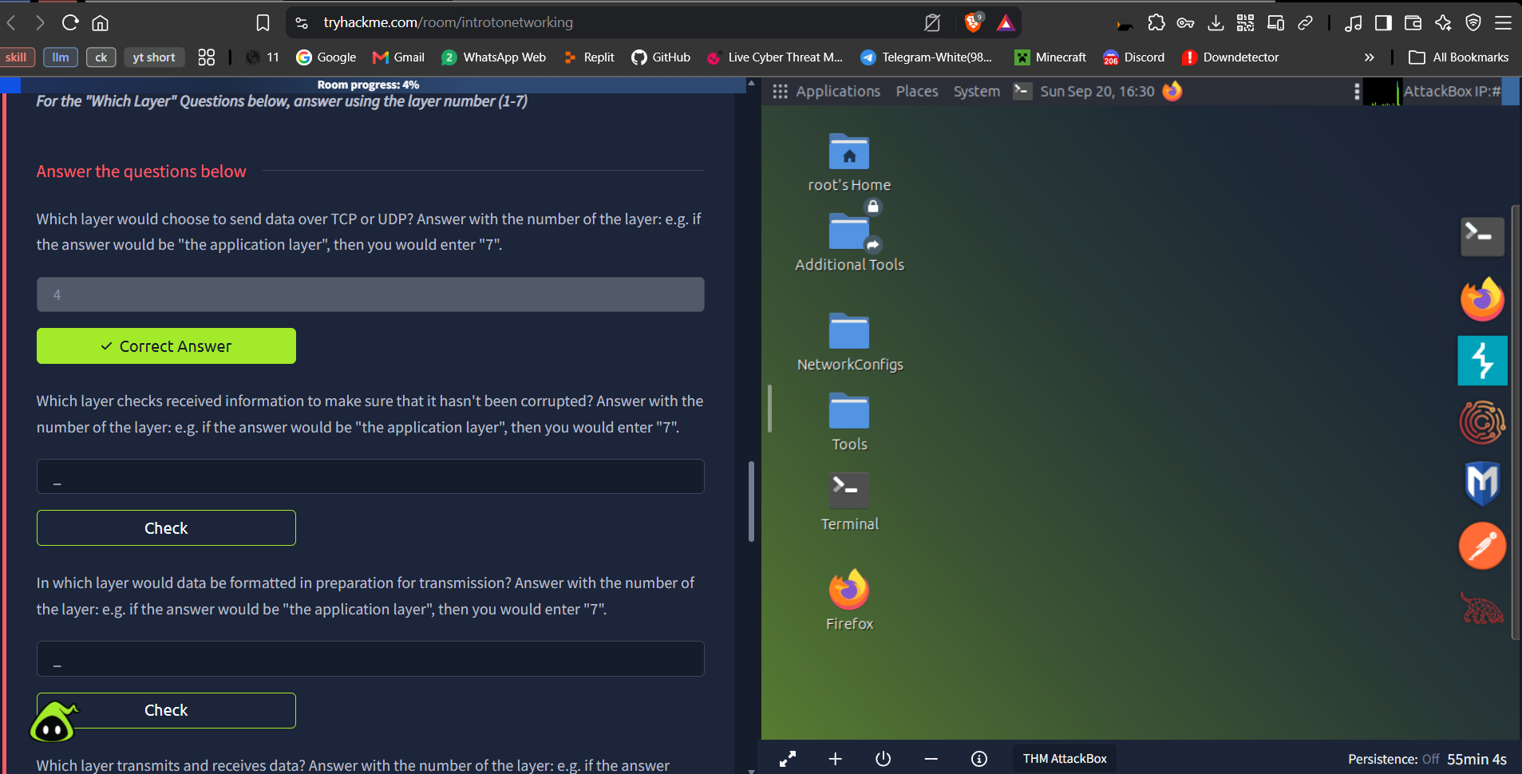
Figure 7. Beginning of the “Introductory Networking” room in the AttackBox environment.
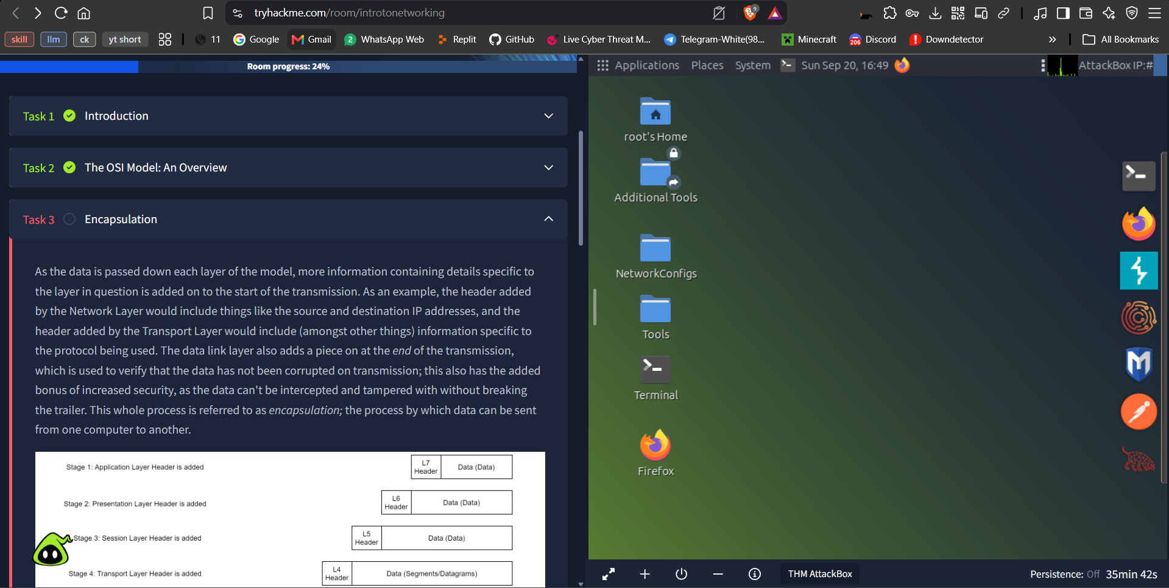
Figure 8. OSI-model material and the layer-by-layer questions.
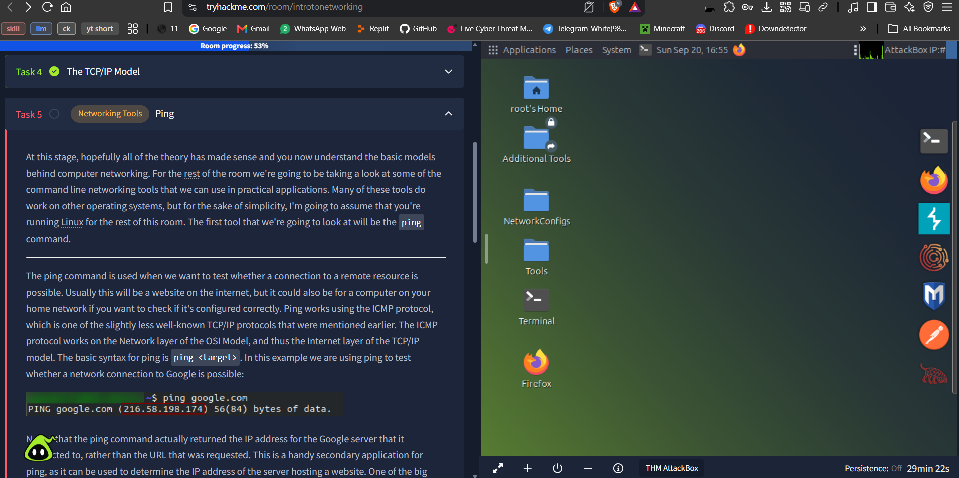
Figure 9. Encapsulation material showing how protocol information is added as data moves down the stack.
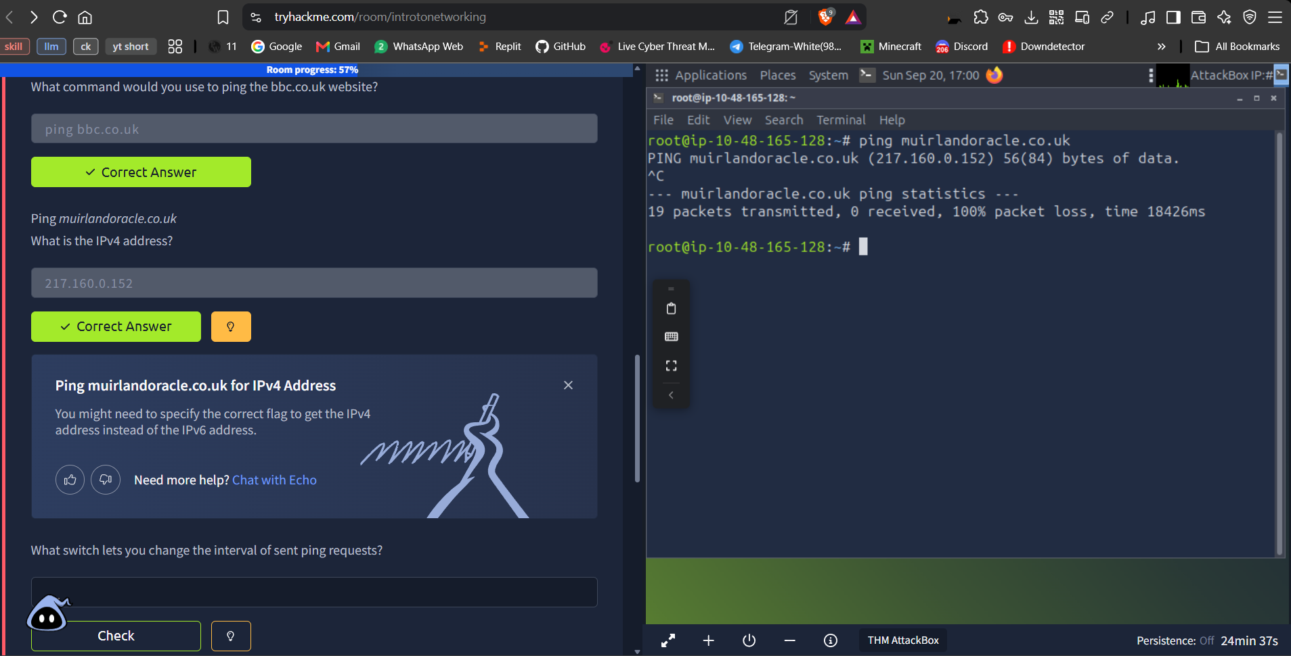
Figure 10. Ping-tool task and terminal output from the networking-tools section.
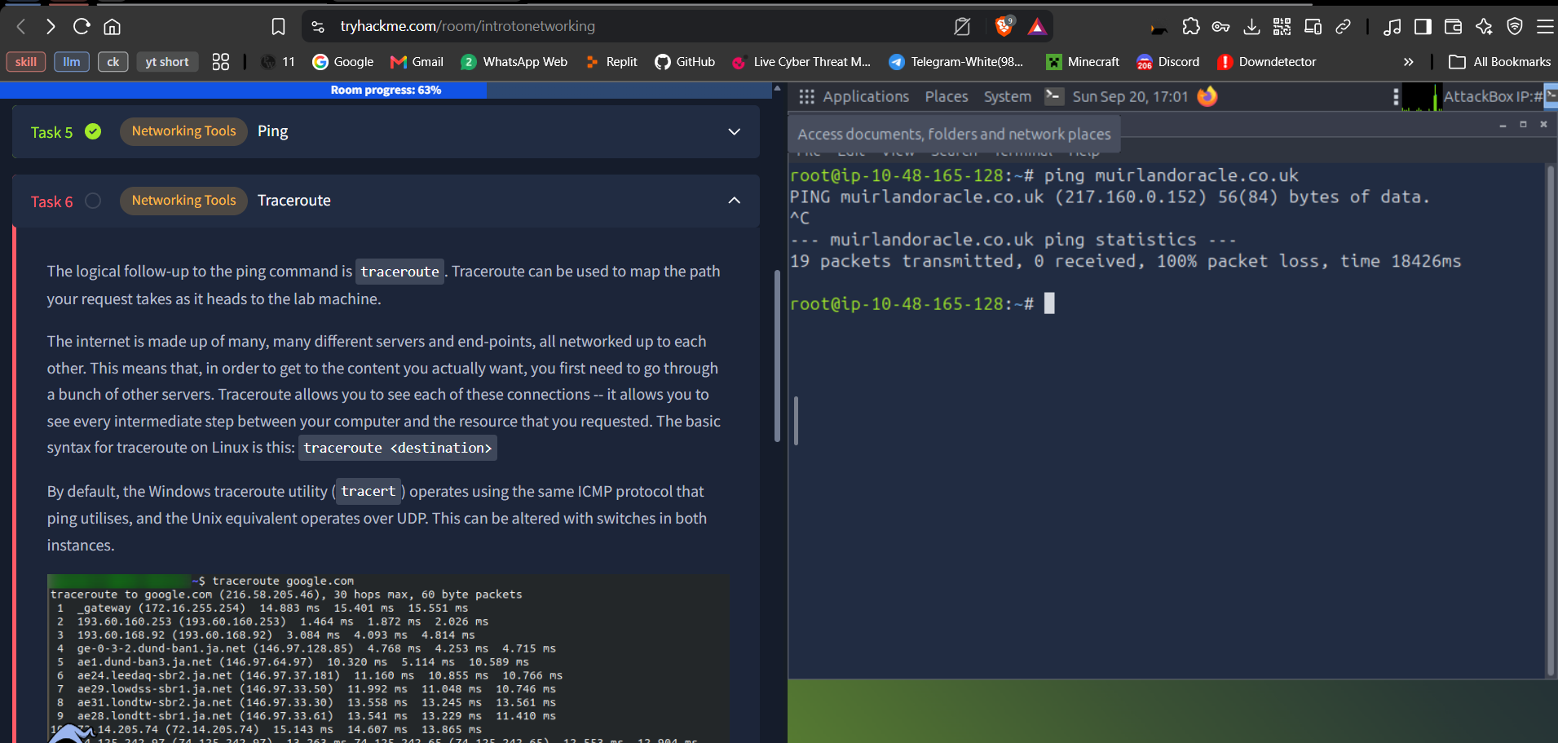
Figure 11. Traceroute/whois practice in the AttackBox terminal.
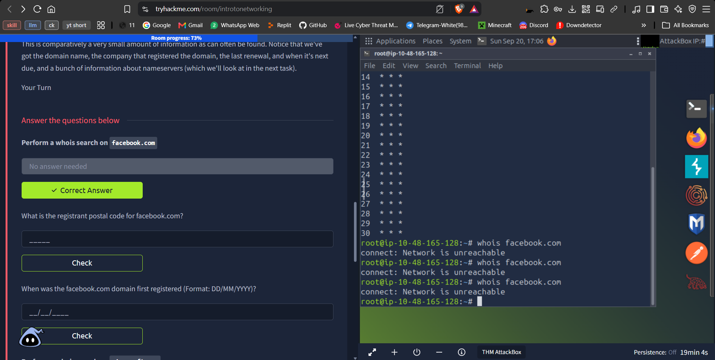
Figure 12. Troubleshooting the networking-tool task: the terminal output did not match the expected result.
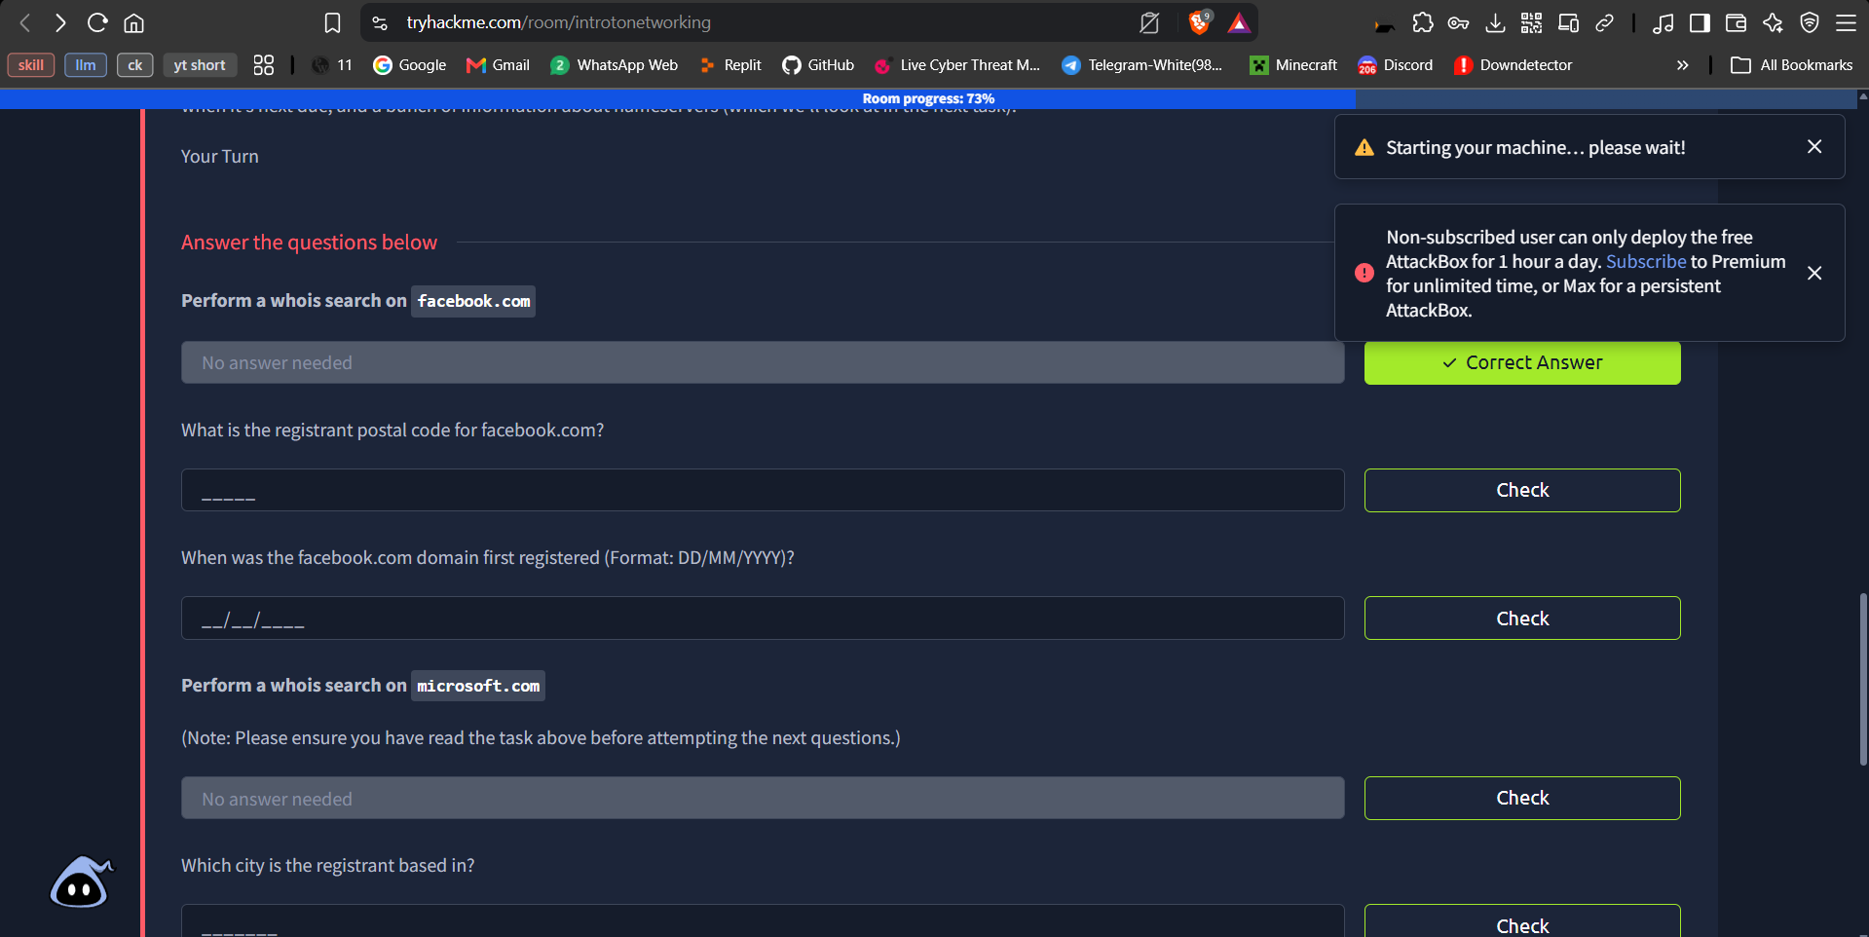
Figure 13. Error encountered while completing the room, which caused a one-day delay.
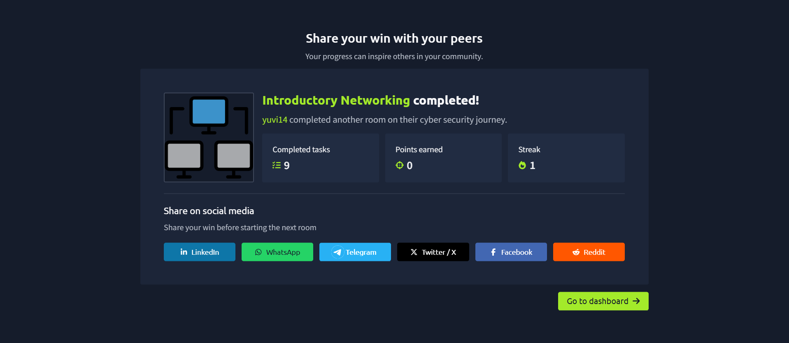
Figure 14. Final completion screen for “Introductory Networking”.

B.2 What I learned
Topic | Explanation | Practical takeaway
OSI model | The seven-layer model is a shared way to reason about network communication. Each layer has a distinct responsibility, from physical signals to application protocols. | When troubleshooting, identify the layer where the failure appears instead of treating “the network” as one undifferentiated system.
Encapsulation | Each layer adds information needed for delivery. At the receiver, de-encapsulation removes those headers and checks the message at each stage. | Packet analysis becomes easier when the names and headers are connected to the layer that created them.
TCP/IP model | The four-layer TCP/IP model groups several OSI functions into a model used more directly by real protocols. | Knowing both models makes documentation and troubleshooting easier across different learning resources.
Ping, traceroute, whois | Ping checks reachability with ICMP; traceroute shows the path through intermediate hops; whois exposes available domain-registration information. | These tools answer different questions and should be used only for systems and domains where observation is permitted.

