Holland Career Interest Assessment Report

Name: MONU MEENA

Class: IX

Section: A

Roll Number: 1245

# 1. Introduction

Purpose of the Career Interest Profiler (CIP)

The Career Interest Profiler was developed to help people clarify their interests and relate them to work and career options. When a person can link what they like to do, with jobs that fulfill those interests, they can make better career decisions.

The Career Interest Profiler was designed to clarify the types of activities a person enjoys and highlight occupations where these interests can be met. By combining an in-depth description of a person’s likes and dislikes along with jobs that match these preferences, the CIP can guide career decision makers.

The Career Interest Profiler is built upon John Holland’s theory of vocational personality. This theory, which has become one of the most widely, accepted approaches for helping people make occupational choices, is based on six vocational personality types. Holland believed that people could be described by one of the six types which are briefly described below.

REALISTIC

INVESTIGATIVE

ARTISTIC

SOCIAL

ENTERPRISING

CONVENTIONAL

# 2. Score Analysis

Your Holland Code: RAC

|  |  |  |
| --- | --- | --- |
| Type | Raw Score | Percentile |
| Realistic | 25 | 91 |
| Investigative | 15 | 75 |
| Artistic | 22 | 85 |
| Social | 15 | 64 |
| Enterprising | 20 | 20 |
| Conventional | 13 | 79 |

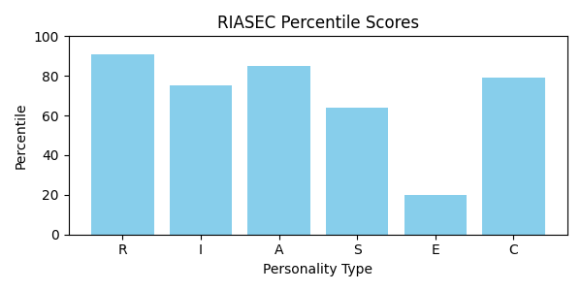

# 3. Your Top 3 Personality Themes (In Order of Strength)

## Realistic (R)

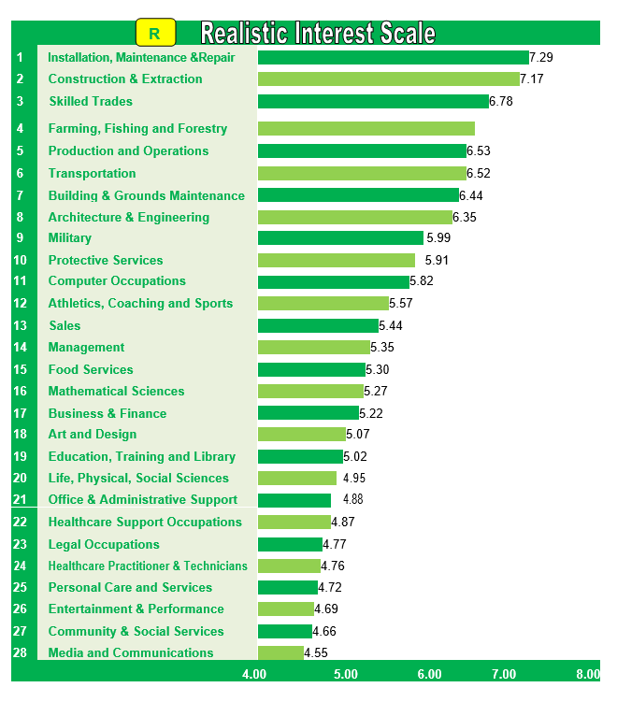

Realistic occupational personality types like to work with their hands, focus on things in the physical world and use physical skills. They like to explore places and things and frequently have a desire for adventure. They like to repair and make things with their hands, tools, and machines. Outdoor work is often preferred.

Realistic individuals are active and stable and enjoy manual activities, such as building, mechanics, machinery operation and athletics. They prefer to work with things rather than ideas and people. People who fall into this category generally prefer to “learn by doing” in a practical, task-oriented setting, as opposed to spending extended periods of time in a classroom.

Realistic types tend to communicate in a frank, direct manner and value material things. They perceive themselves as skilled in mechanical and physical activities but may be uncomfortable or less adept with human relations. The preferred work environment of the realistic type fosters technical competencies and work that allows them to produce tangible results. Typical realistic careers include electrician, engineer, veterinarian and the military

Realistic people are practical, self-reliant, and mechanically inclined. They tend to be traditional and value things they can see and touch. Realistic individuals usually have well developed skills for working with tools, operating machines or raising animals. They enjoy work that happens outdoors and involves physical activity. They also like adventurous activities such as riding roller coasters or sky diving.

Since the Realistic people enjoy hands-on activities that involve concrete problem solving, they would rather avoid dealing with people, abstract ideas and lots of data. When faced with a problem, they come up with action oriented solutions instead of verbal or interpersonal ones. As a result, Realistic people tend to avoid careers that involve a lot of social interaction and dealing with people, such as teaching or nursing. Instead, they are drawn toward occupations that produce tangible results.

Common Leisure Activities: Building and repairing, gardening and crafts, playing sports, outdoor recreational activities, cars, motor sports, boats, mechanics, home improvement, camping, hunting, fishing

Typical Skills and Strengths: Building and repairing, operating machinery and equipment, concrete problem solving

Dislikes: Public speaking, social events, cultural and aesthetic activities, mediating disputes, work that involves close interpersonal relationships

Basic Outlook and Qualities of Realistic Peoples:

v   Robust, rugged, practical, physically strong

v   Uncomfortable in social settings

v   Good motor coordination

v   Weak verbal and interpersonal skills

v   See themselves as mechanically and athletically inclined

v   Stable, natural, persistent

v   Prefer concrete to abstract problems

v   Have conventional political and economic goals

v   Rarely perform creatively in the arts or science

v   Like to build things with tools

v   Like to work outdoors, Cool to radical new ideas

v   Like to work with big, powerful machines

v   Buy boats, campers, snowmobiles, motorcycles

## Artistic (A)

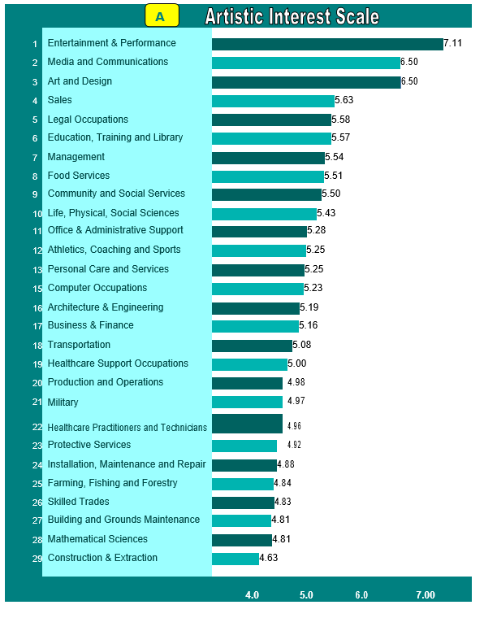

Artistic individuals are original, intuitive and imaginative and enjoy creative activities, such as composing or playing music, writing, drawing or painting and acting in or directing stage productions. They seek opportunities for self- expression through artistic creation. People who fall into this category prefer flexibility and ambiguity and have an aversion to convention and conformity.

Artistic occupational personality types are the most creative of all the types and tend to focus on creativity and exploration through various forms/mediums, images, materials, music, words, movement, as well as systems and programs. They are able to see possibilities in various settings and are not afraid to experiment with their ideas. They like variety and tend to feel cramped in structured situations.

Artistic types are generally impulsive and emotional and tend to communicate in a very expressive and open manner. They value aesthetics and view themselves as creative, non-conforming and as appreciating or possessing musical, dramatic, artistic or writing abilities while lacking clerical or organizational skills. The preferred work environment of the artistic type fosters creative competencies, and encourages originality and use of the imagination in a flexible, unstructured setting. Typical artistic careers include musician, reporter and interior decorator.

Artistic people are creative and imaginative. They are original, independent people who have a strong desire to express themselves creatively. Artistic individuals value aesthetics and enjoy creative activities such as art, drama, writing, dance and music. They like to use their intuition and originality to develop new ideas. In this way they are similar to Investigative people. However, they are more interested in cultural-aesthetic pursuits than scientific ones. Artistic people find the most satisfaction in environments that have variety and change. They dislike work activities that are highly structured or repetitive. They are more interested in ideas and people, than data or things.

Common Leisure Activities: Drawing, painting, creative writing, photography; playing musical instruments; attending concerts, the theatre and art exhibits; reading fiction, plays and poetry.

Typical Skills and Strengths: Using imagination and originality to develop new ideas; dealing with change in flexible environments; designing products; creating, using intuition and self-expression; artistic abilities – writing, drama, music, art

Dislikes : Repetitive, structured tasks; lack of variety; processing information; working with numbers

Basic Outlook and Qualities of Artistic People.

v   Like art, music, drama, other creative interests

v   Prefer free, unstructured situations

v   Impulsive, non-conforming, independent

v   Adverse to rules

v   Deal with problems through self-expression in art

v   Value beauty and aesthetic qualities

v   Expressive, original, intuitive

v   Like to work in free environments

v   Like small, intimate groups

v   Willing to take risks to try something new

v   Dress in freer styles than other people

v   Have need for individualistic expression

v   Not assertive about own capabilities

v   Sensitive and emotional

v   Spend money on art objects–books, paintings, DVD’s, CD’s

## Conventional (C)

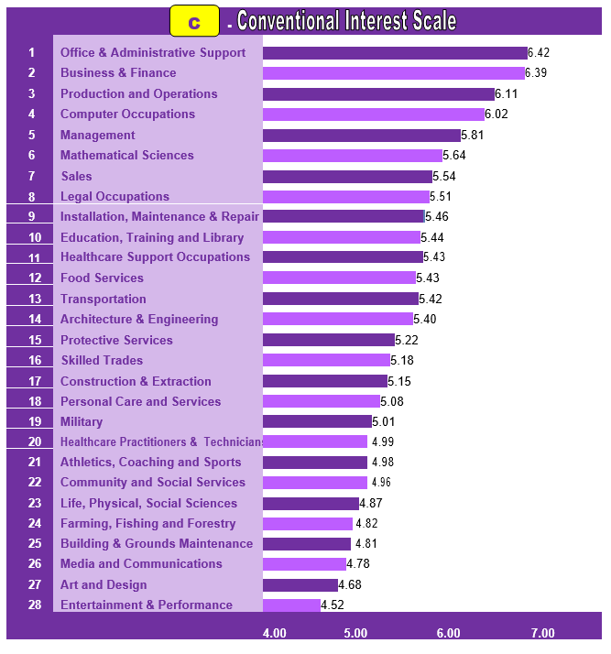

Conventional individuals are efficient, careful, conforming, organized and conscientious. They are comfortable working within an established chain of command and prefer carrying out well-defined instructions over assuming leadership roles. They prefer organized, systematic activities and have an aversion to ambiguity. They are skilled in and often enjoy maintaining and manipulating data, organizing schedules and operating office equipment .While they rarely seek leadership or “spotlight” roles ,they are thorough, persistent and reliable in carrying out tasks .

Conventional types view themselves as responsible, orderly and efficient, and possessing clerical, organizational and numerical abilities. They may also see themselves as unimaginative or lacking in creativity. The preferred work environment of the conventional type fosters organizational competencies, such as record keeping and data management, in a structured operation and places high value on conformity and dependability.

Conventional occupational personality types are oriented to completing tasks initiated by others. They pay attention to detail, and prefer to work with data, particularly in the numerical, statistical, and record-keeping realm. They have a high sense of responsibility, follow the rules, and want to know precisely what is expected of them.

Conventional are accurate and like to follow clearly defined procedures. At work they enjoy rules and regulations that keep things running smoothly. They prefer structure and order to ambiguity. As a result they work well within systems or large organizations. Conventional people have high standards for themselves, are accurate, and pay close attention to details.

Conventional individuals are interested in data and things, rather than people. As a result, they prefer to work with the paper and computer based aspects of a business such as accounting, record keeping, and data processing and the typical conventional careers include secretary, accountant and banker.

Common Leisure Activities: Managing personal finances, collecting memorabilia, writing family history, building models, playing computer or card games

Typical Skills and Strengths: Working with numbers, processing information, accuracy, organizing, business writing

Dislikes: Ambiguous, unstructured activities; dealing with interpersonal issues; drawing, painting, creative writing, photography; activities that involve self expression.

Basic Outlook and qualities of Conventional people:

v Prefer well-ordered environments

v Like systematic, verbal and numerical activities

v Avoid ambiguous situations and problems

v Conscientious, efficient, practical

v Identify with power

v Value material possessions and status.

v Orderly, persistent, calm.

v Adverse to free, unsystematic, exploratory behavior in new areas.

v Do not seek outside leadership.

v Stable, controlled, dependable.

v Most effective at well-defined tasks.

v Save money, buy conservatively.

# 4. Career Recommendations

Based on your Holland Code (RAC), here are some career paths to explore:

*Note: The Job Zone indicates the level of preparation needed for a job (1 = little preparation, 5 = extensive preparation).*

**Applied Arts (Written & Spoken)**

• Tool and Die Maker (Job Zone: 3)

**Community Services**

• Security System Installer (Job Zone: 3)

**Construction & Maintenance**

• Electrician (Construction) (Job Zone: 3)

**Crafts & Related**

• Firefighter (Job Zone: 3)

**Creative & Performing Arts**

• Technicians in various fields (for example, Automotive, Avionics, Broadcast, Sound) (Job Zone: 3)

**Education**

• Plumber (Job Zone: 3)

**Health Care**

• Model Makers, Wood (Job Zone: 3)

**Manufacturing & Processing**

• Jewelers and Precious Stone and Metal Workers (Job Zone: 3)

**Mechanical & Electrical Specialties**

• Jewelers and Precious Stone and Metal Workers (Job Zone: 3)

**Natural Science & Technologies**

• Chef/Cook (Job Zone: 3)

# 5. How to Explore Your Interests

• Participate in school clubs, after-school activities, or personal projects that align with your top traits.

• Talk to people! Seek guidance from teachers, counselors, or professionals working in fields that interest you.

• Volunteer or find a part-time job in an area related to your interests to get real-world experience.

# 6. Interest Report Summary

Based on your top scores in Realistic, Artistic, Conventional (RAC), your interests align with traits and work environments typical for these personality types. Use this report as a starting point to explore, learn, and reflect on what truly motivates you.

# 7. A Final Note

Understanding your interests is a powerful first step toward discovering a fulfilling career path. This report is a snapshot in time. Continue to be curious, keep learning, and trust in your unique potential. Your interests may evolve, and that's a natural part of growth!

Holland Career Interest Assessment Report

Name: DEEPAK BOHARA

Class: X

Section: B

Roll Number: 1246

# 1. Introduction

Purpose of the Career Interest Profiler (CIP)

The Career Interest Profiler was developed to help people clarify their interests and relate them to work and career options. When a person can link what they like to do, with jobs that fulfill those interests, they can make better career decisions.

The Career Interest Profiler was designed to clarify the types of activities a person enjoys and highlight occupations where these interests can be met. By combining an in-depth description of a person’s likes and dislikes along with jobs that match these preferences, the CIP can guide career decision makers.

The Career Interest Profiler is built upon John Holland’s theory of vocational personality. This theory, which has become one of the most widely, accepted approaches for helping people make occupational choices, is based on six vocational personality types. Holland believed that people could be described by one of the six types which are briefly described below.

REALISTIC

INVESTIGATIVE

ARTISTIC

SOCIAL

ENTERPRISING

CONVENTIONAL

# 2. Score Analysis

Your Holland Code: RAC

|  |  |  |
| --- | --- | --- |
| Type | Raw Score | Percentile |
| Realistic | 28 | 98 |
| Investigative | 16 | 77 |
| Artistic | 23 | 91 |
| Social | 16 | 67 |
| Enterprising | 21 | 21 |
| Conventional | 14 | 81 |

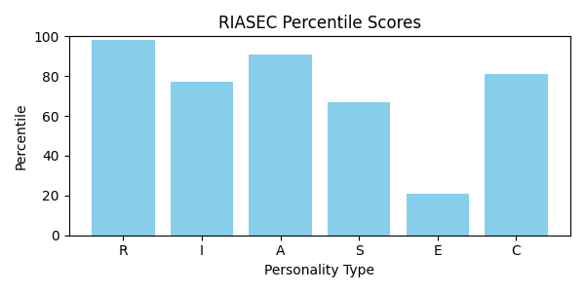

# 3. Your Top 3 Personality Themes (In Order of Strength)

## Realistic (R)



Realistic occupational personality types like to work with their hands, focus on things in the physical world and use physical skills. They like to explore places and things and frequently have a desire for adventure. They like to repair and make things with their hands, tools, and machines. Outdoor work is often preferred.

Realistic individuals are active and stable and enjoy manual activities, such as building, mechanics, machinery operation and athletics. They prefer to work with things rather than ideas and people. People who fall into this category generally prefer to “learn by doing” in a practical, task-oriented setting, as opposed to spending extended periods of time in a classroom.

Realistic types tend to communicate in a frank, direct manner and value material things. They perceive themselves as skilled in mechanical and physical activities but may be uncomfortable or less adept with human relations. The preferred work environment of the realistic type fosters technical competencies and work that allows them to produce tangible results. Typical realistic careers include electrician, engineer, veterinarian and the military

Realistic people are practical, self-reliant, and mechanically inclined. They tend to be traditional and value things they can see and touch. Realistic individuals usually have well developed skills for working with tools, operating machines or raising animals. They enjoy work that happens outdoors and involves physical activity. They also like adventurous activities such as riding roller coasters or sky diving.

Since the Realistic people enjoy hands-on activities that involve concrete problem solving, they would rather avoid dealing with people, abstract ideas and lots of data. When faced with a problem, they come up with action oriented solutions instead of verbal or interpersonal ones. As a result, Realistic people tend to avoid careers that involve a lot of social interaction and dealing with people, such as teaching or nursing. Instead, they are drawn toward occupations that produce tangible results.

Common Leisure Activities: Building and repairing, gardening and crafts, playing sports, outdoor recreational activities, cars, motor sports, boats, mechanics, home improvement, camping, hunting, fishing

Typical Skills and Strengths: Building and repairing, operating machinery and equipment, concrete problem solving

Dislikes: Public speaking, social events, cultural and aesthetic activities, mediating disputes, work that involves close interpersonal relationships

Basic Outlook and Qualities of Realistic Peoples:

v   Robust, rugged, practical, physically strong

v   Uncomfortable in social settings

v   Good motor coordination

v   Weak verbal and interpersonal skills

v   See themselves as mechanically and athletically inclined

v   Stable, natural, persistent

v   Prefer concrete to abstract problems

v   Have conventional political and economic goals

v   Rarely perform creatively in the arts or science

v   Like to build things with tools

v   Like to work outdoors, Cool to radical new ideas

v   Like to work with big, powerful machines

v   Buy boats, campers, snowmobiles, motorcycles

## Artistic (A)



Artistic individuals are original, intuitive and imaginative and enjoy creative activities, such as composing or playing music, writing, drawing or painting and acting in or directing stage productions. They seek opportunities for self- expression through artistic creation. People who fall into this category prefer flexibility and ambiguity and have an aversion to convention and conformity.

Artistic occupational personality types are the most creative of all the types and tend to focus on creativity and exploration through various forms/mediums, images, materials, music, words, movement, as well as systems and programs. They are able to see possibilities in various settings and are not afraid to experiment with their ideas. They like variety and tend to feel cramped in structured situations.

Artistic types are generally impulsive and emotional and tend to communicate in a very expressive and open manner. They value aesthetics and view themselves as creative, non-conforming and as appreciating or possessing musical, dramatic, artistic or writing abilities while lacking clerical or organizational skills. The preferred work environment of the artistic type fosters creative competencies, and encourages originality and use of the imagination in a flexible, unstructured setting. Typical artistic careers include musician, reporter and interior decorator.

Artistic people are creative and imaginative. They are original, independent people who have a strong desire to express themselves creatively. Artistic individuals value aesthetics and enjoy creative activities such as art, drama, writing, dance and music. They like to use their intuition and originality to develop new ideas. In this way they are similar to Investigative people. However, they are more interested in cultural-aesthetic pursuits than scientific ones. Artistic people find the most satisfaction in environments that have variety and change. They dislike work activities that are highly structured or repetitive. They are more interested in ideas and people, than data or things.

Common Leisure Activities: Drawing, painting, creative writing, photography; playing musical instruments; attending concerts, the theatre and art exhibits; reading fiction, plays and poetry.

Typical Skills and Strengths: Using imagination and originality to develop new ideas; dealing with change in flexible environments; designing products; creating, using intuition and self-expression; artistic abilities – writing, drama, music, art

Dislikes : Repetitive, structured tasks; lack of variety; processing information; working with numbers

Basic Outlook and Qualities of Artistic People.

v   Like art, music, drama, other creative interests

v   Prefer free, unstructured situations

v   Impulsive, non-conforming, independent

v   Adverse to rules

v   Deal with problems through self-expression in art

v   Value beauty and aesthetic qualities

v   Expressive, original, intuitive

v   Like to work in free environments

v   Like small, intimate groups

v   Willing to take risks to try something new

v   Dress in freer styles than other people

v   Have need for individualistic expression

v   Not assertive about own capabilities

v   Sensitive and emotional

v   Spend money on art objects–books, paintings, DVD’s, CD’s

## Conventional (C)



Conventional individuals are efficient, careful, conforming, organized and conscientious. They are comfortable working within an established chain of command and prefer carrying out well-defined instructions over assuming leadership roles. They prefer organized, systematic activities and have an aversion to ambiguity. They are skilled in and often enjoy maintaining and manipulating data, organizing schedules and operating office equipment .While they rarely seek leadership or “spotlight” roles ,they are thorough, persistent and reliable in carrying out tasks .

Conventional types view themselves as responsible, orderly and efficient, and possessing clerical, organizational and numerical abilities. They may also see themselves as unimaginative or lacking in creativity. The preferred work environment of the conventional type fosters organizational competencies, such as record keeping and data management, in a structured operation and places high value on conformity and dependability.

Conventional occupational personality types are oriented to completing tasks initiated by others. They pay attention to detail, and prefer to work with data, particularly in the numerical, statistical, and record-keeping realm. They have a high sense of responsibility, follow the rules, and want to know precisely what is expected of them.

Conventional are accurate and like to follow clearly defined procedures. At work they enjoy rules and regulations that keep things running smoothly. They prefer structure and order to ambiguity. As a result they work well within systems or large organizations. Conventional people have high standards for themselves, are accurate, and pay close attention to details.

Conventional individuals are interested in data and things, rather than people. As a result, they prefer to work with the paper and computer based aspects of a business such as accounting, record keeping, and data processing and the typical conventional careers include secretary, accountant and banker.

Common Leisure Activities: Managing personal finances, collecting memorabilia, writing family history, building models, playing computer or card games

Typical Skills and Strengths: Working with numbers, processing information, accuracy, organizing, business writing

Dislikes: Ambiguous, unstructured activities; dealing with interpersonal issues; drawing, painting, creative writing, photography; activities that involve self expression.

Basic Outlook and qualities of Conventional people:

v Prefer well-ordered environments

v Like systematic, verbal and numerical activities

v Avoid ambiguous situations and problems

v Conscientious, efficient, practical

v Identify with power

v Value material possessions and status.

v Orderly, persistent, calm.

v Adverse to free, unsystematic, exploratory behavior in new areas.

v Do not seek outside leadership.

v Stable, controlled, dependable.

v Most effective at well-defined tasks.

v Save money, buy conservatively.

# 4. Career Recommendations

Based on your Holland Code (RAC), here are some career paths to explore:

*Note: The Job Zone indicates the level of preparation needed for a job (1 = little preparation, 5 = extensive preparation).*

**Applied Arts (Written & Spoken)**

• Tool and Die Maker (Job Zone: 3)

**Community Services**

• Security System Installer (Job Zone: 3)

**Construction & Maintenance**

• Electrician (Construction) (Job Zone: 3)

**Crafts & Related**

• Firefighter (Job Zone: 3)

**Creative & Performing Arts**

• Technicians in various fields (for example, Automotive, Avionics, Broadcast, Sound) (Job Zone: 3)

**Education**

• Plumber (Job Zone: 3)

**Health Care**

• Model Makers, Wood (Job Zone: 3)

**Manufacturing & Processing**

• Jewelers and Precious Stone and Metal Workers (Job Zone: 3)

**Mechanical & Electrical Specialties**

• Jewelers and Precious Stone and Metal Workers (Job Zone: 3)

**Natural Science & Technologies**

• Chef/Cook (Job Zone: 3)

# 5. How to Explore Your Interests

• Participate in school clubs, after-school activities, or personal projects that align with your top traits.

• Talk to people! Seek guidance from teachers, counselors, or professionals working in fields that interest you.

• Volunteer or find a part-time job in an area related to your interests to get real-world experience.

# 6. Interest Report Summary

Based on your top scores in Realistic, Artistic, Conventional (RAC), your interests align with traits and work environments typical for these personality types. Use this report as a starting point to explore, learn, and reflect on what truly motivates you.

# 7. A Final Note

Understanding your interests is a powerful first step toward discovering a fulfilling career path. This report is a snapshot in time. Continue to be curious, keep learning, and trust in your unique potential. Your interests may evolve, and that's a natural part of growth!

Holland Career Interest Assessment Report

Name: SAKSHI KUMARI MEENA

Class: XII

Section: C

Roll Number: 1247

# 1. Introduction

Purpose of the Career Interest Profiler (CIP)

The Career Interest Profiler was developed to help people clarify their interests and relate them to work and career options. When a person can link what they like to do, with jobs that fulfill those interests, they can make better career decisions.

The Career Interest Profiler was designed to clarify the types of activities a person enjoys and highlight occupations where these interests can be met. By combining an in-depth description of a person’s likes and dislikes along with jobs that match these preferences, the CIP can guide career decision makers.

The Career Interest Profiler is built upon John Holland’s theory of vocational personality. This theory, which has become one of the most widely, accepted approaches for helping people make occupational choices, is based on six vocational personality types. Holland believed that people could be described by one of the six types which are briefly described below.

REALISTIC

INVESTIGATIVE

ARTISTIC

SOCIAL

ENTERPRISING

CONVENTIONAL

# 2. Score Analysis

Your Holland Code: ACI

|  |  |  |
| --- | --- | --- |
| Type | Raw Score | Percentile |
| Realistic | 14 | 70 |
| Investigative | 17 | 79 |
| Artistic | 24 | 92 |
| Social | 17 | 70 |
| Enterprising | 22 | 22 |
| Conventional | 15 | 83 |

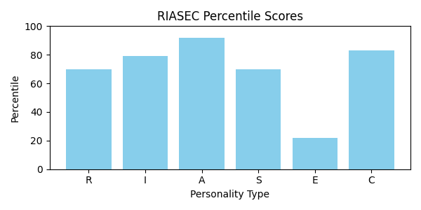

# 3. Your Top 3 Personality Themes (In Order of Strength)

## Artistic (A)



Artistic individuals are original, intuitive and imaginative and enjoy creative activities, such as composing or playing music, writing, drawing or painting and acting in or directing stage productions. They seek opportunities for self- expression through artistic creation. People who fall into this category prefer flexibility and ambiguity and have an aversion to convention and conformity.

Artistic occupational personality types are the most creative of all the types and tend to focus on creativity and exploration through various forms/mediums, images, materials, music, words, movement, as well as systems and programs. They are able to see possibilities in various settings and are not afraid to experiment with their ideas. They like variety and tend to feel cramped in structured situations.

Artistic types are generally impulsive and emotional and tend to communicate in a very expressive and open manner. They value aesthetics and view themselves as creative, non-conforming and as appreciating or possessing musical, dramatic, artistic or writing abilities while lacking clerical or organizational skills. The preferred work environment of the artistic type fosters creative competencies, and encourages originality and use of the imagination in a flexible, unstructured setting. Typical artistic careers include musician, reporter and interior decorator.

Artistic people are creative and imaginative. They are original, independent people who have a strong desire to express themselves creatively. Artistic individuals value aesthetics and enjoy creative activities such as art, drama, writing, dance and music. They like to use their intuition and originality to develop new ideas. In this way they are similar to Investigative people. However, they are more interested in cultural-aesthetic pursuits than scientific ones. Artistic people find the most satisfaction in environments that have variety and change. They dislike work activities that are highly structured or repetitive. They are more interested in ideas and people, than data or things.

Common Leisure Activities: Drawing, painting, creative writing, photography; playing musical instruments; attending concerts, the theatre and art exhibits; reading fiction, plays and poetry.

Typical Skills and Strengths: Using imagination and originality to develop new ideas; dealing with change in flexible environments; designing products; creating, using intuition and self-expression; artistic abilities – writing, drama, music, art

Dislikes : Repetitive, structured tasks; lack of variety; processing information; working with numbers

Basic Outlook and Qualities of Artistic People.

v   Like art, music, drama, other creative interests

v   Prefer free, unstructured situations

v   Impulsive, non-conforming, independent

v   Adverse to rules

v   Deal with problems through self-expression in art

v   Value beauty and aesthetic qualities

v   Expressive, original, intuitive

v   Like to work in free environments

v   Like small, intimate groups

v   Willing to take risks to try something new

v   Dress in freer styles than other people

v   Have need for individualistic expression

v   Not assertive about own capabilities

v   Sensitive and emotional

v   Spend money on art objects–books, paintings, DVD’s, CD’s

## Conventional (C)



Conventional individuals are efficient, careful, conforming, organized and conscientious. They are comfortable working within an established chain of command and prefer carrying out well-defined instructions over assuming leadership roles. They prefer organized, systematic activities and have an aversion to ambiguity. They are skilled in and often enjoy maintaining and manipulating data, organizing schedules and operating office equipment .While they rarely seek leadership or “spotlight” roles ,they are thorough, persistent and reliable in carrying out tasks .

Conventional types view themselves as responsible, orderly and efficient, and possessing clerical, organizational and numerical abilities. They may also see themselves as unimaginative or lacking in creativity. The preferred work environment of the conventional type fosters organizational competencies, such as record keeping and data management, in a structured operation and places high value on conformity and dependability.

Conventional occupational personality types are oriented to completing tasks initiated by others. They pay attention to detail, and prefer to work with data, particularly in the numerical, statistical, and record-keeping realm. They have a high sense of responsibility, follow the rules, and want to know precisely what is expected of them.

Conventional are accurate and like to follow clearly defined procedures. At work they enjoy rules and regulations that keep things running smoothly. They prefer structure and order to ambiguity. As a result they work well within systems or large organizations. Conventional people have high standards for themselves, are accurate, and pay close attention to details.

Conventional individuals are interested in data and things, rather than people. As a result, they prefer to work with the paper and computer based aspects of a business such as accounting, record keeping, and data processing and the typical conventional careers include secretary, accountant and banker.

Common Leisure Activities: Managing personal finances, collecting memorabilia, writing family history, building models, playing computer or card games

Typical Skills and Strengths: Working with numbers, processing information, accuracy, organizing, business writing

Dislikes: Ambiguous, unstructured activities; dealing with interpersonal issues; drawing, painting, creative writing, photography; activities that involve self expression.

Basic Outlook and qualities of Conventional people:

v Prefer well-ordered environments

v Like systematic, verbal and numerical activities

v Avoid ambiguous situations and problems

v Conscientious, efficient, practical

v Identify with power

v Value material possessions and status.

v Orderly, persistent, calm.

v Adverse to free, unsystematic, exploratory behavior in new areas.

v Do not seek outside leadership.

v Stable, controlled, dependable.

v Most effective at well-defined tasks.

v Save money, buy conservatively.

## Investigative (I)

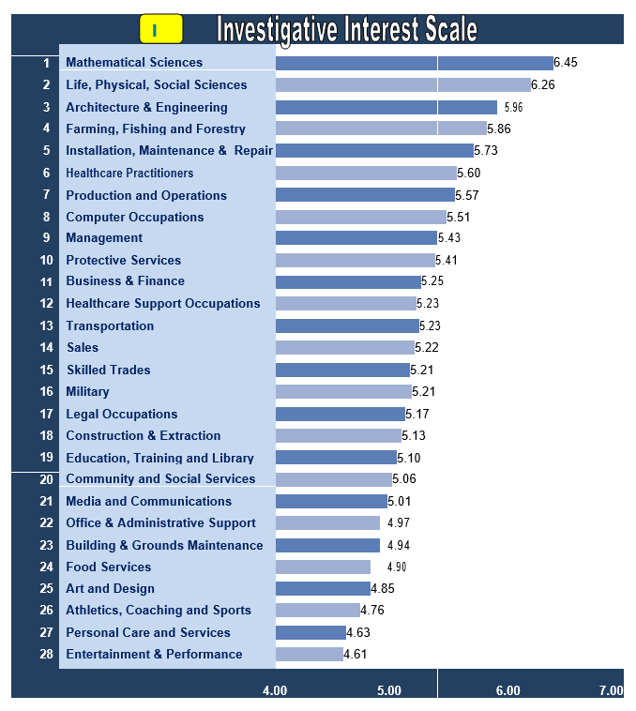

Investigative individuals are analytical, intellectual and observant and enjoy research, mathematical or scientific activities. They place a high value on science and learning and perceive themselves as scholarly and having scientific or logical ability but lacking leadership and persuasive skills. They are drawn to ambiguous challenges and may be stifled in highly structured environments.

People who fall into this category enjoy using logic and solving highly complex, abstract problems. Because they are introspective and focused on creative problem solving, investigative types often work autonomously and do not seek leadership roles.

The preferred work environment of the investigative type encourages scientific competencies, allows independent work and focuses on solving abstract, complex problems in original ways. Typical investigative careers include medical technologist, biologist, chemist and systems analyst.

Their preferred reading material includes scientific or technical magazines. They enjoy working alone because they would rather analyze data and formulate ideas than work with people. Investigative people tend to dislike jobs that involve leading, selling, or persuading others. While they share some of the same interests in the physical world as Realistic people, Investigative types prefer thinking over doing.

Common Leisure Activities:

Scientific, mathematical, and intellectual pursuits; researching and understanding the physical world; using computers; doing complex calculations; astronomy; crossword puzzles, visiting Museums.

Typical Skills and Strengths: Understanding and solving science and math problems; analytical, observant, inquisitive; organizing, analyzing, interpreting data, ideas, theories; working independently with loosely defined problems; researching and understanding the physical world.

Dislikes : Sales, persuading others, leading people

Basic Outlook and Qualities of Investigative Peoples:

v Scientific orientation, Introspective and asocial

v Task-oriented, all wrapped up in their work

v Think through rather than act out a problem

v See themselves as lacking in leadership skills

v Confident of their intellectual abilities

v Analytical, curious, reserved, independent

v Great dislike for repetitive activities

v Buy telescopes, calculators, electronic equipment

v Strong need to understand the world

v  Enjoy ambiguous tasks & prefer to work independently

# 4. Career Recommendations

Based on your Holland Code (ACI), here are some career paths to explore:

*Note: The Job Zone indicates the level of preparation needed for a job (1 = little preparation, 5 = extensive preparation).*

# 5. How to Explore Your Interests

• Participate in school clubs, after-school activities, or personal projects that align with your top traits.

• Talk to people! Seek guidance from teachers, counselors, or professionals working in fields that interest you.

• Volunteer or find a part-time job in an area related to your interests to get real-world experience.

# 6. Interest Report Summary

Based on your top scores in Artistic, Conventional, Investigative (ACI), your interests align with traits and work environments typical for these personality types. Use this report as a starting point to explore, learn, and reflect on what truly motivates you.

# 7. A Final Note

Understanding your interests is a powerful first step toward discovering a fulfilling career path. This report is a snapshot in time. Continue to be curious, keep learning, and trust in your unique potential. Your interests may evolve, and that's a natural part of growth!

Holland Career Interest Assessment Report

Name: DEEPIKA MEENA

Class: XI

Section: D

Roll Number: 1248

# 1. Introduction

Purpose of the Career Interest Profiler (CIP)

The Career Interest Profiler was developed to help people clarify their interests and relate them to work and career options. When a person can link what they like to do, with jobs that fulfill those interests, they can make better career decisions.

The Career Interest Profiler was designed to clarify the types of activities a person enjoys and highlight occupations where these interests can be met. By combining an in-depth description of a person’s likes and dislikes along with jobs that match these preferences, the CIP can guide career decision makers.

The Career Interest Profiler is built upon John Holland’s theory of vocational personality. This theory, which has become one of the most widely, accepted approaches for helping people make occupational choices, is based on six vocational personality types. Holland believed that people could be described by one of the six types which are briefly described below.

REALISTIC

INVESTIGATIVE

ARTISTIC

SOCIAL

ENTERPRISING

CONVENTIONAL

# 2. Score Analysis

Your Holland Code: ARC

|  |  |  |
| --- | --- | --- |
| Type | Raw Score | Percentile |
| Realistic | 23 | 91 |
| Investigative | 18 | 81 |
| Artistic | 25 | 92 |
| Social | 18 | 72 |
| Enterprising | 23 | 23 |
| Conventional | 16 | 86 |

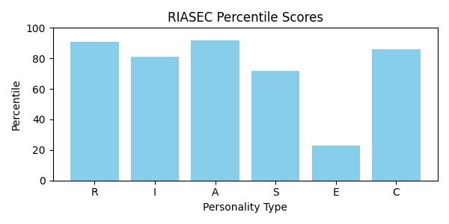

# 3. Your Top 3 Personality Themes (In Order of Strength)

## Artistic (A)



Artistic individuals are original, intuitive and imaginative and enjoy creative activities, such as composing or playing music, writing, drawing or painting and acting in or directing stage productions. They seek opportunities for self- expression through artistic creation. People who fall into this category prefer flexibility and ambiguity and have an aversion to convention and conformity.

Artistic occupational personality types are the most creative of all the types and tend to focus on creativity and exploration through various forms/mediums, images, materials, music, words, movement, as well as systems and programs. They are able to see possibilities in various settings and are not afraid to experiment with their ideas. They like variety and tend to feel cramped in structured situations.

Artistic types are generally impulsive and emotional and tend to communicate in a very expressive and open manner. They value aesthetics and view themselves as creative, non-conforming and as appreciating or possessing musical, dramatic, artistic or writing abilities while lacking clerical or organizational skills. The preferred work environment of the artistic type fosters creative competencies, and encourages originality and use of the imagination in a flexible, unstructured setting. Typical artistic careers include musician, reporter and interior decorator.

Artistic people are creative and imaginative. They are original, independent people who have a strong desire to express themselves creatively. Artistic individuals value aesthetics and enjoy creative activities such as art, drama, writing, dance and music. They like to use their intuition and originality to develop new ideas. In this way they are similar to Investigative people. However, they are more interested in cultural-aesthetic pursuits than scientific ones. Artistic people find the most satisfaction in environments that have variety and change. They dislike work activities that are highly structured or repetitive. They are more interested in ideas and people, than data or things.

Common Leisure Activities: Drawing, painting, creative writing, photography; playing musical instruments; attending concerts, the theatre and art exhibits; reading fiction, plays and poetry.

Typical Skills and Strengths: Using imagination and originality to develop new ideas; dealing with change in flexible environments; designing products; creating, using intuition and self-expression; artistic abilities – writing, drama, music, art

Dislikes : Repetitive, structured tasks; lack of variety; processing information; working with numbers

Basic Outlook and Qualities of Artistic People.

v   Like art, music, drama, other creative interests

v   Prefer free, unstructured situations

v   Impulsive, non-conforming, independent

v   Adverse to rules

v   Deal with problems through self-expression in art

v   Value beauty and aesthetic qualities

v   Expressive, original, intuitive

v   Like to work in free environments

v   Like small, intimate groups

v   Willing to take risks to try something new

v   Dress in freer styles than other people

v   Have need for individualistic expression

v   Not assertive about own capabilities

v   Sensitive and emotional

v   Spend money on art objects–books, paintings, DVD’s, CD’s

## Realistic (R)



Realistic occupational personality types like to work with their hands, focus on things in the physical world and use physical skills. They like to explore places and things and frequently have a desire for adventure. They like to repair and make things with their hands, tools, and machines. Outdoor work is often preferred.

Realistic individuals are active and stable and enjoy manual activities, such as building, mechanics, machinery operation and athletics. They prefer to work with things rather than ideas and people. People who fall into this category generally prefer to “learn by doing” in a practical, task-oriented setting, as opposed to spending extended periods of time in a classroom.

Realistic types tend to communicate in a frank, direct manner and value material things. They perceive themselves as skilled in mechanical and physical activities but may be uncomfortable or less adept with human relations. The preferred work environment of the realistic type fosters technical competencies and work that allows them to produce tangible results. Typical realistic careers include electrician, engineer, veterinarian and the military

Realistic people are practical, self-reliant, and mechanically inclined. They tend to be traditional and value things they can see and touch. Realistic individuals usually have well developed skills for working with tools, operating machines or raising animals. They enjoy work that happens outdoors and involves physical activity. They also like adventurous activities such as riding roller coasters or sky diving.

Since the Realistic people enjoy hands-on activities that involve concrete problem solving, they would rather avoid dealing with people, abstract ideas and lots of data. When faced with a problem, they come up with action oriented solutions instead of verbal or interpersonal ones. As a result, Realistic people tend to avoid careers that involve a lot of social interaction and dealing with people, such as teaching or nursing. Instead, they are drawn toward occupations that produce tangible results.

Common Leisure Activities: Building and repairing, gardening and crafts, playing sports, outdoor recreational activities, cars, motor sports, boats, mechanics, home improvement, camping, hunting, fishing

Typical Skills and Strengths: Building and repairing, operating machinery and equipment, concrete problem solving

Dislikes: Public speaking, social events, cultural and aesthetic activities, mediating disputes, work that involves close interpersonal relationships

Basic Outlook and Qualities of Realistic Peoples:

v   Robust, rugged, practical, physically strong

v   Uncomfortable in social settings

v   Good motor coordination

v   Weak verbal and interpersonal skills

v   See themselves as mechanically and athletically inclined

v   Stable, natural, persistent

v   Prefer concrete to abstract problems

v   Have conventional political and economic goals

v   Rarely perform creatively in the arts or science

v   Like to build things with tools

v   Like to work outdoors, Cool to radical new ideas

v   Like to work with big, powerful machines

v   Buy boats, campers, snowmobiles, motorcycles

## Conventional (C)



Conventional individuals are efficient, careful, conforming, organized and conscientious. They are comfortable working within an established chain of command and prefer carrying out well-defined instructions over assuming leadership roles. They prefer organized, systematic activities and have an aversion to ambiguity. They are skilled in and often enjoy maintaining and manipulating data, organizing schedules and operating office equipment .While they rarely seek leadership or “spotlight” roles ,they are thorough, persistent and reliable in carrying out tasks .

Conventional types view themselves as responsible, orderly and efficient, and possessing clerical, organizational and numerical abilities. They may also see themselves as unimaginative or lacking in creativity. The preferred work environment of the conventional type fosters organizational competencies, such as record keeping and data management, in a structured operation and places high value on conformity and dependability.

Conventional occupational personality types are oriented to completing tasks initiated by others. They pay attention to detail, and prefer to work with data, particularly in the numerical, statistical, and record-keeping realm. They have a high sense of responsibility, follow the rules, and want to know precisely what is expected of them.

Conventional are accurate and like to follow clearly defined procedures. At work they enjoy rules and regulations that keep things running smoothly. They prefer structure and order to ambiguity. As a result they work well within systems or large organizations. Conventional people have high standards for themselves, are accurate, and pay close attention to details.

Conventional individuals are interested in data and things, rather than people. As a result, they prefer to work with the paper and computer based aspects of a business such as accounting, record keeping, and data processing and the typical conventional careers include secretary, accountant and banker.

Common Leisure Activities: Managing personal finances, collecting memorabilia, writing family history, building models, playing computer or card games

Typical Skills and Strengths: Working with numbers, processing information, accuracy, organizing, business writing

Dislikes: Ambiguous, unstructured activities; dealing with interpersonal issues; drawing, painting, creative writing, photography; activities that involve self expression.

Basic Outlook and qualities of Conventional people:

v Prefer well-ordered environments

v Like systematic, verbal and numerical activities

v Avoid ambiguous situations and problems

v Conscientious, efficient, practical

v Identify with power

v Value material possessions and status.

v Orderly, persistent, calm.

v Adverse to free, unsystematic, exploratory behavior in new areas.

v Do not seek outside leadership.

v Stable, controlled, dependable.

v Most effective at well-defined tasks.

v Save money, buy conservatively.

# 4. Career Recommendations

Based on your Holland Code (ARC), here are some career paths to explore:

*Note: The Job Zone indicates the level of preparation needed for a job (1 = little preparation, 5 = extensive preparation).*

# 5. How to Explore Your Interests

• Participate in school clubs, after-school activities, or personal projects that align with your top traits.

• Talk to people! Seek guidance from teachers, counselors, or professionals working in fields that interest you.

• Volunteer or find a part-time job in an area related to your interests to get real-world experience.

# 6. Interest Report Summary

Based on your top scores in Artistic, Realistic, Conventional (ARC), your interests align with traits and work environments typical for these personality types. Use this report as a starting point to explore, learn, and reflect on what truly motivates you.

# 7. A Final Note

Understanding your interests is a powerful first step toward discovering a fulfilling career path. This report is a snapshot in time. Continue to be curious, keep learning, and trust in your unique potential. Your interests may evolve, and that's a natural part of growth!

Holland Career Interest Assessment Report

Name: KOMAL MEENA

Class: XII

Section: E

Roll Number: 1249

# 1. Introduction

Purpose of the Career Interest Profiler (CIP)

The Career Interest Profiler was developed to help people clarify their interests and relate them to work and career options. When a person can link what they like to do, with jobs that fulfill those interests, they can make better career decisions.

The Career Interest Profiler was designed to clarify the types of activities a person enjoys and highlight occupations where these interests can be met. By combining an in-depth description of a person’s likes and dislikes along with jobs that match these preferences, the CIP can guide career decision makers.

The Career Interest Profiler is built upon John Holland’s theory of vocational personality. This theory, which has become one of the most widely, accepted approaches for helping people make occupational choices, is based on six vocational personality types. Holland believed that people could be described by one of the six types which are briefly described below.

REALISTIC

INVESTIGATIVE

ARTISTIC

SOCIAL

ENTERPRISING

CONVENTIONAL

# 2. Score Analysis

Your Holland Code: ACI

|  |  |  |
| --- | --- | --- |
| Type | Raw Score | Percentile |
| Realistic | 12 | 63 |
| Investigative | 19 | 83 |
| Artistic | 26 | 96 |
| Social | 19 | 75 |
| Enterprising | 24 | 24 |
| Conventional | 17 | 87 |

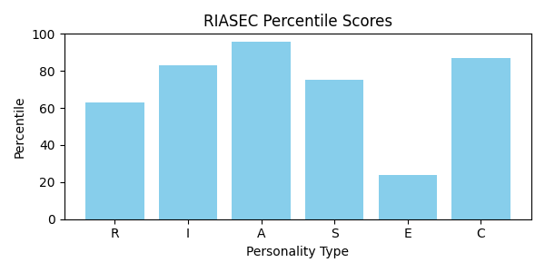

# 3. Your Top 3 Personality Themes (In Order of Strength)

## Artistic (A)



Artistic individuals are original, intuitive and imaginative and enjoy creative activities, such as composing or playing music, writing, drawing or painting and acting in or directing stage productions. They seek opportunities for self- expression through artistic creation. People who fall into this category prefer flexibility and ambiguity and have an aversion to convention and conformity.

Artistic occupational personality types are the most creative of all the types and tend to focus on creativity and exploration through various forms/mediums, images, materials, music, words, movement, as well as systems and programs. They are able to see possibilities in various settings and are not afraid to experiment with their ideas. They like variety and tend to feel cramped in structured situations.

Artistic types are generally impulsive and emotional and tend to communicate in a very expressive and open manner. They value aesthetics and view themselves as creative, non-conforming and as appreciating or possessing musical, dramatic, artistic or writing abilities while lacking clerical or organizational skills. The preferred work environment of the artistic type fosters creative competencies, and encourages originality and use of the imagination in a flexible, unstructured setting. Typical artistic careers include musician, reporter and interior decorator.

Artistic people are creative and imaginative. They are original, independent people who have a strong desire to express themselves creatively. Artistic individuals value aesthetics and enjoy creative activities such as art, drama, writing, dance and music. They like to use their intuition and originality to develop new ideas. In this way they are similar to Investigative people. However, they are more interested in cultural-aesthetic pursuits than scientific ones. Artistic people find the most satisfaction in environments that have variety and change. They dislike work activities that are highly structured or repetitive. They are more interested in ideas and people, than data or things.

Common Leisure Activities: Drawing, painting, creative writing, photography; playing musical instruments; attending concerts, the theatre and art exhibits; reading fiction, plays and poetry.

Typical Skills and Strengths: Using imagination and originality to develop new ideas; dealing with change in flexible environments; designing products; creating, using intuition and self-expression; artistic abilities – writing, drama, music, art

Dislikes : Repetitive, structured tasks; lack of variety; processing information; working with numbers

Basic Outlook and Qualities of Artistic People.

v   Like art, music, drama, other creative interests

v   Prefer free, unstructured situations

v   Impulsive, non-conforming, independent

v   Adverse to rules

v   Deal with problems through self-expression in art

v   Value beauty and aesthetic qualities

v   Expressive, original, intuitive

v   Like to work in free environments

v   Like small, intimate groups

v   Willing to take risks to try something new

v   Dress in freer styles than other people

v   Have need for individualistic expression

v   Not assertive about own capabilities

v   Sensitive and emotional

v   Spend money on art objects–books, paintings, DVD’s, CD’s

## Conventional (C)



Conventional individuals are efficient, careful, conforming, organized and conscientious. They are comfortable working within an established chain of command and prefer carrying out well-defined instructions over assuming leadership roles. They prefer organized, systematic activities and have an aversion to ambiguity. They are skilled in and often enjoy maintaining and manipulating data, organizing schedules and operating office equipment .While they rarely seek leadership or “spotlight” roles ,they are thorough, persistent and reliable in carrying out tasks .

Conventional types view themselves as responsible, orderly and efficient, and possessing clerical, organizational and numerical abilities. They may also see themselves as unimaginative or lacking in creativity. The preferred work environment of the conventional type fosters organizational competencies, such as record keeping and data management, in a structured operation and places high value on conformity and dependability.

Conventional occupational personality types are oriented to completing tasks initiated by others. They pay attention to detail, and prefer to work with data, particularly in the numerical, statistical, and record-keeping realm. They have a high sense of responsibility, follow the rules, and want to know precisely what is expected of them.

Conventional are accurate and like to follow clearly defined procedures. At work they enjoy rules and regulations that keep things running smoothly. They prefer structure and order to ambiguity. As a result they work well within systems or large organizations. Conventional people have high standards for themselves, are accurate, and pay close attention to details.

Conventional individuals are interested in data and things, rather than people. As a result, they prefer to work with the paper and computer based aspects of a business such as accounting, record keeping, and data processing and the typical conventional careers include secretary, accountant and banker.

Common Leisure Activities: Managing personal finances, collecting memorabilia, writing family history, building models, playing computer or card games

Typical Skills and Strengths: Working with numbers, processing information, accuracy, organizing, business writing

Dislikes: Ambiguous, unstructured activities; dealing with interpersonal issues; drawing, painting, creative writing, photography; activities that involve self expression.

Basic Outlook and qualities of Conventional people:

v Prefer well-ordered environments

v Like systematic, verbal and numerical activities

v Avoid ambiguous situations and problems

v Conscientious, efficient, practical

v Identify with power

v Value material possessions and status.

v Orderly, persistent, calm.

v Adverse to free, unsystematic, exploratory behavior in new areas.

v Do not seek outside leadership.

v Stable, controlled, dependable.

v Most effective at well-defined tasks.

v Save money, buy conservatively.

## Investigative (I)



Investigative individuals are analytical, intellectual and observant and enjoy research, mathematical or scientific activities. They place a high value on science and learning and perceive themselves as scholarly and having scientific or logical ability but lacking leadership and persuasive skills. They are drawn to ambiguous challenges and may be stifled in highly structured environments.

People who fall into this category enjoy using logic and solving highly complex, abstract problems. Because they are introspective and focused on creative problem solving, investigative types often work autonomously and do not seek leadership roles.

The preferred work environment of the investigative type encourages scientific competencies, allows independent work and focuses on solving abstract, complex problems in original ways. Typical investigative careers include medical technologist, biologist, chemist and systems analyst.

Their preferred reading material includes scientific or technical magazines. They enjoy working alone because they would rather analyze data and formulate ideas than work with people. Investigative people tend to dislike jobs that involve leading, selling, or persuading others. While they share some of the same interests in the physical world as Realistic people, Investigative types prefer thinking over doing.

Common Leisure Activities:

Scientific, mathematical, and intellectual pursuits; researching and understanding the physical world; using computers; doing complex calculations; astronomy; crossword puzzles, visiting Museums.

Typical Skills and Strengths: Understanding and solving science and math problems; analytical, observant, inquisitive; organizing, analyzing, interpreting data, ideas, theories; working independently with loosely defined problems; researching and understanding the physical world.

Dislikes : Sales, persuading others, leading people

Basic Outlook and Qualities of Investigative Peoples:

v Scientific orientation, Introspective and asocial

v Task-oriented, all wrapped up in their work

v Think through rather than act out a problem

v See themselves as lacking in leadership skills

v Confident of their intellectual abilities

v Analytical, curious, reserved, independent

v Great dislike for repetitive activities

v Buy telescopes, calculators, electronic equipment

v Strong need to understand the world

v  Enjoy ambiguous tasks & prefer to work independently

# 4. Career Recommendations

Based on your Holland Code (ACI), here are some career paths to explore:

*Note: The Job Zone indicates the level of preparation needed for a job (1 = little preparation, 5 = extensive preparation).*

# 5. How to Explore Your Interests

• Participate in school clubs, after-school activities, or personal projects that align with your top traits.

• Talk to people! Seek guidance from teachers, counselors, or professionals working in fields that interest you.

• Volunteer or find a part-time job in an area related to your interests to get real-world experience.

# 6. Interest Report Summary

Based on your top scores in Artistic, Conventional, Investigative (ACI), your interests align with traits and work environments typical for these personality types. Use this report as a starting point to explore, learn, and reflect on what truly motivates you.

# 7. A Final Note

Understanding your interests is a powerful first step toward discovering a fulfilling career path. This report is a snapshot in time. Continue to be curious, keep learning, and trust in your unique potential. Your interests may evolve, and that's a natural part of growth!

Holland Career Interest Assessment Report

Name: SAPNA JOGI

Class: X

Section: B

Roll Number: 1250

# 1. Introduction

Purpose of the Career Interest Profiler (CIP)

The Career Interest Profiler was developed to help people clarify their interests and relate them to work and career options. When a person can link what they like to do, with jobs that fulfill those interests, they can make better career decisions.

The Career Interest Profiler was designed to clarify the types of activities a person enjoys and highlight occupations where these interests can be met. By combining an in-depth description of a person’s likes and dislikes along with jobs that match these preferences, the CIP can guide career decision makers.

The Career Interest Profiler is built upon John Holland’s theory of vocational personality. This theory, which has become one of the most widely, accepted approaches for helping people make occupational choices, is based on six vocational personality types. Holland believed that people could be described by one of the six types which are briefly described below.

REALISTIC

INVESTIGATIVE

ARTISTIC

SOCIAL

ENTERPRISING

CONVENTIONAL

# 2. Score Analysis

Your Holland Code: ACI

|  |  |  |
| --- | --- | --- |
| Type | Raw Score | Percentile |
| Realistic | 10 | 58 |
| Investigative | 20 | 85 |
| Artistic | 27 | 97 |
| Social | 20 | 77 |
| Enterprising | 25 | 25 |
| Conventional | 18 | 89 |

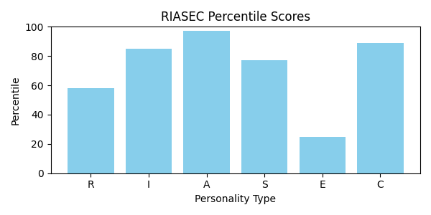

# 3. Your Top 3 Personality Themes (In Order of Strength)

## Artistic (A)



Artistic individuals are original, intuitive and imaginative and enjoy creative activities, such as composing or playing music, writing, drawing or painting and acting in or directing stage productions. They seek opportunities for self- expression through artistic creation. People who fall into this category prefer flexibility and ambiguity and have an aversion to convention and conformity.

Artistic occupational personality types are the most creative of all the types and tend to focus on creativity and exploration through various forms/mediums, images, materials, music, words, movement, as well as systems and programs. They are able to see possibilities in various settings and are not afraid to experiment with their ideas. They like variety and tend to feel cramped in structured situations.

Artistic types are generally impulsive and emotional and tend to communicate in a very expressive and open manner. They value aesthetics and view themselves as creative, non-conforming and as appreciating or possessing musical, dramatic, artistic or writing abilities while lacking clerical or organizational skills. The preferred work environment of the artistic type fosters creative competencies, and encourages originality and use of the imagination in a flexible, unstructured setting. Typical artistic careers include musician, reporter and interior decorator.

Artistic people are creative and imaginative. They are original, independent people who have a strong desire to express themselves creatively. Artistic individuals value aesthetics and enjoy creative activities such as art, drama, writing, dance and music. They like to use their intuition and originality to develop new ideas. In this way they are similar to Investigative people. However, they are more interested in cultural-aesthetic pursuits than scientific ones. Artistic people find the most satisfaction in environments that have variety and change. They dislike work activities that are highly structured or repetitive. They are more interested in ideas and people, than data or things.

Common Leisure Activities: Drawing, painting, creative writing, photography; playing musical instruments; attending concerts, the theatre and art exhibits; reading fiction, plays and poetry.

Typical Skills and Strengths: Using imagination and originality to develop new ideas; dealing with change in flexible environments; designing products; creating, using intuition and self-expression; artistic abilities – writing, drama, music, art

Dislikes : Repetitive, structured tasks; lack of variety; processing information; working with numbers

Basic Outlook and Qualities of Artistic People.

v   Like art, music, drama, other creative interests

v   Prefer free, unstructured situations

v   Impulsive, non-conforming, independent

v   Adverse to rules

v   Deal with problems through self-expression in art

v   Value beauty and aesthetic qualities

v   Expressive, original, intuitive

v   Like to work in free environments

v   Like small, intimate groups

v   Willing to take risks to try something new

v   Dress in freer styles than other people

v   Have need for individualistic expression

v   Not assertive about own capabilities

v   Sensitive and emotional

v   Spend money on art objects–books, paintings, DVD’s, CD’s

## Conventional (C)



Conventional individuals are efficient, careful, conforming, organized and conscientious. They are comfortable working within an established chain of command and prefer carrying out well-defined instructions over assuming leadership roles. They prefer organized, systematic activities and have an aversion to ambiguity. They are skilled in and often enjoy maintaining and manipulating data, organizing schedules and operating office equipment .While they rarely seek leadership or “spotlight” roles ,they are thorough, persistent and reliable in carrying out tasks .

Conventional types view themselves as responsible, orderly and efficient, and possessing clerical, organizational and numerical abilities. They may also see themselves as unimaginative or lacking in creativity. The preferred work environment of the conventional type fosters organizational competencies, such as record keeping and data management, in a structured operation and places high value on conformity and dependability.

Conventional occupational personality types are oriented to completing tasks initiated by others. They pay attention to detail, and prefer to work with data, particularly in the numerical, statistical, and record-keeping realm. They have a high sense of responsibility, follow the rules, and want to know precisely what is expected of them.

Conventional are accurate and like to follow clearly defined procedures. At work they enjoy rules and regulations that keep things running smoothly. They prefer structure and order to ambiguity. As a result they work well within systems or large organizations. Conventional people have high standards for themselves, are accurate, and pay close attention to details.

Conventional individuals are interested in data and things, rather than people. As a result, they prefer to work with the paper and computer based aspects of a business such as accounting, record keeping, and data processing and the typical conventional careers include secretary, accountant and banker.

Common Leisure Activities: Managing personal finances, collecting memorabilia, writing family history, building models, playing computer or card games

Typical Skills and Strengths: Working with numbers, processing information, accuracy, organizing, business writing

Dislikes: Ambiguous, unstructured activities; dealing with interpersonal issues; drawing, painting, creative writing, photography; activities that involve self expression.

Basic Outlook and qualities of Conventional people:

v Prefer well-ordered environments

v Like systematic, verbal and numerical activities

v Avoid ambiguous situations and problems

v Conscientious, efficient, practical

v Identify with power

v Value material possessions and status.

v Orderly, persistent, calm.

v Adverse to free, unsystematic, exploratory behavior in new areas.

v Do not seek outside leadership.

v Stable, controlled, dependable.

v Most effective at well-defined tasks.

v Save money, buy conservatively.

## Investigative (I)



Investigative individuals are analytical, intellectual and observant and enjoy research, mathematical or scientific activities. They place a high value on science and learning and perceive themselves as scholarly and having scientific or logical ability but lacking leadership and persuasive skills. They are drawn to ambiguous challenges and may be stifled in highly structured environments.

People who fall into this category enjoy using logic and solving highly complex, abstract problems. Because they are introspective and focused on creative problem solving, investigative types often work autonomously and do not seek leadership roles.

The preferred work environment of the investigative type encourages scientific competencies, allows independent work and focuses on solving abstract, complex problems in original ways. Typical investigative careers include medical technologist, biologist, chemist and systems analyst.

Their preferred reading material includes scientific or technical magazines. They enjoy working alone because they would rather analyze data and formulate ideas than work with people. Investigative people tend to dislike jobs that involve leading, selling, or persuading others. While they share some of the same interests in the physical world as Realistic people, Investigative types prefer thinking over doing.

Common Leisure Activities:

Scientific, mathematical, and intellectual pursuits; researching and understanding the physical world; using computers; doing complex calculations; astronomy; crossword puzzles, visiting Museums.

Typical Skills and Strengths: Understanding and solving science and math problems; analytical, observant, inquisitive; organizing, analyzing, interpreting data, ideas, theories; working independently with loosely defined problems; researching and understanding the physical world.

Dislikes : Sales, persuading others, leading people

Basic Outlook and Qualities of Investigative Peoples:

v Scientific orientation, Introspective and asocial

v Task-oriented, all wrapped up in their work

v Think through rather than act out a problem

v See themselves as lacking in leadership skills

v Confident of their intellectual abilities

v Analytical, curious, reserved, independent

v Great dislike for repetitive activities

v Buy telescopes, calculators, electronic equipment

v Strong need to understand the world

v  Enjoy ambiguous tasks & prefer to work independently

# 4. Career Recommendations

Based on your Holland Code (ACI), here are some career paths to explore:

*Note: The Job Zone indicates the level of preparation needed for a job (1 = little preparation, 5 = extensive preparation).*

# 5. How to Explore Your Interests

• Participate in school clubs, after-school activities, or personal projects that align with your top traits.

• Talk to people! Seek guidance from teachers, counselors, or professionals working in fields that interest you.

• Volunteer or find a part-time job in an area related to your interests to get real-world experience.

# 6. Interest Report Summary

Based on your top scores in Artistic, Conventional, Investigative (ACI), your interests align with traits and work environments typical for these personality types. Use this report as a starting point to explore, learn, and reflect on what truly motivates you.

# 7. A Final Note

Understanding your interests is a powerful first step toward discovering a fulfilling career path. This report is a snapshot in time. Continue to be curious, keep learning, and trust in your unique potential. Your interests may evolve, and that's a natural part of growth!

Holland Career Interest Assessment Report

Name: Narender Singh

Class: XI

Section: A

Roll Number: 1251

# 1. Introduction

Purpose of the Career Interest Profiler (CIP)

The Career Interest Profiler was developed to help people clarify their interests and relate them to work and career options. When a person can link what they like to do, with jobs that fulfill those interests, they can make better career decisions.

The Career Interest Profiler was designed to clarify the types of activities a person enjoys and highlight occupations where these interests can be met. By combining an in-depth description of a person’s likes and dislikes along with jobs that match these preferences, the CIP can guide career decision makers.

The Career Interest Profiler is built upon John Holland’s theory of vocational personality. This theory, which has become one of the most widely, accepted approaches for helping people make occupational choices, is based on six vocational personality types. Holland believed that people could be described by one of the six types which are briefly described below.

REALISTIC

INVESTIGATIVE

ARTISTIC

SOCIAL

ENTERPRISING

CONVENTIONAL

# 2. Score Analysis

Your Holland Code: CRI

|  |  |  |
| --- | --- | --- |
| Type | Raw Score | Percentile |
| Realistic | 22 | 89 |
| Investigative | 21 | 86 |
| Artistic | 15 | 67 |
| Social | 21 | 79 |
| Enterprising | 12 | 12 |
| Conventional | 24 | 96 |

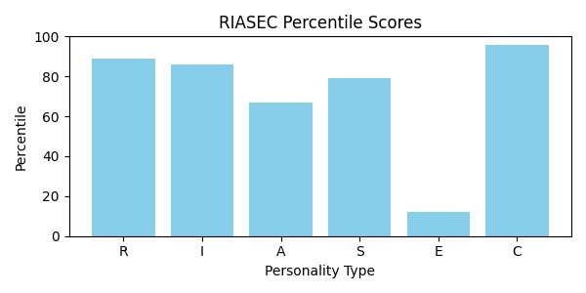

# 3. Your Top 3 Personality Themes (In Order of Strength)

## Conventional (C)



Conventional individuals are efficient, careful, conforming, organized and conscientious. They are comfortable working within an established chain of command and prefer carrying out well-defined instructions over assuming leadership roles. They prefer organized, systematic activities and have an aversion to ambiguity. They are skilled in and often enjoy maintaining and manipulating data, organizing schedules and operating office equipment .While they rarely seek leadership or “spotlight” roles ,they are thorough, persistent and reliable in carrying out tasks .

Conventional types view themselves as responsible, orderly and efficient, and possessing clerical, organizational and numerical abilities. They may also see themselves as unimaginative or lacking in creativity. The preferred work environment of the conventional type fosters organizational competencies, such as record keeping and data management, in a structured operation and places high value on conformity and dependability.

Conventional occupational personality types are oriented to completing tasks initiated by others. They pay attention to detail, and prefer to work with data, particularly in the numerical, statistical, and record-keeping realm. They have a high sense of responsibility, follow the rules, and want to know precisely what is expected of them.

Conventional are accurate and like to follow clearly defined procedures. At work they enjoy rules and regulations that keep things running smoothly. They prefer structure and order to ambiguity. As a result they work well within systems or large organizations. Conventional people have high standards for themselves, are accurate, and pay close attention to details.

Conventional individuals are interested in data and things, rather than people. As a result, they prefer to work with the paper and computer based aspects of a business such as accounting, record keeping, and data processing and the typical conventional careers include secretary, accountant and banker.

Common Leisure Activities: Managing personal finances, collecting memorabilia, writing family history, building models, playing computer or card games

Typical Skills and Strengths: Working with numbers, processing information, accuracy, organizing, business writing

Dislikes: Ambiguous, unstructured activities; dealing with interpersonal issues; drawing, painting, creative writing, photography; activities that involve self expression.

Basic Outlook and qualities of Conventional people:

v Prefer well-ordered environments

v Like systematic, verbal and numerical activities

v Avoid ambiguous situations and problems

v Conscientious, efficient, practical

v Identify with power

v Value material possessions and status.

v Orderly, persistent, calm.

v Adverse to free, unsystematic, exploratory behavior in new areas.

v Do not seek outside leadership.

v Stable, controlled, dependable.

v Most effective at well-defined tasks.

v Save money, buy conservatively.

## Realistic (R)



Realistic occupational personality types like to work with their hands, focus on things in the physical world and use physical skills. They like to explore places and things and frequently have a desire for adventure. They like to repair and make things with their hands, tools, and machines. Outdoor work is often preferred.

Realistic individuals are active and stable and enjoy manual activities, such as building, mechanics, machinery operation and athletics. They prefer to work with things rather than ideas and people. People who fall into this category generally prefer to “learn by doing” in a practical, task-oriented setting, as opposed to spending extended periods of time in a classroom.

Realistic types tend to communicate in a frank, direct manner and value material things. They perceive themselves as skilled in mechanical and physical activities but may be uncomfortable or less adept with human relations. The preferred work environment of the realistic type fosters technical competencies and work that allows them to produce tangible results. Typical realistic careers include electrician, engineer, veterinarian and the military

Realistic people are practical, self-reliant, and mechanically inclined. They tend to be traditional and value things they can see and touch. Realistic individuals usually have well developed skills for working with tools, operating machines or raising animals. They enjoy work that happens outdoors and involves physical activity. They also like adventurous activities such as riding roller coasters or sky diving.

Since the Realistic people enjoy hands-on activities that involve concrete problem solving, they would rather avoid dealing with people, abstract ideas and lots of data. When faced with a problem, they come up with action oriented solutions instead of verbal or interpersonal ones. As a result, Realistic people tend to avoid careers that involve a lot of social interaction and dealing with people, such as teaching or nursing. Instead, they are drawn toward occupations that produce tangible results.

Common Leisure Activities: Building and repairing, gardening and crafts, playing sports, outdoor recreational activities, cars, motor sports, boats, mechanics, home improvement, camping, hunting, fishing

Typical Skills and Strengths: Building and repairing, operating machinery and equipment, concrete problem solving

Dislikes: Public speaking, social events, cultural and aesthetic activities, mediating disputes, work that involves close interpersonal relationships

Basic Outlook and Qualities of Realistic Peoples:

v   Robust, rugged, practical, physically strong

v   Uncomfortable in social settings

v   Good motor coordination

v   Weak verbal and interpersonal skills

v   See themselves as mechanically and athletically inclined

v   Stable, natural, persistent

v   Prefer concrete to abstract problems

v   Have conventional political and economic goals

v   Rarely perform creatively in the arts or science

v   Like to build things with tools

v   Like to work outdoors, Cool to radical new ideas

v   Like to work with big, powerful machines

v   Buy boats, campers, snowmobiles, motorcycles

## Investigative (I)



Investigative individuals are analytical, intellectual and observant and enjoy research, mathematical or scientific activities. They place a high value on science and learning and perceive themselves as scholarly and having scientific or logical ability but lacking leadership and persuasive skills. They are drawn to ambiguous challenges and may be stifled in highly structured environments.

People who fall into this category enjoy using logic and solving highly complex, abstract problems. Because they are introspective and focused on creative problem solving, investigative types often work autonomously and do not seek leadership roles.

The preferred work environment of the investigative type encourages scientific competencies, allows independent work and focuses on solving abstract, complex problems in original ways. Typical investigative careers include medical technologist, biologist, chemist and systems analyst.

Their preferred reading material includes scientific or technical magazines. They enjoy working alone because they would rather analyze data and formulate ideas than work with people. Investigative people tend to dislike jobs that involve leading, selling, or persuading others. While they share some of the same interests in the physical world as Realistic people, Investigative types prefer thinking over doing.

Common Leisure Activities:

Scientific, mathematical, and intellectual pursuits; researching and understanding the physical world; using computers; doing complex calculations; astronomy; crossword puzzles, visiting Museums.

Typical Skills and Strengths: Understanding and solving science and math problems; analytical, observant, inquisitive; organizing, analyzing, interpreting data, ideas, theories; working independently with loosely defined problems; researching and understanding the physical world.

Dislikes : Sales, persuading others, leading people

Basic Outlook and Qualities of Investigative Peoples:

v Scientific orientation, Introspective and asocial

v Task-oriented, all wrapped up in their work

v Think through rather than act out a problem

v See themselves as lacking in leadership skills

v Confident of their intellectual abilities

v Analytical, curious, reserved, independent

v Great dislike for repetitive activities

v Buy telescopes, calculators, electronic equipment

v Strong need to understand the world

v  Enjoy ambiguous tasks & prefer to work independently

# 4. Career Recommendations

Based on your Holland Code (CRI), here are some career paths to explore:

*Note: The Job Zone indicates the level of preparation needed for a job (1 = little preparation, 5 = extensive preparation).*

# 5. How to Explore Your Interests

• Participate in school clubs, after-school activities, or personal projects that align with your top traits.

• Talk to people! Seek guidance from teachers, counselors, or professionals working in fields that interest you.

• Volunteer or find a part-time job in an area related to your interests to get real-world experience.

# 6. Interest Report Summary

Based on your top scores in Conventional, Realistic, Investigative (CRI), your interests align with traits and work environments typical for these personality types. Use this report as a starting point to explore, learn, and reflect on what truly motivates you.

# 7. A Final Note

Understanding your interests is a powerful first step toward discovering a fulfilling career path. This report is a snapshot in time. Continue to be curious, keep learning, and trust in your unique potential. Your interests may evolve, and that's a natural part of growth!

Holland Career Interest Assessment Report

Name: Jyoti Dhabhai

Class: XII

Section: A

Roll Number: 1252

# 1. Introduction

Purpose of the Career Interest Profiler (CIP)

The Career Interest Profiler was developed to help people clarify their interests and relate them to work and career options. When a person can link what they like to do, with jobs that fulfill those interests, they can make better career decisions.

The Career Interest Profiler was designed to clarify the types of activities a person enjoys and highlight occupations where these interests can be met. By combining an in-depth description of a person’s likes and dislikes along with jobs that match these preferences, the CIP can guide career decision makers.

The Career Interest Profiler is built upon John Holland’s theory of vocational personality. This theory, which has become one of the most widely, accepted approaches for helping people make occupational choices, is based on six vocational personality types. Holland believed that people could be described by one of the six types which are briefly described below.

REALISTIC

INVESTIGATIVE

ARTISTIC

SOCIAL

ENTERPRISING

CONVENTIONAL

# 2. Score Analysis

Your Holland Code: CIR

|  |  |  |
| --- | --- | --- |
| Type | Raw Score | Percentile |
| Realistic | 19 | 85 |
| Investigative | 22 | 86 |
| Artistic | 17 | 72 |
| Social | 17 | 70 |
| Enterprising | 18 | 18 |
| Conventional | 26 | 98 |

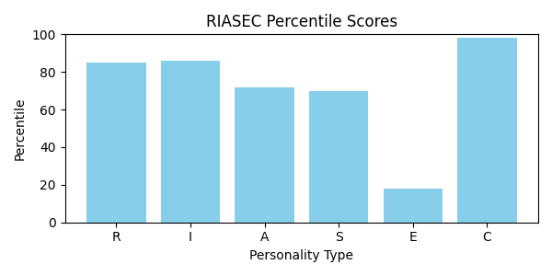

# 3. Your Top 3 Personality Themes (In Order of Strength)

## Conventional (C)



Conventional individuals are efficient, careful, conforming, organized and conscientious. They are comfortable working within an established chain of command and prefer carrying out well-defined instructions over assuming leadership roles. They prefer organized, systematic activities and have an aversion to ambiguity. They are skilled in and often enjoy maintaining and manipulating data, organizing schedules and operating office equipment .While they rarely seek leadership or “spotlight” roles ,they are thorough, persistent and reliable in carrying out tasks .

Conventional types view themselves as responsible, orderly and efficient, and possessing clerical, organizational and numerical abilities. They may also see themselves as unimaginative or lacking in creativity. The preferred work environment of the conventional type fosters organizational competencies, such as record keeping and data management, in a structured operation and places high value on conformity and dependability.

Conventional occupational personality types are oriented to completing tasks initiated by others. They pay attention to detail, and prefer to work with data, particularly in the numerical, statistical, and record-keeping realm. They have a high sense of responsibility, follow the rules, and want to know precisely what is expected of them.

Conventional are accurate and like to follow clearly defined procedures. At work they enjoy rules and regulations that keep things running smoothly. They prefer structure and order to ambiguity. As a result they work well within systems or large organizations. Conventional people have high standards for themselves, are accurate, and pay close attention to details.

Conventional individuals are interested in data and things, rather than people. As a result, they prefer to work with the paper and computer based aspects of a business such as accounting, record keeping, and data processing and the typical conventional careers include secretary, accountant and banker.

Common Leisure Activities: Managing personal finances, collecting memorabilia, writing family history, building models, playing computer or card games

Typical Skills and Strengths: Working with numbers, processing information, accuracy, organizing, business writing

Dislikes: Ambiguous, unstructured activities; dealing with interpersonal issues; drawing, painting, creative writing, photography; activities that involve self expression.

Basic Outlook and qualities of Conventional people:

v Prefer well-ordered environments

v Like systematic, verbal and numerical activities

v Avoid ambiguous situations and problems

v Conscientious, efficient, practical

v Identify with power

v Value material possessions and status.

v Orderly, persistent, calm.

v Adverse to free, unsystematic, exploratory behavior in new areas.

v Do not seek outside leadership.

v Stable, controlled, dependable.

v Most effective at well-defined tasks.

v Save money, buy conservatively.

## Investigative (I)



Investigative individuals are analytical, intellectual and observant and enjoy research, mathematical or scientific activities. They place a high value on science and learning and perceive themselves as scholarly and having scientific or logical ability but lacking leadership and persuasive skills. They are drawn to ambiguous challenges and may be stifled in highly structured environments.

People who fall into this category enjoy using logic and solving highly complex, abstract problems. Because they are introspective and focused on creative problem solving, investigative types often work autonomously and do not seek leadership roles.

The preferred work environment of the investigative type encourages scientific competencies, allows independent work and focuses on solving abstract, complex problems in original ways. Typical investigative careers include medical technologist, biologist, chemist and systems analyst.

Their preferred reading material includes scientific or technical magazines. They enjoy working alone because they would rather analyze data and formulate ideas than work with people. Investigative people tend to dislike jobs that involve leading, selling, or persuading others. While they share some of the same interests in the physical world as Realistic people, Investigative types prefer thinking over doing.

Common Leisure Activities:

Scientific, mathematical, and intellectual pursuits; researching and understanding the physical world; using computers; doing complex calculations; astronomy; crossword puzzles, visiting Museums.

Typical Skills and Strengths: Understanding and solving science and math problems; analytical, observant, inquisitive; organizing, analyzing, interpreting data, ideas, theories; working independently with loosely defined problems; researching and understanding the physical world.

Dislikes : Sales, persuading others, leading people

Basic Outlook and Qualities of Investigative Peoples:

v Scientific orientation, Introspective and asocial

v Task-oriented, all wrapped up in their work

v Think through rather than act out a problem

v See themselves as lacking in leadership skills

v Confident of their intellectual abilities

v Analytical, curious, reserved, independent

v Great dislike for repetitive activities

v Buy telescopes, calculators, electronic equipment

v Strong need to understand the world

v  Enjoy ambiguous tasks & prefer to work independently

## Realistic (R)



Realistic occupational personality types like to work with their hands, focus on things in the physical world and use physical skills. They like to explore places and things and frequently have a desire for adventure. They like to repair and make things with their hands, tools, and machines. Outdoor work is often preferred.

Realistic individuals are active and stable and enjoy manual activities, such as building, mechanics, machinery operation and athletics. They prefer to work with things rather than ideas and people. People who fall into this category generally prefer to “learn by doing” in a practical, task-oriented setting, as opposed to spending extended periods of time in a classroom.

Realistic types tend to communicate in a frank, direct manner and value material things. They perceive themselves as skilled in mechanical and physical activities but may be uncomfortable or less adept with human relations. The preferred work environment of the realistic type fosters technical competencies and work that allows them to produce tangible results. Typical realistic careers include electrician, engineer, veterinarian and the military

Realistic people are practical, self-reliant, and mechanically inclined. They tend to be traditional and value things they can see and touch. Realistic individuals usually have well developed skills for working with tools, operating machines or raising animals. They enjoy work that happens outdoors and involves physical activity. They also like adventurous activities such as riding roller coasters or sky diving.

Since the Realistic people enjoy hands-on activities that involve concrete problem solving, they would rather avoid dealing with people, abstract ideas and lots of data. When faced with a problem, they come up with action oriented solutions instead of verbal or interpersonal ones. As a result, Realistic people tend to avoid careers that involve a lot of social interaction and dealing with people, such as teaching or nursing. Instead, they are drawn toward occupations that produce tangible results.

Common Leisure Activities: Building and repairing, gardening and crafts, playing sports, outdoor recreational activities, cars, motor sports, boats, mechanics, home improvement, camping, hunting, fishing

Typical Skills and Strengths: Building and repairing, operating machinery and equipment, concrete problem solving

Dislikes: Public speaking, social events, cultural and aesthetic activities, mediating disputes, work that involves close interpersonal relationships

Basic Outlook and Qualities of Realistic Peoples:

v   Robust, rugged, practical, physically strong

v   Uncomfortable in social settings

v   Good motor coordination

v   Weak verbal and interpersonal skills

v   See themselves as mechanically and athletically inclined

v   Stable, natural, persistent

v   Prefer concrete to abstract problems

v   Have conventional political and economic goals

v   Rarely perform creatively in the arts or science

v   Like to build things with tools

v   Like to work outdoors, Cool to radical new ideas

v   Like to work with big, powerful machines

v   Buy boats, campers, snowmobiles, motorcycles

# 4. Career Recommendations

Based on your Holland Code (CIR), here are some career paths to explore:

*Note: The Job Zone indicates the level of preparation needed for a job (1 = little preparation, 5 = extensive preparation).*

# 5. How to Explore Your Interests

• Participate in school clubs, after-school activities, or personal projects that align with your top traits.

• Talk to people! Seek guidance from teachers, counselors, or professionals working in fields that interest you.

• Volunteer or find a part-time job in an area related to your interests to get real-world experience.

# 6. Interest Report Summary

Based on your top scores in Conventional, Investigative, Realistic (CIR), your interests align with traits and work environments typical for these personality types. Use this report as a starting point to explore, learn, and reflect on what truly motivates you.

# 7. A Final Note

Understanding your interests is a powerful first step toward discovering a fulfilling career path. This report is a snapshot in time. Continue to be curious, keep learning, and trust in your unique potential. Your interests may evolve, and that's a natural part of growth!