|  |  |
| --- | --- |
| [COS10011] Assignment 1 Report | Version: 1.0 |
| Team Name: AmazingRetard | Date: [2018-26-03] |
| Title: RV Rental Company | |

1. Introduction

The objective of this website is to introduce people to one of the western culture which is camping with Recreational Vehicle (RV). Through multiple social network and also television, we found out that is it quite common for western people to travel from a few days to even weeks in RV. It can be really luxuries and it can also be pretty economic, besides it is also a great choice that they choose to spend time with their family and friends. Therefore we would like to introduce to Malaysian about different types of RV that they can use to travel around Malaysia or even in other country according to their needs and financial ability.

1.1 Scope of the Website

The scope of the RV rental website is to introduce Malaysian people with western culture which is RV Camping which helps them to spend time with their family and friends, to get a chance to travel around places with the ability to stop wherever you want. Besides that, we would also like to introduce to Malaysian about several types of RV and also there are different combination of amenities in different level of luxury even in the same RV.

1.2 Intended Audience

The intended audience would be young adult, adult or even elders who are capable of earning money. This is because even though the rental are cheap, it does not mean it is affordable by anyone. They can use RV Camping as a chance to travel and spend time with their family and friends, also it is a good opportunity for them to travel inside a vehicle without the worry of extra hotel fee provided as long as the basic needs of camper is enough.

2.0 Website Design and Structure

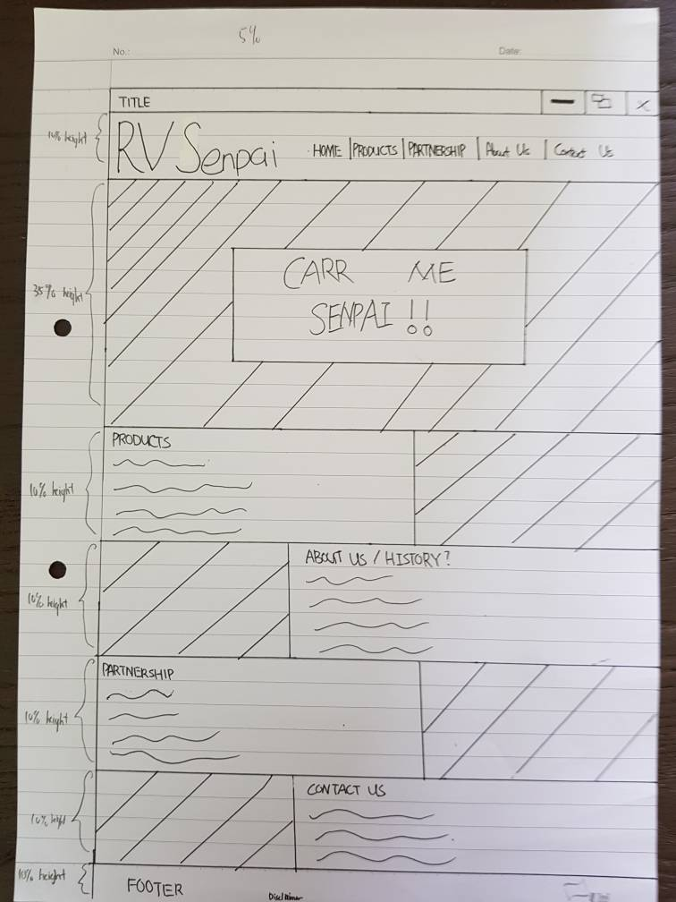 2.1 Website Layout Mock Ups

Figure 1 Old Layout 1

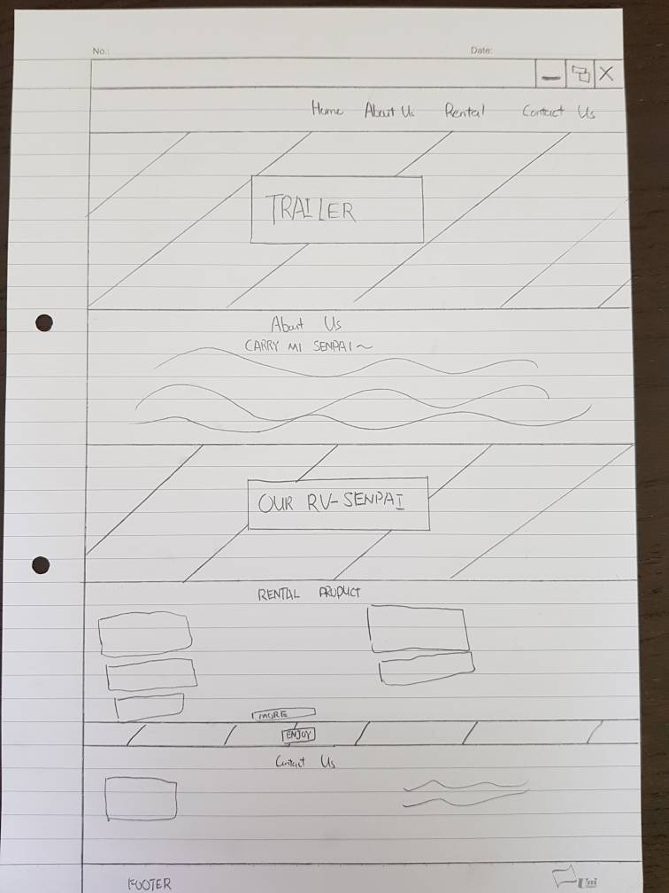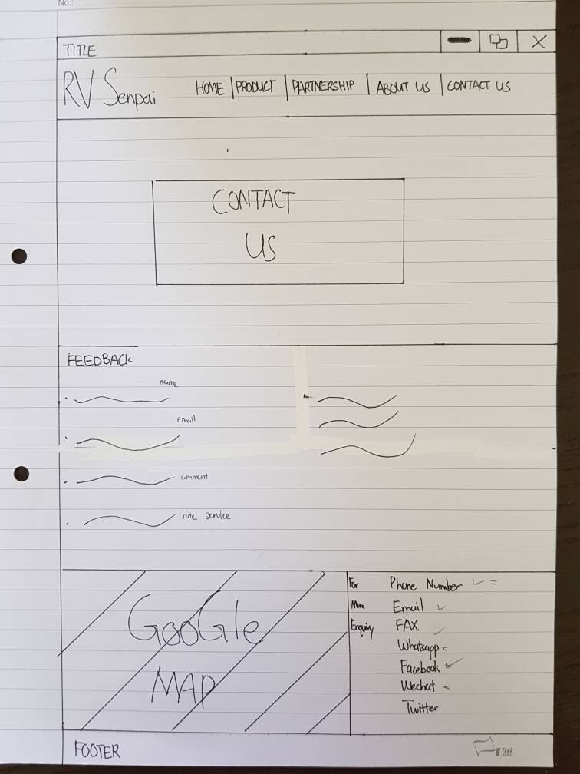

Figure 2 New Layout 1

Figure 3 Old Layout 2

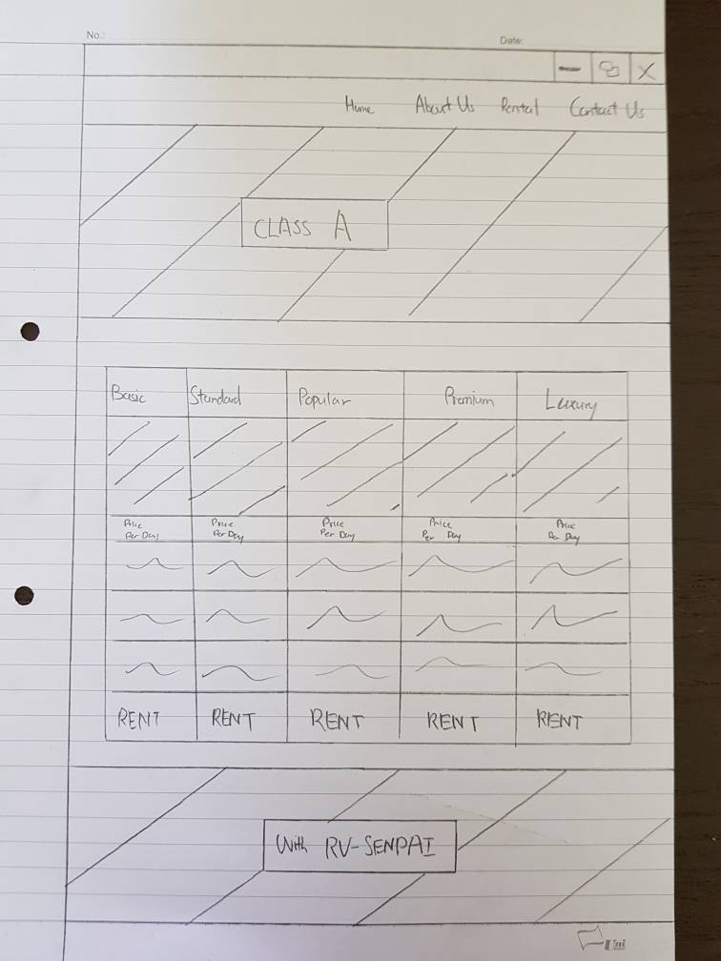

Figure 4 New Layout 2

2.2 Website Structure

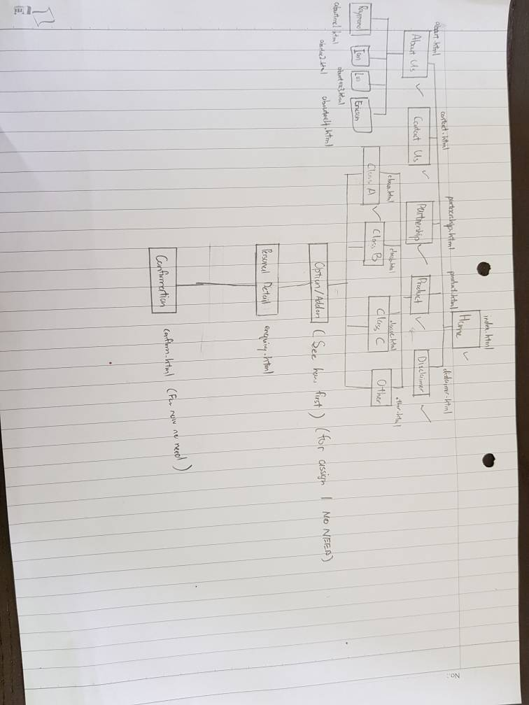

Figure 5 Hierarchical Structure of the Website

3.0 End Product

3.1 Actual User Interface

(Pictures)

3.2Enhancement

(Any Enhancement?)

4.0 Contribution

|  |  |
| --- | --- |
| **Team Member 1** | **Ericson** |
| **Contribution (%)** | **25%** |
| **List of Contribution** | **Layout, CSS, HTML, index.html, product.html, contact.html,** |
|  | **aboutus.html, Information, Image** |

|  |  |
| --- | --- |
| **Team Member 2** | **Ian** |
| **Contribution (%)** | **25%** |
| **List of Contribution** | **HTML, CSS, Images, Information, faq.html,enquiry.html, aboutus.html, layout, images** |
|  |  |

|  |  |
| --- | --- |
| **Team Member 3** | **Raymond** |
| **Contribution (%)** | **25%** |
| **List of Contribution** | **HTML, CSS, product1.html, product2.html, product3.html** |
|  | **product4.html, Information, Images,** |

|  |  |
| --- | --- |
| **Team Member 4** | **Loo** |
| **Contribution (%)** | **25%** |
| **List of Contribution** | **HTML, CSS, Images, disclaimer.html, contactus.html,** |
|  | **Partnership.html, Information** |

5.0 Group Reflection

The challenge that we face is that all of our member are from computing degree and have few concept on how to mix and make up a good combination of color for our RV rental website. Therefore, we all have decided on choosing a color theme online that would best suit our theme. The color theme that we choosing is natural theme which consist of green color. However, we only put in a bit of green color, we also put in black color and the design is modern.

Besides that, we also found problem deciding the layout for the website. At first, we have 2 ideas which are a normal website or parallax website, because we found that parallax is more interesting than normal webpage so we decided to implement the parallax into our website. Ericson is the pioneer to guide us to use the parallax design, he teaches us how to parallax and we learn it. Surely during the process of learning we found difficulty and we use w3school to help us to understand it more.

We found out that everyone have their own strengths and also weakness. For example, Loo have the weakness that is does not have the knowledge of using parallax and Loo is good in making normal website, form and collect information. Ericson is good in html, css and also parallax. Besides that, he also a fast worker because he is the first one to complete the layout. Ian is good in expressing idea which he has a lot of interesting idea, he also works well with his css, html and a fast worker. Raymond is also good in parallax, html and css, he is also a fast worker.

The area of improvement for our website is that we need to learn more about the usability and responsive of the website. We still have not enough skills and knowledge to make our website as responsive as it can.