1 Introduction 3
2 Summary 3
3 A Quick Peek at The Games 4
3.1 sudoku – Sudoku puzzle solver 4
3.1.1 Sudoku Features 6
3.2 race track – simple TWO-DIMENSIONAL race track design and runner 6
3.2.1 Race_track Features 8
3.3 dots – simple "connect the dots, and complete the squares" game 8
3.3.1 Dots Features 11
3.4 good_knights – solve the chess problem of a knight's tour 11
3.4.1 Features 15
4 A quick look at the programs 16
4.1 Sudoku 16
4.1.1 Solving Strategy: 16
4.2 Car Race 16
4.2.1 Objects / Classes 16
4.2.2 BlockBlock – basic building block for components and regions 17
4.2.3 Coordinate Transformation in Graphical Display 18
4.3 Dots 19
4.4 Good Knights 19
5 Ideas, Environment, and Tools 19
6 Principles / ideas / Observations 19
7 General 19
7.1.1 Why Python, Tkinter, … ? 19
7.1.2 Program Logging, Execution Tracing 19
7.1.2.1 Logging / Tracing Example (GitHub raysmith619/resource_lib) 19
7.1.2.2 SelectTrace class Logging/Tracing Features 20
7.1.2.3 A look at TraceControlWindow – more interaction 21
7.1.2.4 Larger Logging/Tracing Example 23
7.1.3 Persistence / Properties Files 24
7.2 Gamming 25
7.2.1 hierarchal component design 25
7.2.2 undo/redo 25
7.2.2.1 implementations 25
7.2.2.2 user vs environment moves 25
7.2.3 command/game saving/loading 25
7.2.4 combining automatic and manual game play 25
7.2.5 providing problem solving support during execution 25
7.2.6 depth or breath first attacks 25
7.3 Graphics / Presentation (for gaming) 25
7.3.1 Python Tkinter vs. others e.g. wxPython 25
7.3.2 Animation – small scale - highlighting 25
7.4 Dialog boxes - for now(model) for always(modeless) 25
7.4.1 Drawing – Canvas 25
7.4.2 coordinate transformations 25
7.4.2.1 Efficiency 25
7.4.2.2 2D homogeneous 25
7.4.3 state persistence, properties files 26
7.4.4 parameters: combining command line, property file, and dialog box 26
7.4.5 execution performance 26
7.5 Do / Undo 26
7.6 Performance 26
7.6.1 Automated Tools 26
7.6.2 Ad hock 26
7.6.2.1 Automated play / log/ results files 26
7.6.2.2 Less is More 26
7.7 Presentation 26
8 Bugs, Issues, Futures, todo 26
8.1 Sudoku 26
8.2 car Race 26
8.3 Dots 26
8.3.1 Do/Undo is not working and probably needs cleaning up. 26
8.3.2 Modifying Player Control values should immediately change the corresponding values in the Score window. 26
8.4 Good Knights 26
9 Notes / Staging Area 26

Introduction
I would like to share some observations from my experiences with programming in the graphics / gaming environment. Although the examples are relatively recent, many of the ideas have appeared over many years of programming. My current goals include generating computer graphics/games using graphics targeted at children of the ages of 3 to 8. Although my programming experience spans many years, my graphics/gaming directions is but a few years in progress. My example programs are all in Python, though I believe most of the principles are applicable to most modern languages. Because of the potential range in audience experience, many of the ideas maybe obvious. I include my observations because at one time or another they seemed interesting or useful to me. I plan to present four python programs to demonstrate my observations. I consider these programs as more investigations of strategy and technique than target products. I make no claim on the programs' "goodness" or application. Though a seasoned programmer of many years, I still consider myself to be "new" to Python, graphics, and gaming.

Summary
The primary programs presented here are:
- Sudoku: Sudoku puzzle solver – Puzzle solver
- race_track: Two-dimensional race track design and racing control – Interactive modeling game
- dots: Connect the dots, and complete the squares game – Multi-person interactive game
- Good-Knights: Solve the chess problem of a knight's tour – Puzzle Solver
The program source code, plus more information can be found on my GitHub account (https://github.com/raysmith619). This document file can be found in ( https://github.com/raysmith619/Graphics-Gaming-Python-Observations/tree/master/Docs).

My programming goals, in addition to providing the primary game solution, included investigating nice graphics displays and analysis tools.
In this presentation I will attempt to touch on a number of ideas outlined below. The primary goal here is not to describe these concepts completely, but to present my impressions / experiences with these concepts in the hope they will be of interest and help to others.
- Gamming
  - hierarchal component design
  - undo/redo
    - implementations
    - user vs environment actions
  - command/game saving/loading
  - combining automatic and manual game play
  - providing programmer support during execution
  - depth or breath first attacks
- Graphics (for gaming)
  - Python Tkinter vs. others e.g. wxPython
  - Animation – small scale - highlighting
  - Dialog boxes - for now(model) for always(modeless)
  - Drawing – Canvas
  - coordinate transformations
    - Efficiency
    - 2D homogeneous
- General
  - Why Python, Tkinter, … ?
  - program logging, tracing
  - state persistence, properties files
  - parameters: combining command line, property file, and dialog box
  - execution performance

A Quick Peek at The Games

sudoku – Sudoku puzzle solver
The game/puzzle Sudoku, most often played on a 9 by 9 grid of squares. Initially a number of the squares, contain a number from 1 to 9. The goal is to fill the remining squares, so that every row, column and sub section (9 3by3 group) has no repeated digits.

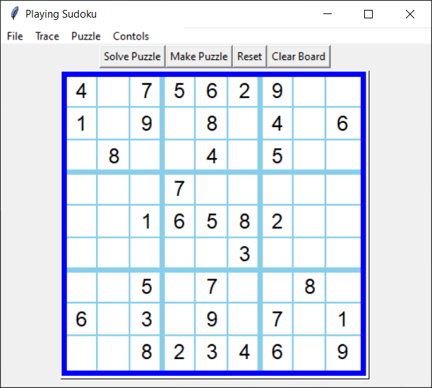
Initial Sudoku Puzzle View
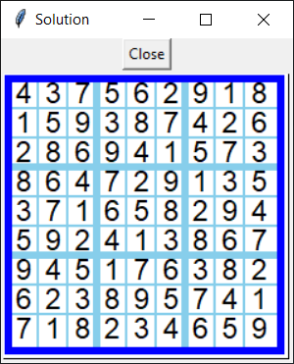
Sudoku Puzzle Solution View

Sudoku Features
- Choice of board dimension: 1x1 to 9x9
- Supports game files providing initial setting
- Supports game list files providing lists of game files
- Display of game search progress

race track – simple TWO-DIMENSIONAL race track design and runner
Race track provides the operator the facility of creating one or more simple race paths, populating these with one or more abstract cars, and watching these cars traverse the paths. The current implantation does not facilitate much variation in the car operation. Track construction consists of adding track segments to the field. The most exercised addition method consists of mouse clicking at the leading portion of the track (left-turn, strait, right-turn)
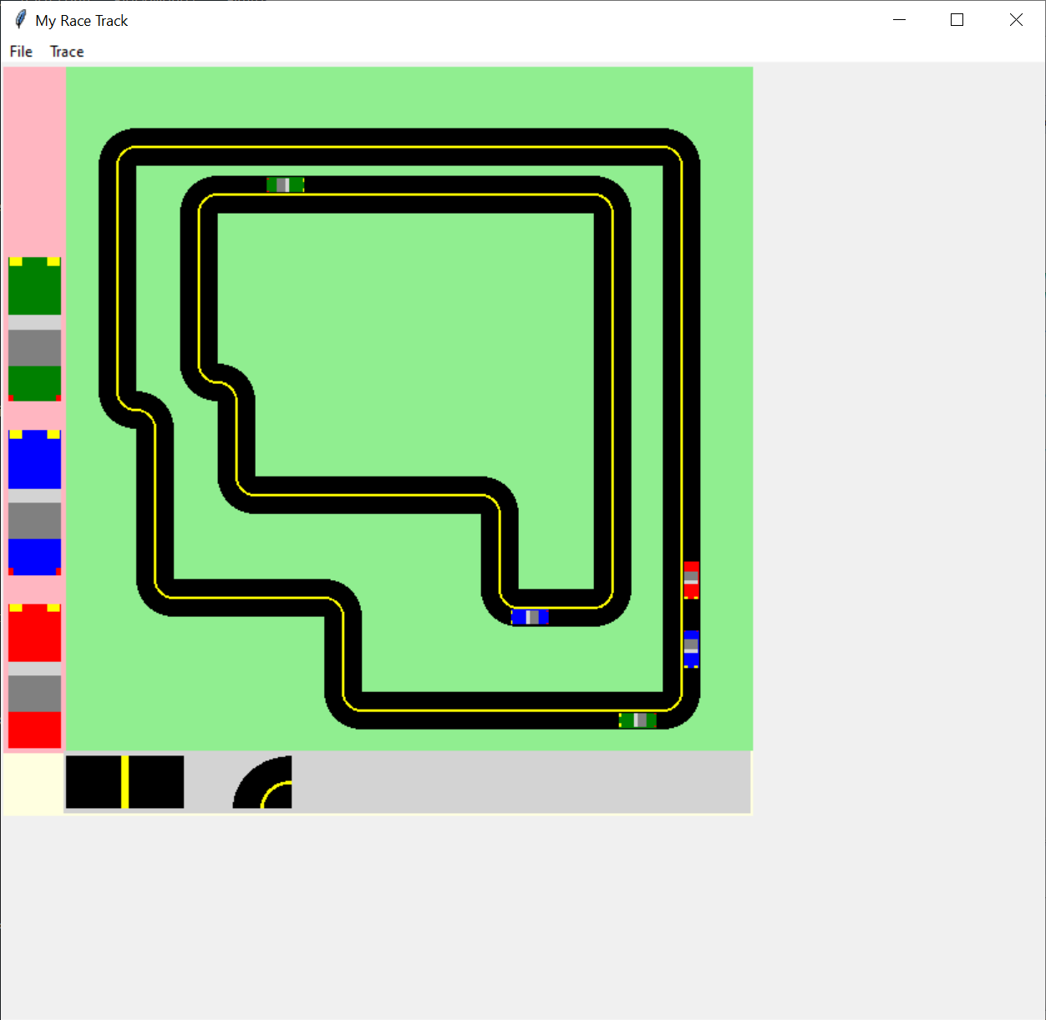
Main view of two tracks, with cars

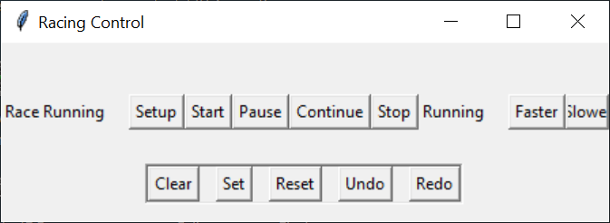
Racing Controls

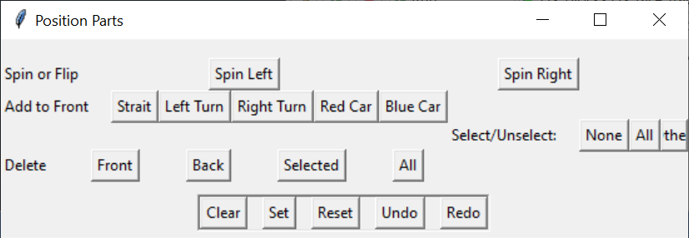
Track Building Controls

Race_track Features
- Mouse / Keyboard driven operator track construction
- Loading / Saving track definition files
- Mouse placement of cars
- Multiple tracks

dots – simple "connect the dots, and complete the squares" game
The dots game starts with an array of dots, and the players alternate connecting adjacent dots, either horizontally or vertically. When such a move completes a square that player places their initial in the square. The player with the most completed squares wins.
Central control of the game operation is via the Game Control window. The operator may choose the grid dimensions.
Game progress is driven by the Player Control window. This controls the number of players, and each player's: name, square label, colors, start position, manual/automatic, and, if automatic, play level, and speed. Some features such as voice are not yet implemented.
To dramatize the players, the players' colors are used to accent their lines in the Player Control and Score windows.

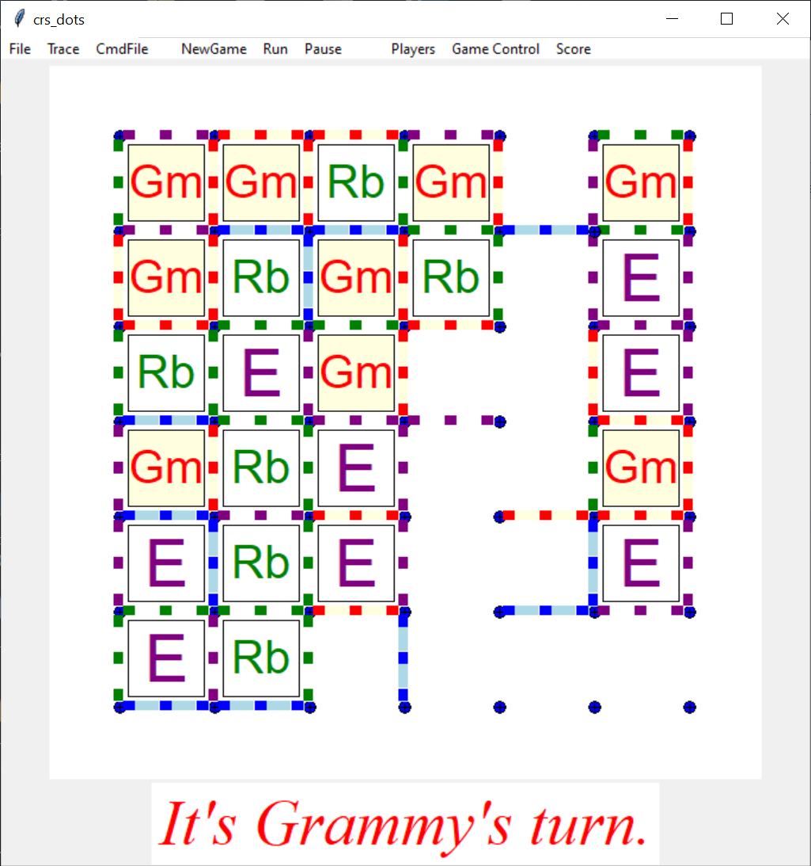
Dots Game in Progress

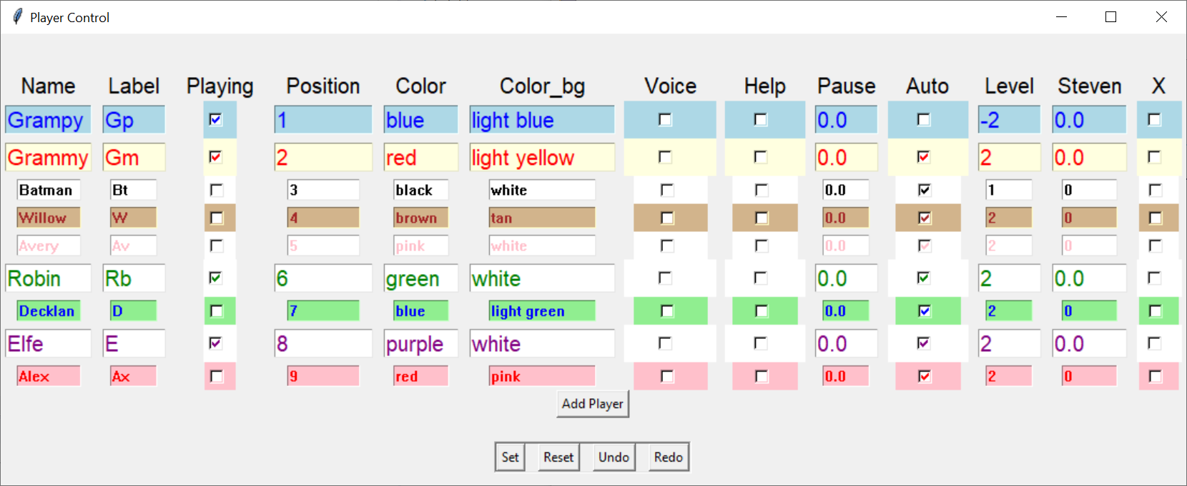
Player Selection

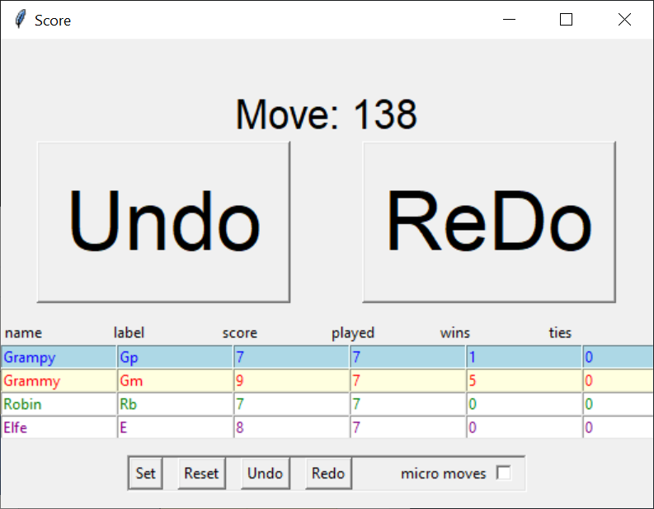
Score Display / Control
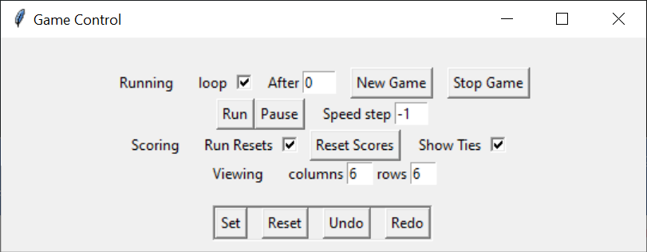
Game Process Control

Dots Features
- Customizable player setup, including manual/automatic specification
- Board dimensions specifiable
- Support both mouse and keyboard player operation
- Player move Do / Undo
- Multiple game playing for statistics generation
- Recorded game results
- Game results processing and analysis

good_knights – solve the chess problem of a knight's tour
The Knight's Tour problem can be stated: Given a single knight on an otherwise empty chess board, show a series of legal knight moves that traverses all the remaining squares of the board, without repeatedly entering any square. If the knight, on the final square, can, with a single move, get to the starting square, the tour is considered a "closed tour".

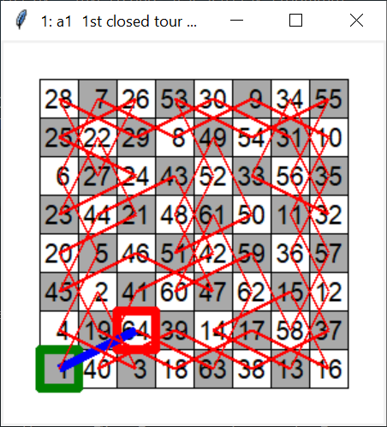
Closed Tour starting at a1, ending at c2
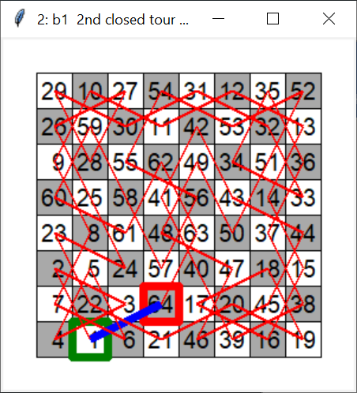
Closed Tour starting at b1, ending at d2
The path display numbers the squares in order of move. The first square is outlined in green. The final square is outlined in red. If the final square is within a legal move of the first, making this a "closed tour", the squares are joined with a blue line.

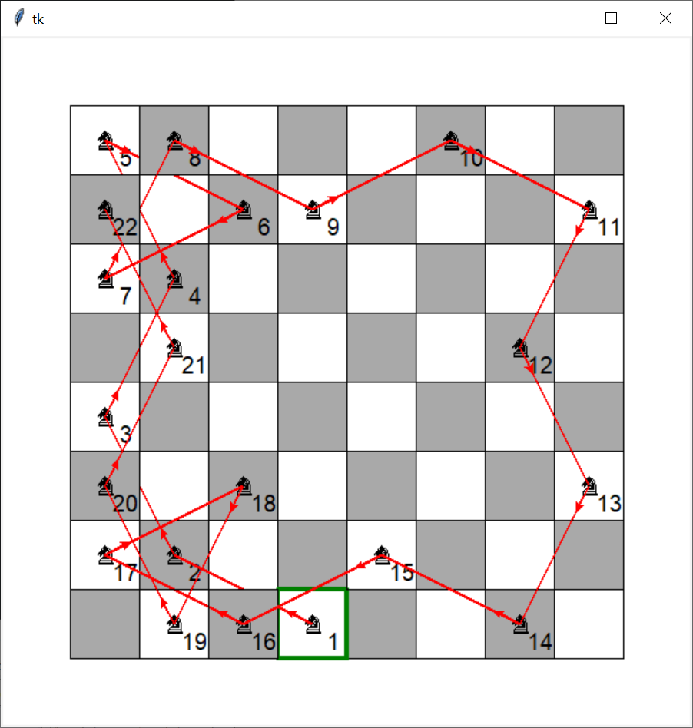
Tour progress display, starting at d1, in progress: d1, b2, a4, b6, …, a7
To aid progress viewing, the move lines start with a small arrow, in the origin square, pointing to the destination square.
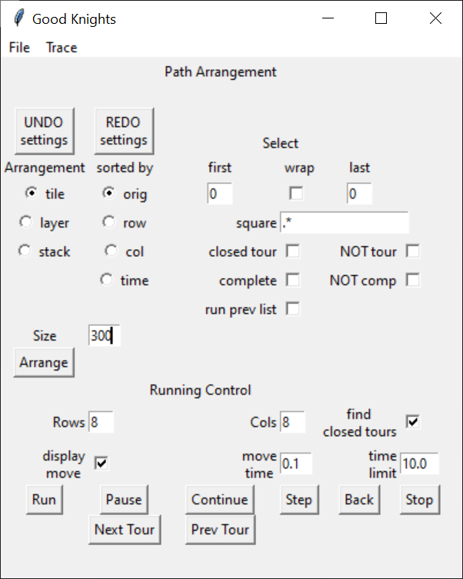
Knight's Tour Calculation and Display Control

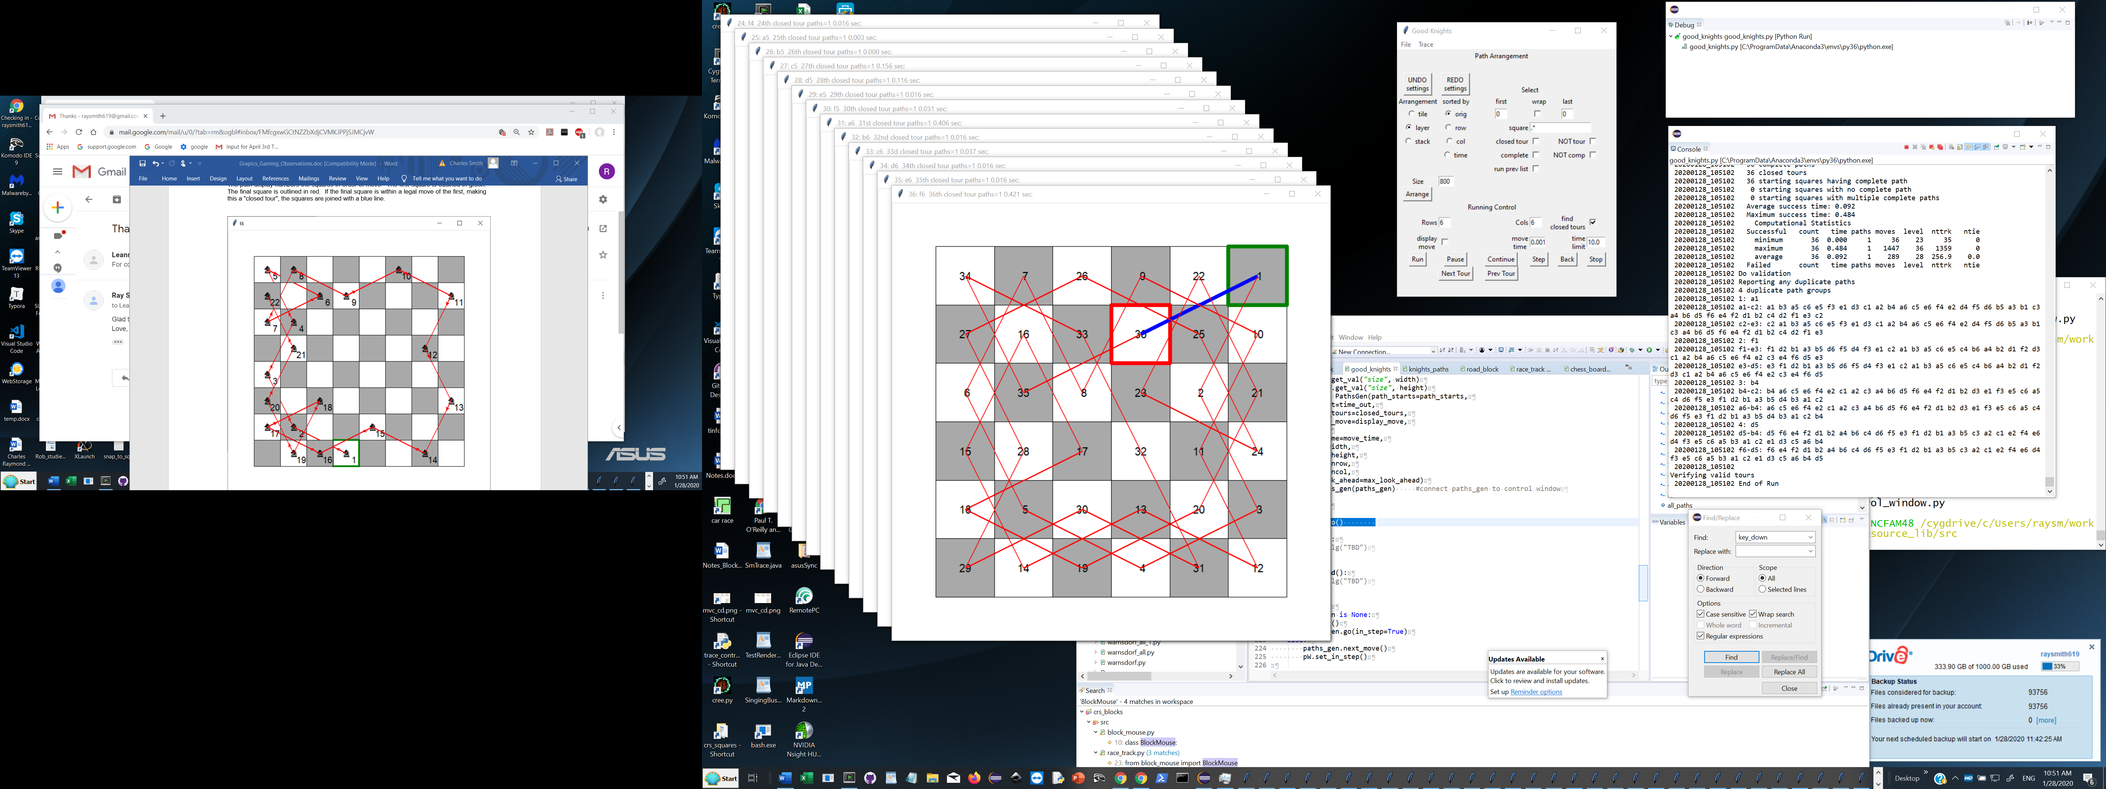
Run showing stacked display of 6x6 solutions

Features
- Supports board configuration number of rows, columns
- Searches multiple starting squares
- Optional display of search progress
- Flexible board display size
- Control over solutions display

A quick look at the programs

Sudoku

Solving Strategy:
- For all the empty squares (choices):
    - Find the candidate values – the values not in same column, same row, or sub square
    - Order these choices (squares) from most constrained (least number of candidate values) to least constrained

Car Race
This program was planned to be an example of model building. My goal was to start with primitives such as points, lines, and polygons, then construct more elaborate objects for use in the game. Of most interest was developing a hierarchal structure which would lend itself to extended design and development. An objective of constructing displayed objects on points was to provide an efficient mechanism to translate objects efficiently.

Objects / Classes
The major construction components used in the game are objects which use the following classes.
BlockBlock -basic display object building block
Types: COMPOSITE, POLYGON, LINE, ARC, CHECK
Based Objects
Construction: BlockCheck, BlockDot, BlockPolygon, BlockRing, BlockText, CarBlock, RoadBlock
Containers: BlockPanel,
RoadBlock – basic block for road construction
Based Objects
Construction: RoadStraight, RoadTurn
Container: BlockPanel
BlockPanel – basic container for displayed car / road
Based Objects
RoadTrack
CarBlock – basis for cars
Based Objects
Construction: CarSimple
RoadBlock – basis for road components
Based Objects
Construction: RoadStraight, RoadTurn
Container: RoadPanel
BlockPolygon – basis for various displayed figures
Based Objects
Construction: BlockArrow, BlockCross, BlockPointer

BlockBlock – basic building block for components and regions
Virtually all of the displayed components of the game are of the type BlockBlock or a derived type. Generally, a displayed component is either an object of type BlockBlock whose points are displayed as a polygon, or an object of type BlockBlock which contains a list of components of type BlockBlock to be displayed. To this purpose, an instance of BlockBlock represents a list of included points or a list of included BlockBlock instances. The following is an abbreviated structure of BlockBlock:
BlockBlock construction parameters
ctype container type default: COMPOSITE
points points, used for this component
comps object's components, if ctype == COMPOSITE
container containing this object default: this is the base object

BlockBlock size / position parameters
width width as a fraction of container's width dimensions'
e.g. 1,1 with container==None ==> block is whole canvas
If container is None
width = width * self.cv_width
height height as a fraction of container's height
position position of lower left corner (x=0, y=0) relative to container's
position (x=0, y=0)
rotation rotation relative to container's rotation
velocity velocity relative to container's velocity

BlockBlock additional parameters
color block's basic color
id Unique object id, default: t created
canvas optional canvas argument - provides Canvas if no container
cv_width optional canvas width
cv_height optional canvas height
visible visible iff container's visible default: seen
Composing Straight Road Segment – An abbreviated code example (from roat_strait.py) is below.
class RoadStraight(RoadBlock):
"""
A Strait Part of a road
which can be used to construct a road layout
"""

def __init__(self,
track,
**kwargs):
""" Setup Road object
"""
super().__init__(track, road_type=RoadType.STRAIT,
**kwargs)
xkwargs = {'fill' : 'black'}

strait = BlockPolygon(container=self,
tag=self.tag,
position=Pt(0,0),
points=[Pt(0,0), Pt(0,1), Pt(1,1), Pt(1,0)],
xkwargs=xkwargs)
median_strip = BlockPolygon(container=self, … more parameters
self.comps.append(median_strip)

left_edge = BlockPolygon(container=self, … more parameters
self.comps.append(left_edge)

right_edge = BlockPolygon(container=self, … more parameters
self.comps.append(right_edge)
self.comps.append(strait)
Composing Straight Road Segment – An abbreviated code example

Displaying Straight Road Segment

Class RoadStraight (RoadBlock):
… other function definitions

def display(self):
""" Display thing as a list of components
"""
if not self.visible:
return # Skip if invisible

SlTrace.lg("display %s: %s" % (self.get_tag_list(), self),
"display")
for comp in self.comps:
comp.display()

self.task_update()
Displaying Straight Road Segment

Coordinate Transformation in Graphical Display
Central to the display design is the fact that placement of an array of points, each represented by an x, y coordinate pair, can be translated, rotated, and scaled using repeated matrix multiplications. Important to performance is that the resulting list of matrix multiplications which are applied to each point can be collapsed in to a single matrix which can be then applied to each point.

Dots

Good Knights

Ideas, Environment, and Tools
SelectTrace – tracing, logging, remember/recover
Eclipse
"Internet"

Principles / ideas / Observations

General

Why Python, Tkinter, … ?
Python is relatively easy, compact. Most of my programming is a prototype. If necessary, I'll convert to another language.
Tkinter, a graphics / graphical user interface (GUI) facility to Python, is good enough and is shipped with Python. If necessary, I'll convert to another package.

Program Logging, Execution Tracing
Almost as long as people have been programming, there has often been a desire to understand the program in progress. Probably the oldest method was to write some of the program state or results. First the output was to lights on the front panel, then to paper, then to a display of some sort. One of the most powerful tools the programmer has to display or analyze the operation of a program is the timely printout of information. Often this is just a call to a write or print function. The limitations or drawbacks to the print style of logging may include the following:
- Extra programmer work
- Slows down programmer execution
- Must be done ahead of time
- Must be removed before production running
- Gone before "real problems/need" - during production running
- Clutters up "production" display / output

Logging / Tracing Example (GitHub raysmith619/resource_lib)
It is helpful to have a logging feature available as early in the program's life as possible. For this to happen, for me at least, the process has to be easy. For that purpose, I developed a logging class SelectTrace. Below is the smallest logging example.
# logging_absolute_minimum.py 22Feb2020 crs

from select_trace import SlTrace

SlTrace.lg("Just the minimum for logging")
Example code for minimum logging example
20200223_111219 Creating Log File Name: C:\Users\raysm\workspace\python\resource_lib\log\logging_absolute_minimum_20200223_111219.sllog
20200223_111219 Just the minimum for logging
Log file contents for minimum logging example
In my programs it is imported from the file select_tract.py as the globally accessible singleton SlTrace. The primary logging / tracing output is done via SlTrace.lg(…text…) calls. Judicious use of logging with postprocessing tools can help with analysis tasks such as performance analysis.

A minimum example of tracing follows below:
# tracing_absolute_minimum.py 22Feb2020 crs

from select_trace import SlTrace
SlTrace.setFlags("good=1,bad=0")
SlTrace.lg("we see good", "good")
SlTrace.lg("we don't see bad", "bad")
Example code for minimum tracing example
20200222_192347 Creating Log File Name: C:\Users\raysm\workspace\python\resource_lib\log\tracing_absolute_minimum_20200222_192347.sllog
20200222_192347 Trace levels from properties file
20200222_192347 loadTraceFlags: good
20200222_192347 good = 0
20200222_192347 we see good
20200222_192347 Saving properties file C:\Users\raysm\workspace\python\resource_lib\tracing_absolute_minimum.properties
20200222_192347 Closing log file C:\Users\raysm\workspace\python\resource_lib\log\tracing_absolute_minimum_20200222_192347.sllog

SelectTrace class Logging/Tracing Features
- Output/Display
  - Dual output to log file and STDOUT (screen)
  - Time stamped output to log file
    - timestamp is optional to Display
    - Resolution is adjustable (default Seconds)
  - Selective tracing (based on flag level)
  - Flag setting persists between program runs (via properties file)
- Logging File
  - Automatic Creation on program beginning, or first logging output
  - Automatic log file naming (default program's base name)
  - Time stamped log file name
    - Default: log/pgm_base_name_time_stamp.extension
    - e.g. log/sudoku_20200116_170821.sllog

A look at TraceControlWindow – more interaction
Often, even when one knows there may be a need to do some tracing, the when is not so clear. To facilitate this process is has been useful to provide a menu-based capability to facilitate setting flag levels during program execution. The following is our minimal example of this.

logging_tracing_menu.py 22Feb2020 crs
# Simple with a menu:
# 1. Named / Dated log files
# 2. Tracing by flag
# 3. Plus change settings easily during running
#
import sys
from select_trace import SlTrace
from trace_control_window import TraceControlWindow

cmd_flags = sys.argv[1] if len(sys.argv)>1 else "flag1,flag2=0,end_loop=0"

SlTrace.setFlags(cmd_flags)
SlTrace.lg(f"cmd_flags:{cmd_flags}")
SlTrace.lg("flag1", "flag1")
SlTrace.lg("flag2", "flag2")
tcw = TraceControlWindow()

for i in range(20):
if SlTrace.trace("big"):
SlTrace.lg(f"{i}: big stuff")
else:
SlTrace.lg(f"{i}: no so big")
tcw.sleep(2)
if SlTrace.trace("end_loop"):
SlTrace.lg("Manual break")
break
SlTrace.lg("Ending Program")
Simple complete code file to demonstrate interactive trace flag operation

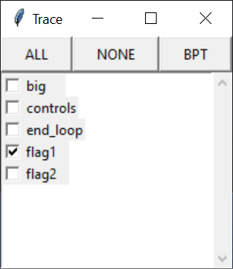
Trace Flag window active during trace flag program above

20200223_120526 Creating Log File Name: C:\Users\raysm\workspace\python\resource_lib\log\logging_tracing_menu_20200223_120526.sllog
20200223_120526 Trace levels from properties file
20200223_120526 loadTraceFlags: flag1,big,controls,end_loop,flag2
20200223_120526 flag1 = 1
20200223_120526 big = True
20200223_120526 controls = False
20200223_120526 end_loop = True
20200223_120526 flag2 = 0
20200223_120526 cmd_flags:flag1,flag2=0,end_loop=0
20200223_120526 flag1
20200223_120526 Standalone TraceControlWindow
20200223_120526 0: big stuff
20200223_120528 1: big stuff
20200223_120530 2: big stuff
20200223_120532 3: no so big
20200223_120534 4: no so big
20200223_120537 5: no so big
20200223_120539 Manual break
20200223_120539 Ending Program
20200223_120539 Saving properties file C:\Users\raysm\workspace\python\resource_lib\logging_tracing_menu.properties
20200223_120539 Closing log file C:\Users\raysm\workspace\python\resource_lib\log\logging_tracing_menu_20200223_120526.sllog
Log file created while executing trace flag menu example

Larger Logging/Tracing Example
Program execution tracing is often tightly connected with logging. My logging file is most often the output of tracing. The logging function SlTrace.lg() has two parameters: The first is the text string to output. The optional second is a text string flag which indicates if output is created. Most programs provide a menu labeled "Trace" which provides the operator with a control window facilitating selection of what flag values to set/clear. This is especially helpful when tracing is only desired under certain program running conditions.

SlTrace.lg(f"best_moves = {best_moves}", "stack_build")
if best_moves is None:
SlTrace.lg(f"best_moves tested is None", "stack_build")
best_moves = self.get_best_moves(board, next_move)
SlTrace.lg(f"best_moves = {best_moves}", "stack_build")
SlTrace.lg(f"len(best_moves)={len(best_moves)}", "stack_build")
Code showing tracing examples

20200115_180048 Creating Log File Name: C:\Users\raysm\workspace\python\good_knights\log\good_knights_20200115_180048.sllog
20200115_180048 loadTraceFlags: in_stroke,region_few_corners,region_rect,add_part,display,get_color,regno,part_check_ok,dbg,part_track_uncleared,edge_unselected,show_id,part_info,enter,on_motion,is_over,part_info_over,edge_highlighted,no_blink,blink_on_first,highlight,get_parts,motion,blink,leave,no_corners,down,selected,edge_selected,get_knight_paths,stack_grow,back_off_trace,complete_paths,no_more_moves,set_piece,non-closed,best_moves,strict_order,track_refine,add_change,controls,backup_move,stack_build,track_vars,track_vals
20200115_180048 SelectControl.__init__ 1
20200115_180048 args: Namespace(closed_tours=True, display_complete=True, display_path_board=False, end_ci=7, end_ri=7, height=300, max_look_ahead=5, move_time=0.1, ncol=8, nrow=8, run=False, time_out=2, trace='', width=300)

20200115_180048 good_knights.py

20200115_180048 SelectControl.__init__ 1
20200115_180120_921 1: a1
20200115_180129 1st closed tour paths=1 (in 7.686 sec) from a1 to c2 path: a1 b3 c1 a2 b4 a6 b8 d7 f8 h7 g5 h3 g1 e2 g3 h1 f2 d1 b2 a4 c5 b7 a5 c6 a7 c8 b6 a8 c7 e8 g7 h5 f6 g8 h6 g4 h2 f1 d2 b1 c3 e4 d6 b5 a3 c4 e3 d5 e7 f5 d4 e6 d8 f7 h8 g6 h4 g2 f4 d3 e5 f3 e1 c2
20200115_180129 1: a1 1st closed tour paths=1 7.686 sec:
20200115_180129 Comp Stats: time=7.686 paths=1 move=65 track_level=64 tie_track=63 ntie=0
20200115_180129 prunes non-closed-tour: 1
20200115_180129_457 2: b1
Beginning of good knights' log created January 15, 2020 6:00:48 PM

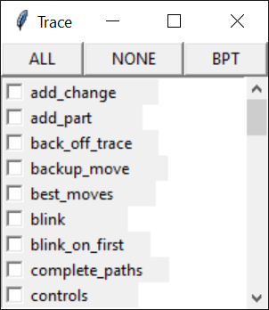
Execution Tracing Control Window

Persistence / Properties Files
Many, if not most, programs which are used often have settings that remain constant. A common solution to this problem is to use a file, sometimes called a configuration or properties file. The most widely known configuration file style is that of properties files used by the Java community. Having been unsuccessful in my 20-minute search for a Python support for properties files, and being from the Perl, do-it-your-self community, I developed a DIY support which I use. I apologize to both communities for my liberties.
The following describes my understanding and use of Properties files.
Properties file contents, aside from comments, are lines of the form:
name.name…. =value

# C:\Users\raysm\workspace\python\crs_dots\crs_dots.properties
score_control.win_y=50
game_control.running.loop_after=0
player_control.win_width=801
score_control.win_width=527
score_control.win_x=1981
…
player_control.win_y=681
player_control.1.name=Grampy
player_control.1.label=Gp
player_control.1.playing=True
…
player_control.2.name=Grammy
player_control.2.label=Gm
…
traceFlag.execute_undo_stack=1
traceFlag.full_undo_stack=1

Abbreviated dots.properties file

My properties files have the program base name, less the extension, with the extension "properties", and reside in the program's main directory. Properties files help ameliorate the difficulty of not knowing how the user desires window placement. The above file example contains, and therefor remembers, how the user sized / positioned the windows with settings of the form "control_name.win_...=value". One may have to guess the first size/placement but if the program saves the settings updated by the user, the program can preserve these in following program executions. Note that the settings of the program trace flags can also be preserved, e.g. " traceFlag.full_undo_stack=1"

Gamming

hierarchal component design

undo/redo

implementations

user vs environment moves

command/game saving/loading

Combining automatic and manual game play
In dealing with automatic play, we need to consider both plays automatically generated for/by the player via a, hopefully intelligent, algorithm and plays generated via a playback mechanism such as reading a previously recorded game result. There may be situations where we would like to change between manual, automatic (algorithm based), and playback. Consider a situation where we may be testing the automatic algorithm by first manually generating the game situation, saving the result, playing the saved state, then exercising the automatic algorithm. With an eye toward such situations we may want to consider environmental issues such as board display, user prompt messages, and undo/redo.
Developing a game without at least considering the possibility of mixed manual, automatic, and recorded operation can lead one into cumbersome programming to shoehorn one or more of these options in later. An additional issue, deserving some early thought is performance. Are there parts of the game which may need to go fast, even if the actual game display need not. For example, a chess playing game may desire to rapidly examine many moves before displaying the played position. For this reason, one might want to decouple position analysis and display. Note one may still desire the ability to display the analysis position(s) in some cases.

providing problem solving support during execution

depth or breath first attacks
In some cases one needs to do both.
For example, the Knight's tour problem provides a very computational intensive depth first attack.

Graphics / Presentation (for gaming)
Graphics and presentation provide the introduction and the continuing view in to the game. The attributes and the power of this may increase or decrease the number of users and length of usage by potential and actual audience. I separate graphics in to introduction and control such as primary window(s) and menus, action display, and analysis/logging.

Python Tkinter vs. others e.g. wxPython

Animation – small scale - highlighting

Dialog boxes - for now(model) for always(modeless)

Drawing – Canvas

coordinate transformations

Efficiency

2D homogeneous

state persistence, properties files

parameters: combining command line, property file, and dialog box

execution performance

Do / Undo
Design Patterns and more
if using Command pattern, i.e. commands are saved for undo/redo do the command objects make the changes or just reflect the changes made?
Decisions:
- Depth
- Performance
- Level of undo/redo – Multigame
- Part of the game / recorded / replayed
- user vs environment moves

Performance

Automated Tools

Ad hock

Automated play / log/ results files

Less is More

Presentation

Bugs, Issues, Futures, todo

Sudoku

car Race

Dots

Do/Undo is not working and probably needs cleaning up.
Improved Command pattern should cleanly handle Do/Undo/Repeat with optional user prompts, command files, result files.

Modifying Player Control values should immediately change the corresponding values in the Score window.

Good Knights

Notes / Staging Area

