Installation and Use of Anaconda

Anaconda is a tool to enhance the use of Python.

From [www.anaconda.com](http://www.anaconda.com):

Anaconda Distribution

With over 6 million users, the open source [Anaconda Distribution](https://www.anaconda.com/distribution/) is the fastest and easiest way to do Python and R data science and machine learning on Linux, Windows, and Mac OS X. It's the industry standard for developing, testing, and training on a single machine.

Anaconda Enterprise

[Anaconda Enterprise](https://www.anaconda.com/enterprise/) is an AI/ML enablement platform that empowers organizations to develop, govern, and automate AI/ML and data science from laptop through training to production. It lets organizations scale from individual data scientists to collaborative teams of thousands, and to go from a single server to thousands of nodes for model training

Installing Anaconda takes some time but it is worth the effort if one wants to do more that the simplest Python programming.

Installation Steps (For Windows)

1. Download Anaconda Distribution for your computer
   1. Browse to <https://www.anaconda.com>
2. Execute installation program
3. Test it

# Installing Anaconda on Windows 10

The following is my step-by-step through the process of downloading and then installing Anaconda on my Windows 10 laptop. An attempt was made to include as many screen shots as possible.



Anaconda Home Site

Click **Downloads in upper right corner.**

The following window appears.

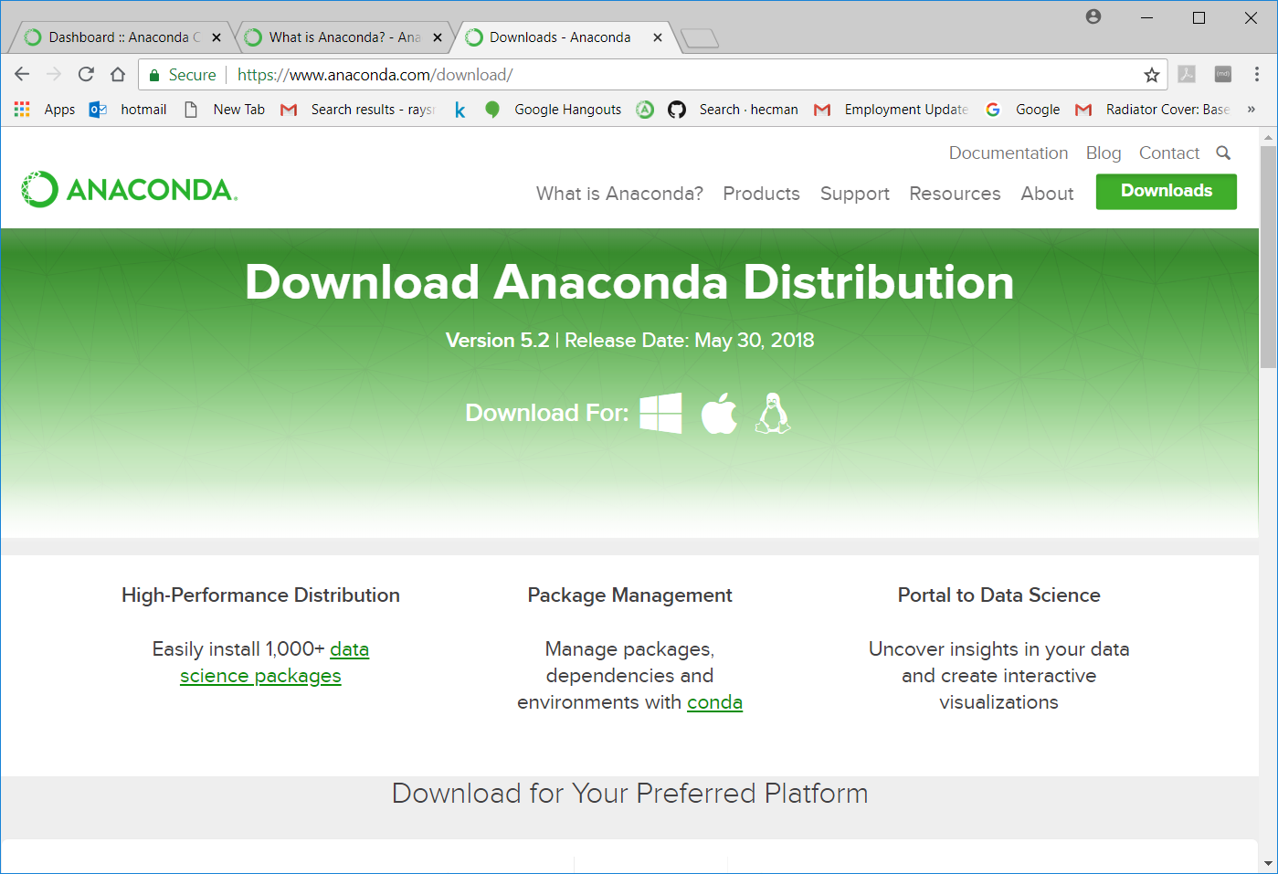

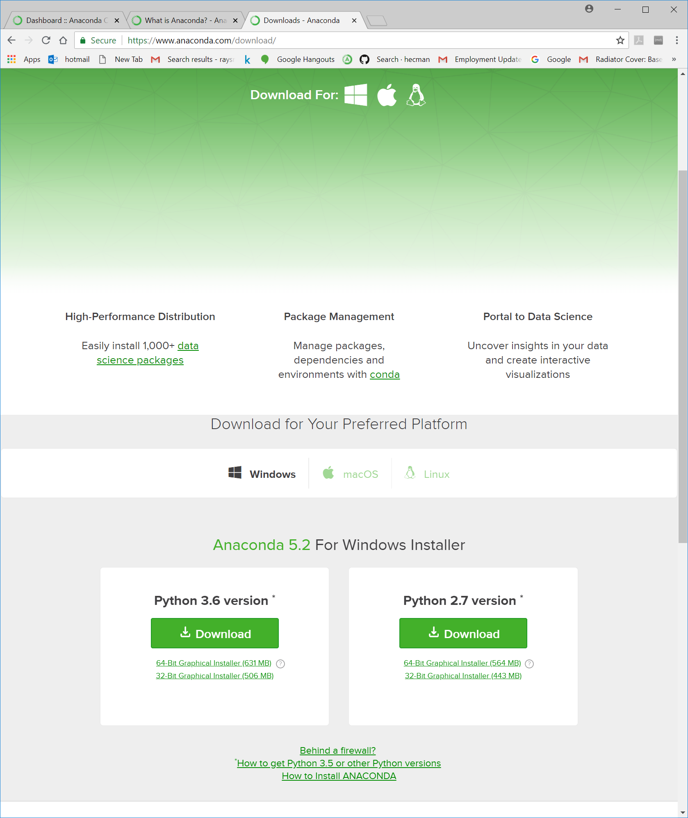

Click on **Download** button below “Python 3.6 version”

The download takes approximately 90 seconds. During the download process “Anaconda3-5.2.0…exe …left” will be displayed in the lower left corner of this window.

When the download is complete, “Anaconda3-5.2.0-…exe ” will be displayed in the lower left corner.

Start this program by a double-click on the Anaconda… text or clicking on the up arrow display just to the right and clicking “open”.

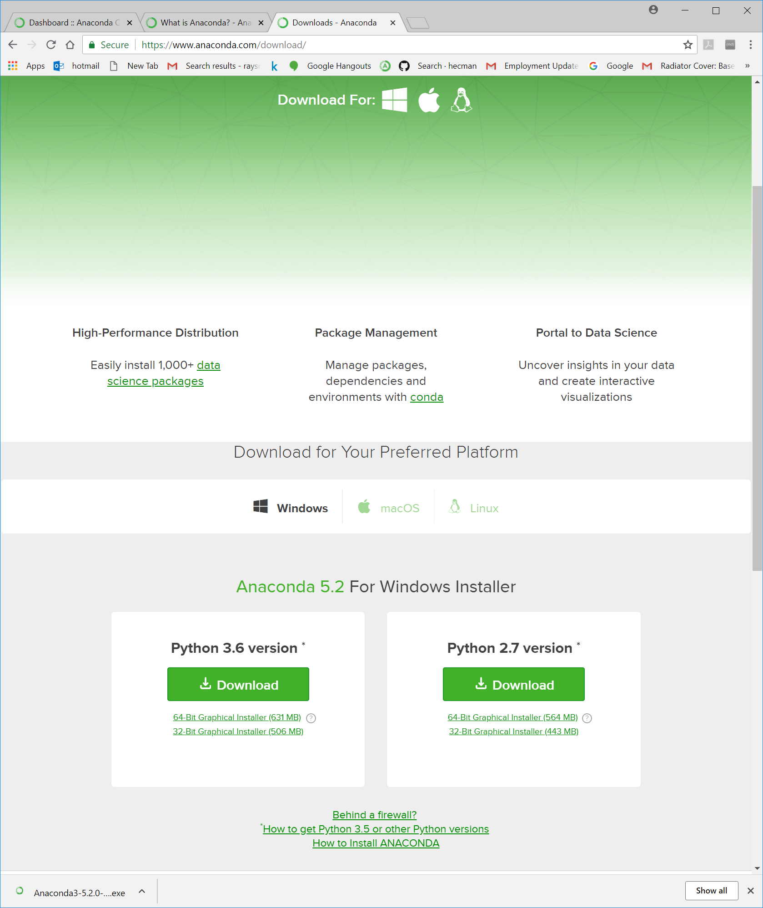

A few seconds after the double-click or clicking “open” the following dialog box will appear.

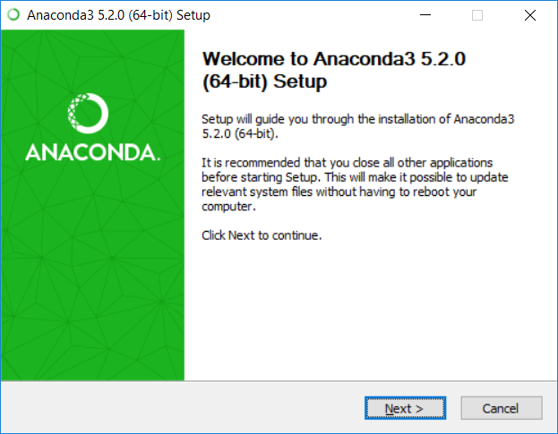

Anaconda3 Setup

Note that the downloader recognized that my machine was a 64-bit processor an used that.

Click the Next button. The following License Agreement dialog box will appear.

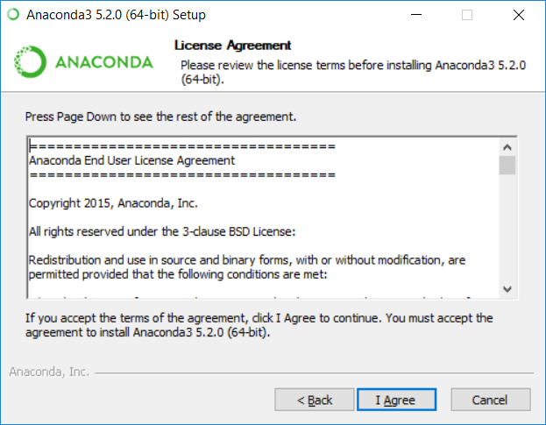

Read it if you want. Click “I Agree” if you choose to continue the setup.

The following dialog box will appear. Use the default which is set – “Just Me”. Click Next.

The following location dialog box will appear. Use the default, if OK and there is enough space. (3.0GB) If you do not have enough space, you might want to consider downloading and installing Miniconda.

Click Next. The following Advanced Installation Options dialog box will appear. Leave the defaults, and click Install.

The Installing dialog box will appear. The process make take several minutes. My installing process took approximately 14 minutes

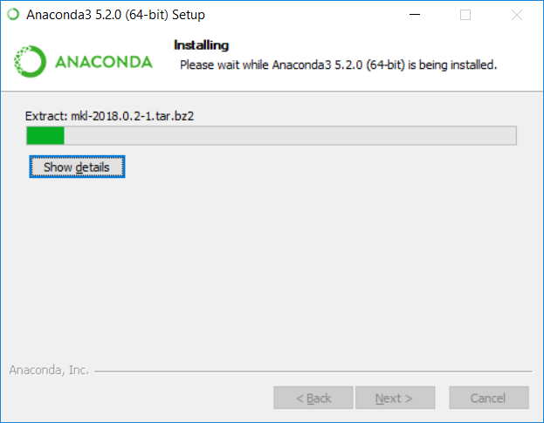

After approximately 14 minutes the following dialog box appeared.

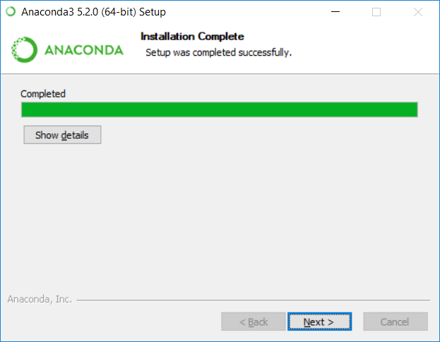

If “show details” clicked the following is displayed:

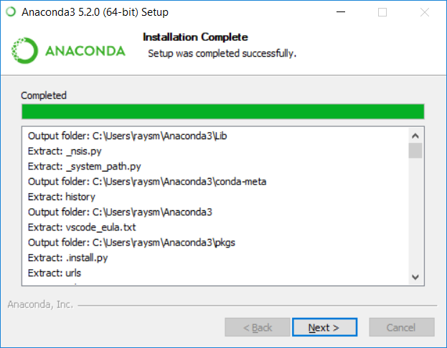

Or at the end of the scrolled display:

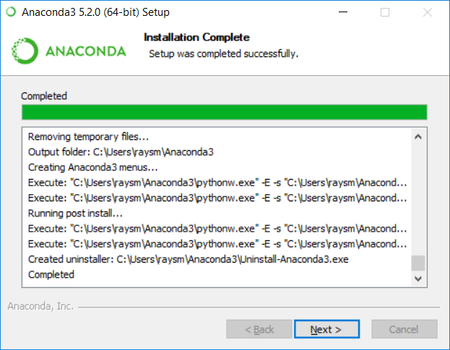

Click “Next”. The following Microsoft Visual Studio Code dialog box appears. I clicked the Install Microsoft VSCode, which is optional. You might opt to click “Skip”.

I got the following dialog box:

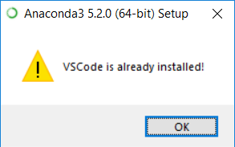

I clicked “OK”. The following dialog box is displayed.

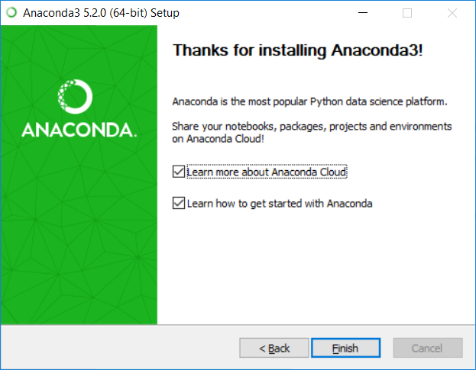

I left the informational boxes checked and clicked “Finish”. The following Window appears:

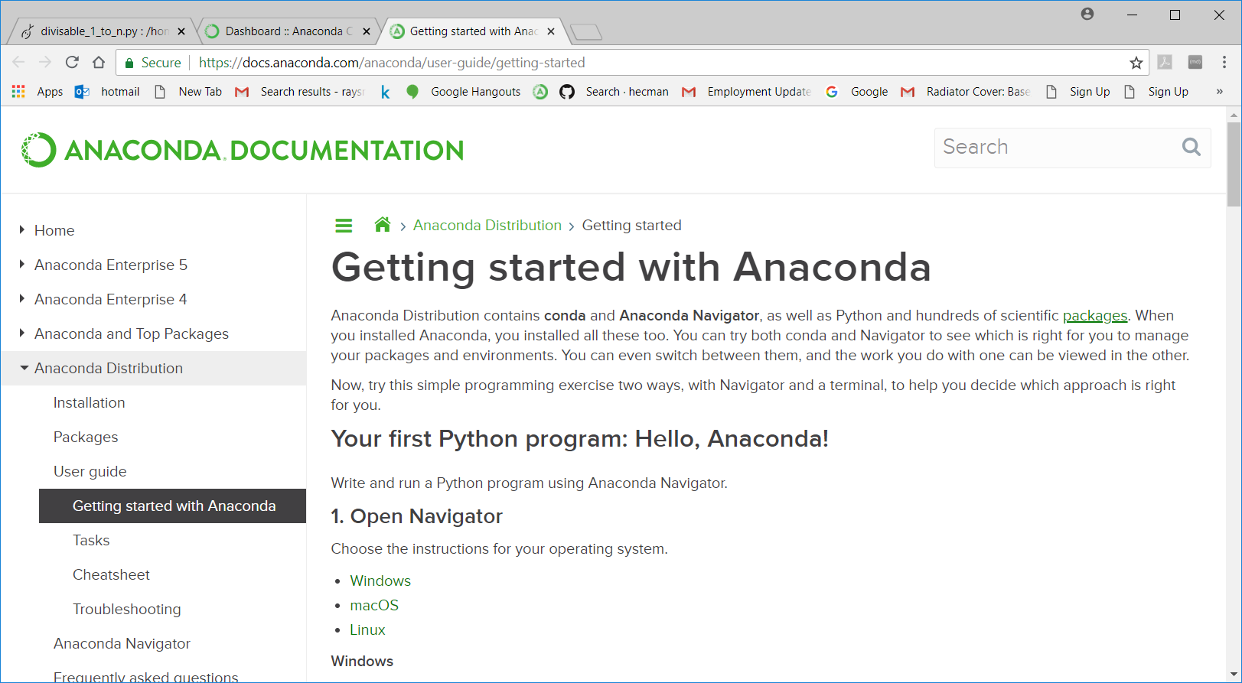

# Simple way to check Anaconda’s python.

Click Window’s “Start” button.

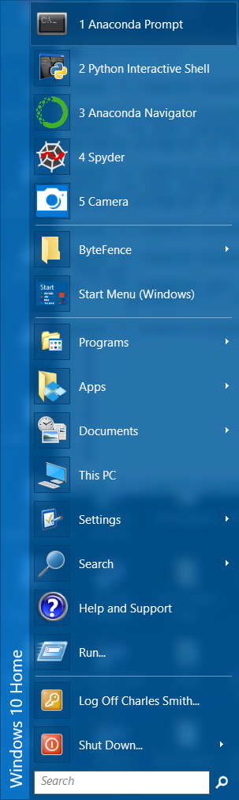

Click on “Anaconda Prompt” entry in pull-down menu. The following Anaconda-Prompt window appears.

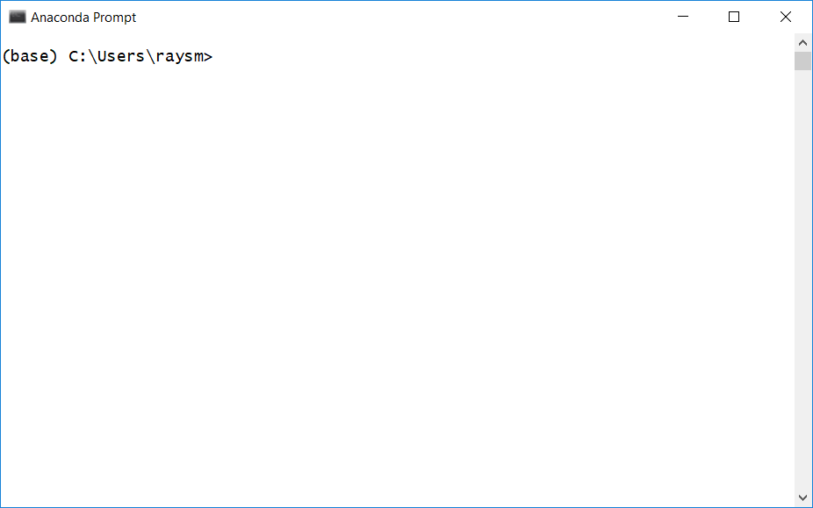

Click inside the Anaconda Prompt window. Type “python” and the press the [ENTER KEY].

Python is started and prints the basic info as below.

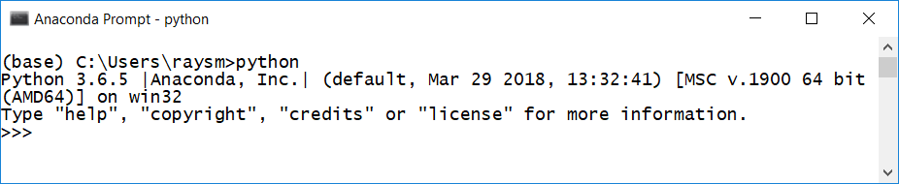

Now we’re in a interactive Python shell:

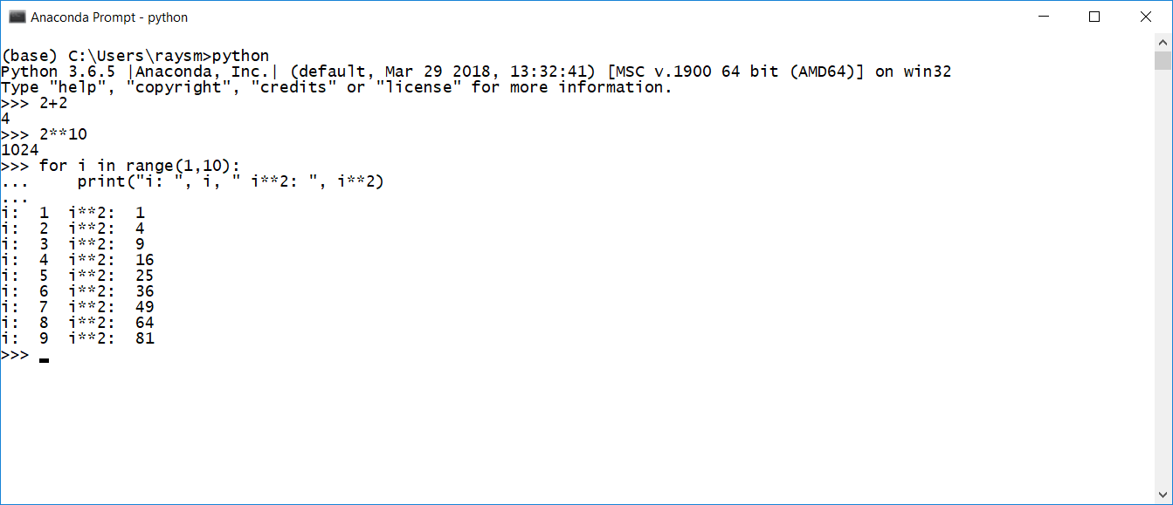

# Miniconda vs Anaconda

The difference is that miniconda is just shipping the repository management system. So when you install it there is just the management system without packages. Whereas with Anaconda, it is like a distribution with some built in packages.

Choose Anaconda if you:

* Are new to conda or Python
* Like the convenience of having Python and over 150 scientific packages automatically installed at once
* Have the time and disk space (a few minutes and 3 GB), and/or
* Don’t want to install each of the packages you want to use individually.

Choose Miniconda if you:

* Do not mind installing each of the packages you want to use individually.
* Do not have time or disk space to install over 150 packages at once, and/or
* Just want fast access to Python and the conda commands, and wish to sort out the other programs later.

1. Miniconda

|  |  |  |  |
| --- | --- | --- | --- |
|  | 1. Windows | 1. Mac OS X | 1. Linux |
| **Python 3.6** | [64-bit (exe installer)](https://repo.continuum.io/miniconda/Miniconda3-latest-Windows-x86_64.exe)   1. [32-bit (exe installer)](https://repo.continuum.io/miniconda/Miniconda3-latest-Windows-x86.exe) | [64-bit (bash installer)](https://repo.continuum.io/miniconda/Miniconda3-latest-MacOSX-x86_64.sh) | [64-bit (bash installer)](https://repo.continuum.io/miniconda/Miniconda3-latest-Linux-x86_64.sh)   1. [32-bit (bash installer)](https://repo.continuum.io/miniconda/Miniconda3-latest-Linux-x86.sh) |
| **Python 2.7** | [64-bit (exe installer)](https://repo.continuum.io/miniconda/Miniconda2-latest-Windows-x86_64.exe)   1. [32-bit (exe installer)](https://repo.continuum.io/miniconda/Miniconda2-latest-Windows-x86.exe) | [64-bit (bash installer)](https://repo.continuum.io/miniconda/Miniconda2-latest-MacOSX-x86_64.sh) | [64-bit (bash installer)](https://repo.continuum.io/miniconda/Miniconda2-latest-Linux-x86_64.sh)   1. [32-bit (bash installer)](https://repo.continuum.io/miniconda/Miniconda2-latest-Linux-x86.sh) |

[Installation instructions](https://conda.io/docs/user-guide/install/index.html)

Other resources:

* [Miniconda with Python 3.6 for Power8](https://repo.continuum.io/miniconda/Miniconda3-latest-Linux-ppc64le.sh)
* [Miniconda with Python 2.7 for Power8](https://repo.continuum.io/miniconda/Miniconda2-latest-Linux-ppc64le.sh)
* [Miniconda Docker images](https://hub.docker.com/r/conda/)
* [MD5 sums for the installers](https://repo.continuum.io/miniconda/)
* [conda change log](https://github.com/conda/conda/blob/master/CHANGELOG.md)

These Miniconda installers contain the conda package manager and Python. Once Miniconda is installed, you can use the conda command to install any other packages and create environments, etc. For example:

$ conda install numpy

...

$ conda create -n py3k anaconda python=3

...

There are two variants of the installer: Miniconda is Python 2 based and Miniconda3 is Python 3 based. Note that the choice of which Miniconda is installed only affects the root environment. Regardless of which version of Miniconda you install, you can still install both Python 2.x and Python 3.x environments.

The other difference is that the Python 3 version of Miniconda will default to Python 3 when creating new environments and building packages. So for instance, the behavior of

$ conda create -n myenv python

will be to install Python 2.7 with the Python 2 Miniconda and to install Python 3.6 with the Python 3 Miniconda. You can override the default by explicitly setting python=2 or python=3. It also determines the default value of CONDA_PY when using conda build.

**Note**: If you already have Miniconda or Anaconda installed, and you just want to upgrade, you should not use the installer. Just use conda update. For instance

$ conda update conda