Installation and Use of PyPy

PyPy fast tool which works like Python.

From:

http://pypy.org/download.html#installing

[Subscribe to the RSS Feed](http://feeds.feedburner.com/PyPyStatusBlog)

[](http://pypy.org/)

[Home](http://pypy.org/index.html) | [What is PyPy?](http://pypy.org/features.html) | [Download](http://pypy.org/download.html) | [Compatibility](http://pypy.org/compat.html) | [Performance](http://pypy.org/performance.html) | [Dev Documentation](http://doc.pypy.org/) | [Blog](http://morepypy.blogspot.com/) | [People](http://pypy.org/people.html) | [Contact](http://pypy.org/contact.html)

* **Download and install**
* There are [nightly binary builds](http://buildbot.pypy.org/nightly/trunk/) available. Those builds are not always as stable as the release, but they contain numerous bugfixes and performance improvements.

We provide binaries for x86, ARM, PPC and s390x running on different operating systems such as Linux, Mac OS X and Windows:

* the Python2.7 compatible release — **PyPy2.7 v6.0** — ([what's new in PyPy2.7?](http://doc.pypy.org/en/latest/release-v6.0.0.html))
* the Python3.5 compatible release — **PyPy3.5 v6.0** — ([what's new in PyPy3.5?](http://doc.pypy.org/en/latest/release-v6.0.0.html)).
* the Python2.7 Software Transactional Memory special release — **PyPy-STM 2.5.1** (Linux x86-64 only)
* Download
  + [Default (with a JIT Compiler)](http://pypy.org/download.html#default-with-a-jit-compiler)
  + [Other versions](http://pypy.org/download.html#other-versions)
* [Installing](http://pypy.org/download.html#installing) (optional)
* [Installing more modules](http://pypy.org/download.html#installing-more-modules)
* [Installing NumPy](http://pypy.org/download.html#installing-numpy) (optional)
* [Building from source](http://pypy.org/download.html#building-from-source)
* [Packaging](http://pypy.org/download.html#packaging)
* [Checksums](http://pypy.org/download.html#checksums)
* **“JIT Compiler” version**

These binaries include a Just-in-Time compiler. They only work on x86 CPUs that have the [SSE2](http://en.wikipedia.org/wiki/SSE2) instruction set (most of them do, nowadays), or on x86-64 CPUs. They also contain [stackless](http://www.stackless.com/) extensions, like [greenlets](http://pypy.readthedocs.org/en/latest/stackless.html" \l "greenlets).

* **Linux binaries and common distributions**

Linux binaries are dynamically linked, as is usual, and thus might not be usable due to the sad story of linux binary compatibility. This means that **Linux binaries are only usable on the distributions written next to them** unless you're ready to hack your system by adding symlinks to the libraries it tries to open. There are better solutions:

* use Squeaky's [portable Linux binaries](https://github.com/squeaky-pl/portable-pypy#portable-pypy-distribution-for-linux).
* or download PyPy from your release vendor (usually an outdated version): [Ubuntu](http://packages.ubuntu.com/search?keywords=pypy&searchon=names) ([PPA](https://launchpad.net/~pypy/+archive/ppa)), [Debian](http://packages.debian.org/sid/pypy), [Homebrew](https://github.com/Homebrew/homebrew-core/blob/master/Formula/pypy.rb), MacPorts,[Fedora](http://fedoraproject.org/wiki/Features/PyPyStack), [Gentoo](http://packages.gentoo.org/package/dev-python/pypy) and [Arch](https://wiki.archlinux.org/index.php/PyPy) are known to package PyPy, with various degrees of being up-to-date.
* or [translate](http://pypy.org/download.html#translate) your own PyPy.
* **Python2.7 compatible PyPy 6.0.0**
* [Linux x86 binary (32bit, built on Ubuntu 12.04 - 16.04)](https://bitbucket.org/pypy/pypy/downloads/pypy2-v6.0.0-linux32.tar.bz2) (see [1] below)
* [Linux x86-64 binary (64bit, built on Ubuntu 12.04 - 16.04)](https://bitbucket.org/pypy/pypy/downloads/pypy2-v6.0.0-linux64.tar.bz2) (see [1] below)
* [ARM Hardfloat Linux binary (ARMHF/gnueabihf, Raspbian)](https://bitbucket.org/pypy/pypy/downloads/pypy2-v6.0.0-linux-armhf-raspbian.tar.bz2) (see [1] below)
* [ARM Hardfloat Linux binary (ARMHF/gnueabihf, Ubuntu Raring)](https://bitbucket.org/pypy/pypy/downloads/pypy2-v6.0.0-linux-armel.tar.bz2) (see [1] below)
* [Mac OS X binary (64bit)](https://bitbucket.org/pypy/pypy/downloads/pypy2-v6.0.0-osx64.tar.bz2)
* FreeBSD x86 and x86_64: see [FreshPorts](http://www.freshports.org/lang/pypy)
* [Windows binary (32bit)](https://bitbucket.org/pypy/pypy/downloads/pypy2-v6.0.0-win32.zip) (you might need the VS 2008 runtime library installer [vcredist_x86.exe](http://www.microsoft.com/en-us/download/details.aspx?id=5582).)
* [PowerPC PPC64 Linux binary (64bit big-endian, Fedora 20)](https://bitbucket.org/pypy/pypy/downloads/pypy2-v5.10.0-ppc64.tar.bz2) (see [1] below)
* [PowerPC PPC64le Linux binary (64bit little-endian, Fedora 21)](https://bitbucket.org/pypy/pypy/downloads/pypy2-v5.10.0-ppc64le.tar.bz2) (see [1] below)
* [s390x Linux binary (built on Redhat Linux 7.2)](https://bitbucket.org/pypy/pypy/downloads/pypy2-v6.0.0-s390x.tar.bz2) (see [1] below)
* [Source (tar.bz2)](https://bitbucket.org/pypy/pypy/downloads/pypy2-v6.0.0-src.tar.bz2); [Source (zip)](https://bitbucket.org/pypy/pypy/downloads/pypy2-v6.0.0-src.zip). See below for more about the sources.
* [All our downloads,](https://bitbucket.org/pypy/pypy/downloads) including previous versions. We also have a [mirror](http://buildbot.pypy.org/mirror/), but please use only if you have troubles accessing the links above
* **Python 3.5.3 compatible PyPy3.5 v6.0.0**
* [Linux x86 binary (32bit, built on Ubuntu 12.04 - 16.04)](https://bitbucket.org/pypy/pypy/downloads/pypy3-v6.0.0-linux32.tar.bz2) (see [1] below)
* [Linux x86-64 binary (64bit, built on Ubuntu 12.04 - 16.04)](https://bitbucket.org/pypy/pypy/downloads/pypy3-v6.0.0-linux64.tar.bz2) (see [1] below)
* [ARM Hardfloat Linux binary (ARMHF/gnueabihf, Raspbian)](https://bitbucket.org/pypy/pypy/downloads/pypy3-v6.0.0-linux-armhf-raspbian.tar.bz2) (see [1] below)
* [ARM Softfloat Linux binary (ARMEL/gnueabi, Ubuntu Raring)](https://bitbucket.org/pypy/pypy/downloads/pypy3-v6.0.0-linux-armel.tar.bz2) (see [1] below)
* [Mac OS X binary (64bit)](https://bitbucket.org/pypy/pypy/downloads/pypy3-v6.0.0-osx64.tar.bz2) (High Sierra, not for Sierra and below)
* [Windows binary (32bit)](https://bitbucket.org/pypy/pypy/downloads/pypy3-v6.0.0-win32.zip) **BETA**
* [s390x Linux binary (built on Redhat Linux 7.2)](https://bitbucket.org/pypy/pypy/downloads/pypy3-v6.0.0-s390x.tar.bz2) (see [1] below)
* [Source (tar.bz2)](https://bitbucket.org/pypy/pypy/downloads/pypy3-v6.0.0-src.tar.bz2); [Source (zip)](https://bitbucket.org/pypy/pypy/downloads/pypy3-v6.0.0-src.zip). See below for more about the sources.
* [All our downloads,](https://bitbucket.org/pypy/pypy/downloads) including previous versions. We also have a [mirror](http://buildbot.pypy.org/mirror/), but please use only if you have troubles accessing the links above

# From Python 3.5.3 compatible PyPy3.5 v6.0.0, We used Windows binary (32 bit) by clicking “Windows binary (32bit)”

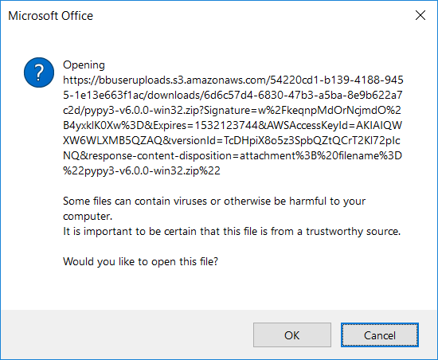

We clicked “OK”

After a few seconds we “pypy3-v6.0.0-win32.zip” appears in the lower left corner of the pypy window.

Click the “pypy3-….”

The following explorer window appears:

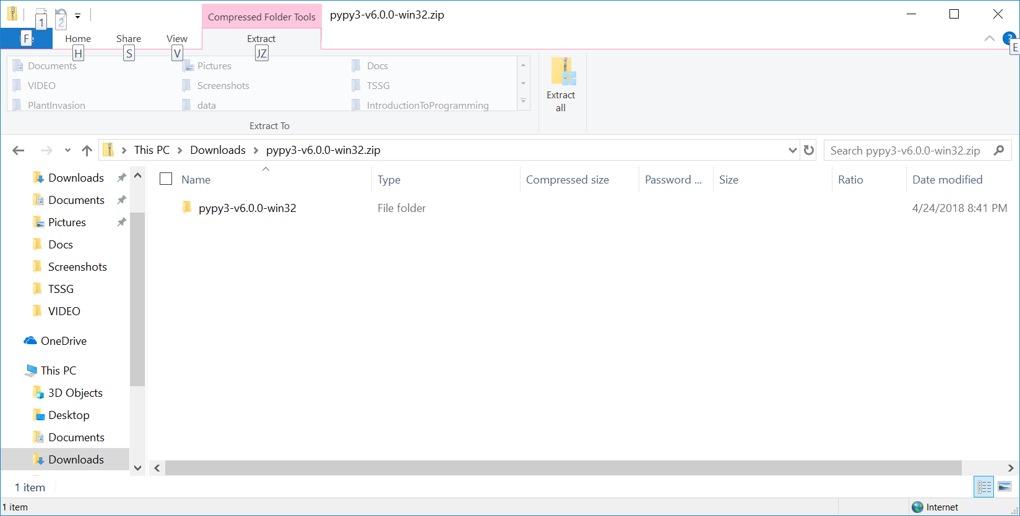

Click “Downloads” in directory line giving:

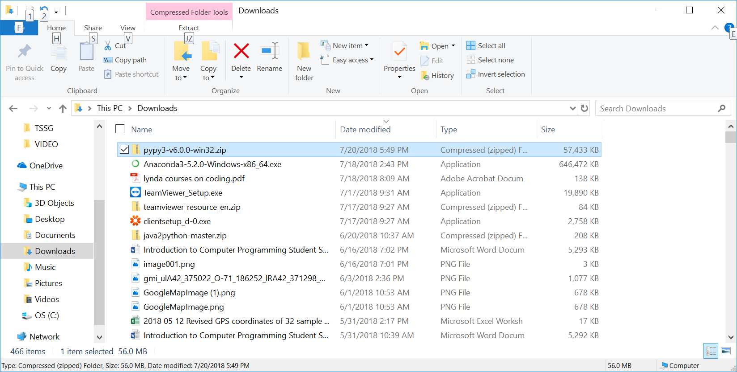

Right lick “pypy3-…” entry: and select “Extract All” from pull-down”

Giving:

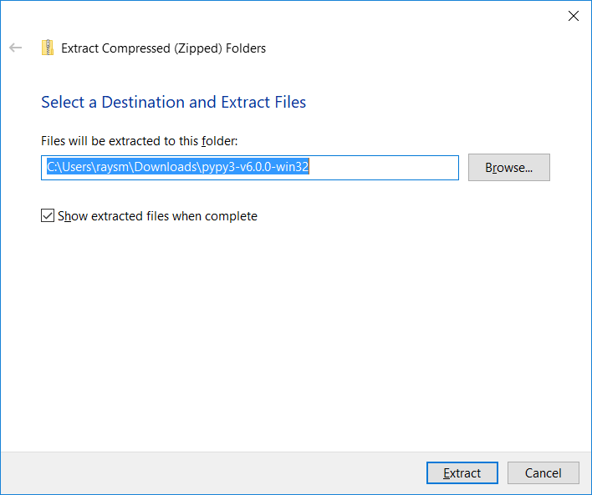

Edit Destination folder from something like “c:\Users\yourfolder\Downloads\pypy3-v6.0.0-win32” to a place for you:

“c:\Users\yourfolder\pypy3-v6.0.0-win32”

Then click “Extract”.

We see:

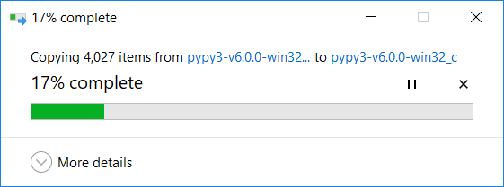

Place pypy executables in path.

Start 🡪Settings🡪Control Panel

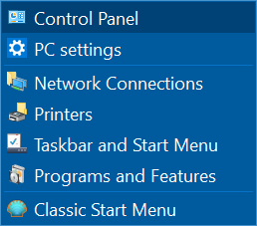

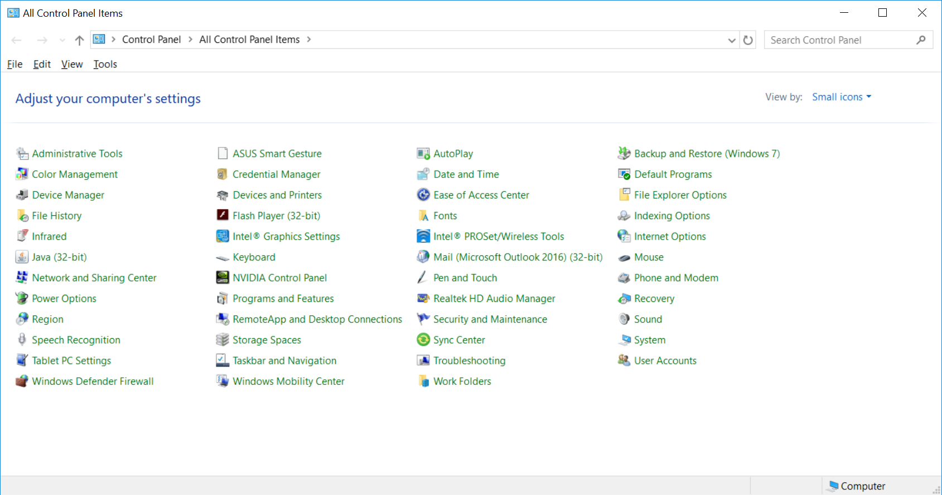

Click “System”

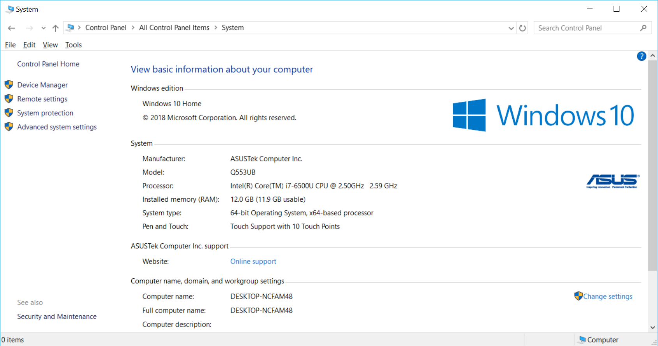

Click “Advanced system settings” in middle left.

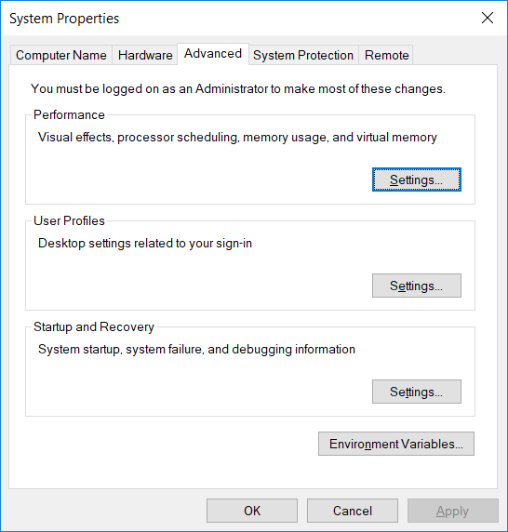

Click “Environment Variables” in lower right.

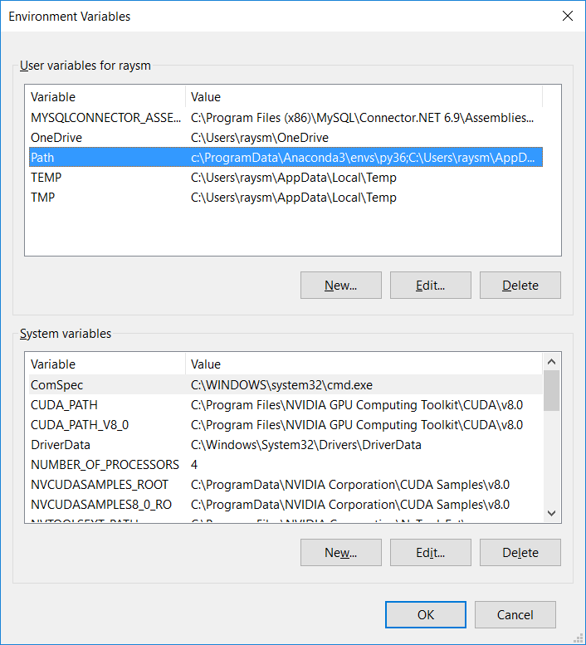

Select “Path” in User variables for *you*

Click “Edit”

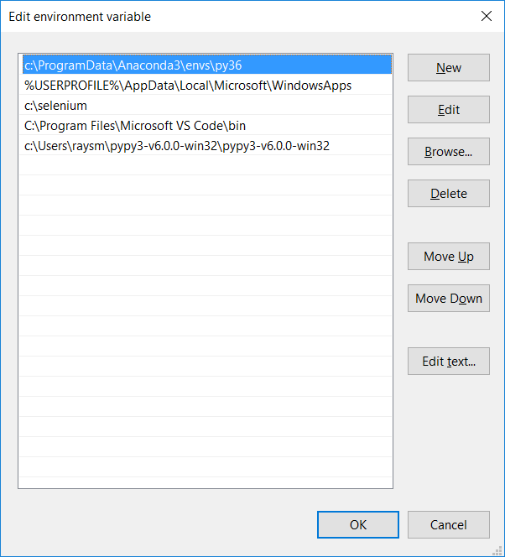

Click “New” to add new path section.

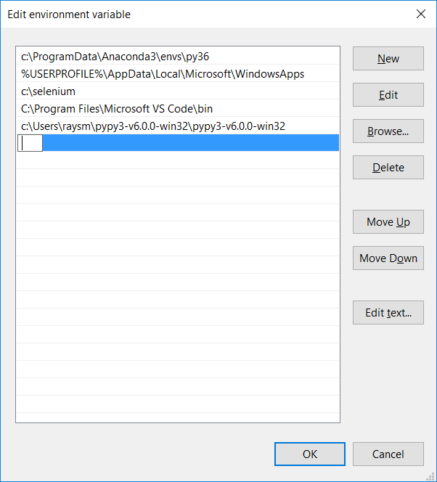

Add the directory in to which you extracted the pypy files, e.g.

c:\Users\your_home_dir\pypy3-v6.0.0-win32\pypy3-v6.0.0-win32

Then click “OK”.

Test the installation by opening a command shell, e.g. Run “cmd”, and typing “pypy3”:

