I would be interested in doing pilot course with the following format:

* The course would be modeled after my adult course:  "Introduction to Programming using Python"
* Each child student would be paired with an active adult participant, preferably from their family.
* The course would be 7-10 sessions in length
* The sessions would be held 1-2 per week.
* Each session would be approximately 1 hour long
* Depending on number of students and accommodations available the course may be online.

Course Goals

* Provide each student with an understanding of what computer programming is.
* Provide a beginning knowledge of the Python programming language
* Topics
  + Programming as a tool
  + Computation / Arithmetic
  + Graphics / Turtle

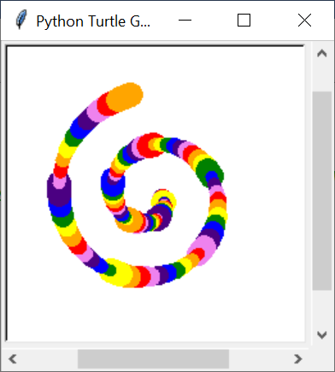

* + Values / Variables
    - Numeric values: integer, floating point
    - Character Strings
    - Lists / Arrays
  + Control Flow
    - If – else
    - Looping
    - Functions
  + Program writing
    - Creating
    - Running
    - Changing