Turtle Braille User Setup

Introduction
With this document we aid the user and or their technical supporting personnel to setup and use the software we use to teach blind students about programming. The primary software components we use are:
- Python – reasonably recent version downloaded from www.python.org
- Visual Studio Code (vscode) – free version
- Some screen reader (JAWS, NVDIA) for each student
- Teaching slides, examples, and Turtle Braille Graphics, our “home grown” Graphics aid via a folder of software plus examples – freely available from me
Our software enhances the user’s “viewing” experience by adding extended graphics views to programs containing turtle statements. An extended graphics view provides an additional user sense to the standard turtle display. While not explicitly necessary for learning, we hope the students will avail themselves of this software to enhance the graphical experience where appropriate.

Setup
This is a detailed setup description which may require technical / administrative help. Where possible installations should be user based (NOT System/Administrator).

Python
Install python for your machine from www.python.org. Latest / recent python should be fine.

Visual Studio Code (vscode)
Install vscode for your machine from https://code.visualstudio.com/download
Installed extensions
Excerpt from: https://marketplace.visualstudio.com/items?itemName=ms-python.python
The Python extension will automatically install the following extensions by default to provide the best Python development experience in VS Code:
- Pylance - to provide performant Python language support
- Python Debugger - to provide a seamless debug experience with debugpy
These extensions are optional dependencies, meaning the Python extension will remain fully functional if they fail to be installed. Any or all of these extensions can be disabled or uninstalled at the expense of some features. Extensions installed through the marketplace are subject to the Marketplace Terms of Use.

Screen Reader
If the student has no screen reader, a free version is available from https://www.nvaccess.org/download/
With the use of a screen reader, vscode plus proper plugins, the blind student can navigate python programming.

Course Presentations, Examples, software

Presentations, Examples
Extract all files from zipped folder intro_2024b attachment, creating a folder named intro_2024b on the student’s computer Desktop folder.

Turtle Braille Software

Install Presentations folder (see A above)

Install Visual Studio Code(VSCODE) (See 2 above)

From inside vscode, open python file: Desktop\intro_2024b\ run_setup_Turtle_braille.py. Run this file.

During the setup program run, use default answers(just press ENTER)

At end of setup run, default to Computer REBOOT

The software setup can be tested, from inside VSCODE, by running the python program: Desktop\intro_2024b\wx_square_colors.py

Output from setup program (Your output will differ a bit):
PS C:\Users\raysm\vscode\resource_lib\src> & c:/Users/raysm/vscode/resource_lib/src/.venv/Scripts/python.exe c:/Users/Owner/OneDrive/Desktop/intro_2024b/run_setup_turtle_braille.py
setup_pgm: setup_turtle_braille.py
Select Turtle Braille Base
1 - distribution: C:\Users\raysm\vscode\resource_lib\src
2 - current setting: c:/Users/raysm/vscode/resource_lib/src
... - full directory path anything else
[1]:
prev_path: C:\Users\raysm\vscode\resource_lib\src
c:\Users\raysm\vscode\resource_lib\src
New Path: C:\Users\raysm\vscode\resource_lib\src
c:\Users\raysm\vscode\resource_lib\src
Setup will NOT be complete until Computer REBOOT
Reboot Now?[Y]

Screen Shot:
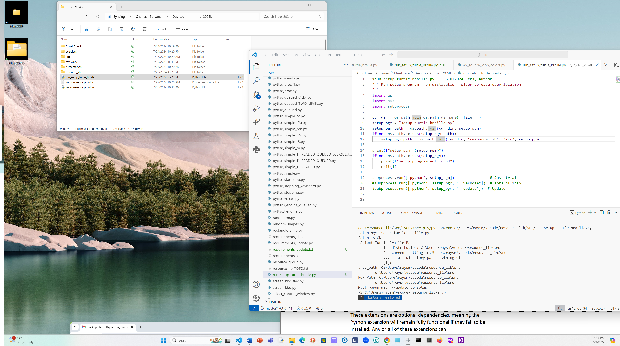
Test program Screen shot:
