GRAPHICS FOR THE BLIND
Goal:
Our goal is to help beginning programming students, who are blind, “see” simple pictures that we often easily present to sighted students.
- Beginners, sighted or not, are often computer savvy but not programming savvy.
- Examples may be useful but are often too abstract to sustain the beginner’s attention and interest. We use pictures.
Project Objective
Provide a free mechanism to aid the blind programming student to experience graphics in a more fulfilling way. In the future, we hope to generalize these ideas with the hope of improving access to graphics for more blind computer users.
Target Audience
Those with an interest and desire in using technology, particularly computer software and hardware to help the blind. These include engineers, blind students, their educators, and educators in general.
Presentation Goals
Demonstrate our tool by which a blind programmer can “see” simple graphics. Show, in a general way, the ideas behind our work. Provide a high-level view of the issues encountered and addressed.
Hopes for the Audience
Our demonstration will serve as proof of concept and inspire the audience to further explore our work. With that, we hope to gain support for improvement and subsequently distribution and use of our tool.

How I Got Here:
For years, I have been introducing computer programming to the novice. I am always searching for better examples to catch and maintain their interest and attention. I landed on the idea of using simple programs to create simple figures such as squares or circles. We start with a short computer program, of 8 to12 lines in length. This displays a multicolored square. Then we make a small program change and see what happens. This works nicely – for the sighted. But what about the blind? I developed a programming tool which enables the blind programmer to feel this simple figure. I plan to offer more details and encourage the audience to participate in improving and sharing this tool with a broader community.
Samples
For the sighted - screen shot containing the following two “windows”:
A: Program to display a square. B. Square displayed 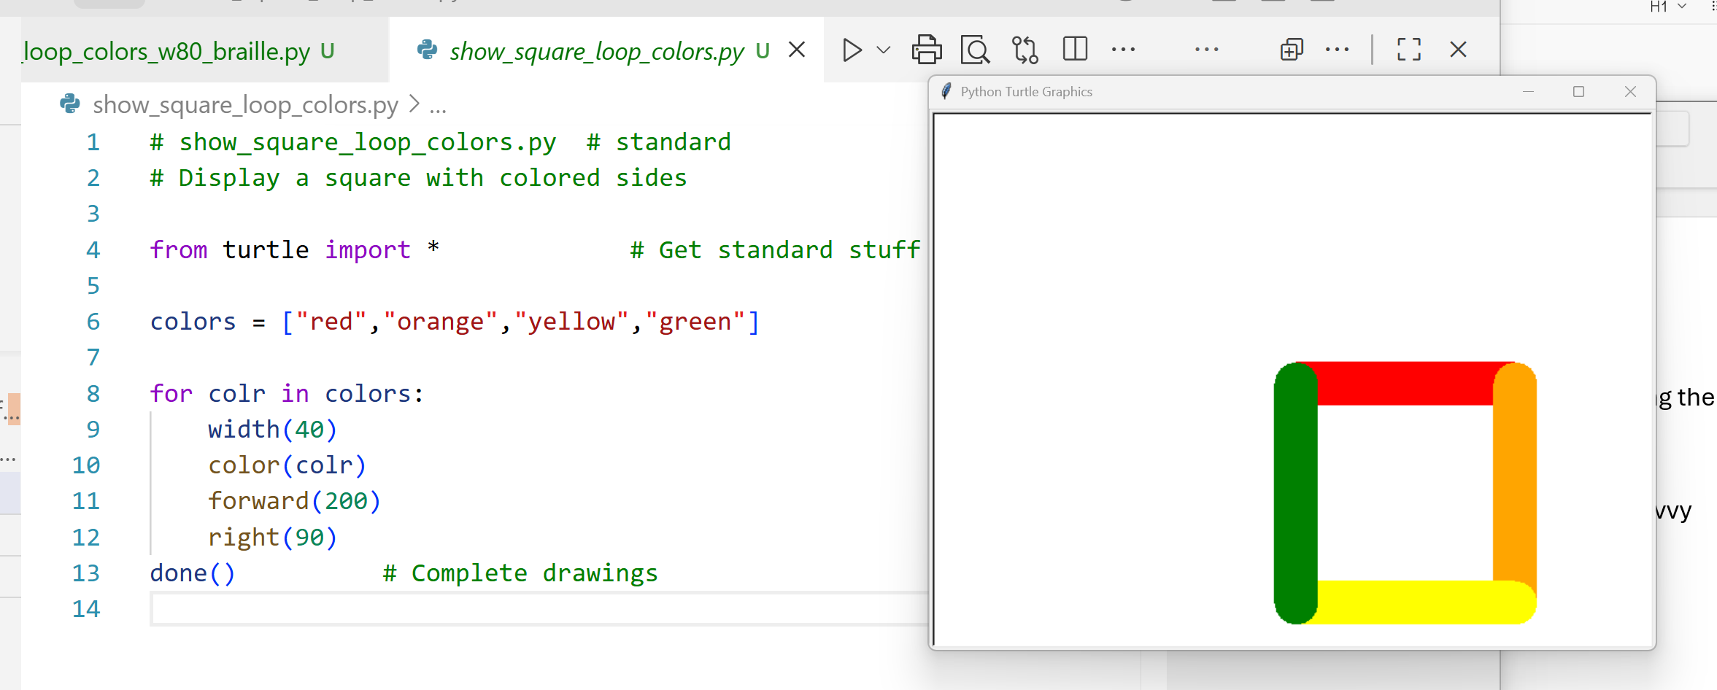
For the blind - screen shot containing the following four “windows”:
A: Program to display square D: Text created for Braille printer
B: Depiction of Braille created C: Square displayed
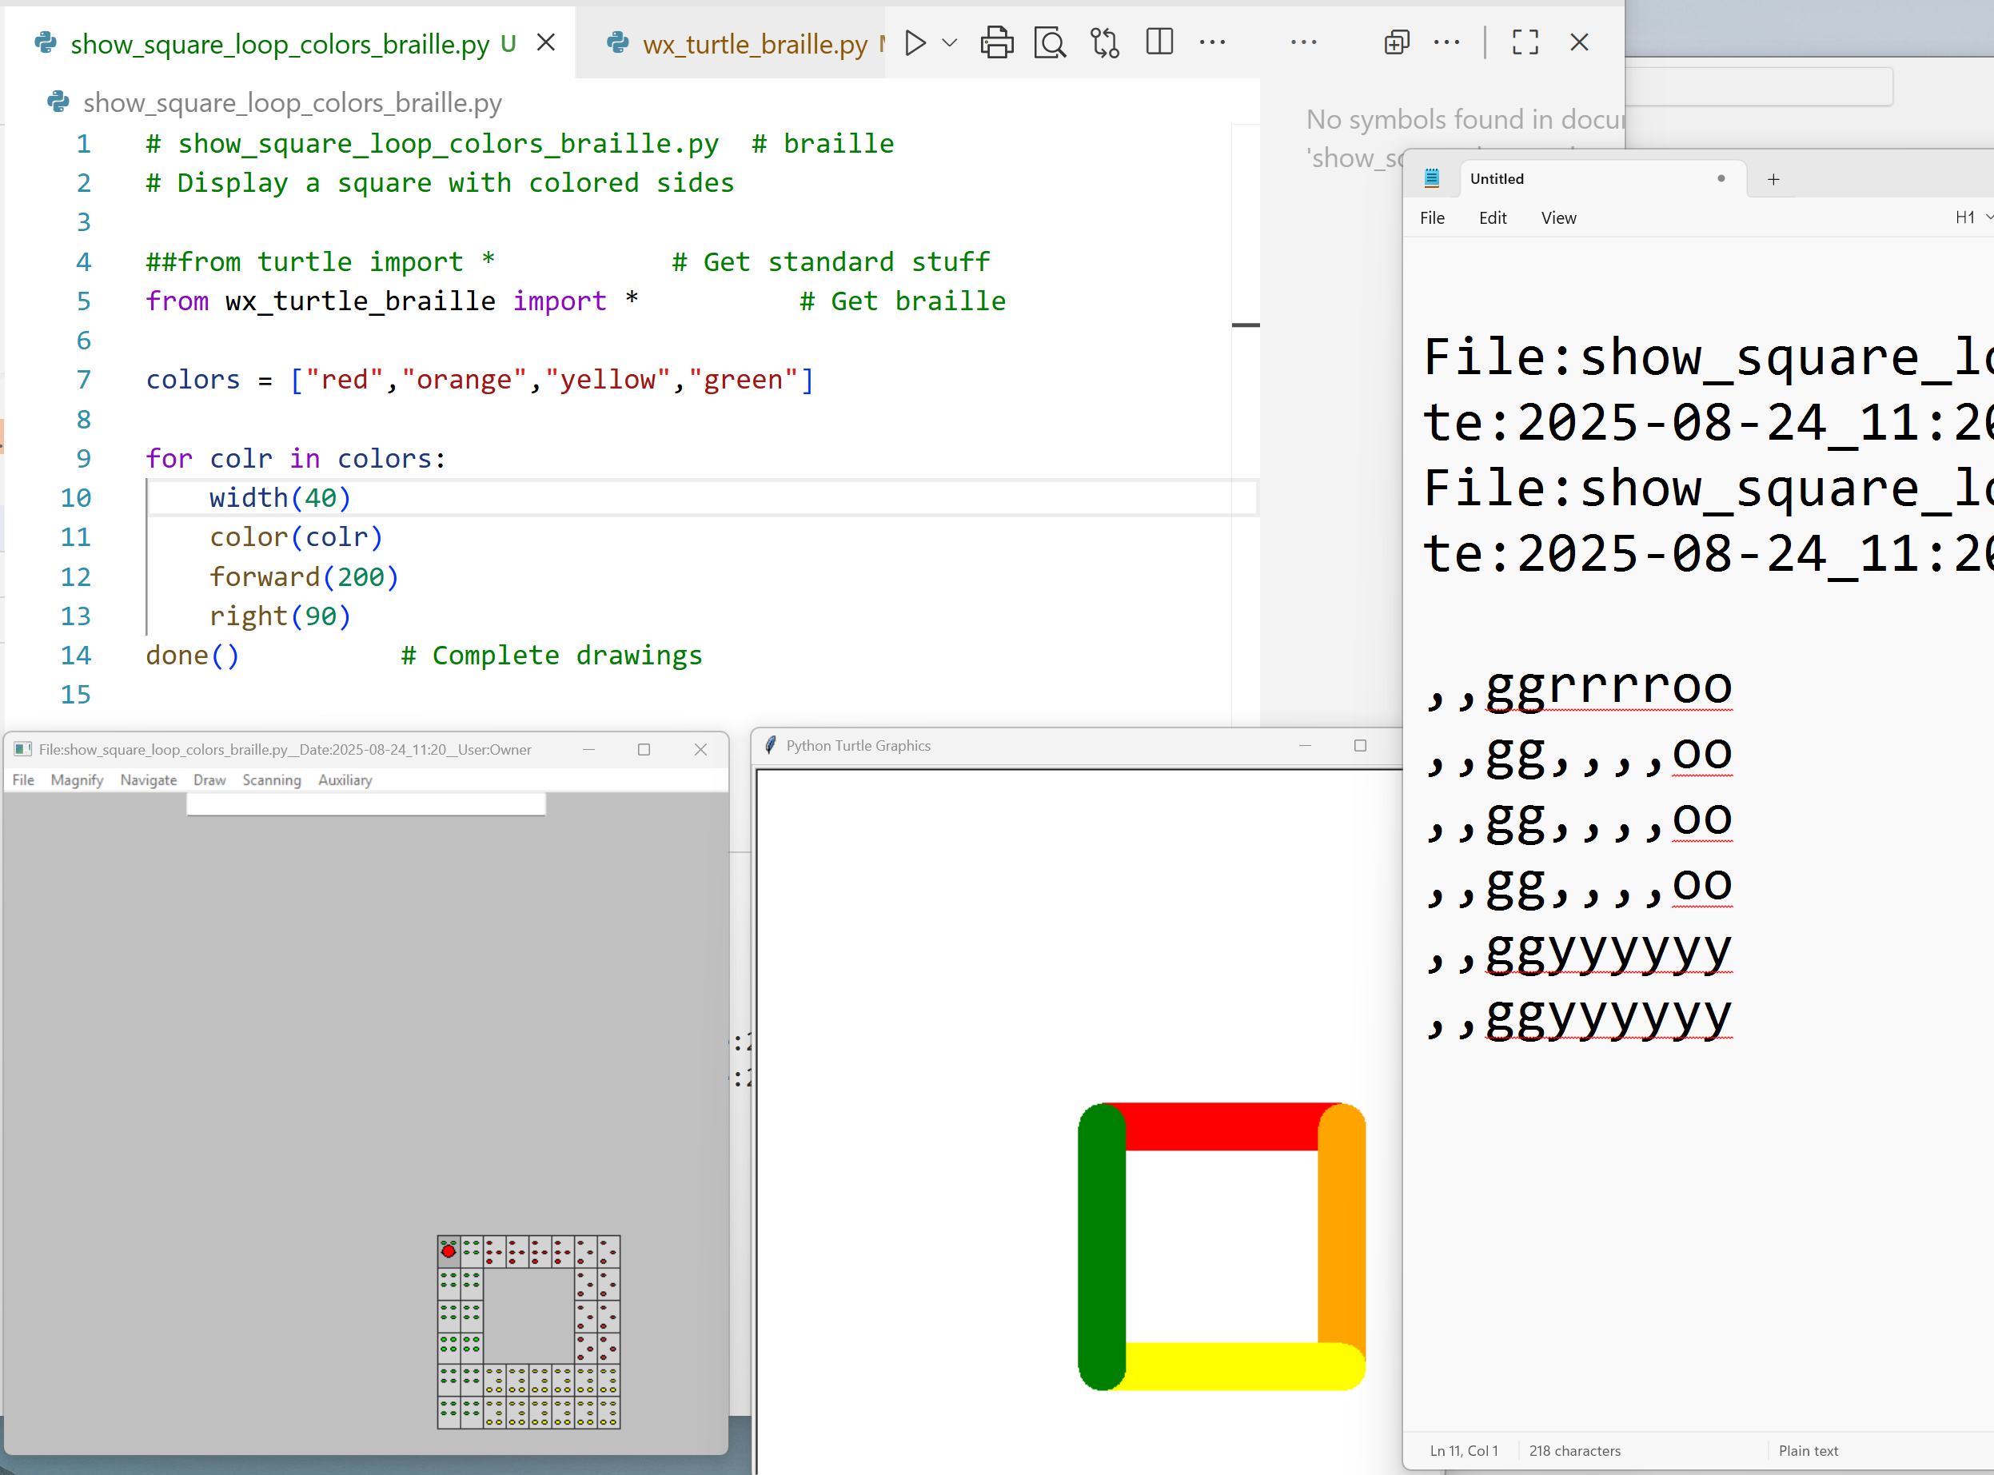
The above version for the blind, with the program adjusted for the blind (A), provides the output as seen by the sighted (C) plus the following additional outputs:
B: The depiction of the figure’s Braille rendering.
D: The text “map” which, when sent to a Braille printer, creates a touchable rendition of the figure.

How can you help?
Testing: This tool needs people to do testing.
Advertising: We hope to get people interested in publicizing this tool and get more users. The best testers will be potential clients – the blind and those who teach the blind.
Engineering: We could use people interested in exploring the tool and suggesting or creating improvements.
Research: This tool could be a great market for an affordable large scale (100 by 100 character) refreshable braille display. Other types of displays with tactile feedback might be useful.

Questions: send to Ray Smith at raysmith@alum.mit.edu or 617-816-8170.

