https://www.newhaptics.com/news
NewHaptics demonstrates its first multiline braille display prototype at University of Michigan's Celebrate Invention 2022
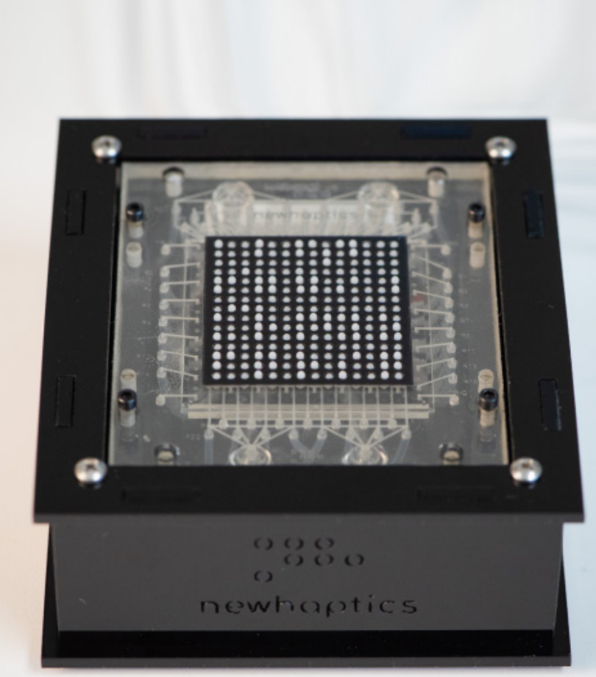

www.sigchi.org
https://www.youtube.com/watch?v=9RruzAYB2sg
https://www.youtube.com/watch?v=BXi1tG78AW4
Electromechanical Refreshable Braille Module : HackadayPrize 2023

Dot Pad X: Multi-Line Braille & Tactile Graphics: Accessibility for the Blind and Visually Impaired
https://www.youtube.com/watch?v=REdE8SDoOJI

133,635 views Oct 10, 2023 #HackadayPrize #braille #assistivetechnology
Source & Design files: https://hackaday.io/project/191181-el... Like the project? buy me a coffee!☕: https://www.buymeacoffee.com/vjvarada

