2-Dimensional Race Track

An Example in Coordinate Transformation

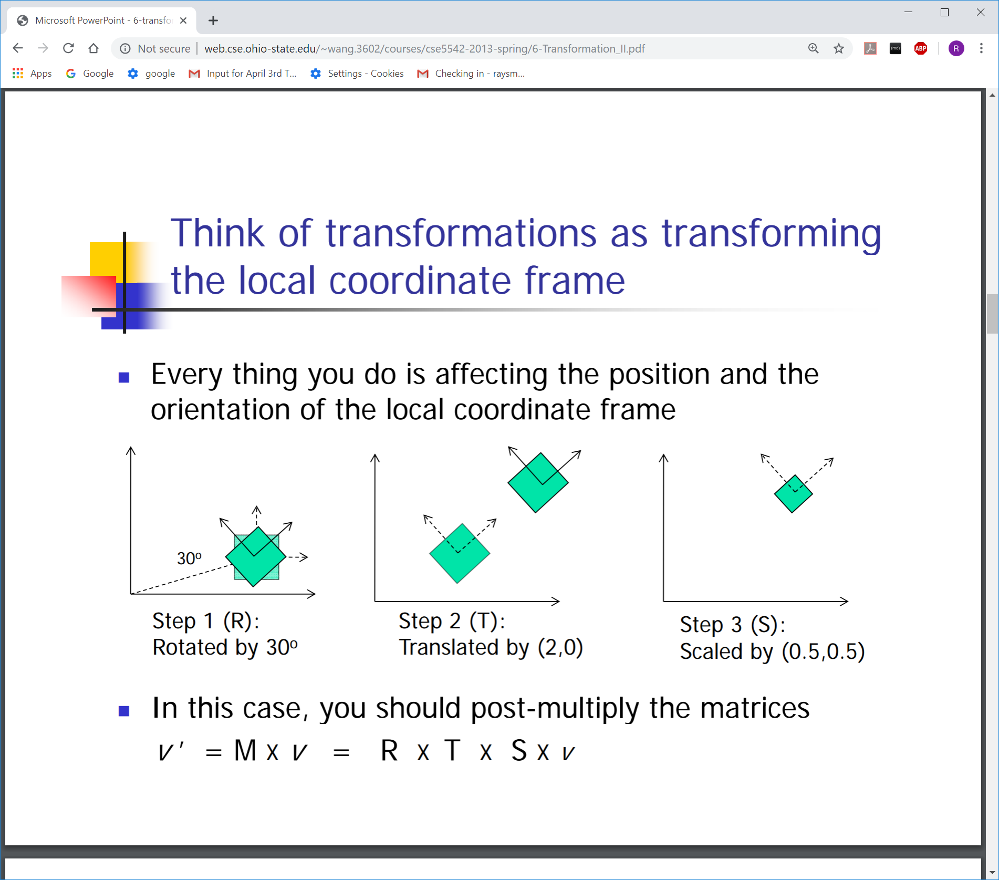

Local

<http://web.cse.ohio-state.edu/~wang.3602/courses/cse5542-2013-spring/6-Transformation_II.pdf>

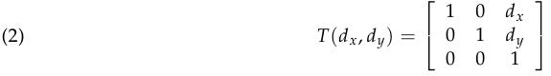

Scaling, multiplying each *x* value by *sx*, and multiplying each *y* value by *sy*:

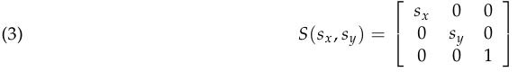

Rotation by an angle θ:

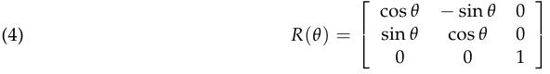

References:

2D coordinate transformations:

<http://graphics.cs.cmu.edu/nsp/course/15-462/Spring04/slides/04-transform.pdf>

Coordinates and

Transformations

MIT ECCS 6.837

Wojciech Matusik

many slides follow Steven Gortler’s book

<https://ocw.mit.edu/courses/electrical-engineering-and-computer-science/6-837-computer-graphics-fall-2012/lecture-notes/MIT6_837F12_Lec03.pdf>

Geometric Transformation CS 211A CS 21

<https://www.ics.uci.edu/~majumder/VC/new-lectures/geom.pdf>

CMSC427

Transformations

<https://www.cs.umd.edu/~reastman/slides/L05P1Transformations.pdf>