Udemy Link

[SQL for Beginners: Learn SQL using MySQL and Database Design](https://cognizant.udemy.com/course/sql-for-beginners-course/learn/lecture/8435392#overview)

Handson

DDL Commands - Create, DML Commands - Insert, Select with and without Where condition

Execute the attached script in MySQL Workbench to create Alumni Management System schema.



Refer the ER diagram.

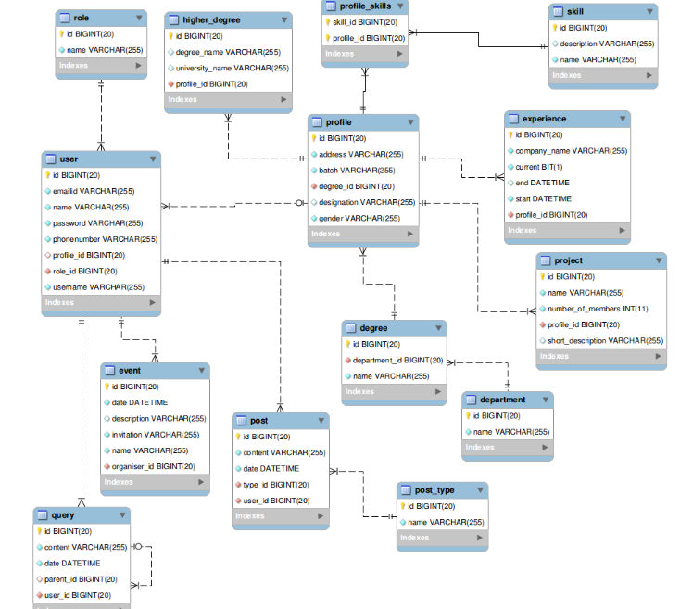

**Write queries for the following DML operations  --- Insert, Update and Delete.**

Insert queries:

* Table role – Insert

Write a query to insert any 2 records into the role table.

* Table event – Insert

Write a query to insert any 2 records into the event table.

Select queries:

* Write a query to display the entire contents of the skill table, sorted by name in ascending order.
* Write a query to display all designations of Female students/alumni from batch 2008 from the profile table sorted in ascending order.

DDL Commands - Alter, Drop, DML - Update and Delete

* Table query – Update

Write a query to update the year in the date entry in the query table from 2012 to 2013.

* Table role – Update

Write a query to change the role name 'Admin' to 'Administrator'

* Table role – Delete

Delete the role 'Student'.

* Table skill – Update

Write a query to change the skill name 'CAD' to 'CADCAM'.

* Table post_type – Delete

Write a query to delete the post_type 'Technology'.

DML - Basic Select Queries II, DML - Inbuilt Functions

* String functions - 1

Write a query to display the name of the users and the length of the names of the users, sorted by the name of the user. Give an alias to the length of the name as length. Use the inbuilt function length().

* String functions – 2

Write a query to display the names of all users that start and end with letter a.

* Select queries II – 1

Write a query to display the number of companies in which the college alumni are currently working in. Give an alias as company_count.

* Select queries II – 2

Write a query to display the number of posts posted in January 2014. Give an alias as number_of_posts.

Normalization, DML - Join Queries, Sub-Queries

* JOIN Queries – 1

Write a query to display the names of the user and the number of posts each user has posted (Give an alias as post_count), sorted by name of the user. Display only the names of users who have posted atleast one post.

* JOIN Queries – 2

Write a query to display the names of the user and the number of events each user has organized (Give an alias as event_count), sorted by name of the user. Display only the names of users who have organized atleast one event.

* JOIN Queries – 3

Write a query to display the entire contents of the table after performing an inner join on role table and user table, sorted by role name and then by name of the user.

* JOIN Queries – 4

Write a query to display the user name and role of all users, sorted by name of the user.

* Subqueries – 1

Write a query to display the contents of queries raised or answered by Ram, sorted by date.

* Subqueries – 2

Write a query to display the contents of posts posted by Ram, sorted by date.

Additional questions:

1. Reference Code : OBL_SQL_H004Complexity : Level1

**Single entity design**  
**Duration : 40 minutes**  
  
A company XYZ has 50,000 employees and it wants to store employee details with following attributes.

* First Name
* Last Name
* Date of Birth
* Salary
* Department Name

Implementation guidelines

* **.NET Track**– Use SQL Server Management Studio to create a database **OBLSqlHandson.**Inside the OBLSqlHandson database, create a table using**Table -> New option**. Generate ER diagram using**Database Diagrams**option.
* **Java Track** – Design ER diagram for this requirement using MySQL Workbench. Define the schema name as *emp-schema* in the ER diagram.

Naming standards

1. Table and column names should be in all lower case.
2. Table name should represent the entity with words separate by underscore (employee, ticket_booking)
3. Identify a unique two character prefix for each table and should be prefixed with each column name. For example, ‘first name’ column in an ‘employee’ table can be named as em_first_name, where ‘em’ is a two character alias prefix for employee.
4. Each table should have an id column to uniquely identify a row in a table. This column should also be the primary key.

2. Reference Code : OBL_SQL_H002Complexity : Level1

**Normalization and One to Many**   
**Duration : 40 minutes**   
  
Each department of company XYZ has its own headquarters. There is need to store each department headquarters location and contact details. Following are the additional details required for each department.

* Address
* City
* Pin code
* Contact Number

Discuss in classroom on how to design for this requirement. Facilitator to request attendees to arrive at possible solution.  
Facilitator to ask questions as specified below:

1. What happens if department columns are added to Employee table?
2. How to solve the data duplication?

* **.NET Track** – Use SQL Server Management Studio to modify the tables using **Table -> [Newly created table] -> Design**. Generate ER diagram using**Database Diagrams**option.
* **Java Track** – Modify existing ER diagram to accommodate this requirement using MySQL Workbench.

Naming standards – **Java track**

1. Foreign key referencing column should have the two character alias of the referencing table. For example, department id column in employee table should be named as em_de_id, where em refer to the alias for employee and de refers to the alias for department.
2. Inline to the above point, name of the foreign key should be defined as em_de_fk.

Naming standards - **.Net track**

1. Use SQL server management studio standards for Foreign key creation.

3. Reference Code : OBL_SQL_H003Complexity : Level1

**Many to Many**   
**Duration : 40 minutes**   
  
Company XYZ wants to store the skill details of each employee.  
Discuss with classroom to arrive at the design. Facilitator to ask the following questions:

1. Will skill be a new entity?
2. What is the type of relationship between employee and skill?
3. One employee can possess multiple skills
4. One skill can be possessed by multiple employees
5. Where will “skill id” reference column reside?

Facilitator explains about “Many to Many” relationship and the additional mapping table required. 

* **.NET Track**– Use SQL Server Management Studio to create a new table and modify. Generate ER diagram using**Database Diagrams**option.
* **Java Track** – Modify existing ER diagram to accommodate this requirement using MySQL Workbench. Generate the schema creation script using MySQL Workbence, execute the generated SQL Script in the database and verify the tables and referential integrity are created appropriately.

4. Reference Code : obl_sql_h001Complexity : Level1

**Database Design for Library  
Duration : 40 minutes**   
  
Design schema for a library. It has to support the following features:

1. Add a book with title, author name, price, publisher and ISBN
2. Register a subscriber to the library with name, address and contact number
3. Capture book-lending details of a subscriber with following details
   1. Subscriber
   2. Books
   3. Date of Lending

Steps to arrive at the design:  
Facilitator to arrive at the design on the board by asking questions with attendees:

1. What are the entities required?
2. What is the type of relationship between entities? What is the relationship between book and subscriber?
3. Can a subscriber borrow multiple books? If so, what is the relationship between the lending transaction and the subscriber?
4. What are the attributes for a specific entity?

Implement the ER diagram on the board. Refer sample ER Diagram below and come up with a similar diagram on the board. 

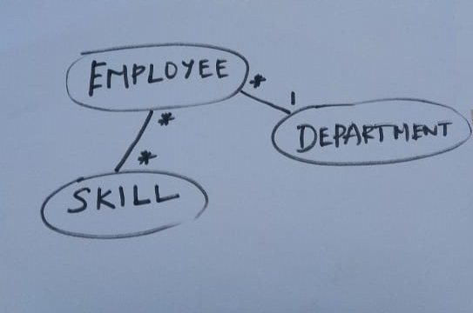

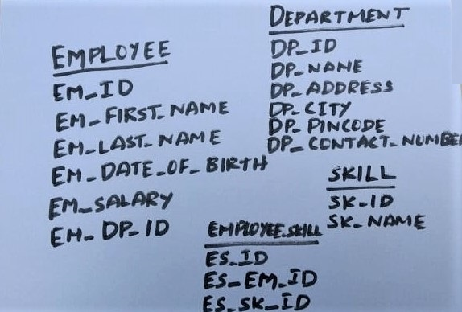

5. Reference Code : OBL_SQL_H005Complexity : Level1

**Database Design for Movie Booking**  
**Duration : 80 minutes**   
  
Features of Movie Booking app:

1. Add cinema hall with name, capacity and city
2. Add seats to cinema hall with seat number
3. Add movie with title, release date, running time, rating, genre, language
4. Schedule show with cinema hall, movie, show time, active
5. Book movie ticket with schedule, booking date, show date and seat numbers

Form groups within the classroom. Each group should contain 3 or 4 members. Attendees seated in a row can be considered as one group. If attendees are interested, the groups can be formed by shuffling.  
Each group has to come up with the database design in a paper and present their design to the entire classroom.  
*Activity Split*  
Design by Group – 30 minutes  
Presentation by each team (8 Team * 5 minutes) – 40 minutes  
Presentation of ideal design by facilitator – 10 minutes