Virtual Meeting Tips
ha'lit'miism na̱xnox sag̱aytwa̱n yawłmx

For All Calls / txa̱'nii sag̱aytwa̱n

- Mute your Microphone when not Speaking
- xspawks ha’liamuks akadi algya̱x


- Pay Attention to the Meeting
- ‘niisago sag̱aytwa̱n
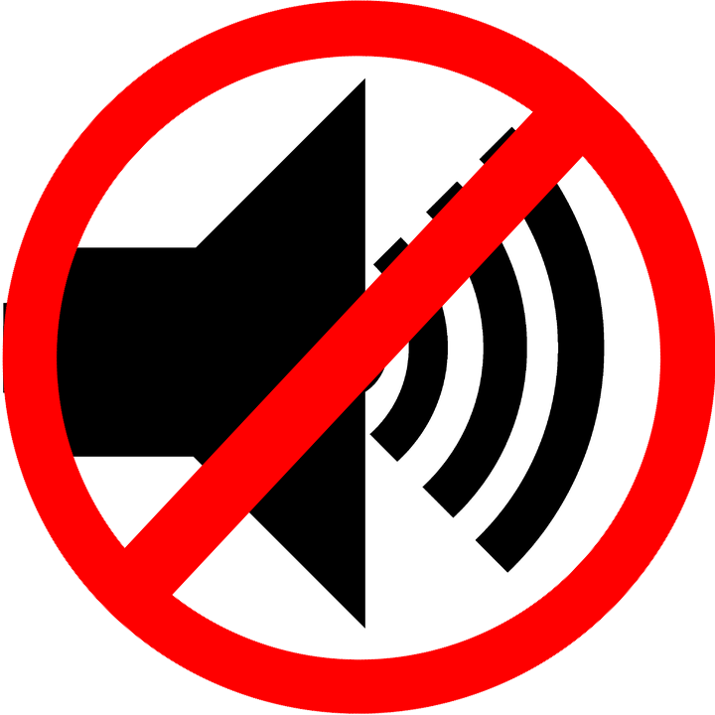
- Avoid Distractions
- wudnt’aa hamoolksm

- Find a Quiet Location
- Ts’iin gyimo’oxk

For Video Calls / txa̱'nii niits sag̱aytwa̱n
- Avoid Large Movements
- da̱xsmt'aa

- Look Presentable with a clean back ground
- nuutga ada txalhawli aamadzap

