First steps to start transitioning your data to our template will be to download your data from your current CMS regardless of which CMS that is.

- Identify All the data Columns you plan on bringing over to meet requirements
- Copy the full columns from your data and paste into our template
- Correct data points to match examples in our template by using find and replace

Ensure that you are downloading all of your data that is possible regardless if you plan on bringing it over. The more data you have the easier it will be to ensure that you are filling out the required fields that is on our template.

The bare minimum that you would need to bring over would be clients. Regardless of your prior CMS you should have a file that has all of the required information that we will go over.

You will notice once you open our template that the first tab is labeled Clients

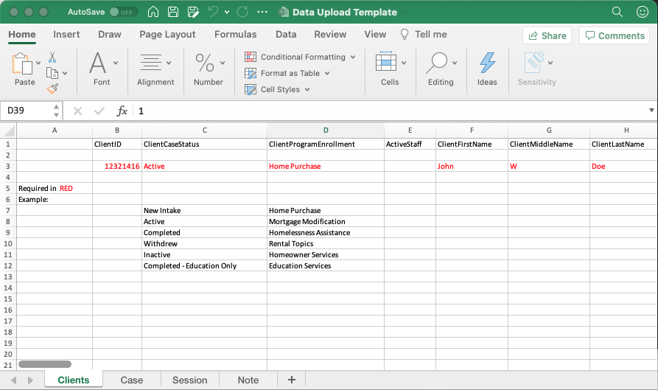

Any required field will be listed in red on our spreadsheet. These fields are required for reporting by HUD, you should easily have access to all of these fields for at least the clients tab.

IF YOU DO NOT USE A COLUMN, DO NOT DELETE IT

Once you have opened our template and looked through the data to see what you will need to transfer

Open up your data export folder. You could potentially have more files than what you will truly need.

But you will want to be sure to look through the files and find where all of your client data is, keeping in mind that all the data that you need for the clients, could potentially be in multiple files depending on the CMS and how they do their export.
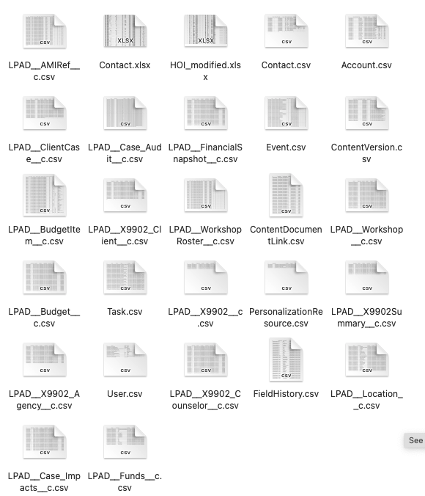

In this data export, the client data is in the Contact.xlsx file. This may not always be the case though. So it will be important that you examine your data.

Once you have found the correct file with client data, you will need to start identifying the columns that you will need to bring over.

The first column will be the Client ID

Select the entire column by clicking on the letters that designate that column

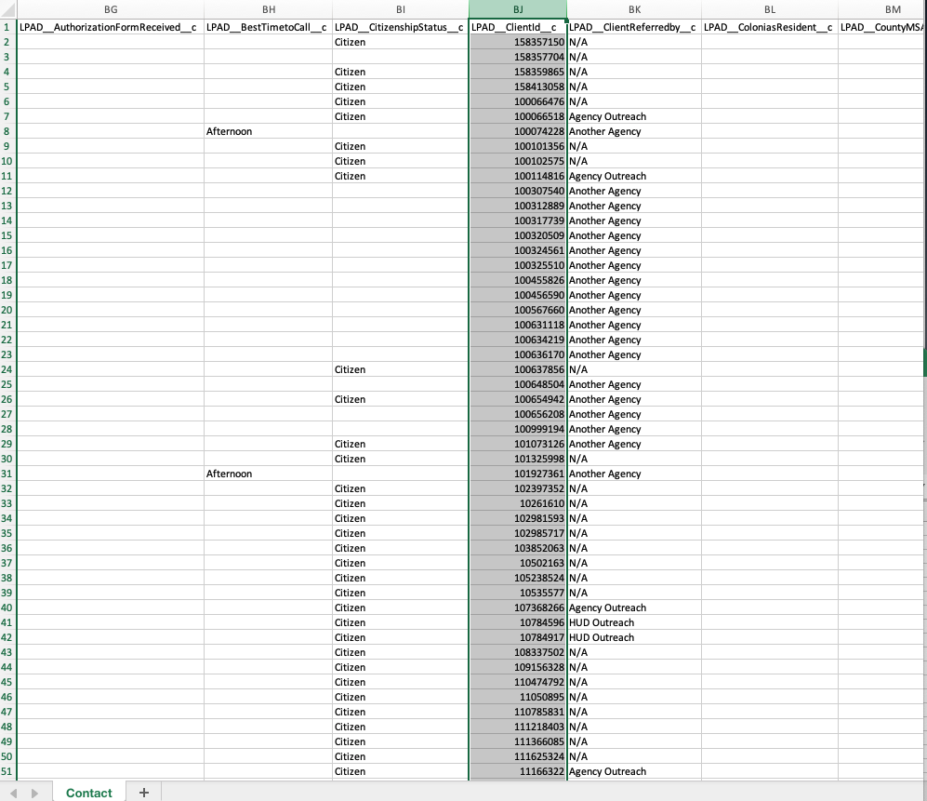

This will select all of the Client ID’s that are in your export.

Once selected and highlighted you can right click on the shaded region to copy the entire column.

Open up our data template and you will see we have examples of what the data looks like along the top of the template.

DO NOT DELETE THIS DATA YOU WILL NEED IT IN THE NEXT STEP.

Find the ClientID column in our template and paste your data in the cell labeled PASTE HERE

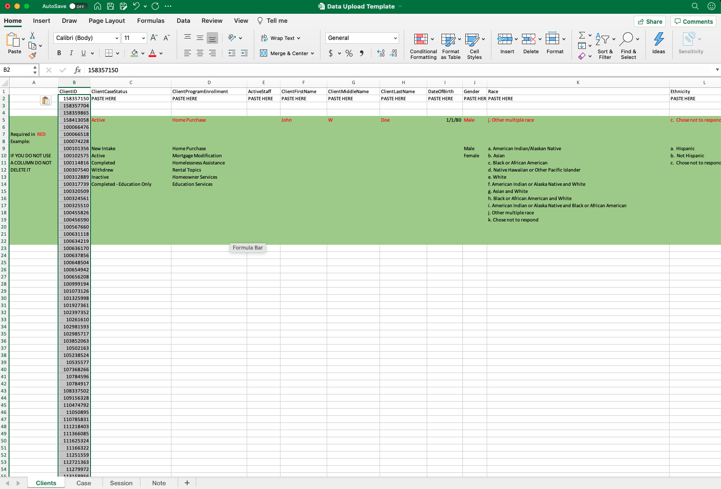

You will need to do this for each column that has red text for the example.

The red text marks fields that are REQUIRED FOR HUD SUBMISSION

You don’t need to fill out every single column, but you will need to make sure you have transferred over all of the data that is required for a submission, otherwise you will have to go through and update each of these clients once they are in the system.

After you have transferred your columns, now is time for step three which will consist of matching up some of the data points to match what our options are.

If you remember, the examples that were at the top of our template when we started is what we will use Find & Select in excel to correct.

If you properly copied over your data, those examples will now be at the bottom of the template now.

There are potentially 12 columns that you will need to use the Find & Select feature of Excel for. However, 7 of those 12 columns are the only ones that are required, meaning you may only have 7 columns to correct.

Those columns will be
Required fields
- ClientCaseStatus
- ClientProgramEnrollment
- Race
- Ethnicity
- HouseholdIncomeBand
- RuralAreaStatus
- EnglishProficiencyLevel

Not Required fields, but if they are filled you will need to correct these as well
- ImmigrationStatus
- MaritalStatus
- HouseholdType
- Education
- ReferalSource

This is the example of what the data for the Race column should look like.

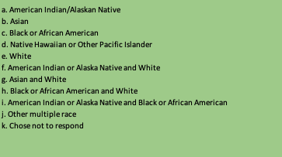

To use find and select, Locate the button on your toolbar:

Select the whole column you plan on starting with.

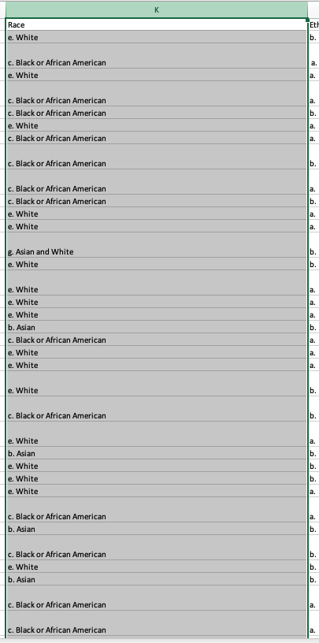

Once you have selected a column click on the find & select button and choose Replace

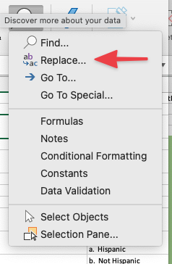

Once you click replace this will be the window that you do ALL of your replacements from for THE COLUMN THAT YOU HAVE SELECTED.

In the example above, the column highlighted is the Race column, So that means for each race option, you would have to go through letters A-K from the example listed above and make sure that all of the options for race, match what is needed on the template.

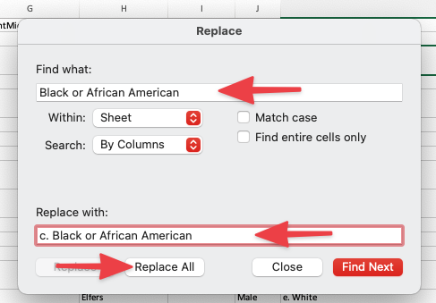

Just add the first item you wish to replace at the top in the Find what: box,

And insert our proper selection into the replace with box.

Do this for each selection item for this column, then move on to the next.

Once you have completed this step on all of the columns that will need data corrected.

Your data should now line up properly with our template.

