# JMeter

POC to use JMETER with https://blazedemo.com/

- Created a Thread Group (Click right > Add > Thread Group)

- Add HTTP Test Script Recorder (non-Test Elements)

- Add View Results Tree (Listener)

- Add aggregate Report

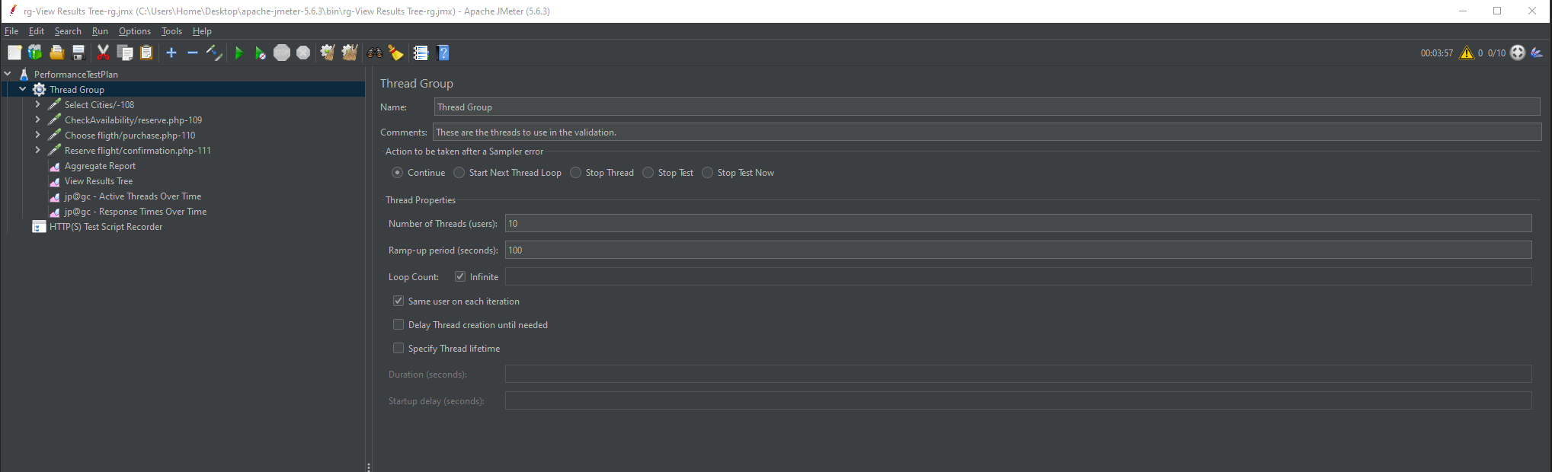

- Browser Extension used to mimic Proxy: Foxy Proxy

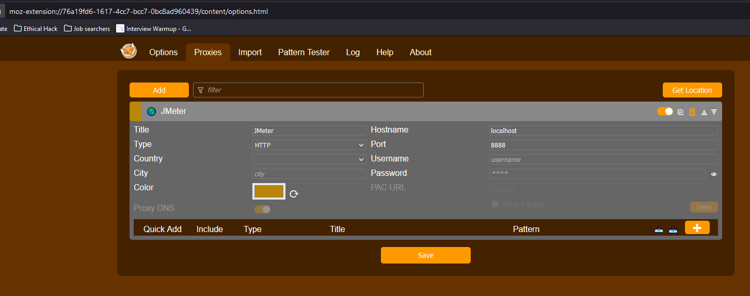

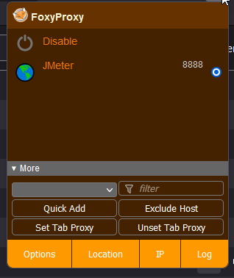

Issue got during recording steps: GET http://detectportal.firefox.com/success.txt

Mitigation: about:config

Set to false the rule: network.captive-portal-service.enabled

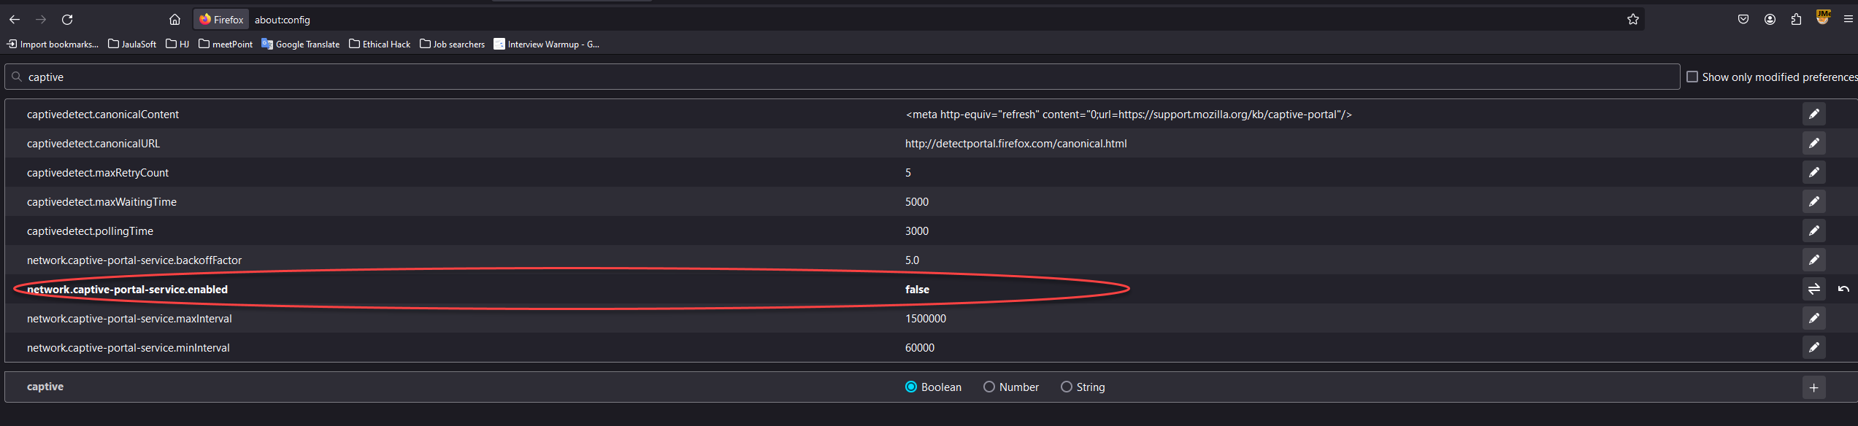

* Assertions:

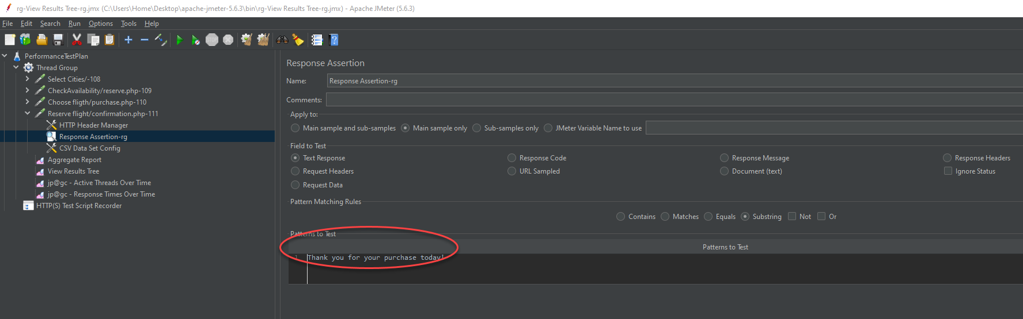

* Variables and Data Set Config

In the step, click Add > Config Element > CSV Data Set Config.

Also prepare your csv file.

Once in the new row, The variable Names should be separated by commas

Take Notes of those names.

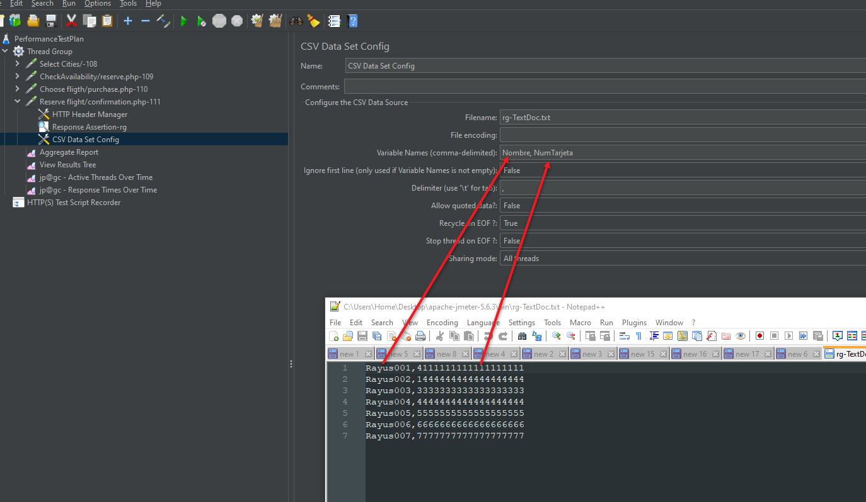

Go to the step where POST is sent

Add the variable with previous names, use the following Notation ${VARIABLE__NAME_HERE}.

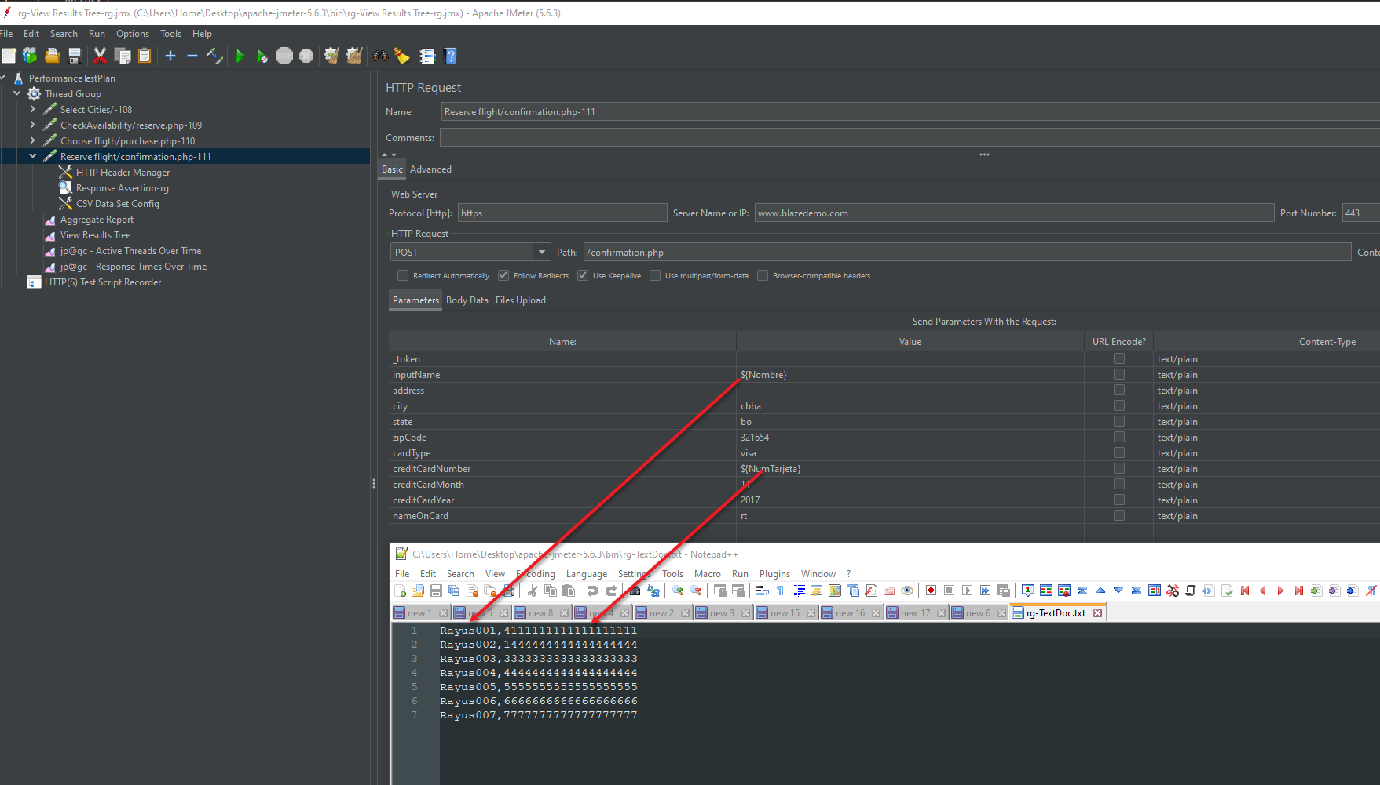

* Plugins:

Install the following plugin: <https://jmeter-plugins.org/wiki/PluginsManager/>

Download it and paste it in bin/ext

Restart JMeter

Now Open the Plugins manager and install ‘jpgc – standard set’

Add new Listeners to have graphs and more stuff.

