1a-1 Virtualisation and Linux Setup
Install Ubuntu ISO on VirtualBox
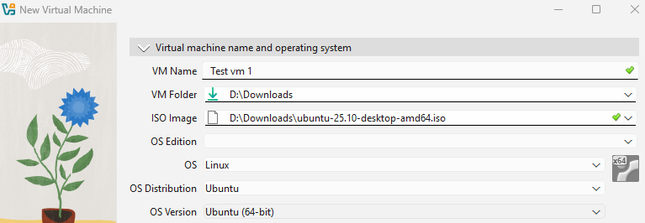
Virtual Machine Created
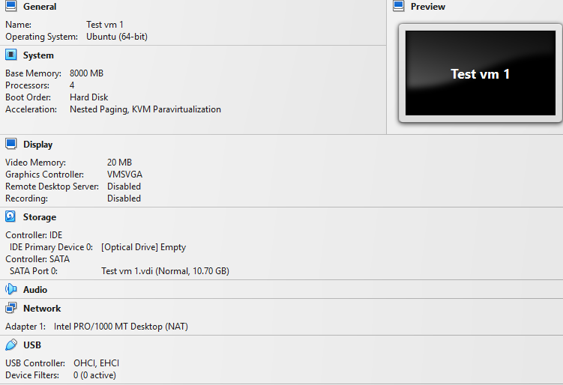
Networking Mode Configured
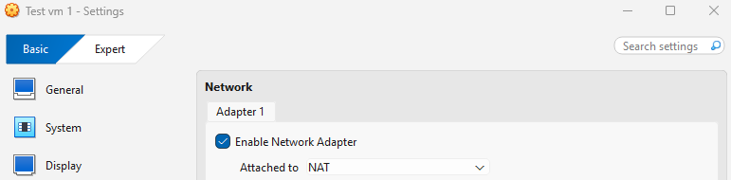
Ubuntu Running with GUI
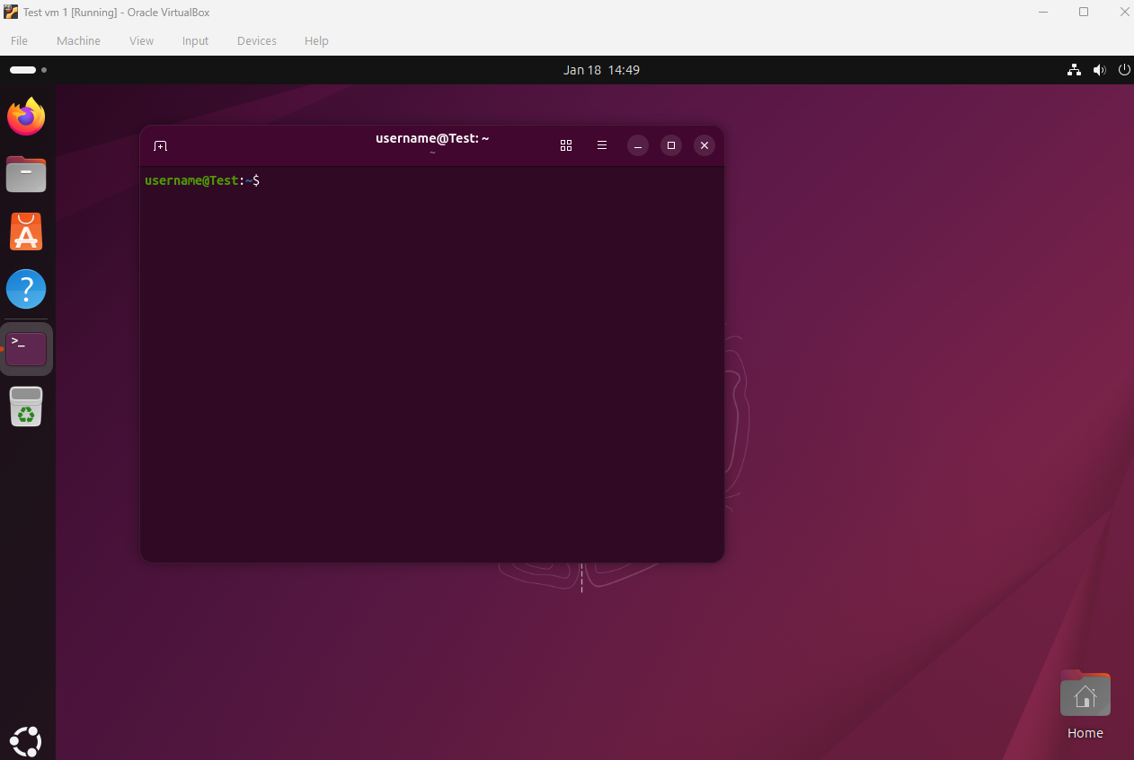
VirtualBox Guest Additions Installed
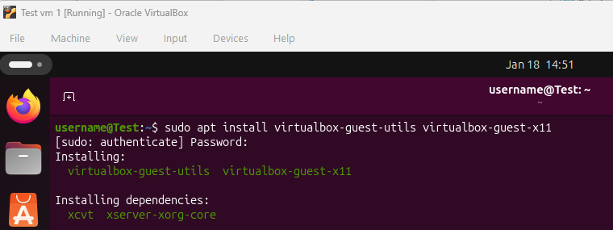
SSH Enabled
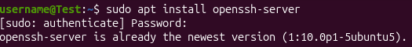
Reflection/Report Prompts
- What are the advantages of using virtual machines for testing and development?
It can be used to test potentially risky software or configurations without affecting the host system. If something breaks only the VM is affected.
- What challenges did you face during installation or network setup?
Needing to enable VT-x/AMD-V in BIOS settings for virtualisation as it was not enabled and Balancing RAM and CPU allocation between host and guest OS to prevent system slowdowns.
- What are the differences between NAT and Bridged networking in VirtualBox?
NAT (Network Address Translation)
The VM accesses the internet through the host machine's network connection
Bridged Networking
The VM appears as a separate device on your physical network
- What did you learn about Linux distributions (distros) from your reading?
There are hundreds of Linux distributions, each tailored for different purposes (Ubuntu for beginners, CentOS for servers, Kali for security testing)

