Script to Storyboard Quick Guide
A short handoff guide for the animation team
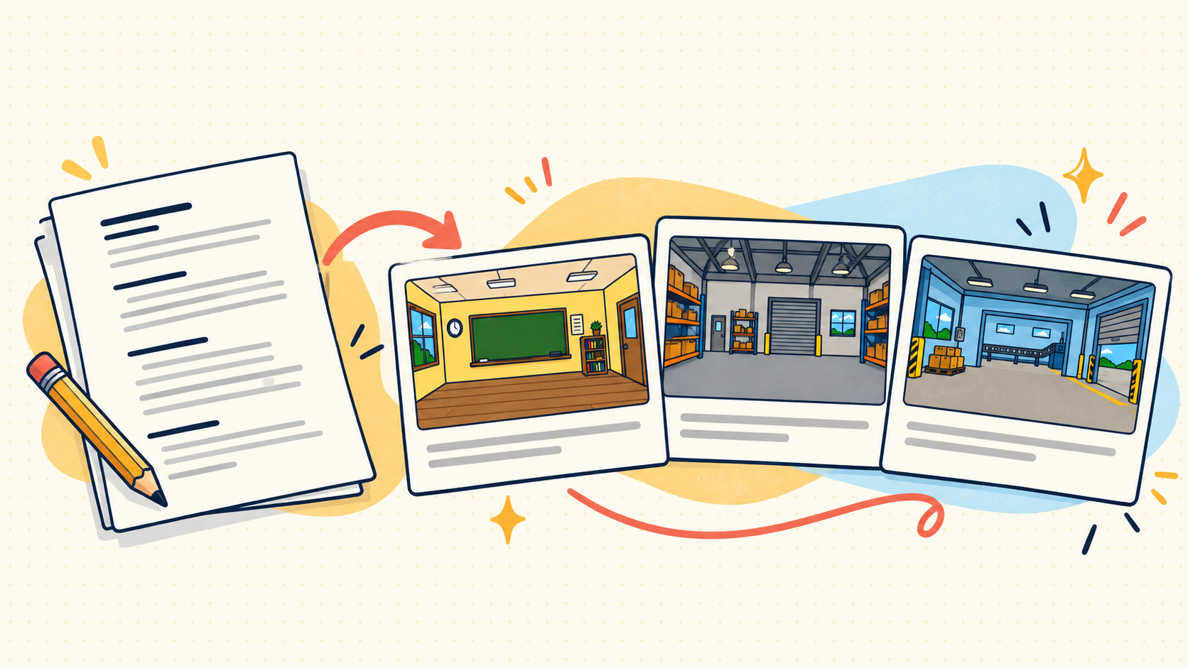
OPEN THE LIVE DEMO
https://script-to-storyboard-six.vercel.app/
Paste one complete narration to get a full scene-by-scene storyboard, followed by up to six custom-fit background plates. The storyboard gives animators a clear visual plan; the generated images provide empty environments for the hand-drawn characters and action.
FULL STORYBOARD | UP TO SIX BACKGROUNDS | EMAIL HANDOFF

How the Demo Works
The web app runs two connected n8n workflows. The first plans the full storyboard and creates backgrounds. The second saves image files and handles the CSV and email handoff.
Step | What happens
1 Plan | The planner reads the complete script and consults approved storyboard examples and style notes in Google Sheets.
2 Generate | The planner selects up to six distinct settings. The image model creates one full-frame 16:9 background per request, in sequence.
3 Deliver | Each PNG is uploaded to Google Drive and returned to the UI with its filename and link.
4 Notify | The operator can save the storyboard CSV to Drive, record the run in Google Sheets, and email the configured recipient.

Workflow Tools
Tool | Purpose
n8n | Runs the planning, image, upload, and notification steps.
GPT-5 mini via Vercel AI Gateway | Plans the storyboard from the script and reference examples.
GPT Image 2.5 Flare via OpenRouter | Creates one background image per request.
Google Sheets and Drive | Provide reference context, settings, process history, and file storage.
Gmail and Vercel | Send the editing-team email and host the web app.

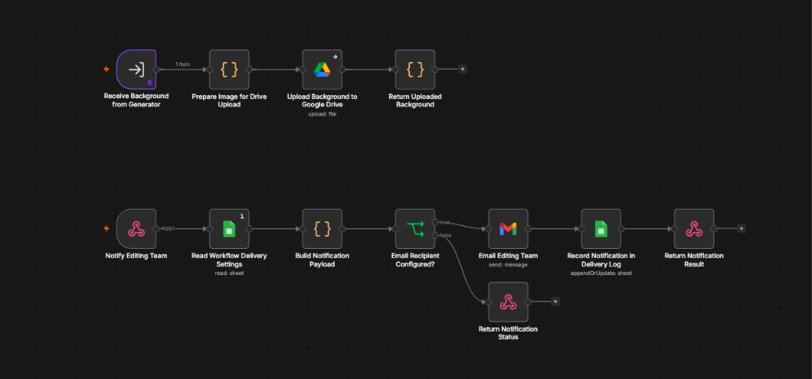
Generation workflow in n8n

Storyboard and Animator Handoff
The CSV follows the established animator-facing layout. The full narration stays in order, and scene descriptions stay concise. Supplied timestamps are preserved; otherwise, the planner estimates continuous timing.
CSV column | What it describes
Scene | Scene number.
Timestamp | Scene time range.
Voiceover | The narration assigned to the scene.
What's happening | The visual beat.
Background | The setting and composition.
Hand-drawn characters & props | Characters and movable elements for the animators.
On-screen text | Words that are shown on screen.
Transitions/Motion | Short transition or motion note.

What the Team Receives
Background images: separate 16:9 environments with a consistent hand-drawn 2D treatment. The setting, palette, and composition follow each scene.
Storyboard CSV: available for download in the UI. Selecting Notify editing team also saves a copy in the Google Drive output folder.
Email handoff: includes the script title, processing date, storyboard CSV link, and links to the generated background PNGs.

File Names and Access
The first non-empty script line becomes the title slug. Files follow names like YYYY-MM-DD-title-slug-bg001-scenes-01.png and title-slug-storyboard.csv.
Characters, props, diagrams, on-screen text, and motion are drawn by the animators. Drive links follow the output folder's sharing settings; if a file asks for permission, the project owner must share the folder with your Google account.
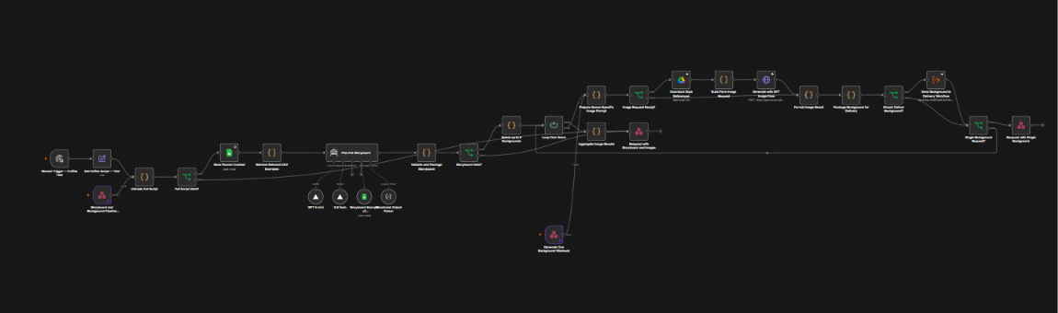
Drive delivery and email workflow in n8n

