ONLINE EXAMINATION AND QUIZ SYSTEM
A Desktop Application using Java Swing, JDBC (SQLite) and Java I/O
Project Report
submitted in partial fulfilment of the requirements for the degree of B.Tech in Computer Science and Engineering
Submitted by: ______________________________
Roll No.: ______________________________
Guide: ______________________________
Department of Computer Science and Engineering
Institution: ______________________________
Academic Year: 2026 – 2027

Table of Contents

(In Word: right-click the table and choose Update Field to fill in page numbers.)

Abstract
Paper-based tests are slow to evaluate, give students no immediate feedback, and do not tell a student which topics need more practice. This project implements an Online Examination and Quiz System as a Java desktop application aimed at third-year B.Tech CSE students. It covers eight core subjects (Data Structures, Java, Python, OOP Concepts, DBMS, Operating Systems, Computer Networks and Linux Commands), each divided into subtopics, with 460 multiple-choice questions in three modes: Easy (20 theory questions), Medium (10 questions mixing in-depth theory with "predict the output" code snippets) and Hard (5 in-depth questions with tricky code). Every mode has a 10-minute timer that submits automatically, and harder modes carry more marks per question.
Students can test a whole subject or focus on one subtopic. During a test they navigate freely, mark questions for review and, in Medium and Hard modes, reveal a starting hint. Unanswered questions are listed before submission and score zero. After submitting, the student sees a score chart, then reviews each question with the correct answer and an explanation. An analytics screen identifies weak and strong subtopics from every individual answer. Administrators manage subjects, subtopics and questions through the GUI and can import or export whole question banks as plain-text files.
The application follows a layered architecture (presentation, service, data access) and demonstrates object-oriented design, the Java Collections Framework, event-driven GUI programming with custom-painted Swing components, custom exception handling, JDBC persistence with SQLite (including an automatic schema migration) and file I/O. The code has 63 Java source files and a self-test suite of 95 automated checks, all passing. Every code-output answer in the question bank was checked by actually running the snippet.

1. Introduction

1.1 Problem Statement
Design and build a desktop quiz application that presents multiple-choice questions organised by topic, accepts answers through a graphical interface, calculates scores, handles unanswered questions and stores both questions and results.

1.2 Objectives
- Organise questions into subjects and subtopics relevant to a third-year B.Tech CSE curriculum.
- Offer three difficulty modes with different question counts, marks and question styles: Easy tests fundamentals, Medium tests observation and analytical thinking with code, and Hard tests mastery.
- Accept answers through an attractive event-driven Swing GUI, with a timer, a question palette, marking for review and hints.
- Calculate scores accurately (correct, wrong and unanswered counts, percentage, grade, accuracy) and handle unanswered questions explicitly.
- Store questions and results with JDBC, and import and export question banks with Java I/O.
- Help students improve, through explanations in the answer review and analytics that point out weak subtopics.

1.3 Scope
A single-machine desktop application for classroom practice, lab assessments and self-study, with multiple student and admin accounts. Networked exams, proctoring and descriptive (non-MCQ) answers are listed as future work.

2. Requirements Specification

2.1 Functional Requirements
ID | Requirement | Implemented in
FR1 | Student registration and login with a show/hide password toggle; admin login | LoginPanel, RegisterDialog, PasswordInput, AuthService
FR2 | Browse subjects as cards and choose a subtopic (or all subtopics) | DashboardPanel, SubjectPanel
FR3 | Choose Easy (20 Qs), Medium (10 Qs) or Hard (5 Qs); each lasts 10 minutes | Difficulty, SubjectPanel, QuizService
FR4 | Draw a shuffled set of questions of the chosen mode | QuizService.startQuiz
FR5 | Show code snippets for code-output questions | CodeBlock, QuizPanel
FR6 | Answer, navigate, clear, mark for review, and use keyboard shortcuts | QuizPanel, QuizSession, OptionCard
FR7 | Starting hints in Medium and Hard; hint usage recorded | QuizSession.revealHint, QuizPanel
FR8 | Countdown timer that auto-submits at zero | QuizPanel (javax.swing.Timer)
FR9 | Warn about unanswered questions; score them as 0 | QuizPanel.submit, QuizSession.finish
FR10 | Score with marks per mode; show grade, accuracy, hints used and time | QuizSession.finish, ResultPanel
FR11 | Review answers with explanations; filter by correct, wrong, unanswered or hint used | ReviewPanel
FR12 | Analytics by subject and mode; weak and strong subtopics | AnalyticsPanel, ResultDAO.subtopicStats
FR13 | Result history with filters and CSV export | HistoryPanel, AdminService.exportResults
FR14 | Admin: manage subjects, subtopics and questions; import and export .qb banks; add admins | AdminPanel, QuestionDialog, SubjectDialog, QuestionBankFormat

2.2 Non-Functional Requirements
- Reliability: a result and all its answers are saved in one transaction, and question imports are all-or-nothing. A database from version 1 is migrated automatically and keeps user accounts.
- Correctness of content: 124 code-based answers were checked automatically by executing the code; numerical answers (scheduling, paging, subnetting, CRC and so on) were recomputed with scripts.
- Security: passwords are stored as salted SHA-256 hashes, and all SQL uses PreparedStatement.
- Usability: a consistent palette (cool indigo, sky and teal with warm orange, amber and rose accents), colour-coded modes, rounded custom components, keyboard shortcuts and confirmation dialogs.
- Maintainability: layered design with DAO interfaces; question content lives in plain-text files that teammates can edit without touching Java code.

2.3 Hardware and Software Requirements
Item | Minimum
Processor / RAM | Any dual-core CPU, 2 GB RAM
Operating system | Windows 10/11, Linux (e.g. Fedora, Ubuntu) or macOS
Java | JDK 11 or newer (compiled with --release 11)
Database | SQLite 3 via sqlite-jdbc 3.46.1.3 (bundled in lib/)
GUI toolkit | Java Swing / AWT (Nimbus base look and feel plus custom painting)

3. System Design

3.1 Architecture
Three layers keep responsibilities separate. The Swing presentation layer handles events and drawing only. The service layer holds the exam rules: drawing questions, scoring, hints, validation and import parsing. The data access layer hides all SQL behind DAO interfaces whose JDBC implementations talk to an SQLite file. Question banks and result exports use Java I/O streams.
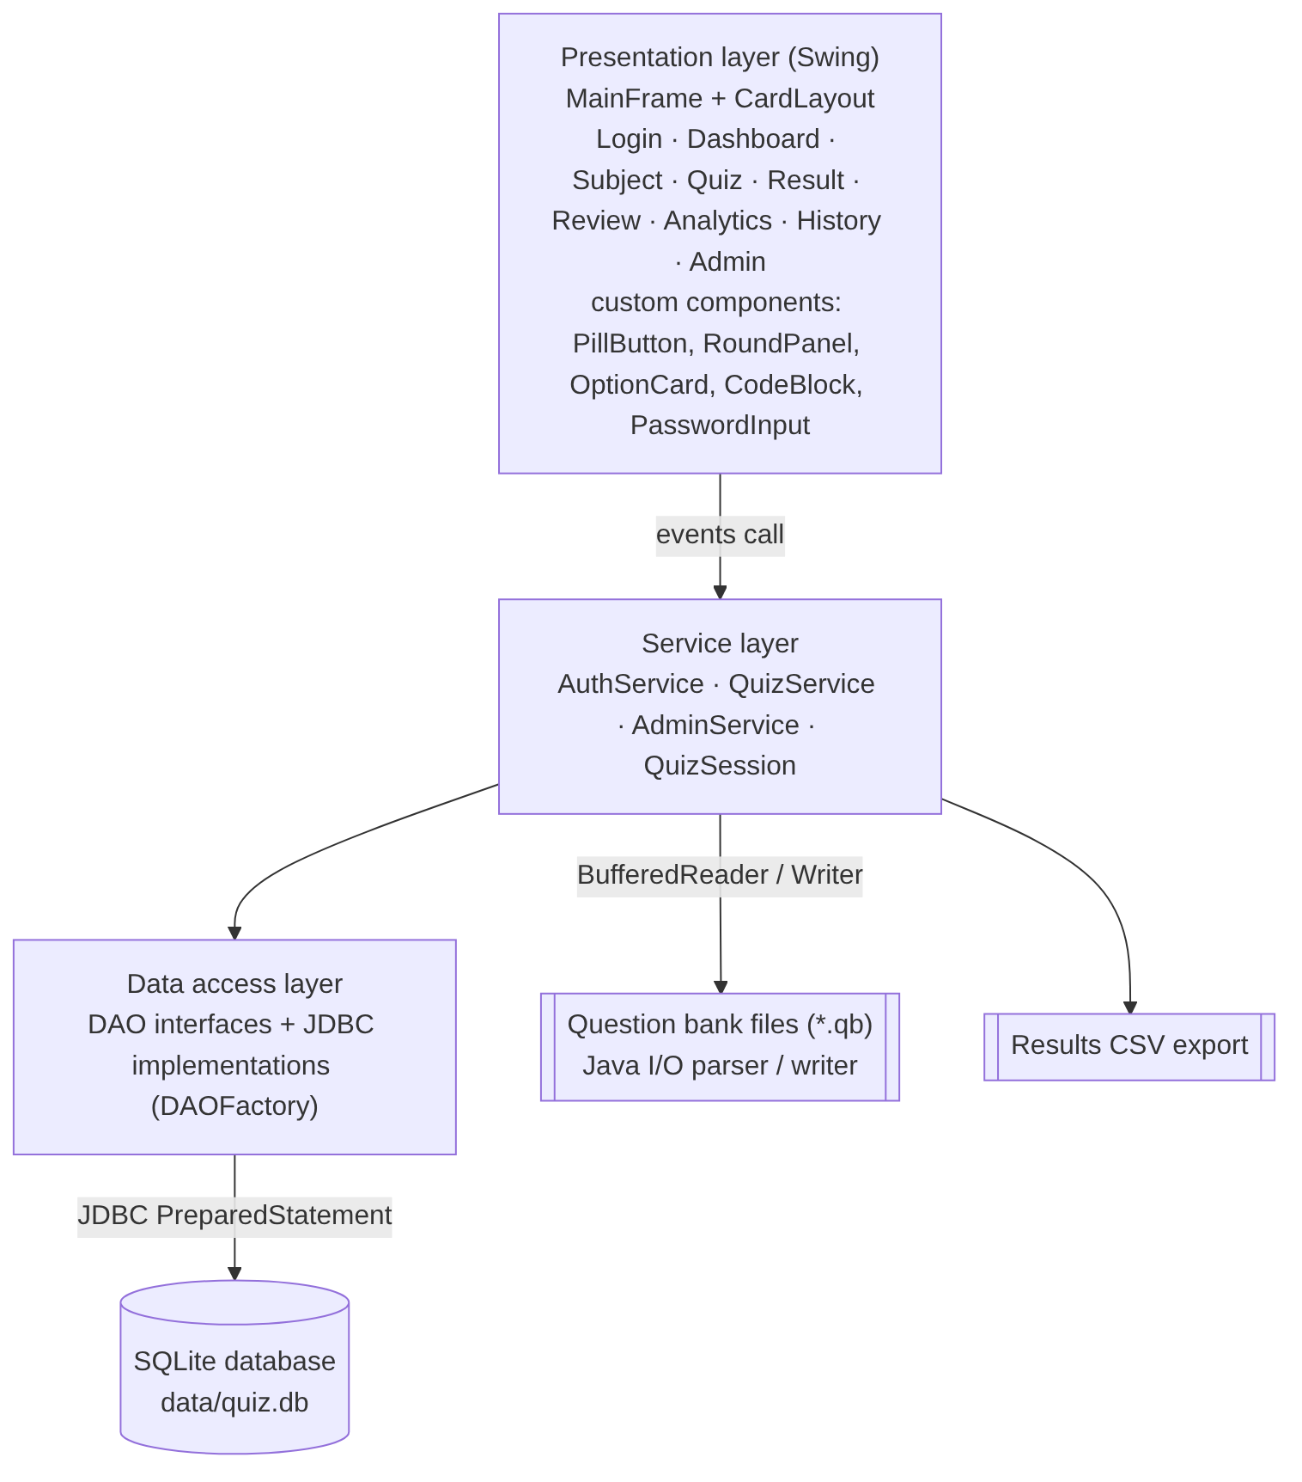
Figure 3.1 – Layered architecture

3.2 Package Structure
Package | Responsibility | Key classes
com.quiz.model | Domain objects | Subject, Subtopic, Question, Difficulty, QuizResult, AnswerRecord, TopicStat, User
com.quiz.exception | Custom checked exceptions | QuizException, DataAccessException, ValidationException, AuthenticationException
com.quiz.db | Connection, schema and migration, seed data | DatabaseManager, DataSeeder
com.quiz.dao / .jdbc | Persistence interfaces and JDBC implementations | SubjectDAO, SubtopicDAO, QuestionDAO, ResultDAO, UserDAO, DAOFactory, Jdbc*DAO
com.quiz.service | Business logic | QuizSession, QuizService, AdminService, AuthService
com.quiz.util | File formats and helpers | QuestionBankFormat, CsvUtil, PasswordUtil, AppConfig
com.quiz.ui | Screens and dialogs | MainFrame, LoginPanel, DashboardPanel, SubjectPanel, QuizPanel, ResultPanel, ReviewPanel, AnalyticsPanel, HistoryPanel, AdminPanel
com.quiz.ui.components | Reusable custom-painted widgets | PillButton, RoundPanel, GradientPanel, OptionCard, CodeBlock, PasswordInput, TextInput, Badge, Chip, BarChart

3.3 Class Diagram
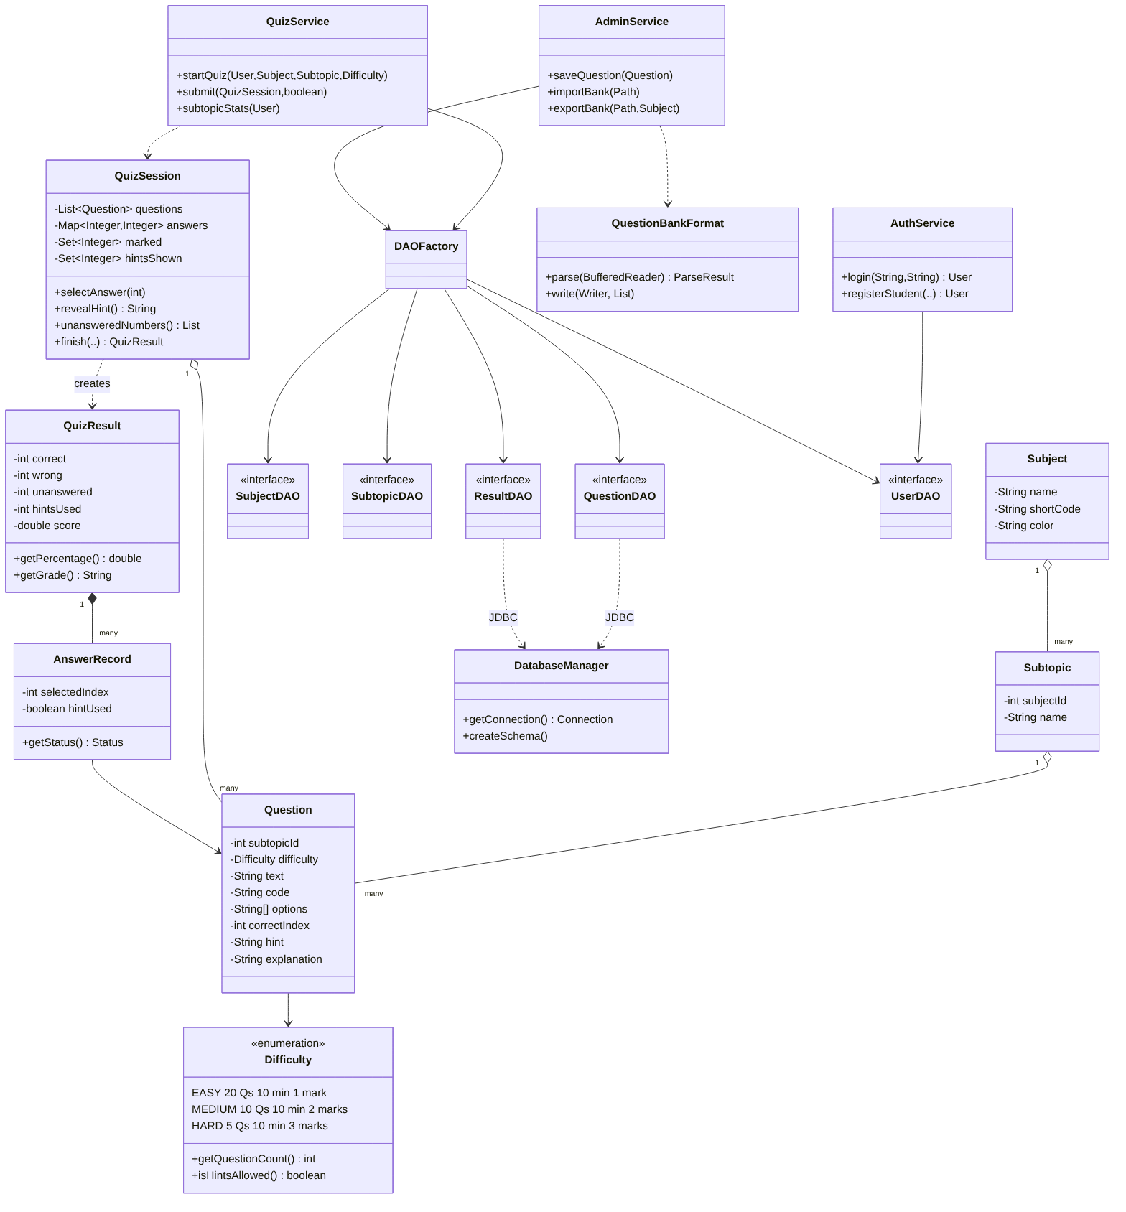
Figure 3.2 – Class diagram (main classes and relationships)

3.4 Database Design
Six tables are used, with foreign keys enforced (PRAGMA foreign_keys = ON). Subjects contain subtopics, which contain questions, and deleting a subject cascades down that chain. Results keep the subject name and difficulty, and each result_answers row stores a snapshot of the question, its code, hint and explanation. A student's history and answer review therefore survive later edits or deletions. The schema version is kept in PRAGMA user_version; a version-1 database is upgraded automatically on start-up and its user accounts are preserved.
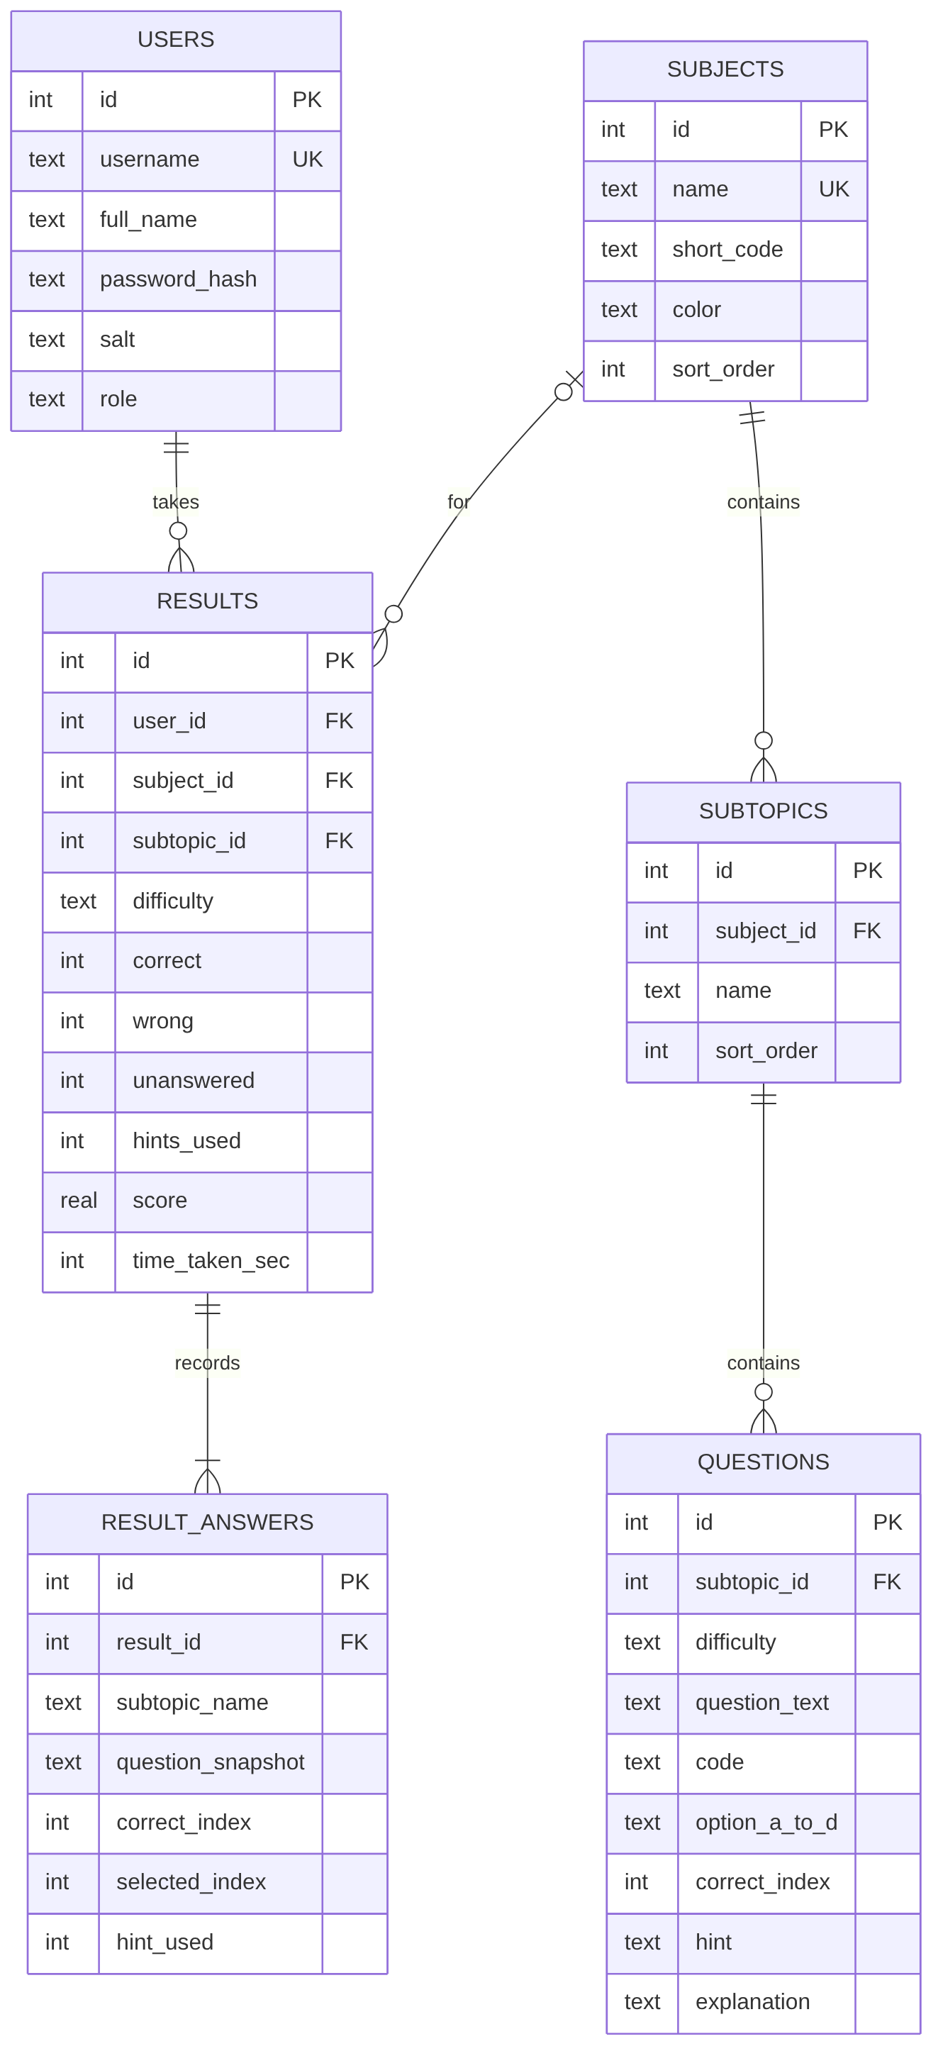
Figure 3.3 – Entity-relationship diagram

3.5 Test Modes
Mode | Questions | Time | Marks each | Content | Hints
Easy | 20 | 10 min | 1 | Core theory, definitions and basic commands; checks fundamentals | No
Medium | 10 | 10 min | 2 | Theory in depth plus "predict the output" code; tests observation and analytical thinking | Yes
Hard | 5 | 10 min | 3 | In-depth concepts, edge cases, numericals and tricky code | Yes

All values can be changed in config.properties without recompiling (for example easy.questions=25).

3.6 Subjects and Subtopics
Subject | Subtopics
Data Structures | Arrays & Strings, Linked Lists, Stacks & Queues, Trees, Graphs, Sorting & Searching
Java Programming | Java Basics, OOP in Java, Exception Handling, Collections & Generics, Multithreading, GUI (AWT/Swing) & JDBC
Python Programming | Python Basics, Strings & Lists, Tuples/Sets/Dictionaries, Functions & Scope, OOP in Python, Advanced Python
OOP Concepts | Classes & Objects, Encapsulation & Abstraction, Inheritance, Polymorphism, Design Principles & Patterns
DBMS | ER Model & Keys, SQL Queries, Normalization, Transactions & Concurrency, Indexing & Query Processing
Operating Systems | Processes & Threads, CPU Scheduling, Synchronization, Deadlocks, Memory Management, File Systems & Disk Scheduling
Computer Networks | OSI & TCP/IP Models, Data Link Layer, IP Addressing & Subnetting, Routing, Transport Layer, Application Layer
Linux Commands | Files & Directories, Permissions & Users, Text Processing & Pipes, Processes & System, Shell Scripting, Networking Commands

Each subtopic has Easy, Medium and Hard questions (typically 5, 3 and 2), so every subject has at least 25 Easy, 15 Medium and 10 Hard questions: enough for a full test in every mode, with variety across attempts.

4. Implementation

4.1 Object-Oriented Concepts Used
Concept | Where it appears
Encapsulation | Model fields are private; Question.getOptions() returns a defensive copy; Question.copy() lets edit dialogs work on a copy.
Abstraction | DAO interfaces hide SQL; services expose operations, not tables.
Inheritance | Exception hierarchy under QuizException; every screen extends JPanel; PillButton extends JButton; AppBar extends GradientPanel.
Polymorphism | Services use DAO interfaces implemented by JDBC classes; custom components override paintComponent; table models override getValueAt.
Enums with behaviour | Difficulty carries its question count, time, marks, hint rule and description.
Interfaces | Five DAO interfaces, the UiUtil.Action functional interface, Scrollable, Icon (EyeIcon), Comparable (TopicStat).
Design patterns | Singleton (DatabaseManager), Factory (DAOFactory), DAO, Observer (Swing listeners), Strategy-like enum configuration.

4.2 Collections
- List<Question>: the questions drawn for an attempt, shuffled with Collections.shuffle.
- Map<Integer, Integer> (HashMap): question position → chosen option. A missing key means unanswered.
- Set<Integer>: a TreeSet of positions marked for review, and a HashSet of positions whose hint was revealed.
- EnumMap<Difficulty, Integer>: question counts per mode for each subject and subtopic.
- Streams with groupingBy: analytics group results by subject and mode; TopicStat implements Comparable so the weakest subtopics sort first.

4.3 GUI and Event Handling
MainFrame swaps screens with a CardLayout. To get a modern look without external libraries, the UI uses its own custom-painted components: gradient app bars, rounded cards with soft shadows, pill-shaped buttons with hover states, option cards with letter bubbles, a dark code viewer with line numbers, a password field with an eye toggle, and bar and donut charts drawn with Graphics2D. In QuizPanel every mouse click, key binding (InputMap/ActionMap) and javax.swing.Timer tick updates the QuizSession, and the screen is then redrawn from that state, which keeps the display consistent.

4.4 Password Visibility Toggle
PasswordInput wraps a JPasswordField and a JToggleButton whose icon is an eye drawn with Java2D paths. Selecting the toggle calls setEchoChar((char) 0) to show the text; deselecting restores the bullet character. The same component is used on the login screen and in both password fields of the registration dialog.

4.5 Scoring and Hints
for (int i = 0; i < questions.size(); i++) {
AnswerRecord rec = new AnswerRecord(questions.get(i), getAnswer(i),
hintsShown.contains(i));
switch (rec.getStatus()) {
case CORRECT: correct++; break;
case WRONG: wrong++; break;
default: break; // UNANSWERED scores 0
}
}
score = correct * marks - wrong * marksWrong; // marksWrong = 0 by default
maxScore = questions.size() * marks; // Easy 20, Medium 20, Hard 15
percent = max(0, score) * 100 / maxScore;

Hints are available only when the mode allows them and the question has one (enforced in QuizSession.revealHint). Using a hint costs no marks but is stored per answer, so the result, review and analytics screens can show it.

4.6 Question Bank Format and Java I/O
Questions are kept in readable .qb text files (one per subject). QuestionBankFormat is a hand-written line-oriented parser built on BufferedReader. Code blocks between CODE and END are kept exactly as written (indentation included); lines without a keyword continue the previous field; invalid questions are reported with file and line number and skipped. The same class writes banks back out, which the admin uses for export, and teammates can add questions in a text editor and import them.
[MEDIUM]
Q: What is the output of this program?
CODE java
public class Main { ... }
END
A) 7 12
B) 6 11
C) 7 11
D) 6 12
ANSWER: A
HINT: x++ uses the old value then increments; ++x increments first.
EXPLAIN: y = 5 + 7 = 12, and x ends as 7.

4.7 Verifying the Question Bank
Wrong answer keys would ruin a quiz system, so the bank was checked automatically. A script parsed every .qb file, executed each "what is the output" snippet (javac/java, python3, gcc/g++, bash and SQLite), and compared the real output with the marked answer, also checking that no wrong option matched the output. All 124 executable questions passed. Numerical answers (CPU scheduling, page replacement, disk scheduling, subnetting, CRC, Hamming distance, the Banker's algorithm) were recomputed with separate scripts.

4.8 Exception Handling and Persistence
SQLException and IOException are wrapped in DataAccessException with readable messages; invalid input raises ValidationException; failed logins raise AuthenticationException. Every GUI action runs through UiUtil.run(), which turns these into dialogs. All JDBC and file resources use try-with-resources, and multi-row writes use commit/rollback. DatabaseManager creates the schema, records its version in PRAGMA user_version, and migrates a version-1 database while keeping its user accounts.

5. Screenshots
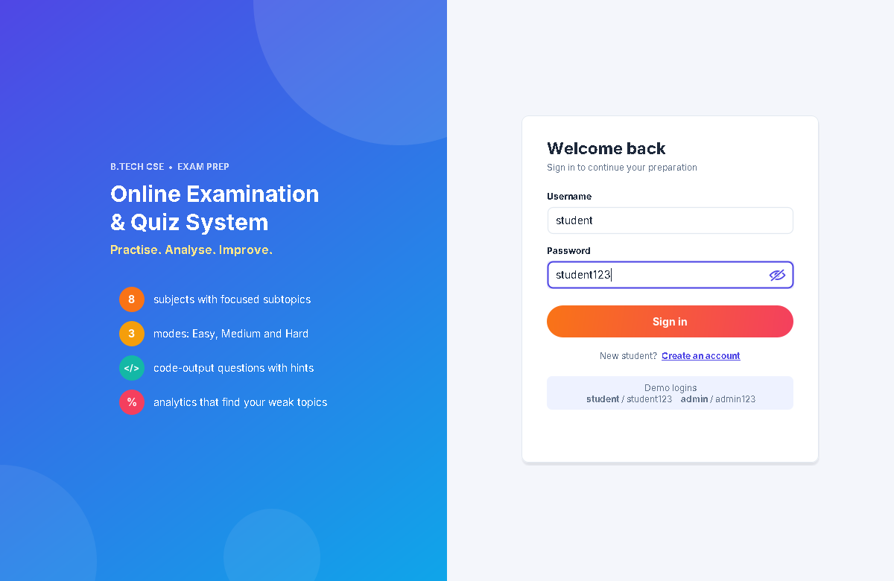
Figure 5.1 – Login screen; the eye toggle shows the typed password
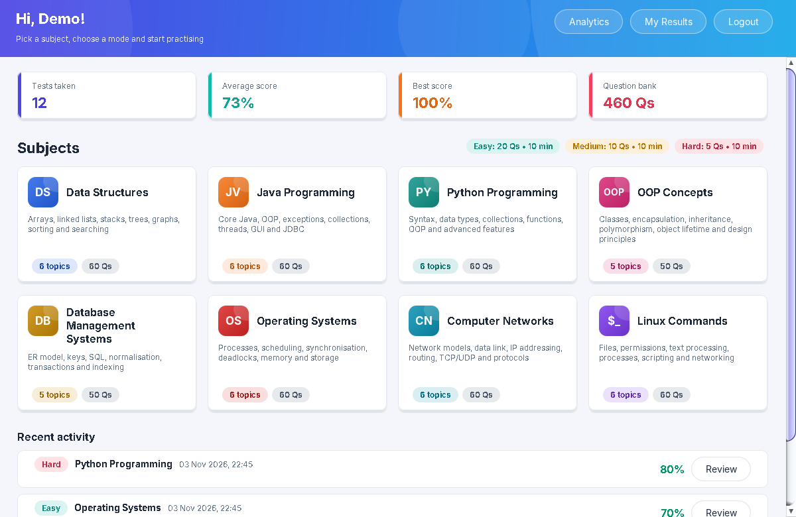
Figure 5.2 – Dashboard with progress statistics and colour-coded subject cards
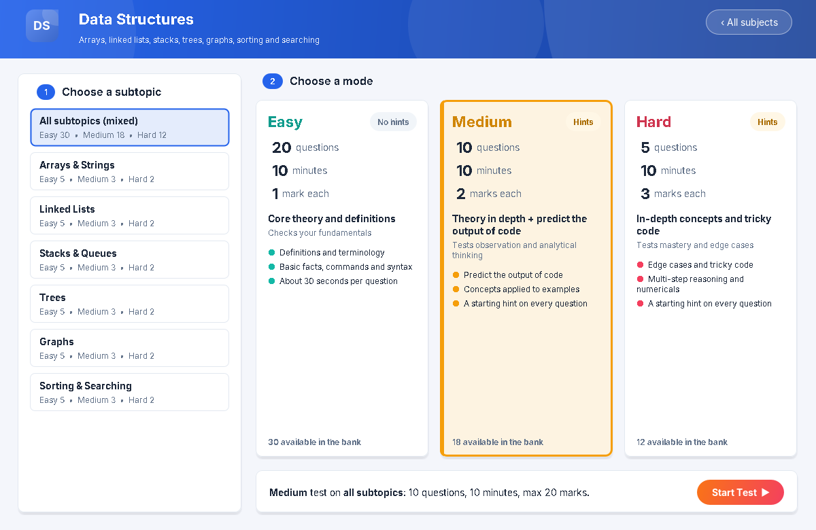
Figure 5.3 – Test set-up: choose a subtopic and a mode (Medium selected)
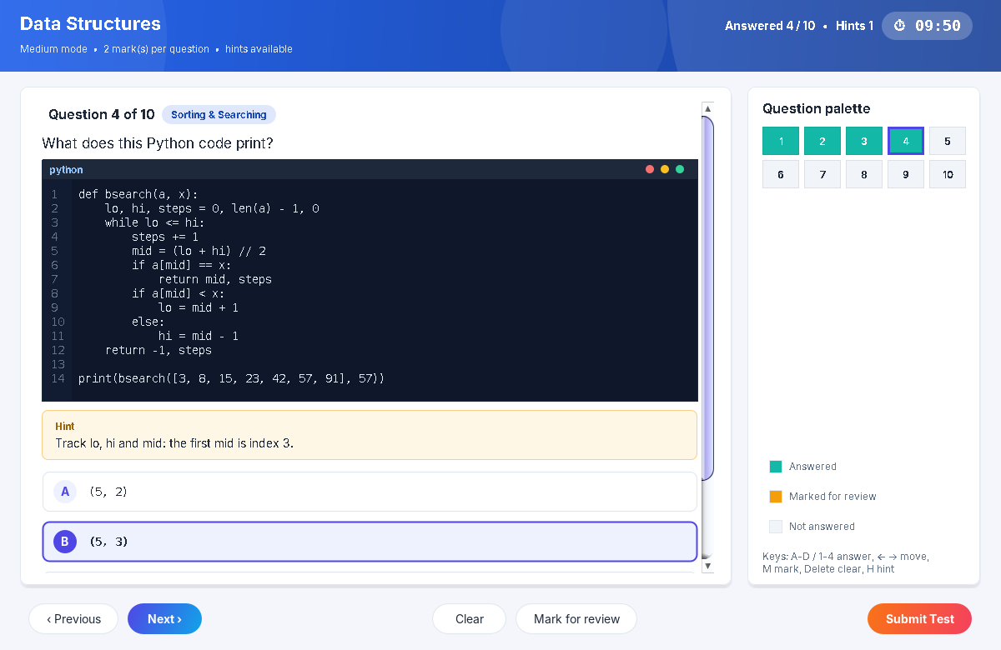
Figure 5.4 – Medium test: predict-the-output question with code viewer and revealed hint
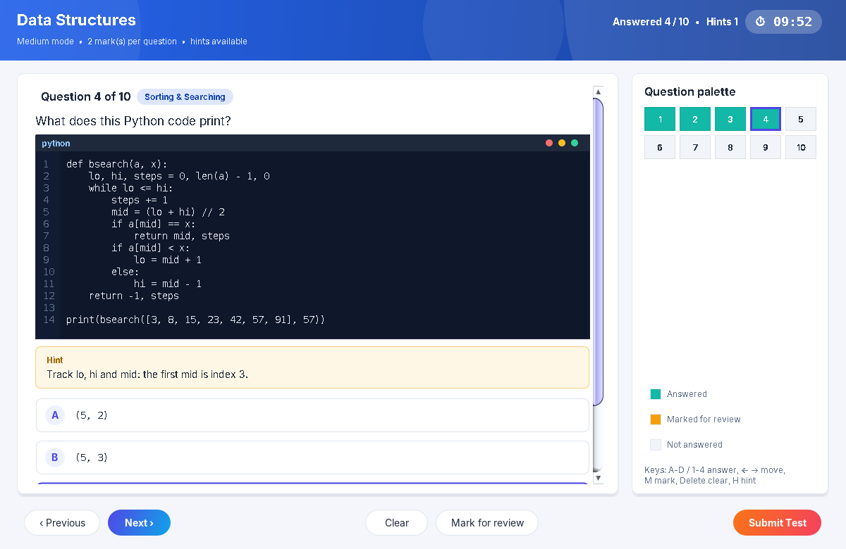
Figure 5.5 – Medium theory question with its starting hint
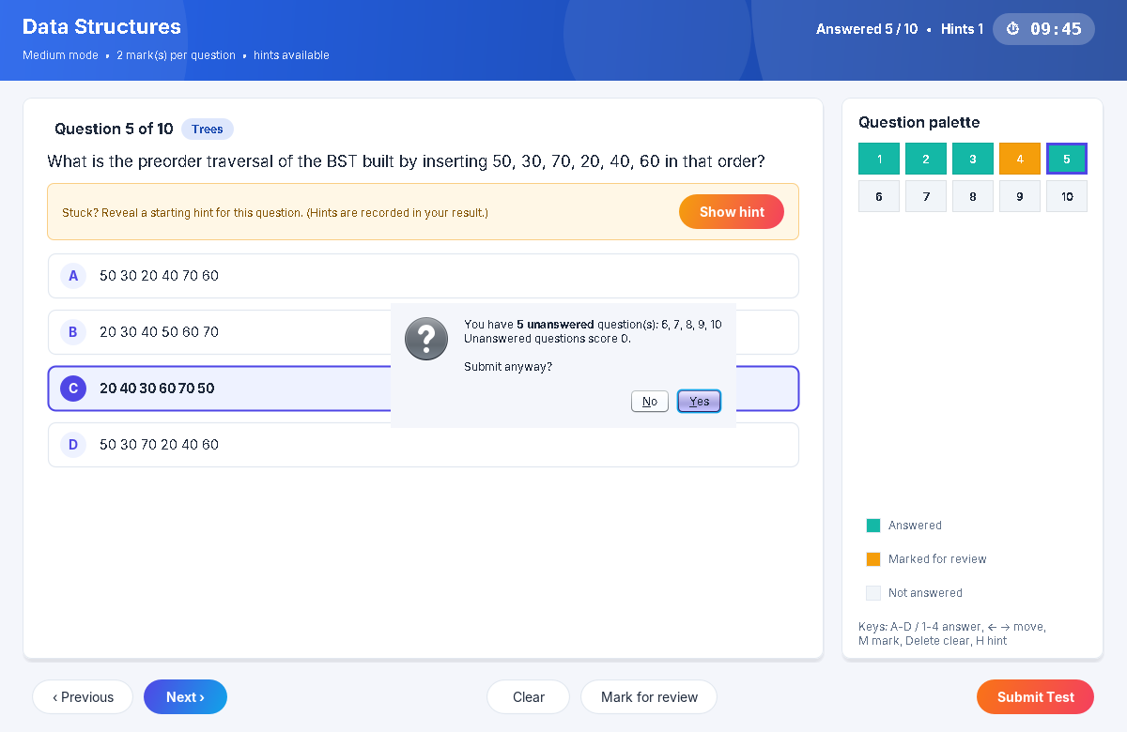
Figure 5.6 – Unanswered-question warning before submission
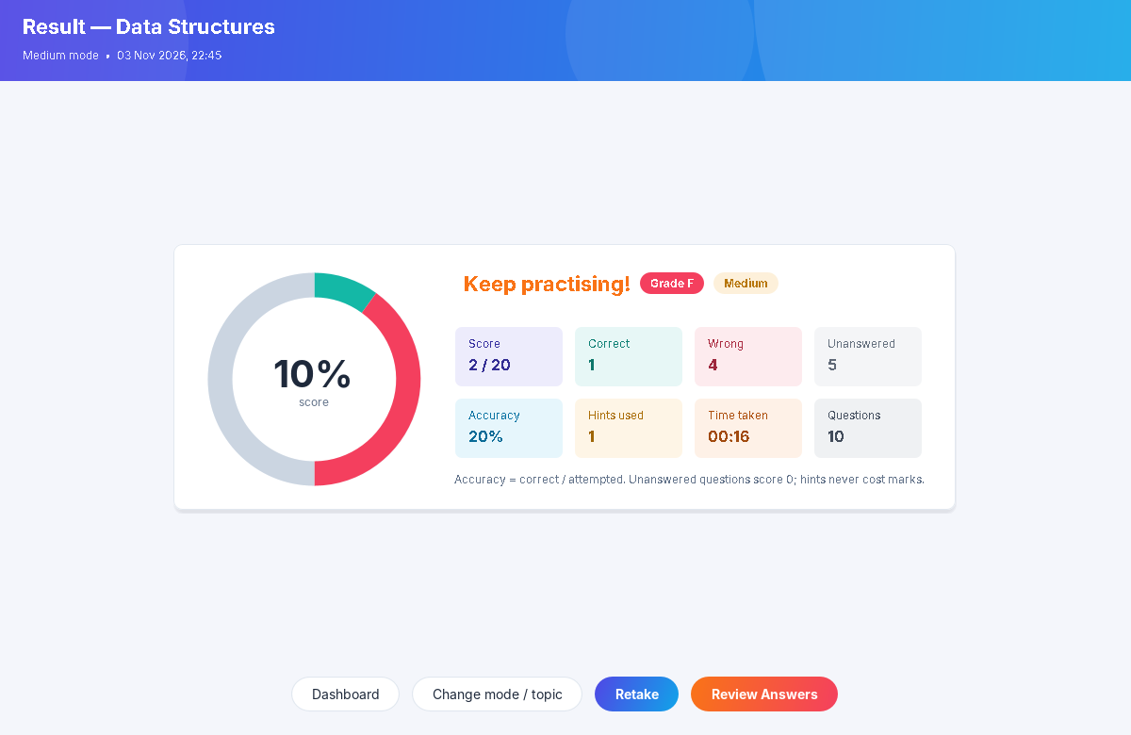
Figure 5.7 – Result screen with score chart, grade, accuracy and hints used
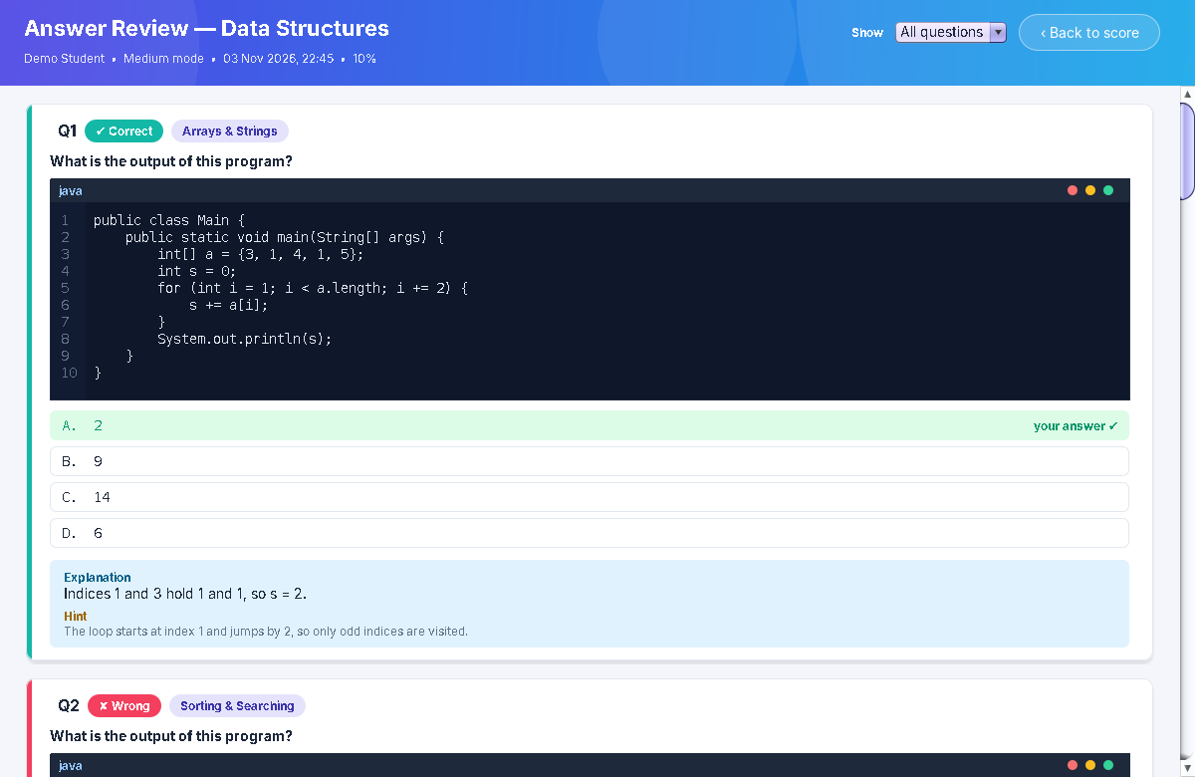
Figure 5.8 – Answer review with code, correct and chosen answers, explanation and hint
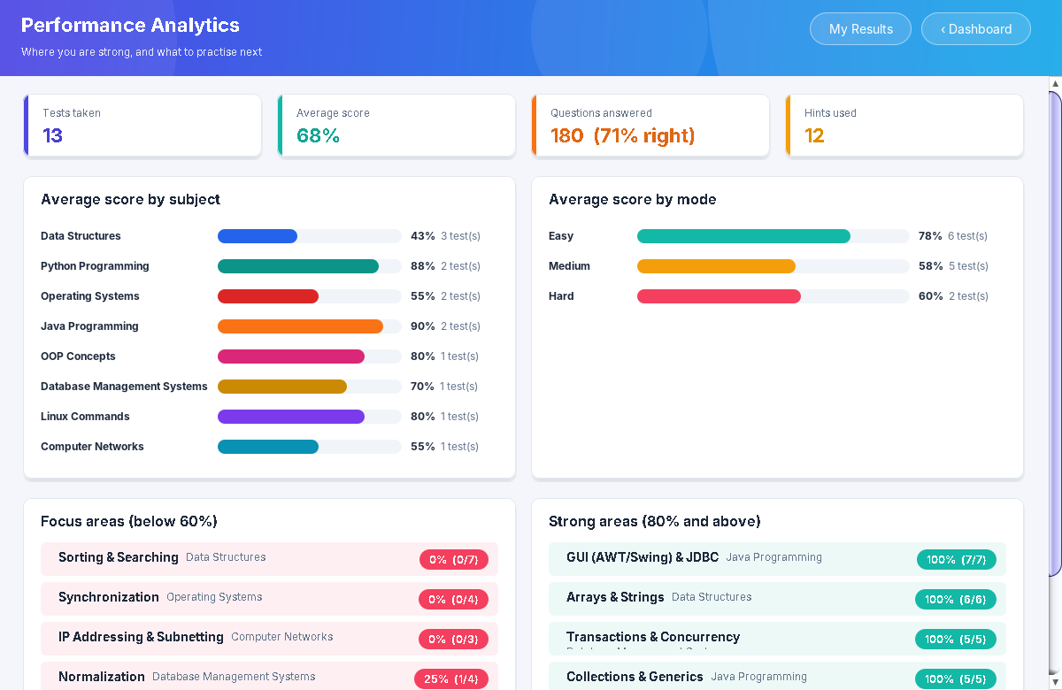
Figure 5.9 – Performance analytics: by subject, by mode, weak and strong subtopics
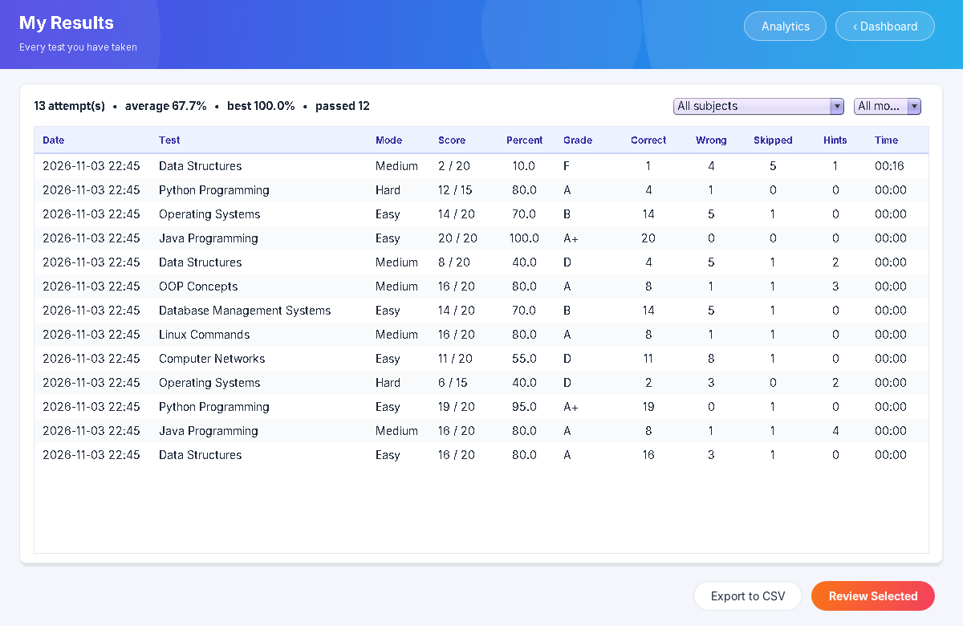
Figure 5.10 – Result history with subject and mode filters
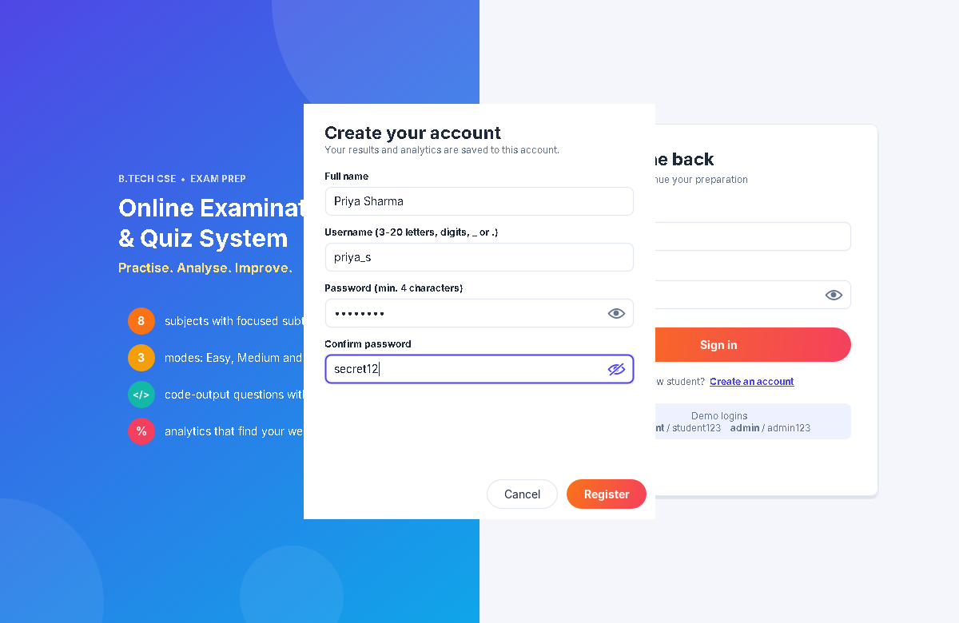
Figure 5.11 – Registration dialog with password visibility toggles
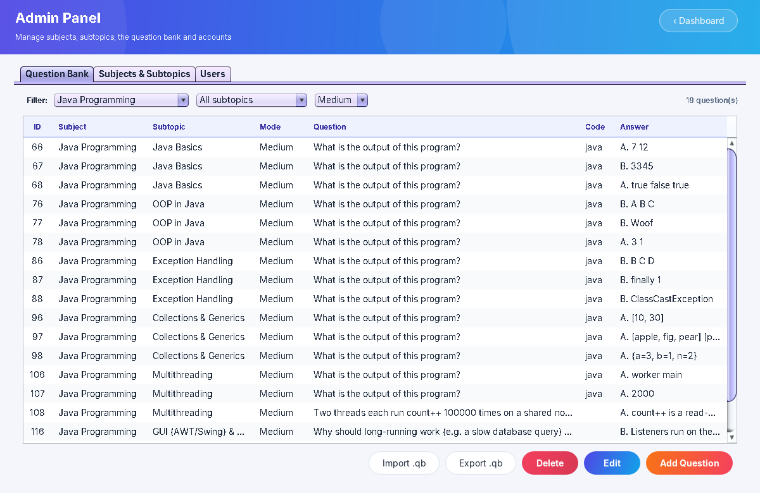
Figure 5.12 – Admin: question bank filtered by subject and mode
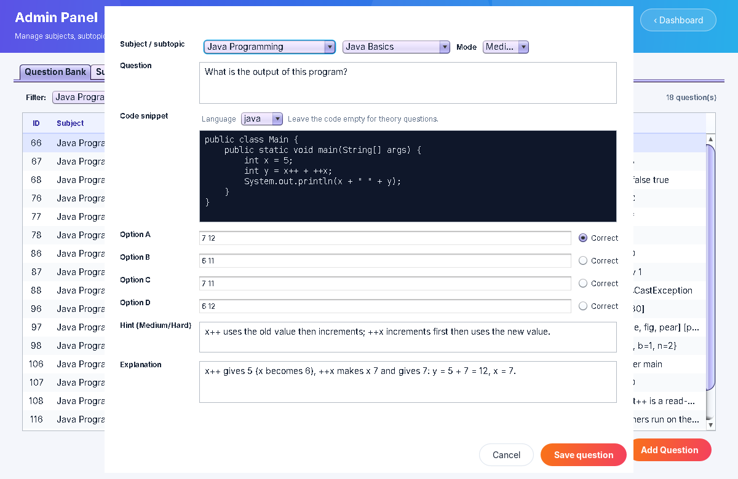
Figure 5.13 – Admin: editing a code question with hint and explanation
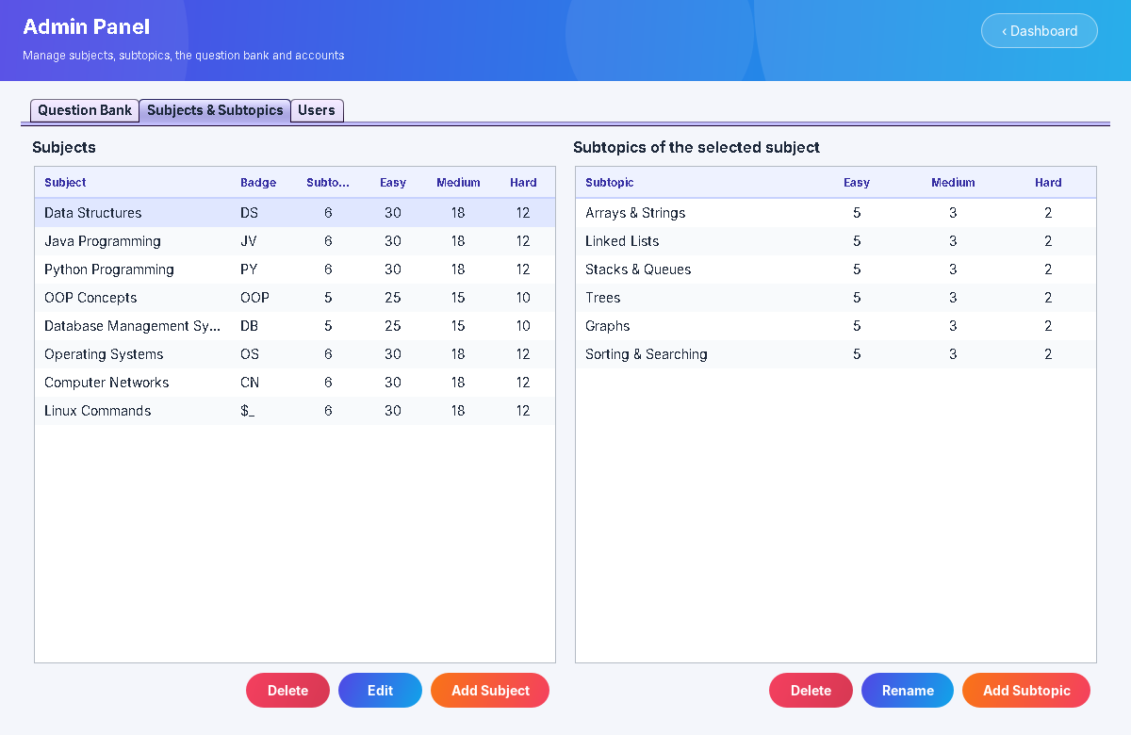
Figure 5.14 – Admin: subjects and their subtopics

6. Testing
The test suite (test/com/quiz/SelfTest.java) needs no external library and runs against temporary databases. Run it with ./test.sh (Linux/macOS) or test.bat (Windows). Result: 95 checks passed, 0 failed. Representative cases:
# | Test case | Expected result | Status
1 | Open a version-1 database | Accounts kept, old tables removed, schema version 2 | Pass
2 | Parse a .qb file with valid and invalid questions | 2 parsed, 2 errors with line numbers, code indentation kept | Pass
3 | Write a bank and parse it again | Identical questions, code and hints | Pass
4 | Seed the bundled banks | 8 subjects, 46 subtopics, 460 questions, no errors | Pass
5 | Every subject and every mode | Enough questions for a full Easy, Medium and Hard test | Pass
6 | Every Medium/Hard question | Has a hint; Easy questions have no code | Pass
7 | Mode settings | Easy 20/10 min/1 mark; Medium 10/10/2; Hard 5/10/3 | Pass
8 | Start Easy, Medium and Hard tests on a subject | 20, 10 and 5 distinct questions of the right mode | Pass
9 | Start a subtopic test | Only that subtopic; limited to the questions available | Pass
10 | Medium: 2 correct, 1 wrong, 2 unanswered, 1 hint | Score 4/10 (40%), hint recorded, no marks lost | Pass
11 | Ask for a hint in Easy mode | IllegalStateException | Pass
12 | Submit, then reload history and answers | Mode, hints, code and explanations persisted | Pass
13 | Analytics after two tests | Per-subtopic stats cover every answered question | Pass
14 | Invalid or duplicate subject/subtopic/question data | ValidationException or DataAccessException | Pass
15 | Delete a subject that has results | Questions cascade-deleted; results and review kept | Pass

The GUI was tested by hand and with an automated walkthrough (java.awt.Robot under a virtual display). The walkthrough signs in with the password revealed, opens a subject, chooses Medium mode, answers questions, reveals hints, marks for review, submits with unanswered questions, reviews answers, and opens the analytics, history, registration and admin screens. The screenshots in Chapter 5 come from that run.

7. How to Build and Run
# Linux / macOS (Fedora: sudo dnf install java-21-openjdk-devel)
cd OnlineQuizSystem
./run.sh # compiles when needed, then starts the app
./test.sh # runs the 95 self-tests

# Windows
run.bat
test.bat

Default accounts: admin / admin123 and student / student123. New students register from the login screen. Delete data/quiz.db to reset the application. To add questions, write them in the .qb format (see docs/sample_import.qb) and use Admin Panel › Import .qb.

8. Conclusion and Future Scope
The project meets every stated requirement and extends it into a practical exam-preparation tool. Questions are organised by subject, subtopic and difficulty. Answers are captured through an event-driven, custom-styled Swing interface. Scores handle unanswered questions correctly and weight harder modes more heavily. Questions and results are stored with JDBC, while question banks are read and written with Java I/O. Hints, explanations and subtopic analytics turn a single score into concrete guidance on what to study next. Verifying every code-based answer by execution gives confidence that the content is correct.
Possible enhancements:
- Client-server mode (MySQL/PostgreSQL) so a whole class can take a test from different machines.
- Shuffling option order, and a timed "exam mode" set by a teacher for a whole batch.
- Question types beyond single-answer MCQ: multiple-correct, true/false and images.
- Progress charts over time and printable PDF scorecards.
- Adaptive tests that pick more questions from a student's weak subtopics.

References
- Oracle, “Creating a GUI With Swing”, The Java Tutorials. https://docs.oracle.com/javase/tutorial/uiswing/
- Oracle, “JDBC Database Access”, The Java Tutorials. https://docs.oracle.com/javase/tutorial/jdbc/
- Oracle, “The Collections Framework” and “Basic I/O”, The Java Tutorials.
- Xerial, sqlite-jdbc driver. https://github.com/xerial/sqlite-jdbc
- A. Silberschatz, P. Galvin, G. Gagne, Operating System Concepts; A. Forouzan, Data Communications and Networking (question-bank reference material).

