resig-global

2022-07-08

## Note

working age population OECD: 15 to 64

prime-working-age population US: 25 to 54

Age group difference, young workers usually have higher unemployment To control the effects, I set age group 20/25 +

Can’t find labor force participation rate by ethnicity

# labor force participation rate, 2020-2021 annual, age 25-54

### men plot

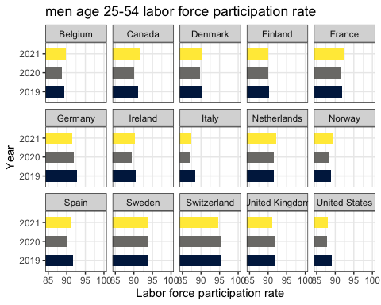 comment: In general, men’s lfprs are above 85. Switzerland has the highest men’s lfprs, around 95. some countries’ lfprs in 2021 are higher than of that in 2020 even 2019. But Germany, Italy, UK, US, Spain, Finland, Ireland are lower than it in 2019.

notes: other factor, migrant labor. lower participation. US, Spain, Italy. look migrant labor dependence. Eurostats migrant flows. childcare provision Netherlands (private, vouchers), market of childcare increased, opening of private childcare centers. Germany(local government), public support on childcare. modality, the ways of childcare provision.

### women plot

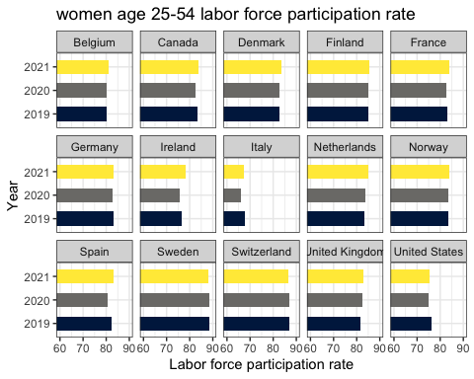 comment: All women’s lfprs are below 90. Sweden, Switzerland, Finland are higher than 85. Italy has the lowest, between 65-70. US, Switzerland, Germany, and Italy’s rates in 2021 are lower than in 2019.

### gender comparison plot

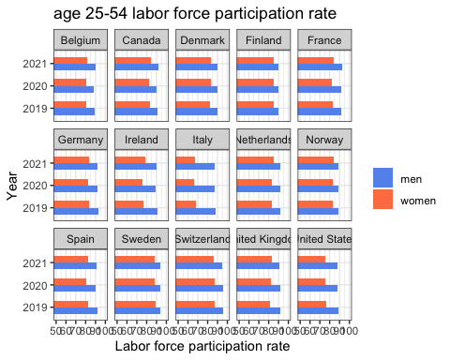 comment: Women’s lfprs are generally lower than men’s. Italy has the largest gender gap, then US, Ireland.

**Net child cost**

definitions: <https://data.oecd.org/benwage/net-childcare-costs.htm>

This indicator measures the net childcare costs for parents using full-time centre-based childcare, after any benefits designed to reduce the gross childcare fees. Childcare benefits can be received in the form of childcare allowances, tax concessions, fee rebates and increases in other benefit entitlements. Net childcare costs are calculated for both couples and lone parents assuming two children aged 2 and 3. For couples, one parent earns 67% of the average wage whereas the other earns either minimum wage, 67% or 100% of the average wage.

### comment

Germany has remained a high level of child cost (above 25) from 2018 to 2021

Nordic countries generally have a low level of child cost (below 20) from 2018 to 2021

Before the COVID, the US has the highest child cost level nearly 30, but the cost dropped significantly to 15 from 2020 to 2021

### Plot 2004-2001 child costs

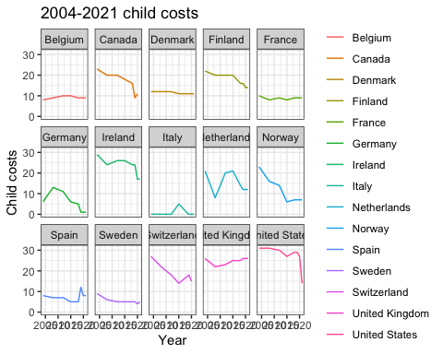

2018-2021

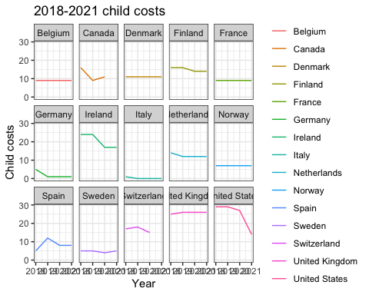

# Financial disincentive to enter employment with childcare costs

<https://data.oecd.org/benwage/financial-disincentive-to-enter-employment-with-childcare-costs.htm#indicator-chart>

This indicator measures the percentage of earnings lost to either higher taxes or lower benefits when a parent of two children takes up full-time employment and uses centre-based childcare. Calculations refer to a couple with two children aged 2 and 3 where the other parent works full-time at 67% of the average wage.

### comment:

Canada, Denmark, and the US financial disincentive are over 80, higher than other European countries. Sweden, Norway, Spain, and Italy are below 80, lower than other European countries.

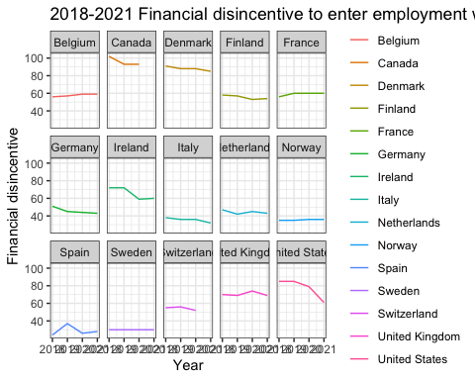

# Job leavers & starters

Eurostat report: <https://ec.europa.eu/eurostat/web/products-eurostat-news/-/ddn-20200422-2> database: <https://ec.europa.eu/eurostat/web/lfs/data/database>

two age groups: 20-64, 15-74. But I only choose 20-64 due to childcare considerations

1. Recent job leavers by sex and age 2018 Q1-2022 Q2 quarterly, seasonally adjusted <https://ec.europa.eu/eurostat/databrowser/view/LFSI_LEA_Q__custom_3611506/default/table?lang=en> Recent job leavers are those persons who report to have left their job in the last 3 months before the interview
2. Recent job starters by sex and age 2018 Q1-2022 Q2 quarterly, seasonally adjusted <https://ec.europa.eu/eurostat/databrowser/view/LFSI_STA_Q__custom_3621184/default/table?lang=en> Recent job starters are those persons who have started their employment in the last 3 months before the interview.

Job leavers:

comment:

France, Italy, and Germany have a much higher number of job leavers. France and Italy have an obvious increase of job leavers from 2021 Q2 to 2021 Q3. But not see a very significant gender difference.

comment:

I don’t find solid statistical evidence that women are more likely than men to leave the job market in Euro Area (15 countries in Euro stat survey). This plot actually shows more men left than women.

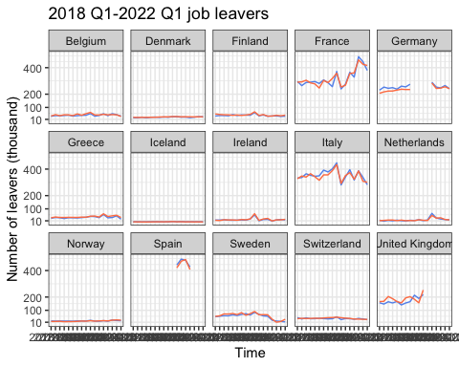

### job leavers 2021 euro countries

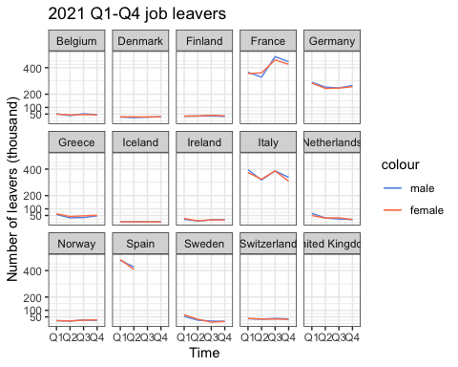 ###

### General Euro job leavers

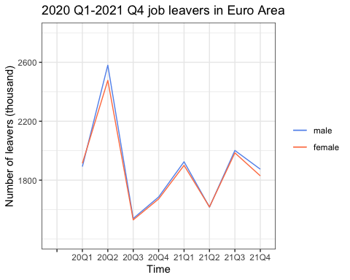 ###

# relationship between childcare cost and labor force participation

OECD dataset

comment: correlation test does not show that childcost is correlated to female/male labor force participation.

#male

##